**Table of Contents**

* Purpose And Objective
* Test Principle
* Test Strategy 
  + Test Methodology
  + User Story/ Sprint planning
  + Acceptance Criteria
* Text Execution Using Test Pyramid
  + Development
  + Developer Testing
  + Automated functional and non-functional tests
  + Regression testing
  + User Acceptance Testing
* Test Coverage
  + Types of Testing
  + Test quadrants
  + Test Execution flow in TDD
* Test Environments
* Tools/ Framework for Testing
* Test Management
* Issue/Defect Management
* Scope , Timelines and Milestones
  + Resource Allocation
* Risks and Mitigation Plans
* Test Coverage Analysis
* Key Metrics and Reporting
* Done Criteria

**Purpose And Objective**

* This document covers the Test Strategy we will be following to test any project developed using the Spree Ecommerce App.
* The purpose is to deliver a bug free , fully functional project / Application which is developed using the Spree Ecommerce platform.
* Once the test strategy is in place, the project can be expanded with limited scope ( timeframe) and delivered with high quality at a low maintenance cost.
* Provide a comprehensive documentation reference guide to be used throughout the testing effort for validation purposes.
* Document the test strategy for Functional & Technical test.

**Test Principle**

The mission of the testing across all stages / phases for an Ecommerce application is based on the following principles

* Plan early to facilitate starting tests on time and staying on schedule
* Test early. It is far less costly to fix errors earlier in the systems development life cycle than later
* Ensure that gaps and overlaps in testing are minimised by clearly defining the objectives of each test stage / phase
* Establish entry and exit criteria to ensure that the objectives of each testing stage / phase are met
* Define the test cases and test scripts in order to ensure that the design specifications are covered
* Develop well-documented, repeatable tests to facilitate defect analysis

**Test Strategy**

The Test Strategy provides a comprehensive documentation reference guide to be used throughout the testing effort for any Spree Ecommerce Application.

**Test Methodology**:

**Agile** : The test methodology that we are proposing to follow is Agile.

**Scrum**: Scrum is an Agile methodology in which the Project is divided into User Stories and Each Story is worked upon in a Sprint.

A Sprint will be typically 3 or 2 weeks in scope.

In Agile, QA is the responsibility of everyone, not only the testers. QA is all the activities we do to ensure correct quality during the development of new products.

This means, the entire project is divided into a set of user stories and then each story is worked upon by the project team.

**User Story / Sprint Planning:**

* In each story workshop, everyone in the team learns about the details of the stories so developers and QA know the scope of the work.
* Everybody should have the same understanding of what the story is about.
* Developers should have a good understanding of the technical details that are involved in delivering the story,
* QA should know how the story will be tested and if there are any impediments to test the stories.
* In the sprint planning meetings, the estimates given for a story should include the testing effort as well and not just coding effort. QA (manual and automation) must also be present in the sprint planning meetings to provide an estimate for testing of the story.
* Each story will have an acceptance criteria.

Example user stories for a Spree Ecommerce application,

* Develop a login page using the spree commerce app, which has the facility to both sign in and register.
* A home page with categories to select different products in each categories.

Assumptions and deliverables in each stories should be pointed out clearly.

**Acceptance Criteria:**

* Each of the User stories must contain acceptance criteria. This is possibly the most important element which encourages communication with different members of the team.
* Acceptance criteria should be written at the same time the user story is created and should be embedded within the body of the story. All acceptance criteria should be testable.
* Each Acceptance Criteria should have a number of Acceptance Tests presented as scenarios.

**Text Execution Using Test Pyramid**

Each Story in the Spree Ecommerce Application will follow what is called a “ Test Pyramid “ for testing the entire Story/ feature and deliver quick and quality product.

The approach to be followed here is TDD - Test Driven Development , where in the tests are developed even before the Development of code , so the safety net is already built.

This helps in quick finding and closure of defects early in the Story lifecycle.

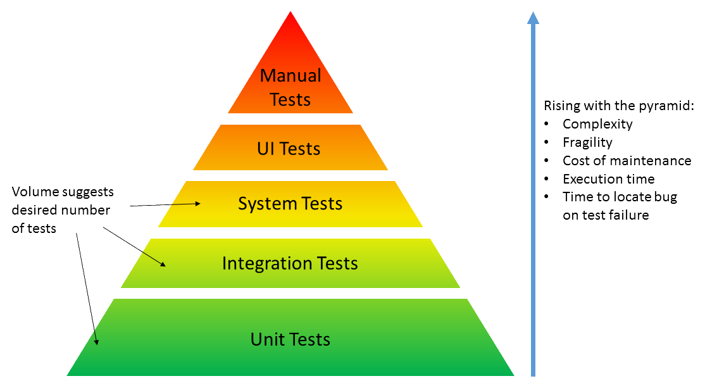

**Development**:

* When development starts, new production code and/or modification to legacy code should be backed by unit tests written by developers and peer-reviewed by another developer or a skilled SDET.
* Any commit to the code repository should trigger an execution of the unit tests from the CI server. This provides a fast feedback mechanism to the development team.
* Unit tests ensure that the system works at a technical level and that there are no errors in the logic.

**Developer Testing:**

* As a developer, behave as if you don’t have any QA in the team or organisation. It is true that QAs have different mindset but you should test to the best of your ability.
* Any new code and/or refactoring of legacy code should have appropriate unit tests that will be part of the unit regression test.
* When a new user story is developed, for example, the login page is developed, all the possible functionalities of the login page can be tested through unit tests and only UI level tests will be pending from the QA side.
* The QA and Dev should collaboratively work to figure out which functionality can be tested with Unit tests and which are not.

**Automated functional and non-functional tests:**

* The automated acceptance tests include Integration Tests , Service Tests , UI tests which aim to prove the software works at a functional level and that it meets user’s requirements and specifications.
* Non-functional tests (Performance and Security) tests are as equally important as functional tests, therefore need to be executed on each deploy.
* It is vital that this should be a completely automated process with very little maintenance to get the most benefit out of automated deployments. This means there should be no intermittent test failures, test script issues, and broken environment.
* Failures should only be due to genuine code defects rather than script issues, therefore any failing test which is not due to genuine failures should be fixed immediately or removed from the automation pack, to be able to get consistent results.

**Regression Testing:**

1. **Smoke Test:**

This pack contains only high-level functionality to make sure the application is stable enough for further development or testing.

Example of Smoke Pack for a Spree application is,

* + Login or Account signup
  + Search a Product
  + Add a Product to cart
  + Purchase an item

1. **Full regression Test:**
   * This pack contains the full regression suite of tests and contains everything else which is not included in the smoke pack.
   * It should be easily maintainable.
   * Should not run for more than an hour or so and should give clear feedback on the tests.

**UAT and Exploratory Testing:**

* Manual testing of the business flows to confirm the built product is what was expected and that it meets user’s expectations.
* Can be run in parallel with Automated regression suits and other Functional automated tests.
* Mostly done by the PO and all others in the team.
* Exploratory testing should focus on user scenarios and should find bugs that automation misses. Exploratory testing should not find trivial bugs, rather it should find subtle issues.

**Test** Coverage

**Types of Tests to be carried out for a Spree Ecommerce Application:**

|  |  |  |  |  |  |  |
| --- | --- | --- | --- | --- | --- | --- |
| Test Type | Test Level | Who | What | When | Where | How |
| Functional Testing | Unit Testing | Dev | All new code + re-factoring of legacy code as well as Javascript unit Testing | As soon as the code is developed | Dev Box | Checked in to CI /CD pipeline as well  Automated using Unit, PHPUnit etc |
|  | API/Service Testing | Dev, QA | All new APIs involved in the project to be tested individually | Parallel automation of APIs can be done during API development cycle | QA | Checked into CI/CD pipeline  Automated using TestNG , REST Assured frameworks, Manual testing using Postman for tests that cannot be automated |
|  | Functional UI Testing | QA | UI tests on the Application | Parallel Automation of UI pages during Development | QA | Automation using Selenium.  Manual testing of the flows that cannot be / need not be automated. |
|  | Integration Testing | QA | All the components are integrated and tested together end to end | Once the components are ready and deployed in an integrated environment | Integrated Environment ( staging) | Mostly integrated tests are carried out manually. A minimal set of integrated tests can be automated and checked into CI pipeline |
| Acceptance Testing | Acceptance criteria Test | QA, BA, Dev | The acceptance criteria tests for each story is tested | During Dev to QA handover | Dev box , QA Environment | Mostly Manual as it covers a minimal set of tests for a single user story |
| Regression Testing | Full Regression test | QA | Scenario Testing, User flows and typical User Journeys | After the functional tests are certified and story or project moves to Integration environment | Integration Environment | The pack should have a set of automated User flow tests that can be run parallel and easy to maintain. |
|  | Smoke Test | QA | Quick check of main functionalities ( Typically P1s and P2s) | After each build (once the builds are stable and there are checkins for bug fixes) | Integration Environment | A small set of Smoke test to be automated and run through CICD pipeline. Should not take long time to give feedback |
| UAT (User Acceptance Tests) | Exploratory Testing | QA, BA, PO ( Can conduct bug bash with different Users) | Exploratory testing should focus on user scenarios and should find bugs that automation misses. | Once regression starts , the UAT can also start in parallel or the Team may start it once regression completes | Integration Environment | Manual testing of the user flow and different actions an end customer can perform.  The aim of UAT is to ensure that the developed features make business sense and helpful to customers. |
| Security Testing | Integration Testing | Security Engineer / QA | Security Tests should check for basic security vulnerabilities derived from [OWASP](https://www.owasp.org/index.php/Main_Page) | In each stage ( QA, Integration and UAT ) | QA and Integration Environment | Few Security standards are tested across all stages (UI, API and integration). Can be covered in Unit tests and Service Tests in automation |
| Performance Testing |  | Performance Engineer / QA | Performance Tests should check performance metrics on each deploy to ensure no performance degradation | Once the story is in QA, and is stable in QA environment | QA and Integration Environment | Tools like JMeter can be used to measure the performance parameters |
| Cross Browser Testing | UI Testing | QA | UI responsiveness in different Browsers and OS.This will include testing across multiple operating systems on both Android and iOS platforms | Once the story is in QA, and is stable in QA environment | QA and Integration environment | High level functional test cases are executed on different browsers having latest version –  Chrome, Firefox, Safari & Edge/IE.  Application as a whole is continually validated from usability point of view. |
| Cross Device Testing | UI Testing | QA | UI responsiveness and load in different devises like mobile devices, mobile apps etc | Once the story is in QA, and is stable in QA environment | In QA and Integration Environment | Manual testing of few high level User flows in all the mobile apps and devices.Cross device testing would be performed across different devices – desktops, Tablets & mobile phones. |
| Accessibility testing | UI Testing | QA | Are the pages / UI accessibility friendly | In QA | Integration Environment | Accessibility parameters to be tested in the web pages manually |

Test Quadrants:

The agile testing quadrants separate the whole process in four Quadrants and help to understand how agile testing is performed,

Quadrant 1 : Unit testing , Component testing , API testing

Quadrant 2: Functional UI Manual tests, Functional UI automated tests, Tests with mocks / Stubs/ Simulations

Quadrant 3: Exploratory testing , UAT, Accessibility tests , Cross browser, cross Device testing

Quadrant 4: Performance tests, Load tests, Security Tests wrt Authentication, Hacking etc.

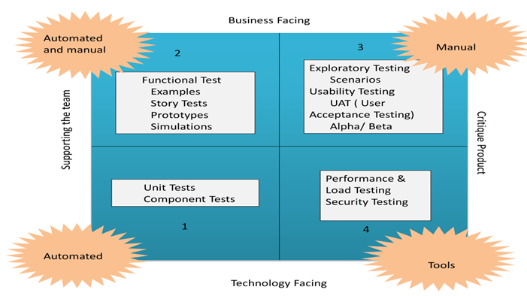

Test execution Flow in a TDD Approach: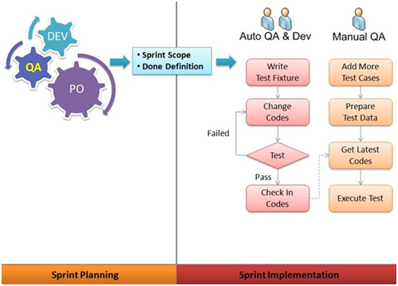

Test Environments

|  |  |
| --- | --- |
| Environment Type | Link to Access |
| DEV | <<Dev Link>> |
| QA | <<QA>> |
| INTEGRATION/ STAGING | <<Staging Environment>> |
| PRE-PROD | <<Pre-prod Link>> |
| PROD | <<Prod Link>> |

Mocks/ Stubs and Third Party Integration Environments:

* In addition to the above environments, plan needs to be done for any third party integration that needs to be facilitated for testing.
* If the third party integration can happen only at the later stage in the cycle/ sprint, there should be stubs or mocks in place to leverage the integration capability for carrying out integration testing.
* The mock/ stub should be designed well in advance before the Dev to QA happens , so that Integration testing can happen quickly and easily.

Example of a Mock in our application is : Payment gateway which needs to be integrated for testing.

Also while doing End to end testing, if the underlying APIs are not ready we can mock them as well for testing the UI flows.

Though a Mock or Stub is used, it is always a good idea to test by integrating directly with the third party once before UAT to avoid any last minute surprises.

<<Mock And Stubs link for Spree Ecommerce>>

Tools/ Framework for Testing

Manual Testing:

* Service / API tests - PostMan, SOAP UI
* Functional UI tests - Web Browsers

Automation Frameworks:

* Appium - For Mobile devices Automation
* Selenium - For UI Automation
* Rest Assured - for REST API testing

TestNG - Test Automation tool and reporting tool

Maven - Build tool to facilitate CI/ CD pipeline

Git - Version Control System to manage automation scripts and enable central storage of all tests

<<Link to the GitHub repo for this project>>

Test Management

Test Data:

1. Test Data for automation tests as well as manual tests can be prepared once the story/ Sprint starts and the Dev is in progress. This will facilitate quick test execution once the dev to QA happens.

2. Test Data to be got from the client ( for any integration testing ) , should be clearly communicated and the format of the Data to be documented.

3. The client data is to be validated against the standard format and approved well before the Dev to QA happens and before the project is in text execution phase.

For Spree Ecommerce App, the test data includes and not limited to,

* Registered users on the Application
* The different categories to be tested
* The products to be tested
* Users with different types of items in their cart

These kind of test data can be prepared through automation in earlier, and can be executed when the test execution phase happens.

<<Test Data repository Link>>

Maintenance of tests:

* Automated tests are to be checked in and maintained in a Central Version control system. The proposed version control for Spree eCommerce App is GIT.
* Manual tests ( Acceptance Tests, Functional UI tests which cannot be automated etc) to be maintained in Excel sheets and checked in along with the project automation test suite to maintain a single point of lookup for the entire project documents.
* The tests are to be updated frequently as and when a new defect arises because of an unidentified / leaked test.

Issue/Defect Management

* Issue Management is done using JIRA.
* Tag the issues to the User Story the issue is currently raised on.
* If the User Story is complete, then the issue goes to the backlog and is picked in the next sprint.
* The Issue Management Process should be repeated at regular intervals throughout the duration of the project or program.
* In a program context, you may find that it makes sense to increase the frequency at which you run the Issue Management Process as your program nears completion, even running the process twice daily to ensure issues are being closed off quickly and effectively as time runs out.

<<Link to User Stories for Spree Ecommerce in JIRA>>

Severity Definitions:

Once a problem has been identified during a testing phase, it will be raised with the Business and discussed. If appropriate the Business will agree to a Severity for the problem, log it as an issue and progress.

The table below lists the classification types that apply to Severity.

|  |  |
| --- | --- |
| Field | Description |
| SEV1 –Critical | Functional or procedure failure of the complete system with no work around, or defects that are urgent customer care driver.  Examples:  • Major feature unavailable to the user and/or QA (or seems to be) without workaround |
| SEV2 – High | Major Functional or procedural failure, with acceptable work around.  Examples:  • Major functionality unavailable, but workaround exists  • Minor functionality unavailable, no workaround  • Data loss or corruption with obvious workaround |
| SEV3 – Medium | The defect causes no system failure, but the system produces incorrect, incomplete, or inconsistent results.  Examples:  • Minor functionality unavailable or faulty, but easy workaround for users exists |
| SEV4 - Low | The defect does not result in failure or significant impairment of usability, and there are one or more easy workarounds.  Examples:  Product behaviour or UI visually not up to specification in a minor way, but the functionality is available. |

Priority Code Definitions:

The table below lists the classification types that apply to Priority.

|  |  |
| --- | --- |
| Field | Description |
| CRITICAL | Defect which results in the failure of the complete software system, of a critical subsystem so that no work or testing can be carried out after the occurrence of the defect. It also applies to data loss failures and with processes that leave inconsistent data stored on the database. |
| MAJOR | Defect which also causes failure of entire or part of system, but there are some processing alternatives which allows further operation of the system. It also applies to the system crashing, or aborting, during normal operation of a non-critical flow. |
| MINOR | Defect which do not result in failure but causes the system to show incorrect, incomplete, or inconsistent results (note that show inconsistent results is way different of generating inconsistent results at database level as explained above). A critical usability issue fits also in this category, as well as if there is a simple workaround. |
| TRIVIAL | Defects which are small errors that do not prevent or hinder functionality, typos, grammar mistakes, wrong terminology, general usability issues and styling. |

Scope , Timelines and Milestones

|  |  |  |  |
| --- | --- | --- | --- |
| User Story / Task | Weeks/ Sprints | Resources allocated | Milestone / Date of Release |
| User story1 <<Jira Link>> |  |  |  |
| User Story 2 |  |  |  |
| Integration Testing |  |  |  |
| UAT |  |  |  |
| Pre - Production Testing |  |  |  |
| Done Criteria |  |  |  |

For Each User Story, the milestones can be further fixed for each of the different tests as and when the sprint starts.

Resource allocation:

* No of QA resources required for the project
* No of QA for each sprint
* No of Automation engineers needed
* Any special needs for a specific tool expertise needed or not, to be called out

Risks and Mitigation plans

* Delay in QA Environment Readiness might impact QA activities and estimates, which could lead to delay in delivery
* Unavailability of Resource Expertise & Specialisation in planned automation tool might impact QA estimation
* Failure to identify complex functionalities and time required to develop those functionalities would impact QA estimates & project delivery
* Unexpected project scope expansions would impact current QA efforts and additional efforts would be estimated for the same

RCA ( Root Cause Analysis):

Each Defect with a Severity and Priority of 1 or 2 will have to undergo the RCA process to avoid leakage of those defects in further cycles.

Root : Where the Defect has been caught

Cause: What caused the defect and where it got leaked

Analysis: How did the defect leak and where and how it could have been prevented.

Once the RCA is done, the particular test can be added to the corresponding test suite for regression of further User Stories.

Test Coverage Analysis

Test coverage measures the amount of testing performed by a set of test.

It will include gathering information about which parts of a program are actually executed when running the test suite in order to determine which branches of conditional statements have been taken.

What Test Coverage does -

* Finding area of a requirement not implemented by a set of test cases
* Helps to create additional test cases to increase coverage
* Identifying a quantitative measure of test coverage, which is an indirect method for quality check
* Identifying meaningless test cases that do not increase coverage.

Test Coverage will be accomplished -

* Test coverage can be done by exercising the static review techniques like peer reviews, inspections and walk-through
* By transforming the ad-hoc defects into executable test cases
* At code level or unit test level, test coverage can be achieved by availing the automated code coverage or unit test coverage tools like Junit Coverage.
* Functional test coverage can be done with the help of proper test management tools

Key metrics and reporting

* # of Test Cases
* # of Manual Test Cases
* # of Automated Test Cases
* # of Passed Manual Test Cases
* # of Passed Automated Test Cases
* # of Failed Test Cases
* # of Test Cases Blocked
* Percentage TCs Passed

Other Metrics can include,

* Defects metrics ( No of Defects logged, no of P1s, No of defects open at each checkpoint etc)
* Test Coverage - Manual Test coverage, Automation test coverage , Automation test pass percentage
* Defect Leakage percentage
* Environment downtime

Automation Reports can include, ( These report to be published for each of the automation suite running in Pipeline and then collated)

* Type of test
* Total number of Tests
* No of tests passed
* Test pass percentage

Done Criteria

A Definition of Done drives the quality of work and is used to assess when a User Story has been completed.

"Done means every task under the User Story has been completed and any work created is attached to the User Story so the Product Owner can review it and make sure it meets his or her expectations."

Example of a Done Criteria for Spree eCommerce can be:

Any User is successfully able to login and do a purchase and can see the purchased product in his Order Page.

Each user Story ( and the project ) should have a done criteria and the activities are performed at the end and the story is marked done.

Once all the above activities are completed and no issues found, a story is Done!