**Uber API example**

Objective: As a person who uses yelp a lot, it would be helpful if I could have a way to request a Uber ride from Yelp.

Step 1: Built a chrome extension called YelpUberExtension. The extension first locates an address on the yelp page and will display a green marker in the address.



Step 2: Clicking the green marker will pop open a small box that will display Uber time estimate to get from user’s location to the destination.



Step 3: Clicking the time estimate will help user login to uber and display the first product.

Assumptions: a. User has a valid Uber login. b. Displayed first product to build a simple complete working example.

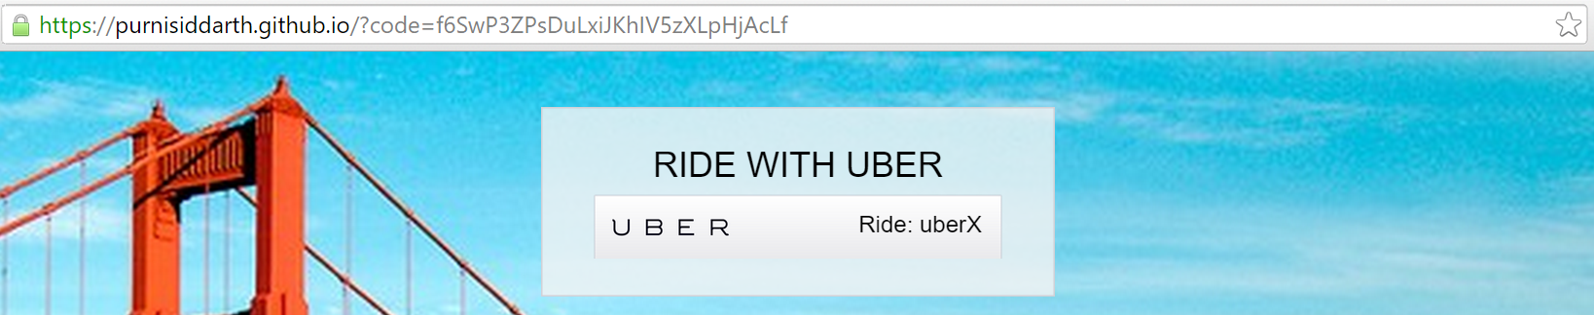

Step 4: Clicking the Uber button will request(sandbox request) a ride for the user. And show status.

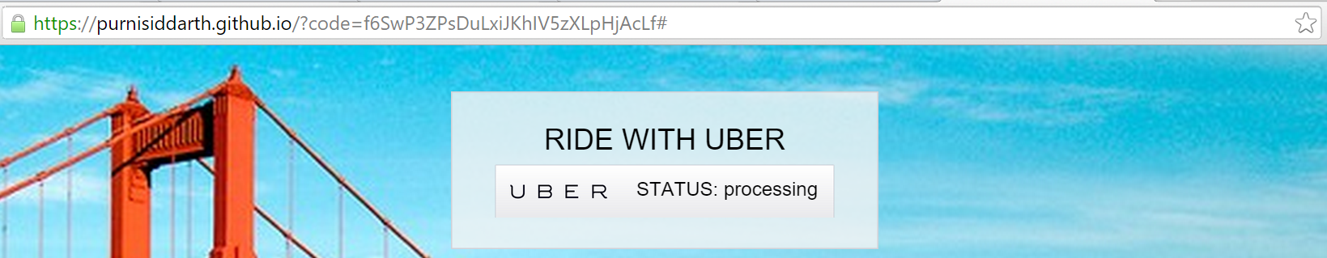

What I learned in the process:

1. Build a Chrome extension. Add it to chrome. Add manifest and content security policy
2. Use navigator.geolocation, map.googleapis.com, api.uber.com
3. Uber design guidelines, endpoints, tutorials
4. OAuth2 for Uber - Authorize, Receive redirect, get access token, use Bearer token
5. Use Uber sandbox and request a ride and troubleshoot outcomes (401 Unauthorized, 400 BadRequest, 406 Not acceptable. Use Advanced REST Client extension for troubleshooting.
6. GitHub and GitHub Pages, just enough to host the test page and do end to end test.