DYNAMIC & INFORMATIVE VISUALIZATIONS IN R
Week 2 — Data Visualization and Insight Communication
Dataset: Titanic — Machine Learning from Disaster

Dataset | Titanic training dataset
Observations | 891 passengers
Visualization library | ggplot2
Chart types | Bar, histogram, scatter, line, boxplot, correlation heatmap

1. Visualization Objective
The objective of this week's work is to communicate patterns in the Titanic dataset through carefully selected visualizations. Rather than producing charts only for presentation, each visualization answers a specific analytical question. The charts cover categorical comparisons, distributions, relationships between numerical variables, group-level trends, potential anomalies, and correlations.

1.1 Audience and Design Approach
The report is designed for a non-technical audience. Titles use plain language, axes are explicitly labelled, and numerical annotations are added where they make the comparison easier. The visualizations are intentionally different because different questions require different graphical forms.
The same Titanic dataset from Week 1 is reused. Age values are filled using the same group-wise median approach from the cleaning task so that the age-based charts are not distorted by missing observations.

2. Data Overview and Key Variables
The dataset contains 891 passengers and records whether each passenger survived, passenger class, sex, age, family counts, fare, cabin and embarkation information. The target variable Survived is binary, while Pclass, Sex and Embarked are categorical variables. Age and Fare are numerical variables and are especially useful for distribution and relationship visualizations.
Variable | Type | Visualization use
Survived | Binary | Outcome comparison
Sex | Categorical | Bar chart
Pclass | Ordinal categorical | Bar chart / boxplot
Age | Numerical | Histogram / scatter / line grouping
Fare | Numerical | Scatter / boxplot
SibSp, Parch | Numerical counts | Correlation

3. Bar Chart — Survival Rate by Sex
The bar chart compares a single percentage across two categories, making it the most direct choice for this question. Female survival was 74.2%, while male survival was 18.9%. The large difference is immediately visible and is easier to communicate with bars than with a table.
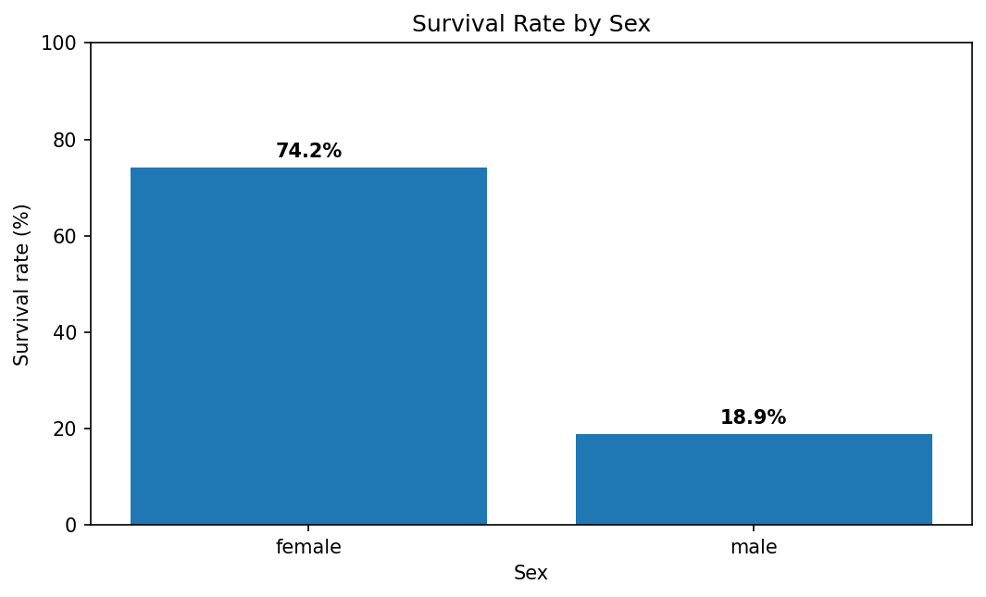
Figure — Survival Rate by Sex

R Code
sex_summary <- titanic_viz %>%
group_by(Sex) %>%
summarise(
Survival_Rate = mean(Survived) * 100,
Passengers = n(),
.groups = "drop"
)
ggplot(sex_summary, aes(x = Sex, y = Survival_Rate)) +
geom_col() +
geom_text(aes(label = paste0(round(Survival_Rate, 1), "%")),
vjust = -0.3) +
labs(title = "Survival Rate by Sex",
x = "Sex", y = "Survival rate (%)") +
coord_cartesian(ylim = c(0, 100)) +
theme_minimal()

Interpretation for a Non-Technical Audience
The chart shows a strong descriptive difference by sex. It does not establish that sex alone caused the difference; other factors such as class and age may also be related to the outcome.

4. Bar Chart — Passenger Volume by Class
This chart answers a simple composition question: how many passengers were in each class? The counts were 216 in first class, 184 in second class, and 491 in third class. A bar chart is appropriate because the categories are discrete and the audience needs an easy comparison.
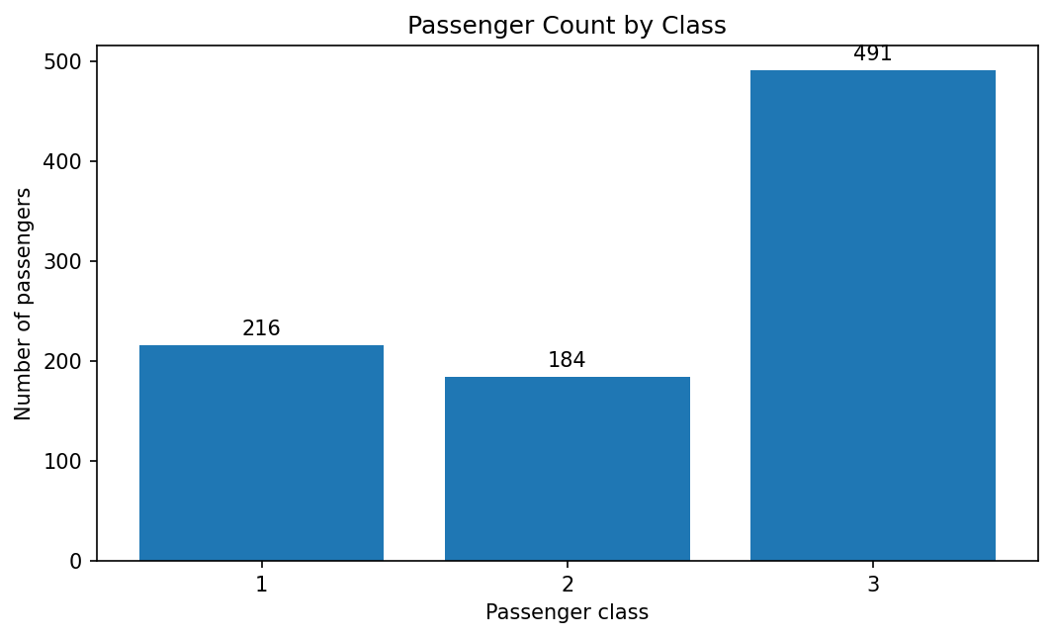
Figure — Passenger Volume by Class

R Code
ggplot(titanic_viz, aes(x = Pclass)) +
geom_bar() +
geom_text(stat = "count", aes(label = after_stat(count)),
vjust = -0.3) +
labs(title = "Passenger Count by Class",
x = "Passenger class", y = "Number of passengers") +
theme_minimal()

Interpretation for a Non-Technical Audience
Third class represents the largest passenger group. This matters when interpreting other charts: overall survival patterns are influenced by the different numbers of passengers in each class.

5. Histogram — Age Distribution
A histogram was selected because Age is continuous and the question concerns its distribution. The cleaned age values have a mean of 29.1 years and a median of 26.0 years. The histogram makes the concentration of passengers across age ranges visible and highlights the relatively small number of very old passengers.
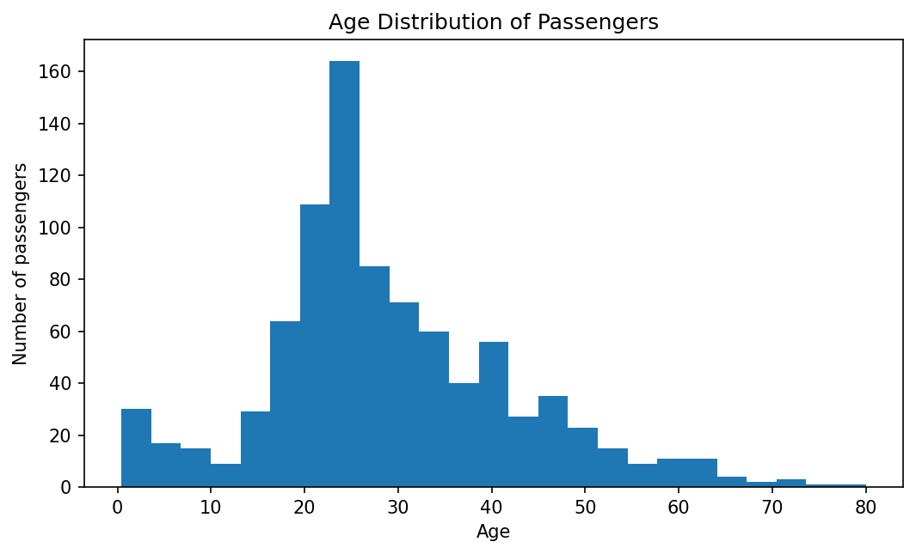
Figure — Age Distribution

R Code
ggplot(titanic_viz, aes(x = Age)) +
geom_histogram(bins = 25) +
labs(title = "Age Distribution of Passengers",
x = "Age", y = "Number of passengers") +
theme_minimal()

Interpretation for a Non-Technical Audience
The distribution is concentrated among younger and middle-aged passengers. A histogram is more informative here than a bar chart because it shows the shape of a continuous distribution.

6. Scatter Plot — Age vs Fare by Survival
The scatter plot examines whether age and fare show a visible relationship and whether survival outcomes occupy different parts of the plot. The correlation between Age and Fare is 0.123. The plot also exposes clusters and high-fare observations that would be hidden in separate one-variable charts.
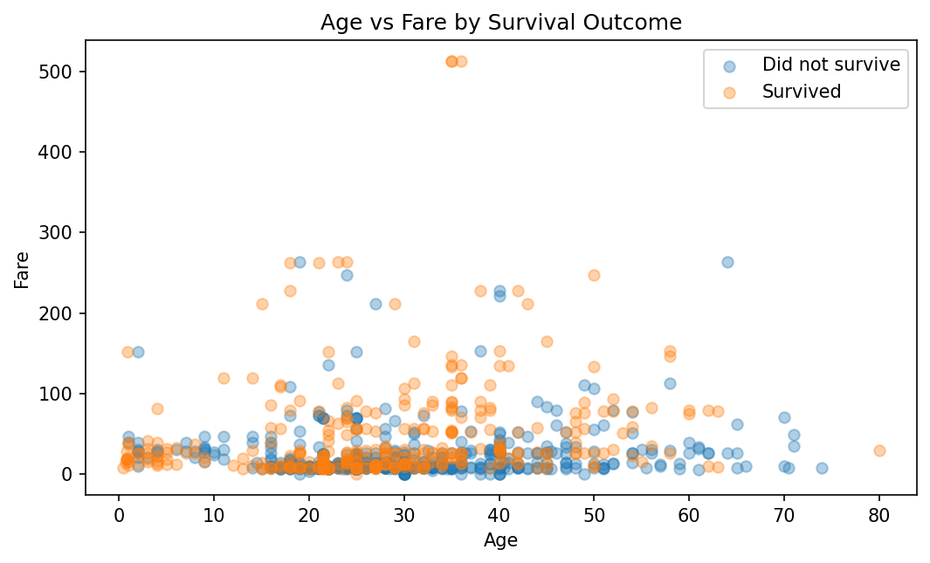
Figure — Age vs Fare by Survival

R Code
ggplot(titanic_viz,
aes(x = Age, y = Fare, shape = factor(Survived))) +
geom_point(alpha = 0.55) +
labs(title = "Age vs Fare by Survival Outcome",
x = "Age", y = "Fare", shape = "Survived") +
theme_minimal()

Interpretation for a Non-Technical Audience
There is a modest relationship between age and fare, but the points are widely dispersed. High fares appear in a relatively small set of observations. The visual reinforces the Week 1 decision to inspect, rather than automatically delete, extreme fare values.

7. Line Chart — Survival Rate Across Age Groups
A line chart is used here to emphasize the ordered progression from children to older age groups. It should be interpreted as a trend across ordered age bands rather than as a continuous time series.
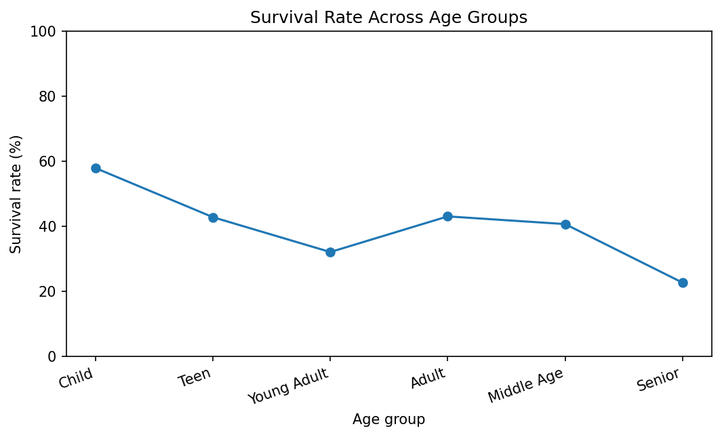
Figure — Survival Rate Across Age Groups

R Code
age_summary <- titanic_viz %>%
group_by(AgeGroup) %>%
summarise(
Survival_Rate = mean(Survived) * 100,
Passengers = n(),
.groups = "drop"
)
ggplot(age_summary,
aes(x = AgeGroup, y = Survival_Rate, group = 1)) +
geom_line() +
geom_point(size = 3) +
labs(title = "Survival Rate Across Age Groups",
x = "Age group", y = "Survival rate (%)") +
coord_cartesian(ylim = c(0, 100)) +
theme_minimal()

Interpretation for a Non-Technical Audience
The age-group pattern varies across groups, with children showing a distinct survival profile. Because age groups have different sample sizes, percentages should be interpreted together with the passenger counts.

8. Boxplot — Fare Distribution by Passenger Class
The boxplot compares the full distribution of Fare across classes. It shows the median, spread and potential extreme observations in one view. Mean fare was 84.15 for first class, 20.66 for second class and 13.68 for third class.
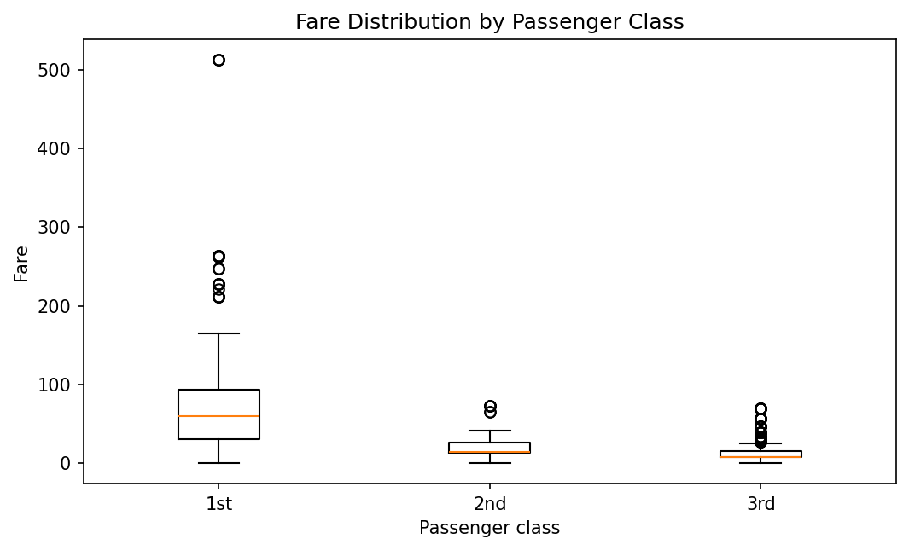
Figure — Fare Distribution by Passenger Class

R Code
ggplot(titanic_viz, aes(x = Pclass, y = Fare)) +
geom_boxplot() +
labs(title = "Fare Distribution by Passenger Class",
x = "Passenger class", y = "Fare") +
theme_minimal()

Interpretation for a Non-Technical Audience
First-class fares have a substantially wider and higher distribution than lower classes, with several high-value observations. This visualization is especially useful for explaining why a single average can hide the spread and outliers in a variable.

9. Correlation Heatmap — Key Numerical Variables
The heatmap summarizes pairwise linear correlations in a compact format. Survived has correlation 0.257 with Fare and -0.338 with Pclass. Fare and Pclass also show a strong negative association because lower numerical class codes represent more expensive classes.
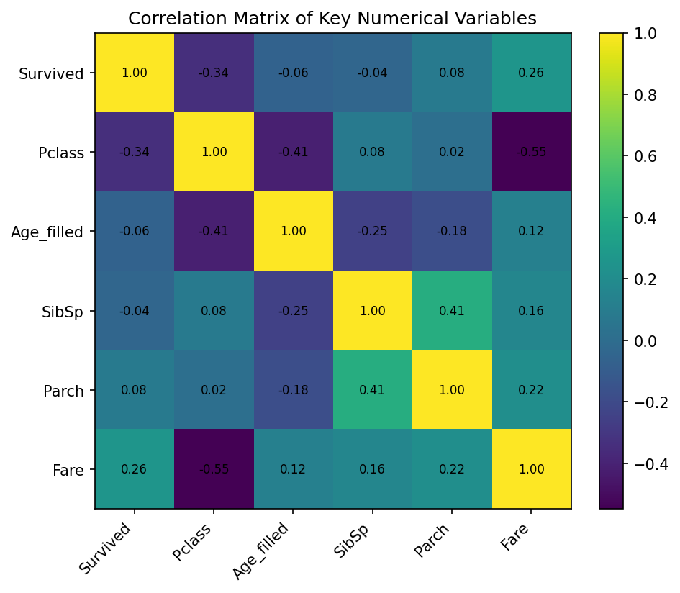
Figure — Key Numerical Variables

R Code
cor_data <- titanic_viz %>%
select(Survived, Pclass, Age, SibSp, Parch, Fare)
cor_matrix <- cor(cor_data, use = "complete.obs")
cor_long <- as.data.frame(as.table(cor_matrix))
ggplot(cor_long, aes(Var1, Var2, fill = Freq)) +
geom_tile() +
geom_text(aes(label = round(Freq, 2)), size = 3) +
scale_fill_gradient2(low = "steelblue", mid = "white",
high = "firebrick", midpoint = 0,
limits = c(-1, 1)) +
labs(title = "Correlation Matrix of Key Numerical Variables",
x = NULL, y = NULL, fill = "Correlation") +
theme_minimal() +
theme(axis.text.x = element_text(angle = 45, hjust = 1))

Interpretation for a Non-Technical Audience
The heatmap is useful as a screening tool: it identifies relationships worth investigating further without claiming causation.

10. Cross-Visualization Insights
- Sex and passenger class are two of the clearest categorical differences in survival outcomes. Looking at both is more informative than relying on one chart.
- The age histogram provides context for the age-group survival line chart: percentages can be unstable when an age group contains relatively few passengers.
- The scatter plot and fare boxplot complement each other. The scatter plot shows the relationship between two variables, while the boxplot explains the distribution of fare within passenger classes.
- The correlation heatmap provides a compact overview of numerical relationships and helps identify variables that deserve deeper analysis in a future predictive project.
- Together, the visualizations move from simple comparisons to distributions, relationships and multivariable patterns, creating a coherent visual story rather than a collection of unrelated charts.

11. Visualization Design Principles Applied
- Choose the chart based on the analytical question rather than using one chart type for every variable.
- Use clear titles that communicate the subject of the chart.
- Label axes with meaningful variable names and units.
- Add data labels when they improve comparison, especially for percentages and counts.
- Avoid unnecessary 3D effects and decorative elements that distract from the data.
- Use transparency in dense scatter plots so overlapping observations remain visible.
- Treat line charts as trends across ordered categories here, not as evidence of a time-series process.
- Interpret correlations as associations, not causal relationships.

12. Conclusion
The Titanic dataset provides a strong example of how visualization can turn cleaned data into an understandable narrative. The charts show clear differences in survival by sex and class, the distribution of passenger ages, the relationship between age and fare, survival patterns across age groups, fare variation by class, and correlations among key numerical variables. Using ggplot2, the visualizations are reproducible and can be modified easily for further analysis.

Appendix A — Complete R Script
# ============================================================
# Week 2: Dynamic & Informative Visualizations in R
# Dataset: Titanic - Machine Learning from Disaster
# ============================================================
library(tidyverse)
library(scales)
# 1. Load and prepare data -------------------------------------
titanic <- read.csv("train.csv", stringsAsFactors = FALSE)
# Use the Week 1 cleaning logic for age-based visualizations.
titanic_viz <- titanic %>%
group_by(Sex, Pclass) %>%
mutate(Age = ifelse(is.na(Age), median(Age, na.rm = TRUE), Age)) %>%
ungroup() %>%
mutate(
Sex = factor(Sex),
Pclass = factor(Pclass),
Embarked = factor(Embarked),
AgeGroup = cut(
Age,
breaks = c(0, 12, 18, 30, 45, 60, 100),
labels = c("Child", "Teen", "Young Adult",
"Adult", "Middle Age", "Senior"),
include.lowest = TRUE
)
)
# --------------------------------------------------------------
# 2. BAR CHART: Survival rate by sex
# --------------------------------------------------------------
sex_summary <- titanic_viz %>%
group_by(Sex) %>%
summarise(
Survival_Rate = mean(Survived) * 100,
Passengers = n(),
.groups = "drop"
)
ggplot(sex_summary, aes(x = Sex, y = Survival_Rate)) +
geom_col() +
geom_text(aes(label = paste0(round(Survival_Rate, 1), "%")),
vjust = -0.3) +
labs(
title = "Survival Rate by Sex",
subtitle = "Percentage of passengers who survived",
x = "Sex", y = "Survival rate (%)"
) +
coord_cartesian(ylim = c(0, 100)) +
theme_minimal()
# --------------------------------------------------------------
# 3. BAR CHART: Passenger volume by class
# --------------------------------------------------------------
ggplot(titanic_viz, aes(x = Pclass)) +
geom_bar() +
geom_text(
stat = "count",
aes(label = after_stat(count)),
vjust = -0.3
) +
labs(
title = "Passenger Count by Class",
x = "Passenger class", y = "Number of passengers"
) +
theme_minimal()
# --------------------------------------------------------------
# 4. HISTOGRAM: Age distribution
# --------------------------------------------------------------
ggplot(titanic_viz, aes(x = Age)) +
geom_histogram(bins = 25) +
labs(
title = "Age Distribution of Passengers",
x = "Age", y = "Number of passengers"
) +
theme_minimal()
# --------------------------------------------------------------
# 5. SCATTER PLOT: Age and Fare by survival
# --------------------------------------------------------------
ggplot(titanic_viz,
aes(x = Age, y = Fare, shape = factor(Survived))) +
geom_point(alpha = 0.55) +
labs(
title = "Age vs Fare by Survival Outcome",
x = "Age", y = "Fare", shape = "Survived"
) +
theme_minimal()
# --------------------------------------------------------------
# 6. LINE CHART: Survival across age groups
# --------------------------------------------------------------
age_summary <- titanic_viz %>%
group_by(AgeGroup) %>%
summarise(
Survival_Rate = mean(Survived) * 100,
Passengers = n(),
.groups = "drop"
)
ggplot(age_summary,
aes(x = AgeGroup, y = Survival_Rate, group = 1)) +
geom_line() +
geom_point(size = 3) +
labs(
title = "Survival Rate Across Age Groups",
x = "Age group", y = "Survival rate (%)"
) +
coord_cartesian(ylim = c(0, 100)) +
theme_minimal()
# --------------------------------------------------------------
# 7. BOXPLOT: Fare distribution by class
# --------------------------------------------------------------
ggplot(titanic_viz, aes(x = Pclass, y = Fare)) +
geom_boxplot() +
labs(
title = "Fare Distribution by Passenger Class",
x = "Passenger class", y = "Fare"
) +
theme_minimal()
# --------------------------------------------------------------
# 8. CORRELATION HEATMAP
# --------------------------------------------------------------
cor_data <- titanic_viz %>%
select(Survived, Pclass, Age, SibSp, Parch, Fare)
cor_matrix <- cor(cor_data, use = "complete.obs")
cor_long <- as.data.frame(as.table(cor_matrix))
ggplot(cor_long, aes(Var1, Var2, fill = Freq)) +
geom_tile() +
geom_text(aes(label = round(Freq, 2)), size = 3) +
scale_fill_gradient2(
low = "steelblue",
mid = "white",
high = "firebrick",
midpoint = 0,
limits = c(-1, 1)
) +
labs(
title = "Correlation Matrix of Key Numerical Variables",
x = NULL, y = NULL, fill = "Correlation"
) +
theme_minimal() +
theme(axis.text.x = element_text(angle = 45, hjust = 1))
# --------------------------------------------------------------
# 9. Optional: save high-resolution plots
# --------------------------------------------------------------
# ggsave("survival_by_sex.png", width = 8, height = 5, dpi = 300)
# ggsave("passengers_by_class.png", width = 8, height = 5, dpi = 300)
# ggsave("age_histogram.png", width = 8, height = 5, dpi = 300)
# ggsave("age_vs_fare.png", width = 8, height = 5, dpi = 300)
# ggsave("survival_by_age_group.png", width = 8, height = 5, dpi = 300)
# ggsave("fare_by_class.png", width = 8, height = 5, dpi = 300)
# ggsave("correlation_heatmap.png", width = 8, height = 6, dpi = 300)

Appendix B — Suggested GitHub Structure
For a portfolio submission, place the R script in an R/ folder, the PNG outputs in outputs/, and this report in report/. Keep the Week 1 and Week 2 projects in the same repository so the progression from cleaning to visualization is visible.

