STATISTICAL ANALYSIS AND PREDICTIVE MODELING USING R
Week 3 Internship Project | STAR98 California School District Data | Multiple Linear Regression
This project performs hypothesis testing, correlation analysis, assumption checks, multiple linear regression, 10-fold cross-validation, model diagnostics, and performance evaluation.

1. Dataset Identification and Rationale
The STAR98 dataset contains 303 California county-level school observations and measures student performance, student demographics, teacher experience and salary, spending, pupil-teacher ratios, and participation in college-preparatory courses. The original dataset contains counts of students above and below the national median on a mathematics test. For predictive modeling, the target was transformed into PercentAbove = NABOVE / (NABOVE + NBELOW) × 100.
The dataset was selected because it is publicly available, compact enough for transparent statistical analysis, contains multiple explanatory variables, and supports a continuous regression target. The analysis is educational and describes associations; it does not establish that any school policy or demographic characteristic causes student performance.
Original source/reference: Jeff Gill, Generalized Linear Models: A Unified Approach; the dataset is distributed in the statsmodels dataset collection.

2. Research Questions and Hypotheses
RQ1: Is participation in UC/CSU preparation courses (PCTAF) associated with the percentage of students above the national mathematics median?
H0: Pearson correlation between PCTAF and PercentAbove is zero. H1: the correlation is not zero.
RQ2: Do districts below the median PCTAF level differ in average PercentAbove from districts at/above the median?
H0: the two group means are equal. H1: the means differ.
A Pearson correlation test and Welch two-sample t-test were used. Welch's test is robust to unequal variances and sample sizes.

3. Data Overview and Preparation
The final analysis file contains 303 observations and 13 analysis variables. No missing values were present in the supplied modeling table.
star98 <- read.csv("STAR98_California_Schools.csv")
str(star98)
summary(star98)
dim(star98)
colSums(is.na(star98))

4. Exploratory Statistical Analysis
The Pearson correlation between PCTAF and PercentAbove was r = 0.500, with p = 1.374e-20. This indicates a statistically significant positive linear association in this dataset.
The Welch t-test also found a statistically significant difference between the two PCTAF groups (t = 7.606, p = 3.98e-13). The mean PercentAbove was 36.29% below the median PCTAF threshold and 51.05% at/above the threshold.
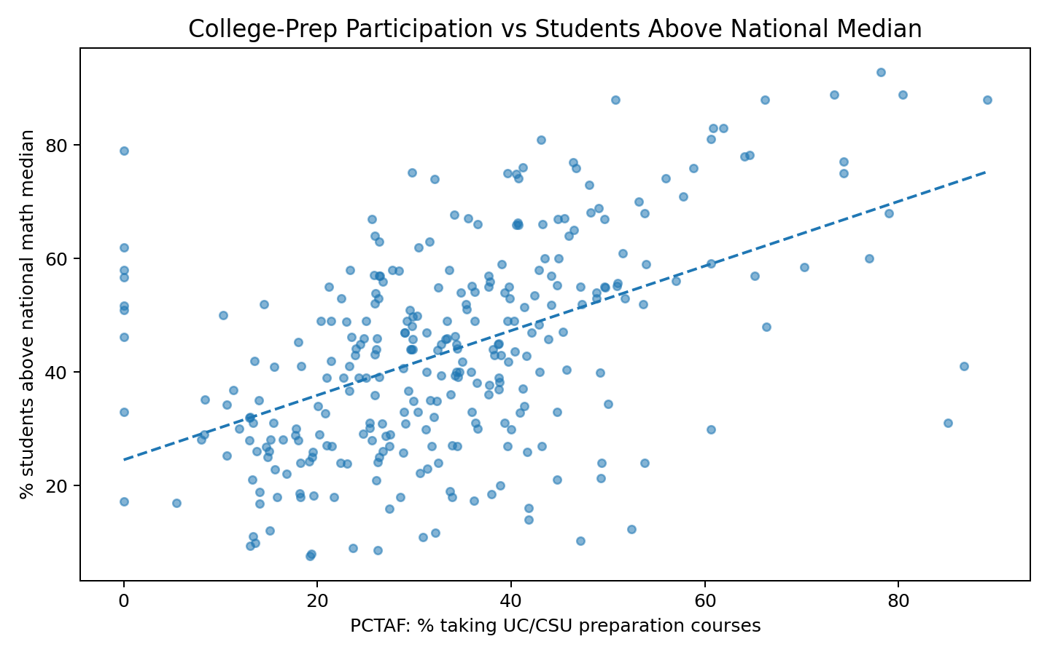
Figure 1. PCTAF and student performance relationship.

5. Train/Test Split
An 80/20 train-test split was created using random seed 42. The training set was used for model fitting and cross-validation, while the held-out test set was used for final performance evaluation.
set.seed(42)
train_index <- sample(seq_len(nrow(star98)),
size = floor(0.80 * nrow(star98)))
train <- star98[train_index, ]
test <- star98[-train_index, ]

6. Multiple Linear Regression Model
Multiple linear regression was selected because PercentAbove is continuous. The model uses 12 district-level predictors. The objective is prediction and interpretation of associations, not causal inference.
model <- lm(
PercentAbove ~ LOWINC + PERASIAN + PERBLACK + PERHISP + PERMINTE +
AVYRSEXP + AVSALK + PERSPENK + PTRATIO + PCTAF + PCTCHRT + PCTYRRND,
data = train
)
summary(model)
On the held-out test set, the model achieved MAE = 6.28 percentage points, RMSE = 7.32 percentage points, and R² = 0.863. The model therefore explains about 86.3% of test-set variation under this linear specification.

7. Cross-Validation
Ten-fold cross-validation on the training set produced mean RMSE = 9.06, mean MAE = 7.19, and mean R² = 0.689. Cross-validation provides a more stable estimate of expected predictive performance than a single validation split.
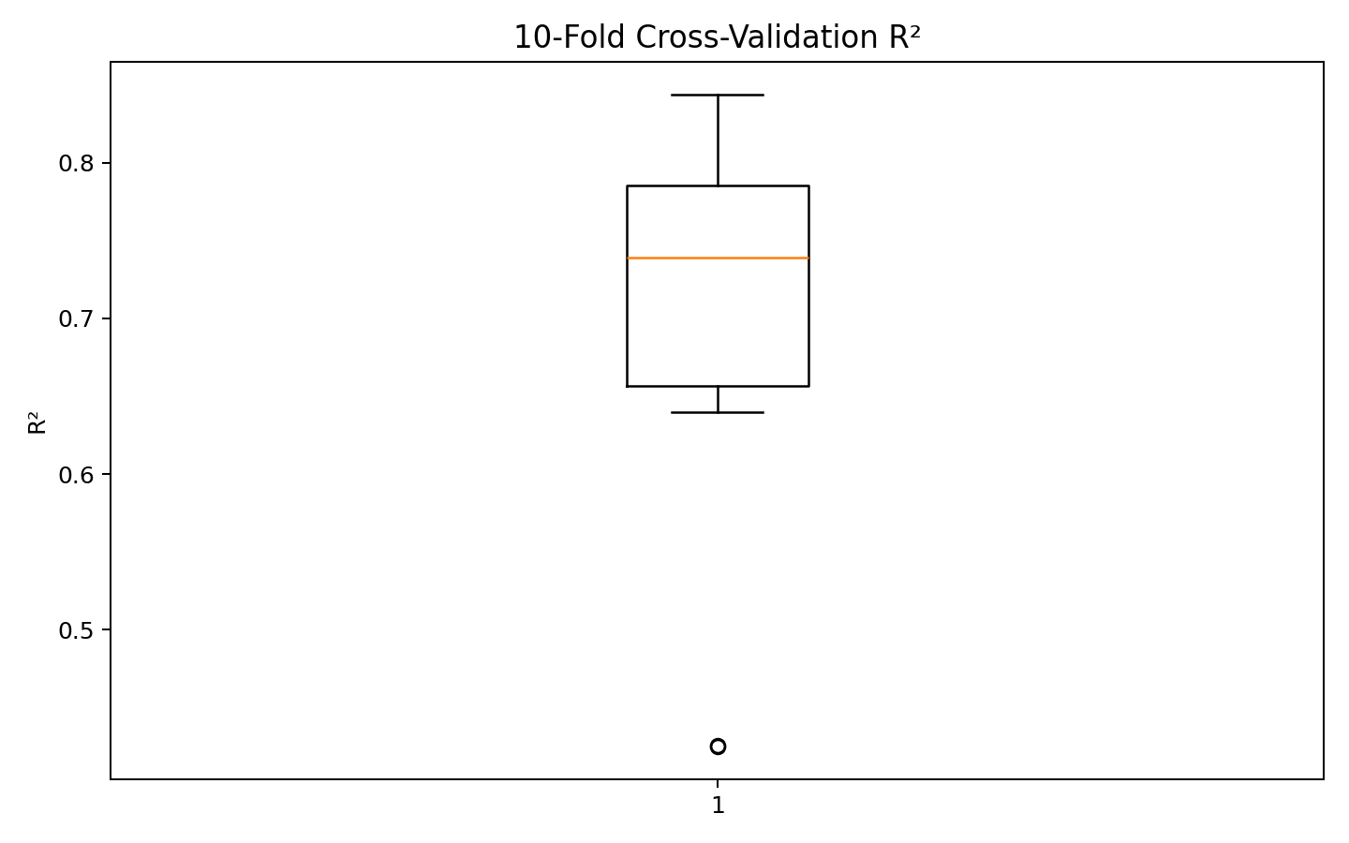
Figure 2. R² across the 10 validation folds.

8. Model Diagnostics and Assumptions
The Shapiro-Wilk test on the 61 held-out residuals returned W = 0.966 and p = 0.08868. The test should be interpreted alongside the Q-Q plot because normality tests can be sensitive to sample size and because prediction quality does not require perfectly normal residuals.
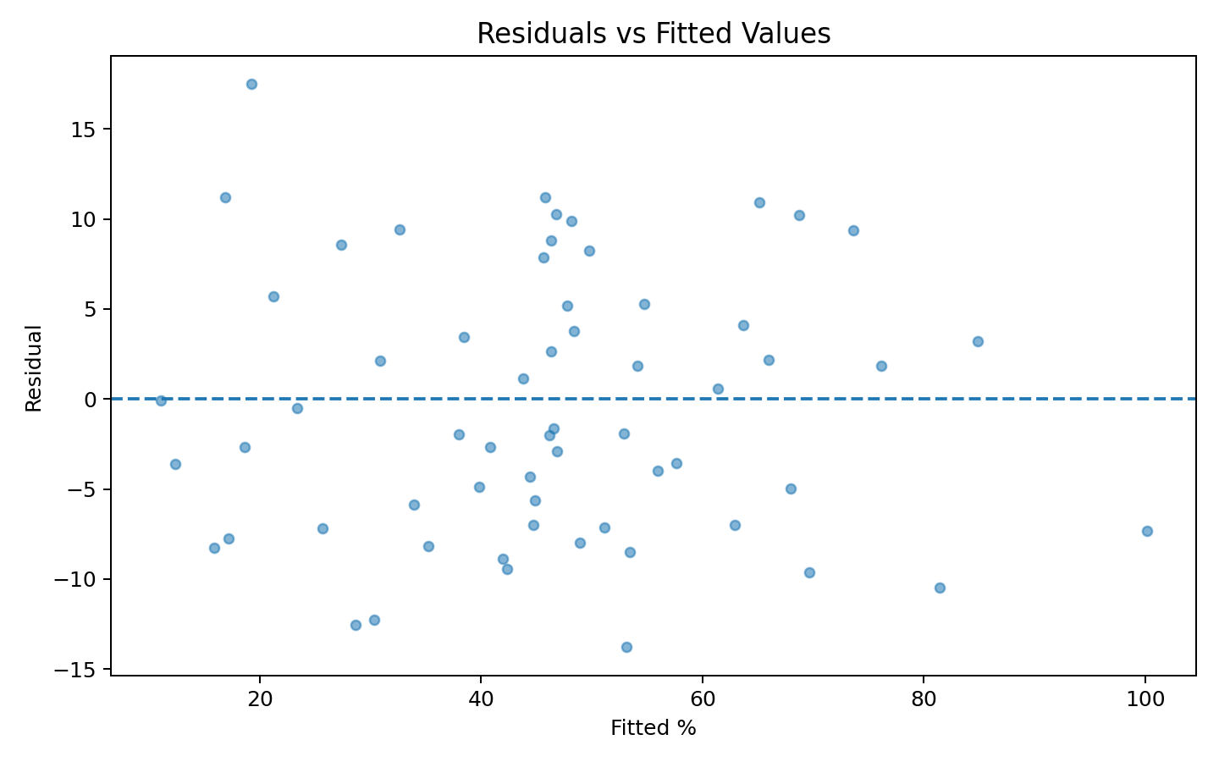
Figure 3. Residuals versus fitted values.
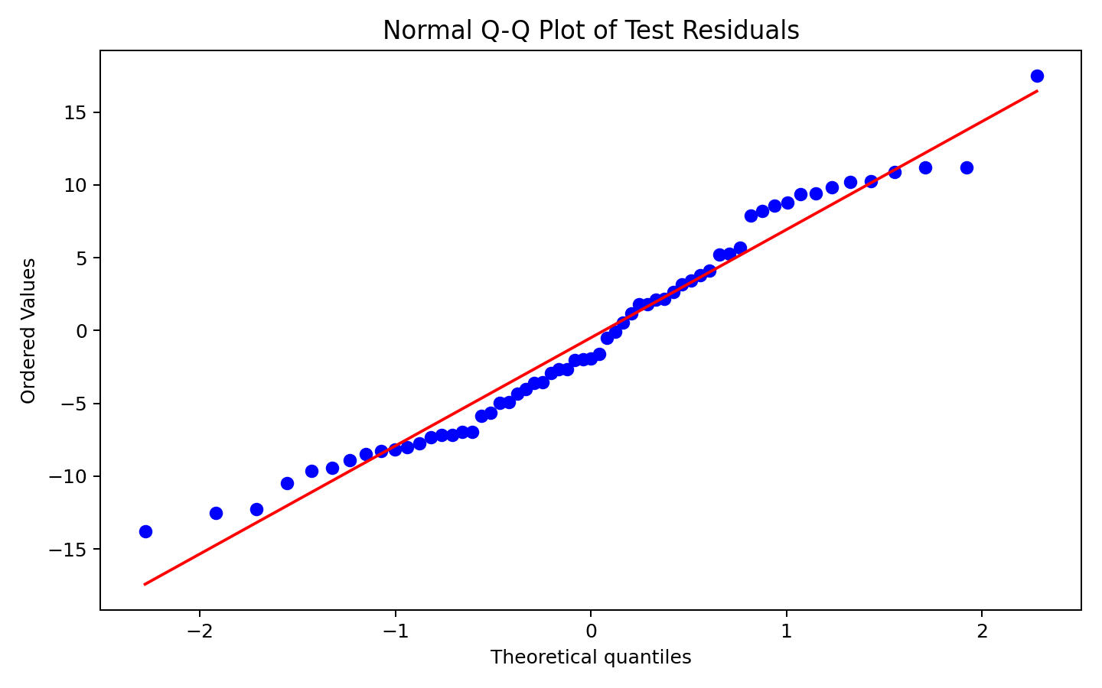
Figure 4. Normal Q-Q plot of test residuals.

9. Multicollinearity
Manual VIF calculations were used. Larger VIF values indicate stronger overlap among predictors.
- PERHISP: VIF = 3.87
- PTRATIO: VIF = 3.30
- PERMINTE: VIF = 3.21
- LOWINC: VIF = 2.77
- AVSALK: VIF = 2.55
- PERSPENK: VIF = 2.46
- PERBLACK: VIF = 1.82
- PCTAF: VIF = 1.49
- AVYRSEXP: VIF = 1.41
- PCTYRRND: VIF = 1.22
- PERASIAN: VIF = 1.19
- PCTCHRT: VIF = 1.16
VIF results should be considered when interpreting individual coefficients. A predictor can still be useful for prediction even when coefficient interpretation is affected by collinearity.

10. Actual vs Predicted Performance
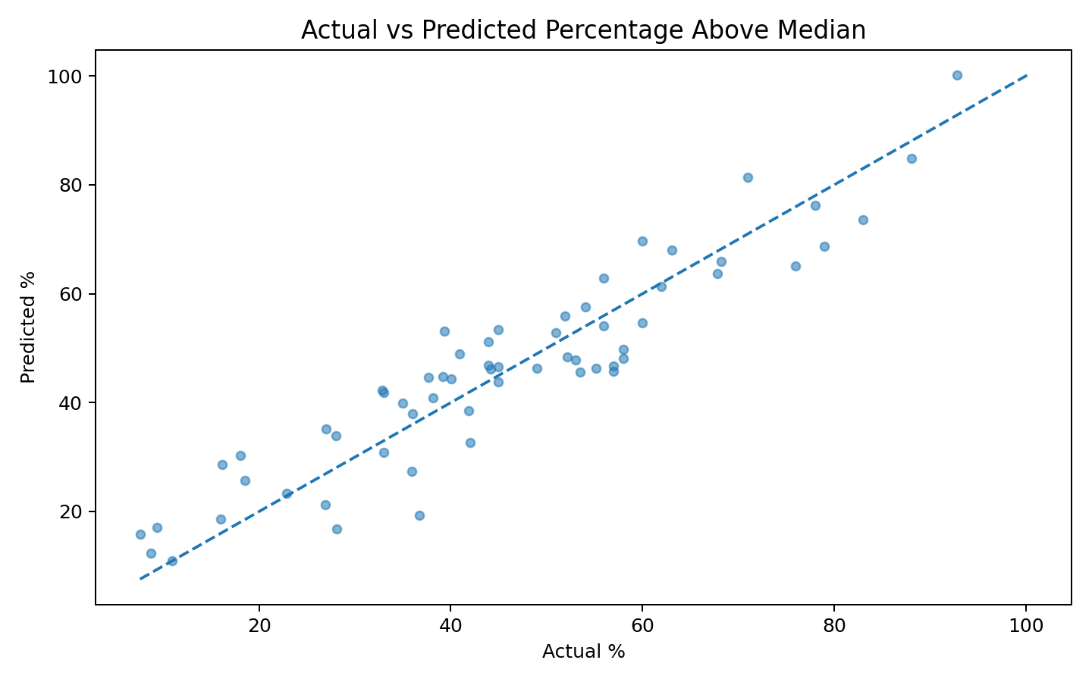
Figure 5. Actual versus predicted PercentAbove values.
Points close to the 45-degree reference line indicate smaller prediction errors. The spread around the line shows that the linear model does not capture every factor associated with school-level performance.

11. Key Results
Analysis | Result | Interpretation
Pearson correlation | r = 0.500, p = 1.374e-20 | Statistically significant positive association.
Welch t-test | t = 7.606, p = 3.98e-13 | The two PCTAF groups have different mean outcomes.
Test MAE | 6.28 | Average absolute error in percentage points.
Test RMSE | 7.32 | Penalizes larger prediction errors more strongly.
Test R² | 0.863 | Proportion of test variation explained by the model.
Mean CV R² | 0.689 | Average out-of-fold explanatory performance.

12. Model Strengths
- Uses a publicly available dataset with a clearly defined continuous outcome.
- Combines hypothesis testing with predictive modeling rather than relying only on descriptive statistics.
- Uses an 80/20 holdout and 10-fold cross-validation.
- Includes residual, Q-Q, actual-vs-predicted, correlation, and VIF diagnostics.
- Uses a fixed random seed for reproducibility.

13. Potential Improvements
- Compare linear regression with regularized regression such as Ridge or Lasso.
- Test nonlinear relationships using polynomial terms, splines, or generalized additive models.
- Explore interaction effects between spending, teacher experience, demographics, and course participation.
- Use robust regression if influential observations materially affect coefficients.
- Compare with Random Forest or Gradient Boosting using the same cross-validation folds.
- Use repeated cross-validation for a more stable estimate because the dataset contains only 303 observations.

14. Conclusion
The analysis provides evidence of a statistically significant relationship between PCTAF and student performance in this dataset. The baseline multiple linear regression achieved a test R² of 0.863 and mean 10-fold CV R² of 0.689. The model is a useful and interpretable baseline, but the diagnostic results and remaining prediction error suggest that nonlinear effects, interactions, regularization, and tree-based models could improve performance. The statistical associations should not be interpreted as proof that any single school characteristic causes the observed outcome.

15. R Output Reference and Screenshot Guidance
The numerical summaries below were calculated from the same dataset and fixed-seed workflow. For final submission, run the supplied R script in R/RStudio and capture screenshots of the actual R console showing cor.test(), t.test(), summary(model), test metrics, shapiro.test(), VIF output, and cv_results.
> dim(star98)
[1] 303 13
> cor.test(star98$PCTAF, star98$PercentAbove)
Pearson correlation = 0.5002
p-value = 1.374e-20
> t.test(PercentAbove ~ PCTAF_Group)
t = 7.6059
p-value = 3.98e-13
> shapiro.test(test$Residual)
W = 0.9661
p-value = 0.08868
> Test MAE
6.2762
> Test RMSE
7.3222
> Test R-squared
0.8629
> 10-fold cross-validation
Mean RMSE = 9.0605
Mean MAE = 7.1897
Mean R2 = 0.6890

16. Suggested GitHub Structure
week3-r-statistical-modeling/
├── data/
│ └── STAR98_California_Schools.csv
├── R/
│ └── STAR98_Week3_Analysis.R
├── outputs/
│ ├── 01_pctaf_vs_percent_above.png
│ ├── 02_actual_vs_predicted.png
│ ├── 03_residuals_vs_fitted.png
│ ├── 04_residual_qq_plot.png
│ ├── 05_cross_validation_r2.png
│ ├── 06_correlation_heatmap.png
│ └── 07_pctaf_group_boxplot.png
├── reports/
│ └── Week3_Statistical_Analysis_and_Predictive_Modeling_R.docx
└── README.md

