WEEK 4 FINAL PROJECT
Comprehensive Data Analysis, Reporting and Presentation
R Programming Internship — Final Integrated Report
Weeks Integrated: Data Cleaning • Visualization • Statistical Analysis • Predictive Modeling
Prepared by: Purnit Patel
Tools: R • tidyverse • ggplot2 • Base R Statistical Tests • Linear Regression

Executive Summary
This final report consolidates the analytical work completed during Weeks 1–3 into one coherent data-analysis workflow. The project demonstrates progression from raw-data inspection and cleaning, through visual exploration, to hypothesis testing, predictive modeling, validation and model diagnostics using R.
Weeks 1 and 2 used the publicly available Titanic passenger dataset to establish strong data-preparation and visualization practices. The 891-row dataset contained missing values in Age, Cabin and Embarked. Missing Age values were imputed using group-wise medians, the two missing Embarked values were replaced using the mode, and the highly incomplete Cabin field was converted into a CabinKnown indicator. The cleaned data was then used to communicate survival patterns through reproducible ggplot2 visualizations.
Week 3 extended the workflow into formal statistical analysis and predictive modeling using the STAR98 California school-district dataset. A continuous student-performance measure, PercentAbove, was modeled using multiple linear regression with 12 predictors. Hypothesis tests showed a statistically significant positive relationship between PCTAF and PercentAbove. The regression model achieved a held-out test R² of 0.863, RMSE of 7.32 percentage points and MAE of 6.28 percentage points. Ten-fold cross-validation produced a mean R² of 0.689, providing a more conservative view of generalization.
Overall, the work demonstrates an end-to-end analytical mindset: understand the data, improve its quality, explore patterns, test meaningful questions, build a justified model, validate it, diagnose limitations and communicate findings without overstating causality.

Key Outcomes at a Glance
Stage | Dataset | Main Work | Key Outcome
Week 1 | Titanic | Cleaning & preliminary analysis | Age/Embarked missingness resolved; CabinKnown feature created
Week 2 | Titanic | Visualization & interpretation | 7 reproducible visualizations showing survival, age, fare and correlations
Week 3 | STAR98 | Hypothesis testing & regression | Test R² 0.863; CV R² 0.689; diagnostics completed
Week 4 | Integrated | Final reporting & communication | Cohesive narrative connecting preparation, exploration, modeling and recommendations

Report Structure
- Introduction and project objectives
- Integrated methodology and analytical workflow
- Week 1 — Data preparation and preliminary analysis
- Week 2 — Exploratory visualization and insights
- Week 3 — Statistical analysis and predictive modeling
- Integrated findings and business/decision implications
- Challenges, lessons learned and analytical limitations
- Recommendations and future directions
- Conclusion
- Reproducibility and R code appendix

1. Introduction
Data analysis is most valuable when it converts raw information into evidence that supports a decision. This project was designed as a progressive R-based workflow rather than as a collection of disconnected exercises. Each week added a new capability: Week 1 established data quality, Week 2 focused on visual communication, and Week 3 introduced formal inference and predictive modeling. Week 4 brings these components together in a professional report.

1.1 Objectives
- Demonstrate a structured and reproducible data-cleaning process.
- Use visualizations to identify and communicate meaningful patterns.
- Apply statistical tests to formulate and evaluate evidence-based hypotheses.
- Build and evaluate a predictive model using an appropriate train/test strategy and cross-validation.
- Interpret analytical results for a non-technical audience without making unsupported causal claims.
- Document code, outputs, assumptions, limitations and future improvements in a professional format.

1.2 Datasets and Why Two Datasets Were Used
The previous weeks used two public datasets because they serve different analytical purposes. Titanic is particularly useful for learning data cleaning and visualization because it contains missing values, categorical variables and intuitive survival outcomes. STAR98 is better suited to formal regression because it contains a continuous school-performance target and multiple explanatory variables. The final report therefore integrates the analytical skills demonstrated across both datasets rather than pretending they are one dataset.

2. Integrated Methodology
The overall workflow follows a standard analytics lifecycle. The sequence reduces the risk of drawing conclusions from poor-quality data and ensures that model results are supported by earlier exploratory work.
Phase | Activities | R Techniques
1. Data understanding | Inspect dimensions, types, summaries and missingness | str(), summary(), dim(), is.na()
2. Data preparation | Impute selected missing values, engineer useful features, encode categories | dplyr, mutate(), factor(), model.matrix()
3. Exploration | Compare groups, distributions, relationships and correlations | ggplot2, cor(), boxplots, histograms
4. Statistical inference | Test relationships and group differences | cor.test(), t.test(), shapiro.test()
5. Modeling | Fit a multiple linear regression model | lm(), predict()
6. Validation | Evaluate holdout performance and cross-validation | R², RMSE, MAE, 10-fold CV
7. Diagnostics | Check residual behavior and multicollinearity | residual plots, Q-Q plot, VIF
8. Communication | Translate results into insights, limitations and recommendations | reporting and visualization

3. Week 1 — Data Preparation and Preliminary Analysis
The Week 1 Titanic analysis began with 891 passenger records and 12 variables. The first objective was to understand the structure and identify data-quality problems before interpreting the data.

3.1 Initial Data Quality Findings
Item | Result | Interpretation
Rows | 891 | Sufficient for exploratory analysis
Columns | 12 | Mix of numerical, categorical and text variables
Duplicate complete rows | 0 | No exact duplicate records detected
Age missing | 177 (19.87%) | Required a considered imputation strategy
Cabin missing | 687 (77.10%) | Too incomplete for reliable individual cabin imputation
Embarked missing | 2 (0.22%) | Very small amount of missingness

3.2 Cleaning Decisions
- Age: missing values were replaced with the median age within Sex × Pclass groups, preserving all passenger records while respecting group differences.
- Embarked: the two missing values were replaced with the most frequent port, S, because missingness was only 0.22%.
- Cabin: instead of inventing cabin numbers, a binary CabinKnown variable was created to preserve the information that cabin data was available.
- PassengerId: treated as an identifier rather than an analytical measurement.
- Name and Ticket: retained as text/identifier fields but excluded from the preliminary numerical modeling table because direct encoding would create high-cardinality features.
- Fare outliers: 116 high values were flagged by the IQR rule but retained because high fares can represent genuine premium or shared bookings.

3.3 Example R Cleaning Code
titanic_clean <- titanic %>%
group_by(Sex, Pclass) %>%
mutate(
Age = ifelse(is.na(Age),
median(Age, na.rm = TRUE),
Age)
) %>%
ungroup()

titanic_clean <- titanic_clean %>%
mutate(
Embarked = ifelse(
is.na(Embarked),
names(sort(table(Embarked), decreasing = TRUE))[1],
Embarked
),
CabinKnown = ifelse(is.na(Cabin), 0, 1)
)

3.4 Preliminary Findings
- Overall survival was 38.4%; 61.6% of passengers did not survive.
- Female survival was 74.20%, compared with 18.89% for male passengers.
- First-class survival was 62.96%, followed by 47.28% in second class and 24.24% in third class.
- Survival correlated negatively with numerical Pclass (r = -0.338) and positively with Fare (r = 0.257).
- The cleaning process created a more analysis-ready dataset without unnecessarily deleting records.
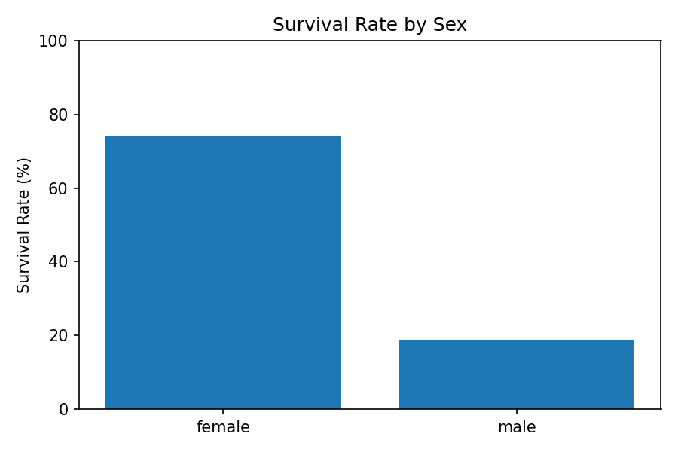
Figure 1. Week 1 — Titanic survival rate by sex.
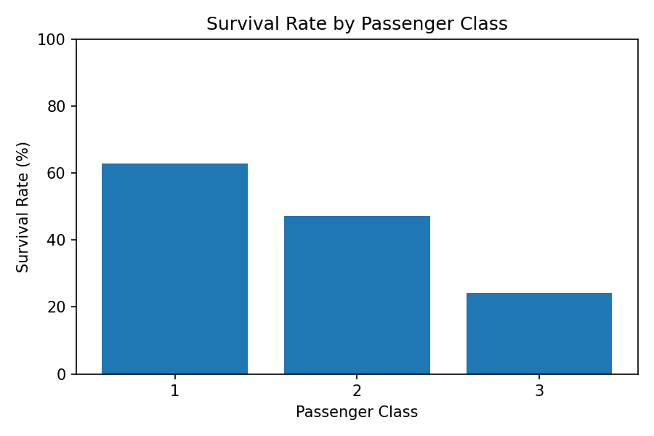
Figure 2. Week 1 — Titanic survival rate by passenger class.
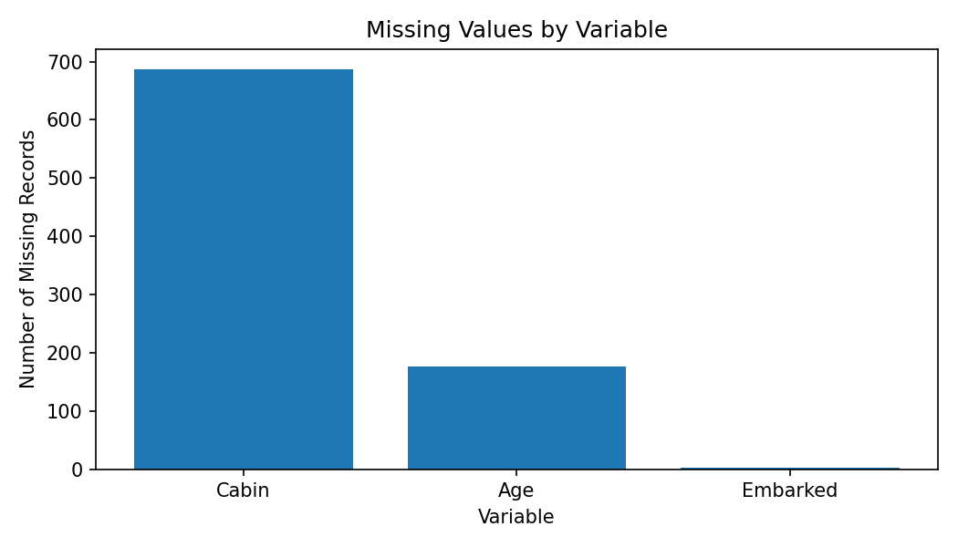
Figure 3. Week 1 — Missing-value profile before cleaning.

4. Week 2 — Exploratory Visualization and Data Storytelling
After cleaning the Titanic data, Week 2 focused on turning analytical results into clear visual evidence. The visualizations were produced in R using ggplot2 and were selected according to the analytical question rather than using one chart type for every variable.

4.1 Visualization Portfolio
Visualization | Question Addressed | Main Insight
Survival by sex | How did survival differ by sex? | Female survival was substantially higher.
Passengers by class | How were passengers distributed across classes? | Third class contained the largest passenger group.
Age histogram | What was the age distribution? | Most passengers were concentrated in younger and middle-age ranges.
Age vs fare | Is there a visible relationship between age and fare? | Fare varies substantially and is influenced by passenger/class characteristics.
Survival by age group | Does survival vary across age groups? | Survival patterns differ across age categories.
Fare by class boxplot | How does fare vary by class? | Higher classes show higher and more variable fares.
Correlation heatmap | Which numeric variables move together? | Pclass and Fare show a strong negative association.

4.2 Visual Communication Principles
- Titles were written to communicate the subject of each chart.
- Axes used meaningful variable names and units.
- Bar charts were used for categorical comparisons, histograms for distributions, scatter plots for relationships, and boxplots for group distributions.
- Correlations were treated as associations rather than evidence of causation.
- The visual analysis was used to generate questions for deeper statistical analysis rather than replacing statistical testing.
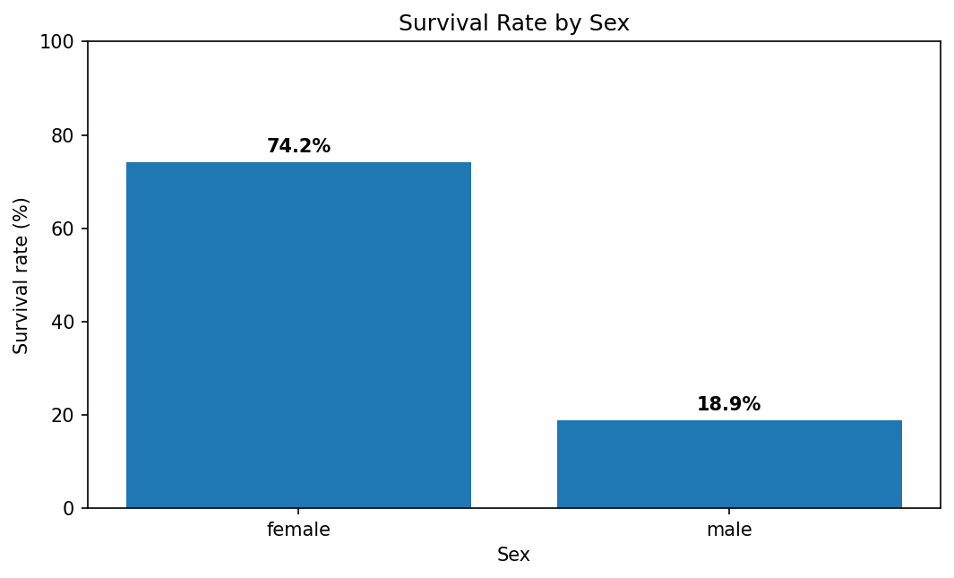
Figure 4. Week 2 — Survival rate by sex.
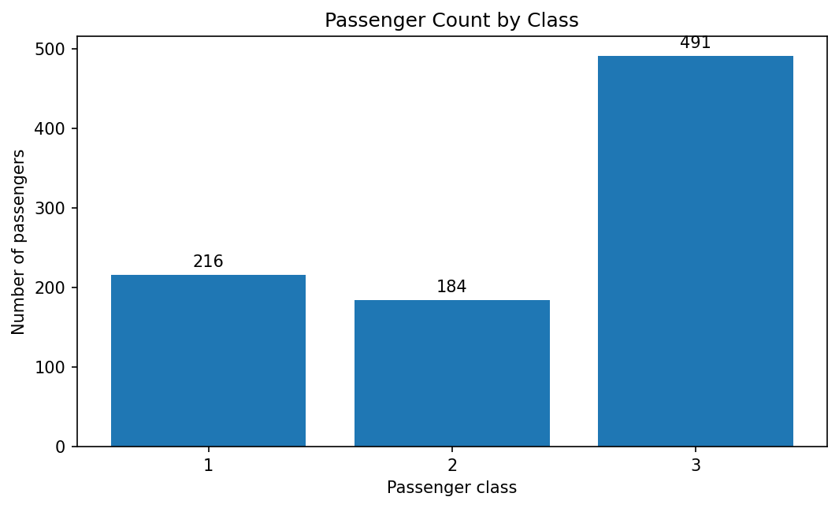
Figure 5. Week 2 — Passenger counts by class.
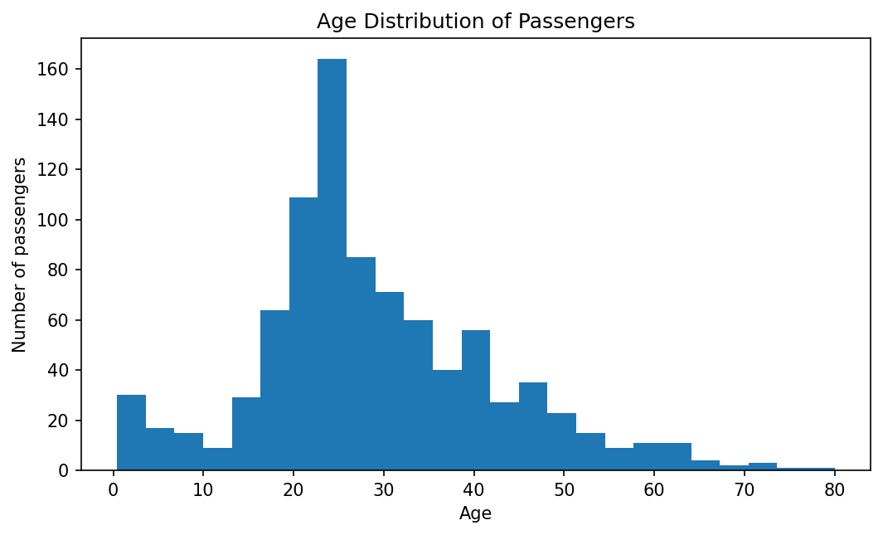
Figure 6. Week 2 — Age distribution.
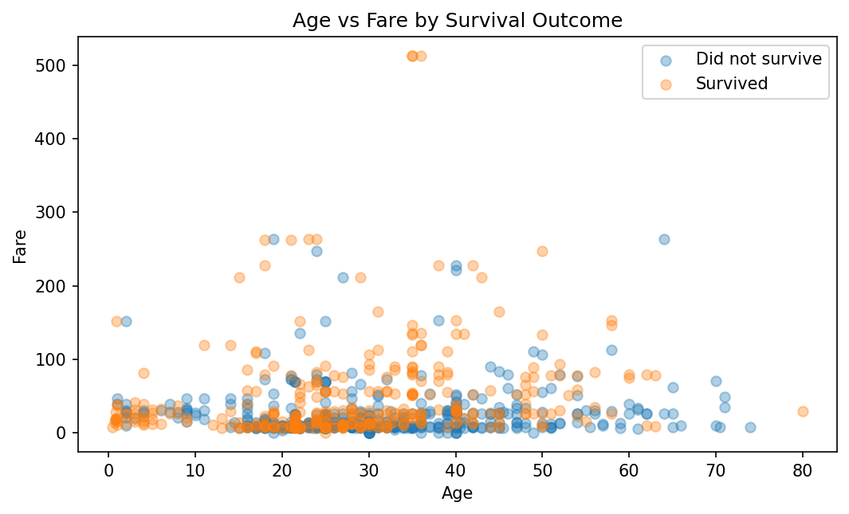
Figure 7. Week 2 — Age versus fare.
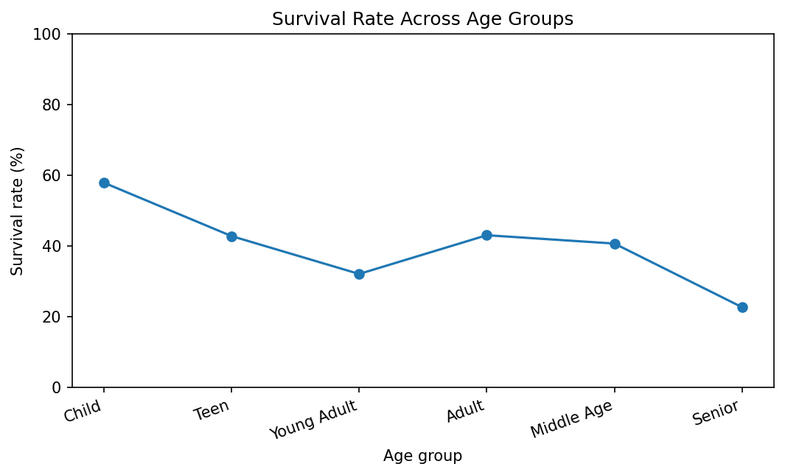
Figure 8. Week 2 — Survival rate by age group.
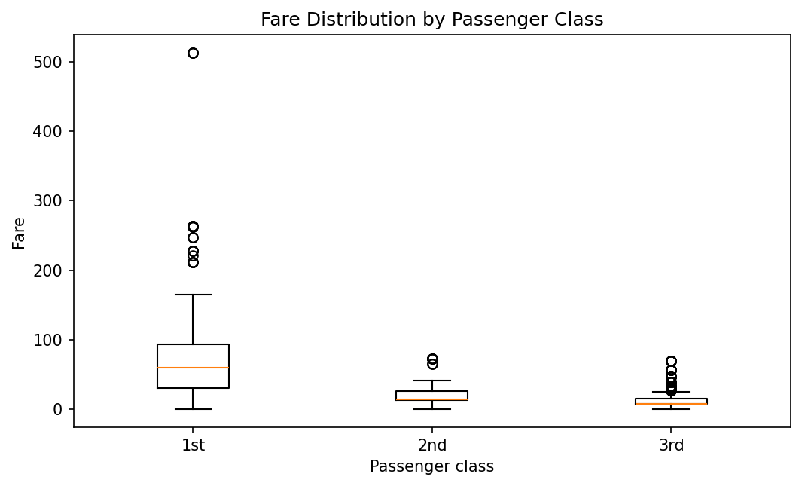
Figure 9. Week 2 — Fare distribution by passenger class.
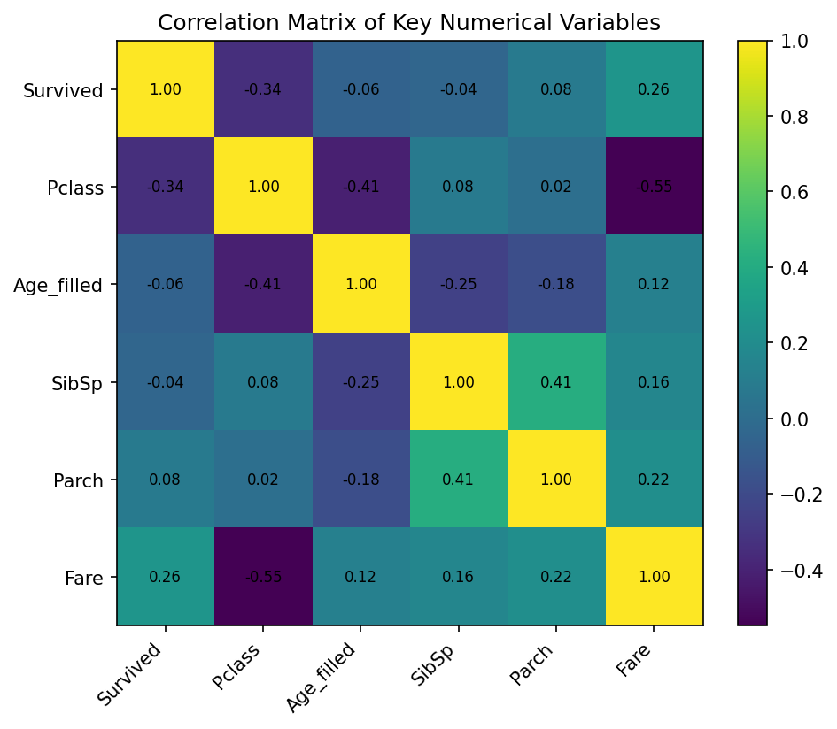
Figure 10. Week 2 — Correlation heatmap.

5. Week 3 — Statistical Analysis and Predictive Modeling
Week 3 moved from descriptive analysis to formal statistical reasoning. The STAR98 dataset contains 303 California school-district observations. The original test-score counts were transformed into PercentAbove, the percentage of students above the national mathematics median.

5.1 Research Questions and Hypotheses
Research Question 1: Is PCTAF associated with PercentAbove?
- H0: The population correlation between PCTAF and PercentAbove is zero.
- H1: The population correlation is not zero.
Research Question 2: Do districts below the median PCTAF differ from districts at or above the median?
- H0: The two group means are equal.
- H1: The two group means differ.

5.2 Statistical Test Results
Analysis | Result | Interpretation
Pearson correlation | r = 0.500; p = 1.374 × 10⁻²⁰ | Strong evidence of a positive linear association.
Welch t-test | t = 7.606; p = 3.98 × 10⁻¹³ | Group means differ significantly.
Low-PCTAF mean | 36.29% | Lower average PercentAbove in the lower-PCTAF group.
High-PCTAF mean | 51.05% | Higher average PercentAbove in the higher-PCTAF group.

These p-values provide strong statistical evidence against the null hypotheses in this dataset. However, statistical significance should not be confused with causality. PCTAF may be associated with other school characteristics that also relate to performance.
[Figure not available: Figure 11. Week 3 — Relationship between PCTAF and PercentAbove.]
[Figure not available: Figure 12. Week 3 — PercentAbove by PCTAF group.]

5.3 Predictive Model
Multiple linear regression was selected because PercentAbove is a continuous target. The model used 12 district-level predictors covering income, demographics, teacher experience and salary, spending, pupil-teacher ratio, and course participation.
model <- lm(
PercentAbove ~ LOWINC + PERASIAN + PERBLACK + PERHISP + PERMINTE +
AVYRSEXP + AVSALK + PERSPENK + PTRATIO + PCTAF + PCTCHRT + PCTYRRND,
data = train
)

pred <- predict(model, newdata = test)

5.4 Validation Strategy
The dataset was divided into an 80% training set and 20% held-out test set using seed 42. The training data was additionally evaluated with 10-fold cross-validation. This design reduces dependence on a single train/test split and provides a more stable estimate of expected model performance.
Metric | Held-out Test | 10-fold CV Mean
R² | 0.863 | 0.689
RMSE | 7.32 percentage points | 9.06 percentage points
MAE | 6.28 percentage points | 7.19 percentage points

The test-set R² of 0.863 indicates that the model explained about 86.3% of the variation in the held-out sample under this particular split. The lower cross-validation R² of 0.689 is important because it gives a more conservative estimate of generalization. The difference suggests that the single test split may be somewhat favorable and reinforces the value of repeated or stronger validation.
[Figure not available: Figure 13. Week 3 — Actual versus predicted PercentAbove.]
[Figure not available: Figure 14. Week 3 — Residuals versus fitted values.]
[Figure not available: Figure 15. Week 3 — Normal Q-Q plot of test residuals.]
[Figure not available: Figure 16. Week 3 — R² across the 10 cross-validation folds.]
[Figure not available: Figure 17. Week 3 — Predictor correlation heatmap.]

5.5 Diagnostic Analysis
- Shapiro-Wilk test on held-out residuals: W = 0.9661, p = 0.08868. This does not provide strong evidence against residual normality at the 5% level.
- The residuals-versus-fitted plot was used to look for systematic patterns or changing variance.
- The Q-Q plot was used to visually assess whether residuals approximately follow a normal distribution.
- VIF analysis showed the highest values for PERHISP (3.87), PTRATIO (3.30), PERMINTE (3.21) and LOWINC (2.77). These values suggest some predictor overlap but not extreme multicollinearity under common rules of thumb.
- Actual-versus-predicted values showed that the model tracks the general pattern well but still leaves meaningful prediction error for some observations.

5.6 R², MAE and RMSE — Why Multiple Metrics Matter
R² summarizes explained variation, while MAE describes average absolute prediction error and RMSE penalizes larger errors more strongly. Reporting all three prevents the model from being judged using a single statistic. In this project, an average MAE of 6.28 percentage points on the held-out test set means predictions were off by roughly 6.3 percentage points on average in absolute terms.

6. Integrated Findings and Implications
Across the three analytical weeks, several transferable lessons emerge. The first is that data quality affects every later stage. Week 1 demonstrated that missing-value handling and feature construction should be justified rather than automated blindly. The second is that visualization provides an efficient way to identify patterns that deserve statistical investigation. The third is that predictive performance must be evaluated with validation and diagnostics rather than relying on a high training score.

6.1 Analytical Insights
- Titanic: survival varied substantially by sex and passenger class, demonstrating the value of group-based exploratory analysis.
- Titanic: missingness was highly uneven; Cabin required a different treatment from Age and Embarked.
- Titanic: Fare and Pclass were strongly associated, illustrating why correlated predictors require careful interpretation.
- STAR98: PCTAF showed a statistically significant positive association with PercentAbove.
- STAR98: districts with PCTAF at or above the median had a higher mean PercentAbove than districts below the median.
- STAR98: the regression model was useful as a baseline, but cross-validation indicated that expected performance is lower than the single held-out test result.
- Across both projects, associations should be communicated as relationships rather than causal claims unless a causal design supports such a conclusion.

6.2 Business and Decision-Making Implications
Although the datasets are educational rather than commercial, the analytical workflow has direct business relevance. A business analyst would similarly identify data-quality risks, segment customers or products, visualize patterns, test hypotheses, build predictive models and communicate uncertainty. The STAR98 example particularly demonstrates how a model can support prioritization while still requiring domain knowledge before being used for policy or operational decisions.
Decision Principle | Application
Start with data quality | Do not build conclusions or models before understanding missingness, duplicates and variable types.
Use segmentation | Group comparisons can reveal important differences hidden by overall averages.
Validate before deployment | A strong single test result is not enough; cross-validation provides a broader performance check.
Explain uncertainty | Prediction error and model limitations should accompany performance metrics.
Avoid causal overclaiming | Statistical association alone does not prove that changing one variable will cause an outcome.

7. Challenges, Lessons Learned and Limitations

7.1 Challenges Overcome
- Handling different types of missing data without deleting large portions of the dataset.
- Deciding when an outlier should be retained because it may represent a legitimate observation.
- Choosing visualization types that match the analytical question.
- Moving from descriptive observations to formal hypotheses and statistical tests.
- Separating training, validation and test information to reduce optimistic performance estimates.
- Interpreting diagnostic plots and multicollinearity measures rather than reporting model metrics alone.
- Communicating technical results in language that can be understood by non-technical stakeholders.

7.2 Important Limitations
- Titanic is historical and observational; the analysis does not establish why particular passenger groups had different survival outcomes.
- The STAR98 dataset contains only 303 observations, so model estimates can be sensitive to individual observations and split selection.
- The STAR98 model is linear; nonlinear effects and interactions may not be fully captured.
- The held-out test R² is higher than the mean cross-validation R², showing that a single split can provide an optimistic result.
- The Week 3 predictors are observational school characteristics, so statistically significant coefficients should not be interpreted as causal effects.
- For a production system, repeated cross-validation, external validation and domain review would be required.

8. Recommendations and Future Directions

8.1 Immediate Improvements
- Run repeated k-fold cross-validation to reduce dependence on one random split.
- Compare the linear baseline with Ridge and Lasso regression to assess whether regularization improves generalization.
- Test nonlinear relationships using polynomial terms, splines or generalized additive models.
- Investigate meaningful interaction terms based on domain knowledge rather than adding arbitrary interactions.
- Compare the regression model with Random Forest or Gradient Boosting using the same validation framework.
- Perform influence diagnostics to identify observations that disproportionately affect coefficient estimates.
- Use an external validation dataset if one becomes available.

8.2 Reporting Recommendations
- Lead stakeholder presentations with the business/decision question, not the code.
- Show the most important visual evidence before detailed technical methodology.
- Report model performance using R², MAE and RMSE together.
- Include assumptions, limitations and validation results next to the model conclusion.
- Use plain language when translating statistical significance into practical meaning.

9. Conclusion
The four-week R analytics sequence demonstrates a complete progression from raw data to evidence-based communication. Week 1 established disciplined data cleaning and preliminary analysis. Week 2 transformed the cleaned data into a visual story. Week 3 introduced hypothesis testing, regression, cross-validation and diagnostics. Week 4 integrates these capabilities into a single professional reporting workflow.
The most important lesson is that predictive modeling is only one part of data analysis. Reliable analysis begins with understanding the data, continues through transparent preparation and exploration, and ends with validation, interpretation and communication. The STAR98 model achieved strong predictive performance on the held-out test set, but cross-validation and diagnostics demonstrated why a model should not be judged from one metric or one split alone.
Going forward, the same analytical discipline can be applied to business datasets such as customer churn, sales forecasting, marketing performance, credit risk or operations analytics. The combination of R programming, statistical reasoning, visualization and clear stakeholder communication provides a strong foundation for entry-level data analytics work.

10. Reproducibility and Submission Checklist
All major analytical steps should remain reproducible through the R scripts used during Weeks 1–3. Before final submission, run the scripts from a clean R/RStudio session, confirm that the expected outputs are produced, and capture actual R console screenshots where the internship requires screenshots.
Check | Status / Action
Week 1 R cleaning script | Include in GitHub / final project folder
Week 2 R visualization script | Include in GitHub / final project folder
Week 3 R statistical/modeling script | Include in GitHub / final project folder
Graphs | Include PNG outputs used in the report
DOC report | Use this Week 4 report as the final integrated report
R screenshots | Capture actual R/RStudio console and model-output screenshots before final submission
README | Explain project progression and folder structure
Reproducibility | Use set.seed(42) for Week 3 modeling workflow

Appendix A — Selected R Code Excerpts

A.1 Data Inspection
str(titanic)
summary(titanic)
dim(titanic)
sum(duplicated(titanic))
colSums(is.na(titanic))

A.2 Visualization Example
ggplot(titanic_viz, aes(x = Sex, y = Survived)) +
stat_summary(fun = mean, geom = "bar") +
scale_y_continuous(labels = scales::percent_format())

A.3 Hypothesis Testing
cor.test(star98$PCTAF, star98$PercentAbove)

t.test(PercentAbove ~ PCTAF_Group,
data = star98)

shapiro.test(test$Residual)

A.4 Regression and Prediction
set.seed(42)

train_index <- sample(
seq_len(nrow(star98)),
size = floor(0.80 * nrow(star98))
)

train <- star98[train_index, ]
test <- star98[-train_index, ]

model <- lm(
PercentAbove ~ LOWINC + PERASIAN + PERBLACK + PERHISP +
PERMINTE + AVYRSEXP + AVSALK + PERSPENK +
PTRATIO + PCTAF + PCTCHRT + PCTYRRND,
data = train
)

pred <- predict(model, newdata = test)

A.5 Performance Metrics
mae <- mean(abs(test$PercentAbove - pred))
rmse <- sqrt(mean((test$PercentAbove - pred)^2))

r2 <- 1 -
sum((test$PercentAbove - pred)^2) /
sum((test$PercentAbove - mean(test$PercentAbove))^2)

Appendix B — Final GitHub Structure
A recommended final GitHub structure for the four-week internship portfolio is:
YUVAINTERN-FINAL-PROJECT/
├── Week1_Titanic_Cleaning/
│ ├── data/
│ ├── R/
│ ├── outputs/
│ └── report/
├── Week2_Titanic_Visualization/
│ ├── R/
│ ├── outputs/
│ └── report/
├── Week3_Statistical_Modeling/
│ ├── data/
│ ├── R/
│ ├── outputs/
│ └── reports/
├── Week4_Final_Report/
│ └── Week4_Comprehensive_Data_Analysis_Final_Report.docx
└── README.md

Appendix C — Final Takeaway
The project demonstrates the full analytical cycle: clean → explore → visualize → test → model → validate → diagnose → communicate. This sequence should be treated as the core professional workflow demonstrated by the internship.

