**ITERATIVE MODEL**

Iterative development is an approach in the software development life cycle where the development process is broken into smaller, manageable iterations or cycles.

So basically software design start with taking requirements and analysis the about project. Now Iteration model is start from the phase of 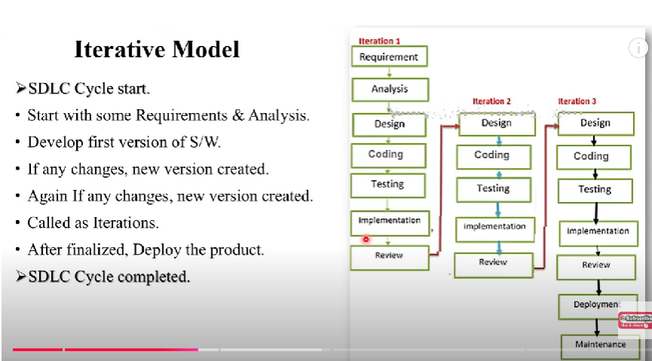

**When to use this Iterative model…?**

When there is requirement of change in future.

When software application was large.

**Advantages of the Iterative Model:**

1. **Flexibility and Adaptability**:
   * **Change-Friendly**: The iterative model allows for changes in requirements at any stage of development. If user needs or market conditions change, these changes can be incorporated in future iterations without disrupting the entire project.
   * **Continuous Improvement**: Feedback from each iteration can be incorporated into the next, ensuring that the software continuously evolves and improves in response to new insights or requirements.
2. **Early Detection of Issues**:
   * **Bug Identification**: Since each iteration includes testing, any issues or bugs are identified early in the process, preventing them from becoming major problems later on.
   * **Improved Quality**: Continuous testing and refinement mean that the quality of the software improves incrementally, with issues being addressed in each iteration.
3. **Customer Feedback Integration**:
   * **Frequent Feedback**: Customers or stakeholders can review the progress of the project after each iteration, which allows them to provide valuable feedback that can be used to refine future iterations.
   * **Customer Satisfaction**: Because the customer can see tangible progress early and regularly, they are more likely to be satisfied with the final product, as it evolves according to their feedback.
4. **Risk Mitigation**:
   * **Reduced Risk of Failure**: By breaking the project into smaller, manageable iterations, the project is less likely to fail because there is ongoing assessment and corrective action taken at each stage.
   * **Proactive Issue Resolution**: Risks are identified and addressed as they arise during the iterative process, minimizing their impact on the overall project.
5. **Faster Time to Market**:
   * **Early Deliverables**: Each iteration results in a working version of the software, so the product can be partially delivered and used earlier than if it was completed all at once. This allows for early feedback and possible early market entry.
   * **Incremental Value**: The product can be marketed or used incrementally, even if it's not yet fully complete, allowing businesses to start generating value sooner.
6. **Easier Resource Management**:
   * **Efficient Resource Allocation**: Since iterations are short, project managers can plan resources more effectively, focusing on tasks that will deliver the most value at each stage.