

{{date}}

{{name}}

{{company}}

{{address}}

Re: Class Action Settlement Recovery Services

Dear {{name}}:

{{txt1}}

**ENGAGEMENT SCOPE**

{{txt2}} due to the matter entitled Payment Card Interchange Fee and Merchant Discount Antitrust Litigation – MDL No. 1720.

Our services will include the following:

* Identification and collection of transactions eligible for submission to the Claims Administrator. {{company}} agrees to assist in providing the necessary documentation which may be required and requested to complete the submissions.
* Create summaries and analyses of eligible transactions consistent with the requirements of the Settlement Agreement for review by the Claims Administrator.
* Preparation and submission of the claim, including the documentation required per the terms of the settlement.
* Following the submission of the claim, monitor all claim processing activities and respond to any requests by the Claims Administrator as required.
* {{txt3}}
* {{txt11}}
* In the potential sale setting, {{company}} agrees to provide all requested data, to the best of its ability, for the purpose of maximizing any recoveries via this sale option.

**ENGAGEMENT PERIOD**

Our review will cover all available relevant transactions as determined by the Court in the matter described above.

**RESPONSIBILITIES**

Mr. Kevin Prins, Principal, will serve as the Engagement Principal for this project. Additionally, throughout the course of this engagement, we will make every effort to arrange and schedule all work to avoid interruption to {{company}}’s normal business operations.

Ryan is not a law firm, and, accordingly, {{company}} acknowledges that Ryan’s services are not and shall not be deemed to constitute legal services or advice.

**COMPENSATION**

{{txt4}}

{{txt5}}

{{txt6}}

**NOTICE**

Any notice to be given under this Agreement shall be given in writing and may be made by personal delivery or hand delivery by courier, by overnight reputable national courier, or by placing such in the United States certified mail, return receipt requested. Notices to {{company}} should be sent to the address indicated on the first page of this Agreement and notices to Ryan should be addressed as follows:

Ryan, LLC

Three Galleria Tower

13155 Noel Road

Suite 100

Dallas, Texas 75240

Attn: General Counsel

**INTEGRITY AND CONFIDENTIALITY**

We guarantee that all matters associated with the professional services we render will be directed with the highest degree of professional integrity. Accordingly, all information that {{company}} makes available to Ryan shall be considered confidential, proprietary information, and Ryan shall not disclose such information to any third party except as required in fulfilling duties described by this Agreement or to comply with an official order of a court of law.

{{txt7}}

**CONFLICTS**

{{txt8}}

**LIMITATION OF LIABILITY**

{{txt9}}

**LAW GOVERNING AGREEMENT**

{{txt10}}

**ACKNOWLEDGMENT**

{{company}} has been advised by Ryan as required by the Court that Plaintiffs in the Rule 23(b)(3) Class (Money Damages Class) have reached a proposed settlement in this action. Materials reflecting this proposed settlement were filed September 18, 2018 with the Court. No claim forms are available at this time, and no claims-filing deadline exists. If the settlement is approved, no-cost assistance will be available from the Class Administrator and Class Counsel during any claims-filing period. No one is required to sign up with any third-party service in order to participate in any settlement. For additional information regarding the status of the litigation, interested persons may visit [www.paymentcardsettlement](http://www.paymentcardsettlement).com, the Court-approved website for this case.

Thank you for the opportunity to assist you with this project. If the above terms and conditions meet with your approval, please sign and return the enclosed copy of this Agreement at your convenience. Upon acceptance, we will contact you to arrange a mutually acceptable time to begin our review. If you have any questions, or if you would like to discuss this Agreement further, please contact Kevin Prins at 616.747.7631 or RYAN PRINCIPAL at 972.934.0022.

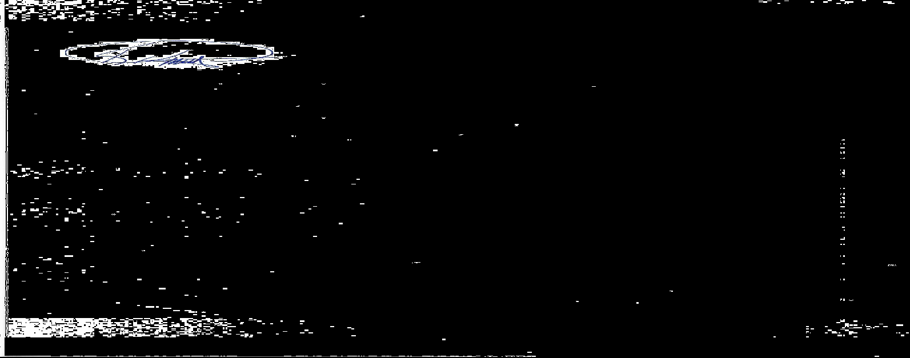

**RYAN, LLC:** {{company}}**:**

By: By:

Name: Kevin L. Prins Name: {{name}}

Date: Date:

**AUTHORIZATION TO FILE CLAIM**

Pursuant to that certain engagement letter between Ryan, LLC (“Ryan”) and {{name}} (“{{company}}”) dated {{date}}, this letter is to confirm that {{company}} has retained Ryan to assist in the preparation and filing of claims in the matter of Payment Card Interchange Fee and Merchant Discount Antitrust Litigation, MDL No. 1720.

This is to confirm that Ryan is {{company}}’s authorized representative in the above matter and has the authority to file claims and see the claims through completion.

Further this is to confirm that {{company}} has been advised by Ryan as required by the Court that Plaintiffs in the Rule 23(b)(3) Class (Money Damages Class) have reached a proposed settlement in this action. Materials reflecting this proposed settlement were filed September 18, 2018 with the Court. No claim forms are available at this time, and no claims-filing deadline exists. If the settlement is approved, no-cost assistance will be available from the Class Administrator and Class Counsel during any claims-filing period. No one is required to sign up with any third-party service in order to participate in any settlement. For additional information regarding the status of the litigation, interested persons may visit [www.paymentcardsettlement](http://www.paymentcardsettlement).com, the Court-approved website for this case.

**RYAN, LLC:** {{company}}**:**

By: By:

Name: Kevin L. Prins Name: {{name}}

Date: Date: