

DATE

Name

Title

CLIENT

Address

City, State ZIP

Re: Class Action Settlement Recovery Services

Dear **AfullName**:

Thank you very much for the opportunity to assist **AfullName** (“**Acompany**”). As discussed, this letter (the “Agreement”) outlines the terms and conditions of our engagement to assist {{company}}.

**ENGAGEMENT SCOPE**

Ryan, LLC (“Ryan”) will assist **Acompany** with {{company}}’s preparation and submission of claims available to {{company}} due to the matter entitled Payment Card Interchange Fee and Merchant Discount Antitrust Litigation – MDL No. 1720.

Our services will include the following:

* Identification and collection of transactions eligible for submission to the Claims Administrator. **Acompany** agrees to assist in providing the necessary documentation which may be required and requested to complete the submissions.
* Create summaries and analyses of eligible transactions consistent with the requirements of the Settlement Agreement for review by the Claims Administrator.
* Preparation and submission of the claim, including the documentation required per the terms of the settlement.
* Following the submission of the claim, monitor all claim processing activities and respond to any requests by the Claims Administrator as required.
* All requests to submit such claims are subject to **Acompany**’s approval. {{company}} agrees not to unduly withhold or delay such approval. {{company}} acknowledges that it has the ability to file claims on its own and has agreed to retain Ryan to assist in these matters.
* To the extent **Acompany** instructs Ryan to investigate the potential sale of a claim prior to final determination by the Claims Administrator; Ryan will attempt to locate a buyer, analyze {{company}}’s data for purposes of estimation of value in a potential sale setting, review and analyze the offer of said buyer and assist in the collection of funds from the buyer.
* In the potential sale setting, **Acompany** agrees to provide all requested data, to the best of its ability, for the purpose of maximizing any recoveries via this sale option.

**ENGAGEMENT PERIOD**

Our review will cover all available relevant transactions as determined by the Court in the matter described above.

**RESPONSIBILITIES**

Mr. Kevin Prins, Principal, will serve as the Engagement Principal for this project. Additionally, throughout the course of this engagement, we will make every effort to arrange and schedule all work to avoid interruption to **Acompany**’s normal business operations.

Ryan is not a law firm, and, accordingly, **Acompany** acknowledges that Ryan’s services are not and shall not be deemed to constitute legal services or advice.

**COMPENSATION**

In the event that Ryan obtains or recovers any amounts on **Acompany**’s behalf related to those claims that have been approved by the Claims Administrator or via a sale transaction with a third party purchaser relating to {{company}}’s claim in this matter or via any other method in which {{company}} receives monies relating to its claim in this matter, {{company}} agrees to pay Ryan and hereby assigns to Ryan, as compensation for this service, twenty five percent (25%) of any amounts paid to or otherwise realized by {{company}} pursuant to the terms of the above-described settlement agreements or sale transaction. {{company}} agrees that Ryan’s fees shall be based upon the gross amounts attributable to Ryan and shall not be reduced by any existing liabilities of {{company}} that may be applied or offset against such amounts. Our fee will be invoiced upon {{company}}’s receipt or realization of any amounts or benefits related to the claims. In the event Ryan does not obtain or recover any amounts on {{company}}’s behalf, then no fee will be due to Ryan.

**Acompany** acknowledges that the filing of a claim on behalf of {{company}} does not guarantee that {{company}} will receive monies from the settlement funds or from any third-party other source.

All invoices are due and payable in full within thirty (30) days. **Acompany** agrees to pay interest of one and one-half percent (1½%) per month on any past due fees. {{company}} further agrees to pay all costs of collection, including, but not limited to, any collection agency or attorneys’ fees, incurred by Ryan in connection with fees more than sixty (60) days past due. Ryan accepts checks, electronic funds transfers (EFTs), credit cards, and purchasing cards. If payment is made using a credit card or purchasing card, {{company}} authorizes Ryan to add a processing fee to the payment. Such processing fee is currently three percent (3%) of the payment amount and is subject to change upon thirty (30) days prior notice.

**NOTICE**

Any notice to be given under this Agreement shall be given in writing and may be made by personal delivery or hand delivery by courier, by overnight reputable national courier, or by placing such in the United States certified mail, return receipt requested. Notices to **Acompany** should be sent to the address indicated on the first page of this Agreement and notices to Ryan should be addressed as follows:

Ryan, LLC

Three Galleria Tower

13155 Noel Road

Suite 100

Dallas, Texas 75240

Attn: General Counsel

**INTEGRITY AND CONFIDENTIALITY**

We guarantee that all matters associated with the professional services we render will be directed with the highest degree of professional integrity. Accordingly, all information that **Acompany** makes available to Ryan shall be considered confidential, proprietary information, and Ryan shall not disclose such information to any third party except as required in fulfilling duties described by this Agreement or to comply with an official order of a court of law.

Additionally, **Acompany** agrees that Ryan’s work product, including specific engagement procedures and techniques, constitutes proprietary and exclusive information, and {{company}} further agrees not to disclose such information to any third party without obtaining prior written approval from Ryan. This Agreement does not include information independently developed by {{company}}, information previously known to {{company}}, or information rightfully received by {{company}} from a third party without confidential limitations.

**CONFLICTS**

Based upon the names of parties and other persons relevant to this Matter as provided by **Acompany**, Ryan is unaware of any conflict of interest in the performance of the Agreement. Should Ryan become aware of a conflict of interest, at Ryan’s discretion, Ryan may withdraw from the Agreement. {{company}} acknowledges that Ryan may be retained at any time in an unrelated matter to represent certain of its {{company}}’s interests, if any, that are in opposition to {{company}}’s interests underlying in this Agreement, and {{company}} agrees that such matter(s) would not be considered a conflict of interest other than at the discretion of Ryan.

**LIMITATION OF LIABILITY**

Ryan does not guarantee a particular result in a particular matter, and Ryan shall not be liable for an adverse or unsatisfactory result unless such result is solely and directly caused by Ryan’s negligence. Ryan shall not be liable for the following: (i) any failure or delay by **Acompany** in executing claims, forms, or letters of authorization; (ii) inaccurate, untimely, incomplete, or otherwise unreliable information provided by {{company}} or its representatives; or (iii) statutory, administrative, or judicial changes or rulings occurring after the submission of claims or filings to the jurisdictions. Ryan shall not be liable to {{company}} for any claim, liability, damage, or expense under any theory in excess of the amount actually paid by {{company}} to Ryan under this Agreement during the previous twelve (12) months.

**LAW GOVERNING AGREEMENT**

This Agreement shall be governed by and construed in accordance with the laws of the State of Texas. Exclusive venue for any dispute with respect to this Agreement shall reside in a court of competent jurisdiction in Dallas, Dallas County, Texas. **Acompany** represents that it has the authority to bind all {{company}} affiliates and subsidiaries receiving services under this Agreement. {{company}} will be responsible for all fees earned by Ryan under this Agreement.

**ACKNOWLEDGMENT**

**Acompany** has been advised by Ryan as required by the Court that Plaintiffs in the Rule 23(b)(3) Class (Money Damages Class) have reached a proposed settlement in this action. Materials reflecting this proposed settlement were filed September 18, 2018 with the Court. No claim forms are available at this time, and no claims-filing deadline exists. If the settlement is approved, no-cost assistance will be available from the Class Administrator and Class Counsel during any claims-filing period. No one is required to sign up with any third-party service in order to participate in any settlement. For additional information regarding the status of the litigation, interested persons may visit [www.paymentcardsettlement](http://www.paymentcardsettlement).com, the Court-approved website for this case.

Thank you for the opportunity to assist you with this project. If the above terms and conditions meet with your approval, please sign and return the enclosed copy of this Agreement at your convenience. Upon acceptance, we will contact you to arrange a mutually acceptable time to begin our review. If you have any questions, or if you would like to discuss this Agreement further, please contact Kevin Prins at 616.747.7631 or RYAN PRINCIPAL at 972.934.0022.

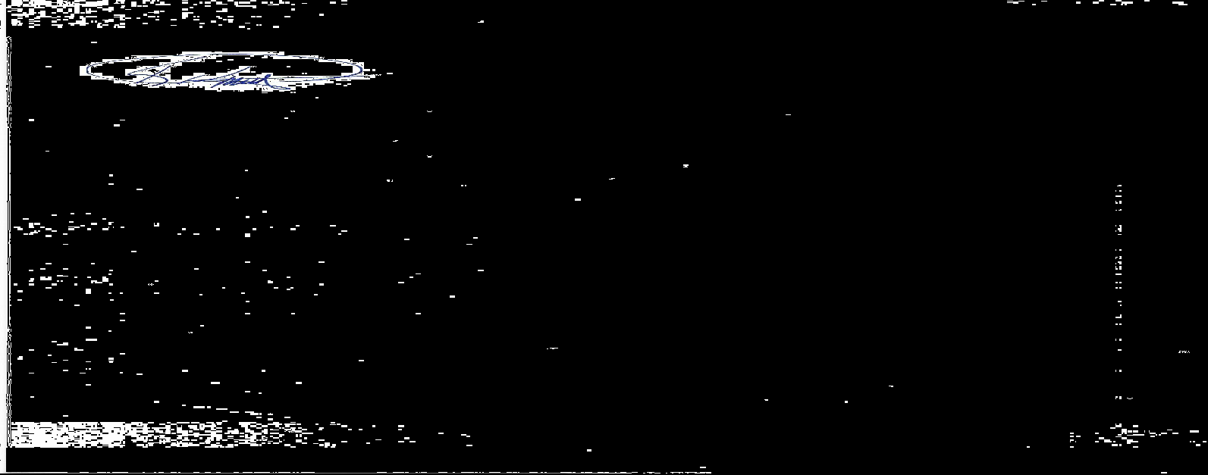

**RYAN, LLC: AfullName:**

By: By:

Name: Kevin L. Prins Name:

Title: Principal Title:

Date: Date:

**AUTHORIZATION TO FILE CLAIM**

Pursuant to that certain engagement letter between Ryan, LLC (“Ryan”) and **AfullName** (“**Acompany**”) dated 8/2/2023, this letter is to confirm that {{company}} has retained Ryan to assist in the preparation and filing of claims in the matter of Payment Card Interchange Fee and Merchant Discount Antitrust Litigation, MDL No. 1720.

This is to confirm that Ryan is **Acompany**’s authorized representative in the above matter and has the authority to file claims and see the claims through completion.

Further this is to confirm that **Acompany** has been advised by Ryan as required by the Court that Plaintiffs in the Rule 23(b)(3) Class (Money Damages Class) have reached a proposed settlement in this action. Materials reflecting this proposed settlement were filed September 18, 2018 with the Court. No claim forms are available at this time, and no claims-filing deadline exists. If the settlement is approved, no-cost assistance will be available from the Class Administrator and Class Counsel during any claims-filing period. No one is required to sign up with any third-party service in order to participate in any settlement. For additional information regarding the status of the litigation, interested persons may visit [www.paymentcardsettlement](http://www.paymentcardsettlement).com, the Court-approved website for this case.

**RYAN, LLC: AfullName:**

By: By:

Name: Kevin L. Prins Name:

Title: Principal Title:

Date: Date: