**Angular – Task Manager Front End**

**Machine ID: VBDOTNET-Stu-87-VBDOTNET-CTS**

**Hosted URL:**

* **UI -** [**http://localhost/**](http://localhost/)
* **API -** [**http://fsetaskmgr.net/**](http://fsetaskmgr.net/)

**SCM:**

* **UI -** [**https://github.com/venkatdev22/Cap_Task_UI**](https://github.com/venkatdev22/Cap_Task_UI)
* **API - https://github.com/venkatdev22/FSE_Cap_TaskMGRAPI**

**Dev File path:**

* **UI - C:\Users\Administrator\Source\capangular\taskmanager**
* **API - C:\Users\Administrator\Source\Repos\FSE_Cap_TaskMGRAPI**

Add Task

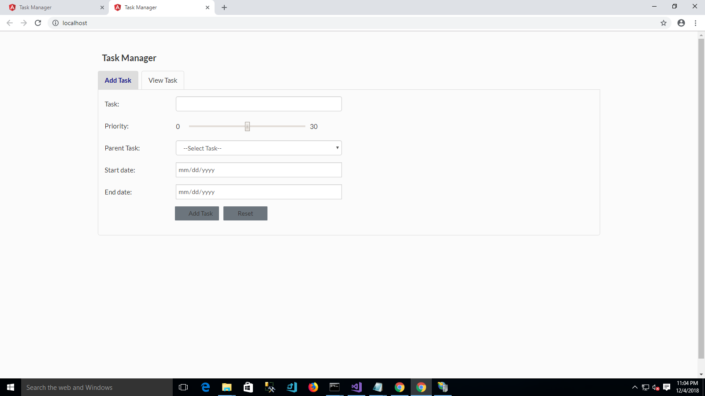

Mandatory Validaion.

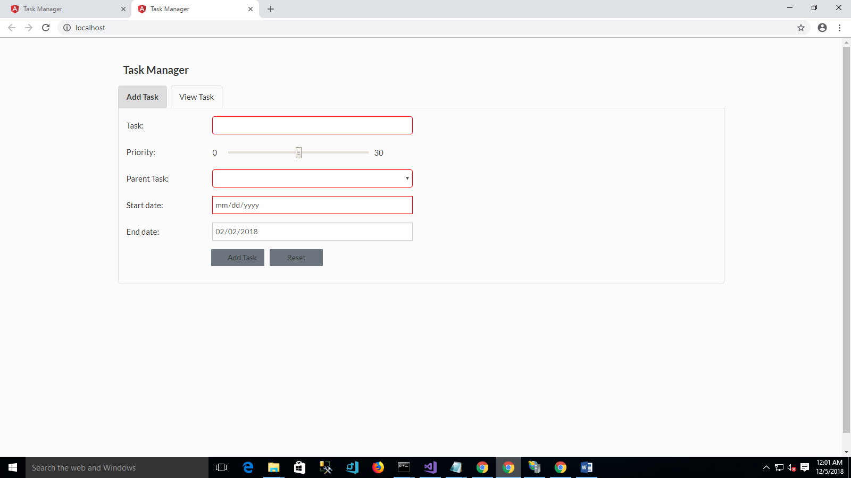

Add Task Post Method

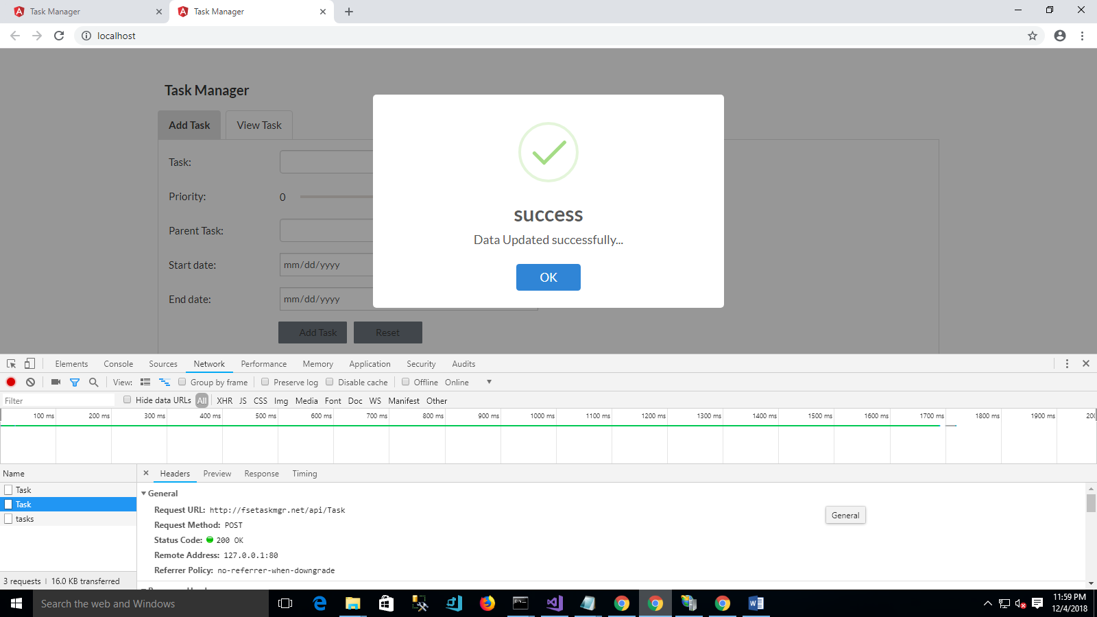

View Task

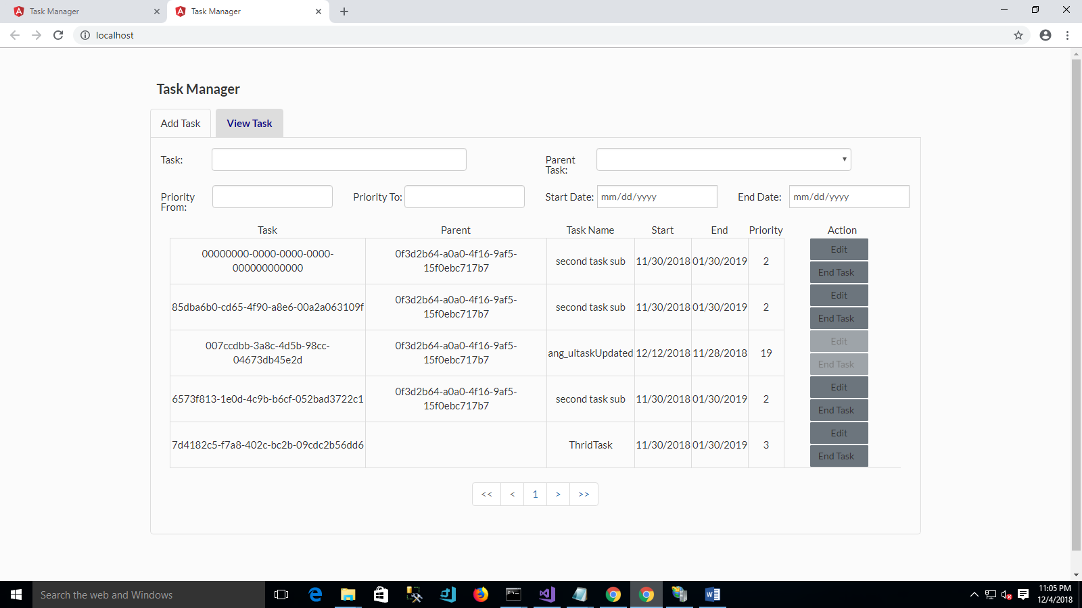

Get Task from api

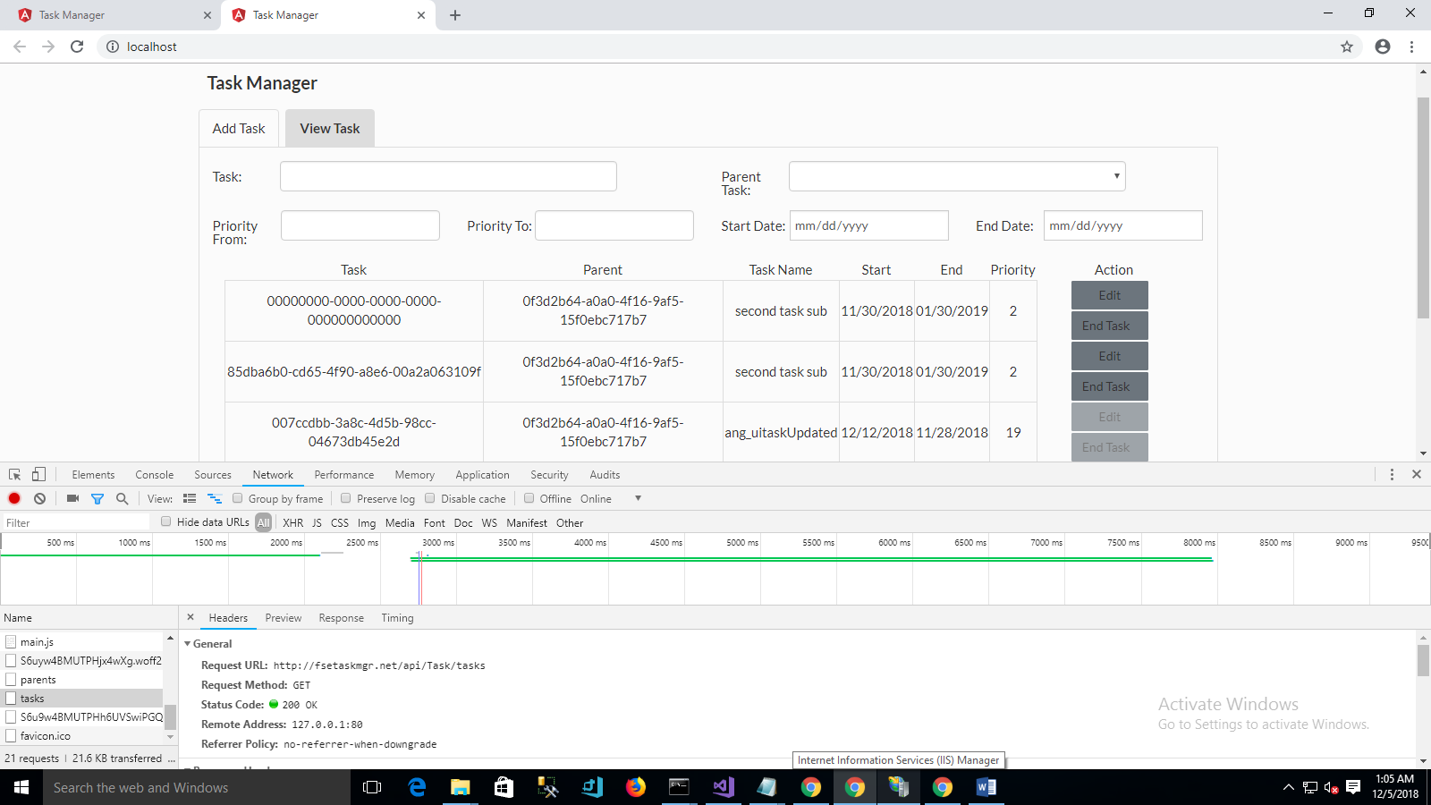

Get Parent Task from API

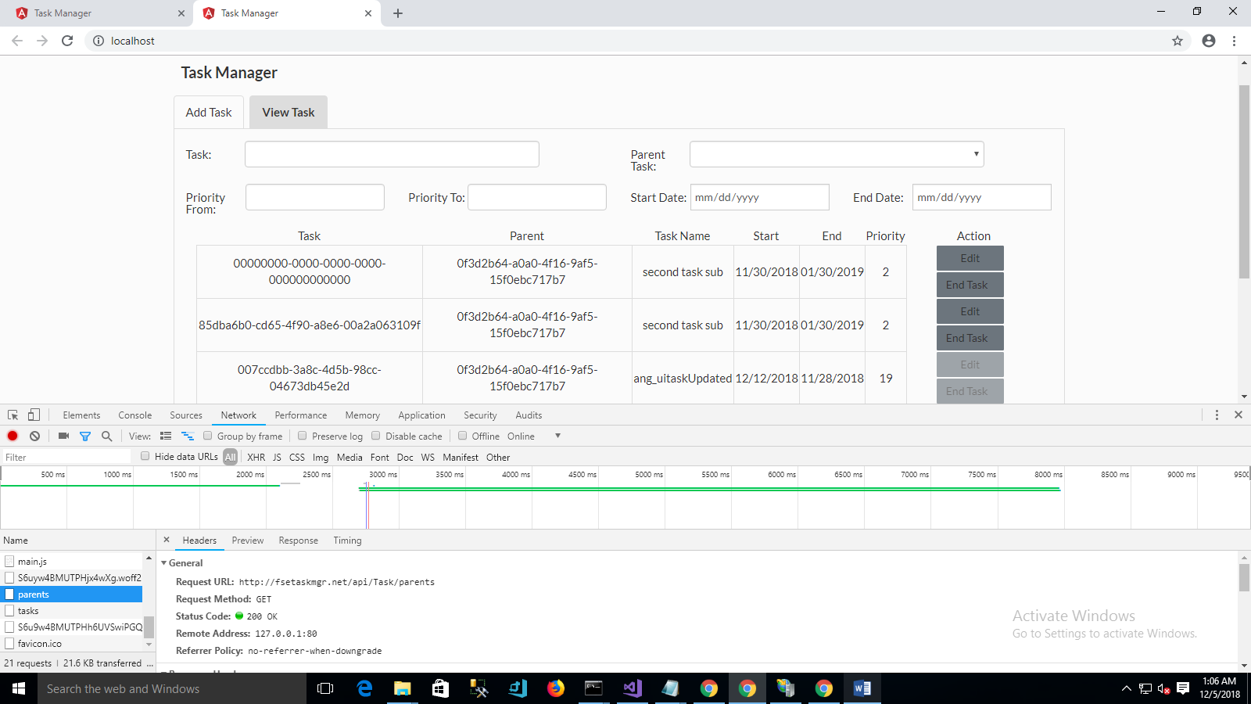

Update Task

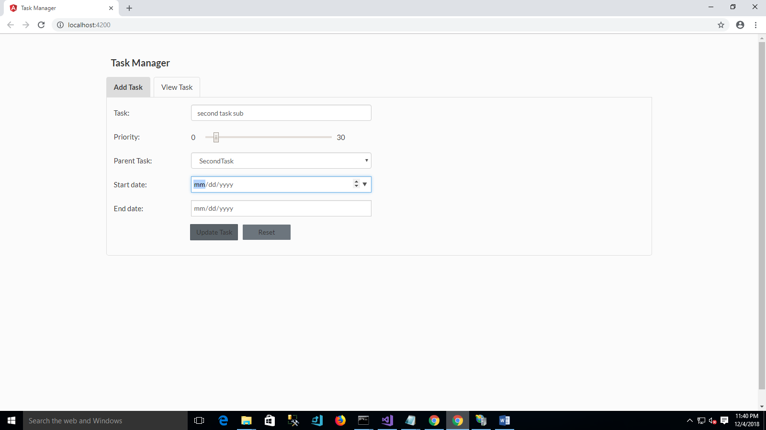

Update Task API

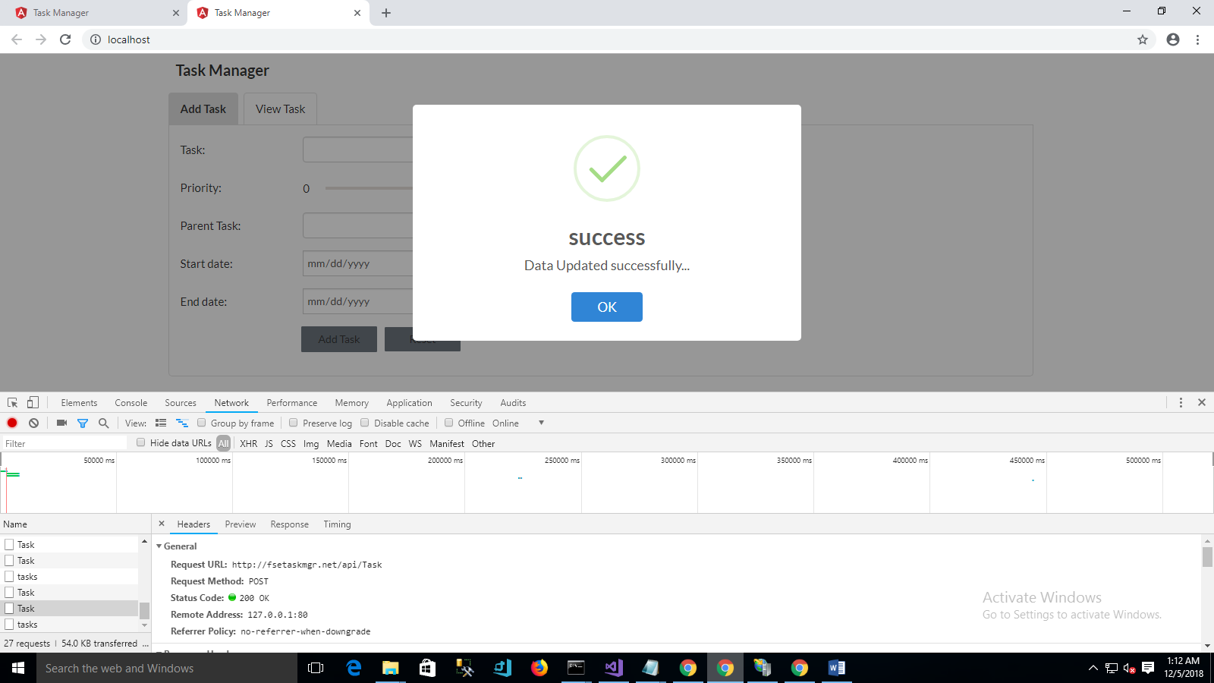

End Task API

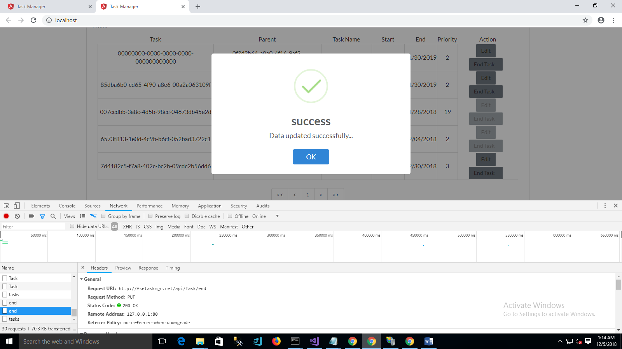

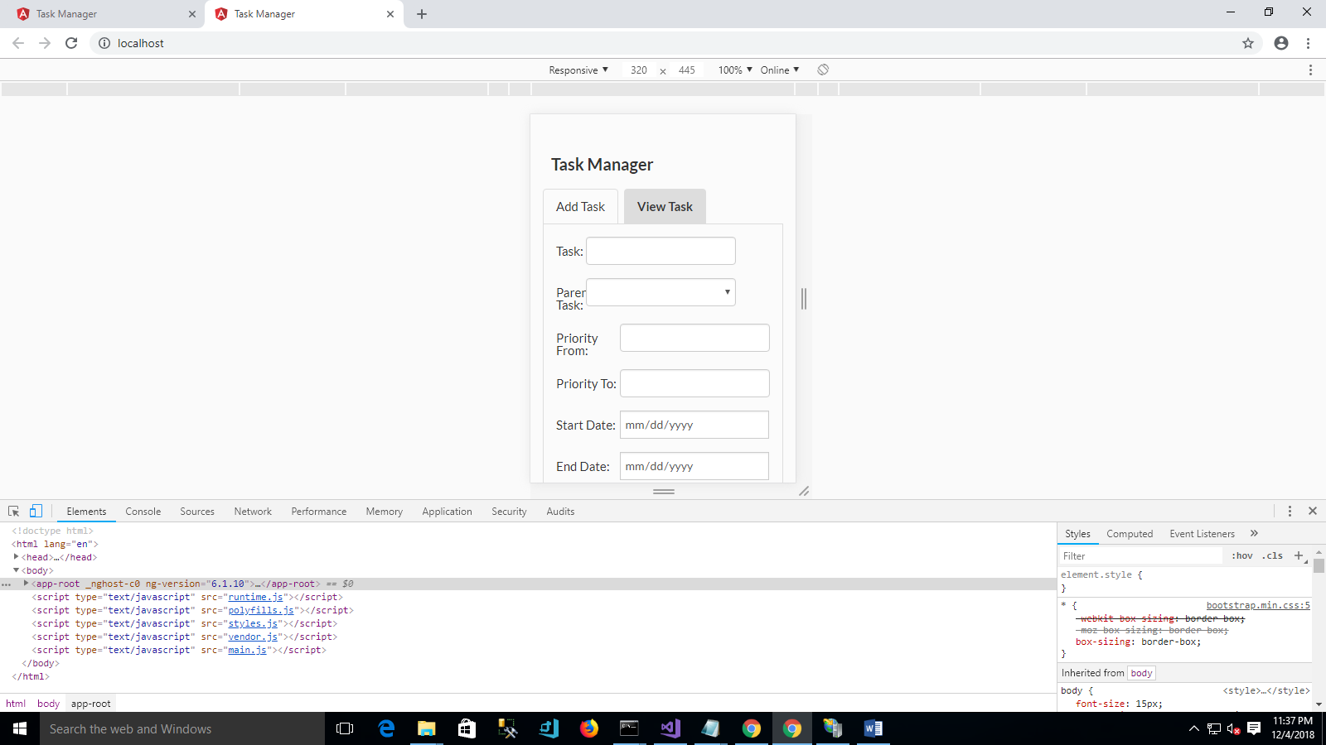

Karma Test

