**Angular – Task Manager Unit Test Results**

**Machine ID: VBDOTNET-Stu-87-VBDOTNET-CTS**

**Hosted URL:**

* **UI -** [**http://localhost/**](http://localhost/)
* **API -** [**http://fsetaskmgr.net/**](http://fsetaskmgr.net/)

**SCM:**

* **UI -** [**https://github.com/venkatdev22/Cap_Task_UI**](https://github.com/venkatdev22/Cap_Task_UI)
* **API - https://github.com/venkatdev22/FSE_Cap_TaskMGRAPI**

**Dev File path:**

* **UI - C:\Users\Administrator\Source\capangular\taskmanager**
* **API - C:\Users\Administrator\Source\Repos\FSE_Cap_TaskMGRAPI**

**Angular – NG test**

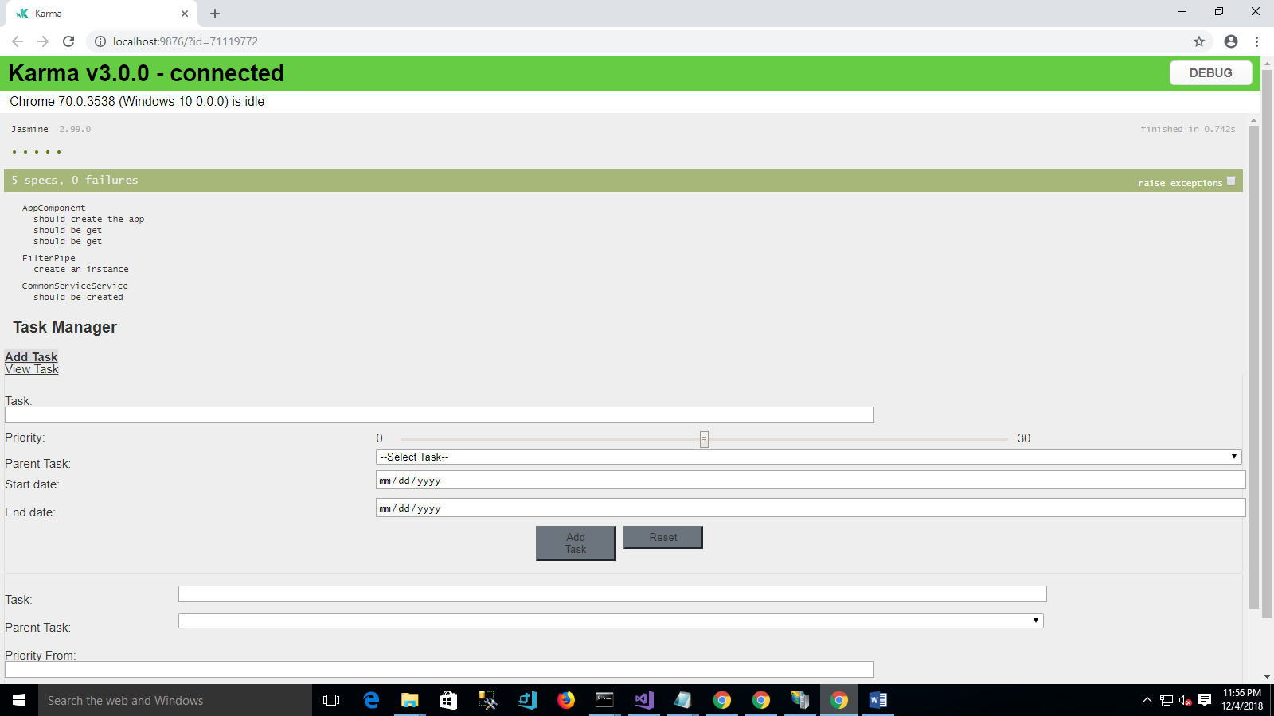

**API – Nunit results**

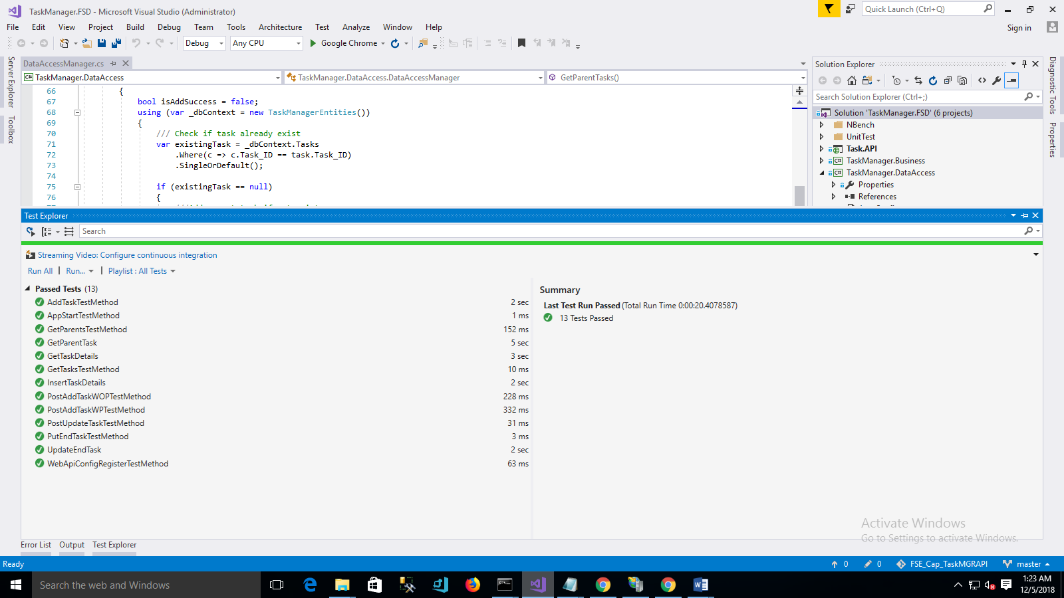

**NBench Performance Test**

Nbench runner CMD:

C:\Users\Administrator\Source\Repos\FSE_Cap_TaskMGRAPI\packages\NBench.Runner.1.0.1\lib\net45\NBench.Runner.exe "C:\Users\Administrator\Source\Repos\FSE_Cap_TaskMGRAPI\NBench\TaskManager.NBench\bin\Debug\TaskManager.NBench.dll" output-directory="C:\Perf"

output:

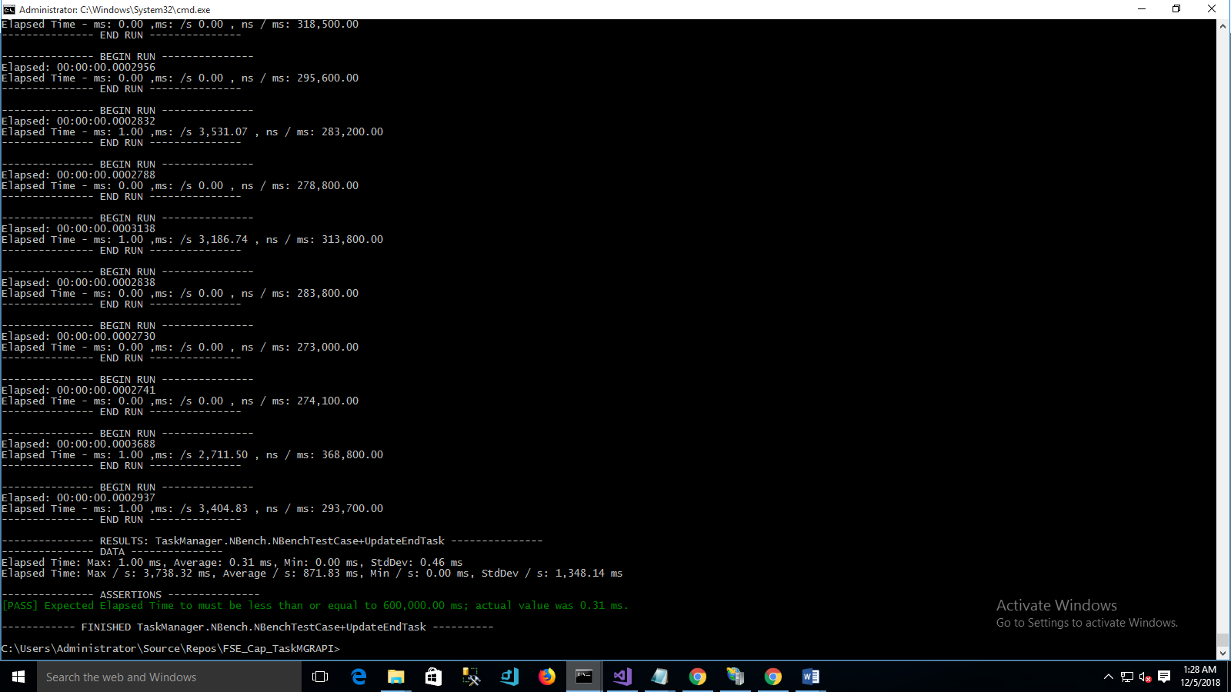

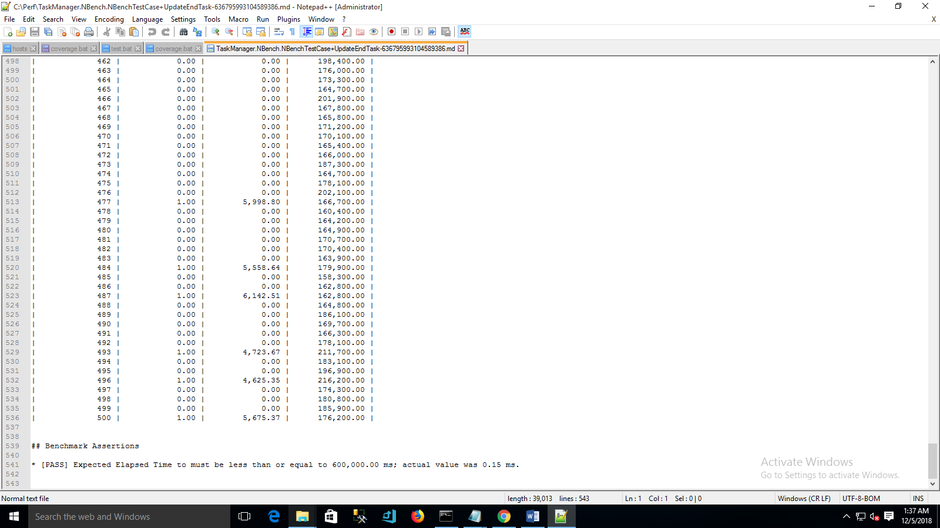

**OpenCover**

