

Purple Finance - Decentralized Finance The truly community driven DeFi platform

By Mderramus

**TABLE OF CONTENTS**

* **Introduction------------------------------------------------------------------------------------------------- 4**
* **Yield Farming ----------------------------------------------------------------------------------------------- 5**
* **Why is it called decentralized finance?------------------------------------------------------------- 5**
* **Why is DeFi’s impact so large?---------------------------------------------------------------------- 5**
* **Why would you want to lend money to someone that already has it?------------------- 6**
* **I heard something about pools…?------------------------------------------------------------------ 6**
* **Different Types of Liquidity Pools-------------------------------------------------------------------- 7**
* **Farming Strategies-------------------------------------------------------------------------------------------7**
* **Some general disadvantages to keep in mind------------------------------------------------------8**
* **That sounds like a lot of work! Can’t we automate it?-------------------------------------------8**
* **YFI -----------------------------------------------------------------------------------------------------------------8**
* **YFI’s Yearn Protocol: what to expect?-----------------------------------------------------------------8**
* **We have automation! Are we done now? -------------------------------------------------------------9**
* **Vaults.-------------------------------------------------------------------------------------------------------------9**
* **Community governance with YFI Token-------------------------------------------------------------10**
* **Let’s fork! YFII-------------------------------------------------------------------------------------------------10**
* **PURPLEBURN FINANCE (PPB) -------------------------------------------------------------------------11**
* **PPB GOVERNANCE TOKEN------------------------------------------------------------------------------15**
* **PPB POOLS---------------------------------------------------------------------------------------------------15**
* **PPB VAULT----------------------------------------------------------------------------------------------------15**
* **ITOKENS--------------------------------------------------------------------------------------------------------15**

We’re living in a digital era, our modern times have broken any kind of world barriers and frontiers. The world we’re living is more global and connected than ever. However, in our modern and connected digital world, we’re still using regular centralized FIAT money totally centralized controlled by Central Banks around the planet. Also, the emission of that money is not controlled, and that creates a lot of artificial money without any value circulating in the world economies causing among other issues high inflation rates in the underdeveloped countries, high poverty rates and an every time major social gap between multimillionaires and average persons. Here’s when the paradigm of cryptocurrencies solves two of the major issues of the FIAT money, since they have: controlled and limited emission and definitely represent truly digital money. When we talk about a digital world, necessarily we need to have digital money and also we need digital investment alternatives. With this in mind, Purpleburn (PPB) is introducing a real alternative to enter in the digital currency world, plus a series of decentralized financial instruments, investment options and lending, based on the original Yearn Finance project and implementing its more updated versions and protocols. Furthermore, we’ve got a firm goal in mind: become a truly community driven Decentralized Finance platform (DeFi), where our investors can make their voices heard and the Purple Burn team just provides the foundations and a framework to create a real governance over the token PPB. Purpleburn belongs to the community!

1. **Yield Farming**

Yield Farming is the “rocket fuel” of DeFi (Decentralized Finance). To understand that better, you first need to know about COMPOUND¹: it’s a protocol to set and give interest rates. The people that provide the liquidity needed are called liquidity providers or even liquidity farmers. COMPOUND, and its governance token COMP, are not the only interest protocols. Before COMPOUND, MakerDAO, another DeFi protocol, was king. And it was number 1 since the DeFi Pulse platform began measuring values (Pulse tracks ETH + tokens locked in DeFi projects). Its governance tokens is called MKR. This brings us to: what is “yield farming”? It’s a shorthand for clever strategies where putting crypto temporarily at the disposal of some startup’s application earns its owner more cryptocurrency. Another term floating around is “liquidity mining”: when a yield farmer gets his usual return as well as a new token in exchange for the farmer’s liquidity (that’s the “mining” part)

1. **Why is it called decentralized finance?**

Governance token holders vote almost every week on small changes to parameters that govern how much it costs to borrow and how much savers earn, and so on. Tokens are worth money, so you can bank with them or at least do things that look very much like banking. Hence: decentralized finance. Up to 2018 also called “open finance”.

1. **Why is DeFi’s impact so large?**

If you use a DeFi app, all you have to do to get started is to link your Ethereum wallet with some tokens in it. You can now borrow money without anyone even asking for your name, address or an ID. DeFi applications don’t worry about trusting you because they have the collateral you put up to back your debt (on Compound, for instance, a $10 debt will require around $20 in collateral)

1. **Why would you want to lend money to someone that already has it?**

The most obvious answer is that it’s used to short a token (the act of profiting if its price falls). It’s also good for someone who wants to hold onto a token but still play the market. “In some types of products, the product experience gets much better if you have liquidity. instead of borrowing from VCs or debt investors, you borrow from your users,” said Electric Capital managing partner Avichal Garg. Let’s take Uniswap as an example. Uniswap is an “automated market maker”, or AMM. This means Uniswap is a robot on the internet that is always willing to buy and it’s also always willing to sell any cryptocurrency for which it has a market. On Uniswap, there is at least one market pair for almost any token on Ethereum. Behind the scenes, this means Uniswap can make it look like it is making a direct trade for any two tokens, which makes it easy for users, but it’s all built around pools of two tokens. And all these market pairs work better with bigger pools.

1. **I heard something about pools…?**

The pools we are talking about here are called liquidity pools. Normally, a liquidity pool will contain 2 tokens. The catch is that the total value of the tokens in the pool must be equal. The value of each token depends on the pool’s balance. In a pool with only 2 USDC and 2 DAI it would offer a price of 1 USDC for 1 DAI. But then imagine that someone put in 1 DAI and took out 1 USDC. Then the pool would have 1 USDC and 3 DAI. The pool would be very out of whack. A savvy investor could make an easy $0.50 profit by putting in 1 USDC and receiving 1.5 DAI. That’s a 50% arbitrage profit, and that’s the problem with limited liquidity. This is why Uniswap’s prices tend to be accurate, because traders watch it for small discrepancies from the wider market and trade them away for arbitrage profits very quickly. So if someone, let’s say, buys ETH from a DAI/ETH pool they reduce the supply of ETH and add the supply of DAI which results in an increase in the price of ETH and a decrease in the price of DAI. How much the price moves depends on the size of the trade, in proportion to the size of the pool. The Yearn Finance 3 - Decentralized Finance Whitepaper. Rev. 1.0.1 – November 2020 7 bigger the pool is in comparison to a trade, the lesser the price impact a.k.a slippage occurs, so large pools can accommodate bigger trades without moving the price too much. Because larger liquidity pools create less slippage and result in a better trading experience, some protocols like Balancer started incentivizing liquidity providers with extra tokens for supplying liquidity to certain pools. This process is called liquidity mining. The concepts behind liquidity pools and automated market making are quite simple yet extremely powerful as we don’t have to have a centralized order book anymore and we don’t have to rely on external market makers to constantly keep providing liquidity to an exchange.

1. **Different Types of Liquidity Pools**

The liquidity pools that we just described are used by Uniswap and they are the most basic forms of liquidity pools. Other projects iterated on this concept and came up with a few interesting ideas. Curve, for example, realized that the automated market making mechanism behind Uniswap doesn’t work very well for assets that should have a very similar price, such as stable coins or different flavors of the same coin, like wETH and sETH. Curve pools, by implementing a slightly different algorithm, are able to offer lower fees and lower slippage when exchanging these tokens. The other idea for different liquidity pools came from Balancer that realized that we don’t have to limit ourselves to having only 2 assets in a pool and in fact Balancer allows for as many as 8 tokens in a single liquidity pool. Using a liquidity pool is not risk-free. Sometimes being a HODL’er is better than being an LP (Liquidity Provider), due to bugs or impermeant loss. This Medium post explains that in detail: Uniswap a good deal for Liquidity Providers.

1. **Farming Strategies**

Yield farming strategies are sets of steps that aim at generating a high yield on the capital. These steps usually involve at least one of the following elements: lending, borrowing, supplying capital to liquidity pools or staking LP tokens.

1. **Some general disadvantages to keep in mind**

It’s worth keeping in mind that yield farming strategies can become obsolete very quickly by for example protocol or incentive changes and something that may be super profitable right now may not be profitable at all the next day, so it’s important to keep an eye on the running strategies and rotate crops if necessary.

1. **That sounds like a lot of work! Can’t we automate it?**

Yes we can! After my long introduction above it’s about time to get passed 2018 and in to 2020 with YFI. After that, YFII & PPB will be discussed too.

1. **YFI**

In early 2020, the author of Yearn protocol — Andre Cronje, started looking into automating his strategy for choosing the highest paying lending protocol for his stable coins. Before the first iteration of the protocol, Andre woke up every day and he had to manually check which protocol paid the best APY (Annual Percentage Yield) on that day and consider moving his funds to that protocol. There were always a few options available at a time such as Compound, Aave, Fulcrum or dYdX.

1. **YFI’s Yearn Protocol: what to expect?**

The Yearn protocol, in essence, creates a pool for each stable coin. By depositing a stable coin to a pool, the user (the LP) receives their yTokens that are the yield-bearing equivalents of the deposited coin. For example, if a user deposits DAI, the protocol issues yDAI. The DAI that is pooled together can then be moved between different lending protocols to always maximize the yield. If a user wants to withdraw their initial DAI + accrued interest they can burn their yDAI and receive the underlying DAI. When a user deposits DAI (or any stablecoin), the protocol would never swap it to USDC, even if USDC has a higher yield. This is because most users want to withdraw the same stable coins as they initially deposited. Yearn Finance 3 - Decentralized Finance Whitepaper. Rev. 1.0.1 – November 2020 9

1. **We have automation! Are we done now?**

After the initial warm welcome by the community, Andre started working on improving the Yearn protocol itself. As the money in the pools started growing, some of the previously obvious strategies like moving coins into the highest paying lending protocol stopped working. Now, the protocol had to also anticipate what would happen to the APY if a large amount of funds are moved in, so it would have to also optimize splitting funds between different protocols and choose the most optimal solution. At this point, Andre also started working with Curve on the yCRV liquidity pool. yCRV pool contains the following yTokens: yDAI, yUSDC, yUSDT, yTUSD, making it easy to swap between the yTokens without unwrapping them into their underlying tokens. By depositing stable coins to the yCRV pool, the users can earn trading fees for providing liquidity on top of getting a return on their yield-bearing yTokens. COMP farming basically changed the whole landscape of liquidity mining and finding the best yield. Checking the APY of a deposit was no longer sufficient. To find out the actual yield, you’d have to add up all the extra tokens that were being distributed and as a consequence, finding the best strategies became even more complex.

1. **Vaults**

Yearn Vaults are pools of funds with an associated strategy for maximizing returns on the asset in the vault. Vault strategies are more active than just lending out coins like in the standard Yearn protocol. Yearn Vaults were created as a direct response to yield farming and liquidity mining that made searching for the highest yield much more complex than just switching between different lending protocols. Most vault strategies can do multiple things to maximize the returns. This can involve supplying collateral and borrowing other assets such as stable coins, providing liquidity and collecting trading fees or farming other tokens and selling them for profit. Each vault follows a strategy that is voted in by the Yearn community. One of the important rules when it comes to Vaults or Yearn protocol is that you always withdraw the same asset that was initially deposited. So farmed tokens and accrued fees are sold for Yearn Finance 3 - Decentralized Finance Whitepaper. Rev. 1.0.1 – November 2020 10 the main asset in the vault. The amount that is withdrawn is the initial amount that was put in, plus the pool yield that was earned, minus the fees. Yield farming can be a pretty time-consuming and expensive activity, so if you’re not willing to spend hours searching for the best yield farming opportunity, spend hundreds of dollars in gas fees to move funds around and keep monitoring your collateralization ratio, it is probably better to rely on the Vaults. For community-made strategies, currently, 10% of its fees go to the strategy creator. Creating new vault strategies can be a good opportunity for a skilled developer.

1. **Community governance with YFI Token**

To further decentralize the Yearn protocol and allow other people to make meaningful decisions on the future of the protocol, Andre decided to distribute a governance token to the Yearn community: YFI. Regardless of a disclaimer that the YFI token has zero financial value, the money started flowing into the incentivized pools, topping $600M in locked value. Also, the YFI token itself started rapidly appreciating in value, quickly peaking at $43000 USD

1. **Let’s fork! YFII**

YFII (DFI.Money) has earne the Chinese DeFi community’s trust shortly after forking from YFI. Among the reasons given for the hard fork include preventing wealthy participants from spoiling the party. YFII offers a different token distribution model where token emissions are halved every week (YIP-8). This economic design encourages active participation in the mining of $YFII whilst allowing late-comers to still earn rewards. Governance issues on the network are delegated to 11 signatories that engage using a multisignature model. Seven of the 11 signatories have to agree to reach consensus. However, this is a temporary governance model as the project implements governance through a decentralized autonomous organization (DAO). Just with DeFi protocols such as SushiSwap,Uniswap YFII’s smart contract is unaudited.

Purpleburn finance (PPB)

Purpleburnfinance.github.com is a yield aggregator for DeFi lending platforms that rebalances for highest yield during contract interaction which supports Compound, dYdX, Aave and DDEX protocols. When users put their money into the platform, it automatically transfers the assets into the protocol that has the highest yield, and returns a proof of stake called yToken. Users can send back yTokens at any time to withdraw their deposits along with the interest. PPB is the token for community governance and the key to farming yields of various DeFi platforms. It is used for revenue allocation and voting in the PPB DAO. By placing PPB directly into the hands of users and applications, an increasingly large ecosystem will be able to upgrade the protocol, and will be incentivized to collectively steward the protocol into the future with good governance.

**RoadMap**

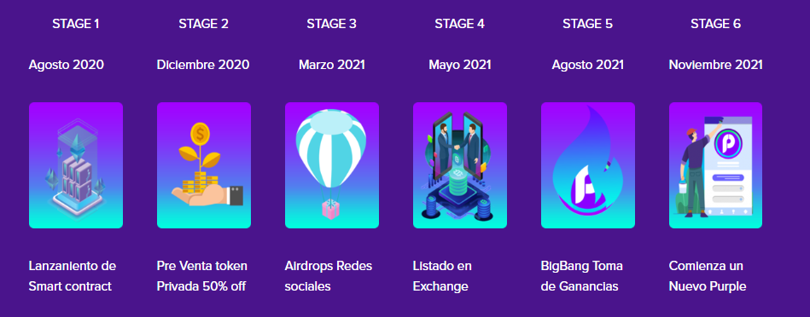

**Token Info**

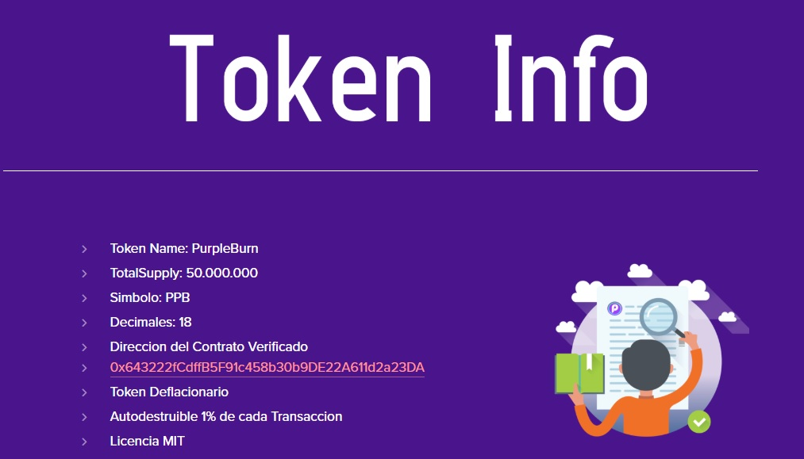

<https://etherscan.io/address/0x643222fcdffb5f91c458b30b9de22a611d2a23da>