Ringing in New Zealand

This article is written to provide an insight into who, what and why ringers are in Christchurch, New Zealand.

I have also tried to include some local history about New Zealand and Christchurch, on the East coast of the South Island.

New Zealand

New Zealand/Aotearoa (land of the long white cloud) lies in the South Pacific, 1,000miles east of Australia. The native people are the Maori. The Polynesian ancestors of the Maori arrived between 950 and 1300. The first European was Dutchman Abel Tasman in 1642 (who didn't actually set foot on land), followed by Capt. James Cook in 1733, who brought the first pair of sheep ashore!. On 6 February 1840, the Waitangi Treaty was signed by the Maori, allowing for the British to claim sovereignty over the whole of New Zealand. Today, the total population has just passed 3.8million (just over half the size of London), of which, only 930,000 live on the larger South Island.
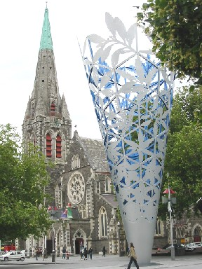
Christchurch Cathedral, New Zealand
I have been travelling and working in New Zealand for 4 months. I took a couple of picture-taking weeks to make my way from Auckland on the North Island, to Christchurch in the province of Canterbury on the South Island.

Christchurch is the third largest city in New Zealand at 340,000 people (5,000 fewer than the capital, Wellington). It has 2 of the 3 towers available for change ringing on the South Island - the third is in Dunedin, a mere 226miles South. Christchurch’s two towers are the centrally based Cathedral and a small wooden tower at Papanui (approximately 2.5miles North of the city centre).

Christchurch Cathedral

The Cathedral is by far the most visited tourist attraction in the city and houses the most eastern peal of bells in the world. Building started in 1864 and was eventually completed to its present state in 1904. The cathedral is built mainly of Canterbury stone (grey volcanic basalt and lime) and the timber comes from local native trees – matai and totara.

During the building of the cathedral, Mr Robert Heaton Rhodes (one of the first Canterbury settlers in 1848 and a Provincial Council member in 1853) paid for eight heavy bells from John Taylor and Sons of Loughborough. This was later changed to ten, for the benefits of suitable bells to teach on. These first ten bells (32Cwt), in D, were dedicated on 31 October 1881 and rung a day later for the Cathedral’s consecration.

A full new peal of twelve bells (24Cwt) was installed in 1978, again cast in Loughborough. A lot of the metal came from the bells of the Holy Trinity Church, Coventry - they are even hung identically, except for the treble and 2, which are swapped around. There are in fact thirteen bells, including a flat 6 (C natural). The flat 6 is used to ring eight or six bells in the key of G, with bells 2 to 9. The twelve bells remain in the key of D.

St Paul’s, Papanui, Christchurch

Papanui is a Maori name, meaning 'platform in a tree from which birds are snared'. It was an area of dense native bush, dominated by totara, matai, kahikatea and kanuka trees.

St Paul's was the fifth in the region to be built, in 1852, with timber donated from the area by W.G.Britten, who acquired the land during early settlement of the Canterbury region.

The original church stopped being used in 1877, when the new church was built at its present location. By 1905, an electric tram ran between Papanui and the centre of Christchurch, when the districts were separate entities. Unfortunately, only a very small amount of the bush still remains.

Originally, there were five bells hung for ringing in 1880. There was a shipment of five bells prior to that in 1879, but the ship (the Knowsley Hall) sank off the Cape of Good Hope, taking the bells with it (they’re still there if you’d like a light set of 5!). Fortunately, insurance paid up and a John Warner and Sons of London 6-0-26 five were hung for ringing in 1880.

In 1969, a 2-3-16 treble was added by John Taylor. The peal of six was finally augmented and tuned to eight (in B flat) in 1983, with the addition of two more trebles, again by John Taylor. This latest addition caused some structural problems in the wooden tower, as supporting beams had to be removed to fit them in. The tower was re-strengthened by a criss-cross of metal supports from the ground. During ringing, these creek as the whole tower (and the shrubbery around it) shakes.

The ringing and ringers

Ringing here is not too different to that which I know in Kent and Sussex. There is a very broad spectrum of ringers, from rope handling learners to Surprise Royal (and Maximus) ringers. There is also a fairly broad spectrum of ages, from me (24) through to those over 80 (Jim’s 84 this month!). We do lack the younger teenagers though.

Since 1880, the cathedral has managed an unbroken record of service. As with most towers, there have been times when numbers were low and the band faced near extinction. At the moment, both towers usually have enough to ring all of their bells on a practice night and very often for Sunday service too.

The Cathedral averages a couple of visitors a week during these summer months, as a result, we often get to ring the more common Surprise Major methods. We also have a local band to ring Surprise Major on a reasonably regular basis – occasionally, even Stedman Caters starts being whispered around the tower. A few members of the band are learning call changes and Plain Bob, others are learning to call it, some just diligently study the 'hard' methods, ever hopeful of ringing visitors or a full complement of locals!

Papanui is very similar with their eight bells. Like the cathedral, there is a very good team of people who are always there, keen to pass on knowledge and to learn it. We look forward to a good touch of Plain Bob and Stedman Triples – as well as being able to get our learners through plain courses of Grandsire Doubles.

We regularly get comments of appreciation from the locals, and often leave Sunday ringing and practices patting ourselves on the back. There is no shortage of team work, back-up and help from and to any standard of ringer. There is always time to have a new idea explained (often more than once), so that everyone is happy.

We have attempted a number of 1/4s to help people learn the methods, namely Stedman Triples, Grandsire Triples, Plain Bob Minor and Cambridge Minor. Even when these 1/4s have not been successful, everyone has been happy to have had the chance (for a pint and to get out of the sun!) and know they’ve learned a lot.

This photo is a snapshot of the ringers at the Cathedral one random Tuesday in March. I apologise to those missing.
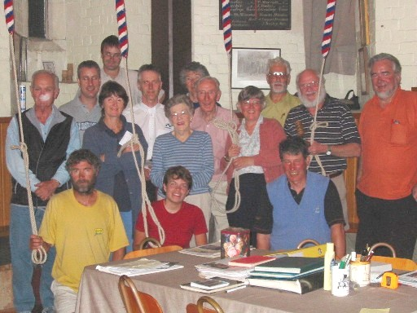

Front row - Simon (yellow), Jo (red), other Mr Visitor (blue)
Second row - Clive, Midge, Pat (stripy), Erica, Master Mike, John (orange)
Third row - David (grey), Paul (white), Jim, Dudley (yellow)
Fourth row - Robbie, Beryl (hiding)
Cathedral ringers missing: Bob, Karen, Chris.

Every visitor here is always made very welcome. Many people are surprised to find that a lot of Kiwis have either lived in or come from the UK, and usually have some common knowledge and interest! The ringers do, however, have a strange tradition of not going to the pub after ringing. I used to have to wait for an English ringer to come along! In my couple of months here I seem to have changed that though.

I'd also like to take this opportunity to thank the warmth of welcome I received from everyone since I arrived in Christchurch. I would especially like to thank my chauffeurs, Robbie, Bob, Mike and Eleanor.

For anyone interested in any further images of New Zealand, Christchurch and the ringers, please visit my web site at http://uk.geocities.com/tigger2031.

Jo, March 2003.
☺

