

Practices for Secure Software Report

Table of Contents
Document Revision History 3
Client 3
Instructions 3
Developer 4
1. Algorithm Cipher 4
2. Certificate Generation 4
3. Deploy Cipher 4
4. Secure Communications 4
5. Secondary Testing 4
6. Functional Testing 4
7. Summary 4
8. Industry Standard Best Practices 4

Document Revision History

Version | Date | Author | Comments
1.0 | February 20, 2026 | Nicole Lumbert | Initial completion of Project Two secure software report.

Client
Artemis Financial (client) — modernization of a public-facing web application to protect client data and financial information.
Global Rain (development team) — responsible for implementing secure communications and checksum-based integrity verification.

Instructions

Submit this completed practices for secure software report. Replace the bracketed text with the relevant information. You must document your process for writing secure communications and refactoring code that complies with software security testing protocols.

- Respond to the steps outlined below and include your findings.
- Respond using your own words. You may also choose to include images or supporting materials. If you include them, make certain to insert them in all the relevant locations in the document.
- Refer to the Project Two Guidelines and Rubric for more detailed instructions about each section of the template.

Developer
Nicole Lumbert

1Algorithm Cipher

I recommend using HTTPS with TLS 1.2 or 1.3 for secure data transfer, and SHA-256 for verifying file integrity with checksums.
TLS is the standard protocol for encrypting data sent between a browser and a server. When a connection starts, the server proves its identity with a certificate using public and private keys. After this step, the connection uses fast symmetric encryption, usually AES in a secure mode like GCM, to keep data private and protected from tampering.
For checking files, SHA-256 is a good choice because Artemis Financial needs to make sure files have not been changed, not to encrypt them. SHA-256 turns any size of input into a fixed 256-bit (32-byte) value. Even a small change in the input creates a completely different result, which makes SHA-256 reliable for verifying checksums.
Hash functions and bit levels: SHA-256 outputs 256 bits and is designed to resist preimage and collision attacks at practical security levels. Legacy hashes like MD5 and SHA-1 are no longer recommended for security measures due to collision weaknesses; SHA-256 ( SHA-2 family) is widely accepted for modern integrity checks.
Random numbers are important for security, such as creating session keys, nonces, and stopping replay attacks. TLS uses random values when setting up a connection. Public and private keys are used to prove identity and agree on keys, while symmetric keys handle most of the data encryption after the connection is set up.
Older algorithms like DES are outdated because their keys are too short. Today, AES is the preferred choice for encrypting data, and SHA-2 or SHA-3 are used for hashing. TLS 1.2 and 1.3 meet current security and compliance standards for safe communication.

Certificate Generation
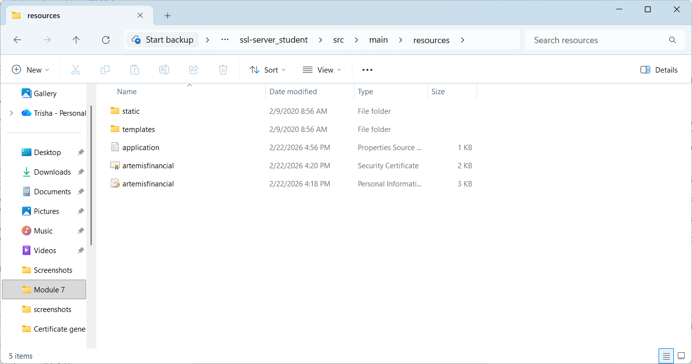

Deploy Cipher
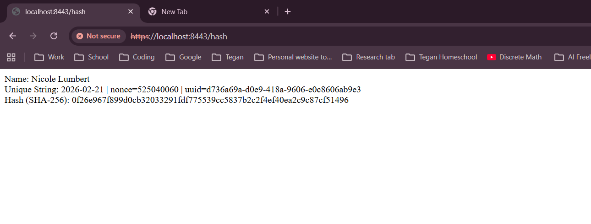

Secure Communications


Secondary Testing
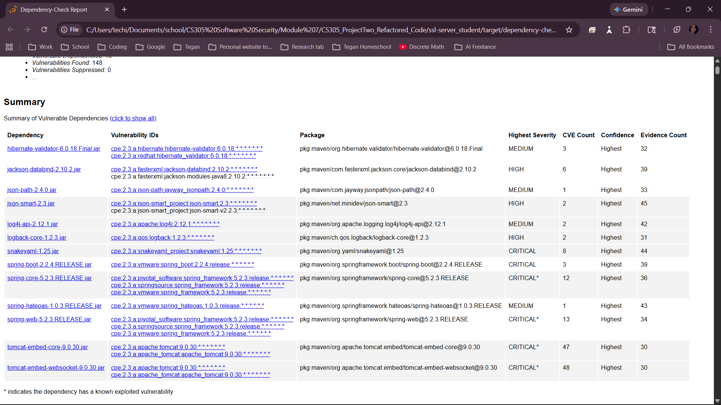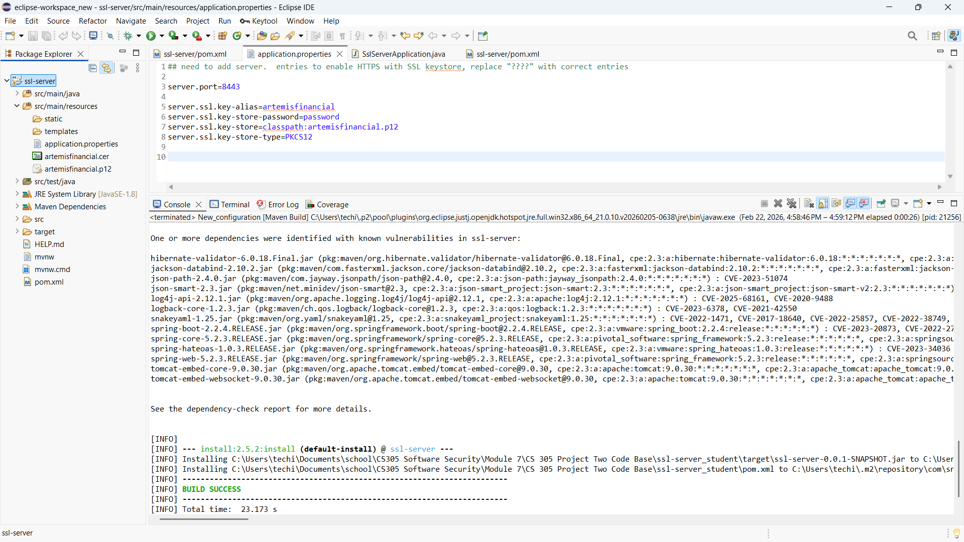

Functional Testing
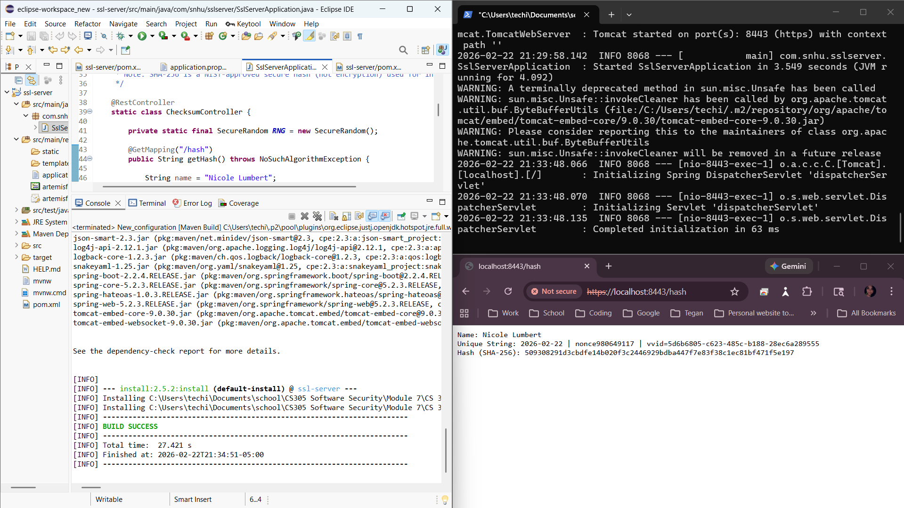

Summary

For this project, I updated Artemis Financial’s Spring Boot app to include secure communication and a step to verify data integrity during transfers.
Security improvements covered the following areas:
- Cryptography: Added a SHA-256 checksum for a unique data string from the `/hash` endpoint. This lets us check for tampering each time.
- Client/Server: Set up HTTPS (TLS) on port 8443 with a self-signed certificate. This keeps data safe while it moves between client and server.
- Code Quality / Encapsulation / Error Handling: Used Java’s security libraries (`MessageDigest`, `SecureRandom`) for checksums, organized in helper methods. Exceptions are handled securely so users don’t see internal errors.
- Code Review & Static Testing: Checked all changes with a manual review and a dependency scan to make sure no new security issues were added.
Layered security steps:
1) Begin with HTTPS/TLS to keep data private and unchanged while it’s sent.
2) Add a SHA-256 checksum to make sure data isn’t changed.
3) Re-test with 3) Run static analysis (dependency-check) again to confirm the app still works well.nual functional review for logical, syntactical, and security concerns before final submission.
- Industry Standard Best Practices
I applied industry standard secure codI followed secure coding best practices to lower risk and keep the app working as before. standards: I used Java’s built-in cryptography providers and a well-known hash algorithm (SHA-256) instead of implementing custom crypto.
- Least exposure of sensitive information: The checksum endpoint only returns the data string and digest needed to show integrity. It doesn’t reveal system details or secrets.
- Secure defaults for transport: Using HTTPS/TLS meets today’s standards for keeping client data safe while it’s sent.
- Validation through testing: Dependency-Check helps find known vulnerable dependencies. Reviewing the results supports ongoing improvement and lowers supply-chain risk.
Value to the organization: These practices lower the risk of data breaches, build customer trust, and help Artemis Financial meet compliance for secure data handling, integrity, and safe dependencies.

