* Effect of number of trees @train perc=75%

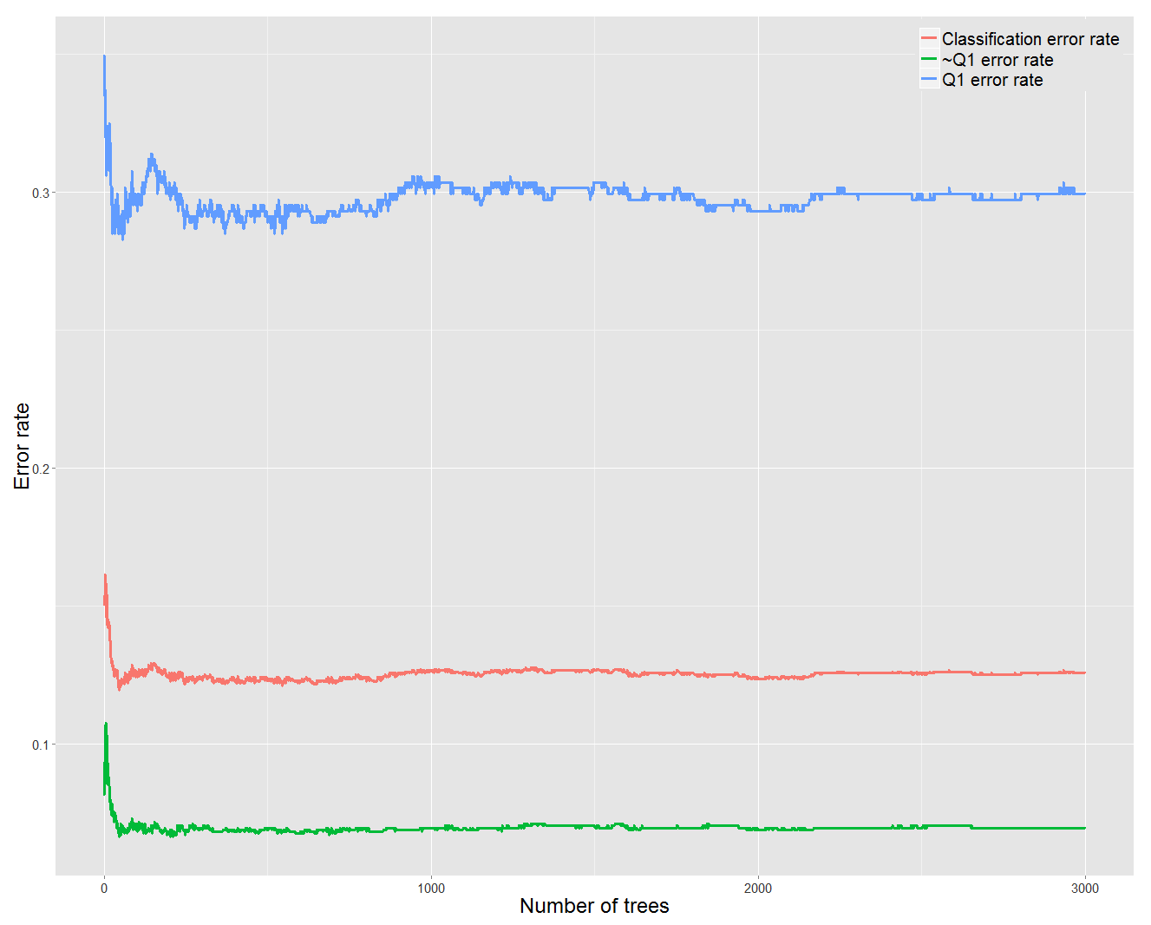

* Effect of number of variables in each split (Set m=5)

m n.Tree Train.Perc Accy TP TN

[1,] 3 500 0.75 0.8566363 0.6917606 0.9134760

[2,] 5 500 0.75 0.8647416 0.7092859 0.9163999

[3,] 6 500 0.75 0.8637285 0.7138675 0.9168837

[4,] 10 500 0.75 0.8606890 0.7117669 0.9126980