**The adjustment and use of spectroscope**

2022级 人工智能 ZYH

**Abstract**

In 1814, German physicist Fraunhofer designed and manufactured the first spectrometer consisting of an Abbe collimating lens, a collimator, and a prism to study the dark lines of the sun. Later, through continuous improvement by people, the spectrometer gradually improved and its application in the field of optical technology research became increasingly widespread. Many optical instrument (such as grating spectrometer, spectrophotometer, prism spectrometer, monochromator, etc.) are designed and manufactured based on the optical structure of spectrometer. Spectrometer is an instrument for accurately measuring the deflection angle of light, also known as goniometer. Through angle measurement, we can measure the wavelength of light wave, refractive index, dispersion, grating constant and other physical quantities. This experiment introduces using a spectrometer with an accuracy of 1 'to measure the top angle and minimum deviation angle of a prism, and then calculating the refractive index of the prism.

1. **Objectives**

1. Understand the structure, function, and working principle of a spectrometer 2. Learn how to adjust and use a spectrometer

3. Use a spectrometer to measure the refractive index of a prism

1. **Experiment Equipment**

JJY1 spectrometer, flat reflector, mercury lamp, and prism.

1. **Experiment Principles**
2. **Construction of Spectrometer**

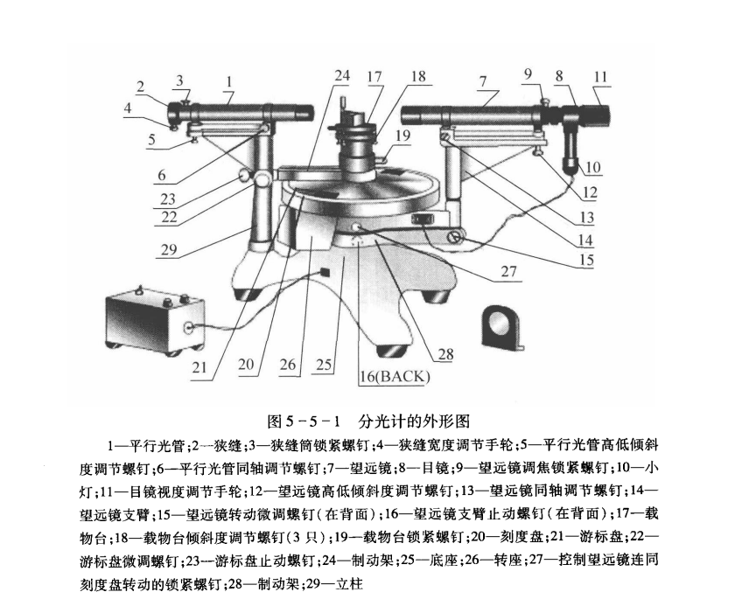

Figure 1

1. The function of a collimator is to generate parallel light. One end of it is equipped with a composite lens to counteract color difference, and the other end is equipped with a width adjustable slit and its sleeve. Changing the distance between the slit and the lens so that the slit is exactly located on the main focal plane of the lens can make the light shining on the slit pass through the lens and become parallel light.

2. The telescope used in this experiment is the Abbe type autocollimator telescope. Like ordinary telescopes, it has an eyepiece reticle and an objective lens, as shown in Figure 2(a). The reticle is marked with a "Feng" shaped guide line, and a small 45°total reflection prism is attached. The side of the small prism close to the reticle is coated with a layer of opaque film, and a small cross window is carved on the film. Turn on the power switch of the small lamp, adjust the front and rear positions of the eyepiece, and you can see the scene shown in Figure 2(b) in the eyepiece field of view. The small prism reticle and the small lamp are fixed to cylinder B, the eyepiece is fixed to cylinder C, and the objective lens is fixed to cylinder A. C can move along B and B can move back and forth along A. Move cylinder B back and forth. When the reticle and cross window are located on the focal plane of the objective lens, the light emitted by the small lamp will be reflected by the prism and become a parallel light through the cross window through the objective lens. These parallel lights are reflected by the reflector on the stage, and then imaged on the reticle through the objective lens. Observe with the focused eyepiece (that is, the reticle has been imaged at the clear vision distance of the observer), and you can clearly see the image of the cross window. If the optical axis of the telescope is perpendicular to the reflecting mirror surface, this image should be located at the upper intersection of the collimation line, as shown in Figure 2(c).

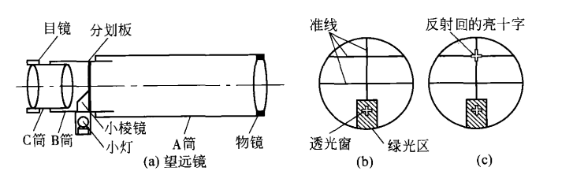

Figure 2: (a)left (b)middle (c)right

3. The stage is used to place the object to be tested or the spectrometer component. There are three screws below it to adjust the height and level of the platform, as shown in Figure 3(a). Loosen the locking screw of the loading platform to adjust the lifting of the loading platform.

4. The reading device consists of a main scale disc and two angular verniers. The dial is divided into 360°divisions with a minimum division value of 30', which is the main ruler for measuring angles in a spectrometer. Readings less than half a degree are read using a cursor. The two angular verniers are located 180 degrees relative to the edge of the disk, and there are 30 grid measurement values on the vernier that can be read to 1'. The reading method of an angle cursor is the same as that of a straight cursor. As shown in Figure 3(b), the reading is 116'10''. Two cursors are symmetrically placed to eliminate the eccentricity caused by the misalignment between the center of the dial and the center of the cursor. When measuring, note the readings indicated by both cursors simultaneously.

5. There is a rotating shaft sleeve in the center of the base along the vertical direction, and the telescope, circular dial vernier, and stage can rotate around the axis of this shaft sleeve.

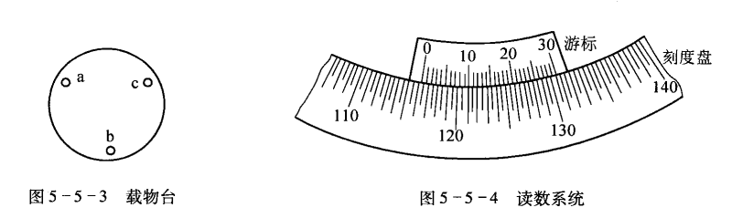

Figure 3: (a)left (b) right

1. **The principle of angle measurement measures the angle between light rays**

Essentially determining the azimuth angle of parallel light beams. As shown in Figures 4, AB represents parallel beams and converging image points on the focal plane of the telescope, respectively. Each point on the focal plane corresponds to a parallel beam of light emitted by a person in a certain direction. If the optical axis of the telescope rotates around the axis perpendicular to the rotation of beams 1 and 2, and the optical axis changes from the direction parallel to beam 1 (the convergence image point on the optical axis is A) to the direction parallel to beam 2 (the convergence image point on the optical axis is B), then the angle that the light passes through is the angle $θ$ between beam 1 and beam 2.

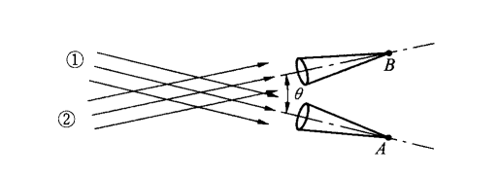

Figure 4

1. **The principle of measuring the refractive index n of a prism using the minimum deviation angle method**

As shown in Figures 5. Monochromatic light is projected onto the AB surface of the prism at an incidence angle $α_{1}$, and after two refractions, it is emitted from the AC surface at an angle ${α_{2}}^{'}$. The angle $θ$ between the incident beam and the refracted beam is called the deviation angle. Obviously:

$$θ= \left(α_{1}- {α_{1}}^{'}\right)+ \left({α_{2}}^{'}-α_{2}\right)= α_{1}+{α_{2}}^{'}- φ$$

In the equation, $φ$ is the top angle of the prism. For a given prism, its vertex angle $φ$ It is known and the angle of deviation $θ$ is a function of a1. It can be proven through differential calculus that when $α_{1}$ = ${α_{2}}^{'}$, ${α_{1}}^{'}$ = $α_{2}$, i.e., MM '//BC (frosted surface), the $θ$ is minimum value that is called the minimum deviation angle, which is calculated using $θ_{0}$ represents. At this point:

$${α_{1}}^{'}= \frac{φ}{2}, α_{1}= \frac{φ+θ_{0}}{2}$$

Then the refractive index:

$$n= \frac{\sin{\frac{1}{2}(φ+θ_{0}) }}{\sin{\frac{φ}{2}}}$$

The vertex angle of a prism $φ$ Provided by the laboratory, as long as the minimum deviation angle is measured during the experiment $θ_{0}$ can be used to calculate the refractive index n of the prism from the above equation.

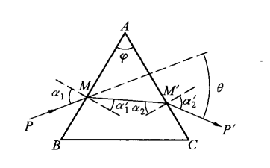

Figure 5

1. **Content Steps**
2. **Adjusting the telescope**

Before adjusting the spectrometer, it is necessary to refer to Figure 1 and compare the position and function of each adjustment screw and stop screw of the spectrometer with the actual object.

**1. Visual coarse adjustment refers to directly observing**

Adjust the tilt adjustment screw 12 of the telescope and the tilt adjustment screw 5 of the collimator to align the telescope and the collimator with the dial. Adjust the tilt adjustment screw of the stage so that the stage is parallel to the dial. This coarse adjustment is the foundation and prerequisite for fine adjustment, and it must be repeatedly and carefully adjusted to the best state, so that the reflected green cross can be seen on both sides of the reflector.

**2. Requirements for fine adjustment and step**

1) Eyeglass, so that the alignment of the reticle can be clearly seen. The method is to connect the small light bulb and turn on the switch, and observe whether there is a green light area in the lower half of the field of view. If there is, slowly rotate the eyepiece focusing handwheel until you can clearly see the guide line and the black cross in the green light area, as shown in Figure 6:

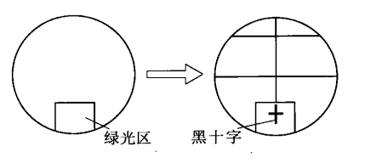

Figure 6

2) Adjust the telescope to receive parallel light using self-alignment method. The method is to align the three 120°bisectors on the stage with the three adjustment screws under the stage, and then place the double-sided reflector on the stage as shown in Figure 7(a). Loosen the stage locking screw 19, and lift the stage so that the center of the reflector is at the same height as the axis of the telescope. Loosen the stop screw 23 of the vernier disk, rotate the vernier disk (together with the stage) so that the mirror surface is facing the telescope and adjust the tilt adjustment screw of the telescope appropriately so that it can observe a blurred bright spot (or an unclear green cross) reflected back in the eyepiece, loosen the focus adjustment locking screw 9 of the telescope, slowly retract the eyepiece sleeve B back and forth until a clear green cross can be seen, and there is no parallax with the reticle alignment, as shown in Figure 7(b). At this point, the telescope has been tuned to receive parallel light. Tighten screw 9 again. This step adjustment can also make the reflecting surface of the plane mirror close to the telescope object tube, and the reflecting surface of the plane mirror will be roughly perpendicular to the optical axis of the telescope. If the reticle is on the focal plane of the object lens, a clear green cross reflection image can be seen. If the reticle is not on the focal plane of the objective lens, a light spot can be seen. At this time, slowly retract the eyepiece sleeve forward and backward, so that a clear green cross reflection image can be seen in the eyepiece.

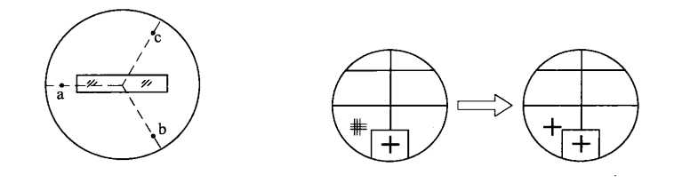

Figure 7: left (a) right(b)

3) Adjust the optical axis of the telescope to align with the rotation axis of the spectrometer. The method is to first use the half step adjustment method (also known as the half step method) to adjust the green cross to the upper intersection point of the alignment line on the side where the clear green cross is visible, that is, adjust the telescope tilt adjustment screw to raise (or lower) the green cross $\frac{h}{2}$, and then adjust the platform tilt adjustment screw b (or c) to raise (or lower) the green cross $\frac{h}{2}$, as shown in Figure 8:

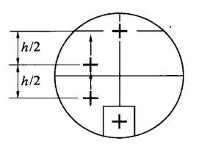

Figure 8

4) Adjust the normal of the stage to be parallel to the rotation axis of the spectrometer as Figure 9. The purpose is to make the plane scanned by the telescope axis parallel to the plane of the stage, so as to ensure that the normal of the optical surface of the optical element to be tested (such as a prism) can be parallel to the optical axis of the telescope after being placed on the stage.

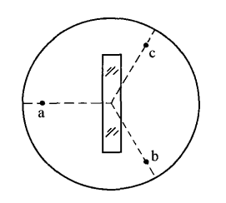

Figure 9

5) Adjust the collimator to emit parallel light and make it coaxial with the telescope. The method is to move the spectrometer so that the collimator is facing the light source, rotate the telescope to align with the slit of the collimator, and loosen the locking screw 3 of the slit sleeve of the collimator. The front and rear telescopic slit sleeves are so clear that the clearest slit image can be seen in the telescope without parallax (note that the telescope cannot be refocused), and the collimator can emit parallel light. Then, tighten the screw 3. Adjust the slit width adjustment handwheel 4 so that the slit width observed in the field of view of the eyeglass is 1~2mm. Adjust the high and low inclination adjustment screw 5 of the collimator so that the slit image is bisected by the central horizontal alignment of the reticle.

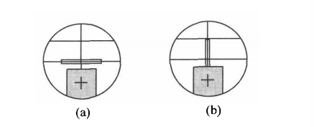

Figure 10: left(a) right(b)

1. **Measure the minimum deviation angle of the triangular prism.**

As shown in Figures 11, place the prism on the stage so that the light can be directed towards the AC surface of the triangular prism (note that the angle should be slightly larger). Lock the stop screw of the vernier plate, and rotate the telescope towards the BC surface to search for the narrow-slit image of the light refracted by the triangular prism. In the process of searching for a slit image, sometimes it may not be possible to observe it through a telescope. At this point, the telescope can be removed and the eye can be directly directed towards the refracted light to observe and find the slit image. If the slit image still cannot be observed, the prism can be rotated appropriately to observe at the same time until the slit image is visible on that side, and then the telescope can be moved in that direction to find the slit image. Then loosen the screw 23 and slowly rotate the vernier plate to move the observed refracted light towards the direction of the human beam OP. If it cannot move in the direction of decreasing deviation angle, slowly rotate the vernier plate in the opposite direction. If the slit image exceeds the field of view during the rotation process, rotate the telescope to track it and keep the slit in the field of view. When the slit image that moves with the rotation of the cursor is about to start moving in the opposite direction, this is the position of the minimum deviation angle of the refracted light. Fine tune the telescope so that the vertical line of the reticle alignment is aligned with the center of the slit image, and record the readings of the left and right verniers $θ_{1}$ and ${θ_{1}}^{'}$。 $θ_{1}$, ${θ_{1}}^{'}$ is the reading of the position of the light emitted. Lock the locking screw 27 that controls the telescope and the dial to rotate together, lock the vernier disk, remove the prism, rotate the telescope to align with the slit of the collimator, and align the vertical collimation line of the reticle with the center of the slit image, and record the readings of the left and right verniers $θ_{2}$ and ${θ_{2}}^{'}$。 $θ_{2}$， ${θ_{2}}^{'}$ is the light position reading. The minimum deviation angle is:

$$θ_{0}= \frac{\left|θ_{1}- θ_{2}\right|+\left|{θ_{1}}^{'}- {θ_{2}}^{'}\right| }{2}$$

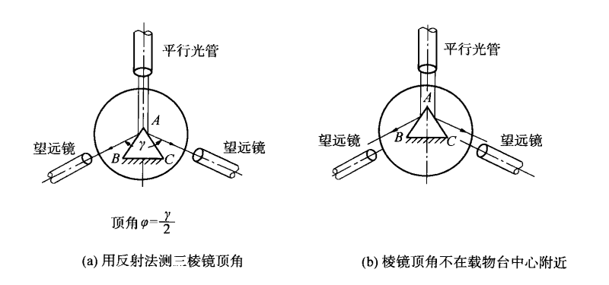

Figure 11

1. **Data processing**

|  |  |  |  |  |  |  |  |
| --- | --- | --- | --- | --- | --- | --- | --- |
| Measurement time k | Refracted light position | | Location of incident light | | $$θ_{0}$$ | $$n_{i}$$ | $$\overline{n}$$ |
| $$α_{1}$$ (left) | $${α_{1}}^{'}$$ (right) | $$α_{2}$$ (left) | $${α_{2}}^{'}$$ (right) |
| 1 | $$40°06'$$ | $$220°07'$$ | $$87°36'$$ | $$267°39'$$ | $$47°31'$$ | $$1.6131$$ | $$1.6114$$ |
| 2 | $$38°01'$$ | $$218°$$ | $$85°10'$$ | $$265°12'$$ | $$47°{10}^{'}30''$$ | $$1.6095$$ |
| 3 | $$31°20'$$ | $$211°21'$$ | $$78°40'$$ | $$258°36'$$ | $$47°{17}^{'}30''$$ | $$1.6107$$ |
| 4 | $$33°30'$$ | $$213°30'$$ | $$80°55'$$ | $$260°53'$$ | $$47°24'$$ | $$1.6119$$ |
| 5 | $$26°11'$$ | $$206°11'$$ | $$73°37'$$ | $$253°40'$$ | $$47°{27}^{'}30''$$ | $$1.6125$$ |
| 6 | $$20°55'$$ | $$200°56'$$ | $$67°40'$$ | $$247°40'$$ | $$47°{15}^{'}30''$$ | $$1.6104$$ |

For the measured $α_{1}$， ${α_{1}}^{'}$， $α_{2}$， ${α_{2}}^{'}$, we have:

$$θ_{0}= \frac{\left|α_{1}- α_{2}\right|+\left|{α_{1}}^{'}- {α_{2}}^{'}\right| }{2}$$

Calculated 6 sets of data $θ_{0}$ which is shown in the table shown in column $θ_{0}$. The vertex angle of a known prism $φ=60°0^{'}±5'$, including:

$$n= \frac{\sin{\frac{1}{2}(φ+θ_{0}) }}{\sin{\frac{φ}{2}}}$$

Calculate the $n$ of the 6 sets of data as shown in the table.

For six sets of data $n_{i}$. There are:

$$\overline{n}= \sum_{i=1}^{6}{n_{i}}=1.6114$$

Calculate the variance of the data:

$${σ_{n}}^{2}= \sum_{i=1}^{6}{{\left(\overline{n}- n_{i}\right)}^{2} }=9.61 ×{10}^{-6}$$

We can see that the variance of the whole data set is small, so that the data is all available for the later calculating.

Among them:

$$σ_{\overline{n}}= \sqrt{\frac{\sum_{i=1}^{k}{{\left(\overline{n}- n_{i}\right)}^{2}}}{k\left(k-1\right)}}= \sqrt{\frac{\sum_{i=1}^{6}{{\left(\overline{n}- n_{i}\right)}^{2}}}{6\left(6-1\right)}}=5.6125 ×{10}^{-4}$$

Then:

$$n=\overline{n} ±σ_{\overline{n}}= 1.6114 ± 0.0006$$

1. **Conclusion and analysis**

**Conclusion:**

The refractive index of the prism is $1.6114 ± 0.0006$, the error of the data measuring is small, so that less data processing is needed.

**Analysis:**

Systematic error:

In the case of a spectroscope, systematic errors could arise from issues such as the calibration of the instrument or the alignment of the optical components. For example, if the calibration of the spectroscope is incorrect, all the measurements taken with it will be systematically off by a certain amount.

Accidental error:

These errors can be caused by external factors such as changes in temperature, vibration, or electromagnetic interference, or by limitations in the precision of the measurement instruments. In the case of a spectroscope, accidental errors could arise from factors such as fluctuations in the intensity of the light source or from noise in the detectors used to measure the spectra.

1. **Appendix**

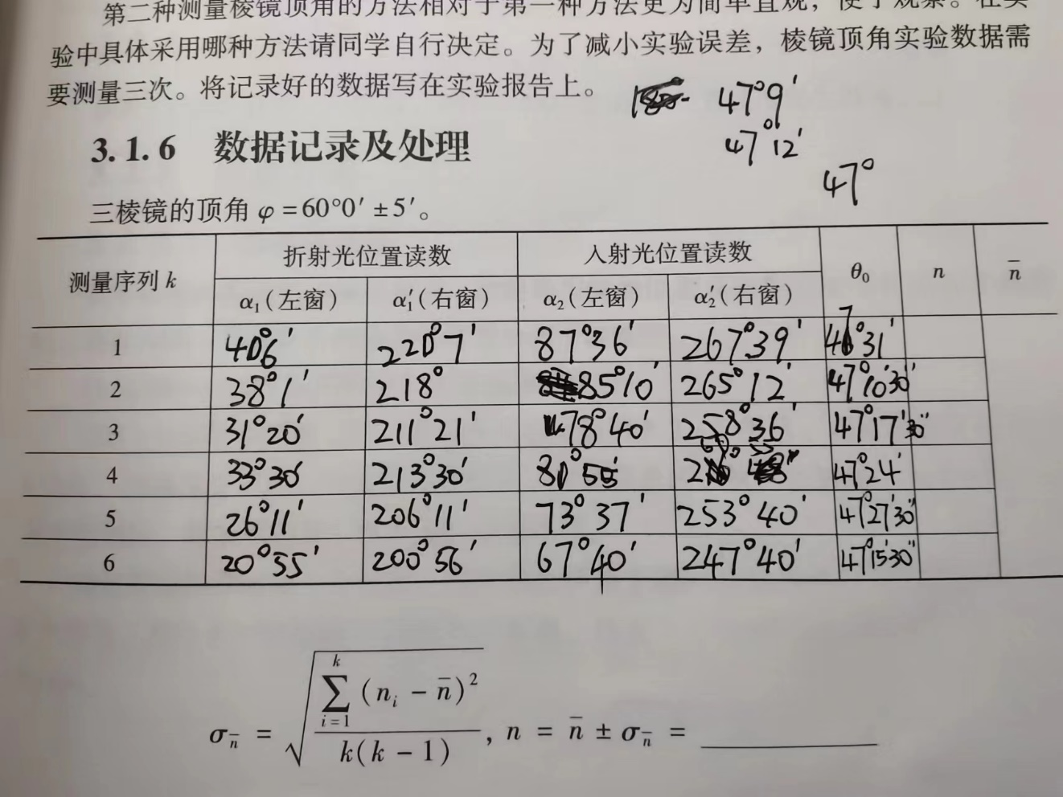

Figure 12 The deviation angle of the triangular prism (Original Data)