**Experiment on Measurement of Weak Vibration with Double Grating**

2022级 人工智能 ZYH

**Abstract**

During the propagation of electromagnetic waves, the phenomenon that the frequency of the light wave received by the receiver is different from the frequency of the light wave emitted by the source due to the relative movement between the light source and the receiver is called the Doppler effect, and the resulting frequency change is called the Doppler shift. If the moving grating moves relative to the stationary grating, so that the laser beam can produce the Doppler effect of light through such double gratings, the frequency shifted and non-frequency shifted two beams of light can be directly stacked in parallel to obtain the light beat, and then through the photoelectric square law detector detection, the differential frequency signal can be taken out to accurately measure the displacement of weak vibration.

The physical characteristics of Doppler frequency shift are also widely used, such as medical ultrasound diagnostic instruments, measuring the velocity and direction of ocean currents at various depths of seawater, satellite navigation and positioning systems, and tuning instruments.

The dual grating weak vibration measuring instrument is used in mechanical experimental projects for tuning fork vibration analysis, weak amplitude (displacement) measurement, and light beat research.

1. **Objectives**

1. Understand the principle of using the Doppler frequency shift of light to form a optical beat and use it to measure the frequency of optical beats.

2. Learn to use a method of accurately measuring weak vibration displacement.

1. **Experiment Equipment**

Laser source, signal generator, frequency meter (integrated in the measurement instrument box)

1. **Experiment Principles**

**Doppler frequency shift of mobile optical phase grating**

The so-called phase objects refer to transparent bodies with only spatial phase structures and the same transparency, such as biological slices, oil films, thermoplastics, etc., which only change the phase of incident light without affecting its amplitude. When the laser plane wave is vertically incident on the phase grating, due to the phase delay effect of different light density and light sparse media on the phase grating, the incident plane wave becomes a folded wave front when it is emitted, as shown in Figure 1.

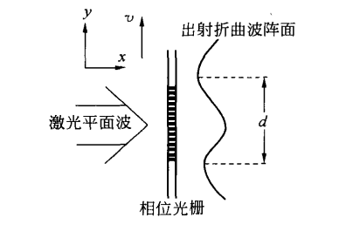

Figure 1

Due to the diffraction effect of a single slit on the grating and the interference between the slits, the intensity of light undergoes periodic changes after passing through the grating. In the far field, the well-known grating diffraction equation can be used to represent the principal maximum position:

$$dsinθ= ±kλ k=0,1,2,⋯$$

In the formula, the integer $k$ is the main maximum series, and $d$ is the grating constant, $θ$ Is the diffraction angle, $λ$ Is the wavelength of the light wave.

If the grating moves at the speed v in the y direction, the Wavefront of the light emitted from the grating also moves at the speed v in the y direction. Therefore, at different times, for diffraction of the same order, when it exits the grating, there is also a displacement of vt in the y-direction, as shown in Figure 2.

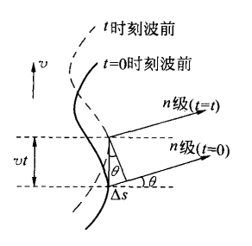

Figure 2

This displacement corresponds to the change in phase of the emitted light wave, which is $∆ϕ(t)$:

$$∆ϕ\left(t\right)= \frac{2π}{λ}∆s=\frac{2π}{λ}vtsinθ$$

Substituting the above formula into:

$$∆ϕ\left(t\right)=\frac{2π}{λ}vt\frac{kλ}{d}=k∙2π\frac{v}{d}t=kω_{d}t$$

Where $ω_{d}=2π\frac{v}{d}$.

If the laser is emitted from a stationary grating, the optical wave electric vector equation is:

$$E= E_{0}\cos{ω_{0}t}$$

When the laser is emitted from the corresponding moving grating, the optical wave electric vector equation is:

$$E= E_{0}\cos\left[ω_{0}t+∆ϕ\left(t\right) \right] =E_{0}\cos\left[\left(ω_{0}+kω_{d}\right)t \right]$$

It is obvious that the moving phase grating has a Doppler frequency shift in the k-order diffraction light wave relative to the stationary phase grating, with a frequency:

$$ω_{D}= ω_{0}+kω_{d}$$

As shown in Figure 3.

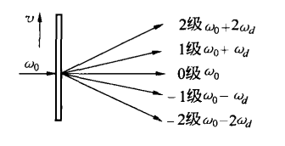

Figure 3

**Acquisition and Detection of Optical Beats**

The frequency of light is very high. In order to detect the Doppler shift in the frequency of light, the "beat" method must be used, which means that the frequency shifted and non-frequency shifted beams must be overlapped parallel to each other to form a optical beat. Due to the low beat frequency, it is easy to measure, and the Doppler frequency shift can be detected through the beat frequency.

The method of forming a light beat in this experiment is to use two identical gratings that are parallel and tightly attached, with one $B$ stationary and the other $A$ moving relative. The diffracted light formed by the laser passing through a double grating is the parallel superposition of two or more types of beams. The Doppler frequency shift of the k-th diffraction light wave formed by it is shown in Figure 4.

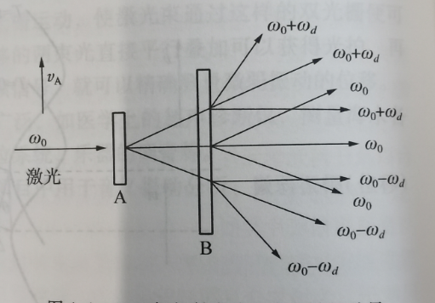

Figure 4

Raster A moves at speed $v_{A}$ and acts as a frequency shift, while grating $B$ remains stationary and only acts as a diffraction. Therefore, the diffracted light emitted through the double gratings contains two or more parallel beams with different frequency components. Due to the tight fitting of the double gratings, the laser has a certain width, and the grating constant $d$ is much larger than the wavelength of the light wave $λ$. So the beams of the same row of light spots can be stacked in parallel, forming a light beat directly and simply, as shown in Figure 5.

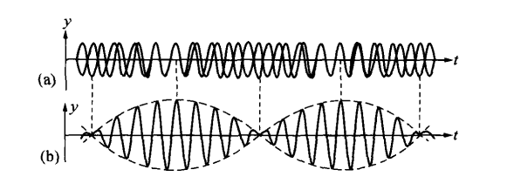

Figure 5

When the laser passes through the double grating to form a optical beat signal, the optical beat signal enters the photodetector and its output current can be obtained from the following relationship:

Let the electric vector of beam 1 be:

$$E_{1}= E_{10}\cos{(ω_{0}t+φ_{1})}$$

The electric vector of beam 2 be:

$$E_{2}= E_{20}cos⁡[\left(ω_{0}+ω_{d}\right)t+φ_{2}]$$

If $k=1$, then photocurrent:

$$I= ξ{\left(E_{1}+E_{2}\right)}^{2} \\ =ξ\{{E_{10}}^{2}\cos^{2}\left(ω_{0}t+φ_{1}\right)+ {E_{20}}^{2}\cos^{2}\left[\left(ω_{0}+ω_{d}\right)t+φ_{2}\right]+ \\ E_{10}E_{20}\cos\left[\left(ω_{0}+ω_{d}- ω_{0}\right)t+\left(φ_{2}- φ_{1}\right)\right]+ \\ E_{10}E_{20}\cos\left[\left(ω_{0}+ω_{d}+ ω_{0}\right)t+\left(φ_{2}+ φ_{1}\right)\right]\}$$

among them $ξ$ is the photoelectric conversion constant.

Due to the frequency of light waves $ω_{0}$ is very high, and in the first, second, and fourth terms of the equation, the photodetector cannot react. The third term of the equation is the beat frequency signal, because the frequency is low, the photodetector can respond accordingly, and its photocurrent is:

$$i_{s}=ξ\{ E_{10}E_{20}\cos\left[ω_{d}t+\left(φ_{2}- φ_{1}\right)\right]\}$$

Therefore, the frequency of the light beat signal that the photodetector can detect is the beat frequency $F_{beat}$:

$$F_{beat}= \frac{ω_{d}}{2π}= \frac{v_{A}}{d}=v_{A}n_{θ}$$

Among them, $n_{θ}= \frac{1}{d}$ is the grating density, and in this experiment, $n_{θ}=100 pieces/mm$.

**Detection of weak vibration displacement**

From the above equation, it can be seen that $F_{beat}$ and light frequency $ω_{0}$ is independent, and when the grating density $n_{θ}$ is a constant, it is only proportional to the grating movement speed $v_{A}$. If the grating is glued to the tuning fork, then $v_{A}$ is periodically changing. So, the frequency of the light beat signal $F_{beat}$ also changes over time. The displacement amplitude of weak vibration is:

$$A= \frac{1}{2}\int_{0}^{\frac{T}{2}}{v\left(t\right)}dt= \frac{1}{2}\int_{0}^{\frac{T}{2}}{\frac{F_{拍}(t)}{n_{θ}}}dt= \frac{1}{2n_{θ}}\int_{0}^{\frac{T}{2}}{F_{拍}(t)}dt$$

In the formula, $T$ is the vibration period of the tuning fork, and $\int_{0}^{\frac{T}{2}}{F_{beat}(t)}dt$ represents the waveform number of the beat wave within $\frac{T}{2}$ time. So as long as the waveform number of the beat wave is measured, the displacement amplitude of the weaker vibration can be obtained.

The waveform number consists of three parts: the complete waveform number, the first number of waves, and the last number of waves. According to the calculation displayed on the oscilloscope, it is:

$$Waveform count=integer waveform count + \frac{a}{l}+ \frac{b}{l}$$

In the formula, a and b are the lengths of the head and tail of the wave group, respectively; L is the average length of a complete waveform.

1. **Content Steps**

(1) Connect the $Y_{1}$, $Y_{2}$ and $X$ external triggers of the oscilloscope to the output sockets of the dual grating weak vibration measuring instrument, and turn on their respective power supplies.

(2) First, set the "Power" knob to 30mW, adjust the frequency to around 508Hz, set the accuracy value to 0.01Hz, and then fine tune the frequency to make the tuning fork resonant. When adjusting, the ear can listen and find the direction of adjustment. Find the value that allows the tuning fork to display the maximum number of beats within $\frac{T}{2}$. Record the vibration frequency of the tuning fork at this time, the number of complete waves on the screen, the first and last values of less than one complete waveform, and the amplitude value of the corresponding complete waveform.

(3) Measure the resonance curve of the tuning fork when driven by external force. Fix the driving power of the tuning fork, carefully adjust the frequency near the resonance point of the tuning fork, measure the vibration frequency of the tuning fork and the corresponding signal amplitude. The frequency interval can be taken as 0.1Hz, select 8 points, and measure the corresponding number of waves. Using the above formula, calculate the respective amplitude A.

(4) Make the tuning fork vibrate at the resonant frequency, adjust the signal output power, measure and calculate the vibration amplitude of the tuning fork under the action of each signal output power, and measure the relationship between the tuning fork power and the vibration amplitude of the tuning fork.

Attention:

(1) The laser power is generally adjusted to the middle and does not need to be adjusted frequently.

(2) It is best to wait for the waveform to stabilize before counting the number of beat waves on the oscilloscope fluorescent screen.

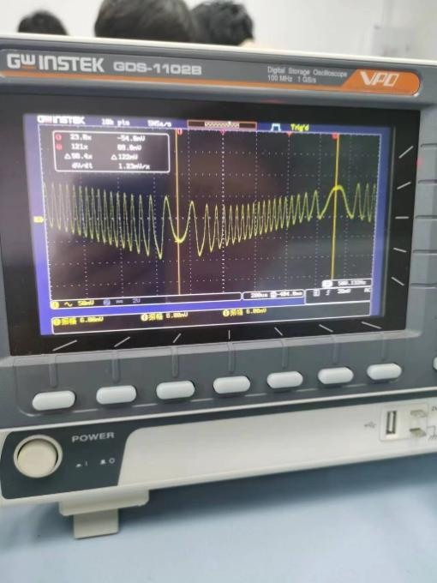

Figure 6

1. **Data processing**

In the experiment, we selected the tuning fork resonance frequency f=508.17Hz, and the maximum number of waveforms observed at this time is 20.

When $I=20.0mA$, the amplitude changes with frequency data:

|  |  |  |  |  |  |  |  |
| --- | --- | --- | --- | --- | --- | --- | --- |
| Frequency | 507.87 | 507.97 | 508.07 | 508.17 | 508.27 | 508.37 | 508.47 |
| Waveform number | 6 | 11 | 20 | 20 | 9 | 6 | 4 |
| Amplitude | 0.03 | 0.055 | 0.1 | 0.1 | 0.045 | 0.03 | 0.02 |

Draw the data into a coordinate graph and obtain the following results:

We found that the amplitude obtained at the resonant frequency of the tuning fork $f=508.17Hz$ is not the maximum value, and the number of waveforms of $f=508.17Hz$ and $f=508.07Hz$ in the data table is the same. It can be seen that there is a certain measurement error here. Tuning fork resonance frequency $f≠508.17Hz$. The resonant frequency of the tuning fork should be reasonably in $f∈\left(508.07Hz, 508.17Hz\right)$.

Data on the relationship between tuning fork power and amplitude at frequency f=508.17Hz:

|  |  |  |  |  |  |  |  |  |  |  |
| --- | --- | --- | --- | --- | --- | --- | --- | --- | --- | --- |
| Power/mA | 10 | 20 | 30 | 40 | 50 | 60 | 70 | 80 | 90 | 100 |
| Waveform number | 5 | 8 | 11 | 13 | 15 | 17 | 18 | 20 | 22 | 25 |
| Amplitude/mm | 0.025 | 0.04 | 0.055 | 0.065 | 0.075 | 0.085 | 0.09 | 0.1 | 0.11 | 0.125 |

Draw the data into a coordinate graph and obtain the following results:

From $R^{2}=0.9884$, it can be seen that there is a significant linear correlation between the amplitude of the tuning fork and the power of the tuning fork.

1. **Conclusion and analysis**

**Conclusion:**

1. When the frequency is close to the resonance frequency, the amplitude significantly increases, and the amplitude near the resonance frequency is much greater than that at other frequencies.

2. The amplitude is positively correlated with the power path, and the amplitude increases with the increase of power.

**Error analysis:**

In the given data, the amplitude at 508.17Hz is 0.1, which is not the only maximum amplitude compared to other frequencies. Possible reasons include the following:

1. Measurement error: Possible error when measuring amplitude. This may be due to accuracy limitations of measuring equipment or technical errors by operators. If possible, repeated measurements can be made to verify the consistency of the results.

2. Data collection error: Possible errors when collecting data. This may involve the accuracy of data recording or discontinuous waveform changes near a specific frequency.

3. Instrument response: The response of measuring equipment may be affected by frequency characteristics, and therefore may exhibit lower amplitudes at certain frequencies. This requires consideration of the characteristics and frequency response curves of the measuring equipment.

4. Environmental interference: In actual measurements, there may be interference from the environment, such as vibration or electromagnetic interference. These interferences may affect the measurement results of amplitude.

According to the frequency variation chart data, we can see that the amplitude is 0.1 at a frequency of 508.17Hz. However, in the data on the relationship between tuning fork power and amplitude, the waveform number at 508.17Hz is 13, corresponding to an amplitude of 0.065, not 0.1 in the frequency variation graph. This inconsistency may be due to one of the following reasons:

1. Differences in experimental conditions: During the two sets of data collection processes, there may be differences in experimental conditions, such as different measurement equipment, environmental conditions, or technical differences among operators. These differences may lead to inconsistent measurement results.

2. Measurement error: Errors in measuring amplitude and power may also lead to inconsistencies. The accuracy limit of measuring equipment, Personal equation or other Confounding may affect the results.

3. Limitations of data sampling: Both sets of data are limited sample datasets and may not fully reflect the behavior of the entire system. More data collection and repeated experiments may provide more accurate results.

1. **Reflection Questions**

**1. What would be the result if the dynamic and static gratings were transposed with each other? Why?**

If the moving grating and the static grating are transposed with each other, that is, their positions are exchanged in the experiment, it will result in the following results:

1. Direction of grain movement: The direction of grain movement between the moving grating and the static grating will change. In the original configuration, the dynamic grating is vibrating, while the static grating is fixed, so the movement of the pattern is caused by the dynamic grating. However, if transposed, the vibration effect will appear on the static grating, while the dynamic grating will remain stationary. Therefore, the movement direction of the pattern will be opposite to the original configuration.

2. Intensity change: The displacement of the grating may cause a change in the intensity of the interference mode. In the original configuration, the vibration of the moving grating may affect the interference mode of light, while transposing it to the stationary grating may cause changes in the interference effect, as the interference effect of light is related to the position and vibration of the grating.

3. Frequency change: After transposition, it may have an impact on the frequency of vibration. In the original configuration, the quality and inherent characteristics of the moving grating determine the frequency of vibration, but after transposition, the properties of the static grating will have an impact on the frequency of vibration.

**2. If there are burrs in the beat frequency waveform, it is a high octave beat frequency. So, do we need to include the number of waveforms with high octave frequencies?**

If burrs are observed in the beat frequency waveform, it usually indicates the presence of high octave beat frequency. High octave beat frequency refers to the existence of a large integer multiple relationship between frequencies, such as 2nd octave, 3rd octave, etc. When there is a high octave beat frequency, you can choose to include or exclude the waveform number of the high octave frequency, depending on the purpose of the analysis and the needs of the research. The following are two common processing methods:

1. Calculate the waveform number of high octave frequency: If you are interested in or have special significance in the research of high octave frequency beat frequency, you can include the waveform number of high octave frequency. This means that when collecting and analyzing data, the number of high octave waveforms will be included, and their impact on the beat frequency phenomenon will be considered.

2. Exclude the number of waveforms with high frequency multiplication: If the research pays more attention to the fundamental frequency beat (that is, the beat with the lowest frequency), or believes that the high frequency beat may be noise or interference signals, you can choose to exclude the number of waveforms with high frequency multiplication. This can focus more on the characteristics and behavior of the fundamental beat frequency.

**3. What are the advantages of the measurement method in this experiment? What is the sensitivity of measuring micro vibration displacement?**

The advantages of the measurement method in this experiment include:

1. Non-contact measurement: The double grating interferometry can measure without touching the measured object, and is suitable for situations where the integrity of the object needs to be maintained or direct contact is not possible.

2. High precision: The double grating interferometry has high measurement accuracy and can achieve displacement measurement at the micron or even submicron level.

3. Wide dynamic range: This method can be applied to a large range of vibration frequencies and amplitudes, and is suitable for vibration measurements of different scales and frequencies.

4. Real time measurement: Double grating interferometry can monitor and record changes in vibration in real time, which has advantages in studying dynamic processes. The displacement measurement sensitivity of the double grating interferometry can reach the submicron level.

**4. What is the difference between the amplitude calculated using waveform numbers in the experiment and the amplitude displayed on the oscilloscope?**

In the experiment, we recorded the oscilloscope amplitudes of two experiments, as shown in the following figure.

When $I=20.0mA$, the amplitude and the variation data of the oscilloscope amplitude with frequency:

|  |  |  |  |  |  |  |  |
| --- | --- | --- | --- | --- | --- | --- | --- |
| Frequency | 507.87 | 507.97 | 508.07 | 508.17 | 508.27 | 508.37 | 508.47 |
| Waveform number | 6 | 11 | 20 | 20 | 9 | 6 | 4 |
| Amplitude | 0.03 | 0.055 | 0.1 | 0.1 | 0.045 | 0.03 | 0.02 |
| Oscilloscope amplitude | 92 | 130 | 30 | 122 | 144 | 102 | 86 |

At frequency $f=508.17Hz$, the relationship between tuning fork power and amplitude, as well as oscilloscope amplitude data:

|  |  |  |  |  |  |  |  |  |  |  |
| --- | --- | --- | --- | --- | --- | --- | --- | --- | --- | --- |
| Power/mA | 10 | 20 | 30 | 40 | 50 | 60 | 70 | 80 | 90 | 100 |
| Waveform number | 5 | 8 | 11 | 13 | 15 | 17 | 18 | 20 | 22 | 25 |
| Amplitude/mm | 0.025 | 0.04 | 0.055 | 0.065 | 0.075 | 0.085 | 0.09 | 0.1 | 0.11 | 0.125 |
| Oscilloscope amplitude | 40 | 100 | 60 | 30 | 34 | 16 | 20 | 14 | 36 | 40 |

It can be observed that there is no significant correlation between the amplitude of the oscilloscope and the calculated amplitude, and there is no obvious linear correlation. During the experiment, it was found that the amplitude of the oscilloscope changes significantly, continuously changing with the surrounding environment. Therefore, the recorded data has a large error range and cannot be used as a basis for judgment.

**Reason analysis:**

In the experiment, there may be some differences between the amplitude calculated by the number of waveforms and the amplitude displayed on the oscilloscope:

1. Calculation method: The amplitude displayed on the oscilloscope is directly obtained by measuring and displaying voltage, while the amplitude calculated by the number of waveforms is estimated based on the periodicity of the signal and the number of waveforms.

2. Accuracy and error: The amplitude displayed on the oscilloscope usually has high measurement accuracy and accuracy, which is affected by the performance and calibration of the oscilloscope itself. The amplitude calculated through waveform numbers may be affected by errors in experimental settings, measurement methods, and data processing, and may have some uncertainty.

3. Dynamic range: The dynamic range (range) of the oscilloscope determines the maximum amplitude range that can be measured. The amplitude displayed on the oscilloscope is limited by the range of the oscilloscope, and the amplitude calculated by the number of waveforms may not have such limitations because it is estimated based on the periodicity of the signal.

4. Waveform characteristics: The amplitude displayed on the oscilloscope can provide more detailed waveform characteristics, such as amplitude changes, peaks, peak to peak, etc. The amplitude calculated by the number of waveforms usually only provides an estimated value and may not provide the same detailed information.

Therefore, in order to ensure accuracy and reliability, it is best to use the measurement results of the oscilloscope as the main reference, especially in experiments that require high precision and accuracy. The amplitude calculated by the number of waveforms can serve as supplementary information, but its relatively low accuracy and limitations need to be considered.