**Frank Hertz experiment**

2022级 人工智能 ZYH

**Abstract**

In 1913, Danish physicist Bohr put forward the concept of atomic energy level and established the atomic model theory on the basis of Ernest Rutherford's nuclear model and Planck's quantum theory, which successfully explained the stability of atoms and the linear spectrum of atoms. This theory states that atoms do not radiate energy when they are in a stable state, and only radiate energy when they transition from a high-energy state (energy $E_{m}$) to a low-energy state (energy $E$). The radiation energy satisfies $∆E= E_{m}- E_{n}$. For the energy provided by the outside world, atoms only absorb and transition when the energy level difference for atomic transitions to the high-energy level is met, otherwise they will not absorb.

In 1914, German physicists Frank and Hertz tested the first excitation potential of mercury atoms using slow electrons passing through mercury vapor, thereby proving the existence of atomic discrete energy states. Later, they observed the light emitted by the excited atoms in the experiment when they returned to their normal state, and the frequency of the radiation light measured well met the Bohr theory. The results of the Frank Hertz experiment provide direct evidence for the Bohr theory. Bohr won the Nobel Prize in Physics in 1922 for his atomic model theory, and Frank and Hertz's experiment also won the Nobel Prize in Physics in 1925.

1. **Objectives**
2. Learn to measure the first excitation potential of atoms and obtain methods.
3. Verify the existence of atomic energy levels through experiments.
4. Study the factors that affect the anode current of gas-filled electron tubes and analyze their mechanisms
5. **Experiment Equipment**

Electronic tube comprehensive experimental instrument.

1. **Experiment Principles**

According to Bohr's atomic theory, atoms can only stay in some stable states for a long time, referred to as "stationary states". When atoms are in a stationary state, they neither emit nor absorb energy. The energy of each stationary state is discrete, meaning that they are at different energies. Atoms can only receive or radiate energy equivalent to the difference between energy levels. When an atom transitions from one stationary state to another, energy is emitted or absorbed, and the frequency of the emitted or absorbed energy radiation is also a certain value. The radiation frequency $v$ is determined by $hv = ∆E = E_{m}-E_{n}$. H is the Planck constant. There are:

$$v =\frac{E_{m}- E_{n}}{h}$$

To change the atomic state, an external energy must act on the atom, bombarding it to obtain energy and generate a transition. The Frank Hertz experiment is achieved by accelerating electrons and exchanging energy between electrons with a certain energy and atoms to achieve a change in atomic energy state.

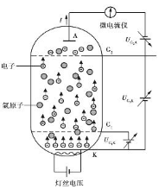

Figure 1: Schematic diagram of Franck Hertz experiment

In an electron tube filled with argon gas, $K$ is the cathode, $A$ is the anode, and $G_{1}$. $G_{2}$ are the first and second gates, respectively. Apply a forward voltage between Cathode $K$, gate $G_{1}$, Gate $G_{2}$ to provide energy for the electrons. The main function of $V_{G_{1}k}$ is to eliminate the influence of space charge on cathode electron emission and improve emission efficiency. Apply reverse voltage $V_{G_{2}A}$ between anode $A$ and Gate $G_{2}$, forming a repulsive electric field. Electrons are emitted from the hot cathode $K$ and obtained energy in interval $K$- $G_{2}$, and loss energy in the $G_{2}$- $A$ range. If electrons enter $G_{2}$– $A$ and the kinetic energy is greater than or equal to $eV_{G_{2}A}$, it can reach the anode to form anode current $I_{A}$.

The situation of electrons in different intervals:

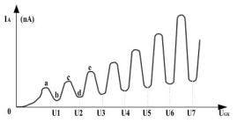

Figure 2: Situation of electrons in different intervals

At $K$- $G_{1}$ range, electrons are rapidly accelerated by an electric field to obtain energy; In $G_{1}$- $G_{2}$ range, electrons continue to obtain energy from the electric field and continuously collide with argon atoms. When its energy is less than the energy level difference between the first excited state and the ground state of argon atom $∆E =E_{2}- E_{1}$, argon atoms do not absorb the energy of electrons, and collisions belong to elastic collisions; When the kinetic energy of the electron reaches $∆E$, it may be absorbed by argon atoms in the collision, and the collision at this time belongs to inelastic collision. $∆E$ is called critical energy. In $G_{2}$– $A$ range, electrons overcome repulsive electric field forces and lose energy by doing work. If the kinetic energy of the electron entering this range is less than $eV_{G_{2}A}$, it cannot reach the anode.

From this, it can be seen that electrons pass from $K$ to $G_{2}$ accelerations, if $eV_{G_{2}K}<∆E$, then the electron carries the energy of $eV_{G_{2}A}$ to enter $G_{2}$– $A$. With the increase of $eV_{G_{2}K}$, more and more electrons have sufficient energy to overcome the repulsive electric field and reach the anode. The current $I_{A}$ increases (as shown in paragraph ab in Figure 2).

If $eV_{G_{2}K}$ = $∆E$, as $V_{G_{2}K}$ increases, the probability of electron energy being absorbed $∆E$ by argon atoms gradually increases. The remaining kinetic energy cannot overcome the repulsion voltage, and the anode current gradually decreases (as shown in section ab in Figure 2). Continue to increase $V_{G_{2}K}$, the remaining energy after electron collision also increases, and the number of electrons reaching the anode gradually increases (as shown in the bc segment in Figure 2).

If $eV_{G_{2}K}>n∆E$, then electrons enter $G_{2}$- $A$ region may have lost energy due to $n$ collisions with argon atoms before. Anode current $I_{A}$ with acceleration voltage $V_{G_{2}K}$ variation curve forms $n$ peaks, as shown in Figure 4.11-2. Where:

$$v_{G_{2}K}=nV_{0}$$

The anode current will decrease accordingly. The voltage difference $V$ between adjacent peaks is called the first excitation potential of the argon atom. Energy level difference between the first excited state and ground state of argon atom:

$$∆E=eV_{0}$$

1. **Content Steps**

Measure the first excitation potential of an atom (using argon atom as an example). Through $I_{A}$- $V_{G_{2}K}$ curve, observe the atomic energy quantization, and calculate the first excitation potential of argon atom.

The Frank Hertz experimental module of this electronic tube comprehensive experimental instrument is divided into two modes: automatic and manual. The experimental data obtained in automatic mode can be reproduced on the oscilloscope after being connected to $I_{A}$- $V_{G_{2}K}$ curve. Attention: Please refer to the parameter table on the black box for setting the parameters of the Frank Hertz experiment, and do not exceed the range. Due to aging during the use of Frank Hertz tubes, the optimal state of each tube may change. Experienced users can refer to the original parameters and reset the label parameters within the following range:

Filament voltage: $DC 0-6.3V$

First gate voltage: $V_{G_{1}K} :DC 0-5V$

Second gate voltage: $V_{G_{2}K} :DC0-85V$

Rejection voltage: $V_{G_{2}A}:DC0-12V$

**Measurement of atomic first excitation potential in automatic mode**

① Connect the experimental circuit according to Figure 1 and turn on the power.

② After the host is started, click on the "first column on the left" in the Frank Hertz experiment main menu to set the parameters, and set the following parameters: filament voltage $V_{f} ≈2.3V$, first gate voltage $V_{G_{1}K} ≈1.5V$, rejection voltage $V_{G_{2}A} ≈8.5V$.

③ Preheat for 3 minutes, click on "Automatic Mode $V_{G_{2}K}$". In the Frank Hertz experiment main menu to start the "Automatic Mode" experiment. The instrument controls $V$ from 0 to 85V and plots $I_{A} -V_{G_{2}K}$ curve at a step of 0.2V and save the experimental data.

④ Pay attention to the shape of the curve on the screen. If the curve peaks, the filament voltage $V_{f}$ should be appropriately reduced; If the grain is cut, the rejection voltage $V_{G_{2}A}$ should be appropriately reduced. Start over until I draw an I that includes 6 intact peaks and valleys $I_{A} -V_{G_{2}K}$ curve.

⑤ In the main menu of the Frank Hertz experiment, click on "Next" on the right to query the data. List the latest automatic mode measurement data on the screen, find each peak and valley value of the current in the data list, and record the rejection voltage $V_{G_{2}K}$ corresponding to the extreme current and fill it in Table.

**Study the effect of each voltage on $I_{A} -V_{G_{2}K}$ Curve**

The influence of rejection voltage $V_{G_{2}A}$:

1. Setting the filament voltage $V_{f} \sim 2.3V$, first gate voltage $V_{G_{1}K} \sim 1.5V$, rejection voltage $V_{G_{2}A} ≈8.0V$.
2. Enter automatic mode, click the "Automatic Mode $V_{G_{2}K}$" button to start drawing the curve
3. Draw the complete $I_{A} -V_{G_{2}K}$ curve, return data query, record the V corresponding to each peak and valley’s $V_{G_{2}K}$ and fill in the table. Analyze the $V_{G_{2}K}$ corresponding to the peak and valley of the curve under different rejection voltages and find out what are the changes and patterns of them.

The influence of cathode filament voltage:

1. Set filament voltage $V_{f} \sim 2.2V$, first gate voltage $V_{G_{1}K} \sim 1.5V$, rejection voltage $V_{G_{2}A} ≈8.5V$.
2. Enter automatic mode, click the "Automatic Mode $V_{G_{2}K}$" button to start drawing the curve.
3. After drawing the complete curve, return to the data query and record the $V_{G_{2}K}$ corresponding to each peak and valley and fill in the table. Compare the difference between the initial image curve and analyze the effect of filament voltage $V_{f}$ on the curve.

The influence of the first gate voltage:

1. Set filament voltage $V_{f} \sim 2.3V$, first gate voltage $V_{G_{1}K} \sim 1.7V$, rejection voltage $V_{G_{2}A} ≈8.5V$.
2. Enter automatic mode and click the "Automatic Mode $V_{G_{2}K}$" button to start drawing the curve
3. After drawing the complete curve, return to the data query and record the $V_{G_{2}K}$ corresponding to each peak and valley and fill in the table. Compare the differences between the previously drawn curve and the newly drawn curve, and analyze the impact of different first gate voltages on the curve.

Precautions:

1. When connecting the circuit before the start of the experiment and unplugging the circuit after the experiment, do not touch the metal parts of the circuit to avoid high voltage causing harm to the body.

2. The filament voltage should not exceed 3V to avoid anode current exceeding the range.

1. **Data processing**

**Measure reference curve $I_{A} -V_{G_{2}K}$ in automatic mode**

In the process of measuring the reference curve in automatic mode, we chose to set the following parameters: filament voltage $V_{f} ≈2.3V$, first gate voltage $V_{G_{1}K} ≈1.5V$, rejection voltage $V_{G_{2}A} ≈8.5V$. After completing the automatic image drawing, we obtained the following images:

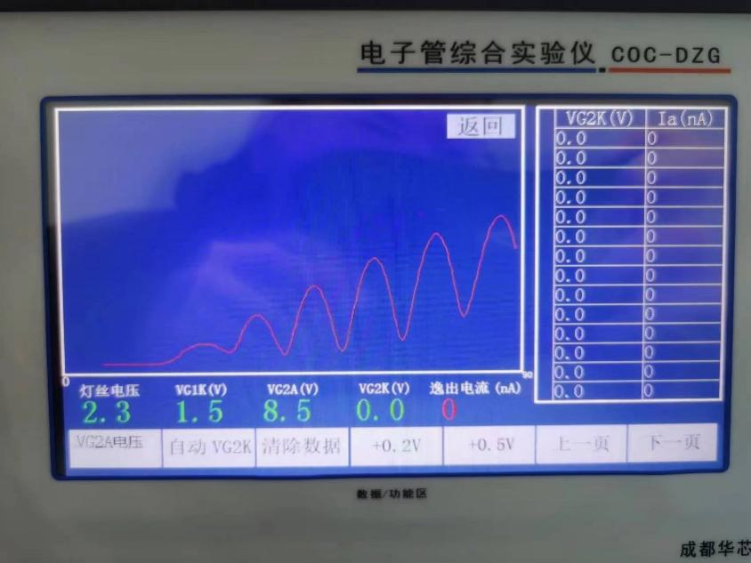

Figure 3

Record the $V_{G_{2}K}$ corresponding to each peak and valley, we obtained curve peak and valley voltage data of $I_{A} -V_{G_{2}K}$, which is shown in the table below:

|  |  |  |  |  |  |  |  |  |  |  |
| --- | --- | --- | --- | --- | --- | --- | --- | --- | --- | --- |
| Serial Number $i$ | 1 | 2 | 3 | 4 | 5 | 6 | $$V_{i+3}- V_{i} /V$$ | | | Average |
| Peak $V_{G_{2}K}/V$ | 20.6 | 30.8 | 42.1 | 54.0 | 66.2 | 79.0 | 33.4 | 35.4 | 36.9 | 35.23 |
| Trough $V_{G_{3}K}/V$ | 25.2 | 36.2 | 47.6 | 59.5 | 71.6 | None | 34.7 | 35.4 | None | 35.05 |

|  |  |  |  |  |  |  |  |  |  |  |  |  |
| --- | --- | --- | --- | --- | --- | --- | --- | --- | --- | --- | --- | --- |
|  | 1 | | 2 | | 3 | | 4 | | 5 | | 6 | |
| peak | trough | peak | trough | peak | trough | peak | trough | peak | trough | peak | trough |
| $$I_{A}/nA$$ | 79 | 44 | 196 | 37 | 308 | 44 | 420 | 92 | 514 | 186 | 586 |  |
| $$V_{G_{2}K}/V$$ | 20.6 | 25.2 | 30.8 | 36.2 | 42.1 | 47.6 | 54.0 | 59.5 | 66.2 | 71.6 | 79.0 |  |

Based on the above chart, we can obtain the following images:

Figure 4

Observing this image, we can observe 5 sets of peaks and valleys, and based on the horizontal coordinate distance between each set of peaks and valleys, it can be concluded that they exhibit periodic changes.

The average value of Peak $V_{G_{2}K}$ is 35.23V, while the average value of the valley $V_{G_{3}K}$ is 35.05V. These two averages are very close, indicating that there is no significant shift in the position of the peak and valley on the voltage difference. By calculating the ratio of $V(i+3) - V(i)$, it can be observed that the voltage interval between each peak and valley is relatively uniform. The average value is 36.9, indicating that the voltage difference between each group of peaks and valleys is relatively consistent. It was observed that the current value of the first valley was smaller than that of the second valley. This is because there was noise influence in the experiment, and it was found in the calculation that the distance between the first valley and other valleys was significantly different. It can be concluded that the cause of the first valley is noise influence.

**Study the impact of rejection voltage $V_{G_{2}A}$ on images $I_{A} -V_{G_{2}K}$**

In the experiment of studying the effect of rejection voltage $V_{G_{2}A}$ on images $I_{A} -V_{G_{2}K}$, we chose to set the filament voltage $V_{f} \sim 2.3V$, first gate voltage $V_{G_{1}K} \sim 1.5V$, rejection voltage $V_{G_{2}A} \sim 8.0V$, the rejection voltage will be reduced by 0.5V, and other parameters will not change.

After completing the automatic image drawing, we obtained the following images:

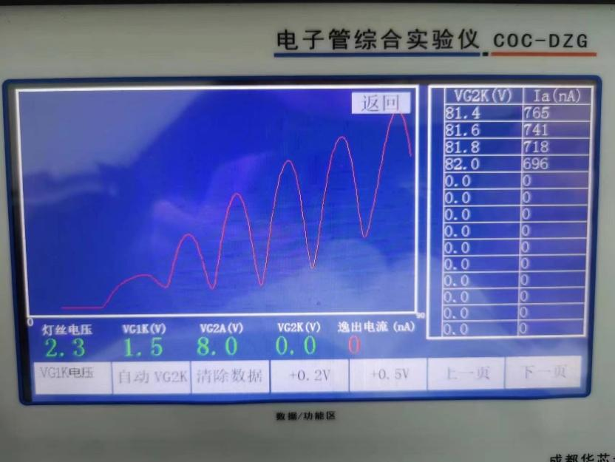

Figure 5

Record the $V_{G_{2}K}$ corresponding to each peak and valley, we obtained $I_{A} -V_{G_{2}K}$ curve peak and valley voltage data, which is shown in the table below:

|  |  |  |  |  |  |  |  |  |  |  |
| --- | --- | --- | --- | --- | --- | --- | --- | --- | --- | --- |
| Serial Number i | 1 | 2 | 3 | 4 | 5 | 6 | $$V_{i+3}- V_{i} /V$$ | | | Average |
| Peak $V_{G_{2}K}/V$ | 19.9 | 30.4 | 41.9 | 53.7 | 66.1 | 78.8 | 33.8 | 35.7 | 36.9 | 35.47 |
| Trough $V_{G_{3}K}/V$ | 24.8 | 35.7 | 47.1 | 59.0 | 71.2 | None | 34.2 | 35.5 | None | 34.85 |

|  |  |  |  |  |  |  |  |  |  |  |  |  |
| --- | --- | --- | --- | --- | --- | --- | --- | --- | --- | --- | --- | --- |
|  | 1 | | 2 | | 3 | | 4 | | 5 | | 6 | |
| peak | trough | peak | trough | peak | trough | peak | trough | peak | trough | peak | trough |
| $$I_{A}/nA$$ | 152 | 95 | 344 | 85 | 526 | 101 | 677 | 180 | 785 | 321 | 907 |  |
| $$V_{G_{2}K}/V$$ | 19.9 | 24.8 | 30.4 | 35.7 | 41.9 | 47.1 | 53.7 | 59.0 | 66.1 | 71.2 | 78.8 |  |

Based on the above chart, we can obtain the following images:

Figure 6

Observing the images of the second group of experiments, after reducing the rejection voltage by 0.5V compared to the reference state parameters, we found that the abscissa of each group of peaks and valleys slightly shifted to the left, which means the values of each group of peaks $V_{G_{2}K}$ decreased. Also, the images shifted significantly upwards compared to the reference state images, which means the current values of each group of peaks and valleys increased.

**Study the Influence of Cathode Filament Voltage on Images**

In the experiment of studying the effect of cathode filament voltage $V_{f}$ on images $I_{A} -V_{G_{2}K}$, we chose to set the filament voltage $V_{f} \sim 2.2V$, first gate voltage $V_{G_{1}K} \sim 1.5V$, rejection voltage $V_{G_{2}A} \sim 8.5V$, which means reducing the cathode filament voltage by 0.1V without changing other parameters. After completing the automatic image drawing, we obtained the following images:

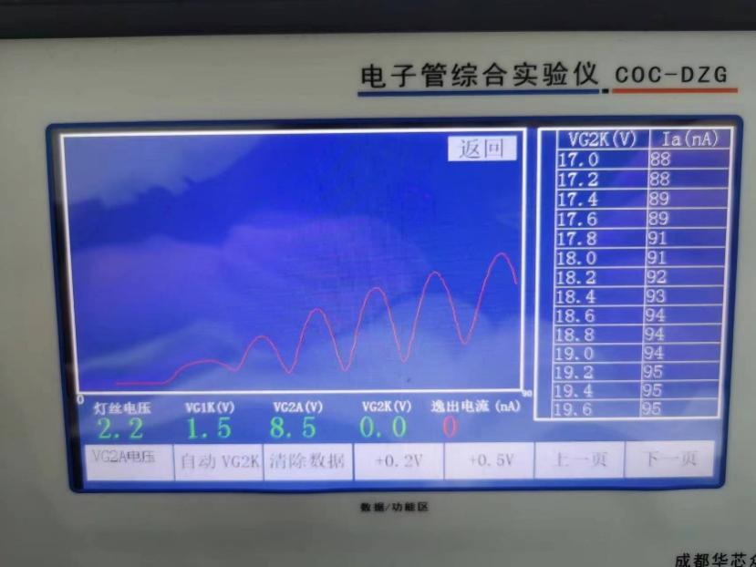

Figure 7

Record the $V_{G_{2}K}$ corresponding to each peak and valley, we obtained $I_{A} -V_{G_{2}K}$ curve peak and valley voltage data, as shown in the table below:

|  |  |  |  |  |  |  |  |  |  |  |
| --- | --- | --- | --- | --- | --- | --- | --- | --- | --- | --- |
| Serial Number i | 1 | 2 | 3 | 4 | 5 | 6 | $$V_{i+3}- V_{i} /V$$ | | | Average |
| Peak $V_{G_{2}K}/V$ | 19.7 | 30.6 | 42.0 | 54.0 | 65.6 | 78.9 | 34.3 | 35 | 36.9 | 35.4 |
| Trough $V_{G_{3}K}/V$ | 25.1 | 36.2 | 47.6 | 59.6 | 71.7 | None | 34.5 | 35.5 | None | 35 |

|  |  |  |  |  |  |  |  |  |  |  |  |  |
| --- | --- | --- | --- | --- | --- | --- | --- | --- | --- | --- | --- | --- |
|  | 1 | | 2 | | 3 | | 4 | | 5 | | 6 | |
| peak | trough | peak | trough | peak | trough | peak | trough | peak | trough | peak | trough |
| $$I_{A}/nA$$ | 95 | 53 | 196 | 41 | 302 | 45 | 387 | 84 | 449 | 157 | 521 |  |
| $$V_{G_{2}K}/V$$ | 19.7 | 25.1 | 30.6 | 36.2 | 42.0 | 47.6 | 54.0 | 59.6 | 65.6 | 71.7 | 78.9 |  |

Based on the above chart, we can obtain the following images:

Figure 8

Observing the images of the third group of experiments, we reduced the cathode filament voltage by 0.1V when other values remained unchanged compared to the reference state parameters. We found that the abscissa of each group of peaks and valleys shifted slightly to the left, that is, the $V_{G_{2}K}$ of each group of peaks decreases. Also, the image shifts downwards compared to the reference state image, meaning that the current values of each peak and valley decrease.

**Study the influence of the first gate voltage $V_{G_{1}K}$ on the image $I_{A} -V_{G_{2}K}$**

In the experiment of studying the effect of the first gate voltage on the image, we chose to set the filament voltage $V_{f} \sim 2.3V$, first gate voltage $V_{G_{1}K} \sim 1.7V$, rejection voltage $V_{G_{2}A} \sim 8.5V$, which means that the first gate voltage increases by 0.2V, and other parameters remain unchanged.

After completing the automatic image drawing, we obtained the following images:

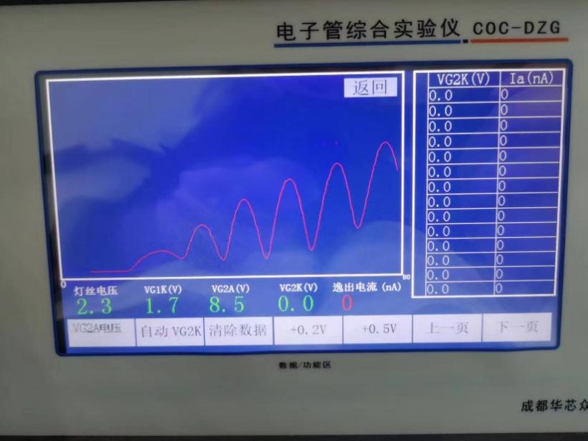

Figure 9

Record the $V_{G_{2}K}$ corresponding to each peak and valley, we obtained $I_{A} -V_{G_{2}K}$ curve peak and valley voltage data, as shown in the table below:

|  |  |  |  |  |  |  |  |  |  |  |
| --- | --- | --- | --- | --- | --- | --- | --- | --- | --- | --- |
| Serial Number i | 1 | 2 | 3 | 4 | 5 | 6 | $$V_{i+3}- V_{i} /V$$ | | | Average |
| Peak $V_{G_{2}K}/V$ | 20.0 | 30.7 | 42.0 | 54.0 | 66.3 | 78.9 | 34 | 35.6 | 36.9 | 35.5 |
| Trough $V_{G_{3}K}/V$ | 25.1 | 36 | 47.5 | 59.6 | 71.6 | None | 34.5 | 35.6 | None | 35．05 |

|  |  |  |  |  |  |  |  |  |  |  |  |  |
| --- | --- | --- | --- | --- | --- | --- | --- | --- | --- | --- | --- | --- |
|  | 1 | | 2 | | 3 | | 4 | | 5 | | 6 | |
| peak | trough | peak | trough | peak | trough | peak | trough | peak | trough | peak | trough |
| $$I_{A}/nA$$ | 110 | 63 | 246 | 51 | 374 | 56 | 480 | 99 | 557 | 210 | 661 |  |
| $$V_{G_{2}K}/V$$ | 20.0 | 25.1 | 30.7 | 36 | 42.0 | 47.5 | 54.0 | 59.6 | 66.3 | 71.6 | 78.9 |  |

Based on the above chart, we can obtain the following images:

Figure 10

Observing the images of the fourth group of experiments, we increased the first gate voltage by 0.2V when other values remained unchanged compared to the reference state parameters. We found that the horizontal coordinates of each group of peaks and valleys did not change much compared to the reference state horizontal coordinates, and we were unable to obtain an offset conclusion; The image moves upwards compared to the reference state image, meaning that the current values of each peak and valley increase.

1. **Conclusion and analysis**

**Conclusion:**

1. $I_{A} -V_{G_{2}K}$ curve shows periodic changes, and the voltage difference between each peak and valley is relatively consistent.
2. Reduce rejection voltage $V_{G_{2}A}$, the peak and valley $V_{G_{2}K}$ value decreases, $I_{A} -V_{G_{2}K}$ curve shifts to the left, and the current values of each peak and valley increase, causing the image to shift upwards compared to the reference state image.
3. Reduce cathode filament voltage $V_{f}$, the peak and valley $V_{G_{2}K}$ value decreases, $I_{A} -V_{G_{2}K}$ curve shifts to the left, and the current values of each peak and valley decrease, causing the image to shift downwards compared to the reference state image.
4. Increase the first gate voltage $V_{G_{1}K}$, the peak and valley $V_{G_{2}K}$ in the curve is temporarily unknown, and the current values of each peak and valley increase, causing the image to shift upwards compared to the reference state image.

**Error analysis:**

Usually, the current value corresponding to the first peak should be smaller than the current value of the second peak. This is because in the Franck Hertz experiment, energy loss occurs when electrons are accelerated through gas atoms. When electrons have high energy, they can cross the atomic barrier and generate relatively large currents. When the energy of electrons decreases, they are blocked by the atomic barrier, resulting in a relatively small current. If the current value of the first peak in the measured image is greater than that of the second peak, it may indicate that some abnormal situations have occurred. The following are possible analysis directions:

1. Instrument error: The first step is to eliminate possible errors in the measuring instrument. Ensure that the experimental instruments are calibrated correctly and operated correctly.

2. Impact of ionized state: The current corresponding to the first peak may be affected by the ionized state. In some cases, the ionized state may cause additional current peaks. You can consider checking the experimental conditions for the possibility of ionization, such as gas purity or pressure.

3. Energy loss: reflect on the possible energy loss when electrons pass through gas International Atomic Time in the experiment. The energy loss may be related to factors such as the initial energy of the electron, the type of gas atom, and the band structure. You can check if the experimental conditions match the expected energy loss.

4. Collision mechanism: Check the collision mechanism between electrons and gas atoms in the experiment. Specific collision mechanisms may result in small or significant electron energy loss, thereby affecting the order of current peaks. Ensure that you understand the interaction process between electrons and atoms.

If it is found in the experiment that the $V_{G_{2}K}$ values of each peak and valley do not change much, there may be the following reasons:

1. Stable experimental conditions: During the experiment, other parameters may be controlled very stably, such as cathode current, rejection voltage, anode voltage, etc. This can ensure that the working state of the inflatable electronic tube remains basically unchanged, resulting in relatively stable $V_{G_{2}K}$ values for peaks and valleys.

2. Inflatable electronic tube characteristics: Inflatable electronic tubes themselves may have stable characteristics and are not sensitive to parameter changes within a given operating range. This may be determined by the internal structure and material characteristics of inflatable electronic tubes.

3. Experimental error or measurement accuracy: The accuracy of measurement equipment or errors in experimental operations may have an impact on the results. If the measurement accuracy is insufficient or the experimental error is large, it may not be possible to accurately measure small changes in the $V_{G_{2}K}$ values of peaks and valleys.

**Appendix:**

