**Measurement of optical rotation of matter**

2022级 人工智能 ZYH

**Abstract**

The optical rotation property of the medium reflects the macroscopic phenomenon of the interaction process between light and matter, from which the important information about the molecular structure of matter can be obtained. When plane polarized light passes through certain substances in a magnetic field, the vibrating surface rotates, which is called the Faraday magneto optical effect. This property of matter is called Magneto genic optical rotation, which indicates the connection between optical and magnetic phenomena. A polarimeter is an instrument for measuring the optical rotation of substances. By measuring the optical rotation of the sample, the concentration, content, and purity of the substance can be analyzed and determined. Polarimeter is widely used in medicine, food, organic chemical industry and other fields, such as antibiotic, vitamins, glucose and other drug analysis in medicine, sugar, monosodium glutamate, soy sauce and other production process control and finished product inspection in food production, etc.

**1. Purposes of the experiment**

1. Determine the polarization of the light source

2. Verifying Marius' Law

3. Measuring the optical rotation of glucose solution

**2. Experimental Instrument**

OEX-PSP polarized optical rotation experimental instrument and sample tube containing 15% mass concentration glucose solution.

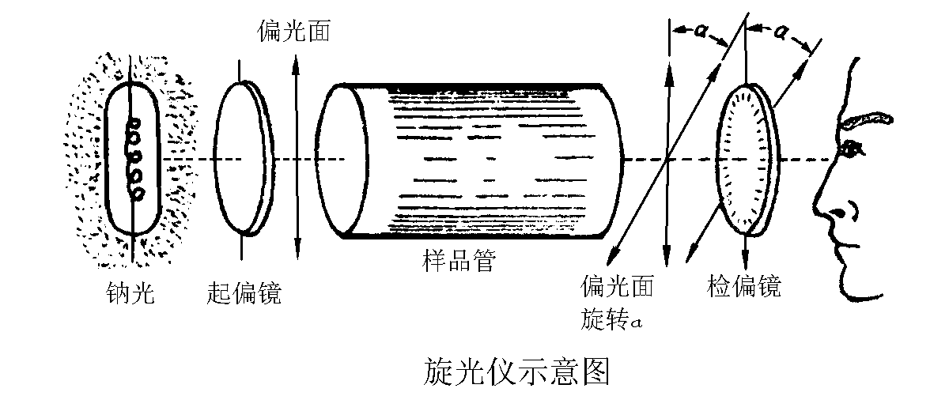

**3. Experimental Principles**

Many compounds such as petroleum and glucose have optical activity, which is due to their asymmetric molecular structure. Optical activity exists in various forms of these substances, including their solutions.

Research shows:

For liquids with optical rotation characteristics, when polarized light passes through it, the angle of rotation of the polarization plane $φ$ is proportional to the thickness $l$ of the solution through which light passes and the concentration $c$ of the solution, that is:

$$φ= αlc$$

Where $α$ is called the optical rotation rate of a substance, which is related to the wavelength of the incident light wave and the optical rotation material. That is, the angle of rotation of the vibrating surface varies when linearly polarized light of different wavelengths passes through a certain length of optical rotation material. This phenomenon is called optical rotation dispersion, $α$ is also related to temperature, but not much. For most substances, for every 1℃ increase in temperature, the optical rotation decreases by about a few thousandths.

Malus' law: When linearly polarized light with the intensity of $I_{0}$ passes through the polarizer, the intensity of transmitted light (regardless of absorption) is

$$I= I_{0}\cos^{2}θ$$

Where $θ$ is the angle between the optical vibration direction of the incoming polarized light and the polarization direction of the polarizer. Using this formula, we can indirectly calculate the optical rotation of a substance by measuring the intensity of light $α$.

There are two types of optical matter: left-handed light and right-handed light. When the experimenter observes against the light, the substance whose vibration surface rotates clockwise is called a right-handed substance, and vice versa, is called a left-handed substance.

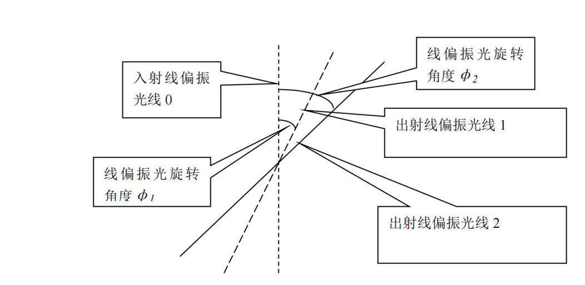

As shown in the figure above, a simple judgment method is to still select $l_{1}$ and $l_{2}$ as prime numbers, where $l_{2}$ > $l_{1}$ and their difference is not large. If measured $θ_{2}$ > $θ_{1}$, it can be determined that the substance is a right-handed optical substance, or it is a left-handed optical substance on the contrary.

**4. Procedures**

**Determine the polarization of the light source and verify Malus Law**

1.1 Place the laser and light intensity detector on the guide rail, and then connect the light intensity detector with the Optical power meter.

1.2 Turn on the power switch of the Optical power meter, adjust the range accuracy of the Optical power meter to the thousandth, turn on the semiconductor laser and adjust it to the maximum intensity. When there are no other elements on the guide rail, make the laser input the optical intensity detector vertically. Observe the value change on the optical power meter and adjust its attenuation value to a suitable range.

1.3 Place a polarizer and adjust the height of the polarizer to allow the laser to pass through its center; Adjust the polarizer angle to maximize the light intensity reading. Start at the maximum light intensity position and rotate for 90°. Change the polarizer angle step by step. Record a set of data every 15°. Judge the polarization state of the light source based on the obtained data. If it is found that the light source is linearly polarized, use these data as $I\sim {（cos{θ）}}^{2}$ to Verify Marius' law.

1.4 If the light source is not linear polarized light, please adjust the polarizer back to the position where the light intensity reading is the largest, put it in the polarizer, and adjust the polarizer to make the light intensity reading the largest. From this position to the rotation of 90°, change the angle of the polarizer step by step, record a group of data every 15°, and use the obtained data validation Marius Law.

**Measuring the optical rotation of glucose solution**

2.1 Install and fix the semiconductor laser, polarizer, sample tube bracket, and light intensity detector on the optical holder, and adjust the coaxial contour to make the laser emitted by the laser vertically pass through the center of the polarizer and light intensity detector.

2.2 Adjust the polarizer turntable to maximize the output polarized light. Fix the polarizer on the slider of the guide rail so that the polarizer is parallel to the polarizer and coaxial at the same height. Rotate the polarizer 360°and observe the changes in light intensity during the rotation process.

2.3 After adjusting the polarizer turntable and maximizing the light intensity output from the polarizer, record the angle value of the polarizer at this time . Place a glucose solution test tube with a mass concentration of , rotate the polarizer 360°, adjust the polarizer to maximize the light intensity output from the polarizer, and record the angle of the polarizer at this time . Remove the glucose solution test tube, rotate the polarizer 360°, adjust the polarizer turntable to maximize the light output from the polarizer, and record the angle value of the polarizer again . Repeat the above steps 5 times to obtain five sets of data, and finally calculate the final value and the optical rotation of the glucose solution at this concentration through the differential method.

**5. Data processing**

1.Determining the Polarization of a Light Source with a Single Polarizer

Place the laser and light intensity detector on the guide rail, and then turn on the power switch of the light intensity detector. When there are no other components on the guide rail, make the laser vertically shoot into the light intensity detector. Place a polarizer and adjust the height of the polarizer to allow the laser to pass through its center. Adjust the angle of the polarizer to maximize the light intensity reading. Starting at the maximum light intensity position and rotating through 90°, change the angle of the polarizer one by one, and record a set of data every 15°, as follows:

|  |  |  |
| --- | --- | --- |
|  | 起偏器偏转角度 | 光强(10^(-7)A) |
| 第一次 | 0° | 3.895 |
| 第二次 | 15° | 3.662 |
| 第三次 | 30° | 3.149 |
| 第四次 | 45° | 2.425 |
| 第五次 | 60° | 1.721 |
| 第六次 | 75° | 1.264 |
| 第七次 | 90° | 1.131 |

From the data in the table, it can be seen that:

According to the least square method, the fitted trend line is:

ŷ = -0.0346x + 4.0191（where = 0.9745）

2. Simultaneous use of polarizer to determine the polarization of the light source

Place the laser and light intensity detector on the guide rail, and then turn on the power switch of the light intensity detector. When there are no other components on the guide rail, make the laser vertically shoot into the light intensity detector. Place the polarizer and polarizer, and adjust the height of the polarizer and polarizer to allow the laser to pass through its center. Adjust the polarizer to the position where the light intensity reading is maximum, place the polarizer, and adjust the polarizer to maximize the light intensity reading. From this position to rotate 90°, change the angle of the polarizer one by one, and record a set of data every 15°, as follows:

|  |  |  |
| --- | --- | --- |
|  | 起偏器偏转角度 | 光强(10^(-7)A) |
| 第一次 | 0° | 2.841 |
| 第二次 | 15° | 2.745 |
| 第三次 | 30° | 2.309 |
| 第四次 | 45° | 1.662 |
| 第五次 | 60° | 0.958 |
| 第六次 | 75° | 0.412 |
| 第七次 | 90° | 0.133 |

From the drawing of the data in the table, it can be concluded that:

According to the least square method, the fitted trend line is:

ŷ = -0.0337x + 3.0951（where ${ R}^{2}$ = 0.9743）

It was observed that the correlation coefficient was large and the data showed a linear decreasing trend, indicating that the light source was linearly polarized.

3.Verifying Malus' Law

By simultaneously using the polarizer and the polarizer to determine the experimental data in the polarization of the light source, the polarizer deflection angle $θ$ is changed to ${（cos{θ）}}^{2}$：

|  |  |  |  |
| --- | --- | --- | --- |
|  | 起偏器偏转角度 | 偏转角度余弦值的平方 | 光强(10^(-7)A) |
| 第一次 | 0° | 1 | 2.841 |
| 第二次 | 15° | 0.933 | 2.745 |
| 第三次 | 30° | 0.75 | 2.309 |
| 第四次 | 45° | 0.5 | 1.662 |
| 第五次 | 60° | 0.25 | 0.958 |
| 第六次 | 75° | 0.06 | 0.412 |
| 第七次 | 90° | 0 | 0.133 |

And draw the relationship diagram of $I\sim {(cos{θ)}}^{2}$ as follows:

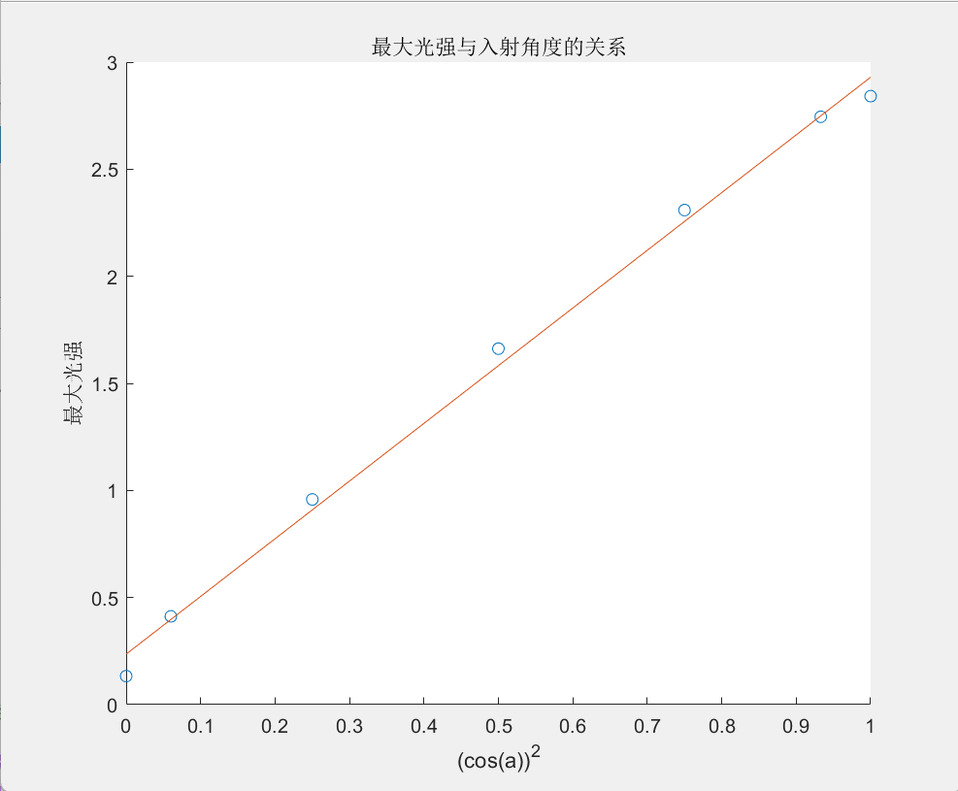

According to the least square method, the fitted trend line is:

ŷ = 2.6937x + 0.2358（where ${ R}^{2}$ = 0.9959）

The correlation coefficient is large, so $I$ is proportional to ${(cos{θ)}}^{2}$, which conforms to Marius' law.

4. Measuring the optical rotation of glucose solution

After adjusting the polarizer turntable and maximizing the light intensity output from the polarizer, record the angle value of the polarizer at this time . Place a glucose solution test tube with a mass concentration of , rotate the polarizer 360°, adjust the polarizer to maximize the light intensity output from the polarizer, and record the angle of the polarizer at this time . Remove the glucose solution test tube, rotate the polarizer 360°, adjust the polarizer turntable to maximize the light output from the polarizer, and record the angle value of the polarizer again. Repeat the above steps 5 times to obtain five sets of data, and finally calculate the final value and the optical rotation of the glucose solution at this concentration through the differential method.

In the experiment of measuring the optical rotation of glucose solution, we obtained the original data as shown in the following figure:

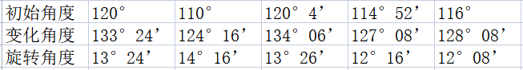

After conversion, the percentage angle obtained is:

$φ_{1}=13.4{，φ}_{2}=14.27$， $φ_{3}=13.43$， $φ_{4}=12.27$， $φ_{5}=12.13$

$\overline{φ}$ = $\frac{φ_{1} + φ_{2} + φ_{3} + φ_{4 }+ φ_{5}}{5}$ = 13.10°

The optical rotation of the glucose solution is:

$$φ= \overline{φ}=13.10°$$

Measure the length of the solution test tube:

$$l=1.66 ±0.01 dm$$

Known solution mass concentration:

$$c=0.15g/{dm}^{3}$$

reach $α$ Optical rotation:

$$φ= αlc$$

$$α= \frac{φ}{lc}=52.61(° ∙ {cm}^{3 }∙ g^{-1}∙ {dm}^{-1})$$

Take natural logarithm on both sides of the function:

$$lnα=lnφ-lnL-lnc$$

Taking the total differential, we obtain:

$\frac{dα}{α}$ = $\frac{dφ}{φ}$- $\frac{dL}{L}$- $\frac{dc}{c}$

Substitute the error amount for the differential component, take the sum of the squares of each term, and then multiply the square:

$\frac{σ_{α}}{α}$ = $\sqrt{{\left(\frac{σ_{φ}}{φ}\right)}^{2}+{\left(\frac{σ_{L}}{L}\right)}^{2}+{\left(\frac{σ_{c}}{c}\right)}^{2}}$ = $\sqrt{{\left(\frac{0.01}{1.66}\right)}^{2}}$ = 0.00602

Calculate the standard deviation, and obtain:

$σ_{α}$ = $α∙\frac{σ_{α}}{α}$ = 0.32 (° $∙ {cm}^{3 }∙ g^{-1}$ $∙ {dm}^{-1}$)

So, the measured optical rotation is:

$α$ =52.61 ± 0.32(° $∙ {cm}^{3 }∙ g^{-1}$ $∙ {dm}^{-1}$)

**6.Experimental conclusion**

In the experiment to determine the polarization of the light source, we obtained data with a large linear correlation coefficient fitting, and the data showed a linear decreasing trend, which determined that the light source was polarized light.

In verifying Marius' law, we linearly fitted the data and obtained a fitted straight line with $R^{2}$ very close to 1, and the light intensity I corresponds to $\cos^{2}θ$. Demonstrate a significant linear relationship and a monotonically increasing function, thereby successfully verifying Marius' law.

In the experiment of measuring the optical rotation of glucose solution, we took into account the significant impact of environmental errors, so after each 15°rotation of the polarizer, the initial angle of the polarizer will be measured again to achieve the effect of reducing errors. After reading the angle once, rotate $P_{2}$ 360 $°$ and read again to reduce contingency. Note that $P_{2}$ must be rotated in one direction to eliminate pitch error.

The experimental results are relatively ideal, and the data can prove that the optical rotation of glucose solution is within the standard value error.