**Characteristics and Design of Voltage Stabilizing Circuits**

2022级 人工智能 ZYH

**Abstract**

The so-called voltage stabilizing circuit refers to a circuit that can maintain a constant output voltage even when there are changes in input voltage, load, environmental temperature, circuit parameters, etc. The voltage stabilizing circuit is a commonly used circuit in modern electronic technology, and it is also an important component to ensure the normal and stable operation of electronic equipment. The voltage stabilizing circuit usually includes four parts: adjusting elements, reference voltage circuit sampling circuit, and comparative amplification circuit.

1. **Objectives**

1. Master the working principle of voltage stabilizing circuits and the role of various components in the circuit.

2. Learn the installation, adjustment, and testing methods of DC regulated power supplies.

3. Get familiar with and master the working principle of linear integrated voltage stabilizing circuits.

4. Learn the measurement methods for the technical indicators of linear integrated voltage stabilizing circuits.

1. **Experiment Equipment**

9-hole plug-in board, AC power supply, digital multimeter, capacitor ($0.1μF$, $1μF$, $470μF$), resistance ($100Ω$, $200Ω$, $1kΩ$), Potentiometer ($10kΩ$), diode, three terminal voltage regulator (7805), dual trace oscilloscope, connecting line.

1. **Experiment Principles**

**3.1 Circuit composition**

When the voltage of the power grid changes or the output load changes, the circuit that can keep the output voltage unchanged is called a voltage stabilizing circuit. DC regulated power supply is one of the most basic and commonly used instruments in electronic equipment. As an energy source, it can ensure the normal operation of electronic devices. DC regulated power supply generally consists of three parts: rectification circuit, filtering circuit, and regulated circuit, as shown in Figure 1. This experiment mainly explores the DC voltage stabilizing circuit composed of linear integrated voltage stabilizing element 7805.

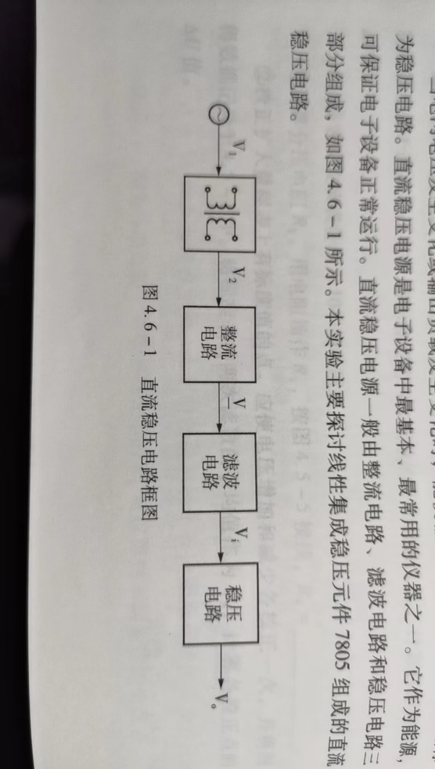

Figure 1

Figure 2a shows a fixed output 5V voltage regulator circuit composed of bridge rectifier, capacitor filter, and 7805 linear voltage regulator integrated block. Figure 2b shows an adjustable output voltage regulator circuit composed of bridge rectifier, capacitor filter, and 7805 linear voltage regulator integrated block. The functions of each capacitor in the circuit are as follows: $C_{1}$ is the filtering capacitor, and the empirical formula between this capacitance and the load current $I_{0}$ is usually described as $C_{1}=(1500\sim 2000)∙1∙(μF)$; $C_{2}$ is to restrain Self-oscillation of voltage regulator; $C_{3}$ is a high-frequency noise bypass capacitor.

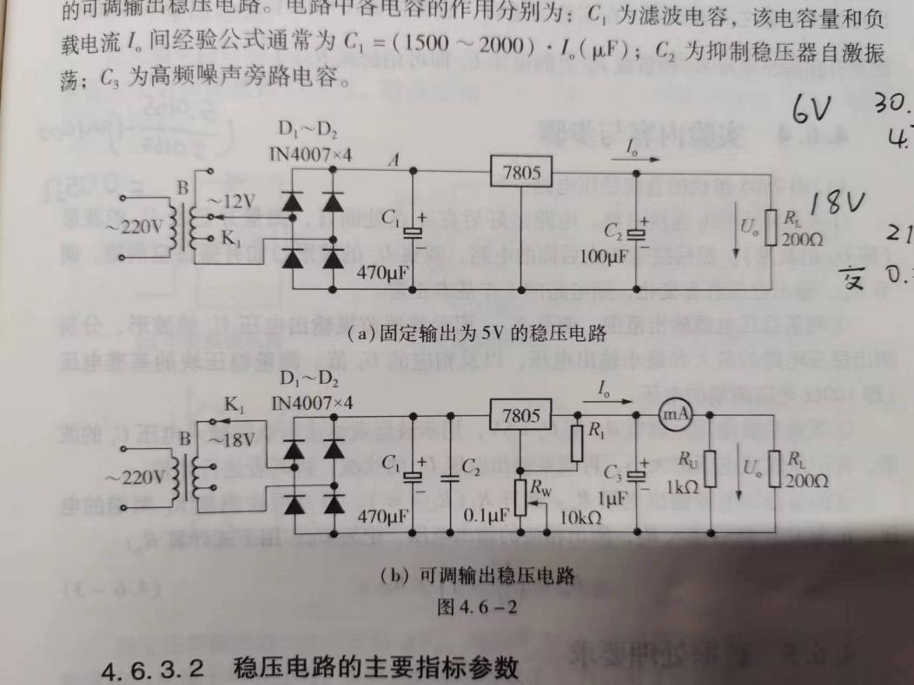

Figure 2

**3.2 The main indicators and parameters of the voltage stabilizing circuit**

Output voltage and its adjustable range: For adjustable regulated power supplies, the adjustable range of output voltage reflects the adaptability of the power supply's output application range.

Voltage regulation coefficient $S_{r}$: refers to the ratio of the relative change in output voltage $U_{o}$ to the relative change in input voltage $U_{i}$ of a DC regulated power supply when the load current and ambient temperature remain constant, expressed as:

$$S_{r}= \frac{\frac{∆U_{o}}{U_{o}}}{\frac{∆U_{i}}{U_{i}}}$$

Ripple suppression ratio $S_{SRPP}$: The voltage stabilizing circuit cannot completely eliminate the AC component, and the introduction of ripple suppression ratio is used to describe the performance of the voltage stabilizing circuit. Defined as 20 times the logarithmic value of the ratio of input ripple voltage peak to peak and output ripple voltage peak to peak:

$$S_{SRPP}=20lg\frac{U_{ipp}}{U_{opp}}$$

The larger the ripple suppression ratio, the stronger the ability of the voltage stabilizing circuit to eliminate AC components.

Output resistance $R_{o}$: Defined as the ratio of the change in output voltage to the change in output current when there is no change in input voltage and ambient temperature. In experimental measurements, the output resistance is usually regarded as a resistance similar to that of a power source, and the open circuit output voltage ${U_{o}}^{'}$ and Voltage $U_{o}$ on load $R_{L}$ so that formula can be used immediately to calculate $R_{o}= \left(\frac{{U_{o}}^{'}}{U_{o}}-1\right)∙R_{L}$.

1. **Content Steps**
2. Connect the circuit as shown in Figure 3, disconnect the circuit at point A, measure and record the waveform of $U_{1}$ (the waveform of $U_{A}$). Then connect the circuit behind point A and observe $U_{o}$. The waveform should be eliminated if there is any oscillation. If there is a change in the output voltage by adjusting $R_{W}$, the operation of the circuit is basically normal.
3. Measure the output range of the regulated power supply. Adjust $R_{W}$ and monitor the output voltage $U_{o}$ with an oscilloscope. Measure the maximum and minimum output voltage of the voltage stabilizing circuit, as well as the corresponding $U_{1}$ value, based on the waveform. Measure the reference voltage of the voltage regulator block (the voltage at both ends of the $100Ω$ resistor).
4. Observe the ripple voltage. Adjust $R_{W}$ to make $U_{o}=5V$, observe the waveform of the input voltage $U_{i}$ of the voltage stabilizing circuit with an oscilloscope, record the magnitude of the ripple voltage, and then observe the output voltage $U_{o}$. Compare the ripple of the two.
5. Measure the output resistance $R_{o}$ of the regulated power supply. Disconnect $R_{L}(R_{L}=∞)$, and measure the voltage at both ends of $R_{L}$ with a multimeter, denoted as ${U_{o}}^{'}$. Then connect $R_{L}$ and measure the corresponding output voltage, denoted as $U_{O}$, Calculate $R_{o}$ using the following equation:

$$R_{o}= \left(\frac{{U_{o}}^{'}}{U_{o}}-1\right)∙R_{L}$$

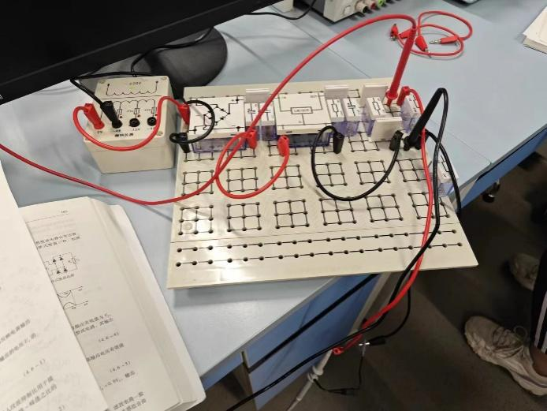

Figure 3

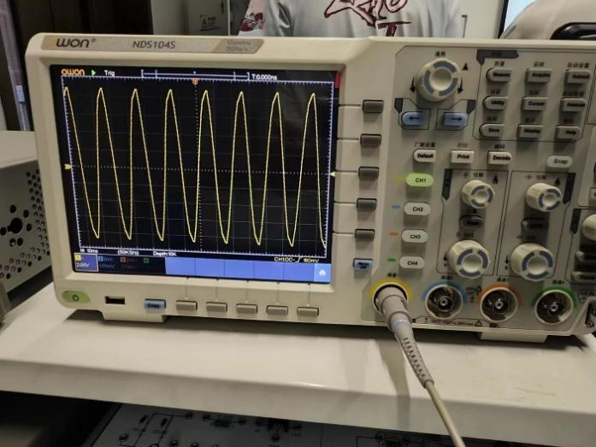

Figure 4

1. **Data processing**

**5.1 Measuring Voltage Regulation Coefficient $S_{r}$**

When measuring the voltage stabilization coefficient $S_{r}$, we conducted two sets of experiments in the voltage range of 6V-12V and 6V-18V, as shown in the table below.

|  |  |  |  |
| --- | --- | --- | --- |
| 6V | | 12V | |
| Input Voltage $U_{i}$ (AC) | 6.415V | Input Voltage ${U_{i}}^{'}$ (AC) | 12.760V |
| Output Voltage $U_{o}$ (DC) | +4.707V | Output Voltage ${U_{o}}^{'}$ (DC) | +13.341V |

By calculation, it can be concluded that:

$$∆U_{o}={U_{o}}^{'}- U_{o}=13.341V-4.707V=8.634V$$

$$∆U_{i}={U_{i}}^{'}- U_{i}=12.760V-6.415V=6.345V$$

$$S_{r}= \frac{\frac{∆U_{o}}{U_{o}}}{\frac{∆U_{i}}{U_{i}}}= \frac{\frac{8.634V}{4.707V}}{\frac{6.345V}{6.415V}}=1.8545$$

|  |  |  |  |
| --- | --- | --- | --- |
| 6V | | 18V | |
| Input Voltage $U_{i}$ (AC) | 6.414V | Input Voltage ${U_{i}}^{'}$ (AC) | 19.985V |
| Output Voltage $U_{o}$ (DC) | +4.715V | Output Voltage ${U_{o}}^{'}$ (DC) | +21.570V |

By calculation, it can be concluded that:

$$∆U_{o}={U_{o}}^{'}- U_{o}=21.570V-4.715V=16.855V$$

$$∆U_{i}={U_{i}}^{'}- U_{i}=19.985V-6.414V=13.571V$$

$${S_{r}}^{'}= \frac{\frac{∆U_{o}}{U_{o}}}{\frac{∆U_{i}}{U_{i}}}= \frac{\frac{16.855V}{4.715V}}{\frac{13.571V}{6.414V}}=1.6895$$

**5.2 Measuring Ripple Suppression Ratio $S_{SRPP}$**

When measuring the ripple suppression ratio $S_{SRPP}$, we measured two sets of experimental data, namely the experimental data under input voltage of 12V and 18V, as shown in the table below:

|  |  |  |
| --- | --- | --- |
| Input Voltage | 12V | 18V |
| Input ripple voltage peak $U_{ipp}$ | 1.152V | 1.120V |
| Output ripple voltage peak $U_{opp}$ | 20mV | 24mV |

Ripple suppression ratio under 12V input voltage $S_{SRPP}$：

$$S_{SRPP}=20lg\frac{U_{ipp}}{U_{opp}}=20lg\frac{1.152V}{2×{10}^{-2}V}=35.2084$$

Ripple suppression ratio under 18V input voltage $S_{SRPP}$：

$${S_{SRPP}}^{'}=20lg\frac{U_{ipp}}{U_{opp}}=20lg\frac{1.120V}{2.4×{10}^{-2}V}=33.3801V$$

**5.3 Measuring Output resistance $R_{o}$**

When measuring the output resistance $R_{o}$, we selected two different loads $R_{L}$ of $100Ω$ and $1000Ω$ for calculation. The measured open circuit voltage ${U_{o}}^{'}$ and the voltage on the load $R_{L}$ are shown in the following figure:

|  |  |  |
| --- | --- | --- |
| Load Resistance $R_{L}$ | $$100Ω$$ | $$1000Ω$$ |
| Voltage $U_{o}$ on load $R_{L}$ | 5.0138V | 5.0163V |
| Open circuit voltage ${U_{o}}^{'}$ | 5.0165V | 5.0165V |

When the load resistance $R_{L}$ is $100Ω$, the output resistance $R_{o}$ is:

$$R_{o}= \left(\frac{{U_{o}}^{'}}{U_{o}}-1\right)∙R_{L}=\left(\frac{5.0165V}{5.0138V}-1\right)×100Ω= 5.39×{10}^{-2}Ω$$

When the load resistance $R_{L}$ is $1000Ω$, the output resistance $R_{o}$ is:

$${R_{o}}^{'}= \left(\frac{{U_{o}}^{'}}{U_{o}}-1\right)∙R_{L}=\left(\frac{5.0165V}{5.0162V}-1\right)×1000Ω= 5.98×{10}^{-2}Ω$$

1. **Conclusion and Analysis**

**Conclusion:**

Due to the limited experimental data, our conclusions are not absolute and may be speculative.

1. Based on the measurement data, we calculated the voltage stabilization coefficients as 1.8545 and 1.68952, respectively.

2. Based on the measurement data, we calculated the ripple suppression ratios as 35.2084 and 33.3801.

3. Based on the measurement data, we calculated the output resistance to be $5.39×{10}^{-2}Ω$ and $5.98×{10}^{-2}Ω$.

**Error Analysis:**

For cases where the input voltage measurement value is too large or too small, there may be some operational or experimental factors that may affect it:

1. The error of the voltage measurement instrument: there may be some error in the measurement instrument itself. If the error of the voltage measuring instrument is significant, the measurement results may deviate from the actual value.
2. Poor contact or loose connection: If the circuit connection is poor or the connector is loose, it will cause impedance changes in voltage signal transmission, which will affect the measurement results. For example, poor contact of the power cord, voltage probe, or measuring wire can cause the voltage measurement value to be too small or fluctuate.
3. Non ideal power supply: The actual power supply may have certain internal resistance or output voltage fluctuations. The existence of internal resistance can cause changes in input voltage during load changes, affecting the accuracy of measurement results.
4. Line impedance: Components such as resistors, inductors, or capacitors in a circuit can cause changes in the impedance of the circuit, thereby affecting the voltage measurement results. Especially in high-frequency or high-speed circuits, the influence of line impedance on measured values is more significant.
5. Power supply stability: If the stability of the power supply is not high, that is, the output voltage of the power supply is easily affected by external factors and fluctuates, which can cause the measured value of the input voltage to fluctuate or deviate from the expected value.
6. Temperature effect: Temperature changes can cause changes in the parameters of circuit components, such as resistance and capacitance values, thereby affecting the working state and voltage measurement results of the circuit.

To reduce the impact of these errors, the following measures can be taken:

1. Use high-precision voltage measurement instruments and calibrate the instruments to ensure accuracy.
2. Ensure that the circuit connections are tight and stable, and check for good contact.
3. Choose a power source with high stability and use a regulated power source to reduce the impact of power fluctuations on the measurement results.
4. Pay attention to changes in ambient temperature and perform temperature compensation or control.
5. Perform multiple repeated measurements, take the average value, or perform data processing to improve the accuracy of measurement results.