**Measurement of Focal Length of Thin Lens Combination**

2022级 人工智能 ZYH

**Abstract**

Thin lens refers to a lens whose central thickness can be ignored compared to the curvature radius of the sphere. At present, thin lenses are widely used in the field of imaging, such as astronomy, medicine, digital cameras, mobile phones, and so on. It is necessary to measure the focal length of thin lenses due to the different occasions and purposes in which they are used and the different lenses or lens groups that should be selected. There are many methods for measuring the focal length of thin lenses, such as geometric method, Fourier method, instrument method, etc. Geometric methods include autocollimation, object distance imaging, one imaging, and two imaging methods. Instrument methods include resistance wire method, spectrometer method, etc. In this experiment, we used autocollimation method, primary imaging method, and secondary imaging method (conjugation method) to measure the focal length of convex lenses, while using object distance imaging method and autocollimation method to measure the focal length of concave lenses.

1. **Objectives**

1. Learn coaxial adjustment of optical components.

2. Learn several methods for measuring the focal length of convex and concave lenses.

3. Deepen the understanding of imaging laws of thin lenses.

1. **Experiment Equipment**

Optical holder and its accessories, converging and diverging thin lenses, parallel white light source, sodium light lamp, object screen meter ruler, etc.

1. **Experiment Principles**

For a thin lens, its object distance u, image distance f, can be considered as the distance between the object, image, focal length, and the center of the lens. The imaging formula (Gaussian formula) for thin lenses under paraxial light conditions is:

$$\frac{1}{f}= \frac{1}{u}+ \frac{1}{v}$$

Directly applying the Gaussian formula to measure the focal length will result in significant measurement errors due to the difficulty in accurately measuring the u value and the inability of the divergent lens to produce a real image. Here is a commonly used method for measuring the focal length of converging and diverging lenses.

**（1） Measurement of the focal length of convex lenses using parallel light focusing method**

The experimental principle of measuring the focal length of a convex lens using parallel light is based on the fundamental principles of optical imaging. When light rays vertically enter the lens, they are refracted, forming a focal point. For a convex lens, light rays entering from both ends of the lens converge to a point, which is the focal point of the lens. In the experiment of measuring the focal length of a convex lens using parallel light, a beam of light parallel to the optical axis is directed towards the convex lens. The lens focuses light onto its focal point, which can be observed by placing a white board or screen in front of the convex lens. By moving the position of the convex lens, multiple sets of data on the position and focal point of the convex lens can be obtained. According to the basic principles of optical imaging, the focal length of a convex lens can be calculated using this data. In actual measurement, it is necessary to note that the light source should be bright and uniform enough, and the light should be as close as possible to the parallel light. Convex lenses and whiteboards or screens should be placed perpendicular to the optical axis to avoid measurement errors.

**（2） One shot imaging method (displacement method) for measuring the focal length of convex lenses**

The one-time imaging method determines the focal length of a convex lens by measuring the distance between the object and the convex lens, as well as the position relationship between the convex lens and the imaging screen. The principle of this experiment is to use a convex lens to focus the incident light onto the imaging screen and obtain a clear image at a suitable position. In the experiment, the object can be placed at a certain distance in front of the convex lens, and by adjusting the position of the imaging screen, a clear image can appear on the imaging screen. Then, the focal length can be calculated by measuring the distance between the object and the convex lens, as well as the position relationship between the convex lens and the imaging screen.

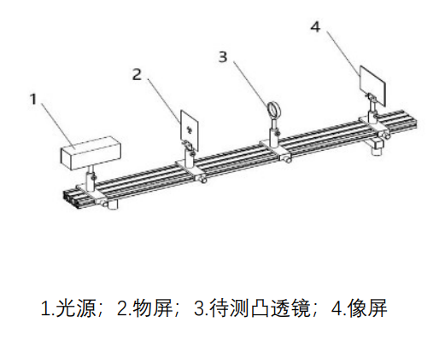

Figure 1

**（3） Secondary imaging method (displacement method) for measuring the focal length of convex lenses**

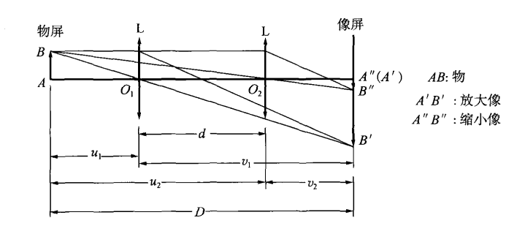

Figure 2

The principle of secondary imaging is the reversibility of light. As shown in the figure, place the convergence lens L between the object screen and the image screen on the guide rail of the optical fixture seat, with the object screen (the arrow shaped transparent hole in the screen) at a distance of D from the image screen. When D>4f (f is the focal length of the test lens), moving L can make the object image on the screen at positions 01 and 02, with position 01 as an enlarged real image and position 02 as a small real image. According to the principle of light reversibility, u1=v2, u2=v1, we can obtain that:

$$D-d= u_{1}+v_{2}=2u_{1}$$

$$u_{1}= v_{2}= \frac{1}{2}\left(D-d\right)$$

$$v_{1}=D- u_{1}= \frac{1}{2}\left(D+d\right)$$

Simplified:

$$f= \frac{D^{2}- d^{2}}{4D}$$

**（4） Measurement of the focal length of concave lenses**

Due to the fact that the divergent lens forms a virtual image, it is necessary to combine it with a convex lens in order to accurately measure the image distance v. The principle of measuring the focal length of divergent lenses is introduced as follows. Firstly, use a converging lens to reduce object AB to a smaller image A'B' on the image screen, as shown in Figures 5-1-2. Insert a divergent lens L2 between L1 and the image screen, treating the image formed by the mirror as an object of L2 (called a virtual object). By moving the image screen appropriately, the image A''B'' of the virtual object can be obtained. Measure the virtual object distance u and image v, substituting the equation:

$$\frac{1}{f}= \frac{1}{u}+ \frac{1}{v}$$

The focal length f of the divergent lens can be obtained.

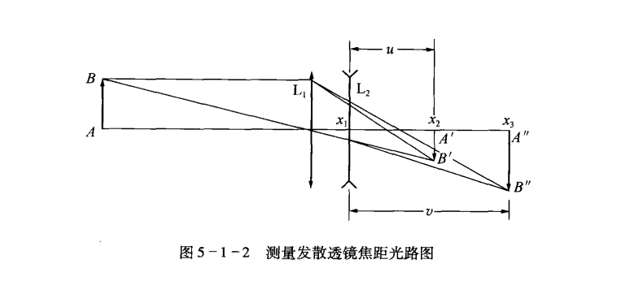

Figure 3

1. **Content Steps**
2. **Coaxial adjustment of optical components**

In order for the light to be paraxial, it is necessary to first adjust the optical components to be coaxial. The requirements for adjusting the coaxiality of optical components on the optical holder are: the optical axes of each lens coincide uniformly, the center of the object is on the optical axis, the image plane of the object is perpendicular to the optical axis, and the optical axis is parallel to the guide rail of the optical holder. Coaxial adjustment should be carried out in two steps:

(1) coarse adjustment. Bring the light source, object, lens, etc. on the light fixture seat together, carefully observe and adjust the height and left and right of each optical element with your eyes, so that the center of the light source, object, and lens is roughly in a straight line with the light fixture seat.

(2) Fine tuning. Fine tuning is the process of determining whether optical components are coaxial based on the imaging pattern of the lens. The following is an example of using a single lens to introduce the adjustment method.

1. Adjust the brightness to a uniform and complete image. Pull the object screen and image screen apart enough on the guide rail (greater than 4/) to form and reduce clear images on the image when the convergence mirror moves between the object screen and image screen. The formed image must be complete and have uniform brightness, otherwise the light source or object screen should be adjusted appropriately.

2. Adjust the vertical contour of the center position. Move the lens L to make a clear enlarged image appear on the image screen. Record the center position 0 and then move the lens to make a clear reduced image appear on the image screen. Record the center position 0 '' as shown in Figure 5-1-3. If the centers of the two images are not equal in height, move the lens L toward the object screen so that a clear and enlarged image reappears on the image screen, and then adjust the height of the center of the object so that the point 0 is close to the point 0 '' to the same height as the point 0 ''; then move the lens L toward the image screen so that the image screen appears a clear and reduced image, and check the height of the point O ', O'.

3. When adjusting, it should be noted that if the 0 point is above the 0 '' point, then the object center 0 point is lower than the adjustment optical axis. At this time, the 0 point should be moved up to make the 0 point lower and close to the 0 '' point; otherwise, the 0 point should be lowered. Adjust the horizontal overlap of the two image centers. Adjust the horizontal screw adjustment handwheel procedure on the relevant optical component sliders on the guide rail, which is the same as step 2.

1. **Measure the focal length of a convex lens**

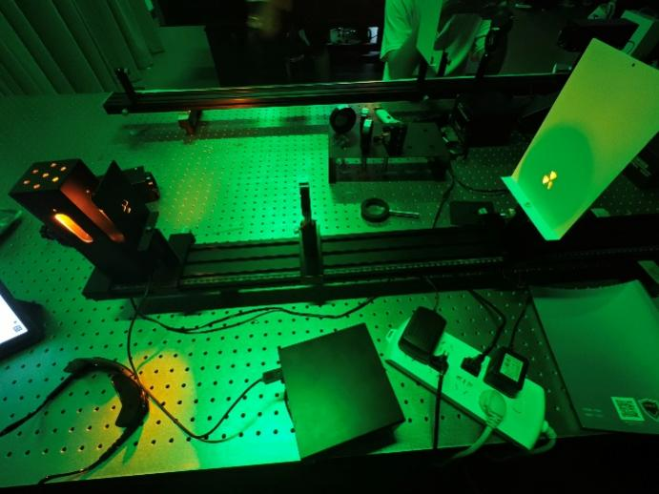

Figure 4

According to Figure 1 optical path, select different D values under the premise of D&gt;4f, move the lens L to produce clear enlarged and reduced images on the image screen, record the position coordinates of the object screen, image screen, and the enlarged and reduced images, and obtain the D and d values. Substitute them into the equation:

$$f= \frac{D^{2}- d^{2}}{4D}$$

To calculate the focal length f.

1. **Measure the focal length of a concave lens**

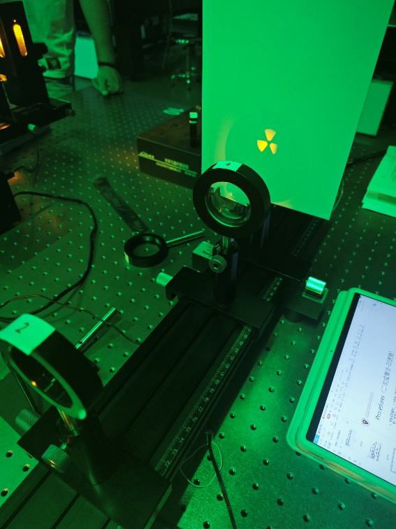

Figure 5

Measure according to the optical path diagram in Figure 3. The steps are as follows: 1. Move the lens to make the object AB form a small image on the image, and record the image position x1. 2 fixed object screens and L1, insert divergent lens L2 between image L1 and image screen, and move the image screen appropriately (L2 and image screen can also be moved simultaneously, but L2 cannot exceed the position of the original image screen) to make object AB appear clear again on the screen (preferably reducing the image). Record the position coordinates x2 of L2 and x3 of the image screen at this time. Calculate the corresponding object distance u and image distance v based on the recorded x1, x2, x3:

$$u= -\left|x_{1}- x_{2}\right|$$

$$v= \left|x_{3}- x_{2}\right|$$

Substitution:

$$\frac{1}{f}= \frac{1}{u}+ \frac{1}{v}$$

Then calculate the focal length f.

1. **Data processing**

**Measure the focal length of the convex lens**

**Measurement of convex lens focal length using parallel light focusing method**

|  |  |  |  |  |
| --- | --- | --- | --- | --- |
| Measurement times | Convex lens 1 | | Convex lens 2 | |
| Convex lens 1 position $x_{1}(cm)$ | Whiteboard position ${x_{1}}^{'}(cm)$ | Convex lens 2 position $x_{2}(cm)$ | Whiteboard position ${x_{2}}^{'}(cm)$ |
| 1 | 20 | 33.5 | 28 | 52.5 |
| 2 | 32 | 45.5 | 36 | 60.6 |
| 3 | 42 | 55.5 | 46 | 70.1 |

According to the optical formula, for a beam of light, there is: $$f= \left|x^{'}-x\right|$$

Calculate the focal length of each set of data as:

|  |  |  |
| --- | --- | --- |
| Measurement times | Convex lens 1 focal length $f_{1}(cm)$ | Convex lens 2 focal length $f_{2}(cm)$ |
| 1 | 13.5 | 24.5 |
| 2 | 13.5 | 24.6 |
| 3 | 13.5 | 24.1 |
| Average | 13.5 | 24.4 |

So, according to the method above, the focal length of convex lens 1 $f_{1}=13.5cm$, the focal length of convex lens 2 $f_{2}=24.4cm$.

**Measuring the focal length of a convex lens using a single imaging method**

|  |  |  |  |  |  |  |
| --- | --- | --- | --- | --- | --- | --- |
| Measurement times | Convex lens 1 | | | Convex lens 2 | | |
| Object (screen) position $x_{S_{1}}(cm)$ | Convex lens 1 position $x_{L_{1}}(cm)$ | Whiteboard position $x_{P_{1}}(cm)$ | Object (screen) position $x_{S_{2}}(cm)$ | Convex lens 2 position $x_{L_{2}}(cm)$ | Whiteboard position $x_{P_{2}}(cm)$ |
| 1 | 13 | 31 | 97 | 13 | 55 | 115.3 |
| 2 | 13 | 33 | 82.1 | 13 | 57 | 113 |
| 3 | 13 | 37 | 72.4 | 13 | 60 | 112.5 |

For measuring the focal length of convex lenses using a single imaging method, there are:

$$\frac{1}{f}= \frac{1}{u}+ \frac{1}{v}$$

Among them,

，

$$u= \left|x_{L}- x_{S}\right|$$

$$v= \left|x_{P}-x_{L}\right|$$

We can obtain the focal length of convex lens:

|  |  |  |  |  |  |  |
| --- | --- | --- | --- | --- | --- | --- |
| Measurement times | Convex lens 1 | | | Convex lens 2 | | |
| Object distance $u(cm)$ | Image distance $v(cm)$ | Focal length ${f_{1}}_{i}(cm)$ | Object distance $u(cm)$ | Image distance $v(cm)$ | Focal length ${f_{2}}_{i}(cm)$ |
| 1 | 18 | 66 | 14.14 | 42 | 60.3 | 24.76 |
| 2 | 20 | 49.1 | 14.21 | 44 | 56 | 24.64 |
| 3 | 24 | 35.4 | 14.30 | 47 | 52.5 | 24.80 |

Among them, the average focal length of convex lens is:

$$f_{1}= \frac{1}{3}\sum_{i=1}^{3}{{f_{1}}_{i}}=14.217cm$$

$$f_{2}= \frac{1}{3}\sum_{i=1}^{3}{{f_{2}}_{i}}=24.733cm$$

**Measurement of convex lens focal length using secondary imaging method**

|  |  |  |  |  |
| --- | --- | --- | --- | --- |
| Measurement times | Convex lens 1 | | Convex lens 2 | |
| The distance $D(cm)$ between the object screen and the image screen | Displacement $d(cm)$ of lens L during two imaging movements | The distance $D(cm)$ between the object screen and the image screen | Displacement $d(cm)$ of lens L during two imaging movements |
| 1 | 83.2 | 46.6 | 102.1 | 17.5 |
| 2 | 65.5 | 23.2 | 100 | 10.9 |
| 3 | 59.5 | 11 | 99 | 4.5 |

Measure the focal length of a convex lens using the secondary imaging method, including:

$$\frac{1}{u}+ \frac{1}{D-u}= \frac{1}{f}$$

$$\frac{1}{u+d}+ \frac{1}{D-u-d}= \frac{1}{f}$$

Simplified to:

$$u= \frac{D-d}{2}$$

Obtained:

$$f= \frac{D^{2}- d^{2}}{4D}$$

Calculate the focal length of each group as:

|  |  |  |
| --- | --- | --- |
| Measurement times | Focal length $f_{1}(cm)$ | Focal length $f_{2}(cm)$ |
| 1 | 14.27 | 24.78 |
| 2 | 14.32 | 24.70 |
| 3 | 14.36 | 24.70 |
| Average | 14.318 | 24.727 |

So, according to the method above, the focal length of convex lens 1 $f_{1}=14.32cm$, the focal length of convex lens 2 $f_{2}=24.73cm$.

**Measure the focal length of the concave lens**

**Measuring the focal length of a concave lens using the object distance and image distance method**

|  |  |  |  |  |
| --- | --- | --- | --- | --- |
| Measurement times | Convex lens position $x_{L_{1}}(cm)$ | Convex lens imaging position $x_{A_{1}}(cm)$ | Concave lens position $x_{L_{2}}(cm)$ | Image position of convex concave lens composition $x_{A_{2}}(cm)$ |
| 1 | 65 | 90 | 86 | 94 |
| 2 | 67 | 91.5 | 87.3 | 97.5 |
| 3 | 69 | 93 | 89.2 | 98 |

Measuring the focal length of a concave lens using the object distance and Image distance method includes:

$$u= \left|x_{A_{2}}- x_{L_{2}}\right|$$

$$v= \left|x_{A_{1}}- x_{L_{2}}\right|$$

$$\frac{1}{f}= \frac{1}{u}+ \frac{1}{v}$$

Measure the focal length of each group as:

|  |  |  |  |
| --- | --- | --- | --- |
| Measurement times | Object distance $u_{i}(cm)$ | Image distance $v_{i}(cm)$ | Concave lens focal length $f_{i}(cm)$ |
| 1 | 8 | 4 | 2.67 |
| 2 | 10.2 | 4.2 | 2.975 |
| 3 | 8.8 | 3.8 | 2.65 |

Calculate the average values of three sets of data regarding the focal length of concave lenses as follows:

$$f= \frac{1}{3}\sum_{i=1}^{3}{f_{i}}=2.765cm$$

The standard deviation of this data:

$$s^{2}= \frac{1}{3}\sum_{i=1}^{3}{{\left(f- f_{i}\right)}^{2}= }\frac{1}{3}\left(0.009025+0.0441+0.013225\right)=0.0221$$

Compared to the average value, this standard deviation can be considered relatively small. Therefore, the relatively small degree of dispersion of these three data indicates their high reliability and can be used to calculate the average value.

1. **Conclusion and analysis**

**Conclusion:**

1. The focal length f of convex lens 1 measured by parallel light source is 13.50 cm. The focal length f of convex lens 2 measured by parallel light source is 24.40cm.
2. Measurement of focal length of convex lens 1 by one - time imaging of f is 14.22cm. Measurement of focal length of convex lens 2 by one - time imaging of f is 24.73cm.
3. Measurement of focal length of convex lens 1 by secondary imaging method of f is 14.32cm. Measurement of focal length of convex lens 2 by secondary imaging method of f is 24.73cm.
4. The object distance image distance method is used to measure the focal length of concave lens 1 is 2.77cm.

**Analysis:**

The overall error of the experiment is small, and some causes of error are as follows.

Systematic error:

(1) Error caused by unclear imaging due to depth of field, focal depth, aberration and color difference.

Accidental error:

(1) Human eyes are uncertain about the position of clear images

(2) Error caused by reading the data on the ruler

(3) The base is not fixed properly, which affects the reading

When using different methods to measure the focal length of convex lenses, the results may also differ due to the different measurement principles and error sources of different methods. Generally speaking, the measurement errors of different methods vary, which may lead to differences in the final focal length values. In addition, for the measurement method of focal length, the experimental operation and measurement accuracy will also have an impact on the measurement results. For example, when measuring the focal length of a convex lens with parallel light, the accuracy of parallel light, the position accuracy of the convex lens and the screen, etc. will all affect the measurement results. Therefore, for the same convex lens, the focal length measured using different methods may be slightly different. We need to consider multiple factors comprehensively to determine the reliability of the final result and minimize errors as much as possible.

1. **Appendix**

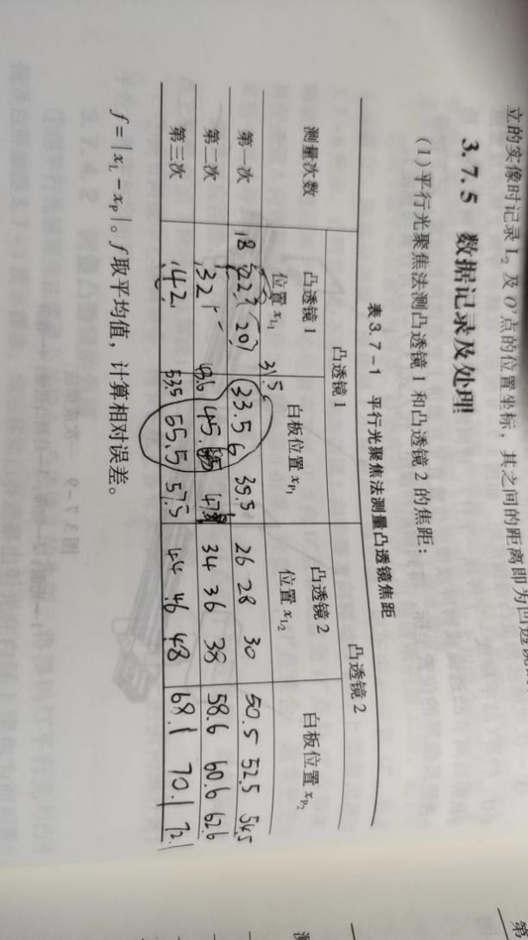

Figure 6 Focal length of a convex lens measured by the parallel light focusing method

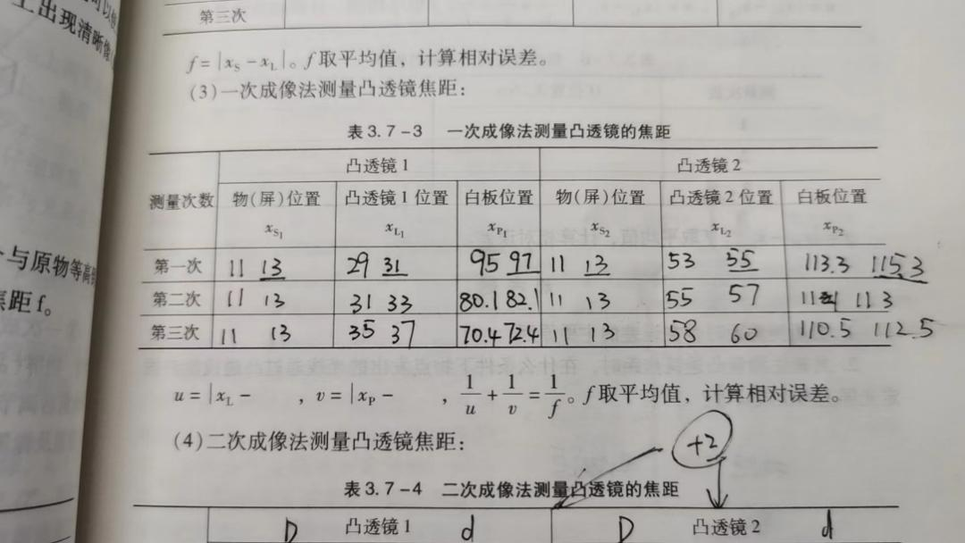

Figure 7 Measurement of focal length of convex lens by one - time imaging

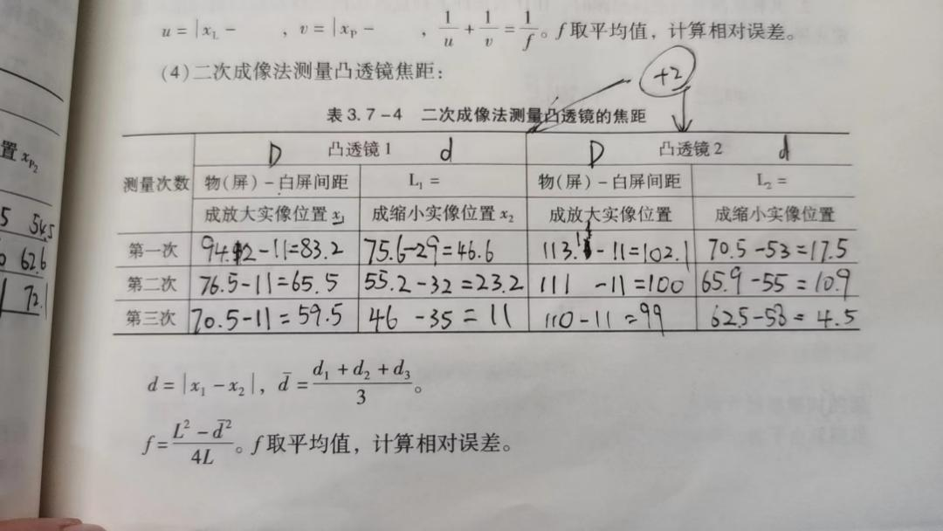

Figure 8 Measurement of focal length of convex lens by secondary imaging method

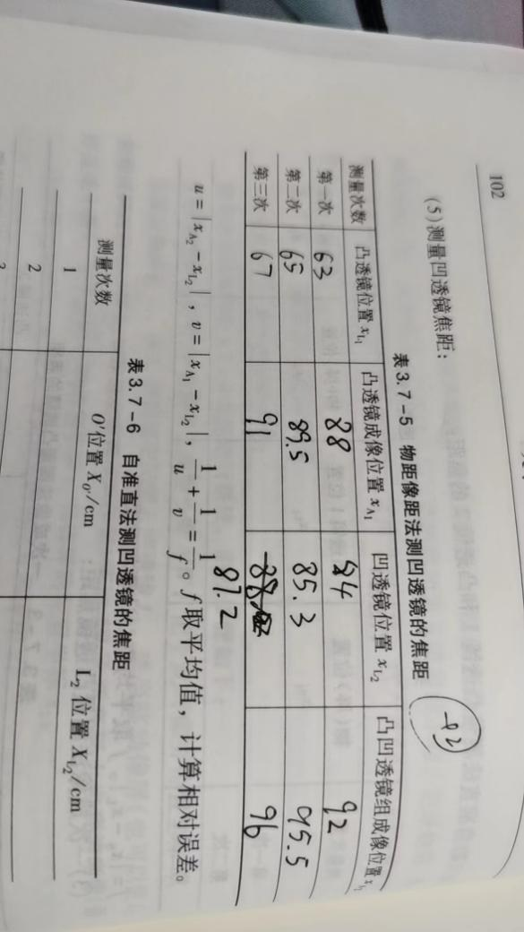

Figure 9 The object distance image distance method is used to measure the focal length of concave lens