17 - Game of Thrones

Given a color movie scene photo, as shown below (file name: game of thrones.jpg).

- Please write a program to convert the color image into an HSV image, separate the three channels, perform histogram equalization on the v channel, assign the equalized v channel back to the HSV image, and compare the results before and after.
- Find the location of the two people in the diagram and calculate the distance between them.

Requirements: the report should include the algorithm steps mentioned and display the processing results for each step.

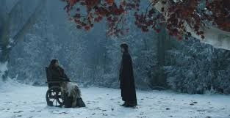
Fig.1 game of thrones

