Schema schedule.xsd

schema location: | C:\SVTU_SVTI9N\Projects\Schema\app\Schemas\schema-publicschedule\src\main\xsd\v2_0\schedule.xsd
attribute form default: | unqualified
element form default: | qualified
targetNamespace: | http://common.tv.se/schedule/v2_0

Elements
schedule

schema location: | C:\SVTU_SVTI9N\Projects\Schema\app\Schemas\schema-publicschedule\src\main\xsd\v2_0\content.xsd
attribute form default: | unqualified
element form default: | qualified
targetNamespace: | http://common.tv.se/content/v2_0

Elements | Complex types | Simple types
content | categoryListType | dvbGenreNibbleType
 | contentListType
 | contentType
 | countryListType
 | creditListType
 | creditType
 | descriptionType
 | dvbGenreType
 | keywordListType
 | keywordType
 | longDescriptionListType
 | longDescriptionType
 | mediaListType
 | mediaType
 | seriesDescriptionListType
 | shortDescriptionListType
 | shortDescriptionType
 | textType
 | titleListType
 | titleType

schema location: | C:\SVTU_SVTI9N\Projects\Schema\app\Schemas\schema-publicschedule\src\main\xsd\v2_0\event.xsd
attribute form default: | unqualified
element form default: | qualified
targetNamespace: | http://common.tv.se/event/v2_0

Elements | Complex types | Simple types
event | basicEventListType | timecode
 | basicEventType
 | embeddedEventListType
 | embeddedEventType
 | eventListType
 | eventType

schema location: | C:\SVTU_SVTI9N\Projects\Schema\app\Schemas\schema-publicschedule\src\main\xsd\v2_0\material.xsd
attribute form default: | unqualified
element form default: | qualified
targetNamespace: | http://common.tv.se/material/v2_0

Elements | Complex types | Simple types
material | audioListType | aspectRatioType
 | audioType | audioFormatType
 | materialListType | subtitleFormatType
 | materialReferenceListType | videoFormatType
 | materialReferenceType
 | materialType
 | rightsCategoryListType
 | rightsCategoryType
 | rightsListType
 | rightsType
 | subtitleListType
 | subtitleType

element schedule
diagram | 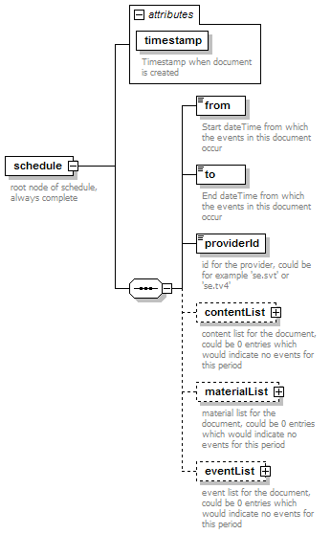
namespace | http://common.tv.se/schedule/v2_0
properties
  content | complex
children | from to providerId contentList materialList eventList
attributes
  Name | Type | Use | Default | Fixed | Annotation
  timestamp | xs:dateTime | required
    documentation | Timestamp when document is created
annotation
  documentation | root node of schedule, always complete
source | <xs:element name="schedule">  <xs:annotation>  <xs:documentation>root node of schedule, always complete</xs:documentation>  </xs:annotation>  <xs:complexType>  <xs:sequence>  <xs:element name="from" type="xs:dateTime">  <xs:annotation>  <xs:documentation>Start dateTime from which the events in this document occur</xs:documentation>  </xs:annotation>  </xs:element>  <xs:element name="to" type="xs:dateTime">  <xs:annotation>  <xs:documentation>End dateTime from which the events in this document occur</xs:documentation>  </xs:annotation>  </xs:element>  <xs:element name="providerId" type="xs:string">  <xs:annotation>  <xs:documentation>id for the provider, could be for example 'se.svt' or 'se.tv4'</xs:documentation>  </xs:annotation>  </xs:element>  <xs:element name="contentList" type="content:contentListType" minOccurs="0">  <xs:annotation>  <xs:documentation>content list for the document, could be 0 entries which would indicate no events for this period</xs:documentation>  </xs:annotation>  </xs:element>  <xs:element name="materialList" type="material:materialListType" minOccurs="0">  <xs:annotation>  <xs:documentation>material list for the document, could be 0 entries which would indicate no events for this period</xs:documentation>  </xs:annotation>  </xs:element>  <xs:element name="eventList" type="event:eventListType" minOccurs="0">  <xs:annotation>  <xs:documentation>event list for the document, could be 0 entries which would indicate no events for this period</xs:documentation>  </xs:annotation>  </xs:element>  </xs:sequence>  <xs:attribute name="timestamp" type="xs:dateTime" use="required">  <xs:annotation>  <xs:documentation>Timestamp when document is created</xs:documentation>  </xs:annotation>  </xs:attribute>  </xs:complexType>  </xs:element>

element schedule/from
diagram | 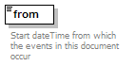
namespace | http://common.tv.se/schedule/v2_0
type | xs:dateTime
properties
  isRef | 0
  content | simple
annotation
  documentation | Start dateTime from which the events in this document occur
source | <xs:element name="from" type="xs:dateTime">  <xs:annotation>  <xs:documentation>Start dateTime from which the events in this document occur</xs:documentation>  </xs:annotation>  </xs:element>

element schedule/to
diagram | 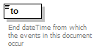
namespace | http://common.tv.se/schedule/v2_0
type | xs:dateTime
properties
  isRef | 0
  content | simple
annotation
  documentation | End dateTime from which the events in this document occur
source | <xs:element name="to" type="xs:dateTime">  <xs:annotation>  <xs:documentation>End dateTime from which the events in this document occur</xs:documentation>  </xs:annotation>  </xs:element>

element schedule/providerId
diagram | 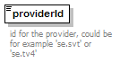
namespace | http://common.tv.se/schedule/v2_0
type | xs:string
properties
  isRef | 0
  content | simple
annotation
  documentation | id for the provider, could be for example 'se.svt' or 'se.tv4'
source | <xs:element name="providerId" type="xs:string">  <xs:annotation>  <xs:documentation>id for the provider, could be for example 'se.svt' or 'se.tv4'</xs:documentation>  </xs:annotation>  </xs:element>

element schedule/contentList
diagram | 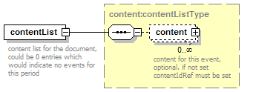
namespace | http://common.tv.se/schedule/v2_0
type | content:contentListType
properties
  isRef | 0
  content | complex
children | content
annotation
  documentation | content list for the document, could be 0 entries which would indicate no events for this period
source | <xs:element name="contentList" type="content:contentListType" minOccurs="0">  <xs:annotation>  <xs:documentation>content list for the document, could be 0 entries which would indicate no events for this period</xs:documentation>  </xs:annotation>  </xs:element>

element schedule/materialList
diagram | 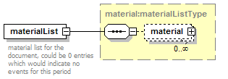
namespace | http://common.tv.se/schedule/v2_0
type | material:materialListType
properties
  isRef | 0
  content | complex
children | material
annotation
  documentation | material list for the document, could be 0 entries which would indicate no events for this period
source | <xs:element name="materialList" type="material:materialListType" minOccurs="0">  <xs:annotation>  <xs:documentation>material list for the document, could be 0 entries which would indicate no events for this period</xs:documentation>  </xs:annotation>  </xs:element>

element schedule/eventList
diagram | 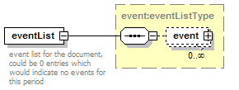
namespace | http://common.tv.se/schedule/v2_0
type | event:eventListType
properties
  isRef | 0
  content | complex
children | event
annotation
  documentation | event list for the document, could be 0 entries which would indicate no events for this period
source | <xs:element name="eventList" type="event:eventListType" minOccurs="0">  <xs:annotation>  <xs:documentation>event list for the document, could be 0 entries which would indicate no events for this period</xs:documentation>  </xs:annotation>  </xs:element>

element content:content
diagram | 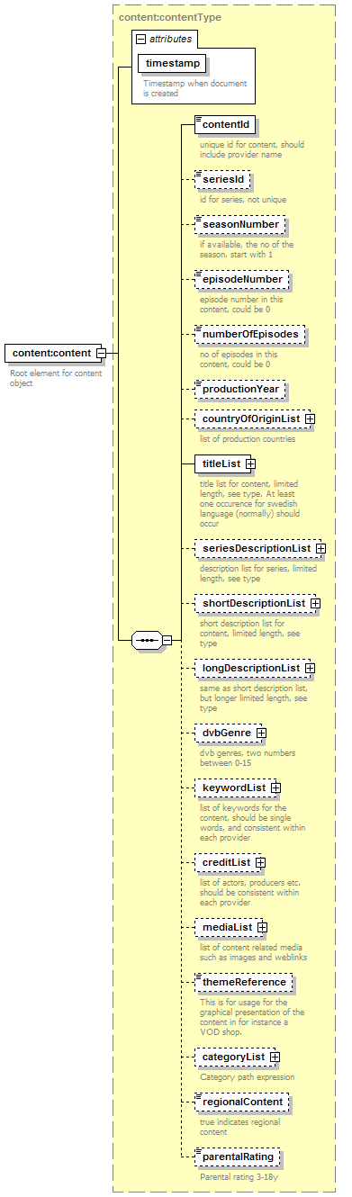
namespace | http://common.tv.se/content/v2_0
type | content:contentType
properties
  content | complex
children | contentId seriesId seasonNumber episodeNumber numberOfEpisodes productionYear countryOfOriginList titleList seriesDescriptionList shortDescriptionList longDescriptionList dvbGenre keywordList creditList mediaList themeReference categoryList regionalContent parentalRating
attributes
  Name | Type | Use | Default | Fixed | Annotation
  timestamp | xs:dateTime | required
    documentation | Timestamp when document is created
annotation
  documentation | Root element for content object
source | <xs:element name="content" type="contentType">  <xs:annotation>  <xs:documentation>Root element for content object</xs:documentation>  </xs:annotation>  </xs:element>

complexType content:categoryListType
diagram | 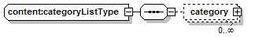
namespace | http://common.tv.se/content/v2_0
children | category
used by
  element | content:contentType/categoryList
source | <xs:complexType name="categoryListType">  <xs:sequence>  <xs:element name="category" minOccurs="0" maxOccurs="unbounded">  <xs:complexType>  <xs:sequence>  <xs:element name="treeNode" minOccurs="0" maxOccurs="unbounded">  <xs:annotation>  <xs:documentation>element in a category tree</xs:documentation>  </xs:annotation>  <xs:complexType>  <xs:simpleContent>  <xs:extension base="xs:string">  <xs:attribute name="order" type="xs:long">  <xs:annotation>  <xs:documentation>position in category tree</xs:documentation>  </xs:annotation>  </xs:attribute>  </xs:extension>  </xs:simpleContent>  </xs:complexType>  </xs:element>  </xs:sequence>  <xs:attribute name="level" type="xs:long">  <xs:annotation>  <xs:documentation>importance of category</xs:documentation>  </xs:annotation>  </xs:attribute>  </xs:complexType>  </xs:element>  </xs:sequence>  </xs:complexType>

element content:categoryListType/category
diagram | 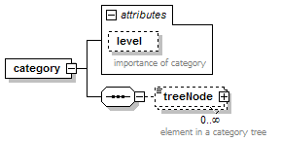
namespace | http://common.tv.se/content/v2_0
properties
  isRef | 0
  content | complex
children | treeNode
attributes
  Name | Type | Use | Default | Fixed | Annotation
  level | xs:long
    documentation | importance of category
source | <xs:element name="category" minOccurs="0" maxOccurs="unbounded">  <xs:complexType>  <xs:sequence>  <xs:element name="treeNode" minOccurs="0" maxOccurs="unbounded">  <xs:annotation>  <xs:documentation>element in a category tree</xs:documentation>  </xs:annotation>  <xs:complexType>  <xs:simpleContent>  <xs:extension base="xs:string">  <xs:attribute name="order" type="xs:long">  <xs:annotation>  <xs:documentation>position in category tree</xs:documentation>  </xs:annotation>  </xs:attribute>  </xs:extension>  </xs:simpleContent>  </xs:complexType>  </xs:element>  </xs:sequence>  <xs:attribute name="level" type="xs:long">  <xs:annotation>  <xs:documentation>importance of category</xs:documentation>  </xs:annotation>  </xs:attribute>  </xs:complexType>  </xs:element>

element content:categoryListType/category/treeNode
diagram | 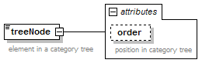
namespace | http://common.tv.se/content/v2_0
type | extension of xs:string
properties
  isRef | 0
  content | complex
attributes
  Name | Type | Use | Default | Fixed | Annotation
  order | xs:long
    documentation | position in category tree
annotation
  documentation | element in a category tree
source | <xs:element name="treeNode" minOccurs="0" maxOccurs="unbounded">  <xs:annotation>  <xs:documentation>element in a category tree</xs:documentation>  </xs:annotation>  <xs:complexType>  <xs:simpleContent>  <xs:extension base="xs:string">  <xs:attribute name="order" type="xs:long">  <xs:annotation>  <xs:documentation>position in category tree</xs:documentation>  </xs:annotation>  </xs:attribute>  </xs:extension>  </xs:simpleContent>  </xs:complexType>  </xs:element>

complexType content:contentListType
diagram | 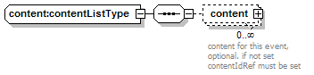
namespace | http://common.tv.se/content/v2_0
children | content
used by
  element | schedule/contentList
source | <xs:complexType name="contentListType">  <xs:sequence>  <xs:element name="content" type="contentType" minOccurs="0" maxOccurs="unbounded">  <xs:annotation>  <xs:documentation>content for this event, optional. if not set contentIdRef must be set</xs:documentation>  </xs:annotation>  </xs:element>  </xs:sequence>  </xs:complexType>

element content:contentListType/content
diagram | 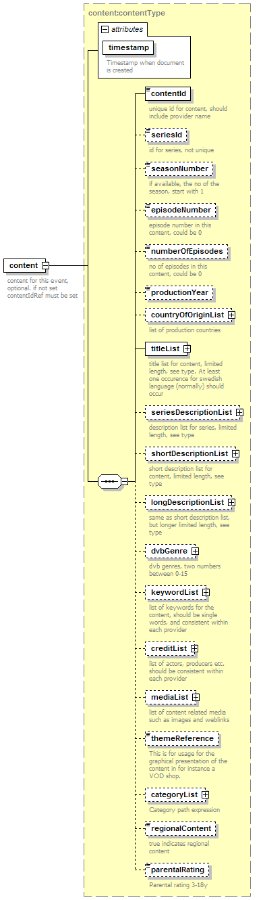
namespace | http://common.tv.se/content/v2_0
type | content:contentType
properties
  isRef | 0
  content | complex
children | contentId seriesId seasonNumber episodeNumber numberOfEpisodes productionYear countryOfOriginList titleList seriesDescriptionList shortDescriptionList longDescriptionList dvbGenre keywordList creditList mediaList themeReference categoryList regionalContent parentalRating
attributes
  Name | Type | Use | Default | Fixed | Annotation
  timestamp | xs:dateTime | required
    documentation | Timestamp when document is created
annotation
  documentation | content for this event, optional. if not set contentIdRef must be set
source | <xs:element name="content" type="contentType" minOccurs="0" maxOccurs="unbounded">  <xs:annotation>  <xs:documentation>content for this event, optional. if not set contentIdRef must be set</xs:documentation>  </xs:annotation>  </xs:element>

complexType content:contentType
diagram | 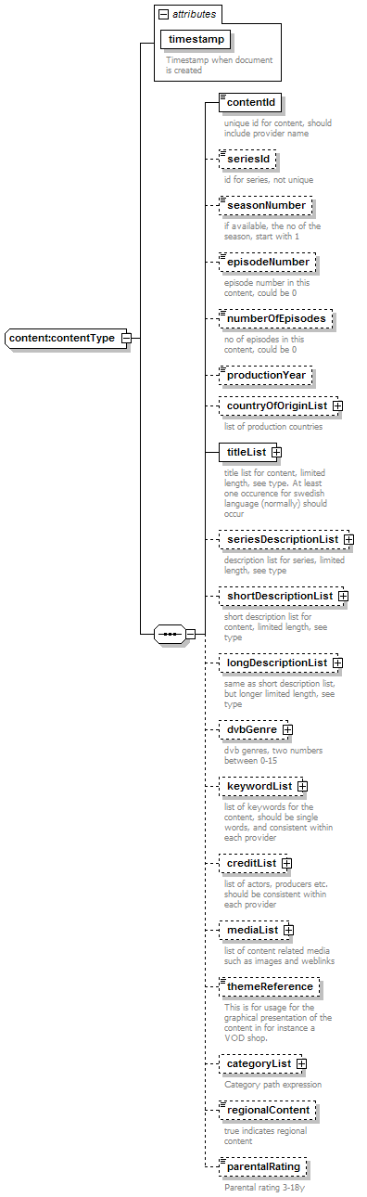
namespace | http://common.tv.se/content/v2_0
children | contentId seriesId seasonNumber episodeNumber numberOfEpisodes productionYear countryOfOriginList titleList seriesDescriptionList shortDescriptionList longDescriptionList dvbGenre keywordList creditList mediaList themeReference categoryList regionalContent parentalRating
used by
  elements | content:contentListType/content content:content
attributes
  Name | Type | Use | Default | Fixed | Annotation
  timestamp | xs:dateTime | required
    documentation | Timestamp when document is created
source | <xs:complexType name="contentType">  <xs:sequence>  <xs:element name="contentId" type="xs:string">  <xs:annotation>  <xs:documentation>unique id for content, should include provider name</xs:documentation>  </xs:annotation>  </xs:element>  <xs:element name="seriesId" type="xs:string" minOccurs="0">  <xs:annotation>  <xs:documentation>id for series, not unique</xs:documentation>  </xs:annotation>  </xs:element>  <xs:element name="seasonNumber" type="xs:long" minOccurs="0">  <xs:annotation>  <xs:documentation>if available, the no of the season, start with 1</xs:documentation>  </xs:annotation>  </xs:element>  <xs:element name="episodeNumber" type="xs:long" minOccurs="0">  <xs:annotation>  <xs:documentation>episode number in this content, could be 0</xs:documentation>  </xs:annotation>  </xs:element>  <xs:element name="numberOfEpisodes" type="xs:long" minOccurs="0">  <xs:annotation>  <xs:documentation>no of episodes in this content, could be 0</xs:documentation>  </xs:annotation>  </xs:element>  <xs:element name="productionYear" minOccurs="0">  <xs:simpleType>  <xs:restriction base="xs:string">  <xs:pattern value="[1-2][0-9][0-9][0-9]"/>  </xs:restriction>  </xs:simpleType>  </xs:element>  <xs:element name="countryOfOriginList" type="countryListType" minOccurs="0">  <xs:annotation>  <xs:documentation>list of production countries</xs:documentation>  </xs:annotation>  </xs:element>  <xs:element name="titleList" type="titleListType">  <xs:annotation>  <xs:documentation>title list for content, limited length, see type. At least one occurence for swedish language (normally) should occur</xs:documentation>  </xs:annotation>  </xs:element>  <xs:element name="seriesDescriptionList" type="seriesDescriptionListType" minOccurs="0">  <xs:annotation>  <xs:documentation>description list for series, limited length, see type</xs:documentation>  </xs:annotation>  </xs:element>  <xs:element name="shortDescriptionList" type="shortDescriptionListType" minOccurs="0">  <xs:annotation>  <xs:documentation>short description list for content, limited length, see type</xs:documentation>  </xs:annotation>  </xs:element>  <xs:element name="longDescriptionList" type="longDescriptionListType" minOccurs="0">  <xs:annotation>  <xs:documentation>same as short description list, but longer limited length, see type</xs:documentation>  </xs:annotation>  </xs:element>  <xs:element name="dvbGenre" type="dvbGenreType" minOccurs="0">  <xs:annotation>  <xs:documentation>dvb genres, two numbers between 0-15</xs:documentation>  </xs:annotation>  </xs:element>  <xs:element name="keywordList" type="keywordListType" minOccurs="0">  <xs:annotation>  <xs:documentation>list of keywords for the content, should be single words, and consistent within each provider</xs:documentation>  </xs:annotation>  </xs:element>  <xs:element name="creditList" type="creditListType" minOccurs="0">  <xs:annotation>  <xs:documentation>list of actors, producers etc. should be consistent within each provider</xs:documentation>  </xs:annotation>  </xs:element>  <xs:element name="mediaList" type="mediaListType" minOccurs="0">  <xs:annotation>  <xs:documentation>list of content related media such as images and weblinks</xs:documentation>  </xs:annotation>  </xs:element>  <xs:element name="themeReference" type="xs:string" minOccurs="0">  <xs:annotation>  <xs:documentation>This is for usage for the graphical presentation of the content in for instance a VOD shop.</xs:documentation>  </xs:annotation>  </xs:element>  <xs:element name="categoryList" type="categoryListType" minOccurs="0">  <xs:annotation>  <xs:documentation>Category path expression</xs:documentation>  </xs:annotation>  </xs:element>  <xs:element name="regionalContent" type="xs:boolean" minOccurs="0">  <xs:annotation>  <xs:documentation>true indicates regional content</xs:documentation>  </xs:annotation>  </xs:element>  <xs:element name="parentalRating" minOccurs="0">  <xs:annotation>  <xs:documentation>Parental rating 3-18y</xs:documentation>  </xs:annotation>  <xs:simpleType>  <xs:restriction base="xs:long">  <xs:minInclusive value="3"/>  <xs:maxInclusive value="18"/>  </xs:restriction>  </xs:simpleType>  </xs:element>  </xs:sequence>  <xs:attribute name="timestamp" type="xs:dateTime" use="required">  <xs:annotation>  <xs:documentation>Timestamp when document is created</xs:documentation>  </xs:annotation>  </xs:attribute>  </xs:complexType>

element content:contentType/contentId
diagram | 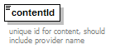
namespace | http://common.tv.se/content/v2_0
type | xs:string
properties
  isRef | 0
  content | simple
annotation
  documentation | unique id for content, should include provider name
source | <xs:element name="contentId" type="xs:string">  <xs:annotation>  <xs:documentation>unique id for content, should include provider name</xs:documentation>  </xs:annotation>  </xs:element>

element content:contentType/seriesId
diagram | 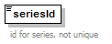
namespace | http://common.tv.se/content/v2_0
type | xs:string
properties
  isRef | 0
  content | simple
annotation
  documentation | id for series, not unique
source | <xs:element name="seriesId" type="xs:string" minOccurs="0">  <xs:annotation>  <xs:documentation>id for series, not unique</xs:documentation>  </xs:annotation>  </xs:element>

element content:contentType/seasonNumber
diagram | 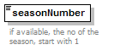
namespace | http://common.tv.se/content/v2_0
type | xs:long
properties
  isRef | 0
  content | simple
annotation
  documentation | if available, the no of the season, start with 1
source | <xs:element name="seasonNumber" type="xs:long" minOccurs="0">  <xs:annotation>  <xs:documentation>if available, the no of the season, start with 1</xs:documentation>  </xs:annotation>  </xs:element>

element content:contentType/episodeNumber
diagram | 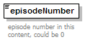
namespace | http://common.tv.se/content/v2_0
type | xs:long
properties
  isRef | 0
  content | simple
annotation
  documentation | episode number in this content, could be 0
source | <xs:element name="episodeNumber" type="xs:long" minOccurs="0">  <xs:annotation>  <xs:documentation>episode number in this content, could be 0</xs:documentation>  </xs:annotation>  </xs:element>

element content:contentType/numberOfEpisodes
diagram | 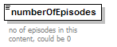
namespace | http://common.tv.se/content/v2_0
type | xs:long
properties
  isRef | 0
  content | simple
annotation
  documentation | no of episodes in this content, could be 0
source | <xs:element name="numberOfEpisodes" type="xs:long" minOccurs="0">  <xs:annotation>  <xs:documentation>no of episodes in this content, could be 0</xs:documentation>  </xs:annotation>  </xs:element>

element content:contentType/productionYear
diagram | 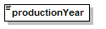
namespace | http://common.tv.se/content/v2_0
type | restriction of xs:string
properties
  isRef | 0
  content | simple
facets
  pattern | [1-2][0-9][0-9][0-9]
source | <xs:element name="productionYear" minOccurs="0">  <xs:simpleType>  <xs:restriction base="xs:string">  <xs:pattern value="[1-2][0-9][0-9][0-9]"/>  </xs:restriction>  </xs:simpleType>  </xs:element>

element content:contentType/countryOfOriginList
diagram | 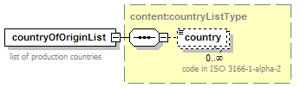
namespace | http://common.tv.se/content/v2_0
type | content:countryListType
properties
  isRef | 0
  content | complex
children | country
annotation
  documentation | list of production countries
source | <xs:element name="countryOfOriginList" type="countryListType" minOccurs="0">  <xs:annotation>  <xs:documentation>list of production countries</xs:documentation>  </xs:annotation>  </xs:element>

element content:contentType/titleList
diagram | 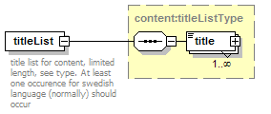
namespace | http://common.tv.se/content/v2_0
type | content:titleListType
properties
  isRef | 0
  content | complex
children | title
annotation
  documentation | title list for content, limited length, see type. At least one occurence for swedish language (normally) should occur
source | <xs:element name="titleList" type="titleListType">  <xs:annotation>  <xs:documentation>title list for content, limited length, see type. At least one occurence for swedish language (normally) should occur</xs:documentation>  </xs:annotation>  </xs:element>

element content:contentType/seriesDescriptionList
diagram | 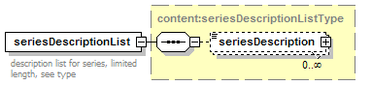
namespace | http://common.tv.se/content/v2_0
type | content:seriesDescriptionListType
properties
  isRef | 0
  content | complex
children | seriesDescription
annotation
  documentation | description list for series, limited length, see type
source | <xs:element name="seriesDescriptionList" type="seriesDescriptionListType" minOccurs="0">  <xs:annotation>  <xs:documentation>description list for series, limited length, see type</xs:documentation>  </xs:annotation>  </xs:element>

element content:contentType/shortDescriptionList
diagram | 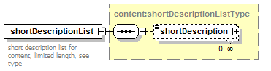
namespace | http://common.tv.se/content/v2_0
type | content:shortDescriptionListType
properties
  isRef | 0
  content | complex
children | shortDescription
annotation
  documentation | short description list for content, limited length, see type
source | <xs:element name="shortDescriptionList" type="shortDescriptionListType" minOccurs="0">  <xs:annotation>  <xs:documentation>short description list for content, limited length, see type</xs:documentation>  </xs:annotation>  </xs:element>

element content:contentType/longDescriptionList
diagram | 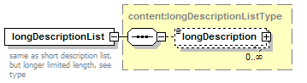
namespace | http://common.tv.se/content/v2_0
type | content:longDescriptionListType
properties
  isRef | 0
  content | complex
children | longDescription
annotation
  documentation | same as short description list, but longer limited length, see type
source | <xs:element name="longDescriptionList" type="longDescriptionListType" minOccurs="0">  <xs:annotation>  <xs:documentation>same as short description list, but longer limited length, see type</xs:documentation>  </xs:annotation>  </xs:element>

element content:contentType/dvbGenre
diagram | 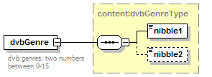
namespace | http://common.tv.se/content/v2_0
type | content:dvbGenreType
properties
  isRef | 0
  content | complex
children | nibble1 nibble2
annotation
  documentation | dvb genres, two numbers between 0-15
source | <xs:element name="dvbGenre" type="dvbGenreType" minOccurs="0">  <xs:annotation>  <xs:documentation>dvb genres, two numbers between 0-15</xs:documentation>  </xs:annotation>  </xs:element>

element content:contentType/keywordList
diagram | 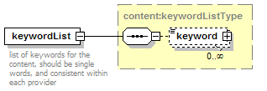
namespace | http://common.tv.se/content/v2_0
type | content:keywordListType
properties
  isRef | 0
  content | complex
children | keyword
annotation
  documentation | list of keywords for the content, should be single words, and consistent within each provider
source | <xs:element name="keywordList" type="keywordListType" minOccurs="0">  <xs:annotation>  <xs:documentation>list of keywords for the content, should be single words, and consistent within each provider</xs:documentation>  </xs:annotation>  </xs:element>

element content:contentType/creditList
diagram | 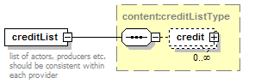
namespace | http://common.tv.se/content/v2_0
type | content:creditListType
properties
  isRef | 0
  content | complex
children | credit
annotation
  documentation | list of actors, producers etc. should be consistent within each provider
source | <xs:element name="creditList" type="creditListType" minOccurs="0">  <xs:annotation>  <xs:documentation>list of actors, producers etc. should be consistent within each provider</xs:documentation>  </xs:annotation>  </xs:element>

element content:contentType/mediaList
diagram | 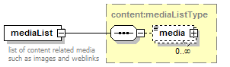
namespace | http://common.tv.se/content/v2_0
type | content:mediaListType
properties
  isRef | 0
  content | complex
children | media
annotation
  documentation | list of content related media such as images and weblinks
source | <xs:element name="mediaList" type="mediaListType" minOccurs="0">  <xs:annotation>  <xs:documentation>list of content related media such as images and weblinks</xs:documentation>  </xs:annotation>  </xs:element>

element content:contentType/themeReference
diagram | 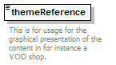
namespace | http://common.tv.se/content/v2_0
type | xs:string
properties
  isRef | 0
  content | simple
annotation
  documentation | This is for usage for the graphical presentation of the content in for instance a VOD shop.
source | <xs:element name="themeReference" type="xs:string" minOccurs="0">  <xs:annotation>  <xs:documentation>This is for usage for the graphical presentation of the content in for instance a VOD shop.</xs:documentation>  </xs:annotation>  </xs:element>

element content:contentType/categoryList
diagram | 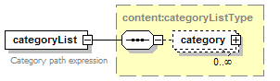
namespace | http://common.tv.se/content/v2_0
type | content:categoryListType
properties
  isRef | 0
  content | complex
children | category
annotation
  documentation | Category path expression
source | <xs:element name="categoryList" type="categoryListType" minOccurs="0">  <xs:annotation>  <xs:documentation>Category path expression</xs:documentation>  </xs:annotation>  </xs:element>

element content:contentType/regionalContent
diagram | 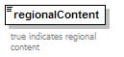
namespace | http://common.tv.se/content/v2_0
type | xs:boolean
properties
  isRef | 0
  content | simple
annotation
  documentation | true indicates regional content
source | <xs:element name="regionalContent" type="xs:boolean" minOccurs="0">  <xs:annotation>  <xs:documentation>true indicates regional content</xs:documentation>  </xs:annotation>  </xs:element>

element content:contentType/parentalRating
diagram | 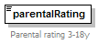
namespace | http://common.tv.se/content/v2_0
type | restriction of xs:long
properties
  isRef | 0
  content | simple
facets
  minInclusive | 3
  maxInclusive | 18
annotation
  documentation | Parental rating 3-18y
source | <xs:element name="parentalRating" minOccurs="0">  <xs:annotation>  <xs:documentation>Parental rating 3-18y</xs:documentation>  </xs:annotation>  <xs:simpleType>  <xs:restriction base="xs:long">  <xs:minInclusive value="3"/>  <xs:maxInclusive value="18"/>  </xs:restriction>  </xs:simpleType>  </xs:element>

complexType content:countryListType
diagram | 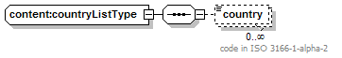
namespace | http://common.tv.se/content/v2_0
children | country
used by
  element | content:contentType/countryOfOriginList
source | <xs:complexType name="countryListType">  <xs:sequence>  <xs:element name="country" type="xs:string" minOccurs="0" maxOccurs="unbounded">  <xs:annotation>  <xs:documentation>code in ISO 3166-1-alpha-2</xs:documentation>  </xs:annotation>  </xs:element>  </xs:sequence>  </xs:complexType>

element content:countryListType/country
diagram | 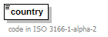
namespace | http://common.tv.se/content/v2_0
type | xs:string
properties
  isRef | 0
  content | simple
annotation
  documentation | code in ISO 3166-1-alpha-2
source | <xs:element name="country" type="xs:string" minOccurs="0" maxOccurs="unbounded">  <xs:annotation>  <xs:documentation>code in ISO 3166-1-alpha-2</xs:documentation>  </xs:annotation>  </xs:element>

complexType content:creditListType
diagram | 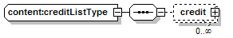
namespace | http://common.tv.se/content/v2_0
children | credit
used by
  element | content:contentType/creditList
source | <xs:complexType name="creditListType">  <xs:sequence>  <xs:element name="credit" type="creditType" minOccurs="0" maxOccurs="unbounded"/>  </xs:sequence>  </xs:complexType>

element content:creditListType/credit
diagram | 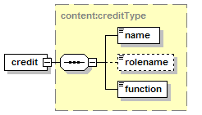
namespace | http://common.tv.se/content/v2_0
type | content:creditType
properties
  isRef | 0
  content | complex
children | name rolename function
source | <xs:element name="credit" type="creditType" minOccurs="0" maxOccurs="unbounded"/>

complexType content:creditType
diagram | 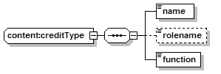
namespace | http://common.tv.se/content/v2_0
children | name rolename function
used by
  element | content:creditListType/credit
source | <xs:complexType name="creditType">  <xs:sequence>  <xs:element name="name" type="xs:string"/>  <xs:element name="rolename" type="xs:string" minOccurs="0"/>  <xs:element name="function">  <xs:simpleType>  <xs:restriction base="xs:string">  <xs:enumeration value="director"/>  <xs:enumeration value="actor"/>  <xs:enumeration value="guest"/>  <xs:enumeration value="host"/>  <xs:enumeration value="artist"/>  <xs:enumeration value="narrator"/>  <xs:enumeration value="other"/>  </xs:restriction>  </xs:simpleType>  </xs:element>  </xs:sequence>  </xs:complexType>

element content:creditType/name
diagram | 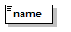
namespace | http://common.tv.se/content/v2_0
type | xs:string
properties
  isRef | 0
  content | simple
source | <xs:element name="name" type="xs:string"/>

element content:creditType/rolename
diagram | 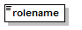
namespace | http://common.tv.se/content/v2_0
type | xs:string
properties
  isRef | 0
  content | simple
source | <xs:element name="rolename" type="xs:string" minOccurs="0"/>

element content:creditType/function
diagram | 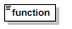
namespace | http://common.tv.se/content/v2_0
type | restriction of xs:string
properties
  isRef | 0
  content | simple
facets
  enumeration | director
  enumeration | actor
  enumeration | guest
  enumeration | host
  enumeration | artist
  enumeration | narrator
  enumeration | other
source | <xs:element name="function">  <xs:simpleType>  <xs:restriction base="xs:string">  <xs:enumeration value="director"/>  <xs:enumeration value="actor"/>  <xs:enumeration value="guest"/>  <xs:enumeration value="host"/>  <xs:enumeration value="artist"/>  <xs:enumeration value="narrator"/>  <xs:enumeration value="other"/>  </xs:restriction>  </xs:simpleType>  </xs:element>

complexType content:descriptionType
diagram | 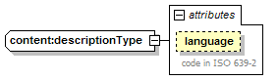
namespace | http://common.tv.se/content/v2_0
type | restriction of content:textType
properties
  base | textType
used by
  element | content:seriesDescriptionListType/seriesDescription
  complexType | content:longDescriptionType
facets
  maxLength | 1000
attributes
  Name | Type | Use | Default | Fixed | Annotation
  language | xs:language
    documentation | code in ISO 639-2
source | <xs:complexType name="descriptionType">  <xs:simpleContent>  <xs:restriction base="textType">  <xs:maxLength value="1000"/>  </xs:restriction>  </xs:simpleContent>  </xs:complexType>

complexType content:dvbGenreType
diagram | 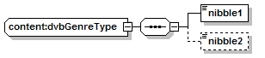
namespace | http://common.tv.se/content/v2_0
children | nibble1 nibble2
used by
  element | content:contentType/dvbGenre
source | <xs:complexType name="dvbGenreType">  <xs:sequence>  <xs:element name="nibble1" type="dvbGenreNibbleType"/>  <xs:element name="nibble2" type="dvbGenreNibbleType" minOccurs="0"/>  </xs:sequence>  </xs:complexType>

element content:dvbGenreType/nibble1
diagram | 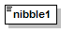
namespace | http://common.tv.se/content/v2_0
type | content:dvbGenreNibbleType
properties
  isRef | 0
  content | simple
facets
  minInclusive | 0
  maxInclusive | 15
source | <xs:element name="nibble1" type="dvbGenreNibbleType"/>

element content:dvbGenreType/nibble2
diagram | 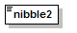
namespace | http://common.tv.se/content/v2_0
type | content:dvbGenreNibbleType
properties
  isRef | 0
  content | simple
facets
  minInclusive | 0
  maxInclusive | 15
source | <xs:element name="nibble2" type="dvbGenreNibbleType" minOccurs="0"/>

complexType content:keywordListType
diagram | 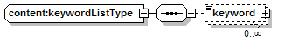
namespace | http://common.tv.se/content/v2_0
children | keyword
used by
  element | content:contentType/keywordList
source | <xs:complexType name="keywordListType">  <xs:sequence>  <xs:element name="keyword" type="keywordType" minOccurs="0" maxOccurs="unbounded"/>  </xs:sequence>  </xs:complexType>

element content:keywordListType/keyword
diagram | 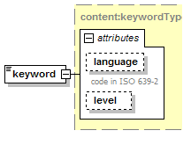
namespace | http://common.tv.se/content/v2_0
type | content:keywordType
properties
  isRef | 0
  content | complex
attributes
  Name | Type | Use | Default | Fixed | Annotation
  language | xs:language
    documentation | code in ISO 639-2
  level | xs:long
source | <xs:element name="keyword" type="keywordType" minOccurs="0" maxOccurs="unbounded"/>

complexType content:keywordType
diagram | 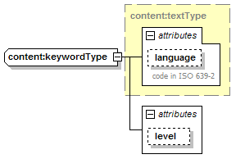
namespace | http://common.tv.se/content/v2_0
type | extension of content:textType
properties
  base | textType
used by
  element | content:keywordListType/keyword
attributes
  Name | Type | Use | Default | Fixed | Annotation
  language | xs:language
    documentation | code in ISO 639-2
  level | xs:long
source | <xs:complexType name="keywordType">  <xs:simpleContent>  <xs:extension base="textType">  <xs:attribute name="level" type="xs:long"/>  </xs:extension>  </xs:simpleContent>  </xs:complexType>

complexType content:longDescriptionListType
diagram | 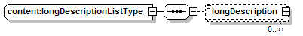
namespace | http://common.tv.se/content/v2_0
children | longDescription
used by
  element | content:contentType/longDescriptionList
source | <xs:complexType name="longDescriptionListType">  <xs:sequence>  <xs:element name="longDescription" type="longDescriptionType" minOccurs="0" maxOccurs="unbounded"/>  </xs:sequence>  </xs:complexType>

element content:longDescriptionListType/longDescription
diagram | 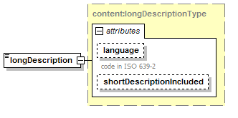
namespace | http://common.tv.se/content/v2_0
type | content:longDescriptionType
properties
  isRef | 0
  content | complex
facets
  maxLength | 1000
attributes
  Name | Type | Use | Default | Fixed | Annotation
  language | xs:language
    documentation | code in ISO 639-2
  shortDescriptionIncluded | xs:boolean
source | <xs:element name="longDescription" type="longDescriptionType" minOccurs="0" maxOccurs="unbounded"/>

complexType content:longDescriptionType
diagram | 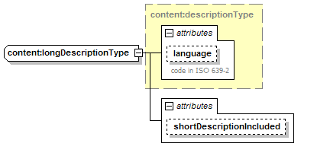
namespace | http://common.tv.se/content/v2_0
type | extension of content:descriptionType
properties
  base | descriptionType
used by
  element | content:longDescriptionListType/longDescription
facets
  maxLength | 1000
attributes
  Name | Type | Use | Default | Fixed | Annotation
  language | xs:language
    documentation | code in ISO 639-2
  shortDescriptionIncluded | xs:boolean
source | <xs:complexType name="longDescriptionType">  <xs:simpleContent>  <xs:extension base="descriptionType">  <xs:attribute name="shortDescriptionIncluded" type="xs:boolean"/>  </xs:extension>  </xs:simpleContent>  </xs:complexType>

complexType content:mediaListType
diagram | 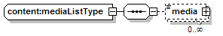
namespace | http://common.tv.se/content/v2_0
children | media
used by
  element | content:contentType/mediaList
source | <xs:complexType name="mediaListType">  <xs:sequence>  <xs:element name="media" type="mediaType" minOccurs="0" maxOccurs="unbounded"/>  </xs:sequence>  </xs:complexType>

element content:mediaListType/media
diagram | 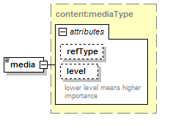
namespace | http://common.tv.se/content/v2_0
type | content:mediaType
properties
  isRef | 0
  content | complex
attributes
  Name | Type | Use | Default | Fixed | Annotation
  refType
  level | xs:long
    documentation | lower level means higher importance
source | <xs:element name="media" type="mediaType" minOccurs="0" maxOccurs="unbounded"/>

complexType content:mediaType
diagram | 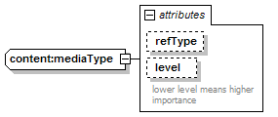
namespace | http://common.tv.se/content/v2_0
type | extension of xs:string
properties
  base | xs:string
used by
  element | content:mediaListType/media
attributes
  Name | Type | Use | Default | Fixed | Annotation
  refType
  level | xs:long
    documentation | lower level means higher importance
source | <xs:complexType name="mediaType">  <xs:simpleContent>  <xs:extension base="xs:string">  <xs:attribute name="refType">  <xs:simpleType>  <xs:restriction base="xs:string">  <xs:enumeration value="weblink"/>  <xs:enumeration value="image"/>  </xs:restriction>  </xs:simpleType>  </xs:attribute>  <xs:attribute name="level" type="xs:long">  <xs:annotation>  <xs:documentation>lower level means higher importance</xs:documentation>  </xs:annotation>  </xs:attribute>  </xs:extension>  </xs:simpleContent>  </xs:complexType>

complexType content:seriesDescriptionListType
diagram | 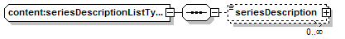
namespace | http://common.tv.se/content/v2_0
children | seriesDescription
used by
  element | content:contentType/seriesDescriptionList
source | <xs:complexType name="seriesDescriptionListType">  <xs:sequence>  <xs:element name="seriesDescription" type="descriptionType" minOccurs="0" maxOccurs="unbounded"/>  </xs:sequence>  </xs:complexType>

element content:seriesDescriptionListType/seriesDescription
diagram | 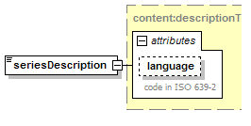
namespace | http://common.tv.se/content/v2_0
type | content:descriptionType
properties
  isRef | 0
  content | complex
facets
  maxLength | 1000
attributes
  Name | Type | Use | Default | Fixed | Annotation
  language | xs:language
    documentation | code in ISO 639-2
source | <xs:element name="seriesDescription" type="descriptionType" minOccurs="0" maxOccurs="unbounded"/>

complexType content:shortDescriptionListType
diagram | 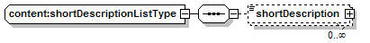
namespace | http://common.tv.se/content/v2_0
children | shortDescription
used by
  element | content:contentType/shortDescriptionList
source | <xs:complexType name="shortDescriptionListType">  <xs:sequence>  <xs:element name="shortDescription" type="shortDescriptionType" minOccurs="0" maxOccurs="unbounded"/>  </xs:sequence>  </xs:complexType>

element content:shortDescriptionListType/shortDescription
diagram | 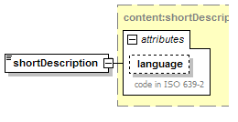
namespace | http://common.tv.se/content/v2_0
type | content:shortDescriptionType
properties
  isRef | 0
  content | complex
facets
  maxLength | 120
attributes
  Name | Type | Use | Default | Fixed | Annotation
  language | xs:language
    documentation | code in ISO 639-2
source | <xs:element name="shortDescription" type="shortDescriptionType" minOccurs="0" maxOccurs="unbounded"/>

complexType content:shortDescriptionType
diagram | 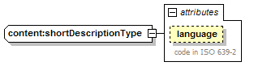
namespace | http://common.tv.se/content/v2_0
type | restriction of content:textType
properties
  base | textType
used by
  element | content:shortDescriptionListType/shortDescription
facets
  maxLength | 120
attributes
  Name | Type | Use | Default | Fixed | Annotation
  language | xs:language
    documentation | code in ISO 639-2
source | <xs:complexType name="shortDescriptionType">  <xs:simpleContent>  <xs:restriction base="textType">  <xs:maxLength value="120"/>  </xs:restriction>  </xs:simpleContent>  </xs:complexType>

complexType content:textType
diagram | 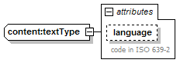
namespace | http://common.tv.se/content/v2_0
type | extension of xs:string
properties
  base | xs:string
used by
  complexTypes | content:descriptionType content:keywordType content:shortDescriptionType content:titleType
attributes
  Name | Type | Use | Default | Fixed | Annotation
  language | xs:language
    documentation | code in ISO 639-2
source | <xs:complexType name="textType">  <xs:simpleContent>  <xs:extension base="xs:string">  <xs:attribute name="language" type="xs:language">  <xs:annotation>  <xs:documentation>code in ISO 639-2</xs:documentation>  </xs:annotation>  </xs:attribute>  </xs:extension>  </xs:simpleContent>  </xs:complexType>

complexType content:titleListType
diagram | 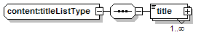
namespace | http://common.tv.se/content/v2_0
children | title
used by
  element | content:contentType/titleList
source | <xs:complexType name="titleListType">  <xs:sequence>  <xs:element name="title" type="titleType" maxOccurs="unbounded"/>  </xs:sequence>  </xs:complexType>

element content:titleListType/title
diagram | 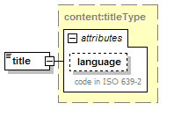
namespace | http://common.tv.se/content/v2_0
type | content:titleType
properties
  isRef | 0
  content | complex
facets
  maxLength | 40
attributes
  Name | Type | Use | Default | Fixed | Annotation
  language | xs:language
    documentation | code in ISO 639-2
source | <xs:element name="title" type="titleType" maxOccurs="unbounded"/>

complexType content:titleType
diagram | 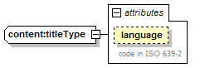
namespace | http://common.tv.se/content/v2_0
type | restriction of content:textType
properties
  base | textType
used by
  element | content:titleListType/title
facets
  maxLength | 40
attributes
  Name | Type | Use | Default | Fixed | Annotation
  language | xs:language
    documentation | code in ISO 639-2
source | <xs:complexType name="titleType">  <xs:simpleContent>  <xs:restriction base="textType">  <xs:maxLength value="40"/>  </xs:restriction>  </xs:simpleContent>  </xs:complexType>

simpleType content:dvbGenreNibbleType
namespace | http://common.tv.se/content/v2_0
type | restriction of xs:int
used by
  elements | content:dvbGenreType/nibble1 content:dvbGenreType/nibble2
facets
  minInclusive | 0
  maxInclusive | 15
source | <xs:simpleType name="dvbGenreNibbleType">  <xs:restriction base="xs:int">  <xs:minInclusive value="0"/>  <xs:maxInclusive value="15"/>  </xs:restriction>  </xs:simpleType>

element event:event
diagram | 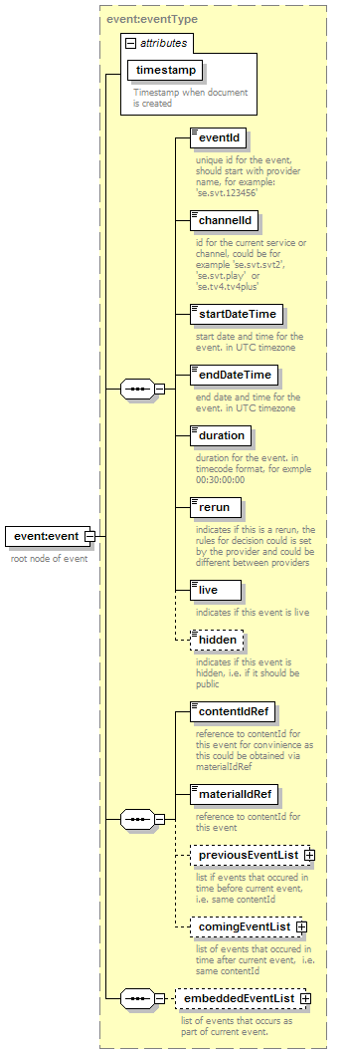
namespace | http://common.tv.se/event/v2_0
type | event:eventType
properties
  content | complex
children | eventId channelId startDateTime endDateTime duration rerun live hidden contentIdRef materialIdRef previousEventList comingEventList embeddedEventList
attributes
  Name | Type | Use | Default | Fixed | Annotation
  timestamp | xs:dateTime | required
    documentation | Timestamp when document is created
annotation
  documentation | root node of event
source | <xs:element name="event" type="eventType">  <xs:annotation>  <xs:documentation>root node of event</xs:documentation>  </xs:annotation>  </xs:element>

complexType event:basicEventListType
diagram | 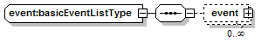
namespace | http://common.tv.se/event/v2_0
children | event
used by
  elements | event:embeddedEventType/comingEventList event:embeddedEventType/previousEventList
source | <xs:complexType name="basicEventListType">  <xs:sequence>  <xs:element name="event" type="basicEventType" minOccurs="0" maxOccurs="unbounded"/>  </xs:sequence>  </xs:complexType>

element event:basicEventListType/event
diagram | 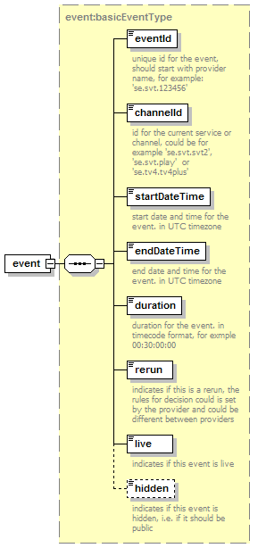
namespace | http://common.tv.se/event/v2_0
type | event:basicEventType
properties
  isRef | 0
  content | complex
children | eventId channelId startDateTime endDateTime duration rerun live hidden
source | <xs:element name="event" type="basicEventType" minOccurs="0" maxOccurs="unbounded"/>

complexType event:basicEventType
diagram | 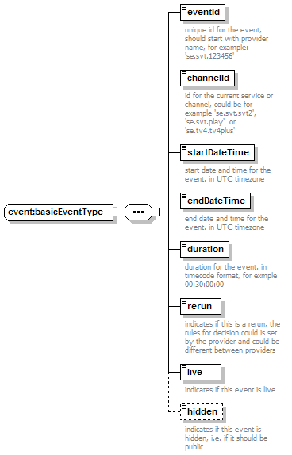
namespace | http://common.tv.se/event/v2_0
children | eventId channelId startDateTime endDateTime duration rerun live hidden
used by
  element | event:basicEventListType/event
  complexType | event:embeddedEventType
source | <xs:complexType name="basicEventType">  <xs:sequence>  <xs:element name="eventId" type="xs:string">  <xs:annotation>  <xs:documentation>unique id for the event, should start with provider name, for example: 'se.svt.123456'</xs:documentation>  </xs:annotation>  </xs:element>  <xs:element name="channelId" type="xs:string">  <xs:annotation>  <xs:documentation>id for the current service or channel, could be for example 'se.svt.svt2', 'se.svt.play' or 'se.tv4.tv4plus'</xs:documentation>  </xs:annotation>  </xs:element>  <xs:element name="startDateTime" type="xs:dateTime">  <xs:annotation>  <xs:documentation>start date and time for the event. in UTC timezone</xs:documentation>  </xs:annotation>  </xs:element>  <xs:element name="endDateTime" type="xs:dateTime">  <xs:annotation>  <xs:documentation>end date and time for the event. in UTC timezone</xs:documentation>  </xs:annotation>  </xs:element>  <xs:element name="duration" type="timecode">  <xs:annotation>  <xs:documentation>duration for the event. in timecode format, for exmple 00:30:00:00</xs:documentation>  </xs:annotation>  </xs:element>  <xs:element name="rerun" type="xs:boolean">  <xs:annotation>  <xs:documentation>indicates if this is a rerun, the rules for decision could is set by the provider and could be different between providers</xs:documentation>  </xs:annotation>  </xs:element>  <xs:element name="live" type="xs:boolean">  <xs:annotation>  <xs:documentation>indicates if this event is live</xs:documentation>  </xs:annotation>  </xs:element>  <xs:element name="hidden" type="xs:boolean" minOccurs="0">  <xs:annotation>  <xs:documentation>indicates if this event is hidden, i.e. if it should be public</xs:documentation>  </xs:annotation>  </xs:element>  </xs:sequence>  </xs:complexType>

element event:basicEventType/eventId
diagram | 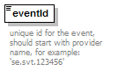
namespace | http://common.tv.se/event/v2_0
type | xs:string
properties
  isRef | 0
  content | simple
annotation
  documentation | unique id for the event, should start with provider name, for example: 'se.svt.123456'
source | <xs:element name="eventId" type="xs:string">  <xs:annotation>  <xs:documentation>unique id for the event, should start with provider name, for example: 'se.svt.123456'</xs:documentation>  </xs:annotation>  </xs:element>

element event:basicEventType/channelId
diagram | 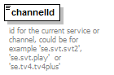
namespace | http://common.tv.se/event/v2_0
type | xs:string
properties
  isRef | 0
  content | simple
annotation
  documentation | id for the current service or channel, could be for example 'se.svt.svt2', 'se.svt.play' or 'se.tv4.tv4plus'
source | <xs:element name="channelId" type="xs:string">  <xs:annotation>  <xs:documentation>id for the current service or channel, could be for example 'se.svt.svt2', 'se.svt.play' or 'se.tv4.tv4plus'</xs:documentation>  </xs:annotation>  </xs:element>

element event:basicEventType/startDateTime
diagram | 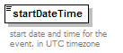
namespace | http://common.tv.se/event/v2_0
type | xs:dateTime
properties
  isRef | 0
  content | simple
annotation
  documentation | start date and time for the event. in UTC timezone
source | <xs:element name="startDateTime" type="xs:dateTime">  <xs:annotation>  <xs:documentation>start date and time for the event. in UTC timezone</xs:documentation>  </xs:annotation>  </xs:element>

element event:basicEventType/endDateTime
diagram | 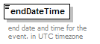
namespace | http://common.tv.se/event/v2_0
type | xs:dateTime
properties
  isRef | 0
  content | simple
annotation
  documentation | end date and time for the event. in UTC timezone
source | <xs:element name="endDateTime" type="xs:dateTime">  <xs:annotation>  <xs:documentation>end date and time for the event. in UTC timezone</xs:documentation>  </xs:annotation>  </xs:element>

element event:basicEventType/duration
diagram | 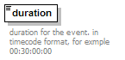
namespace | http://common.tv.se/event/v2_0
type | event:timecode
properties
  isRef | 0
  content | simple
annotation
  documentation | duration for the event. in timecode format, for exmple 00:30:00:00
source | <xs:element name="duration" type="timecode">  <xs:annotation>  <xs:documentation>duration for the event. in timecode format, for exmple 00:30:00:00</xs:documentation>  </xs:annotation>  </xs:element>

element event:basicEventType/rerun
diagram | 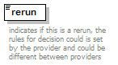
namespace | http://common.tv.se/event/v2_0
type | xs:boolean
properties
  isRef | 0
  content | simple
annotation
  documentation | indicates if this is a rerun, the rules for decision could is set by the provider and could be different between providers
source | <xs:element name="rerun" type="xs:boolean">  <xs:annotation>  <xs:documentation>indicates if this is a rerun, the rules for decision could is set by the provider and could be different between providers</xs:documentation>  </xs:annotation>  </xs:element>

element event:basicEventType/live
diagram | 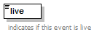
namespace | http://common.tv.se/event/v2_0
type | xs:boolean
properties
  isRef | 0
  content | simple
annotation
  documentation | indicates if this event is live
source | <xs:element name="live" type="xs:boolean">  <xs:annotation>  <xs:documentation>indicates if this event is live</xs:documentation>  </xs:annotation>  </xs:element>

element event:basicEventType/hidden
diagram | 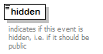
namespace | http://common.tv.se/event/v2_0
type | xs:boolean
properties
  isRef | 0
  content | simple
annotation
  documentation | indicates if this event is hidden, i.e. if it should be public
source | <xs:element name="hidden" type="xs:boolean" minOccurs="0">  <xs:annotation>  <xs:documentation>indicates if this event is hidden, i.e. if it should be public</xs:documentation>  </xs:annotation>  </xs:element>

complexType event:embeddedEventListType
diagram | 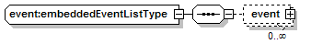
namespace | http://common.tv.se/event/v2_0
children | event
used by
  element | event:eventType/embeddedEventList
source | <xs:complexType name="embeddedEventListType">  <xs:sequence>  <xs:element name="event" type="embeddedEventType" minOccurs="0" maxOccurs="unbounded"/>  </xs:sequence>  </xs:complexType>

element event:embeddedEventListType/event
diagram | 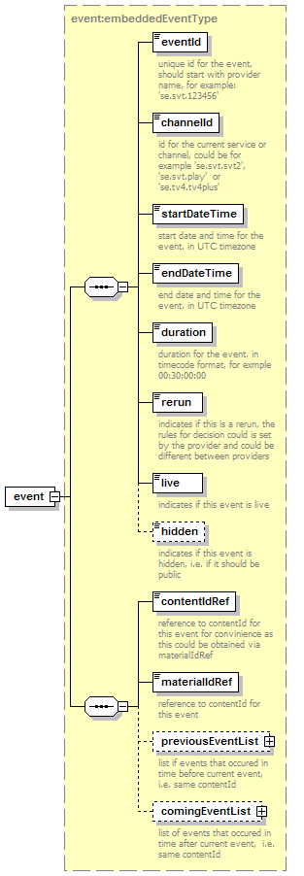
namespace | http://common.tv.se/event/v2_0
type | event:embeddedEventType
properties
  isRef | 0
  content | complex
children | eventId channelId startDateTime endDateTime duration rerun live hidden contentIdRef materialIdRef previousEventList comingEventList
source | <xs:element name="event" type="embeddedEventType" minOccurs="0" maxOccurs="unbounded"/>

complexType event:embeddedEventType
diagram | 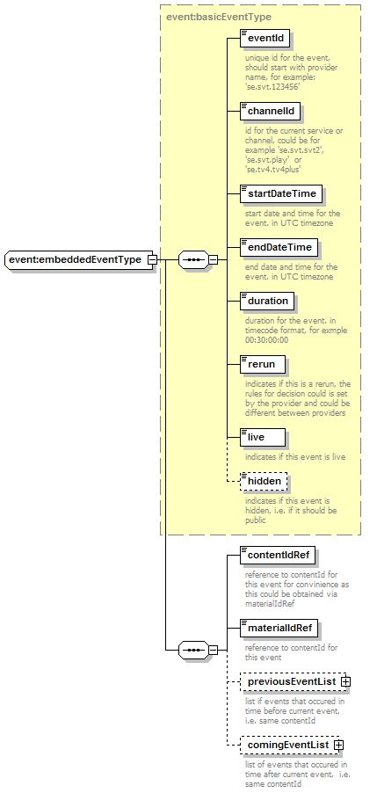
namespace | http://common.tv.se/event/v2_0
type | extension of event:basicEventType
properties
  base | basicEventType
children | eventId channelId startDateTime endDateTime duration rerun live hidden contentIdRef materialIdRef previousEventList comingEventList
used by
  element | event:embeddedEventListType/event
  complexType | event:eventType
source | <xs:complexType name="embeddedEventType">  <xs:complexContent>  <xs:extension base="basicEventType">  <xs:sequence>  <xs:element name="contentIdRef" type="xs:string">  <xs:annotation>  <xs:documentation>reference to contentId for this event for convinience as this could be obtained via materialIdRef</xs:documentation>  </xs:annotation>  </xs:element>  <xs:element name="materialIdRef" type="xs:string">  <xs:annotation>  <xs:documentation>reference to contentId for this event</xs:documentation>  </xs:annotation>  </xs:element>  <xs:element name="previousEventList" type="basicEventListType" minOccurs="0">  <xs:annotation>  <xs:documentation>list if events that occured in time before current event, i.e. same contentId</xs:documentation>  </xs:annotation>  </xs:element>  <xs:element name="comingEventList" type="basicEventListType" minOccurs="0">  <xs:annotation>  <xs:documentation>list of events that occured in time after current event, i.e. same contentId</xs:documentation>  </xs:annotation>  </xs:element>  </xs:sequence>  </xs:extension>  </xs:complexContent>  </xs:complexType>

element event:embeddedEventType/contentIdRef
diagram | 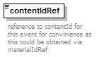
namespace | http://common.tv.se/event/v2_0
type | xs:string
properties
  isRef | 0
  content | simple
annotation
  documentation | reference to contentId for this event for convinience as this could be obtained via materialIdRef
source | <xs:element name="contentIdRef" type="xs:string">  <xs:annotation>  <xs:documentation>reference to contentId for this event for convinience as this could be obtained via materialIdRef</xs:documentation>  </xs:annotation>  </xs:element>

element event:embeddedEventType/materialIdRef
diagram | 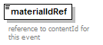
namespace | http://common.tv.se/event/v2_0
type | xs:string
properties
  isRef | 0
  content | simple
annotation
  documentation | reference to contentId for this event
source | <xs:element name="materialIdRef" type="xs:string">  <xs:annotation>  <xs:documentation>reference to contentId for this event</xs:documentation>  </xs:annotation>  </xs:element>

element event:embeddedEventType/previousEventList
diagram | 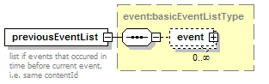
namespace | http://common.tv.se/event/v2_0
type | event:basicEventListType
properties
  isRef | 0
  content | complex
children | event
annotation
  documentation | list if events that occured in time before current event, i.e. same contentId
source | <xs:element name="previousEventList" type="basicEventListType" minOccurs="0">  <xs:annotation>  <xs:documentation>list if events that occured in time before current event, i.e. same contentId</xs:documentation>  </xs:annotation>  </xs:element>

element event:embeddedEventType/comingEventList
diagram | 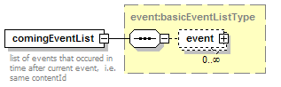
namespace | http://common.tv.se/event/v2_0
type | event:basicEventListType
properties
  isRef | 0
  content | complex
children | event
annotation
  documentation | list of events that occured in time after current event, i.e. same contentId
source | <xs:element name="comingEventList" type="basicEventListType" minOccurs="0">  <xs:annotation>  <xs:documentation>list of events that occured in time after current event, i.e. same contentId</xs:documentation>  </xs:annotation>  </xs:element>

complexType event:eventListType
diagram | 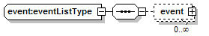
namespace | http://common.tv.se/event/v2_0
children | event
used by
  element | schedule/eventList
source | <xs:complexType name="eventListType">  <xs:sequence>  <xs:element name="event" type="eventType" minOccurs="0" maxOccurs="unbounded"/>  </xs:sequence>  </xs:complexType>

element event:eventListType/event
diagram | 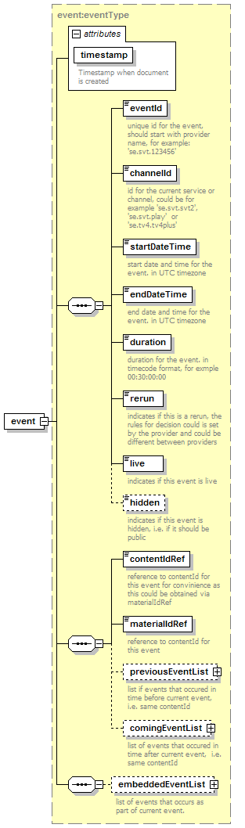
namespace | http://common.tv.se/event/v2_0
type | event:eventType
properties
  isRef | 0
  content | complex
children | eventId channelId startDateTime endDateTime duration rerun live hidden contentIdRef materialIdRef previousEventList comingEventList embeddedEventList
attributes
  Name | Type | Use | Default | Fixed | Annotation
  timestamp | xs:dateTime | required
    documentation | Timestamp when document is created
source | <xs:element name="event" type="eventType" minOccurs="0" maxOccurs="unbounded"/>

complexType event:eventType
diagram | 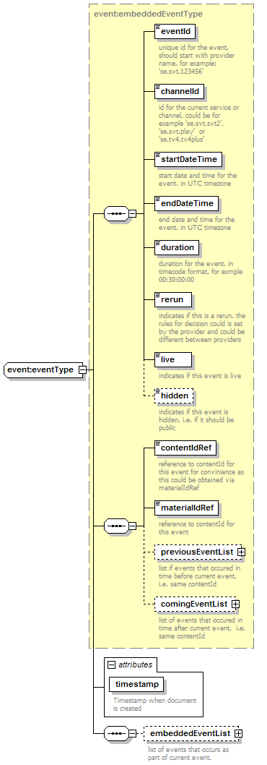
namespace | http://common.tv.se/event/v2_0
type | extension of event:embeddedEventType
properties
  base | embeddedEventType
children | eventId channelId startDateTime endDateTime duration rerun live hidden contentIdRef materialIdRef previousEventList comingEventList embeddedEventList
used by
  elements | event:eventListType/event event:event
attributes
  Name | Type | Use | Default | Fixed | Annotation
  timestamp | xs:dateTime | required
    documentation | Timestamp when document is created
source | <xs:complexType name="eventType">  <xs:complexContent>  <xs:extension base="embeddedEventType">  <xs:sequence>  <xs:element name="embeddedEventList" type="embeddedEventListType" minOccurs="0">  <xs:annotation>  <xs:documentation>list of events that occurs as part of current event.</xs:documentation>  </xs:annotation>  </xs:element>  </xs:sequence>  <xs:attribute name="timestamp" type="xs:dateTime" use="required">  <xs:annotation>  <xs:documentation>Timestamp when document is created</xs:documentation>  </xs:annotation>  </xs:attribute>  </xs:extension>  </xs:complexContent>  </xs:complexType>

element event:eventType/embeddedEventList
diagram | 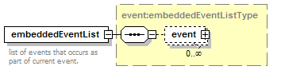
namespace | http://common.tv.se/event/v2_0
type | event:embeddedEventListType
properties
  isRef | 0
  content | complex
children | event
annotation
  documentation | list of events that occurs as part of current event.
source | <xs:element name="embeddedEventList" type="embeddedEventListType" minOccurs="0">  <xs:annotation>  <xs:documentation>list of events that occurs as part of current event.</xs:documentation>  </xs:annotation>  </xs:element>

simpleType event:timecode
namespace | http://common.tv.se/event/v2_0
type | xs:string
used by
  element | event:basicEventType/duration
source | <xs:simpleType name="timecode">  <xs:restriction base="xs:string"/>  </xs:simpleType>

element material:material
diagram | 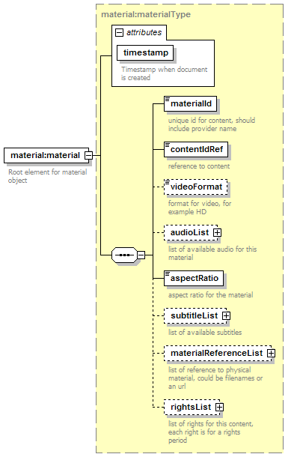
namespace | http://common.tv.se/material/v2_0
type | material:materialType
properties
  content | complex
children | materialId contentIdRef videoFormat audioList aspectRatio subtitleList materialReferenceList rightsList
attributes
  Name | Type | Use | Default | Fixed | Annotation
  timestamp | xs:dateTime | required
    documentation | Timestamp when document is created
annotation
  documentation | Root element for material object
source | <xs:element name="material" type="materialType">  <xs:annotation>  <xs:documentation>Root element for material object</xs:documentation>  </xs:annotation>  </xs:element>

complexType material:audioListType
diagram | 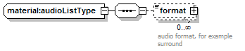
namespace | http://common.tv.se/material/v2_0
children | format
used by
  element | material:materialType/audioList
source | <xs:complexType name="audioListType">  <xs:sequence>  <xs:element name="format" type="audioType" minOccurs="0" maxOccurs="unbounded">  <xs:annotation>  <xs:documentation>audio format, for example surround</xs:documentation>  </xs:annotation>  </xs:element>  </xs:sequence>  </xs:complexType>

element material:audioListType/format
diagram | 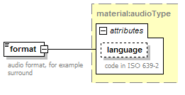
namespace | http://common.tv.se/material/v2_0
type | material:audioType
properties
  isRef | 0
  content | complex
facets
  enumeration | mono
  enumeration | stereo
  enumeration | surround
  enumeration | 5.1
attributes
  Name | Type | Use | Default | Fixed | Annotation
  language | xs:language
    documentation | code in ISO 639-2
annotation
  documentation | audio format, for example surround
source | <xs:element name="format" type="audioType" minOccurs="0" maxOccurs="unbounded">  <xs:annotation>  <xs:documentation>audio format, for example surround</xs:documentation>  </xs:annotation>  </xs:element>

complexType material:audioType
diagram | 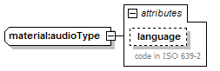
namespace | http://common.tv.se/material/v2_0
type | extension of material:audioFormatType
properties
  base | audioFormatType
used by
  element | material:audioListType/format
facets
  enumeration | mono
  enumeration | stereo
  enumeration | surround
  enumeration | 5.1
attributes
  Name | Type | Use | Default | Fixed | Annotation
  language | xs:language
    documentation | code in ISO 639-2
source | <xs:complexType name="audioType">  <xs:simpleContent>  <xs:extension base="audioFormatType">  <xs:attribute name="language" type="xs:language">  <xs:annotation>  <xs:documentation>code in ISO 639-2</xs:documentation>  </xs:annotation>  </xs:attribute>  </xs:extension>  </xs:simpleContent>  </xs:complexType>

complexType material:materialListType
diagram | 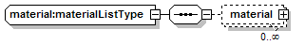
namespace | http://common.tv.se/material/v2_0
children | material
used by
  element | schedule/materialList
source | <xs:complexType name="materialListType">  <xs:sequence>  <xs:element name="material" type="materialType" minOccurs="0" maxOccurs="unbounded"/>  </xs:sequence>  </xs:complexType>

element material:materialListType/material
diagram | 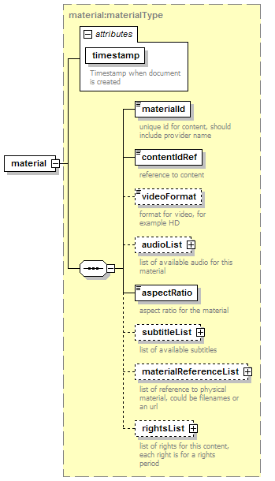
namespace | http://common.tv.se/material/v2_0
type | material:materialType
properties
  isRef | 0
  content | complex
children | materialId contentIdRef videoFormat audioList aspectRatio subtitleList materialReferenceList rightsList
attributes
  Name | Type | Use | Default | Fixed | Annotation
  timestamp | xs:dateTime | required
    documentation | Timestamp when document is created
source | <xs:element name="material" type="materialType" minOccurs="0" maxOccurs="unbounded"/>

complexType material:materialReferenceListType
diagram | 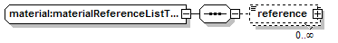
namespace | http://common.tv.se/material/v2_0
children | reference
used by
  element | material:materialType/materialReferenceList
source | <xs:complexType name="materialReferenceListType">  <xs:sequence>  <xs:element name="reference" type="materialReferenceType" minOccurs="0" maxOccurs="unbounded"/>  </xs:sequence>  </xs:complexType>

element material:materialReferenceListType/reference
diagram | 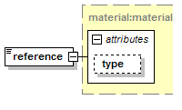
namespace | http://common.tv.se/material/v2_0
type | material:materialReferenceType
properties
  isRef | 0
  content | complex
attributes
  Name | Type | Use | Default | Fixed | Annotation
  type
source | <xs:element name="reference" type="materialReferenceType" minOccurs="0" maxOccurs="unbounded"/>

complexType material:materialReferenceType
diagram | 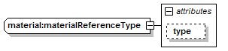
namespace | http://common.tv.se/material/v2_0
type | extension of xs:string
properties
  base | xs:string
used by
  element | material:materialReferenceListType/reference
attributes
  Name | Type | Use | Default | Fixed | Annotation
  type
source | <xs:complexType name="materialReferenceType">  <xs:simpleContent>  <xs:extension base="xs:string">  <xs:attribute name="type">  <xs:simpleType>  <xs:restriction base="xs:string">  <xs:enumeration value="video"/>  <xs:enumeration value="audio"/>  <xs:enumeration value="subtitle"/>  <xs:enumeration value="graphics"/>  </xs:restriction>  </xs:simpleType>  </xs:attribute>  </xs:extension>  </xs:simpleContent>  </xs:complexType>

complexType material:materialType
diagram | 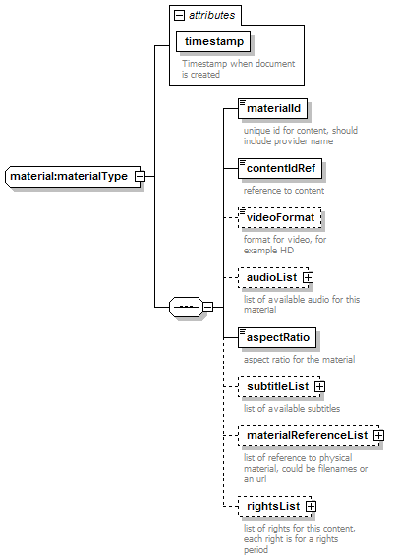
namespace | http://common.tv.se/material/v2_0
children | materialId contentIdRef videoFormat audioList aspectRatio subtitleList materialReferenceList rightsList
used by
  elements | material:materialListType/material material:material
attributes
  Name | Type | Use | Default | Fixed | Annotation
  timestamp | xs:dateTime | required
    documentation | Timestamp when document is created
source | <xs:complexType name="materialType">  <xs:sequence>  <xs:element name="materialId" type="xs:string">  <xs:annotation>  <xs:documentation>unique id for content, should include provider name</xs:documentation>  </xs:annotation>  </xs:element>  <xs:element name="contentIdRef" type="xs:string">  <xs:annotation>  <xs:documentation>reference to content</xs:documentation>  </xs:annotation>  </xs:element>  <xs:element name="videoFormat" type="videoFormatType" minOccurs="0">  <xs:annotation>  <xs:documentation>format for video, for example HD</xs:documentation>  </xs:annotation>  </xs:element>  <xs:element name="audioList" type="audioListType" minOccurs="0">  <xs:annotation>  <xs:documentation>list of available audio for this material</xs:documentation>  </xs:annotation>  </xs:element>  <xs:element name="aspectRatio" type="aspectRatioType">  <xs:annotation>  <xs:documentation>aspect ratio for the material</xs:documentation>  </xs:annotation>  </xs:element>  <xs:element name="subtitleList" type="subtitleListType" minOccurs="0">  <xs:annotation>  <xs:documentation>list of available subtitles</xs:documentation>  </xs:annotation>  </xs:element>  <xs:element name="materialReferenceList" type="materialReferenceListType" minOccurs="0">  <xs:annotation>  <xs:documentation>list of reference to physical material, could be filenames or an url </xs:documentation>  </xs:annotation>  </xs:element>  <xs:element name="rightsList" type="rightsListType" minOccurs="0">  <xs:annotation>  <xs:documentation>list of rights for this content, each right is for a rights period</xs:documentation>  </xs:annotation>  </xs:element>  </xs:sequence>  <xs:attribute name="timestamp" type="xs:dateTime" use="required">  <xs:annotation>  <xs:documentation>Timestamp when document is created</xs:documentation>  </xs:annotation>  </xs:attribute>  </xs:complexType>

element material:materialType/materialId
diagram | 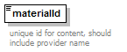
namespace | http://common.tv.se/material/v2_0
type | xs:string
properties
  isRef | 0
  content | simple
annotation
  documentation | unique id for content, should include provider name
source | <xs:element name="materialId" type="xs:string">  <xs:annotation>  <xs:documentation>unique id for content, should include provider name</xs:documentation>  </xs:annotation>  </xs:element>

element material:materialType/contentIdRef
diagram | 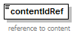
namespace | http://common.tv.se/material/v2_0
type | xs:string
properties
  isRef | 0
  content | simple
annotation
  documentation | reference to content
source | <xs:element name="contentIdRef" type="xs:string">  <xs:annotation>  <xs:documentation>reference to content</xs:documentation>  </xs:annotation>  </xs:element>

element material:materialType/videoFormat
diagram | 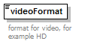
namespace | http://common.tv.se/material/v2_0
type | material:videoFormatType
properties
  isRef | 0
  content | simple
facets
  enumeration | 576i
  enumeration | 720p
  enumeration | 1080i
  enumeration | 1080p
  enumeration | other
annotation
  documentation | format for video, for example HD
source | <xs:element name="videoFormat" type="videoFormatType" minOccurs="0">  <xs:annotation>  <xs:documentation>format for video, for example HD</xs:documentation>  </xs:annotation>  </xs:element>

element material:materialType/audioList
diagram | 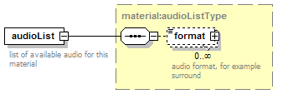
namespace | http://common.tv.se/material/v2_0
type | material:audioListType
properties
  isRef | 0
  content | complex
children | format
annotation
  documentation | list of available audio for this material
source | <xs:element name="audioList" type="audioListType" minOccurs="0">  <xs:annotation>  <xs:documentation>list of available audio for this material</xs:documentation>  </xs:annotation>  </xs:element>

element material:materialType/aspectRatio
diagram | 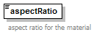
namespace | http://common.tv.se/material/v2_0
type | material:aspectRatioType
properties
  isRef | 0
  content | simple
facets
  enumeration | 4:3
  enumeration | 16:9
  enumeration | 21:9
annotation
  documentation | aspect ratio for the material
source | <xs:element name="aspectRatio" type="aspectRatioType">  <xs:annotation>  <xs:documentation>aspect ratio for the material</xs:documentation>  </xs:annotation>  </xs:element>

element material:materialType/subtitleList
diagram | 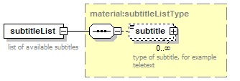
namespace | http://common.tv.se/material/v2_0
type | material:subtitleListType
properties
  isRef | 0
  content | complex
children | subtitle
annotation
  documentation | list of available subtitles
source | <xs:element name="subtitleList" type="subtitleListType" minOccurs="0">  <xs:annotation>  <xs:documentation>list of available subtitles</xs:documentation>  </xs:annotation>  </xs:element>

element material:materialType/materialReferenceList
diagram | 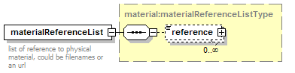
namespace | http://common.tv.se/material/v2_0
type | material:materialReferenceListType
properties
  isRef | 0
  content | complex
children | reference
annotation
  documentation | list of reference to physical material, could be filenames or an url
source | <xs:element name="materialReferenceList" type="materialReferenceListType" minOccurs="0">  <xs:annotation>  <xs:documentation>list of reference to physical material, could be filenames or an url </xs:documentation>  </xs:annotation>  </xs:element>

element material:materialType/rightsList
diagram | 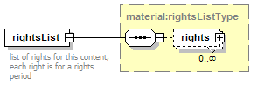
namespace | http://common.tv.se/material/v2_0
type | material:rightsListType
properties
  isRef | 0
  content | complex
children | rights
annotation
  documentation | list of rights for this content, each right is for a rights period
source | <xs:element name="rightsList" type="rightsListType" minOccurs="0">  <xs:annotation>  <xs:documentation>list of rights for this content, each right is for a rights period</xs:documentation>  </xs:annotation>  </xs:element>

complexType material:rightsCategoryListType
diagram | 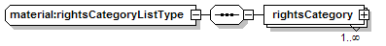
namespace | http://common.tv.se/material/v2_0
children | rightsCategory
used by
  element | material:rightsType/rightsCategoryList
source | <xs:complexType name="rightsCategoryListType">  <xs:sequence>  <xs:element name="rightsCategory" type="rightsCategoryType" maxOccurs="unbounded"/>  </xs:sequence>  </xs:complexType>

element material:rightsCategoryListType/rightsCategory
diagram | 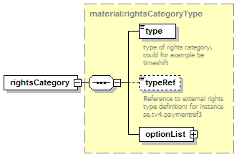
namespace | http://common.tv.se/material/v2_0
type | material:rightsCategoryType
properties
  isRef | 0
  content | complex
children | type typeRef optionList
source | <xs:element name="rightsCategory" type="rightsCategoryType" maxOccurs="unbounded"/>

complexType material:rightsCategoryType
diagram | 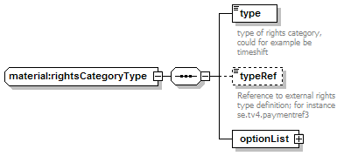
namespace | http://common.tv.se/material/v2_0
children | type typeRef optionList
used by
  element | material:rightsCategoryListType/rightsCategory
source | <xs:complexType name="rightsCategoryType">  <xs:sequence>  <xs:element name="type">  <xs:annotation>  <xs:documentation>type of rights category, could for example be timeshift</xs:documentation>  </xs:annotation>  <xs:simpleType>  <xs:restriction base="xs:string">  <xs:enumeration value="download"/>  <xs:enumeration value="web"/>  <xs:enumeration value="mobile"/>  <xs:enumeration value="vod"/>  <xs:enumeration value="ppv"/>  <xs:enumeration value="timeshift"/>  <xs:enumeration value="broadcast"/>  </xs:restriction>  </xs:simpleType>  </xs:element>  <xs:element name="typeRef" type="xs:string" minOccurs="0">  <xs:annotation>  <xs:documentation>Reference to external rights type definition; for instance se.tv4.paymentref3</xs:documentation>  </xs:annotation>  </xs:element>  <xs:element name="optionList">  <xs:complexType>  <xs:sequence>  <xs:element name="option" minOccurs="0" maxOccurs="unbounded">  <xs:annotation>  <xs:documentation>options for the selected type</xs:documentation>  </xs:annotation>  <xs:simpleType>  <xs:restriction base="xs:string">  <xs:enumeration value="NO_FF"/>  <xs:enumeration value="NO_RWD"/>  <xs:enumeration value="NO_PAUSE"/>  <xs:enumeration value="catchUp"/>  <xs:enumeration value="startOver"/>  <xs:enumeration value="freeView"/>  <xs:enumeration value="noRight"/>  </xs:restriction>  </xs:simpleType>  </xs:element>  </xs:sequence>  </xs:complexType>  </xs:element>  </xs:sequence>  </xs:complexType>

element material:rightsCategoryType/type
diagram | 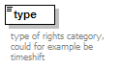
namespace | http://common.tv.se/material/v2_0
type | restriction of xs:string
properties
  isRef | 0
  content | simple
facets
  enumeration | download
  enumeration | web
  enumeration | mobile
  enumeration | vod
  enumeration | ppv
  enumeration | timeshift
  enumeration | broadcast
annotation
  documentation | type of rights category, could for example be timeshift
source | <xs:element name="type">  <xs:annotation>  <xs:documentation>type of rights category, could for example be timeshift</xs:documentation>  </xs:annotation>  <xs:simpleType>  <xs:restriction base="xs:string">  <xs:enumeration value="download"/>  <xs:enumeration value="web"/>  <xs:enumeration value="mobile"/>  <xs:enumeration value="vod"/>  <xs:enumeration value="ppv"/>  <xs:enumeration value="timeshift"/>  <xs:enumeration value="broadcast"/>  </xs:restriction>  </xs:simpleType>  </xs:element>

element material:rightsCategoryType/typeRef
diagram | 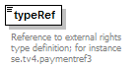
namespace | http://common.tv.se/material/v2_0
type | xs:string
properties
  isRef | 0
  content | simple
annotation
  documentation | Reference to external rights type definition; for instance se.tv4.paymentref3
source | <xs:element name="typeRef" type="xs:string" minOccurs="0">  <xs:annotation>  <xs:documentation>Reference to external rights type definition; for instance se.tv4.paymentref3</xs:documentation>  </xs:annotation>  </xs:element>

element material:rightsCategoryType/optionList
diagram | 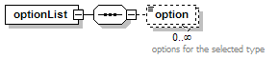
namespace | http://common.tv.se/material/v2_0
properties
  isRef | 0
  content | complex
children | option
source | <xs:element name="optionList">  <xs:complexType>  <xs:sequence>  <xs:element name="option" minOccurs="0" maxOccurs="unbounded">  <xs:annotation>  <xs:documentation>options for the selected type</xs:documentation>  </xs:annotation>  <xs:simpleType>  <xs:restriction base="xs:string">  <xs:enumeration value="NO_FF"/>  <xs:enumeration value="NO_RWD"/>  <xs:enumeration value="NO_PAUSE"/>  <xs:enumeration value="catchUp"/>  <xs:enumeration value="startOver"/>  <xs:enumeration value="freeView"/>  <xs:enumeration value="noRight"/>  </xs:restriction>  </xs:simpleType>  </xs:element>  </xs:sequence>  </xs:complexType>  </xs:element>

element material:rightsCategoryType/optionList/option
diagram | 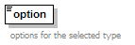
namespace | http://common.tv.se/material/v2_0
type | restriction of xs:string
properties
  isRef | 0
  content | simple
facets
  enumeration | NO_FF
  enumeration | NO_RWD
  enumeration | NO_PAUSE
  enumeration | catchUp
  enumeration | startOver
  enumeration | freeView
  enumeration | noRight
annotation
  documentation | options for the selected type
source | <xs:element name="option" minOccurs="0" maxOccurs="unbounded">  <xs:annotation>  <xs:documentation>options for the selected type</xs:documentation>  </xs:annotation>  <xs:simpleType>  <xs:restriction base="xs:string">  <xs:enumeration value="NO_FF"/>  <xs:enumeration value="NO_RWD"/>  <xs:enumeration value="NO_PAUSE"/>  <xs:enumeration value="catchUp"/>  <xs:enumeration value="startOver"/>  <xs:enumeration value="freeView"/>  <xs:enumeration value="noRight"/>  </xs:restriction>  </xs:simpleType>  </xs:element>

complexType material:rightsListType
diagram | 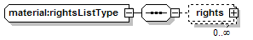
namespace | http://common.tv.se/material/v2_0
children | rights
used by
  element | material:materialType/rightsList
source | <xs:complexType name="rightsListType">  <xs:sequence>  <xs:element name="rights" type="rightsType" minOccurs="0" maxOccurs="unbounded"/>  </xs:sequence>  </xs:complexType>

element material:rightsListType/rights
diagram | 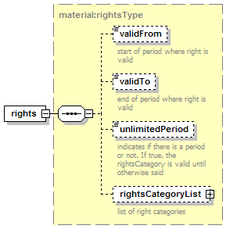
namespace | http://common.tv.se/material/v2_0
type | material:rightsType
properties
  isRef | 0
  content | complex
children | validFrom validTo unlimitedPeriod rightsCategoryList
source | <xs:element name="rights" type="rightsType" minOccurs="0" maxOccurs="unbounded"/>

complexType material:rightsType
diagram | 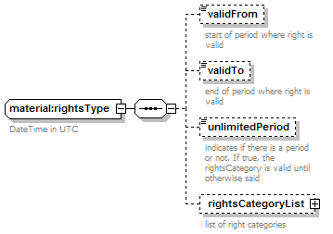
namespace | http://common.tv.se/material/v2_0
children | validFrom validTo unlimitedPeriod rightsCategoryList
used by
  element | material:rightsListType/rights
annotation
  documentation | DateTime in UTC
source | <xs:complexType name="rightsType">  <xs:annotation>  <xs:documentation>DateTime in UTC</xs:documentation>  </xs:annotation>  <xs:sequence>  <xs:element name="validFrom" type="xs:dateTime" minOccurs="0">  <xs:annotation>  <xs:documentation>start of period where right is valid</xs:documentation>  </xs:annotation>  </xs:element>  <xs:element name="validTo" type="xs:dateTime" minOccurs="0">  <xs:annotation>  <xs:documentation>end of period where right is valid</xs:documentation>  </xs:annotation>  </xs:element>  <xs:element name="unlimitedPeriod" type="xs:boolean" minOccurs="0">  <xs:annotation>  <xs:documentation>indicates if there is a period or not. If true, the rightsCategory is valid until otherwise said</xs:documentation>  </xs:annotation>  </xs:element>  <xs:element name="rightsCategoryList" type="rightsCategoryListType" minOccurs="0">  <xs:annotation>  <xs:documentation>list of right categories</xs:documentation>  </xs:annotation>  </xs:element>  </xs:sequence>  </xs:complexType>

element material:rightsType/validFrom
diagram | 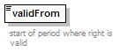
namespace | http://common.tv.se/material/v2_0
type | xs:dateTime
properties
  isRef | 0
  content | simple
annotation
  documentation | start of period where right is valid
source | <xs:element name="validFrom" type="xs:dateTime" minOccurs="0">  <xs:annotation>  <xs:documentation>start of period where right is valid</xs:documentation>  </xs:annotation>  </xs:element>

element material:rightsType/validTo
diagram | 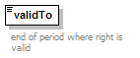
namespace | http://common.tv.se/material/v2_0
type | xs:dateTime
properties
  isRef | 0
  content | simple
annotation
  documentation | end of period where right is valid
source | <xs:element name="validTo" type="xs:dateTime" minOccurs="0">  <xs:annotation>  <xs:documentation>end of period where right is valid</xs:documentation>  </xs:annotation>  </xs:element>

element material:rightsType/unlimitedPeriod
diagram | 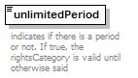
namespace | http://common.tv.se/material/v2_0
type | xs:boolean
properties
  isRef | 0
  content | simple
annotation
  documentation | indicates if there is a period or not. If true, the rightsCategory is valid until otherwise said
source | <xs:element name="unlimitedPeriod" type="xs:boolean" minOccurs="0">  <xs:annotation>  <xs:documentation>indicates if there is a period or not. If true, the rightsCategory is valid until otherwise said</xs:documentation>  </xs:annotation>  </xs:element>

element material:rightsType/rightsCategoryList
diagram | 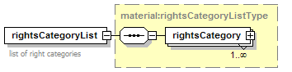
namespace | http://common.tv.se/material/v2_0
type | material:rightsCategoryListType
properties
  isRef | 0
  content | complex
children | rightsCategory
annotation
  documentation | list of right categories
source | <xs:element name="rightsCategoryList" type="rightsCategoryListType" minOccurs="0">  <xs:annotation>  <xs:documentation>list of right categories</xs:documentation>  </xs:annotation>  </xs:element>

complexType material:subtitleListType
diagram | 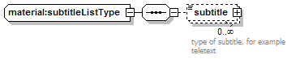
namespace | http://common.tv.se/material/v2_0
children | subtitle
used by
  element | material:materialType/subtitleList
source | <xs:complexType name="subtitleListType">  <xs:sequence>  <xs:element name="subtitle" type="subtitleType" minOccurs="0" maxOccurs="unbounded">  <xs:annotation>  <xs:documentation>type of subtitle, for example teletext</xs:documentation>  </xs:annotation>  </xs:element>  </xs:sequence>  </xs:complexType>

element material:subtitleListType/subtitle
diagram | 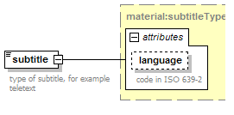
namespace | http://common.tv.se/material/v2_0
type | material:subtitleType
properties
  isRef | 0
  content | complex
facets
  enumeration | invision
  enumeration | teletext
  enumeration | dvb
attributes
  Name | Type | Use | Default | Fixed | Annotation
  language | xs:language
    documentation | code in ISO 639-2
annotation
  documentation | type of subtitle, for example teletext
source | <xs:element name="subtitle" type="subtitleType" minOccurs="0" maxOccurs="unbounded">  <xs:annotation>  <xs:documentation>type of subtitle, for example teletext</xs:documentation>  </xs:annotation>  </xs:element>

complexType material:subtitleType
diagram | 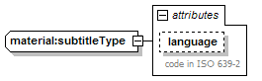
namespace | http://common.tv.se/material/v2_0
type | extension of material:subtitleFormatType
properties
  base | subtitleFormatType
used by
  element | material:subtitleListType/subtitle
facets
  enumeration | invision
  enumeration | teletext
  enumeration | dvb
attributes
  Name | Type | Use | Default | Fixed | Annotation
  language | xs:language
    documentation | code in ISO 639-2
source | <xs:complexType name="subtitleType">  <xs:simpleContent>  <xs:extension base="subtitleFormatType">  <xs:attribute name="language" type="xs:language">  <xs:annotation>  <xs:documentation>code in ISO 639-2</xs:documentation>  </xs:annotation>  </xs:attribute>  </xs:extension>  </xs:simpleContent>  </xs:complexType>

simpleType material:aspectRatioType
namespace | http://common.tv.se/material/v2_0
type | restriction of xs:string
used by
  element | material:materialType/aspectRatio
facets
  enumeration | 4:3
  enumeration | 16:9
  enumeration | 21:9
source | <xs:simpleType name="aspectRatioType">  <xs:restriction base="xs:string">  <xs:enumeration value="4:3"/>  <xs:enumeration value="16:9"/>  <xs:enumeration value="21:9"/>  </xs:restriction>  </xs:simpleType>

simpleType material:audioFormatType
namespace | http://common.tv.se/material/v2_0
type | restriction of xs:string
used by
  complexType | material:audioType
facets
  enumeration | mono
  enumeration | stereo
  enumeration | surround
  enumeration | 5.1
source | <xs:simpleType name="audioFormatType">  <xs:restriction base="xs:string">  <xs:enumeration value="mono"/>  <xs:enumeration value="stereo"/>  <xs:enumeration value="surround"/>  <xs:enumeration value="5.1"/>  </xs:restriction>  </xs:simpleType>

simpleType material:subtitleFormatType
namespace | http://common.tv.se/material/v2_0
type | restriction of xs:string
used by
  complexType | material:subtitleType
facets
  enumeration | invision
  enumeration | teletext
  enumeration | dvb
source | <xs:simpleType name="subtitleFormatType">  <xs:restriction base="xs:string">  <xs:enumeration value="invision"/>  <xs:enumeration value="teletext"/>  <xs:enumeration value="dvb"/>  </xs:restriction>  </xs:simpleType>

simpleType material:videoFormatType
namespace | http://common.tv.se/material/v2_0
type | restriction of xs:string
used by
  element | material:materialType/videoFormat
facets
  enumeration | 576i
  enumeration | 720p
  enumeration | 1080i
  enumeration | 1080p
  enumeration | other
source | <xs:simpleType name="videoFormatType">  <xs:restriction base="xs:string">  <xs:enumeration value="576i"/>  <xs:enumeration value="720p"/>  <xs:enumeration value="1080i"/>  <xs:enumeration value="1080p"/>  <xs:enumeration value="other"/>  </xs:restriction>  </xs:simpleType>

XML Schema documentation generated with XMLSpy Schema Editor http://www.altova.com/xmlspy

