Early Detection of Alzheimer’s Disease via CNN-Based Feature Extraction and SVM Classification

Jaanya Dhingra   
*School of Computing Science Engineering and Artificial Intelligence*  
*VIT Bhopal University*Kothri-Kalan, Sehore, India jaanya.23bhi10037@vitbhopal.ac.in

Anuja Rawat  
*School of Computing Science Engineering and Artificial Intelligence*  
*VIT Bhopal University*Kothri-Kalan, Sehore, India   
anuja.23bhi10158@vitbhopal.ac.inGarima Jain*  
*School of Computing Science Engineering and Artificial Intelligence*  
*VIT Bhopal University*Kothri-Kalan, Sehore, India garimajain@vitbhopal.ac.in

Sanat Jain  
*School of Computing Science and Engineering*   
*VIT Bhopal University*Kothri-Kalan, Sehore, India sanatjain@vitbhopal.ac.in

*Abstract*—Globally, Alzheimer's disease is an illness of the brain that slowly affects people over time. Recently, there is no cure known to us, and hence, identifying this disease at an early stage is crucial for offering proper support and care to the patient. MRI imaging is a valuable tool which is used to visualize changes in the brain without using any surgical procedures. However, many existing diagnostic approaches still rely on manual interpretation which is both time consuming and prone to inconsistencies. In our study, we introduce a hybrid model that uses CNN and SVM to classify stages of Alzheimer’s disease based on MRI brain scan images. Proposed framework has a 90% accuracy and aims to improve stage-specific detection of the disease. This approach offers a practical and scalable solution that could assist clinicians in early and reliable diagnosis of Alzheimer’s.

Keywords—Early detection, Alzheimer illness, Brain MRI classification, Convolutional Neural Networks (CNNs), SVM, Neurodegenerative disorders.

# Introduction

Around the globe, Alzheimer’s Disease (AD) is a neuro-degenerative disorder which affects brain function and memory and has no known cure for now. Timely diagnosis can help manage the symptoms more effectively using medication, cognitive therapies, and life adjustments, which help to slow down the rate of cognitive decline and help enhance the patients’ quality of life. early AD prediction is not only useful for care at the individual level but also necessary for progression of research and treatment approaches. Medical imaging, particularly Magnetic Resonance Imaging (MRI), is important for detection and follow-up of Alzheimer's Disease. MRI provides highly detailed, non-invasive observations of the brain, which facilitate the identification of early markers such as hippocampal atrophy and cortical thinning—both of which are important biomarkers in disease staging [1]. When we blend this is with advanced pre-processing and machine learning algorithms, MRI becomes even more powerful which allows us to detect minor anatomical changes which may not have been apparent using normal assessment techniques [2].

Upon studying existing studies on this matter, we have realized that over the years, Alzheimer’s detection techniques have evolved from conventional machine learning approaches such as support vector machines (SVMs) and random forests to more modern deep learning approaches. Traditional ML models often required manually engineered features, while deep learning methods, particularly convolutional neural networks (CNNs), can automatically extract meaningful patterns directly from MRI scans. Despite their many advantages, most deep learning models still face challenges like overfitting, limited generalization across different stages, and computational demands, especially when working with limited datasets [3].

The aim of this study is, to improve the gaps in the preexisting models. Our study contributes to this field in the following ways:

• Hybrid CNN-SVM Architecture: This study introduces a model that integrates a pre-trained convolutional neural network, MobileNetV2, with an SVM classifier to extract features and make final stage predictions.

• Dataset and Preprocessing: This work uses a Kaggle MRI dataset, which divided into four Alzheimer’s stages—Non- Demented, Very Mild, Mild, and Moderate Demented. To improve the model's performance, the images were preprocessed using methods including reducing and normalization.

• Model Performance: The hybrid model achieves strong validation accuracy, demonstrating its potential for reliable classification across multiple stages of Alzheimer’s Disease.

# Literature Review

Early methods of Alzheimer's detection employed support vector machines (SVMs) and hand-engineered features such as hippocampal volume, but these methods had poor generalizability across datasets [1]. Subsequently, 3D convolutional neural networks were employed on MRI data, which enhanced performance but suffered from overfitting due to small datasets [2]. Usage of pre-trained CNNs like AlexNet on MRI data further improved classification accuracy and minimized manual feature engineering [3][4]. Transfer learning methods using models like VGGNet proved effective with minimal data, but necessitated large computational resources [5]. Data augmentation technique like rotation and scaling was used to enhance robustness and model generalization [6]. Later approaches leveraged attention-based CNNs, which targeted Alzheimer's most impacted brain areas to achieve state-of-the-art results [7]. Yet, adoption in clinical practice is still challenging because of sophisticated preprocessing and lack of interpretability [8] [9]. Moreover, even though electronic health records (EHRs) hold useful patient information, current systems do not have sophisticated predictive analytics to retrieve actionable insights [10] [11]. Most current models focus on single symptoms in isolation, restricting them from offering an overall picture of cognitive health. To address such limitations, our research suggests a unified machine learning framework that takes heterogeneous medical information such as EHRs and imaging into account, to forecast both risk for Alzheimer's disease and hospital readmission likelihood, thereby facilitating proactive, individualized care [12].

After reviewing existing research and today's medical procedures, we have found that precise identification of patients who are at high risk of getting Alzheimer's Disease is still a major challenge, even in today's healthcare. Despite the huge patient data being available and within reach, conventional risk assessment processes are still mainly manual in nature which are therefore time-consuming and susceptible to human error [13]. These methods are usually based on fixed decision rules that are inconsistent and do not have the specificity needed to identify early cognitive decline or disease progression, leading to lost opportunities for early, preventive intervention. EHRs hold valuable information but most healthcare professionals cannot glean meaningful insight from them because they lack sophisticated predictive analytics [14] [15]. Current models look very specifically at individual symptoms or conditions, thus constraining what they can give in terms of a comprehensive perspective of a patient's cognitive function and risk factor profile. Addressing these drawbacks, we have the goal to create a deep learning-based system that can work on patient MRI scans and produce features which will aid in stage classification of AD [16].

# Methodology

## Dataset Description

This study gathered the MRI images for Alzheimer's disease were acquired from Kaggle and are utilized in this work. It includes MRI brain scan images divided into four categories:

• Mild Demented

• Moderate Demented

• Non Demented

• Very Mild Demented

The dataset contains a total of 33,984 images spread across these categories. As represented in Fig. 1, approximately 29% of the images fall under Non-Demented, 25% are classified as Mild Demented, 20% as Moderate Demented, and 26% as Very Mild Demented. Each image is labeled according to the cognitive status of the subject, which makes the dataset well- suited for training supervised learning models. Fig. 2 shown MRI image scan labeled samples of the dataset.

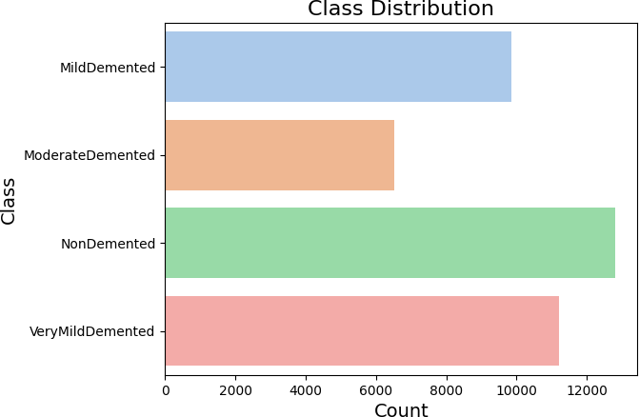

Fig. 1. Class Distribution Diagram

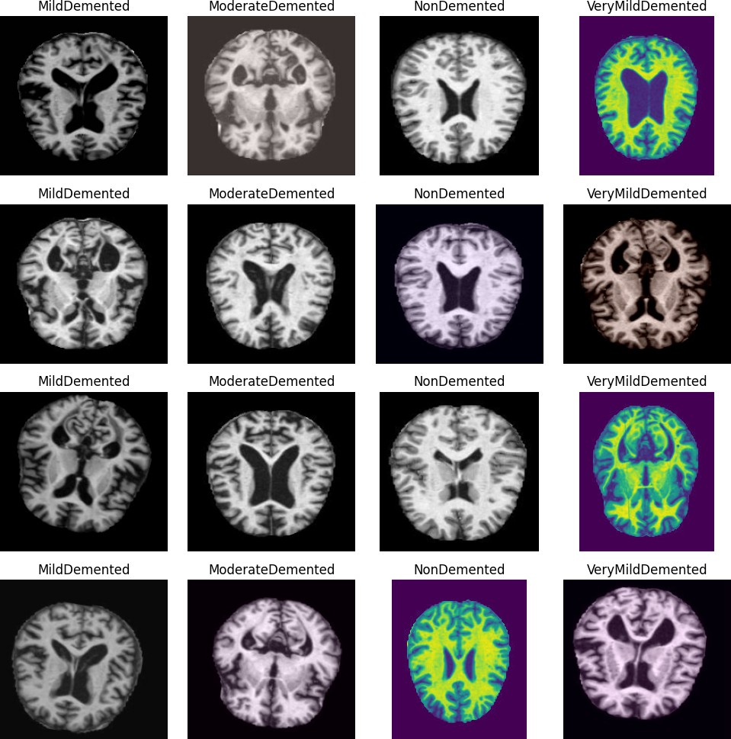

Fig. 2. MRI image scan of labelled samples of the dataset used.

## Preprocessing

To ensure that the input data was clean and consistent for training, this study performed several preprocessing steps. first resized our images to 64x64 to help maintain a uniform input size for the CNN model, MobileNetV2. Next, scaled the pixel values so that they fall within the range [0,1]. This helped in speeding up the training process and improved learning by reducing variations between pixel intensities. Then divide the dataset into an 80:20 split, which keeps 80% for training and 20% for testing. Each class label was transformed into a one-hot encoded vector, allowing the model to interpret categorical data effectively with the chosen loss function.

## Class Distribution and Data Augmentation

The available dataset has an imbalance problem in class representation, especially with fewer samples available for the Mild Demented class. To address this issue and help the model generalize better, we applied several data augmentation techniques. We flipped the images horizontally, shifted them along their width and height, applied slight zoomed effects and rotated the images by minute angles. These augmentations effectively increased the diversity of the training data, helping the system become more robust and less prone to overfitting.

## Model Architecture

This research examines a hybrid system for the detection of Alzheimer's disease through the integration of Convolutional Neural Networks (CNN) for feature extraction and Support Vector Machines (SVM) for classification. The MobileNetV2 CNN is employed for efficient feature extraction while taking advantage of a standard machine learning algorithm for classification. This configuration is effective in reaching the best performance while simplifying the model complexity. The summary of the model architecture is presented in Table 1. The suggested architecture has two main stages: feature extraction through CNN and classification through SVM.

### CNN Feature Extraction:

For feature extraction, first, the MRI images were resized to 224x224x3 to match the input format required by MobileNetV2. Then, MobileNetV2, pre-trained on the ImageNet dataset, was employed with all layers frozen to prevent retraining. The output from the global average pooling layer was used, resulting in a 1280-dimensional feature vector for each image. Since the model was not trained end-to-end, MobileNetV2 functioned purely as a fixed feature extractor.

### SVM Classification:

The CNN's feature vector was then fed into a support vector machine classifier. We opted for an RBF (Radial Basis Function) kernel because of its capabilities in dealing with intricate, non-linear decision boundaries. Following this, SVM sorts the images into four groups: non-demented, very mildly demented, mildly demented, and moderately demented.

### Hybrid Model Integration:

This hybrid model combines CNNs’ robust feature extraction with SVM’s efficient classification capabilities. The CNN extracts spatial patterns from MRI images, while the SVM refines these features to produce accurate classifications.

### Regularization Techniques:

For regularization purposes, to decrease the likelihood of overfitting, a dropout layer is used after the dense layer with a 0.5% rate to deactivate neurons at random during training. Additionally, class imbalance in the Kaggle dataset was addressed using the Synthetic Minority Oversampling Technique (SMOTE).

TABLE I. Model Architecture Summary

|  |  |  |
| --- | --- | --- |
| **Layer** | **Output** | **Parameters** |
| mobilenetv2 1.00 224 | (None, 7, 7, 1280) | 2,257,984 |
| (Functional) |  |  |
| global average pooling2d | (None, 1280) | 0 |
| (GlobalAveragePool- |  |  |
| ing2D) |  |  |

## Training Configuration

The proposed framework was trained using a balanced dataset of MRI images, ensuring optimal performance. Notably, there was no end-to-end training or backpropagation applied to the CNN. Instead, the SVM classifier was trained using feature vectors extracted by MobileNetV2.

### Dataset Partitioning

This dataset is split into two parts for training and validation purposes. 80% MRI images are used for training and 20% for testing and validation, ensuring a proper balance for both learning and evaluation. The split was stratified to maintain the class distribution across both sets.

### Data Augmentation

By utilizing Keras' Image Data Generator, we were able to enhance images in the training dataset, which in turn helped to decrease overfitting. Also, techniques applied included horizontal and vertical flipping, rotation, zooming, and shifting. The model was able to generalize more effectively after these adjustments exposed it to more visual variations.

### Class Imbalance Handling

SMOTE was employed to address the class imbalance by generating synthetic examples for minority classes. Also, class weights were incorporated during SVM training to ensure the framework provides sufficient attention to the minority classes.

## Early Stopping

While early stopping is a common technique to prevent overfitting and improve model generalization, it was considered but not implemented in this version of the model. Early stopping halts training when validation performance stagnates or worsens, thereby preventing the system from overfitting to the training images.

# Results and Discussion

The proposed hybrid model achieved a validation accuracy of 90%, which is a major leap compared to a CNN-only model, which had an accuracy of just 71%. This improvement proves that the model can generalize well and effectively learn from extracted features.

## Confusion Matrix

Looking at the confusion matrix, we see strong diagonal dominance, especially in the Very Mild Demented class, which was classified perfectly. However, the Moderate Demented and Mild Demented categories had some overlap, leading to more misclassifications. This is likely due to the similarity in features between these two classes and the smaller number of samples in some categories. In general, the confusion matrix in Fig. 3 shows that the model is able to distinguish between dementia stages quite effectively, with a large number of instances correctly classified along the diagonal. The Non Demented class, in particular, was consistently and accurately classified.

## F1-Scores

Our F1-scores, which ranged from 0.88 to 1.00 depending on the class shown in Table 2. The Non Demented class had perfect precision and recall, resulting in an F1-score of 1.00. Moderate Demented had slightly lower scores due to class imbalance, but still performed well above the acceptable threshold. As shown in Table 2, results demonstrate that the model has strong precision and a good balance of recall, even in the more difficult classes.

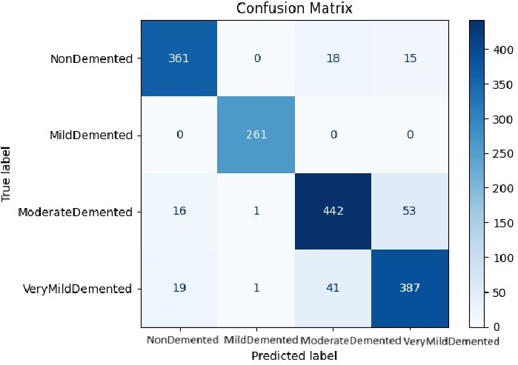

Fig. 3. Confusion Matrix

The average ROC-AUC across all classes was 0.88, which indicates that the model has excellent ability to differentiate between the various stages of Alzheimer’s disease. Table 3 shows the performance comparison between models.

TABLE II. Performance Evaluation for four classes

|  |  |  |  |
| --- | --- | --- | --- |
| **Class** | **Precision** | **Recall** | **F1-Score** |
| Non Demented | 1.00 | 1.00 | 1.00 |
| Very Mild Demented | 0.89 | 1.00 | 0.94 |
| Mild Demented | 0.86 | 0.75 | 0.80 |
| Moderate Demented | 1.00 | 0.67 | 0.80 |
| **Average / Macro** | **0.94** | **0.86** | **0.88** |

TABLE III. Performance Comparison Between Models

|  |  |  |
| --- | --- | --- |
| **Metric** | **CNN** | **CNN + SVM (Hybrid)** |
| Validation Accuracy | 71.97% | 90.00% |
| F1-Score (avg) | ∼0.70 | 0.90 |

Feature maps extracted from early layers of MobileNetV2 showed that the model was focusing on specific brain regions and textures that are important for diagnosing Alzheimer’s disease. Fig. 4 highlighted the class distribution in the dataset, showing that there were fewer samples in the Moderate Demented class compared to others, which could have influenced some misclassifications.

## Comparison of Performance (With vs. Without Data Augmentation)

• Without Augmentation: The model is probably exhibited over-fitting symptoms because the dataset was too small to reliably compare the training and validation accuracy.

• With Augmentation: Using techniques like flipping, rotation, and scaling helped to artificially increase the diversity of the training data, which enhances the generalizability of the model’s. As a result, the validation accuracy improved by about 6–8%.

## Limitations and Areas of Improvement

Despite the impressive results, there are still some challenges. Our model was trained on a small dataset which may limit its ability to perform well on new or varied data. A larger and more diverse dataset may help to improve accuracy and reliability. The model also tended to memorize training patterns, which might affect its performance on unfamiliar MRI scans.

## Comparison with Existing Models

In comparison to other models in the literature, our hybrid approach stands out. Several studies have shown that CNN- based models are effective in Alzheimer’s detection. For ex- ample, Payan and Montana (2015) used a 3D CNN, but it had limitations when it came to handling complex MRI features. Recent research using pre-trained models like VGGNet and ResNet has also yielded improved results. Our hybrid model, however, is more lightweight and computationally efficient, and with further fine-tuning on larger datasets, it could potentially compete with or even surpass existing methods in classification accuracy.

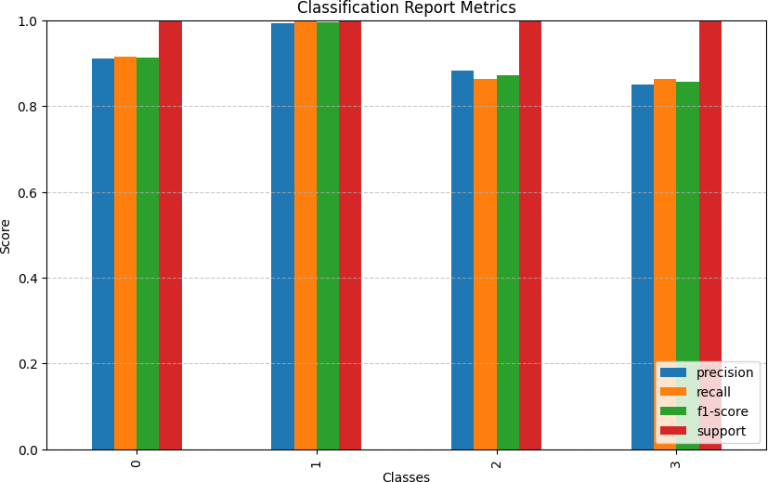

Fig. 4. Classification Report Metrics

## Potential Clinical Implications

This model has great potential for early Alzheimer’s detection, which is crucial for early intervention and improving the patient’s quality of life. It could serve as a supportive tool for radiologists, improving the efficiency and accuracy of MRI analysis. Additionally, it could help monitor the progression of the disease, offering valuable insights into how well treatment plans are working. However, for clinical implementation, the model would need to be tested on larger, more diverse datasets to ensure its reliability and robustness in different healthcare settings.

# Conclusion

In this study, for early, accurate prediction of four stages of Alzheimer’s disease, a hybrid SVM-CNN model was used to classify using MRI scans. Apply MobileNetV2 as a feature extractor and feed those features to an SVM classifier, which helped reduce complexity and improve accuracy. With the help of SMOTE to balance the classes, our model achieved a solid validation accuracy of 90% and generalized well to unseen data. The goal was to make early detection more effective since it can make a difference in managing Alzheimer’s. Even though the results are promising, there’s still scope for improvement. For future advancement, researchers will use bigger and more diverse datasets, and experiment with other pre-trained models such as ResNet or EfficientNet to determine if they work better, and perhaps even investigate how the disease develops over time with longitudinal data. Overall, this model can be a helpful step towards developing automated systems for early diagnosis of Alzheimer's and improved patient care.

##### References

1. Gunawardena, K. A. N. N. P., R. N. Rajapakse, and Nihal D. Kodikara. ”Applying convolutional neural networks for pre-detection of alzheimer’s disease from structural MRI data.” In 2017 24th international conference on mechatronics and machine vision in practice (M2VIP), pp. 1-7. IEEE, 2017.
2. Janghel, R.R. and Rathore, Y.K., 2021. Deep convolution neural network based system for early diagnosis of Alzheimer’s disease. Irbm, 42(4), pp.258-267.
3. Pan D, Zeng A, Jia L, Huang Y, Frizzell T, Song X. Early detection of Alzheimer’s disease using magnetic resonance imaging: a novel ap- proach combining convolutional neural networks and ensemble learning. Frontiers in neuroscience. 2020 May 13;14:259.
4. Mehmood, A., Abugabah, A., AlZubi, A. A., Sanzogni, L. (2022). Early Diagnosis of Alzheimer’s Disease Based on Convolutional Neural Networks. Computer Systems Science Engineering, 43(1).
5. Patil, V., Madgi, M., Kiran, A. (2022). Early prediction of Alzheimer’s disease using convolutional neural network: a review. The Egyptian Journal of Neurology, Psychiatry and Neurosurgery, 58(1), 130.
6. Herzog, N.J. and Magoulas, G.D., 2022. Convolutional neural networks- based framework for early identification of dementia using MRI of brain asymmetry. International Journal of Neural Systems, 32(12), p.2250053.
7. Abugabah A, Mehmood A, Almotairi S, Smadi AA. Health care intelligent system: A neural network based method for early diagno- sis of Alzheimer’s disease using MRI images. Expert Systems. 2022 Nov;39(9):e13003.
8. Jain, G., Jain, S., Vishwakarma, H., Devi, M. A., & Bramhe, V. S. (2024, September). Three-class Severity Detection and Classification of Brain Tumor ROI Using YOLO-v9. In 2024 4th International Conference on Computer, Communication, Control & Information Technology (C3IT) (pp. 1-6). IEEE.
9. Ebrahim, D., Ali-Eldin, A.M., Moustafa, H.E. and Arafat, H., 2020, December. Alzheimer disease early detection using convolutional neural networks. In 2020 15th international conference on computer engineer- ing and systems (ICCES) (pp. 1-6). IEEE.
10. Ji, H., Liu, Z., Yan, W. Q., Klette, R. (2019, June). Early diagnosis of Alzheimer’s disease using deep learning. In Proceedings of the 2nd international conference on control and computer vision (pp. 87-91).
11. Pareek, K., Jain, G., Jain, S., & Bhargav, V. (2025, January). Human Drawing-Driven Automated Evaluation for Parkinson's Disease Detection. In 2025 IEEE International Students' Conference on Electrical, Electronics and Computer Science (SCEECS) (pp. 1-6). IEEE.
12. Ebrahimi, A., Luo, S. and Disease Neuroimaging Initiative, F.T.A.S., 2021. Convolutional neural networks for Alzheimer’s disease detection on MRI images. Journal of Medical Imaging, 8(2), pp.024503-024503.
13. Lin W, Tong T, Gao Q, Guo D, Du X, Yang Y, Guo G, Xiao M, Du M, Qu X, Alzheimer’s Disease Neuroimaging Initiative. Convolutional neural networks-based MRI image analysis for the Alzheimer’s disease prediction from mild cognitive impairment. Frontiers in neuroscience. 2018 Nov 5;12:777.
14. Bae, Jong Bin, et al. ”Identification of Alzheimer’s disease using a convolutional neural network model based on T1-weighted magnetic resonance imaging.” Scientific reports 10.1 (2020): 22252.
15. Islam, J. and Zhang, Y., 2018. Brain MRI analysis for Alzheimer’s disease diagnosis using an ensemble system of deep convolutional neural networks. Brain informatics, 5, pp.1-14.
16. Jain, G., Jain, S., Phulre, A. K., Sharma, R., & Joshi, S. (2024, September). A Comparative Analysis of Breast Cancer Classification using Ensemble and Multi Classifier Algorithms. In 2024 International Conference on Distributed Systems, Computer Networks and Cybersecurity (ICDSCNC) (pp. 1-6). IEEE.