PURRU BALAJI

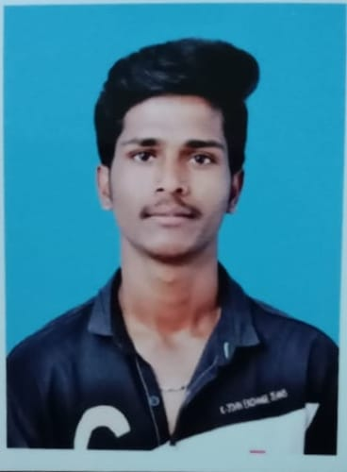

To work hard with full dedication for the achievement of organization objective, hence enhancing my skill and knowledge and ready to learn new things.

# Contact Personal Project

Mobile **Title :** Built visualizations to show the regions that are affected by covid with real time data.

9347717424

Email **Domain** : Excel, power Bi

[purrubalaji13@gmail.com](mailto:purrubalaji13@gmail.com)

Address

Gollapalli , Chittoor District , Andhra Pradesh.

# Education

## Sri Venkateswara College of Engineering And Technology

**Description**

The COVID-19 analytics power Bi dashboard is a comprehensive data visualization project that offers valuable insights into the impact of COVID-19 pandemic worldwide. The dashboard is designed using Microsoft power BI, providing an interactive and user-friendly interface to explore and analyze key metrics related to COVID-19 cases, deaths, recoveries, and more.

# Internship

## BTECH DATA ANALYST

**2021 - 2025 | Pursuing** By using python identifying a person(face detection).

**Sri chainthanya junior college** creating a IPL dashboard using power BI.

MPC-85%

SQL for connecting various databases to power BI.

**ZP High School | Percentage - 85%** Courses

Skills Data Science With Python

Data visualization using power BI

Python(basics) Data cleaning , data manipulation using excel

SQL Certificates

Excel & power Bi

Html & CSS(Bootstrap) power BI from Mindluster.com

Data analyst From ADS(Indo-euro-synchronization

* Data science from Bharat intern

Languages **Achievements**

**Telugu winners of hackathon .**

**English**  winners of cricket and taken trophy from our principal.