EN AI Detector
Visual & Interaction Correction Batch
Designer + Claude · targeted rework only · 2026-08-25
URL: https://plagiarismsearch.com/ai-content-detector
EXECUTION STATUS — CORRECTION NOTE
This file does not replace the approved AI Detector strategy/content baseline (DEC-0038). The original 2026-08-22 Claude brief remains authoritative for product facts, approved copy, page order, SEO, links, FAQ and forbidden claims. This correction note supersedes it only where this file explicitly changes visual hierarchy, state-display behavior, report-demo implementation, document evidence, interpretation composition, API visual weight, or pricing interaction.

1. What this batch is fixing
Do not redesign the whole page. The funnel/content architecture is still approved: checker → report → documents → interpretation → AI vs plagiarism → data handling → API → pricing → FAQ → return to checker. The problem is that several implementation choices obscure that funnel and make the product proof look weaker than it is.
Area | Decision | Instruction
Hero H1 + supporting copy | KEEP | No copy rewrite.
Main paste/upload checker | KEEP BASE | Keep as the dominant product object; fix state behavior around it.
Visible “Checker states” accordion | REMOVE | Technical states must appear only when triggered.
Persistent “Create an account…” card | REMOVE FROM DEFAULT | Auth copy becomes a conditional auth gate only.
Hero proof rail | KEEP | Keep compact. Do not add new claims.
AI report section | MAJOR REWORK | Keep three-metric story; rebuild visual around real product evidence.
Document/file section copy | KEEP | Replace stock photo with real product/file evidence.
Interpretation content | KEEP MEANING | Recompose visually; do not leave as sparse 50/50 text columns.
AI vs plagiarism | KEEP | Only minor spacing polish if necessary.
Data handling | KEEP | Compact excessive whitespace only.
API content/CTA | KEEP | Reduce visual weight to a compact secondary banner.
AI pricing grouping | KEEP | Fix package selection inside each billing group.
FAQ | KEEP | No new generic questions.
Final CTA | KEEP | Returns to the real checker.

2. Funnel that must remain after the correction
- 1. TRY — The user immediately understands that they can paste text or upload a document and run an AI check.
- 2. SEE — The page shows a convincing, real-looking AI report and explains what comes back.
- 3. UNDERSTAND — AI Probability, Total AI Rate and highlighted passages are clearly different.
- 4. USE DOCUMENTS — File/document checking remains a strong product/search use case.
- 5. INTERPRET — The user learns to treat detection as a signal, not a verdict.
- 6. DISTINGUISH — AI detection and plagiarism checking are separated once and clearly.
- 7. TRUST — Data processing/report retention is explained factually.
- 8. EXTEND — API is available for users who need workflow integration, but stays secondary.
- 9. BUY — The user can select one exact AI package without ambiguity.
- 10. RESOLVE — FAQ answers page-specific objections.
- 11. RETURN — Final CTA takes the user back to the real checker.
DO NOT CHANGE PAGE ORDER
The current problem is visual priority and interaction, not the strategic sequence. Do not move Pricing directly under the hero, do not turn API into a primary product story, and do not add persona/keyword filler sections.

3. First screen / checker — mandatory correction

3.1 Remove the visible “Checker states” accordion
REMOVE COMPLETELY — The implementation currently exposes too-short / unreadable / processing / completed / insufficient as a user-visible accordion directly under the checker.
Required correction: Delete this accordion from the rendered page. These strings are implementation states, not page content. Each state appears only when the corresponding event actually occurs inside or immediately adjacent to the checker.
Keep unchanged: The exact approved state messages themselves. Only their display condition changes.
Acceptance: In the normal/default state there is no “Checker states” control, accordion, disclosure, debug list, or documentation block anywhere on the page.
State | When it appears | How it should appear
Default | Before an action | Normal checker only.
Too short | User submits <100 characters | Inline validation in/under the text-input area.
Unreadable file | Text cannot be extracted | Inline file error tied to the uploaded file area.
Processing | A real AI check is running | Checker changes to a processing state; do not show a separate page block.
Completed | Result is ready | Transition to/show the real AI result/report flow.
Insufficient AI balance | Authenticated user lacks enough AI words | Inline account/balance state with View AI pricing → #ai-pricing.
Unauthenticated | User tries to run Check for AI | Trigger the existing auth gate; see 3.2.

3.2 Remove the persistent “Create an account to run your AI check” card
REMOVE FROM DEFAULT STATE — The implementation shows a second large CTA card directly below the checker, creating competing actions: Check for AI / Create free account / Log in / View AI pricing.
Required correction: The account block becomes a conditional authentication state only after an unauthenticated user presses Check for AI. Use the existing shared PlagiarismSearch auth gate/modal/drawer/in-card gate. Do not create a second standalone form below the checker.
Keep unchanged: Exact auth copy: “Create an account to run your AI check”; one-time 1,000-word registration-credit fact; Create free account CTA; Log in link.
Acceptance: Default first screen has one page-level product action: use the checker. Account creation is requested only at the moment it is required to run the check.
AUTH FLOW REQUIREMENT
An unauthenticated user may paste text or attach/upload a document before authentication. When they press “Check for AI”, open the existing auth flow. Preserve the entered text/file state if the current application architecture supports it. After successful signup/login, return the user to the AI-check flow rather than to an unrelated account landing. Do not promise an anonymous AI scan.

Required first-screen composition after the correction:
- H1 + approved supporting sentence
- One real paste/upload checker
- Compact proof rail
- Nothing else before the next main section

4. AI report — rebuild as the signature product-evidence section
This is the highest-priority visual correction on the page. The current schematic report with gray dummy lines and bracket strings such as [REAL AI PROBABILITY] looks like a Figma placeholder rather than a product. The approved strategy was report-led; therefore the report must become the most convincing visual evidence after the checker.

4.1 Remove all bracket placeholders from visible UI
REMOVE COMPLETELY — The current visual exposes [REAL AI PROBABILITY], [REAL TOTAL AI RATE] and [REAL PASSAGE-LEVEL AI PROBABILITY].
Required correction: No bracket placeholder may appear in a user-facing mock or production build. Final demo must use numeric values from a real precomputed AI report/state. The supplied real product screenshot already provides a usable fallback: Total AI Rate = 13.44% and AI probability = 12.5%.
Acceptance: A normal viewer sees a finished report example, not implementation notes.

4.2 Use actual report visual language, not generic skeleton lines
REBUILD VISUAL — The current report graphic uses abstract horizontal bars and does not resemble the real report sufficiently.
Required correction: Base the marketing demo on the supplied real product report: readable document text on one side, real purple highlighted passages, and the Report information panel with Total AI Rate and AI probability. Crop away irrelevant account/browser chrome. Keep the demo AI-focused and do not show a Plagiarism percentage/source-match result.
Keep unchanged: The dark section, H2 “Understand your AI detection report”, the three-layer metric explanation, and the clarification that the values are detection indicators rather than proof.
Acceptance: The report is immediately recognizable as product UI and is visually larger/more important than the explanatory cards.
REAL PRODUCT SOURCE OF TRUTH — supplied report screenshot
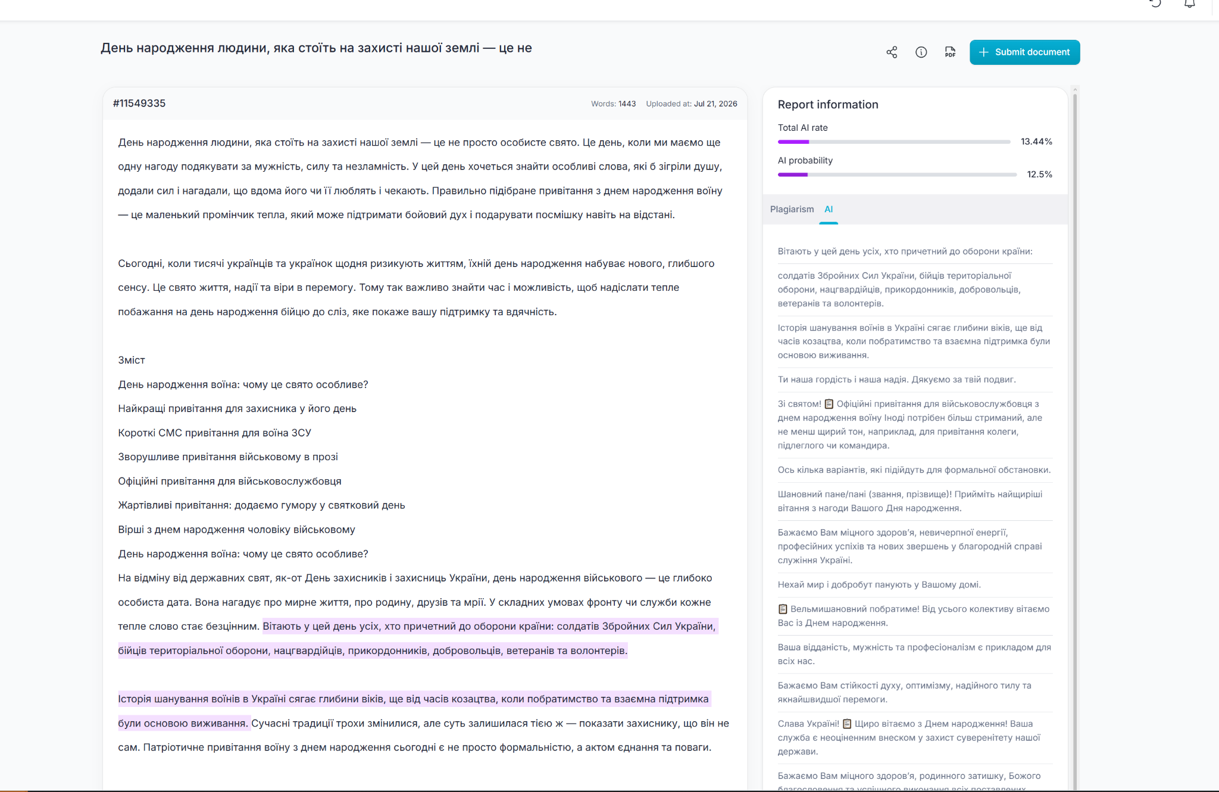
Visible real values in this source: Total AI Rate 13.44% · AI probability 12.5% · real purple passage highlights.
Recommended information hierarchy inside the section:
- Primary visual area (roughly 60–70% of the content width): the real-looking AI report crop.
- Secondary explanation area (roughly 30–40%): three compact metric explanations, not three dominant oversized cards.
- DOCUMENT — AI Probability: document-level likelihood.
- AMOUNT — Total AI Rate: share of the document contained in flagged passages.
- LOCATION — Highlighted passages: where signals appear in the text.
- Clarification callout remains under/beside the report: AI Probability and Total AI Rate are different metrics; values are signals, not proof of authorship.
PASSAGE-LEVEL PROBABILITY
If the real product exposes a numeric AI probability for a selected highlighted passage, capture and show one real state/value from staging. If that numeric state cannot be captured or does not exist in the current UI, do NOT display another [REAL …] placeholder and do NOT invent an interaction. Show the real highlighted passages as the LOCATION layer and keep the passage-level explanation in copy only.

NUMERIC SAMPLE RULE — UPDATED
The old brief prohibited invented report numbers because a real asset was missing. For this correction batch, visible numeric report values are required. Preferred order: (1) capture a stronger real precomputed AI report from staging and use its exact values; (2) otherwise use the supplied real report values 13.44% Total AI Rate and 12.5% AI probability. Do not use bracket placeholders. These report percentages are sample output values, NOT detector-accuracy claims.

5. Document/file section — keep content, replace stock photography

5.1 Replace the person-with-laptop photo
REPLACE VISUAL ONLY — The stock photo does not demonstrate document checking and weakens the product-evidence direction.
Required correction: Use real PlagiarismSearch product evidence: ideally a captured checker state with a document attached/ready for AI analysis. If a final attached-file state is not yet available, use the real upload/checker UI itself as the visual anchor rather than a person photo. Do not invent a fake file-processing dashboard.
Keep unchanged: H2 “Check AI-written text in complete documents”, approved intro, and the four cards: Paste text / Upload a document / Give the detector enough context / Check text in different languages.
Acceptance: A viewer can tell from the visual itself that PlagiarismSearch accepts documents; the section no longer depends on generic photography.

6. Interpretation — keep the message, rebuild the composition
The current 50/50 layout is too sparse: a large H2 sits alone on the left while long paragraphs stack on the right. The content is important; the visual hierarchy is not.
Required composition:
- Place H2 “Use AI detection as a signal, not a verdict” with the first approved explanatory sentence as a clear section intro.
- Under the intro, structure the existing meaning into three compact interpretation steps/tiles using the existing metric terminology — do not add new product claims.
- 1 — Document-level likelihood: start with AI Probability.
- 2 — Share of flagged text: compare Total AI Rate.
- 3 — Highlighted passages: inspect the exact passages and context.
- Make the existing 70% clarification the signature visual callout, not a small note buried beside paragraphs.
- Keep the consequential-use note below the callout in lower visual priority.
SIGNATURE CLARIFICATION — KEEP EXACT MEANING
“A 70% AI Probability does not mean that 70% of the text was written by AI. AI Probability describes the likelihood for the document as a whole. Use Total AI Rate to understand the share of text contained in passages flagged as AI-generated.”

6.1 Avoid a text-heavy empty split
SUBSTANTIAL VISUAL REWORK — The current section reads like two disconnected text columns with excessive empty space.
Required correction: Use cards/steps/callout to create a clear reading sequence. The section should teach how to interpret the result after the report section has shown what the result contains.
Acceptance: Report section answers “what are the three signals?”; Interpretation section answers “how should I use them?”. They no longer feel like duplicate explanations.

7. AI vs plagiarism — leave essentially unchanged
KEEP. The two-card distinction is doing the correct semantic job. Only spacing/alignment polish is allowed. Do not add plagiarism screenshots, plagiarism pricing, database claims, or additional plagiarism cross-links.

8. Data handling — keep content, compact the section if needed
KEEP content and three-step model. The factual wording is correct: processing on PlagiarismSearch infrastructure, checked content not sent to an external AI detector provider, reports may remain in the account and can be permanently deleted. The only permitted visual adjustment is reducing unnecessary vertical whitespace so this secondary trust section does not feel larger than the report/document sections.

9. API section — keep the capability, reduce its visual priority

9.1 Convert the oversized dark API section into a compact secondary banner
REDUCE VISUAL WEIGHT — The current API section is almost as visually dominant as the report despite API being a secondary workflow capability on this page.
Required correction: Keep the exact H2, approved two-paragraph explanation and CTA to /plagiarism-api, but present them in a compact dark banner/callout approximately half the current vertical footprint. One clear CTA is enough.
Keep unchanged: “Add AI detection to your own workflow” and “Explore the PlagiarismSearch API”.
Acceptance: The section is easy to discover for technical users but does not interrupt the primary checker → report → understanding → pricing funnel.

10. AI pricing — keep grouping, fix the package-selection UX
Current problem: each billing column lists two or three different packages but has one generic “Choose plan” button. The user cannot tell which package that button will purchase. This is a real conversion/interaction defect, not a copy preference.
PRICING MODEL TO KEEP
Keep the three grouped cards: One-time / Monthly / Yearly. Keep current approved package rows and backend-driven production pricing. Do NOT expand back into eight large standalone cards unless the grouped interaction cannot be implemented.

Billing group | Selectable packages | Selection behavior | CTA behavior
One-time | 10,000 — $4.95; 50,000 — $9.95 | Each row is an actual radio/select option. Selected row has clear active state. | Button executes only the selected package. Label updates, e.g. “Continue with 10,000 words”.
Monthly | 100,000 — $12.95/month; 300,000 — $25.95/month; 500,000 — $35.95/month | Same radio/select behavior. | Button label reflects selected amount, e.g. “Continue with 300,000 words”.
Yearly | 1,000,000 — $55.95/year; 3,000,000 — $125.95/year; 5,000,000 — $215.95/year | Same radio/select behavior. | Button label reflects selected amount, e.g. “Continue with 3,000,000 words”.
- Each package row must be clickable/selectable, not plain text.
- Use accessible radio/select semantics. A keyboard user must be able to change the selected package.
- If backend provides a default/recommended package for a billing group, use it. Otherwise preselect the first active package in each group.
- Selected row must have an obvious visual state (radio + local background/border/highlight).
- The CTA inside that billing card must target ONLY the selected package/checkout ID.
- Changing the selected row updates the CTA label and destination/state immediately.
- Production package IDs, active packages, prices, billing metadata and checkout destinations remain backend-driven.
Helper copy above the cards — add one short interface instruction: “Select an AI word allowance, then continue with the chosen package.”
Free-credit line — use the more precise verified wording: “New accounts receive a one-time 1,000-word credit that can be used for AI or plagiarism checking.”
DO NOT SHIP GENERIC “CHOOSE PLAN”
A generic CTA is acceptable only if there is exactly one purchasable package in that card. With multiple rows, the selected package must be explicit before checkout.

11. FAQ and final CTA — keep
FAQ: KEEP. Do not expand it with generic AI education, model-name questions, competitor comparisons or unsupported accuracy claims. Maintain accessible accordion behavior and rendered HTML answers.
Final CTA: KEEP. “Check your text for AI-writing signals” must scroll/focus the real checker at #ai-checker. Do not render a second checker.

12. Responsive / interaction acceptance
- First screen: checker remains dominant on desktop and mobile; no persistent auth card or debug-state accordion appears.
- Auth gate: opens only after unauthenticated Check for AI action and does not create a second persistent page form.
- Report: on mobile, metric explanation and report stack without shrinking report text into unreadable thumbnails. Consider a scroll/crop/lightbox only if consistent with the approved system.
- Document evidence: real file/upload UI remains legible on mobile; no stock image fallback.
- Interpretation: three interpretation steps stack cleanly; the 70% clarification stays prominent.
- API banner: stays compact and does not become a tall mobile section.
- Pricing: radio/select rows have sufficient touch targets; selected state is obvious; CTA label does not truncate meaningfully.
- FAQ and final CTA retain keyboard/focus behavior and anchor targets.

13. Product facts / claims — do not regress during visual rework
- AI Probability = document-level percentage likelihood.
- Total AI Rate = share/percentage of text contained in AI-flagged passages.
- AI-only report does not display a Plagiarism percentage/source-match result.
- Pasted text minimum = 100 characters.
- Recommended sample length = 150–200 words or more.
- Any language may be processed; highest detection accuracy is English.
- AI processing runs on PlagiarismSearch infrastructure; checked content is not sent to an external AI detector provider.
- Reports may remain in the account and can be permanently deleted; do not say “No data storage”.
- New-account free credit = one-time 1,000 words usable for AI or plagiarism. The recurring 300/day allowance is plagiarism-only.
- AI uses the main PlagiarismSearch API infrastructure; no separate standalone AI API product.
- 500,000+ is a PlagiarismSearch-wide USERS claim, not AI customers.
- No numeric detector-accuracy/false-positive marketing claims and no named-model coverage claims.

14. Explicit non-scope / do not “improve” these while correcting
- Do not rewrite the H1 or hero supporting copy.
- Do not change the approved section order.
- Do not add audience cards for students/teachers/writers/marketers/bloggers.
- Do not add “How AI detectors work” long-form SEO filler.
- Do not add named models (GPT, Claude, Gemini, LLaMA, etc.).
- Do not add “99% accuracy”, “proven high accuracy”, speed/SLA or “No data storage”.
- Do not add reviews/testimonials merely to fill visual space.
- Do not turn AI vs plagiarism into a large plagiarism-sales section.
- Do not move API or Pricing above the report/document/interpretation story.
- Do not invent new report metrics, thresholds, labels or passage interactions.

15. Definition of done for this correction batch
- ☐ No “Checker states” accordion/disclosure exists in the normal page view.
- ☐ No persistent “Create an account to run your AI check” card exists below the checker.
- ☐ Unauthenticated Check for AI triggers the shared auth gate only when required.
- ☐ The first screen contains one real checker and a compact proof rail — not two competing CTA blocks.
- ☐ The report section uses real product visual language and numeric sample output, not [REAL …] placeholders.
- ☐ The report is visually the dominant element of its section and shows AI Probability, Total AI Rate and highlighted passages clearly.
- ☐ No Plagiarism percentage/source-match result appears in the AI report demo.
- ☐ Stock photo in the document section is replaced with real file/upload product evidence.
- ☐ Interpretation section has a clear three-step reading sequence and prominent 70% clarification.
- ☐ AI vs plagiarism remains compact and unchanged in meaning.
- ☐ Data handling wording remains factual; section height may be compacted only.
- ☐ API block is a compact secondary banner, not a dominant full-screen moment.
- ☐ Every pricing package row is individually selectable.
- ☐ Each billing-group CTA always maps to the selected package and clearly reflects that selection.
- ☐ AI pricing/free-credit facts remain backend/fact correct.
- ☐ FAQ stays page-specific; final CTA returns to the real checker.
- ☐ No new product claims, URLs, audience sections or model/accuracy claims were introduced.
HANDOFF RULE
Designer and Claude should treat this as one correction batch. Change only the sections explicitly marked REMOVE / REBUILD / REDUCE / FIX above. Everything marked KEEP is frozen for this pass. After this batch is implemented, return screenshots/staging for QA before any further AI Detector redesign work.

