CLAUDE EXECUTION BRIEF
EN MOODLE INTEGRATION
PlagiarismSearch - /integration-guide
Approved documentation-led product hybrid baseline - 15 September 2026
This file is the implementation contract for Claude/Designer. It freezes the page role, exact English content baseline, confirmed Moodle technical facts, visual-evidence rules, SEO/AI-search requirements and QA boundaries. Visual composition remains flexible inside the approved PlagiarismSearch design system.

1. OBJECTIVE
Design and implement the new English Moodle Integration page on the existing /integration-guide URL. Preserve the route, but replace the legacy mixed LMS/API/Google-Docs article with one authoritative Moodle product-and-documentation owner.
The page must work simultaneously for: (1) evaluators who need to know whether PlagiarismSearch integrates with Moodle, (2) Moodle administrators installing and connecting the plugin, (3) instructors configuring Moodle Assignments, and (4) support users who need to understand reports, student permissions, Storage behavior, AI detection and deterministic troubleshooting.
This is not a normal commercial landing. The top ~20–25% may perform a compact product/evaluator job; the majority of the page must behave like high-quality first-party technical documentation.

2. SOURCE-OF-TRUTH RULE
The factual boundaries and exact content baseline in this brief are authoritative for this implementation. Current plugin behavior and confirmed product/dev facts override stale legacy website copy, stale Marketplace wording, old screenshots and assumptions.
If a design/copy idea requires a new claim about supported Moodle activities, compatibility, credentials, report behavior, Storage, AI, security, timing, formats, API Debug, student permissions or other product behavior that is not explicitly approved here, do not invent it. Flag it for product/dev verification instead.
Current authoritative Moodle facts
Moodle 2.7–5.2; Moodle Assignment (mod_assign) only; API User + API Key are available self-service from the PlagiarismSearch account/API area. Automatic checking supports Assignment file submissions and online text. The current manual Submit/Resubmit flow is file-based.

3. DESIGN FREEDOM
Claude owns the visual composition, section merging, typography, documentation navigation, screenshot treatment, diagrams, spacing, responsive behavior and visual rhythm inside the approved design system. Do not interpret the section order below as a rigid wireframe.
You may merge compatible information acts, for example Installation + Connect, Reports + Student Access, or Troubleshooting + FAQ, when the resulting page remains easier to navigate and all factual/detail requirements survive.
Do not turn the page into another checker landing. Do not add a checker uploader, pricing matrix, review carousel, generic academic-integrity marketing, decorative feature bento, or repeated sales CTAs. Design quality here means orientation, scanability, evidence and trustworthy technical hierarchy.

4. ARCHITECTURE DECISION - ONE MOODLE OWNER
DEC-0057 is approved: keep /integration-guide as the single canonical EN Moodle owner for now. Do not create /moodle-plagiarism-checker or another commercial Moodle landing in this implementation.
The page is a documentation-led product hybrid: a compact evaluator/product layer above authoritative setup/configuration/use/troubleshooting documentation. It must be architected so a future commercial-vs-docs split remains possible if post-launch evidence later shows two distinct query/conversion clusters.
URL / Page | Owns
/integration-guide | Moodle plugin evaluation + installation + configuration + Assignment workflow + support
/university-plagiarism-checker | Institutional evaluation / procurement
/plagiarism-api | Custom developer/API integration
/how-to-use-plagiarismsearch-google-add-on | Google Docs add-on workflow
Future Canvas page | Canvas-specific integration workflow

5. PERFORMANCE / SEO CONTEXT
The legacy page is not a proven direct-conversion asset and does not justify preserving its old content structure. Historical project evidence shows a small organic footprint and no observed acquisition/payment records for the EN route. Current GSC screenshots show relevant but weak Moodle ownership (for example “plagiarism checker for moodle” with 349 impressions and average position 44.6) plus noisy Google Docs / generic LMS associations caused by the mixed legacy topic.
Therefore the recovery goal is topic tightening, not legacy-copy preservation: PlagiarismSearch + Moodle + plagiarism plugin + Assignments + installation/configuration. Losing irrelevant Google Docs impressions after the rebuild is not a regression if Moodle-qualified visibility improves.

6. PRIMARY SEARCH / USER INTENT
Primary search owner: Moodle plagiarism checker plugin / PlagiarismSearch Moodle integration.
Secondary natural query jobs include: plagiarism checker for Moodle; Moodle plagiarism checker; Moodle plagiarism plugin; plagiarism plugin Moodle; how to install a plagiarism checker in Moodle; PlagiarismSearch Moodle plugin; configure plagiarism plugin Moodle.
Do not create keyword-permutation sections or separate thin pages. Cover these jobs through clear product documentation.

7. RD-013 - GOOGLE AI OVERVIEW / AI MODE / ANSWER-ENGINE READINESS
Apply the project-wide RD-013 requirement. Do not add AI-SEO tricks. The page should become an authoritative first-party technical source because its facts are clear, current, rendered and uniquely grounded in the real integration.
- Keep compatibility, supported activity, credentials, checking modes, Storage behavior, AI setting, report behavior and student permissions in rendered HTML - not only inside screenshots.
- Place short direct answers before detailed explanation for high-value questions such as “Does PlagiarismSearch work with Moodle?”, “Which activities are supported?”, “Where is the API key?”, and “Can Moodle check submissions automatically?”.
- Use explicit product/entity language: this is the PlagiarismSearch Moodle plugin; current confirmed activity support is Moodle Assignment (mod_assign).
- Use first-party screenshots as evidence, but never rely on screenshots as the only source of a critical fact.
- Keep page sections anchorable and semantically headed so answer engines can retrieve specific setup facts.
- Do not create llms.txt, invented AI schema, artificial chunk markup, or separate fan-out pages as part of this implementation.
- Post-launch measure classic Moodle query cohorts plus Google Generative AI visibility and answer-engine referral/citation signals when available.

8. TECHNICAL FACT BASELINE - FREEZE FOR IMPLEMENTATION
Fact | Approved implementation wording / boundary
Compatibility | Moodle 2.7–5.2.
Supported activity | Moodle Assignment (mod_assign) only. Do not claim Workshop, Forum, Quiz or broader activity support.
Submission types | Assignment file submissions and online text.
Automatic checking | Supported for file and online-text submission events when Auto check is enabled.
Manual checking | Current Submit/Resubmit workflow is file-based and permission/config dependent. Do not imply the same manual control for online text.
Credentials | API User + API Key are available in the user’s PlagiarismSearch account/API area.
Source modes | Web + Storage; Web only; Storage only.
Add to Storage | Separate control from whether Storage is searched.
AI | Detect AI is a separate optional setting. AI detection is not plagiarism detection.
Reports | Current plugin supports no report link, PDF, HTML, or PDF + HTML depending on settings; teacher review link can also be enabled.
Student controls | Configurable report visibility, returned percentage visibility, eligible file submit/resubmit controls and resubmission count.
Assignment/site defaults | Assignment-specific values can use/override site defaults where configuration is permitted.
API Debug | Advanced/debug setting exists. Do not repeat legacy callback-encryption explanation without engineering confirmation.

9. PAGE-LEVEL SEO / HTML REQUIREMENTS
SEO title
Moodle Plagiarism Checker Plugin: Setup Guide | PlagiarismSearch
Meta description
Install and configure the PlagiarismSearch Moodle plugin for Assignments. Set up API access, checking modes, reports, student permissions, and optional AI detection.
Visible H1
PlagiarismSearch Moodle Integration: Installation & Setup
- Keep the existing /integration-guide route. No redirect, new Moodle SEO slug or canonical change.
- Exactly one H1.
- Keep the page indexable and self-canonical; preserve valid hreflang relationships.
- Remove Google Docs/add-on content from this page owner.
- Use Moodle plagiarism checker/plugin wording naturally in title, top copy, relevant headings and FAQ; do not keyword-stuff.
- Critical setup instructions and FAQ answers must be present as normal rendered text, not client-only overlays or text baked into images.
- Screenshots need useful alt text/captions describing the workflow shown, not keyword-stuffed alt text.

10. APPROVED SECTION LIBRARY - REFERENCE, NOT FIXED SEQUENCE
Library unit | Moodle instruction
SEC-WORKFLOW-01 | Reuse/adapt the visual grammar for the real multi-step setup workflow; do not force it into only three marketing cards.
SEC-FAQ-01 | Reuse for technical Moodle FAQ.
SEC-RESOURCE-01 | Reuse near the end for Marketplace / GitHub / University / API handoff.
SEC-CONTROL-01 | Design-language reference only. Do not copy homepage scanner controls literally.
SEC-RESULTS-01 | May inspire the result/status/report lifecycle presentation.
SEC-INTEGRATION-01 | Do not use as a generic integrations carousel; the user is already inside the Moodle owner.
Pricing / Reviews / Checker hero | Do not use.

Potential new reusable patterns - documentation in-page navigation and screenshot-led setup/reference treatment - remain page-local candidates until implementation QA and final user approval. Do not add them to 33_Component_Library now.

11. REQUIRED INFORMATION JOBS
These jobs are mandatory even if Claude merges sections or changes the sequence.
- Identify the page immediately as the official PlagiarismSearch Moodle integration/setup guide.
- Tell evaluators the current compatibility, supported activity and core capabilities before they enter long documentation.
- Show prerequisites and the end-to-end setup flow.
- Explain where API User + API Key come from and how Moodle is connected.
- Separate site-wide defaults from Moodle Assignment-level configuration.
- Explain Auto vs Manual checking without falsely implying identical behavior for online text.
- Explain Sources vs Add to Storage as distinct controls.
- Explain filters, reports, AI, student permissions and governance controls in functional groups rather than a flat legacy parameter dump.
- Show what teachers/students see after submission using real evidence.
- Provide deterministic troubleshooting for the confirmed workflow.
- Answer high-value Moodle technical questions directly in FAQ.
- End with Marketplace/GitHub/support and institutional/custom-integration handoff paths.

12. EXACT CONTENT BASELINE
The following copy is approved. Preserve meaning and claim strength. Small editorial adjustments are allowed for layout/readability, but do not strengthen capabilities or remove important limitations.

A. COMPACT DOCUMENTATION / PRODUCT HEADER
Eyebrow
Moodle Integration · Setup Guide
H1
PlagiarismSearch Moodle Integration: Installation & Setup
Intro
Connect PlagiarismSearch to Moodle Assignments so file and online-text submissions can be sent for plagiarism checking directly from the Moodle workflow.
Administrators can configure automatic checking, Web and Storage comparison sources, report access, student permissions, and optional AI detection from the PlagiarismSearch plugin settings.
Compatibility line
Current compatibility: Moodle 2.7–5.2 · Moodle Assignment (mod_assign) only
Primary CTA
Download Moodle Plugin → Moodle Marketplace
Secondary CTA
Start Setup → #installation
Tertiary text link
Open API Credentials → /account/api
Support microcopy
Need help with an institutional Moodle deployment? Contact our team. → /contact-us

B. QUICK FACTS
H2
Moodle Integration at a Glance
Intro
The PlagiarismSearch plugin works inside the Moodle Assignment workflow and lets administrators control when submissions are checked, which comparison sources are used, what report access is available, and which options students can use.
Label | Exact value
Moodle versions | 2.7–5.2
Supported activity | Moodle Assignment (mod_assign)
Submission types | File submissions and online text
Automatic checking | Available for file and online-text submissions
Manual checking | Available for file submissions, subject to permissions and settings
Comparison sources | Web, Storage, or Web + Storage
AI detection | Optional separate setting
Reports | PDF, HTML, or both
API credentials | API User + API Key from your PlagiarismSearch account

C. IN-PAGE NAVIGATION
Label
On this page
Requirements · Installation · Connect your account · Plugin settings · Assignment setup · Reports & student access · Troubleshooting · FAQ
Desktop should provide a sticky or clearly persistent documentation navigation treatment. Mobile may use a compact jump menu. Do not make navigation obscure or horizontally unusable.

D. REQUIREMENTS
H2
Before You Install the Moodle Plugin
Copy
Before starting the setup, make sure you have administrator access to the Moodle site and access to the API credentials in your PlagiarismSearch account.
Moodle also requires plagiarism prevention to be enabled at the site level before plagiarism plugins can be used. In current Moodle documentation, this setting is available under Site administration → Advanced features → Enable plagiarism plugins.
Requirement | Explanation
Moodle administrator access | Required to enable plagiarism prevention, install the plugin, and configure site-wide settings.
Supported Moodle version | Your installation should be within the currently supported Moodle 2.7–5.2 range.
PlagiarismSearch account | Required to obtain the API User and API Key used by the plugin.
Moodle Assignment workflow | The current confirmed integration supports Moodle Assignments only.

E. SETUP OVERVIEW
H2
How the Moodle Integration Works
Intro
PlagiarismSearch uses Moodle’s plagiarism-plugin workflow. Once the plugin is installed and connected, site-wide settings can provide the default checking behavior, while supported settings can also be configured for individual Moodle Assignments.
- Enable plagiarism prevention — Turn on Moodle’s plagiarism-plugin feature at the site level.
- Install PlagiarismSearch — Download the current plugin and install it through Moodle administration.
- Connect your account — Enter the API credentials available in your PlagiarismSearch account.
- Set your defaults — Choose checking mode, comparison sources, report options, AI detection, and student permissions.
- Enable it for an Assignment — Configure PlagiarismSearch in the Moodle Assignment where submissions should be checked.
Supporting copy: When Assignment-level settings are not stored, the plugin falls back to the corresponding site-wide settings. This lets administrators define defaults while still allowing Assignment-specific configuration where permitted.
Diagram allowed
Claude may create a clean schematic flow: Moodle Assignment → file / online-text submission → PlagiarismSearch check → similarity / optional AI result → report links and permitted student/teacher actions. This must be a schematic, not invented Moodle UI.

F. INSTALLATION
Anchor
installation
H2
Install the PlagiarismSearch Plugin in Moodle
Intro
Use the current plugin package from Moodle Marketplace or the official PlagiarismSearch GitHub repository. Moodle menu wording can vary slightly between versions, but the installation flow remains the same.
- In Moodle, go to Site administration → Advanced features and enable plagiarism plugins.
- Download the current PlagiarismSearch plugin ZIP from Moodle Marketplace or the official GitHub releases page.
- In Moodle, open Site administration → Plugins → Install plugins.
- Upload the PlagiarismSearch ZIP package and follow Moodle’s installation prompts.
- After installation, open the PlagiarismSearch plugin settings under Moodle site administration.
- Enable PlagiarismSearch and enter the connection details described in the next section.
- Save the settings and confirm that Moodle can connect to the PlagiarismSearch API.
Links: Download from Moodle Marketplace · View GitHub Releases

G. CONNECT MOODLE TO THE ACCOUNT
H2
Connect Moodle to Your PlagiarismSearch Account
Copy
Sign in to PlagiarismSearch and open the API section of your account. Your API User and API Key are available there.
In the Moodle PlagiarismSearch settings, enter those values in the corresponding API user and API key fields. The current plugin also contains an API URL field for the service endpoint.
Save the settings after entering your credentials.
Link
Open My API Credentials → /account/api
Security note
Keep your API Key private. Do not place it in screenshots, public documentation, support tickets visible to third parties, or other publicly accessible content.

Troubleshooting microcopy: If PlagiarismSearch cannot validate the connection while the plugin is being enabled, check the API connection values and save the settings again.

H. SETTINGS REFERENCE - FUNCTIONAL GROUPS
H2
Configure PlagiarismSearch Settings
Intro
PlagiarismSearch separates connection settings from checking, comparison, reporting, and student-access controls. Site-wide values act as defaults for Moodle Assignments unless an Assignment-specific value has been saved.

Group 1 — Connection
Setting | Explanation
Enable PlagiarismSearch | Turns the PlagiarismSearch plugin on at the site level. The integration must also be enabled for the Assignment where you want to use it.
API url | Defines the PlagiarismSearch API endpoint used by the plugin.
API user | Your PlagiarismSearch API user value.
API key | Your PlagiarismSearch API key.
API debug | Advanced connection/debugging setting. Leave this at the standard configuration unless PlagiarismSearch support instructs you to change it.

Group 2 — Checking behavior
Setting | Explanation
Auto check | Automatically sends supported Moodle Assignment submissions for checking after the relevant submission event. This applies to Assignment file submissions and online text.
Manual check | Enables manual submission and resubmission controls for supported file submissions when the user has the required permission. Student access also depends on the student settings below.

I. SOURCES AND STORAGE
H2
Choose What to Compare — and What to Store
Intro
Sources and Add to Storage are separate controls. One decides where a submission is compared; the other decides whether the new submission is added to PlagiarismSearch Storage.
Source option | Meaning
Doc vs Web + Storage | Compare the submitted content against both Web sources and the configured PlagiarismSearch Storage.
Doc vs Web | Compare the submitted content against Web sources without using Storage as a comparison source.
Doc vs Storage | Compare the submitted content against Storage without using Web sources for that check.

Add to Storage
Add to Storage controls whether the submitted content is added to Storage for future comparisons. Searching Storage does not by itself mean that the current submission will be added to Storage. Likewise, adding a submission to Storage is separate from deciding whether Storage will be searched during the current check.

J. FILTERING CONTROLS
H3
Refine the Comparison
Setting | Explanation
Only Latin characters | Applies the plugin’s character-substitution filter during the search. It is intended to help identify character replacements that can affect text matching.
Exclude references | Excludes detected reference-list content from the similarity calculation when the filter is enabled.
Exclude in-text citations | Excludes qualifying in-text citation content from the similarity calculation when the filter is enabled.
Exclude self-plagiarism | Changes how Storage comparisons involving the same user and/or course are filtered. This setting is relevant when Storage is used as a comparison source.

Self-comparison options
No — do not apply a same-user/course exclusion.
Exclude user plagiarism within the same course — filter matching Storage content associated with the same user in the same course.
Exclude user plagiarism — filter matching Storage content associated with the same user.
Exclude course plagiarism — filter matching Storage content associated with the same course.
Do not rewrite these settings as proof of “self-plagiarism”. They are comparison/filter behavior, not an academic-misconduct verdict.

K. OPTIONAL AI DETECTION
H3
Optional AI Detection
Copy
Detect AI is a separate setting from plagiarism detection. Enable it when you also want the PlagiarismSearch check to request an AI-related result.
When an AI result is available, Moodle can display it separately from the plagiarism/similarity result.
AI-generated text is not automatically plagiarism, and the two signals should be interpreted separately.

L. REPORT SETTINGS
H3
Configure Report Access
Setting | Explanation
Report language | Selects the language used when a supported report language is requested.
Report file type | Controls whether Moodle provides no report link, a PDF report, an HTML report, or both.
Allow teachers review reports | Enables the additional teacher review-report link when the user has the required permission.

Current report-language options
Default (English), English, Spanish, Ukrainian, Polish, and Russian.

M. MOODLE ASSIGNMENT SETUP
H2
Configure PlagiarismSearch for a Moodle Assignment
Critical supported-activity statement
The current PlagiarismSearch Moodle integration supports the Assignment (mod_assign) activity only. It does not currently provide the confirmed PlagiarismSearch workflow for Moodle Workshop, Forum, or Quiz activities.

Copy
Create a new Moodle Assignment or edit an existing one. In the Assignment settings, find the PlagiarismSearch section and enable the integration.
Supported checking and report settings can then use the site-wide defaults or be saved specifically for that Assignment. This allows administrators to establish a standard configuration while still supporting Assignment-level requirements where course configuration is permitted.
Admin governance note
If Only administrators can configure course settings is enabled at the site level, Assignment-level PlagiarismSearch configuration is restricted accordingly.
File and online-text submissions are not identical workflows
Automatic checking supports both Assignment file submissions and online text. The current manual Submit to PlagiarismSearch / Resubmit to PlagiarismSearch workflow is file-based.

N. AFTER SUBMISSION
H2
What Happens After a Student Submits Work
Copy
If Auto check is enabled, PlagiarismSearch listens for supported Moodle Assignment submission events and sends the submitted file or online text for checking.
For file submissions, Manual check can provide a Submit to PlagiarismSearch action when the current user has permission to use it. A completed file can also expose Resubmit to PlagiarismSearch when resubmission is allowed.
While a report is being processed, Moodle can show an In progress status and a Check status link.
After processing is complete, Moodle can display the returned percentage and the report links enabled by your configuration. If AI detection was enabled and an AI result was returned, the AI value is shown separately.
Interpretation note
A similarity result identifies matching content that should be reviewed in context. It should not be treated as an automatic determination that plagiarism or academic misconduct occurred.

O. STUDENT ACCESS CONTROLS
H2
Control What Students Can See and Do
Intro
Student access is configurable. Administrators can determine whether students can see report links, view the returned percentage, manually submit eligible files, or resubmit them after revision.
Setting | Explanation
Allow students view reports | Select whether students receive no report link, PDF, HTML, or both supported report formats.
Allow students view plagiarism percentage | Controls whether students can see the returned percentage in Moodle.
Allow students submit papers | Allows students to manually submit eligible file submissions when Manual check is enabled.
Allow students re-submit papers | Allows students to manually resubmit eligible files after a previous completed check when Manual check is enabled.
The number of re-submits | Limits the number of permitted student resubmissions when a limit is configured.
Student disclosure | Defines the disclosure text shown to students when the plugin is enabled.

Important: student permissions do not override the overall checking mode. Enabling student submission does not create a manual submission action unless Manual check is also enabled.

P. URL PARSING
H3
URL Parsing for Online Text
Copy
The plugin also includes an Allow URL parsing in text option.
When URL parsing is enabled, the plugin can use the configured Valid URLs list for parsing to define which URLs are allowed for that workflow.
Keep the allowed URL list limited to services and domains your institution intentionally supports.
Implementation nuance: treat “Allow URL parsing in text” as an Assignment-level option where available, while “Valid URLs list for parsing” is administrator-maintained site-level configuration. Do not visually imply both are necessarily set at the same level.

Q. TROUBLESHOOTING
H2
Troubleshooting Moodle Integration
Problem | Recommended check
PlagiarismSearch does not appear in the Assignment | Confirm that Moodle plagiarism plugins are enabled, the PlagiarismSearch plugin is installed and enabled, and you are configuring a Moodle Assignment.
The plugin cannot be enabled successfully | Recheck the API URL, API User, and API Key. The plugin validates the API connection when it is enabled.
An online-text submission has no manual Submit button | This is expected in the current implementation. Use Auto check for the online-text submission workflow.
A file has no manual Submit or Resubmit action | Check Manual check, user capability, and the applicable student submit/resubmit settings.
A student cannot see the result | Check Allow students view reports and Allow students view plagiarism percentage.
The result is still processing | Use Check status while the report remains In progress.
Storage behavior is not what you expected | Check both Sources and Add to Storage. They control different behaviors.

R. FAQ
Does PlagiarismSearch work with Moodle?
Yes. PlagiarismSearch provides a Moodle plagiarism plugin for the Moodle Assignment workflow. The current confirmed compatibility range is Moodle 2.7–5.2.
Which Moodle activities does PlagiarismSearch support?
The current confirmed PlagiarismSearch integration supports Moodle Assignment (mod_assign) only. Do not assume support for Workshop, Forum, Quiz, or other Moodle activities unless a later plugin release explicitly adds them.
Can PlagiarismSearch check both files and online text in Moodle?
Yes. Automatic checking supports Moodle Assignment file submissions and online-text submissions. The current manual Submit/Resubmit workflow is file-based.
Where do I get the API User and API Key for Moodle?
Sign in to your PlagiarismSearch account and open the API section. The API User and API Key used by the Moodle plugin are available there. Link: Open API Credentials → /account/api
Can Moodle submissions be checked automatically?
Yes. Enable Auto check in the PlagiarismSearch settings. For supported Moodle Assignment submissions, the plugin can automatically send new file and online-text submissions for checking.
Can I compare Moodle submissions with our own stored documents?
Yes. The Sources setting can use Web, Storage, or Web + Storage. Searching Storage is separate from Add to Storage, which controls whether a new submission is added to Storage for future comparisons.
Does the Moodle plugin include AI detection?
The plugin has a separate Detect AI option. When it is enabled, an AI-related result can be requested and displayed separately from the plagiarism/similarity result. AI detection and plagiarism detection are not the same analysis.
Which report formats are available in Moodle?
The current plugin can provide PDF reports, HTML reports, both formats, or no report link, depending on the selected settings. A separate teacher review link can also be enabled.
Can students see their plagiarism report?
Yes, if the administrator allows it. Student report access and percentage visibility are separate settings, so institutions can control what students can see.
Can students resubmit a paper after checking it?
Yes, for eligible file submissions when Manual check and student resubmission are enabled. Administrators can also configure a resubmission limit.
Are all Moodle submissions automatically stored?
No. Storage behavior is configurable. Add to Storage controls whether a submitted document is added to Storage, while Sources controls whether Storage is searched during a check.

S. SUPPORT / HANDOFF
H2
Need Help with Your Moodle Setup?
Copy
This guide covers the standard PlagiarismSearch Moodle installation and configuration workflow.
If you need help with API access, institutional deployment, account configuration, or a Moodle setup that requires additional technical review, contact the PlagiarismSearch team.
Primary CTA
Contact Support → /contact-us
Contextual route 1
Planning an institution-wide plagiarism workflow? Explore PlagiarismSearch for Universities → /university-plagiarism-checker
Contextual route 2
Need a custom integration instead of the Moodle plugin? Explore the Plagiarism API → /plagiarism-api
External resources
Moodle Marketplace · GitHub Releases

13. VISUAL EVIDENCE PLAN - USE THE PROVIDED SCREENSHOTS SELECTIVELY
The available screenshots are legacy/current-mixed evidence. Do not place all of them on the page. Do not recreate absent current UI. The brief provides raw screenshots for internal reference; the implementation must crop them deliberately around the information job.
Critical security rule
Screenshot assets containing API User / API Key are INTERNAL REFERENCE ONLY. Before any public use, mask API Key and any credential value that could be valid. Do not publish the raw screenshot.

Asset | Use decision | Best placement / Claude task
Raw settings screen (selected) | PRIMARY. Use selected areas only; do not present it as a complete current-settings inventory. | Connection/API crop near “Connect Moodle…”; Sources/Storage/Auto/Manual crop near “Choose What to Compare”; optional student/report-controls crop near “Control What Students Can See and Do”. Mask credentials.
Teacher grading/results screen (selected) | PRIMARY result evidence. | Tight crop around filename → returned percentage → PDF report → Resubmit. Remove Moodle navigation, grades, dates and empty space from the composition. Do not alter UI labels.
Assignment settings screen (fallback/locator only) | OPTIONAL. Old/minimal controls are not a current settings reference. | If useful, crop only enough to show that “PlagiarismSearch” exists inside Updating: Assignment. Do not show its small old control set as the current complete configuration.
Student submission screen | Do not use by default. | Duplicates the stronger teacher/result evidence and adds another visibly old Moodle screen.
Old settings/error screen | Do not use. | Contains error banner, legacy promotional copy, credentials and obsolete/minimal settings.

- Do not modernize/redraw Moodle controls. No fake current Moodle UI.
- Claude may crop, frame, annotate, add callout outlines or external labels, but must not rewrite labels inside the real UI.
- For old Moodle screenshots, prefer narrow evidence crops instead of large hero-like visuals.
- A browser/device frame is optional only if labels remain readable.
- A magnified detail inset is allowed when necessary for readability, as long as the underlying evidence remains unchanged.
- Use neutral captions such as “Example Moodle Assignment result view” rather than “Current Moodle interface”.
- Do not infer missing settings from text and then draw them into the screenshot.

14. PROVIDED SCREENSHOT REFERENCES - INTERNAL
These images are embedded so Claude can identify the exact source assets. They are not instructions to publish the raw files.
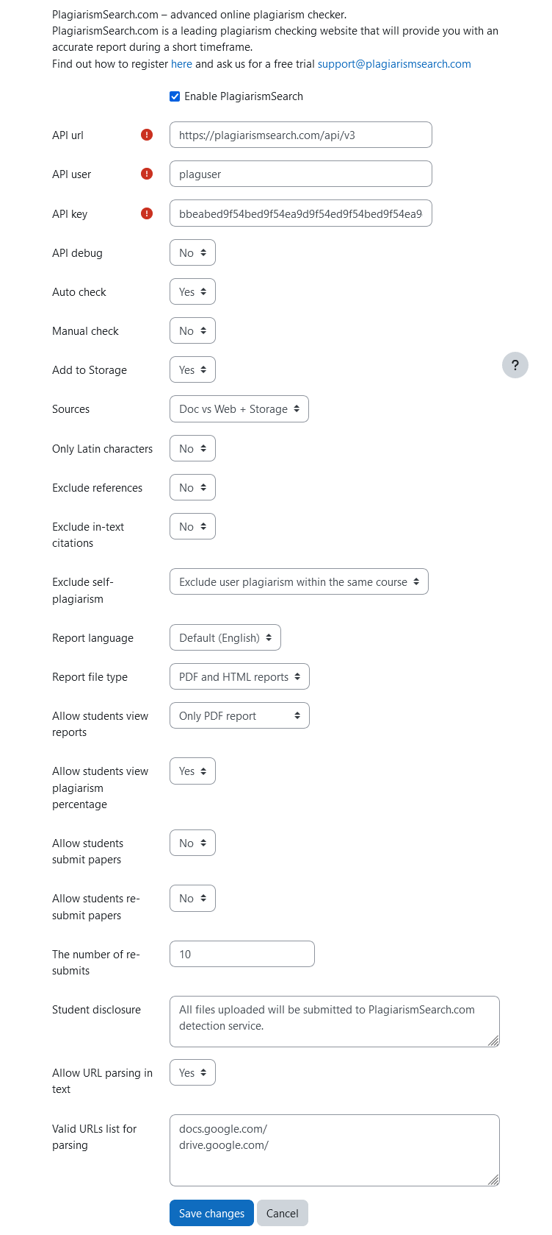
REFERENCE ASSET A — Settings screen (selected source)
Use only deliberate crops. Mask API User/API Key before public use. The screenshot is not proof that every current code-level setting is visible in this UI state.

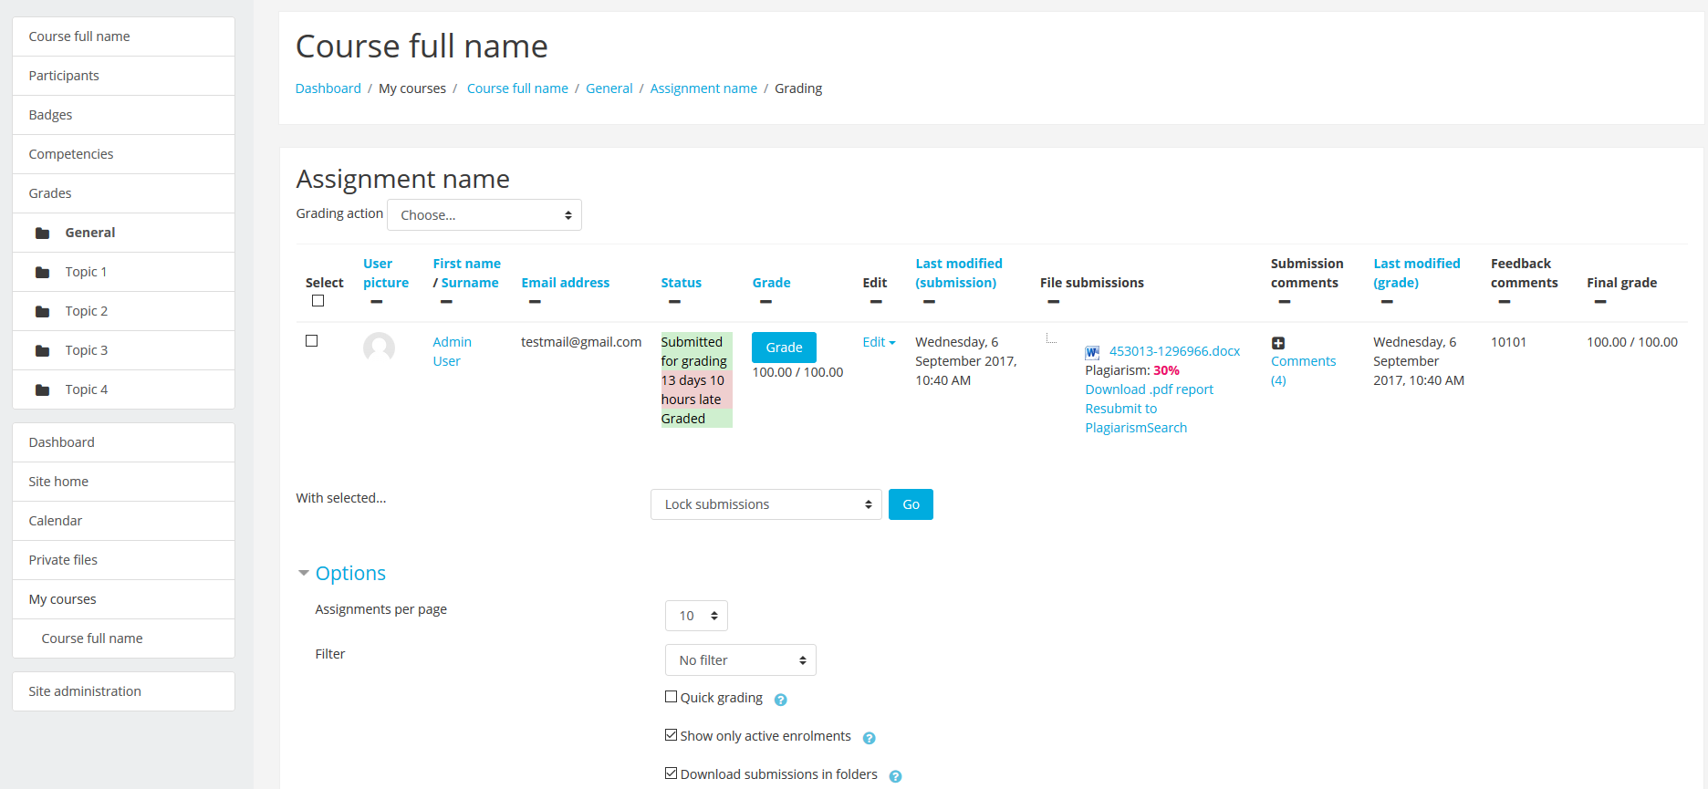
REFERENCE ASSET B — Teacher/grading result view (selected source)
Preferred result evidence. Crop tightly around the file, returned percentage, report link and Resubmit action. The surrounding Moodle theme/date/grade UI should not dominate the design.

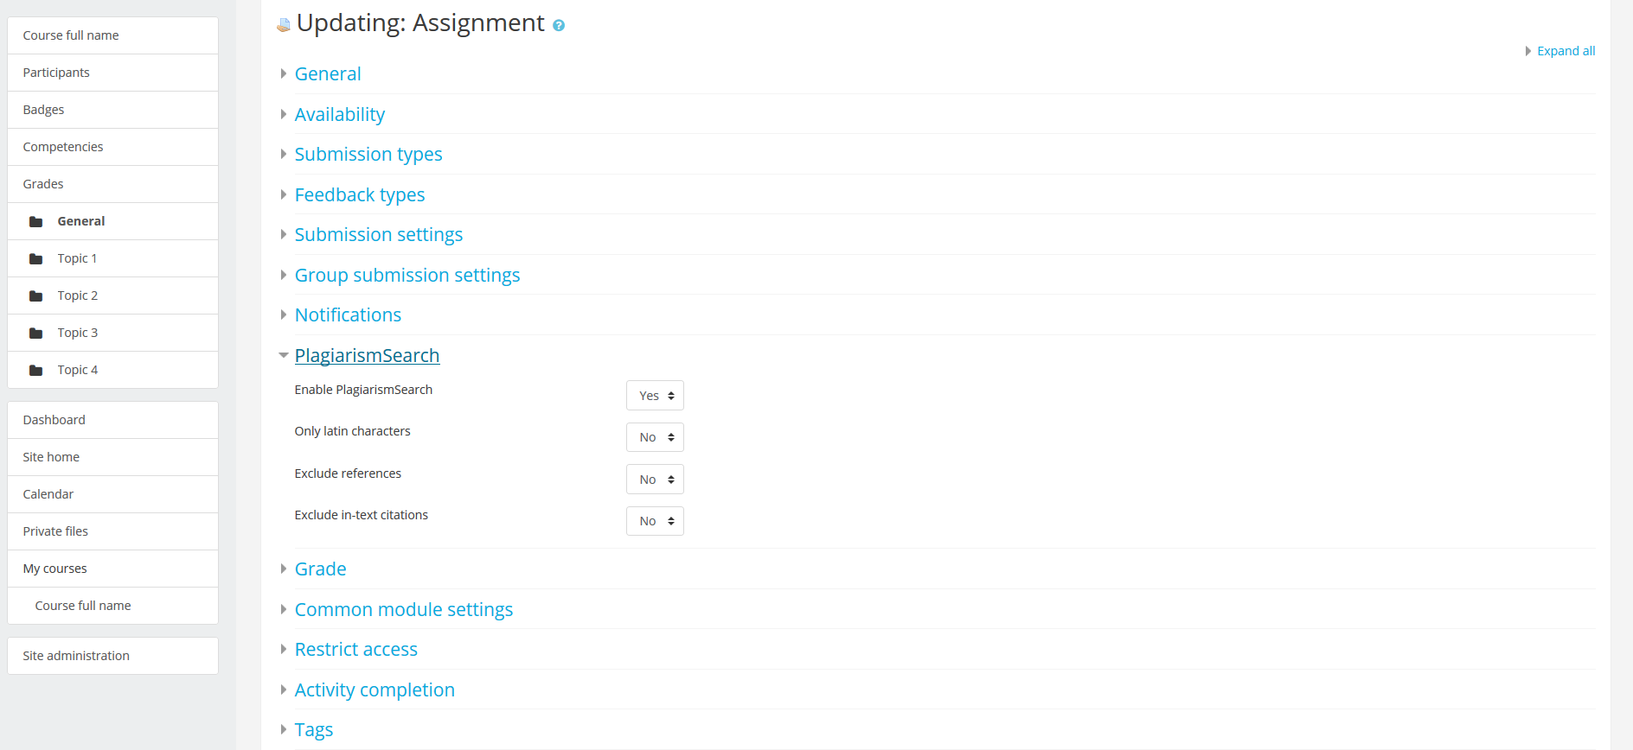
REFERENCE ASSET C — Assignment settings locator (optional fallback)
Use only as a locator showing that PlagiarismSearch appears inside Assignment settings. Do not use the old minimal control list as the current settings reference.

15. DO NOT REINTRODUCE LEGACY / UNSUPPORTED CLAIMS
Legacy / risky statement | Implementation rule
Workshop / Forum / Quiz support | Remove. Current confirmed owner is Moodle Assignment only.
“API credentials are provided by managers” | Remove. Credentials are self-service in account/API.
150+ languages | Do not use on this page unless separately reverified and needed.
Large complete file-extension list | Do not use here.
1–5 minute processing / short timeframe | Remove; no approved SLA.
“Every plagiarized sentence” | Remove; use similarity/match review language.
Plagiarism percentage = proof of plagiarism | Remove. Returned similarity requires review in context.
“Files are never stored” | Remove. Add to Storage is configurable.
API Debug = callback-encryption explanation | Do not state without engineering confirmation.
Free month / 100 free submissions | Do not use unless current commercial facts are separately approved.
Google Docs section | Remove from this Moodle owner.
Generic LMS/API marketing intro | Remove.

16. EXTERNAL FIRST-PARTY CONSISTENCY - MOODLE MARKETPLACE
P1 synchronization task: the Moodle Marketplace description must be audited and updated before or alongside coordinated production launch. It currently contains stale/conflicting statements such as broader activity support and older credential/commercial wording.
- Marketplace should align to Moodle 2.7–5.2 and Moodle Assignment-only support unless product/dev later confirms broader activities.
- Marketplace should align to self-service API credential retrieval.
- Remove or reverify old timing, language-count, free-offer, storage/privacy and plagiarism-verdict wording.
- Keep website / Marketplace / GitHub technical facts consistent so search engines and answer engines do not receive contradictory first-party information.
This synchronization is not a reason to delay visual design, but it is a production-readiness dependency.

17. RESPONSIVE / ACCESSIBILITY / DOCUMENTATION UX
- Desktop in-page navigation may be sticky but must never cover headings or content when anchors are used.
- Mobile jump navigation must remain usable without horizontal overflow or tiny tap targets.
- Long settings/reference tables must either remain readable responsively or transform into an accessible stacked definition pattern. Do not force microscopic desktop tables onto mobile.
- All screenshots require concise alt text and nearby textual explanations; no technical fact should exist only inside the image.
- Preserve sufficient contrast for callouts, captions and navigation states.
- Use semantic H2/H3 hierarchy. Do not style ordinary labels as headings merely for appearance.
- If accordion UI is used in FAQ/troubleshooting, the answer text must remain present in rendered HTML and keyboard accessible.
- External Marketplace/GitHub links should be identifiable; do not visually disguise them as primary purchase buttons.

18. IMPLEMENTATION / BACKEND BINDINGS
- Moodle Marketplace link → current official PlagiarismSearch listing.
- GitHub Releases link → current official plugin releases repository.
- Open API Credentials → /account/api. Respect normal login/session behavior.
- Contact Support → /contact-us.
- Institutional route → /university-plagiarism-checker.
- Custom integration route → /plagiarism-api.
- Anchor links must land correctly after fixed/sticky site navigation offsets.
- Do not hardcode version strings in multiple hidden UI components. The visible compatibility statement must be easy to maintain when Moodle/plugin support changes.

19. STAGING QA - CONTENT / PRODUCT / SEO
QA area | Required check
Route/indexing | /integration-guide remains 200, indexable, self-canonical; hreflang remains valid.
Topic ownership | No Google Docs/add-on section remains. Moodle/Assignment/setup is the dominant topic from the first screen onward.
Compatibility | Visible Moodle range is 2.7–5.2.
Activity support | Every activity statement says Assignment/mod_assign only. No Workshop/Forum/Quiz implication.
Auto/manual | Auto = file + online text; manual Submit/Resubmit = current file-based flow.
Credentials | API User + API Key path is self-service account/API. No manager-provided claim.
Sources vs Storage | Searching Storage and Add to Storage are explained as separate controls.
AI | AI detection is optional/separate and never equated with plagiarism.
Reports | Report format/student visibility claims match the current settings model.
Screenshots | No raw secret values published; old screenshots are tightly scoped/captioned; no fake UI generated.
Claims | No 150+ languages, 1–5 minutes, automatic misconduct verdict, never-store absolute, old free-trial claim or unsupported activity claim.
HTML/RD-013 | Core facts/FAQ exist as rendered text, headings/anchors work, no essential fact is image-only.
External consistency | Marketplace synchronization issue remains tracked until corrected.

20. POST-LAUNCH VALIDATION
Do not judge this page primarily by purchases. Its primary success metrics are qualified Moodle discovery, implementation usefulness and assisted institutional/support paths.
- GSC cohorts: plagiarism checker for moodle; moodle plagiarism checker; moodle plagiarism plugin; plagiarism plugin moodle; PlagiarismSearch Moodle; install/configure/setup variants.
- Track average position, clicks, impressions and CTR for Moodle-qualified queries.
- Track reduction in unrelated Google Docs query noise as a possible positive consequence of cleaner ownership.
- Track clicks to Moodle Marketplace, GitHub Releases and /account/api.
- Track Contact Support and University/API assisted navigation where analytics permit.
- Monitor Google Generative AI visibility and answer-engine citations/referrals for Moodle setup questions.
- Validate that the page does not start cannibalizing /plagiarism-api or /university-plagiarism-checker for their primary intents.

21. ACCEPTANCE CRITERIA
- A first-time evaluator can identify what the Moodle integration supports in under 10 seconds.
- A Moodle admin can follow the setup path without reading generic marketing copy.
- The page clearly says Moodle 2.7–5.2 and Assignment/mod_assign only.
- File vs online-text behavior is not oversimplified: Auto supports both; current manual Submit/Resubmit is file-based.
- API credential acquisition is correct and clear.
- Sources vs Add to Storage is unambiguous.
- AI is optional/separate and not conflated with plagiarism.
- Teacher/student report controls are explained without inventing UI or capabilities.
- Provided screenshots are used only as scoped evidence; secrets are masked; old UI is not misrepresented as current comprehensive UI.
- The page feels like official technical product documentation inside the PlagiarismSearch design system, not a recycled sales landing.
- No new reusable SEC-* is added before implementation review and user approval.

22. FINAL HANDOFF NOTE TO CLAUDE
Treat this brief as an information contract, not a wireframe. Your job is to make a long technical page feel clear, calm and trustworthy while preserving every verified limitation. Prioritize orientation, exact evidence, real screenshots and maintainable documentation patterns. If a visual idea would require inventing current Moodle UI, unsupported settings or stronger product claims, do not do it.
The strongest result will likely use a compact top product/header layer, visible quick facts, a clear in-page documentation nav, one clean end-to-end workflow diagram, selective screenshot-led setup/reference acts, concise settings tables, and a strong troubleshooting/FAQ finish. But the exact composition is yours.

