BLUESTOCK MUTUAL FUND ANALYTICS
Capstone Project Report

Bluestock Fintech Data Analyst Internship Program
End-to-End Mutual Fund Data Analytics Solution
Prepared by: Puru Asthana

Executive Summary
The Bluestock Mutual Fund Analytics Capstone Project was developed as part of the Bluestock Fintech Data Analyst Internship Program with the objective of building a complete end-to-end analytics solution for the mutual fund industry. The project aimed to transform raw financial data into actionable insights through data engineering, analytics, risk assessment, and business intelligence techniques.
The mutual fund industry generates large volumes of structured and time-series data, including NAV histories, investor transactions, portfolio holdings, SIP inflows, and benchmark performance. Extracting meaningful information from these datasets is essential for investors, fund managers, financial advisors, and asset management companies. This project addresses that challenge by creating a comprehensive analytics pipeline capable of processing, analyzing, and visualizing mutual fund data.
The project involved multiple stages including data ingestion, data cleaning, database design, exploratory data analysis, fund performance evaluation, advanced risk analytics, and dashboard development. More than ten financial datasets were integrated into a unified analytics framework using Python, Pandas, SQLite, and Power BI.
Exploratory Data Analysis revealed significant growth in industry AUM, increasing SIP participation, strong retail investor engagement, and category-specific investment preferences. Performance analytics were conducted using industry-standard metrics such as CAGR, Sharpe Ratio, Sortino Ratio, Alpha, Beta, and Maximum Drawdown to evaluate fund performance from both return and risk perspectives.
Advanced analytics modules were implemented to assess downside risk through Value at Risk (VaR) and Conditional Value at Risk (CVaR), identify investor behavior patterns through cohort analysis, monitor SIP continuity, measure portfolio concentration using the Herfindahl-Hirschman Index (HHI), and provide personalized fund recommendations based on investor risk appetite.
The project culminated in the development of an interactive Power BI dashboard consisting of four dedicated analytical pages covering industry trends, fund performance, investor analytics, and SIP market trends. These dashboards enable intuitive exploration of mutual fund data and support data-driven decision making.
Overall, the project successfully demonstrates how data analytics, financial modeling, and business intelligence tools can be integrated to generate meaningful insights within the fintech domain. The resulting solution provides value to investors, fund managers, analysts, and financial institutions while showcasing practical applications of data analytics in real-world financial environments.

1. Project Objectives
The primary objectives of this project were:
- Build a scalable ETL pipeline for mutual fund datasets
- Clean and validate financial data
- Perform exploratory data analysis
- Calculate fund performance metrics
- Analyze investor behavior and SIP trends
- Develop advanced risk analytics
- Build a recommendation engine
- Create an interactive Power BI dashboard

2. Data Sources
The project utilized ten datasets:
- Fund Master
- NAV History
- AUM by Fund House
- Monthly SIP Inflows
- Category Inflows
- Industry Folio Count
- Scheme Performance
- Investor Transactions
- Portfolio Holdings
      - 10.Benchmark Indices

These datasets collectively provide information regarding fund performance, investor activity, market trends, portfolio allocation, and industry growth.

3. Project Architecture
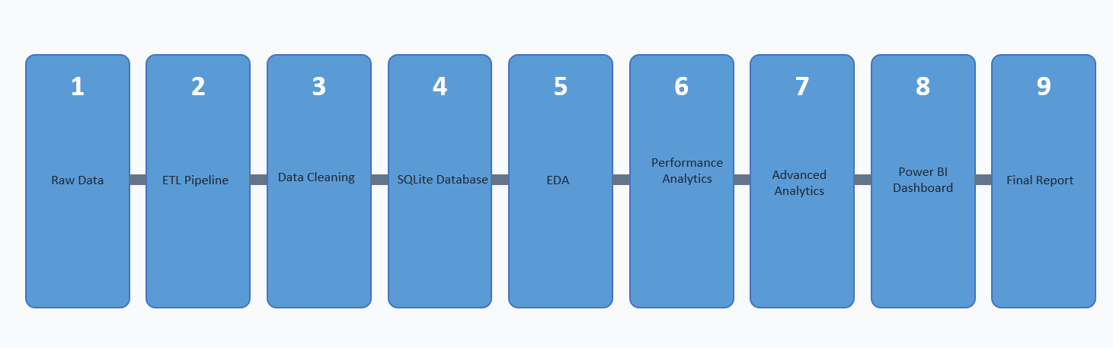

4. ETL Pipeline Design
The ETL pipeline was implemented using Python and Pandas. Key activities included:
- Loading CSV datasets
- Data validation and schema verification
- Missing value detection and data quality assessment
- Live NAV retrieval using MFAPI
The pipeline successfully processed all datasets and ensured consistency across AMFI codes and fund records.

5. Data Cleaning Methodology
Data cleaning activities included:
- Date standardization
- Duplicate removal
- Missing value validation
- NAV validation
- Transaction data normalization
- KYC status verification
- Expense ratio validation
- Data type conversion
Cleaned datasets were stored in the processed data layer for downstream analytics.

6. Exploratory Data Analysis
Exploratory Data Analysis (EDA) was performed to understand patterns, trends, and relationships within the mutual fund datasets. The objective was to gain meaningful insights into fund performance, investor behavior, market participation, and industry growth before proceeding to advanced analytics.

6.1 NAV Trend Analysis
Net Asset Value (NAV) is one of the most important indicators of mutual fund performance. Daily NAV data from 2022 to 2025 was analyzed for all available schemes.
The analysis revealed that equity-oriented funds generally experienced consistent NAV appreciation over the study period. Significant growth was observed during market recovery phases, while temporary corrections aligned with broader market volatility.
The NAV trend analysis helped identify long-term growth patterns and provided a foundation for performance metric calculations such as CAGR, Sharpe Ratio, and Maximum Drawdown.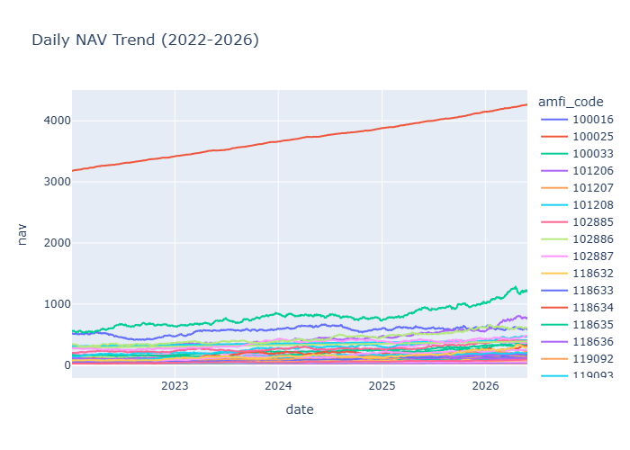

6.2 AUM Growth Analysis
Assets Under Management (AUM) represent the total market value of investments managed by a fund house.
Analysis of AUM trends showed substantial industry growth between 2022 and 2025. SBI Mutual Fund consistently maintained the highest AUM among all fund houses, demonstrating strong investor confidence and market dominance.
The growth in AUM reflects increasing retail participation and rising awareness of mutual fund investments.

6.3 SIP Inflow Analysis
Systematic Investment Plans (SIPs) have become one of the primary investment vehicles for retail investors.
Monthly SIP inflow analysis demonstrated steady growth throughout the study period, eventually reaching record highs by the end of 2025. This indicates growing investor trust in disciplined long-term investing strategies.

6.4 Investor Demographic Analysis
Investor transaction data was analyzed to understand participation across age groups, genders, and geographic regions.
The findings indicated that investors in the 26–45 age bracket contributed the largest share of investment activity. Urban investors from Tier-1 cities represented the majority of transactions, although participation from smaller cities also showed significant growth.

6.5 Geographic Analysis
State-level analysis highlighted regional investment concentration patterns. Metropolitan areas such as Maharashtra, Karnataka, Delhi, and Telangana contributed a substantial portion of total investments.
This analysis helps financial institutions identify regions with high investment penetration as well as underserved markets with growth potential.

Summary of EDA Findings
The EDA phase established a strong understanding of industry growth, investor participation, fund behavior, and market dynamics. These findings guided subsequent performance and risk analytics.

7. Performance Analytics
Performance analytics was conducted to evaluate the effectiveness of mutual funds using both return-based and risk-adjusted metrics.

7.1 Compound Annual Growth Rate (CAGR)
CAGR was calculated to measure the annualized growth rate of mutual fund investments over the available historical period.
Unlike simple returns, CAGR accounts for compounding effects and provides a more realistic assessment of long-term performance.
Funds with higher CAGR values demonstrated superior wealth creation potential over time.

7.2 Sharpe Ratio
The Sharpe Ratio was calculated using a risk-free rate of 6.5%.
This metric measures excess return generated for every unit of risk undertaken by an investor. Funds with higher Sharpe Ratios are considered more efficient in converting risk into returns.
The analysis revealed significant differences in risk-adjusted performance among schemes, highlighting the importance of evaluating risk alongside returns.

7.3 Sortino Ratio
The Sortino Ratio improves upon the Sharpe Ratio by focusing exclusively on downside volatility.
Since investors are generally more concerned about losses than gains, the Sortino Ratio provides a more investor-centric assessment of performance.
Several funds demonstrated stronger Sortino Ratios than Sharpe Ratios, indicating limited downside risk.

7.4 Alpha and Beta Analysis
Alpha measures a fund’s ability to generate returns beyond those explained by market movements.
Beta measures sensitivity to market fluctuations.
Regression analysis against benchmark indices was performed to calculate Alpha and Beta values.
Positive Alpha values indicate superior fund management performance, while Beta values provide insight into market-related risk exposure.

7.5 Maximum Drawdown
Maximum Drawdown measures the largest peak-to-trough decline experienced by a fund.
This metric is particularly important during periods of market stress because it reflects potential investor losses.
Funds with lower drawdowns generally exhibited more stable performance characteristics.

7.6 Composite Fund Scorecard
A composite scorecard was developed to rank funds using multiple metrics.
The scoring model incorporated:
- CAGR
- Sharpe Ratio
- Alpha
- Expense Ratio
- Maximum Drawdown
Weighted scoring enabled holistic evaluation rather than relying on a single performance metric.

Key Observations
- Top-ranked funds consistently outperformed benchmarks.
- Risk-adjusted performance varied significantly across categories.
- Certain funds delivered strong returns with comparatively lower volatility.
- Expense ratios influenced overall rankings.
- Diversification benefits were evident across categories.

Benchmark Comparison: Top 5 Funds vs NIFTY50 & NIFTY100
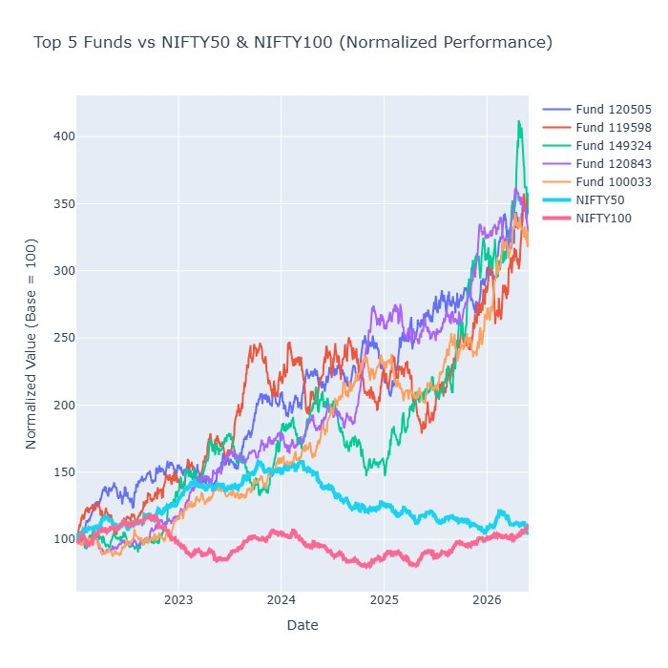
Figure 1: Normalized Performance — Top 5 Funds vs NIFTY50 & NIFTY100 (Base = 100)

Fund Performance Dashboard (Power BI)
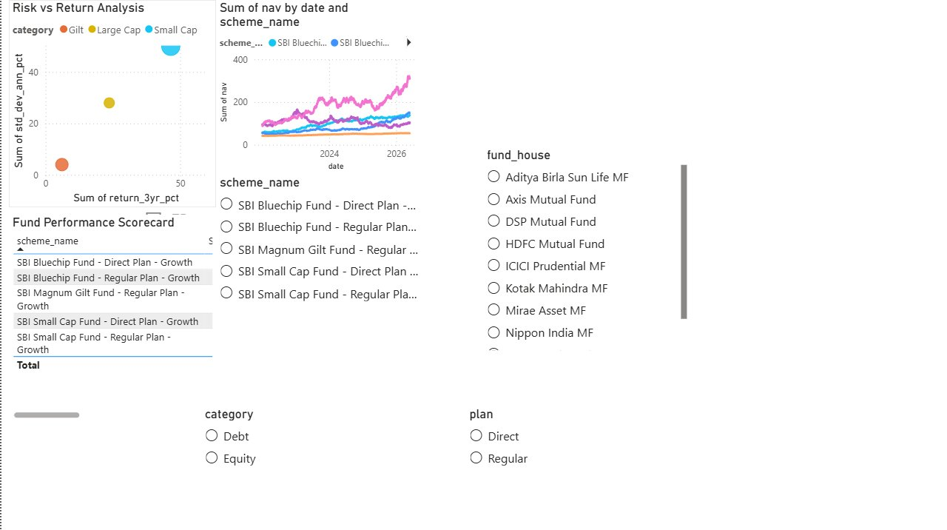
Figure 2: Fund Performance Page — Risk vs Return, NAV Trends, and Fund Scorecard

8. Advanced Analytics and Risk Metrics
Advanced analytics techniques were implemented to enhance the project's predictive and risk management capabilities.

8.1 Value at Risk (VaR)
Value at Risk estimates the maximum expected loss under normal market conditions at a specified confidence level.
A 95% confidence interval was used for all calculations.
The analysis identified schemes with elevated downside exposure and highlighted differences in risk profiles across categories.

8.2 Conditional Value at Risk (CVaR)
While VaR estimates the loss threshold, CVaR measures the average loss beyond that threshold.
CVaR provides a more conservative assessment of extreme market risk and is widely used by financial institutions.

8.3 Rolling Sharpe Ratio
Rolling Sharpe Ratios were calculated using a 90-day window.
This approach enables continuous monitoring of risk-adjusted performance and reveals how fund efficiency changes under varying market conditions.
[Insert Rolling Sharpe Chart]

8.4 Investor Cohort Analysis
Investors were grouped according to their first transaction year.
Cohort analysis revealed differences in investment behavior, average investment amounts, and fund preferences across investor groups.
The findings provide valuable insights into investor acquisition and retention strategies.

8.5 SIP Continuity Analysis
SIP continuity analysis examined transaction intervals for investors with recurring SIP contributions.
Investors with unusually large gaps between transactions were identified as potentially at risk of discontinuing investments.
This analysis can support proactive customer engagement initiatives.

8.6 Sector Concentration Risk
The Herfindahl-Hirschman Index (HHI) was calculated using sector allocation data.
Higher HHI values indicate greater concentration and lower diversification.
The analysis revealed that several funds maintained concentrated sector exposures, increasing susceptibility to sector-specific market shocks.

8.7 Recommendation Engine
A rule-based recommendation engine was developed using investor risk appetite and fund Sharpe Ratios.
The model provides personalized fund recommendations for:
- Low Risk Investors
- Moderate Risk Investors
- High Risk Investors
Although simple, the system demonstrates the potential for future machine learning-based recommendation frameworks.

Summary
The advanced analytics module extended the project beyond traditional reporting by incorporating risk assessment, investor behavior analysis, and decision-support functionality.

9. Dashboard Development
A Power BI dashboard consisting of four pages was developed:

Industry Overview
Covers Total AUM, SIP Inflows, Folios, and AUM Trends by fund house.
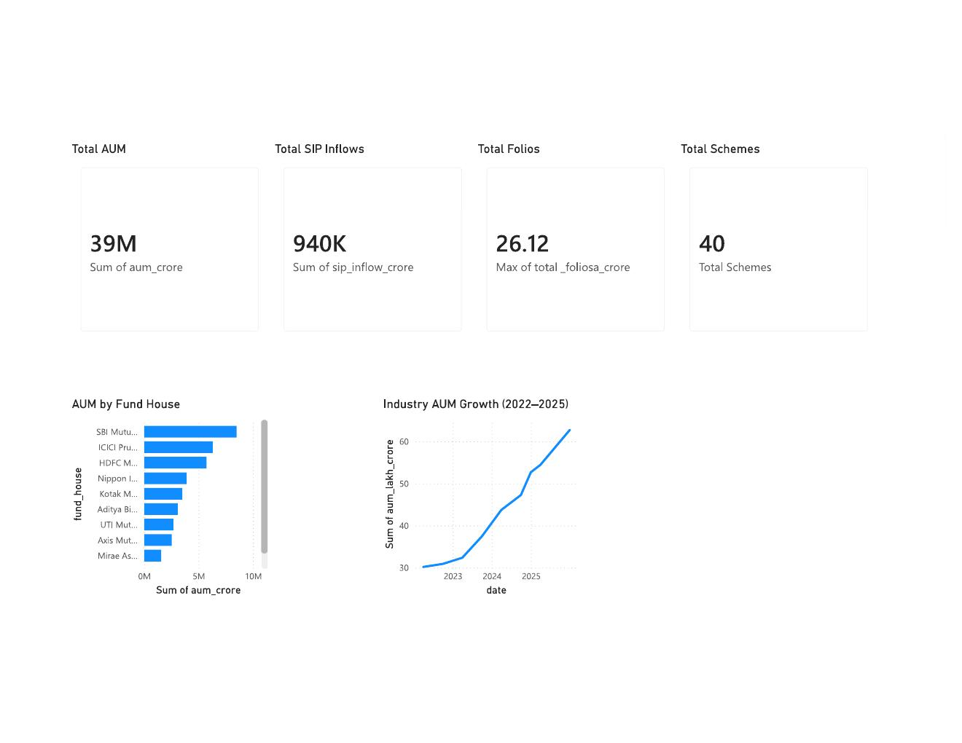
Figure 4: Industry Overview — AUM by Fund House and Industry AUM Growth (2022–2025)

Fund Performance
Includes Risk vs Return Analysis, Fund Scorecard, and NAV Trends.
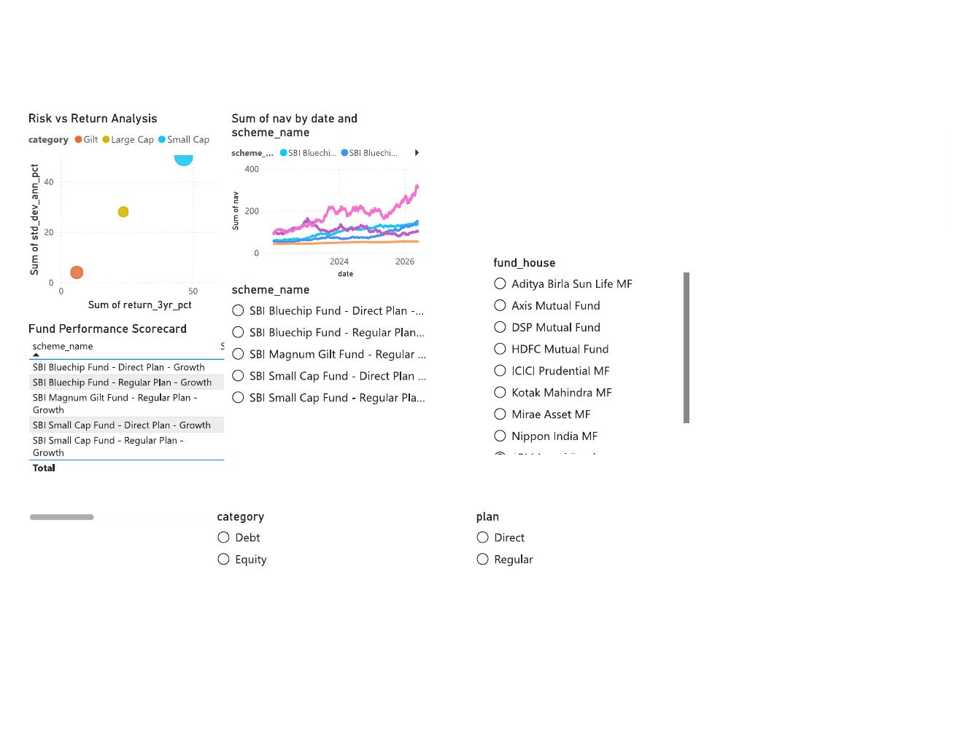
Figure 5: Fund Performance Page — Risk vs Return Scatter, NAV Trends, and Filters

Investor Analytics
Covers Demographics, Geographic Analysis, and Transaction Behavior.
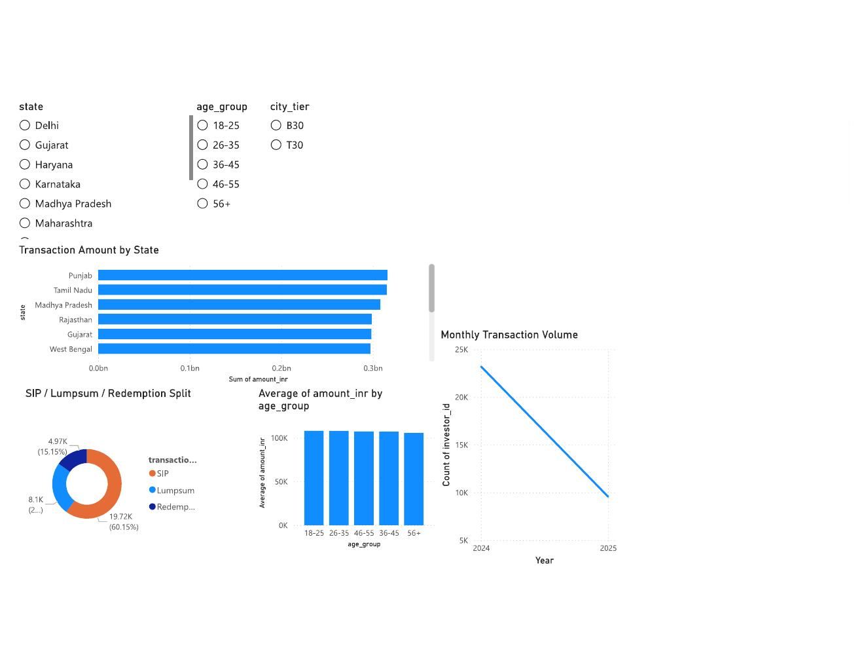
Figure 6: Investor Analytics — Transaction Amount by State, SIP/Lumpsum/Redemption Split, and Monthly Transaction Volume

SIP & Market Trends
Shows SIP Growth, Category Inflows, and Market Comparisons.
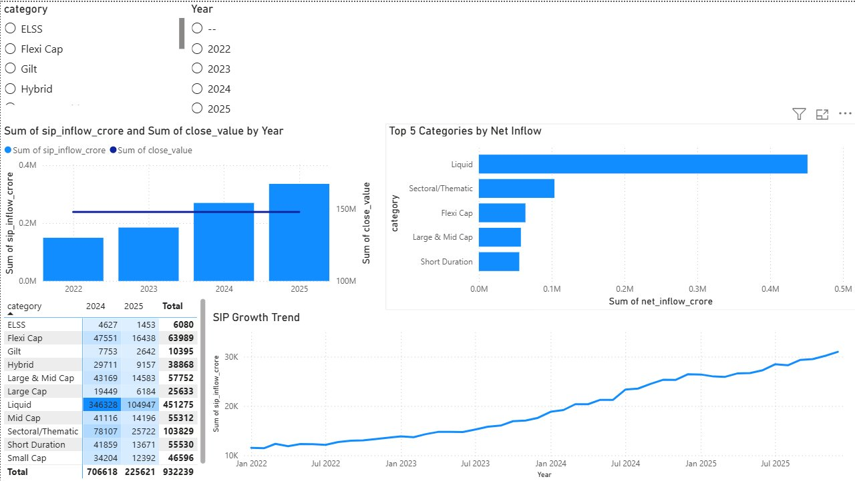
Figure 7: SIP & Market Trends — SIP Growth Trend and Top 5 Categories by Net Inflow
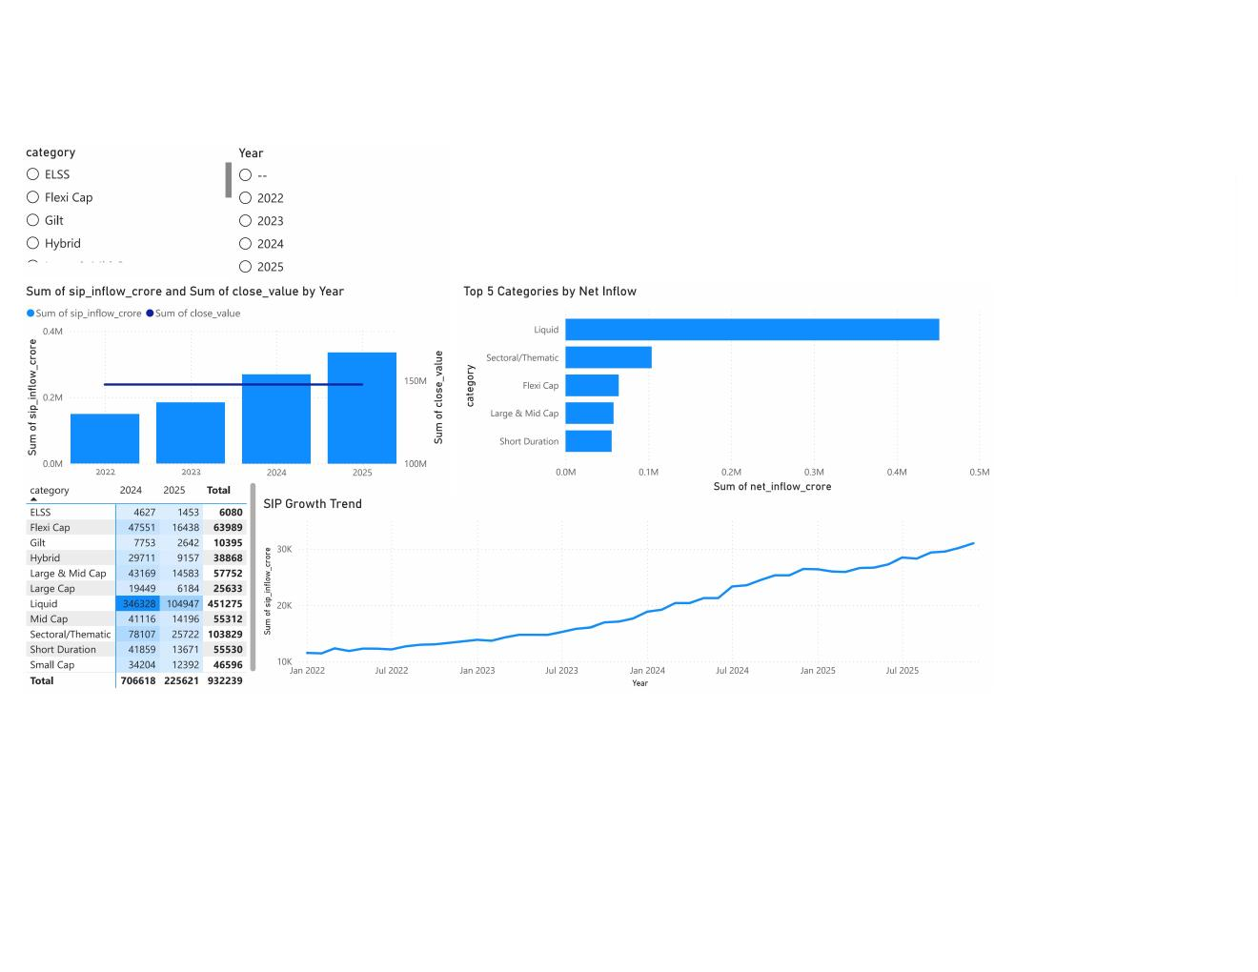
Figure 8: SIP & Market Trends Dashboard Page
Category-wise SIP Inflows (₹ Crore)
Category | 2024 | 2025 | Total
ELSS | 4,627 | 1,453 | 6,080
Flexi Cap | 47,551 | 16,438 | 63,989
Gilt | 7,753 | 2,642 | 10,395
Hybrid | 29,711 | 9,157 | 38,868
Large & Mid Cap | 43,169 | 14,583 | 57,752
Large Cap | 19,449 | 6,184 | 25,633
Liquid | 3,46,328 | 1,04,947 | 4,51,275
Mid Cap | 41,116 | 14,196 | 55,312
Sectoral/Thematic | 78,107 | 25,722 | 1,03,829
Short Duration | 41,859 | 13,671 | 55,530
Small Cap | 34,204 | 12,392 | 46,596
Total | 7,06,618 | 2,25,621 | 9,32,239

10. Key Findings
The project generated several meaningful insights across fund performance, investor behavior, market participation, and portfolio risk.

1. Significant Growth in Industry Assets
Analysis of Assets Under Management (AUM) revealed strong growth across the mutual fund industry between 2022 and 2025. Major asset management companies consistently attracted increasing investments, indicating rising investor confidence in mutual fund products and long-term wealth creation strategies.

2. Record SIP Participation
Monthly SIP inflow analysis demonstrated sustained growth throughout the study period. SIP investments reached record levels by the end of 2025, highlighting increasing adoption of disciplined and systematic investment approaches among retail investors.

3. Strong Retail Investor Engagement
Investor transaction data showed a significant increase in participation from individual investors. Growth was particularly evident among working-age investors between 26 and 45 years old, who contributed a substantial portion of overall investment activity.

4. Outperformance by Top-Ranked Funds
Funds ranked highly using the composite scorecard consistently demonstrated superior performance across multiple metrics, including CAGR, Sharpe Ratio, Alpha, and Maximum Drawdown. These funds delivered stronger risk-adjusted returns compared to many benchmark alternatives.

5. Importance of Risk-Adjusted Evaluation
The analysis highlighted that funds with the highest returns were not always the most efficient investments. Metrics such as Sharpe Ratio and Sortino Ratio revealed significant differences in risk-adjusted performance across schemes, emphasizing the importance of evaluating risk alongside returns.

6. Portfolio Concentration Risk
Sector concentration analysis identified several funds with elevated HHI values, indicating relatively concentrated sector exposure. Such portfolios may be more vulnerable to sector-specific market downturns and therefore require careful monitoring.

7. Investor Retention Opportunities
SIP continuity analysis revealed a group of investors exhibiting irregular contribution patterns and longer transaction gaps. These investors may represent potential churn risks and could benefit from targeted engagement strategies.

8. Cohort-Based Behavioral Differences
Investor cohort analysis demonstrated differences in investment behavior between investor groups. More recent cohorts generally exhibited higher average investment activity and stronger engagement levels, suggesting growing confidence in mutual fund investments.

9. Benchmark Comparison Insights
Comparison against NIFTY benchmarks indicated that several mutual funds successfully generated excess returns while maintaining acceptable risk levels. Positive Alpha values observed across selected funds suggest effective portfolio management and active investment strategies.

10. Dashboard-Driven Decision Support
The Power BI dashboard consolidated complex financial information into an interactive and user-friendly format. This significantly improved accessibility of insights and enabled rapid exploration of trends, risks, and investment opportunities.

11. Business Recommendations
Based on the analysis:
- Encourage portfolio diversification to reduce concentration risk
- Monitor high concentration portfolios using HHI metrics
- Use VaR and CVaR for ongoing risk monitoring
- Improve SIP retention programs to reduce investor churn
- Promote long-term SIP investing through investor education
- Utilize performance scorecards for fund selection and advisory

12. Limitations
While the project successfully achieved its objectives, several limitations should be acknowledged.

Historical Data Dependency
The analysis relies entirely on historical data. Although historical trends provide valuable insights, past performance does not guarantee future results. Market conditions, economic events, and regulatory changes may significantly alter future outcomes.

Limited Time Horizon
The datasets cover a finite time period and may not capture all market cycles or extreme financial events. A longer historical dataset could improve the robustness of performance and risk assessments.

Simplified Recommendation Engine
The recommendation engine implemented in this project is rule-based and relies primarily on risk categories and Sharpe Ratios. While effective as a proof of concept, it does not incorporate advanced machine learning techniques, investor preferences, or behavioral factors.

Data Quality Assumptions
Although extensive cleaning and validation procedures were performed, the project assumes that the underlying source data is fundamentally accurate. Any inaccuracies within the original datasets may influence analytical results.

Benchmark Selection
Performance comparisons were conducted using selected benchmark indices. Alternative benchmark choices may produce different Alpha, Beta, and tracking error results.

Limited Macroeconomic Consideration
The analysis focuses primarily on fund-level and investor-level data. Broader macroeconomic factors such as inflation, interest rates, geopolitical events, and policy changes were not explicitly incorporated into predictive models.

Computational Simplifications
Certain financial metrics and risk calculations were simplified for educational and internship purposes. Institutional-grade financial systems may employ more sophisticated methodologies and assumptions.
Despite these limitations, the project provides a comprehensive and realistic representation of mutual fund analytics workflows and successfully demonstrates practical applications of data analytics within the fintech domain.

13. Future Scope
Potential future enhancements include:
- Real-time NAV integration
- Machine learning recommendation systems
- Portfolio optimization algorithms
- Automated report generation
- Cloud deployment
- Investor churn prediction models

14. Conclusion
The Bluestock Mutual Fund Analytics Capstone Project successfully delivered a comprehensive end-to-end analytics solution covering data engineering, financial analysis, risk assessment, and business intelligence. The project demonstrated the complete lifecycle of a modern data analytics workflow, beginning with raw data ingestion and ending with actionable insights presented through interactive dashboards and analytical reports.
Throughout the project, multiple datasets were integrated, cleaned, validated, and analyzed using industry-standard tools and methodologies. Exploratory analysis provided valuable understanding of mutual fund industry growth, investor participation trends, portfolio structures, and category-level investment behavior. Performance analytics enabled detailed evaluation of funds using widely accepted financial metrics such as CAGR, Sharpe Ratio, Sortino Ratio, Alpha, Beta, and Maximum Drawdown.
Advanced analytical techniques further enhanced the project's value by introducing downside risk measurement through VaR and CVaR, investor behavior analysis through cohort and SIP continuity studies, portfolio diversification assessment through HHI calculations, and personalized investment recommendations through a rule-based recommendation engine.
The Power BI dashboard served as a centralized decision-support platform, enabling stakeholders to explore industry trends, evaluate fund performance, analyze investor demographics, and monitor market developments through intuitive visualizations. The dashboard transformed complex financial datasets into accessible business insights suitable for both technical and non-technical audiences.
From a learning perspective, the project provided hands-on experience in data engineering, SQL database design, exploratory analytics, financial modeling, risk management, dashboard development, and project documentation. It also demonstrated the importance of combining technical skills with domain knowledge to solve real-world fintech problems.
In conclusion, the project successfully met all defined objectives and delivered a scalable analytics framework capable of supporting mutual fund analysis and decision making. The methodologies, workflows, and insights generated through this project can serve as a foundation for future enhancements involving machine learning, real-time analytics, portfolio optimization, and advanced investment advisory systems.

