User’s Guide for the Chemical Transformation Simulator (CTS) (β-Version)

7/18/2018

Chemical Transformation Simulator: A Cheminformatics Tool for Predicting Transformation Pathways and Physicochemical Properties

2018 U.S. Environmental Protection Agency

The Chemical Transformation Simulator (CTS) User’s Guide is designed to provide the novice user a complete understanding of how to utilize the CTS tool. The User’s Guide may be reviewed from start to finish or by moving directly to a topic of interest through selection of the appropriate topic in the Table of Contents.

Table of Contents

Introduction 2

Background 3

Using the CTS Software 4

Restrictions 4

Accessing the CTS 4

CTS Modules Overview 7

Execution of the CTS 10

Single Chemical Entry 10

Batch Chemical Entry 11

Execution of the CTS Workflows 12

Calculate Chemical Speciation Workflow 13

Calculate Ionization Constants 16

Calculate Dominant Tautomer Distribution 18

Calculate Stereoisomers 21

Calculate Physicochemical Properties Workflow 24

Generate Transformation Products Workflow 30

Reaction System Guidelines 33

Generation of PDF, HTML and CSV Reports 42

References 43

# Introduction

The Chemical Transformation Simulator (CTS) provides the calculated physicochemical properties of a target chemical and its transformation products, which are predicted as a function of the reaction system of interest. This is accomplished through the integration of cheminformatics applications for the encoding of process science underlying transformation pathways and computational chemistry tools for the calculation of physicochemical properties.

The β-version of the CTS consists of 3 modules, the selection and order of execution of which is based on the user’s choice of one of three available workflows as described below.

* **Chemical Editor (CE):** Provides options for chemical entry through SMILES notation, IUPAC chemical name, CAS #, or drawn structure, as well as speciation of the parent chemical
* **Physicochemical Properties Calculator (PPC):** Calculates physicochemical properties for the parent chemical and predicted transformation products based on the executions of multiple physicochemical calculators
* **Reaction Pathway Simulator (RPS):** Generates potential transformation products based on user-specified reaction conditions

# Background

A key Agency need identified as a high priority in the Chemical Sustainability and Safety (CSS) National research program is for high throughput computational systems to simulate environmental fate and transport for organic chemicals for which such data are not available. Knowledge of inherent chemical properties (ICP) is essential for the parameterization of environmental fate and transport models. Of the ~85,000 chemicals in the TSCA inventory, it is estimated that high quality measured ICP data are available for less than 2% of these chemicals. Additionally, 20 to 30 new chemicals a month are being assessed through the Office of Pollution Prevention and Toxics (OPPT) Pre-Manufacturing Notification (PMN) process. This ever-growing data gap must be addressed through the development of a high throughput computational system for calculating the ICP necessary for the parameterization of environmental fate models used to estimate environmental concentrations of both the parent chemical and predicted transformation products as a function of environmental conditions.

The key components of the CTS are the Physicochemical Properties Calculator (PPC) and the Reaction Pathway Simulator (RPS). The PPC is based on a consensus approach that allows the user to compare output generated by several calculators that take different approaches to calculating specific physicochemical properties. These calculators include (1) SPARC (SPARC Performs Automated Reasoning in Chemistry), which uses a mechanistic-based approach, (2) EPI Suite, which uses a fragment-based approach, (3) TEST (Toxicity Estimation Software Tool), which uses QSAR-based approaches, and (4) ChemAxon plug-in calculators, which use an atom-based fragment approach. The output derived from these calculators will enable the user to compare the calculated data with measured data in readily accessible web-based databases.

The output of the RPS is based on the selection and execution of reaction libraries that represent one-step reactions for transformation of reactive functional (e.g., abiotic reduction and hydrolysis). These one-step reactions represent viable transformation pathways based on the identification and subsequent transformation of reactive functional groups. A reaction library for human phase I metabolism developed by ChemAxon is also available through the CTS. The development of reaction libraries allows us to “encode” the known process science published (current and future) in the peer-reviewed literature. The encoding of process science is accomplished using Chemical Terms Language and Smart Reaction Smile string through cheminformatics applications. The execution of these reaction libraries provides dominant transformation pathways and products for the chemical of interest as a function of environmental conditions.

# Using the CTS Software

## Restrictions

The CTS is designed to predict transformation pathways and calculate physicochemical properties for organic chemicals. Currently, organometallics, non-dissociating salts of organic chemicals, and polymers are not recognized by the CTS. Also, the CTS cannot be accessed through use of the Internet Explorer browser.

## Accessing the CTS

Currently only EPA intranet users have access to the CTS. The CTS can be accessed through <https://qedinternal.epa.gov>, which provides the models currently available on the web Quantitative Exposure Domain (QED).

**CTS Homepage:** The home page of the CTS is accessed by clicking on the CTS link. The home page provides access to the CTS through the selection of one of three CTS workflows and general information concerning the major modules of the CTS, the physicochemical calculators and reaction libraries as shown below.

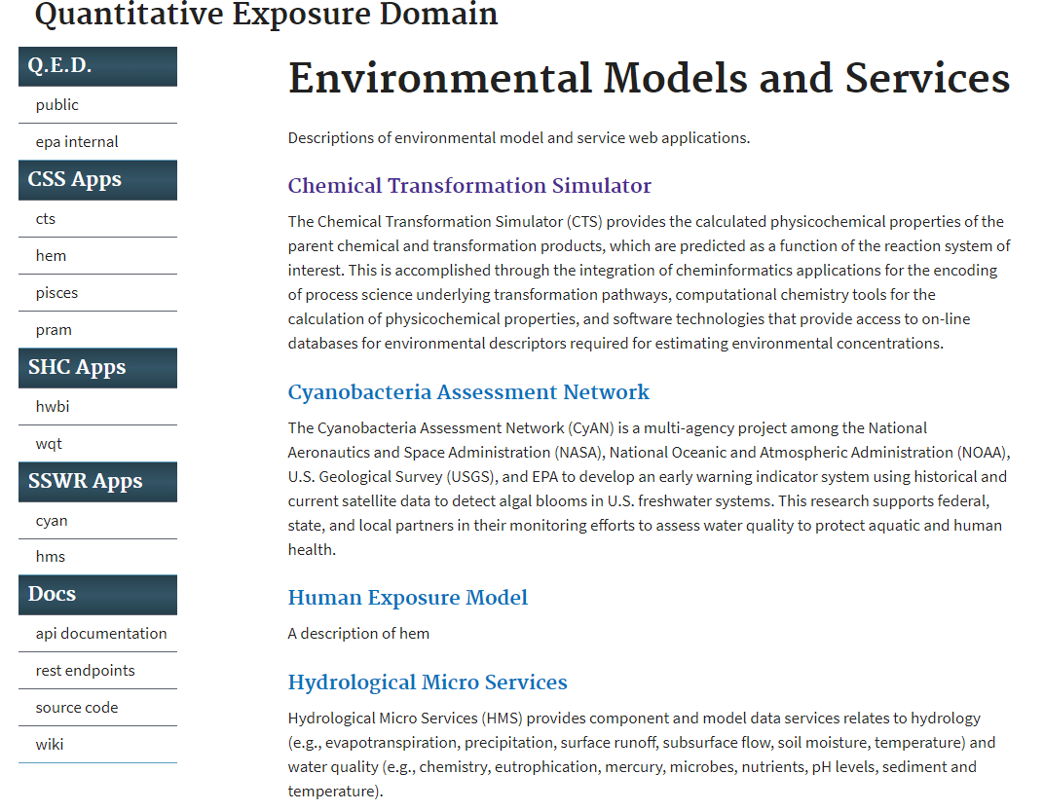

**[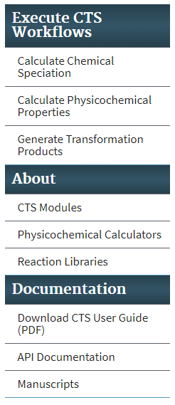CTS: Chemical Transformation Simulator (beta)](https://qedinternal.epa.gov/cts)**

*This web site is under development. It is available for the purposes of receiving feedback and quality assurance from personnel in the EPA.*

The Chemical Transformation Simulator (CTS) is an online tool that calculates the physicochemical properties of a parent chemical and its transformation products. CTS predicts transformation products as a function of the environmental system of interest.   
  
CTS performs these calculations and predictions by integrating:

* + - * Cheminformatics applications that encodes current knowledge (i.e., the process science) underlying transformation pathways;
      * Computational chemistry tools that calculate physicochemical properties; and
      * Software that allows access to online databases of measured physicochemical properties.

**CTS Workflows**: Choose one of the three workflows below to start using the CTS. Full descriptions of the individual workflows and modules are provided by the tabs in the left-hand navigation pane.

**Calculate Chemical Speciation Workflow:** Uses CTS’s Chemical Editor (CE) Module, which provides options for chemical entry and calculates the speciation (i.e., ionization, tautomer distribution and isomerization) of the parent chemical.

**Calculate Physicochemical Properties Workflow:** Uses CTS’s Chemical Editor (CE) and the Physicochemical Properties Calculator (PCP) Module. The PCP Module uses four stand-alone calculators (EPI Suite, SPARC, ChemAxon, and TEST) to find physicochemical properties for the entered chemical.

**Generate Transformation Products Workflow:** The User inputs chemical information through the CE and then invokes the Reaction Pathway Simulator (RPS) Module to generate transformation products through the execution of reaction libraries based on user-specified conditions. The User is then given the option to invoke the PCP Module for the calculation of physicochemical properties for the parent or one or more product chemicals.

## CTS Modules Overview

**Chemical Editor (CE):** CTS's Chemical Editor (CE) appears at the beginning of all workflows and allows users to enter chemicals by their name, Chemical Abstracts Service Registry Number (CAS#), simplified molecular-input line-entry system (SMILES) string, or by drawing the chemical's structure. ChemAxon's [Marvin](https://chemaxon.com/products/marvin) and [JChem](https://chemaxon.com/products/jchem-engines) applications and EPA's [CompTox Chemistry Dashboard](https://comptox.epa.gov/dashboard) are used to generate a standardized SMILES string, preferred common name, IUPAC name, chemical formula, relevant CAS numbers, average and monoisotopic masses, and the [DTXSID](https://jcheminf.springeropen.com/articles/10.1186/s13321-017-0247-6#Sec2) (unique substance identifier assigned by EPA's National Center for Computational Toxicology (NCCT)) for the selected chemical.

Chemical Speciation: CTS's Chemical Speciation (CS) workflow uses [ChemAxon's Plugin Calculators](https://chemaxon.com/products/calculators-and-predictors) to generate:

* The speciation of a chemical as a function of pH;
* The ionization constant(s);
* The dominant tautomer distribution; and
* Structures for all possible isomers.

**Physicochemical Properties Calculator (PPC):** CTS's Physicochemical Properties Calculator (PPC) calculates physicochemical properties for the parent chemical and predicted transformation products based on the findings of multiple physicochemical calculators. The PPC is based on a consensus approach that allows users to compare output from multiple calculators that use different approaches to calculate specific physicochemical properties.

The calculators that PPC is currently accessing include:

1. SPARC Performs Automated Reasoning in Chemistry (SPARC), which uses a mechanistic-based approach;
2. EPI Suite, which uses a fragment-based approach;
3. Toxicity Estimation Software Tool (TEST), which uses QSAR-based approaches; and
4. ChemAxon plug-in calculators, which use an atom-based fragment approach.

Users also have the option to request measured data that is available in the EPI Suite physicochemical database.

**Reaction Pathway Simulator (RPS)**: CTS's Reaction Pathway Simulator (RPS) generates potential transformation products based on user-specified reaction conditions. The output of the RPS is based on the selection and execution of reaction libraries that represent reaction schemes for the transformation of reactive functional groups, such as reduction and hydrolysis. These reaction schemes denote viable transformation pathways based on the identification and transformation of the reactive functional groups. A rank is assigned to each one of the reaction schemes based on available experimental data. The rank is essentially a relative reaction rate, defined on a scale of one to six, with six being assigned to the fastest reaction schemes. The rank of each scheme is used to calculate an approximate percentage production of each potential transformation product.

A reaction library for human phase I metabolism that was developed by ChemAxon is also available through the RPS. Developing reaction libraries allows scientists to "encode" the known process science published – current and future – in the peer-reviewed literature. Encoding process science is accomplished by using Chemical Terms Language and cheminformatics applications.

Executing these reaction libraries provides dominant transformation pathways and products for the chemical of interest as a function of environmental conditions. Users also have the option to execute the PPC for the calculation of physicochemical properties for the parent chemical and transformation products.

Links to the process science supporting the currently available reaction libraries are also available. For example, clicking on the Reaction Libraries tab, followed by clicking “Click here to download the abiotic hydrolysis library” provides the following screen: 

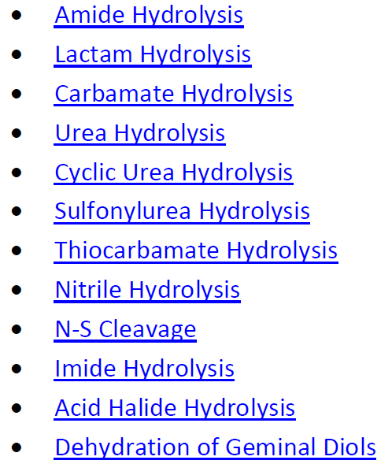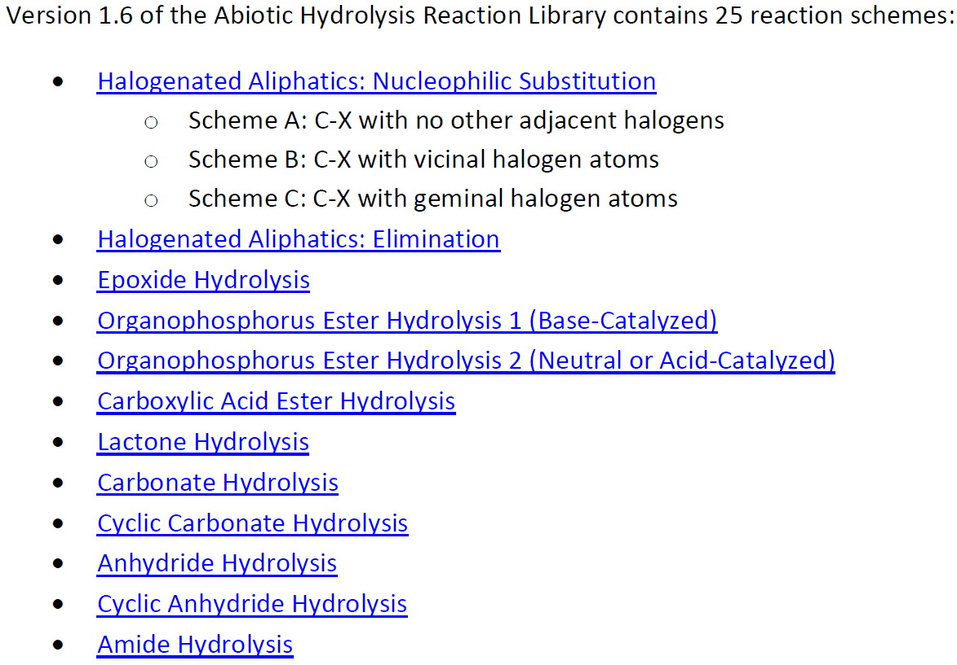

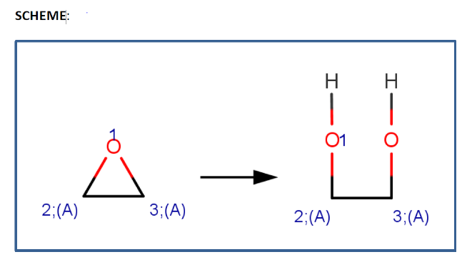Selection of one of the transformation pathways provides the reaction scheme, and documented examples with references. The following illustrates this information for Epoxide Hydrolysis:

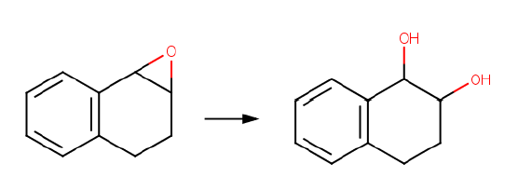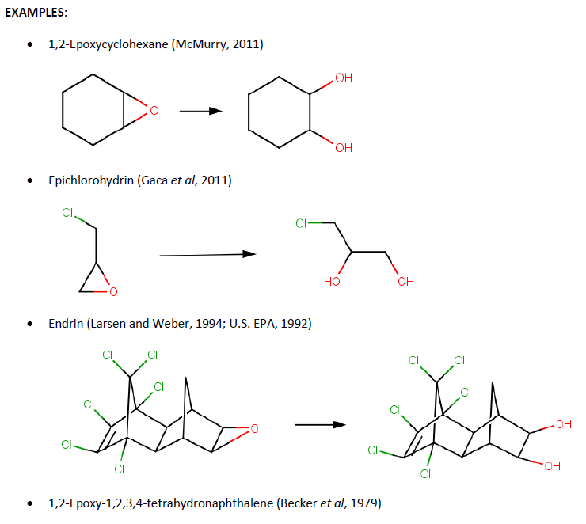

## **Execution of the CTS**

The CTS is executed by selecting one of three available workflows (see descriptions below) and by entering a single chemical or by batch mode. The process for entering a single chemical or by batch, as described below, is identical for each of the workflows.

## **Single Chemical Entry**

For single chemical entry, the Run single chemical tab is selected at the top of the workflow frame. The Chemical Editor appears where there is the option to either enter a SMILES String, IUPAC chemical name, or CAS# in the Lookup Chemical box, or to draw a chemical structure using the Chemical Editor (see below). For either case, the appropriate box must be clicked after providing the required information. Details concerning the use of the chemical editor can be found at

<https://docs.chemaxon.com/display/marvinsketch/MarvinSketch+User%27s+Guide.>

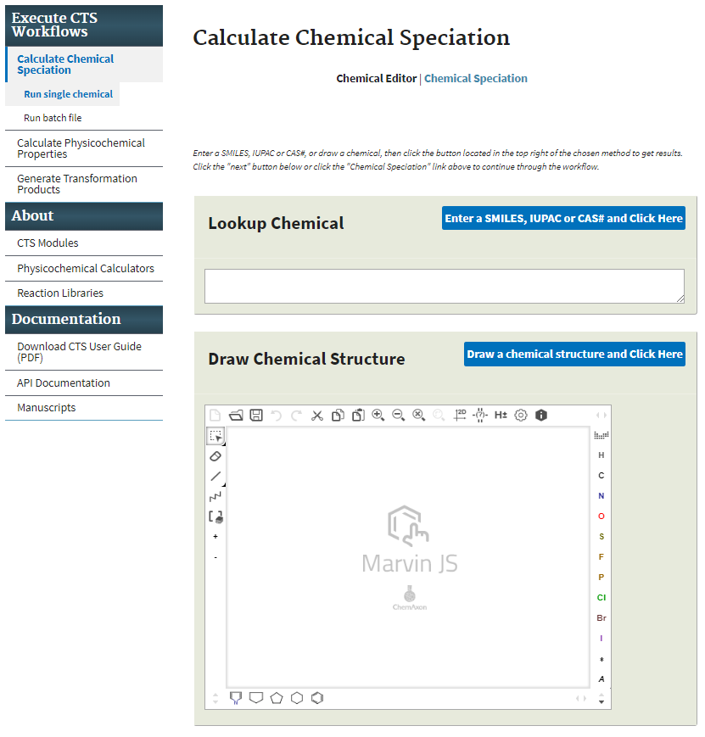

## **Batch Chemical Entry**

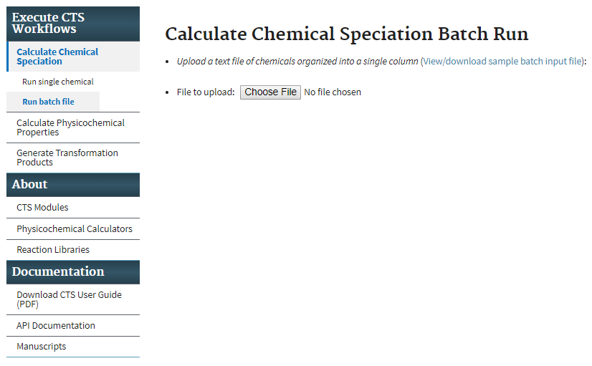

By clicking on the sample batch input link, the example batch file, shown below, is opened or downloaded. The chemicals are entered into a single column of SMILES strings. The default value for the β-version is currently set to a maximum of 10 chemicals. This default value will be increased once testing of the β-version has been completed.

Sample batch input:

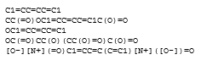

## **Execution of the CTS Workflows**

The user executes the CTS through the selection of one of three available workflows:

* Calculate Chemical Speciation
* Calculate Physicochemical Properties
* Generate Transformation Products

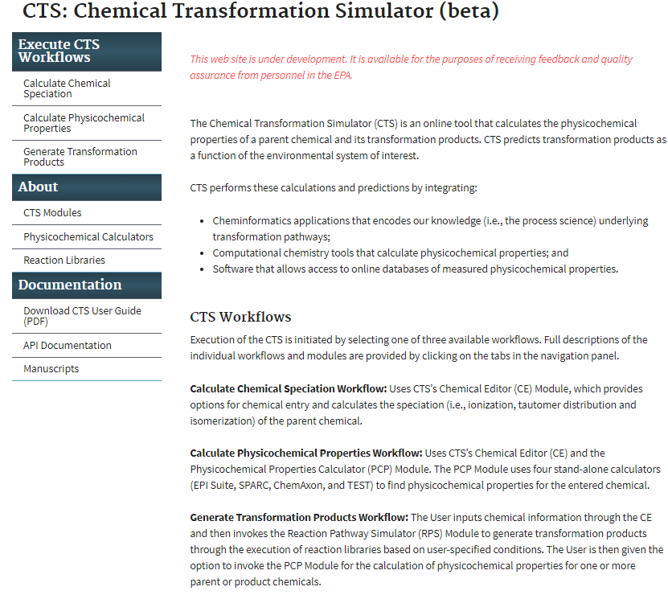

### Calculate Chemical Speciation Workflow

Selection of the Calculate Chemical Speciation Workflow provides this page illustrating the workflow overview as illustrated below. ChemAxon calculator plugins are executed for the calculation of chemical speciation.

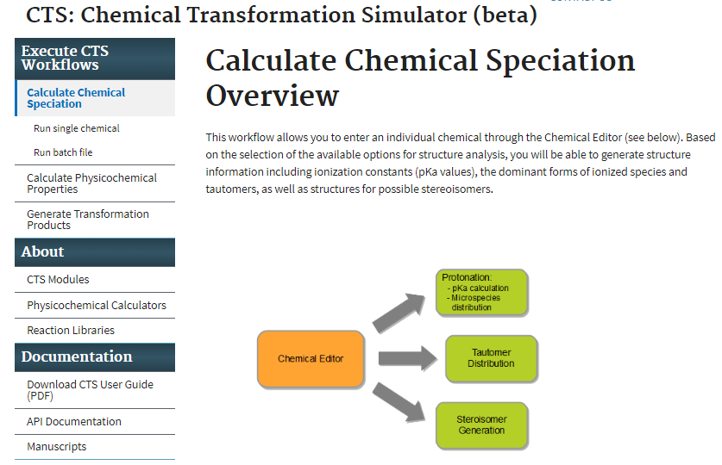

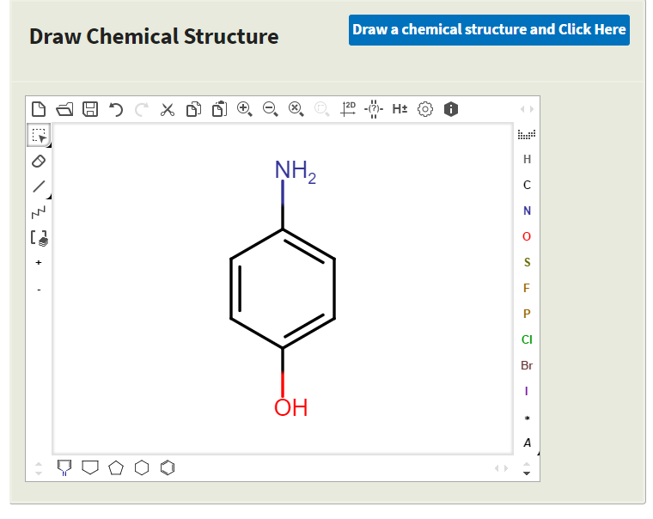Clicking on the Run single chemical link takes the user to the Chemical Editor. For the following example, 4-aminophenol was entered into the Chemical Editor.

After clicking the Next button at the bottom of the Chemical Editor or the Chemical Speciation link at the top of the workflow frame, select from three available options for calculating chemical speciation:

* Calculate Ionization Constants
* Calculate Dominant Tautomer Distribution
* Calculate Stereoisomers

Select any combination of the calculators; use the provided default values or change the default values required by the user. The following parameters can be adjusted:

* Calculate Ionization Constants
* Number of decimals: Number of decimal places calculated for acidic and basic p*K*a values
* pH Lower limit: Specifies the lower end of the pH range for which the microspecies will be generated
* pH Upper limit: Specifies the upper end of the pH range for which the microspecies will be generated
* Generate Major Microspecies at pH: Generates the Major Microspecies at the specified pH.
* pH step size: Specifies the pH step size for the X-Axis of the plot illustrating the distribution of the microspecies as a function of pH
* Isoelectric Point (pI) pH Step Size for Charge Distribution: Specifies the pH step size for the X-Axis of the plot illustrating the Isoelectric Point and charge distribution as a function of pH
* Calculate Dominant Tautomer Distribution
* Maximum Number of Structures: Specifies the maximum number of structures that will be generated.
* At pH: Specifies the pH at which the dominant tautomer distribution will be calculated
* Calculate Stereoisomers
* Maximum Number of Structures: Specifies the maximum number of structures that will be generated.

The user also has the option of running a batch file. By clicking on the Run batch file link, the following screen appears. The user has the option to view or download a sample batch input file or enter a file by clicking on the Choose File button.

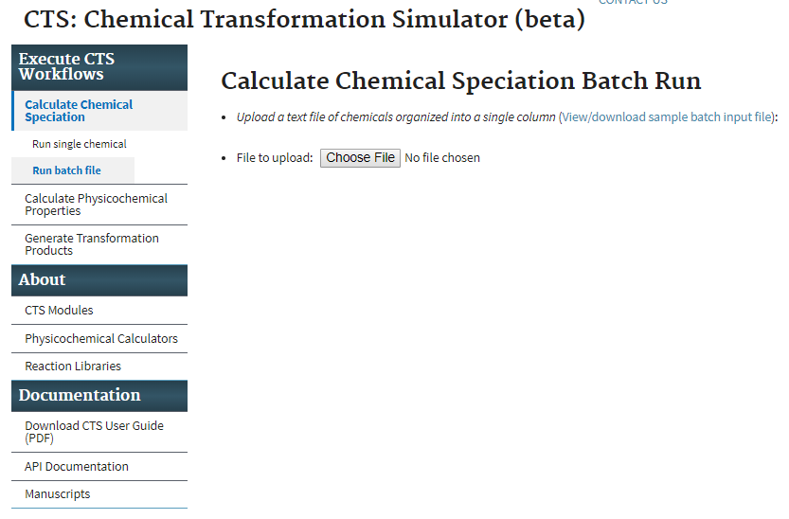

## Calculate Ionization Constants

Once the calculator(s) has been chosen and the appropriate parameters entered, click the Submit button to view the results. The calculator for ionization constants has been chosen for this demonstration.

Inputs: The molecular information and ionization parameters provided by the user.

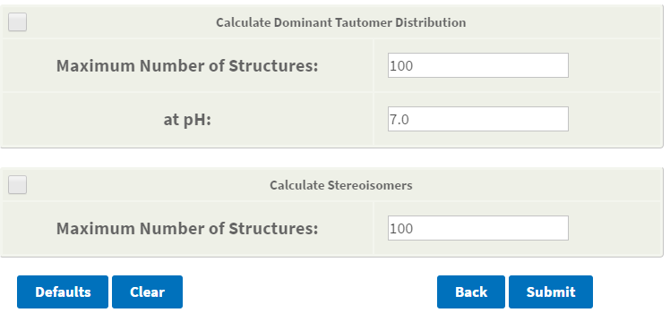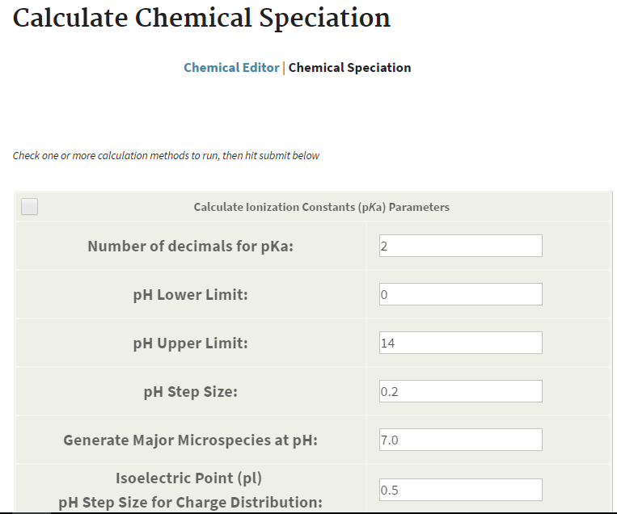

The results of the ionization constant calculation are illustrated in the windows below:

* **pKa Calculations:** Provides the chemical structure entered, the generated microspecies, and the distribution of microspecies as a function of pH over the pH range specified. Results are color coded.
* **Isoelectric Point:** The isoelectric point is provided as well as a graph illustrating the charge on the chemical as a function of pH.
* **Major Microspecies:** The dominant microspecies formed at the pH selected.

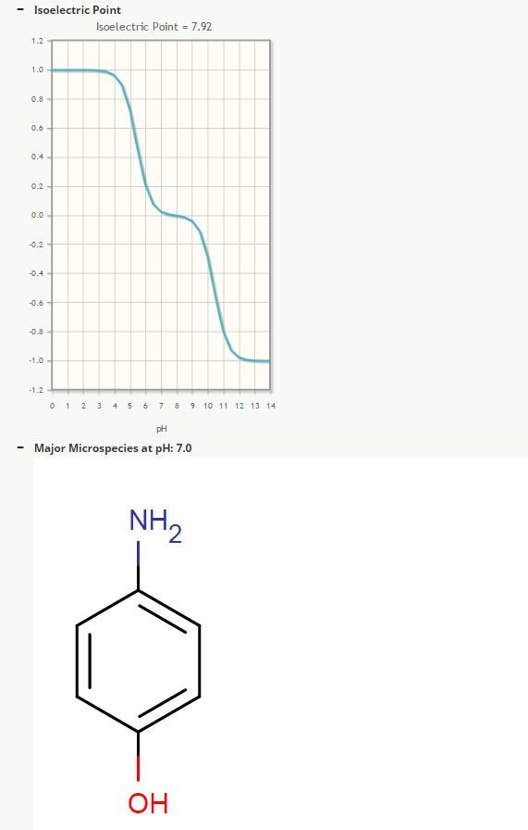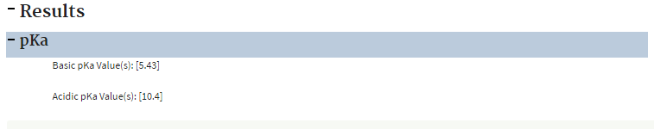

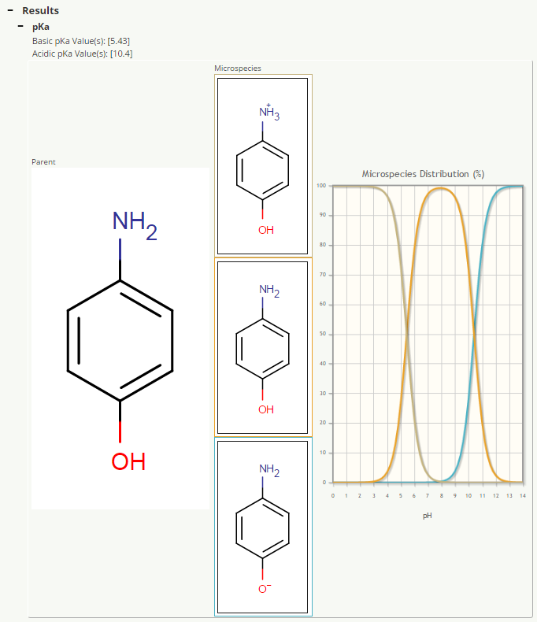

## Calculate Dominant Tautomer Distribution

For this demonstration, 1-phenylbutane-1,3-dione has been entered into the Chemical Editor.

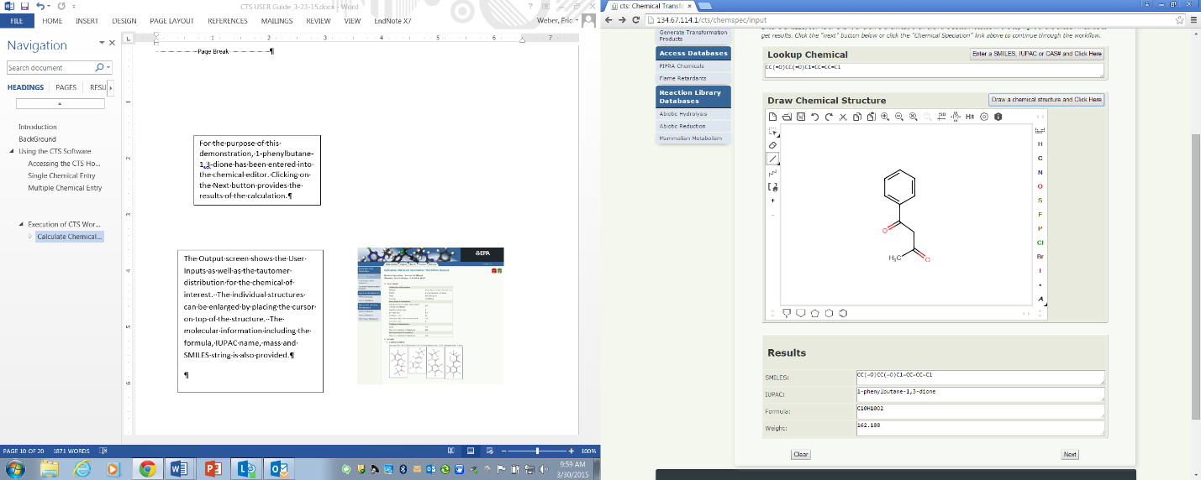

Clicking the Next button brings up the Calculate Chemical Speciation Workflow Inputs page. After selecting the Calculate Dominant Tautomer Distribution option, enter a limit for the number of possible tautomers and the pH value for which the distribution will be calculated. The default values are pH 7.0 and a limit of 100 tautomers.

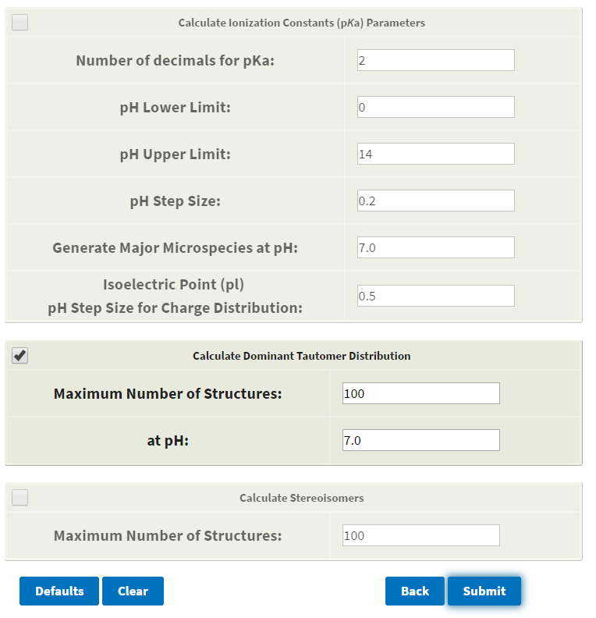

Click on the Submit button to view the output page for the tautomerization distribution based on the user-defined values.



The Output screen shows the User Inputs (see above) as well as the tautomer distribution for the chemical of interest. The individual structures can be enlarged by placing the cursor on top of the structure. The molecular information including the formula, IUPAC name, mass and SMILES string is also provided.

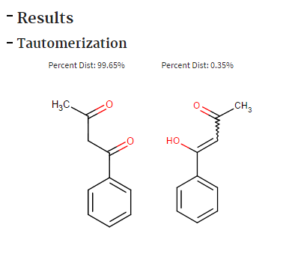

## Calculate Stereoisomers

For this demonstration, 1,2,3,4,5,6-hexabromocyclohexane has been entered into the Chemical Editor.

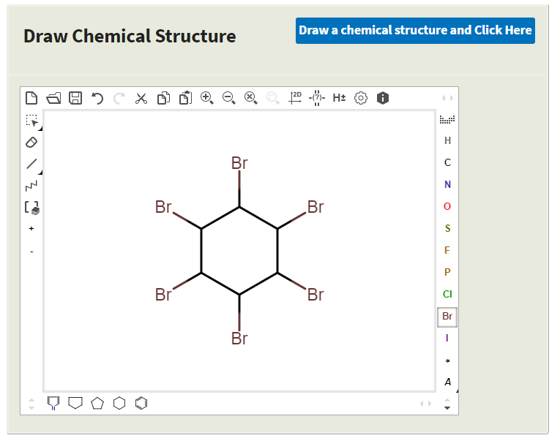

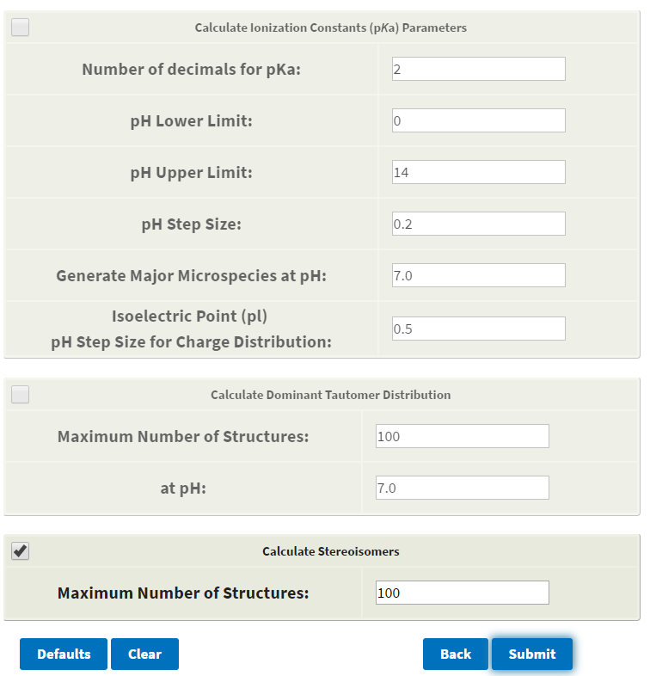

After selecting the Calculate Stereoisomers option, enter a limit for the maximum number of possible stereoisomers. The default value is 100 stereoisomers.

Clicking on the Next button provides the results of the calculation, which illustrate that 1,2,3,4,5,6-hexabromocyclohexane can exist as nine different stereo isomers. The individual structures can be enlarged by placing the cursor over the structure. The molecular information including the formula, IUPAC name, mass and SMILES string is also provided.

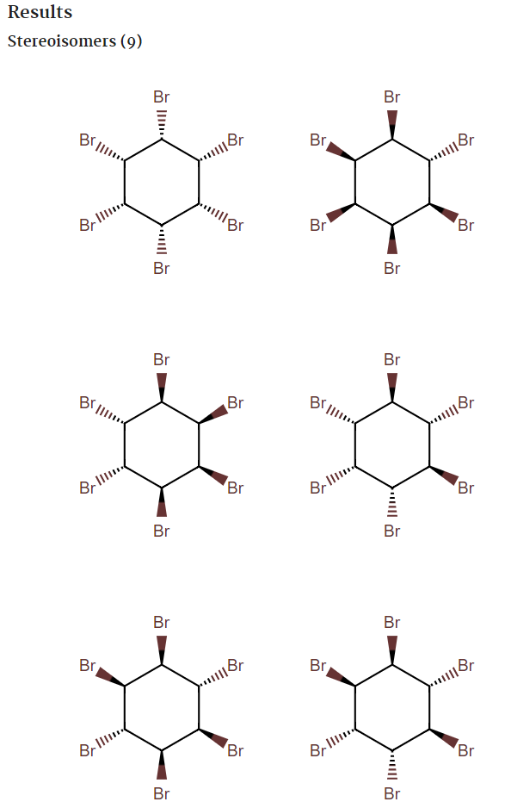

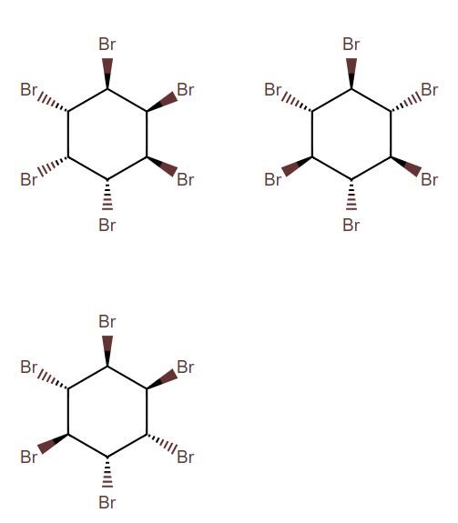

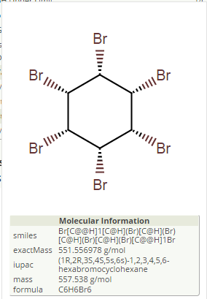

## Calculate Physicochemical Properties Workflow

Selection of the Calculate Physicochemical Properties Workflow provides this page illustrating the workflow overview. Click on the Run single chemical link to submit a single chemical for processing, or click on the “Run batch file” link to submit a batch file.

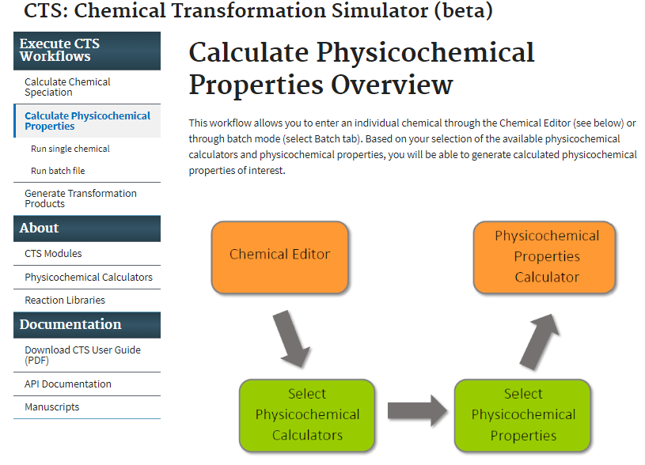

For this demonstration, 1-methoxy-2,4-dinitrobenzene has been entered into the Chemical Editor. The results are illustrated below. Select the Next button to choose the physiochemical calculators and physicochemical properties of interest.

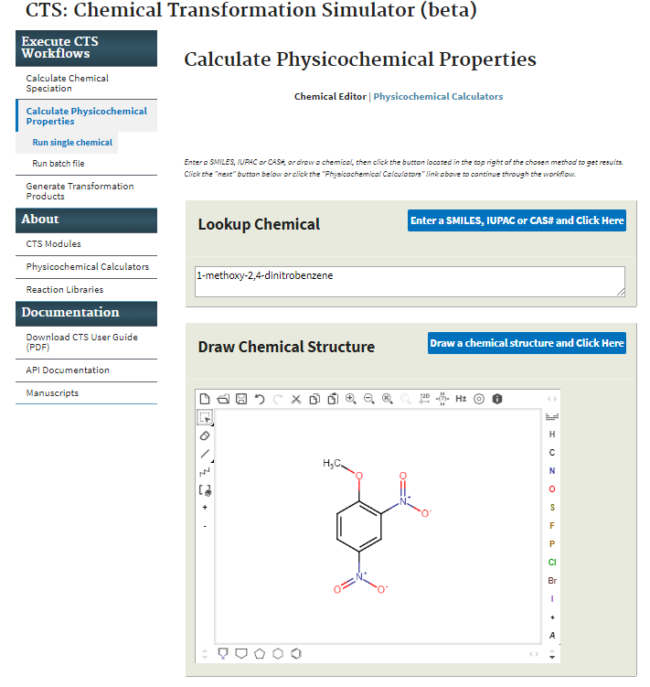

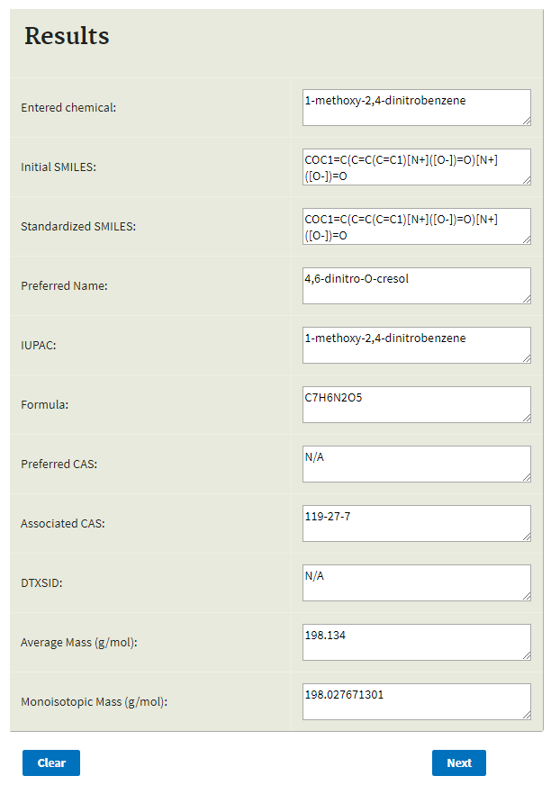

Use the Calculate Physicochemical Properties Workflow Inputs screen to select physicochemical properties and the physicochemical calculators of interest. Selection of the All button for the physicochemical properties selects all properties no matter which calculators are chosen, although only the available properties from each calculator will be calculated. See Table 1 for a summary of the calculators and calculation methods used in the Physicochemical Properties Calculator.

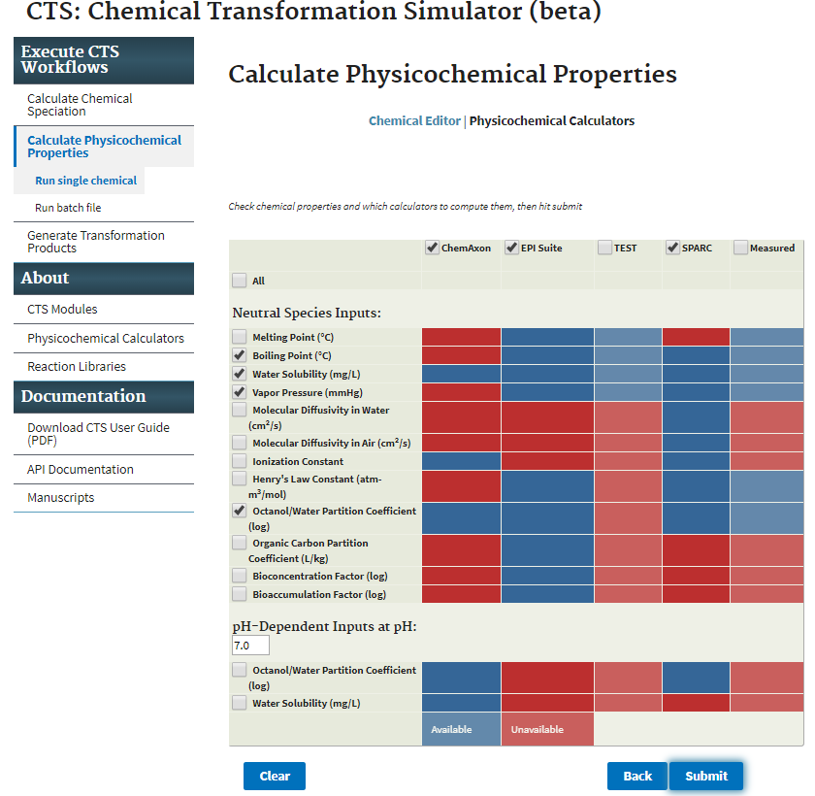

|  |  |  |  |  |  |
| --- | --- | --- | --- | --- | --- |
| Application or Website | Version | Model | Property | Calculation Method | References |
| ChemAxon Plugin Calculators | 16.10.31.0 | KLOP | Kow | Group Contribution: MLR with fragment counts as descriptors | Klopman et al. (1994) |
| VG | Kow | Group Contribution: MLR with fragment counts as descriptors | Viswanadhan et al.  (1989) |
| PHYS | Kow | Group Contribution: MLR with fragment counts as descriptors | Based on Viswanadhan  et al. (1989) with  PHYSPROP as training  set |
| EPI Suite | WSKOW 4.11 | Solubility Predictor | WS | Group Contribution: MLR with atom counts as descriptors | Hou et al. (2004) |
| KOWWIN™ | Kow | Group Contribution: MLR with fragment counts as descriptors | Meylan and Howard  (1995) |
| WATERNT | WS | Group Contribution: MLR with fragment counts as descriptors | US EPA (2012) |
|  | WS | MLR with log Kow, MP and MW as descriptors | Meylan et al. (1996); US  EPA (2012) |
| MPBPVP | MP | Group Contribution: MLR with fragment counts as descriptors for MP and BP; VP from nonlinear function of BP | US EPA (2012) |
| BCFBAFTM | BCF and BAF | Arnot-Gogas method using upper trophic values: calculation from echanistic first princiiples | US EPA (2012) |
| SPARC | 2017 | _ | Kow, WS, VP | Mechanistic perturbation and solute-solvent interaction models | Hilal et al. (2003, 2004) |
| T.E.S.T. | 4.2 | FDA | MP, WS, VP | Hierarchical Clustering with similar chemicals | Contrera et al. (2003);  Martin et al. (2008) |
| Group Contribution | MP, WS, VP | Group Contribution: MLR with fragment counts as descriptors | Martin and Young  (2001) |
| Hierarchical  Clustering | MP, WS, VP | Hierarchical Clustering | Martin et al. (2008) |
| Nearest Neighbor | MP, WS, VP | Average property value for 3 most similar molecules based on cosine similarity coefficient | Martin et al. (2008);  U.S. EPA (2016) |

Table 1. Summary of the calculators and calculation methods used in the Physicochemical Properties Calculator.

After selection of the physicochemical properties and calculators, selection of the Calculate data button provides the physicochemical properties output as illustrated below. Selection of the Measured button provides available experimental data through linkage to EPA’s Chemistry Dashboard.

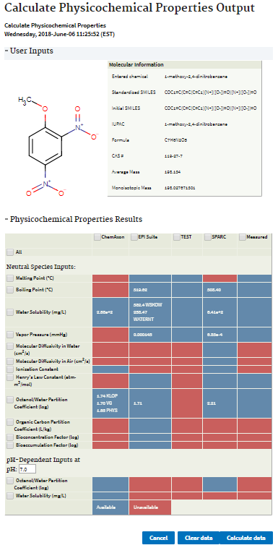

## Generate Transformation Products Workflow

Selection of the Generate Transformation Products Workflow provides this window illustrating the workflow overview. Click on the Run single chemical link to submit a single chemical for processing, or click on the Run batch file link to submit a batch file.

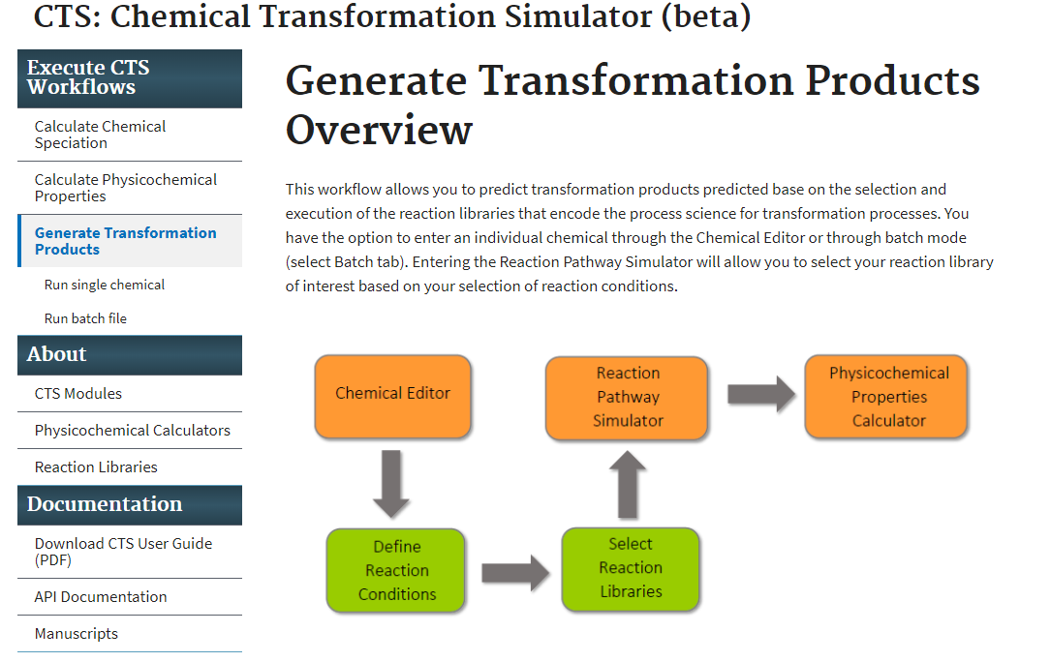

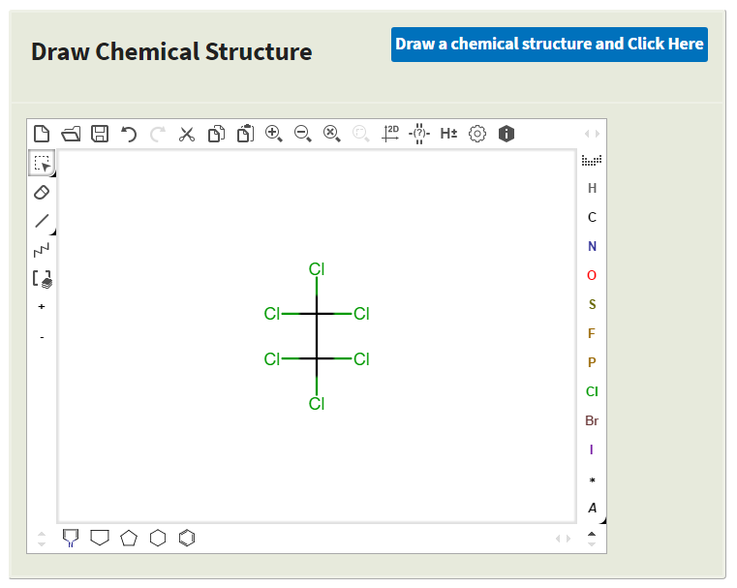For this demonstration, hexachloroethane has been entered into the Chemical Editor.

The first required input is the selection of the reaction libraries based on the transformation pathways of interest. Three reaction libraries, including abiotic hydrolysis, abiotic reduction and human phase I metabolism, are available in the β-version of the CTS. A reaction library for photolysis is currently under development, and a seamless linkage to a reaction library for aerobic biodegradation will be available in the next version of the CTS. Three options are available for the selection of one or multiple reaction libraries:

* Reaction System Conditions
* OCSPP Harmonized Test Guidelines
* User Selected (Advanced)

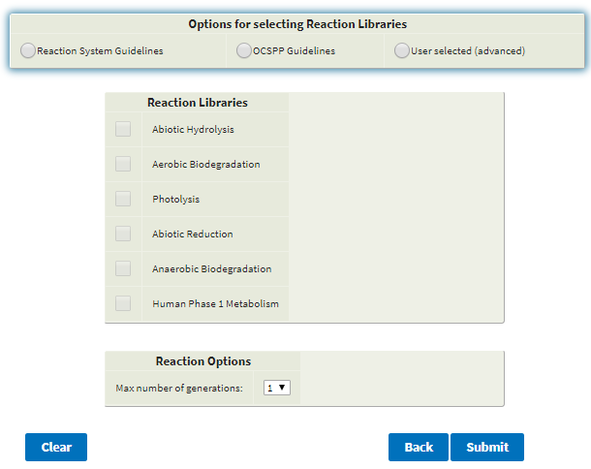

**S**election of the Reaction System Conditions provides two options for reaction systems: Environmental or Mammalian.

Selection of the Environmental Reaction System provides the option to select respiration type: Aerobic or Anaerobic.

Selection of anaerobic respiration opens the window with the reactions libraries for the transformation pathways that are currently available and will potentially occur under these reaction conditions, which includes abiotic hydrolysis and abiotic reduction.

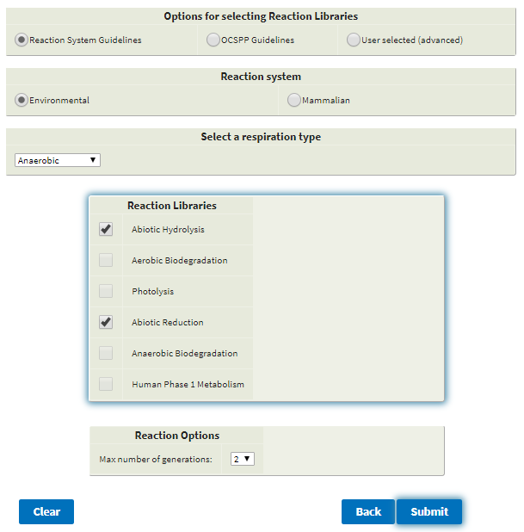

Selection of aerobic respiration opens the window with the reactions libraries that are currently available and will potentially occur under these conditions, which currently includes only abiotic hydrolysis.

## Reaction System Guidelines

Selection of Reaction System Guidelines

Selection of mammalian reaction systems opens the window with the human phase I metabolism reaction library selected. This is the only option available for the mammalian reaction system.

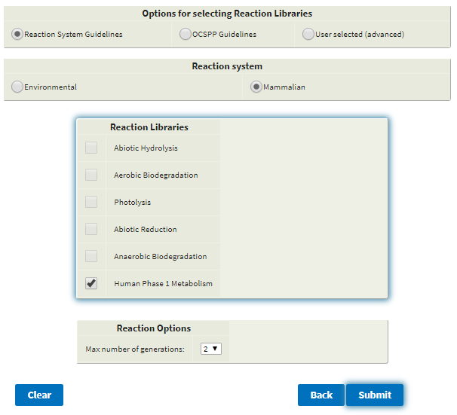

The second option for the selection of reaction libraries is through the selection of the OCSPP’s Fate, Transport, and Transformation (Series 835) or Health Effects (Series 870) Guidelines.

Selection of the Fate, Transformation Series provides three options:

* Laboratory Abiotic Transformation Test Guidelines
* Transformation in Water and Soil Test Guidelines
* Transformation Chemical-Specific Test Guidelines

As an example, selection of the Laboratory Abiotic Transformation Test Guidelines shows that both the abiotic hydrolysis and abiotic reduction are appropriate selections for this option.

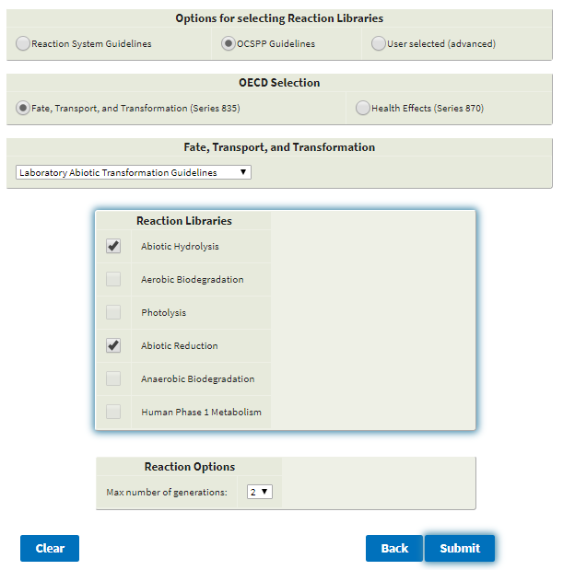

Selection of Health Effects provides one option for selection of a reaction library (i.e., Human Phase I Metabolism).

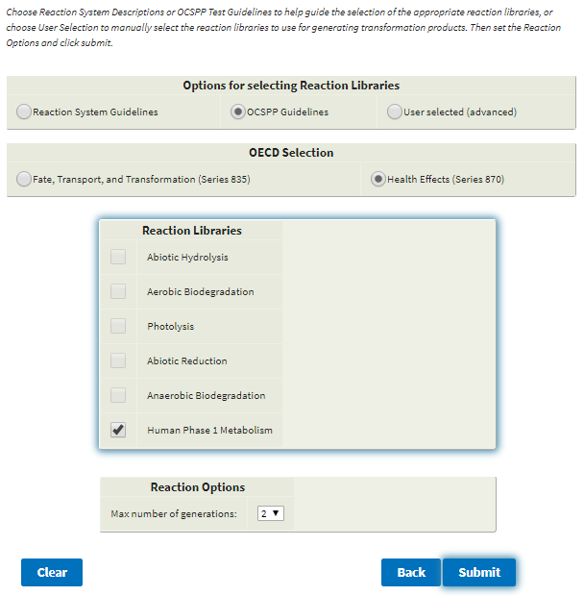

The third option for the selection of reaction libraries is through the selection of the User Selected, which is considered to be an option for the more advanced user. This option provides the ability to select amongst the currently available reaction libraries.

After selecting reaction libraries through one of the three options, the option to change the Reaction Options is given:

* **Max number of generations:**  the maximum number of generations of transformation products that will be generated. The default value is set at one.

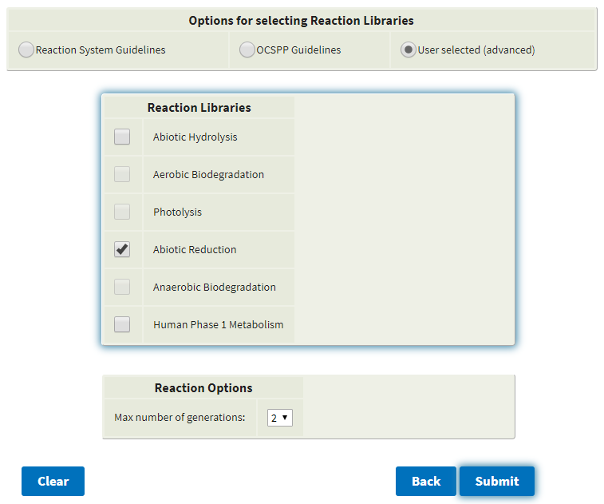

After selection of the reaction libraries and reaction options have been made, click the Submit button to generate transformation products. The results screen summarizes the input data and provides the first generation of transformation products (the default value) based on execution of the abiotic hydrolysis and reduction libraries as previously selected.

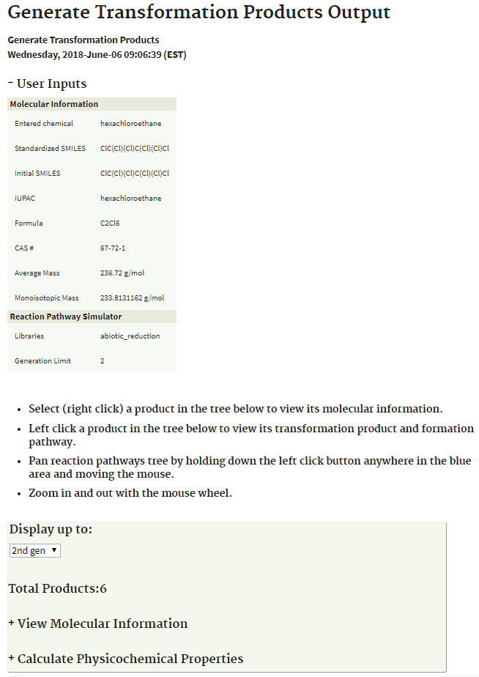

The number of viewed generations can be increased by changing the number of generations in the Display up to window. The screen on the left below illustrates the reaction pathway map for the formation of one generation of products. The screen on the right below illustrates the reaction pathway map for the formation of two generation of products. Note, that the number of observed generations cannot exceed the Generation Limit set on the previous screen.

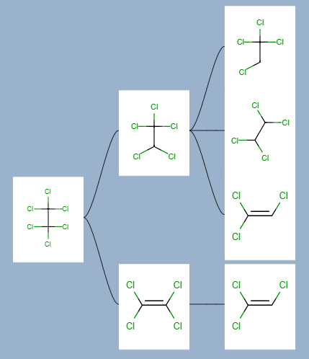

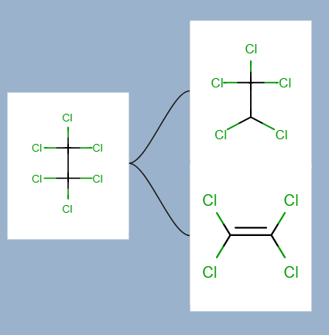

By placing the cursor over a product, a number appears that signifies its place in the reaction pathway map. For this example, tetrachloroethene (1.2.2) is the 2nd product formed in the third generation from the 2nd product (i.e., pentachloroethane, 1.2), which was formed in the second generation from hexachloroethane. By right-clicking on a product, the molecular and metabolite information for the product is displayed. The next generation of transformation 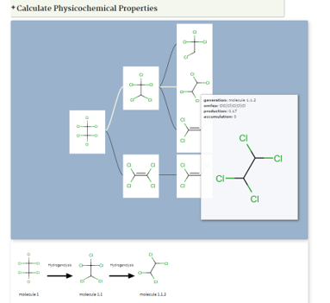products that are predicted to form from a selected product, as well as the reactions that form 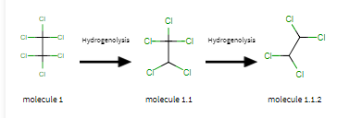them, can also be displayed by left-clicking one of the products.

Clicking on the Calculate Physicochemical Properties link provides the screen below with the various options for physicochemical properties and calculators to be applied to the selected transformation product.

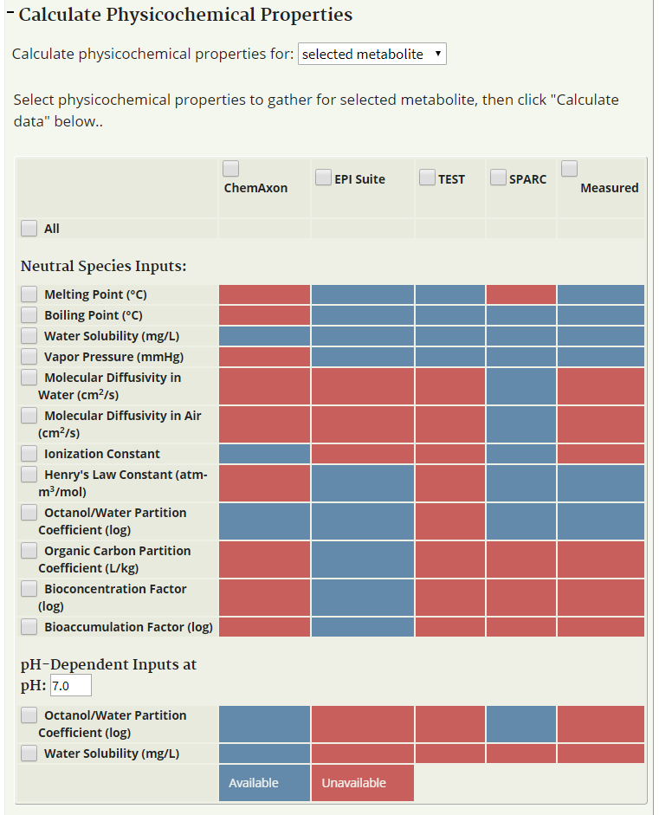

The selected physicochemical properties will be calculated and displayed in the selection table. For example, selection of the All and ChemAxon, EPI Suite, TEST and SPARC buttons and Clicking on the Calculate Physicochemical Properties link provides the screen on the right below showing the results for the selected physicochemical calculators for the selected metabolite, tetrachloroethane.

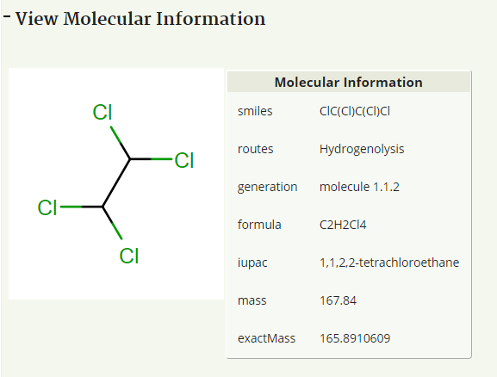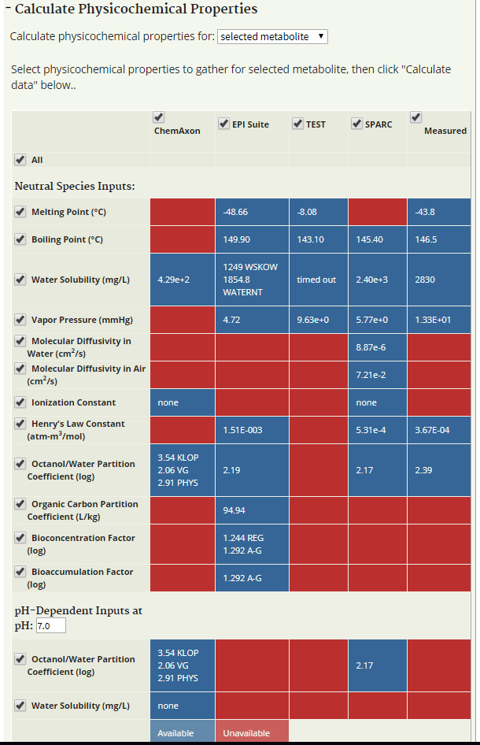

To get physicochemical data for multiple metabolites, select the option for calculating physicochemical properties for up to the first, second, or third generation of metabolites, or for all calculated metabolites from the drop-down menu. Then select the properties and calculators to be used, and click the Calculate data button. The results for multiple metabolites will not be presented in the table as they are for a single metabolite. To view the results for multiple metabolites, download and view the report (as a PDF, CSV, or HTML file) as described below.

## Generation of PDF, HTML and CSV Reports

The .pdf, .html and .csv buttons appear on the top right corner of the results page, regardless of the workflow. Clicking on the .pdf button generates a PDF file that can be viewed in the web browser or using free PDF software. The HTML file can be viewed using a web browser.

The PDF and HTML reports are multi-page reports showing the calculated physicochemical data for the parent compound and the selected transformation products. Examples of the PDF and HTML reports are shown below.

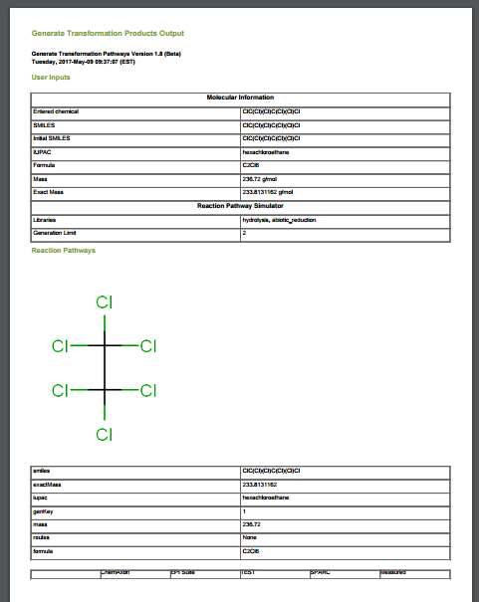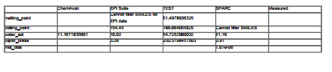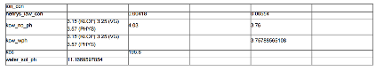

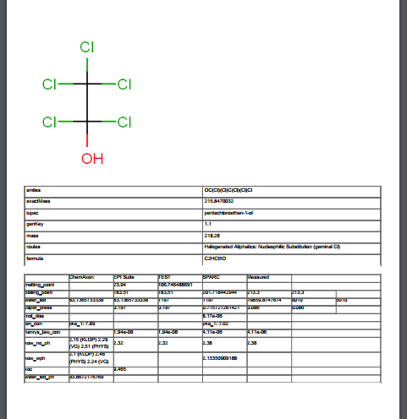

.HTML report

.PDF report

The CSV report is generated in a tabular format as shown below:

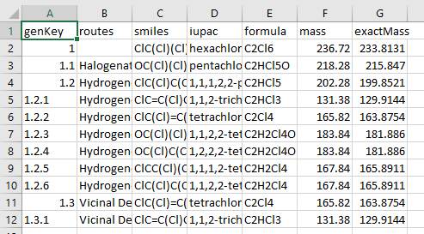

.CSV report

## References

Contrera, J.F., Matthews, E.J., Benz, R.D. 2003. Predicting the carcinogenic potential of pharmaceuticals in rodents using molecular structural similarity and E-state indices. Reg. Toxicol. Pharmacol. 38: 243–259.

Hilal, S.H., Carreira, L.A., Karickhoff, S.W. 2003. Prediction of the vapor pressure, boiling point, heat of vaporization and diffusion coefficient of organic compounds. QSAR & Combinatorial Science 22: 565-574.

Hilal, S.H , Carreira, L.A. Karickhoff, S.W. 2004. Prediction of the solubility, activity coefficient, gas/liquid and liquid/liquid distribution coefficients of organic compounds, QSAR & Combinatorial Science 23: 709-720.

Hou, T.J., Xia, K., Zhang, W., Xu, X.J. 2004. ADME evaluation in drug discovery. 4. prediction of aqueous solubility based on atom contribution approach, J. Chem. Inf. Comput. Sci. 44: 266-275.

Klopman, G., Li, J.-Y., Wang, S., Dimayuga., M. 1994. Computer automated log P calculations based on an extended group contribution approach. J. Chem. Inf. Comput. Sci. 34: 752-781.

Martin, T.M., Harten, P., Venkatapathy, R., Das, S. Young, D.M. A hierarchical clustering methodology for the estimation of toxicity, toxicology mechanisms and methods 18 (2008): 251–266.

Martin, T.M., Young. D.M. 2001. Prediction of the acute toxicity (96-h LC50) of organic compounds in the fathead minnow (Pimephales Promelas) using a group contribution method. Chem. Res. Toxicol. 14: 1378–1385.

Meylan W.M., Howard, P.H. 1995. Atom/Fragment contribution method for estimating octanol-water partition coefficients, Journal of Pharmaceutical Sciences, 84: 83-92.

Meylan, W.M., Howard, P.H., Boethling, R.S. 1996. Improved method for estimating water solubility from octanol/water partition coefficient. Environ. Toxicol. Chem. 15: 100-106.

US EPA. 2012. Estimation Programs Interface Suite™ for Microsoft® Windows, v 4.11. United States Environmental Protection Agency, Washington, DC, USA.

U.S. EPA 2016. User’s Guide for T.E.S.T. (version 4.2) (Toxicity Estimation Software Tool): A Program to Estimate Toxicity from Molecular Structure, EPA/600/R-16/058. United States Environmental Protection Agency, Washington, DC, USA.

Viswanadhan, V.N., Ghose, A.K., Revankar, G.R., Robins, R.K. 1989. Atomic physicochemical parameters for three dimensional structure directed quantitative structure-activity relationships. 4. Additional parameters for hydrophobic and dispersive interactions and their application for an automated superposition of certain naturally occurring nucleoside antibiotics. J. Chem. Inf. Comput. Sci. 29: 163-172.