The following are notes related to the conduct of the Agdrift Model updating and testing of the code.

1. The Agdrift (V2.1.1) model has been essentially rewritten to conform, in terms of functionality, to the Tier I calculations facilitated through the Agdrift model user interface (with the added capability to run multiple simulations, e.g., monte carlo, as opposed to the one at a time with the user interface of V2.1.1). The Tier I calculations include Tier I Aerial, Tier I Ground, and Tier I Orchard(Airblast(Agriculture).
   1. This python version of the model also performs Tier I back calculations.
   2. The “Extended Settings” option for Tier I Ground and Tier I Airblast are not functional in the python coded model.
2. The database of pesticide deposition rates at specific distances downwind of the application area (center line) are used to perform the calculations of average deposition across the area of a downwind area of interest (pond/wetland/terrestrial field). The database is a SQL database entitled 'sqlite_agdrift_distance.db' and is located in the python agdrift test directory within qed/ubertool_ecorest/ubertool/ubertool.
   1. The database contains downwind deposition data for 13 'scenarios'. Each scenario represents a combination of aerial, ground, or airblast application. Aerial applications are included for each of four droplet sizes (very fine to fine, fine to medium, medium to coarse, and coarse to very coarse). Ground application scenarios include combinations of low/high boom height and very fine to fine and fine to medium/coarse droplet size (four combinations in all). The airblast application includes normal, dense, sparse, vineyard, and orchard

The **figure** below displays one of thirteen curves representing spray drift (distance vs deposition) in the downwind direction from an application of pesticides via aerial, ground, or airblast application method. The horizontal bars represent downwind locations where a water body (pond or wetland) or terrestrial field may be located (Note: downwind centerline of plume and centerline of water body/field coincide). The AGDRIFT model (Tier I) focuses on determining the average deposition rate (actually the average fraction of the applied rate which is then multiplied by the user specified application rate to determine the average deposition rate) across the water body or field (along the center line of the plume). It then applies this centerline average deposition to the entire area of interest (i.e., pond/wetland/field area, which is 1 hectare in size and whose width/length are either “EPA Defined” or “User Defined”). The result is either the average concentration within the water column (pond or wetland with user specified depth) or the average deposition rate across the terrestrial field.

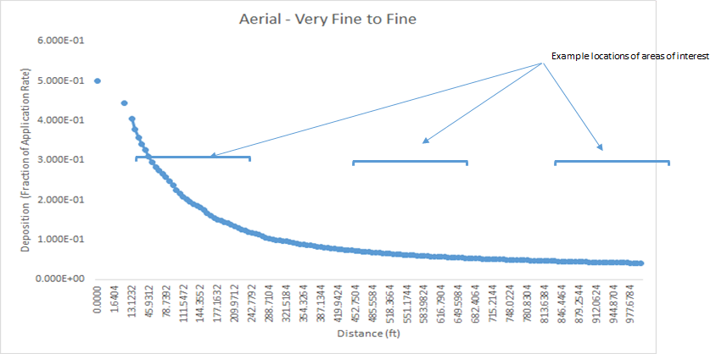

To calculate the average centerline deposition AGDRIFT integrates the curve shown in the figure above over the distance at which the area of concern is located (see horizontal bars in figure). The integration is performed using a linear approximation between x-points (generally each 2-meter [6.56 ft] distance along the x-axis from the front edge to the downwind edge of the area of interest).

**Testing of the Python coded model**

To test our Python code we use the OPP Agdrfit model V2.1.1. The Agdrift code was written in a combination of VB (user interface) and FORTRAN (science modules). Because we are unable to rebuild the executable model our testing focuses on running the OPP Agdrift model via the user interface for a set of specific scenarios (some provided by OPP). We use the results to compare to our running the same scenarios in the Python code.

Two situations involving the area of interest arise when performing the necessary calculations (illustrated in figure above). The area of interest can be located entirely within the distance for which the curve is specified (i.e., between 0 and 997 feet from the edge of the application area) or it may be partially outside the curve extent (i.e., beyond 997 feet). Calculations of average deposition when the area of concern is completely within the curves distance extent is straightforward and involves the linear integration described above. It is executed in the Python code using a callable Scipy Romberg (science utilities for Python) method for integration. Python code generated for these situations replicate results produced by the AGDRIFT model well (i.e., within a tolerance of 0.001 -- see results of integration tests).

When the area of interest is located partially beyond the curve extent (Agdrift does not allow the area of interest to be completely beyond the original curve extent) the AGDRIFT model ‘extends’ the curve. Documentation of how this extension is performed remains is a bit uncertain because the actual AGDRIFT model code, while available, is not easily read (i.e., the code is a combination of Visual Basic and FORTRAN and is not well documented). After some review the FORTRAN routine “AGEXTD.FOR” was located. This routine included the note “AGEXTD extends the deposition profile for pond integration”. It was determined that the routine performed the extension by fitting a line to the natural log transformed values of the last 16 distance/deposition values of the curve (i.e., the tail), as follows:

ln (yi / y0) = a * ln(xi – x0) + b

where

yi fraction of applied (deposition) associated with the final 16 points on the curve

y0 fraction of applied (deposition) associated with the 17th from the last point on the curve

xi distance associated with the final 16 points on the curve

x0 distance associated with the 17th from the last distance on the curve

a,b coefficients of the fitted line

The AGEXTD.FOR routine was coded first in EXCEL to verify its operation (see file named *TestsOfCurveExternderMethods.xlsx* -- worksheet: *ln(x-x0)ln(ydivy0)Aerialvf2f* for AGEXTD.FOR listing and Excel coding). A distance vs deposition (actually fraction of applied) representing one of the application scenarios was placed in the EXCEL spreadsheet and the AGEXTD.FOR calculations applied. The resulting extension of the curve was reasonable with the exception that the first several values of the extension (deposition at x pts from 1003ft to 1056ft) were slightly higher than that at the last point of the original curve (at 997 ft) as shown in figure below. Nonetheless this method was coded in Python and comparisons of results were made with AGDRIFT generated results.

Transition from original curve to extended/extrapolated curve

**Issue with AGDRIFT model calculations**

While conducting the comparisons between the Python code and the AGDRIFT model (v2.1.1) it was noticed that the AGDRIFT model generated two different results when the area of interest was located partially outside the extent of the original distance vs deposition curve (i.e., beyond 997 feet). The figures below illustrate this result. The AGDRIFT model run illustrated in these figures represents a Tier I Aquatic Assessment using Fine to Medium droplet size. In each AGDRIFT run the area of interest is a pond with default EPA Defined dimensions (i.e., 208.7 ft wide by 515.8 ft length). The leading edge of the pond is located at 900 ft, thus the downwind edge of the pond is located at 1108.7 ft (which is 111.7 ft beyond the extent of the distance vs deposition curve). The difference between these two runs of AGDRIFT is the manner in which the pond dimensions are input. In the first figure the dimensions are specified by selecting the EPA Defined Pond radio button (dimensions are automatically set). In the second figure the default pond dimensions are specified by selecting the User Defined Water Body and placing the dimensions in the appropriate window. Note that the user specifies only the water body width (208.7 ft), the water body length is automatically calculated internal to the model as the length required to complement the width and result in a 1 hectare surface area (i.e., the 515.8 ft). [The depth of the pond is not relevant to this discussion but is 6.56 ft for each run].

While the dimensions of the pond are identical in the two runs the results of model calculations are different (with the only difference from the user’s perspective being the means of specifying the default pond dimensions). The average pond concentration is 328.48 ng/L when selecting the EPA Defined Pond and 332.97 ng/L when User-defined Water Body is selected. While these differences are relatively small they are significant and require explanation.

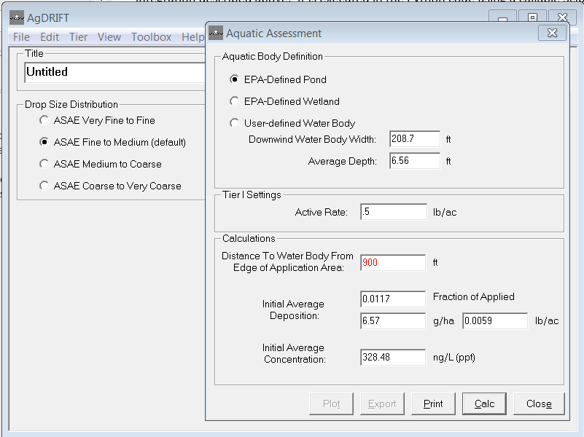

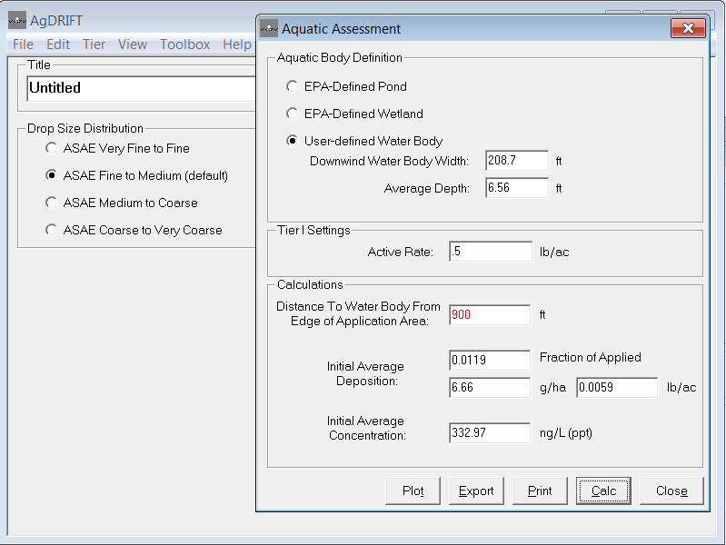

NOTE: All scenarios where the area of interest lies completely within the 997ft extent of the original distance vs deposition data are not affected by this issue. In reviewing these results and building/testing Python code to emulate AGDRIFT we draw the following conclusion.

**Conclusion**

The AGDRIFT model appears to apply different algorithms to extend the distance vs deposition curve, one is applied when EPA Defined Pond or Wetland is selected and one when User-Defined Water Body (or Terrestrial Field) is selected. The difference in the algorithms appears to be the manner in which the log transformation of distance and deposition values is performed. If the User Defined Pond option is selected the following log transformation line of best fit is processed (see discussion above and Agdrift code for AGEXTD.FOR):

ln (yi / y0) = a * ln(xi – x0) + b

where

yi fraction of applied (deposition) associated with the final 16 points on the curve

y0 fraction of applied (deposition) associated with the 17th from the last point on the curve

xi distance associated with the final 16 points on the curve

x0 distance associated with the 17th from the last distance on the curve

a,b coefficients of the fitted line

If the EPA Defined Pond option is selected the following log transformation line of best fit is processed :

ln (yi) = a * ln (xi) + b

where

yi fraction of applied (deposition) associated with the final 16 points on the curve

xi distance associated with the final 16 points on the curve

a,b coefficients of the fitted line

The AGEXTD.FOR routine reflects the first log transformation. No code was found that reflects the second log transformation.

As noted above the first transformation results in deposition values in the extended region that begin with values greater than the last value in the original curve (i.e., at 997 ft) and decrease more slowly than the second method. The second transformation method results in extended values that continue the monotonically decreasing nature of the curve (and visually seems to fit the curve better). The figure below illustrates the comparison between the two transformation methods in terms of the curve extension achieved (also see the Excel file *‘TestsOfCurveExtenderMethods.xlsx’* and worksheet *‘GraphicalComparisons’* for more details). While the first transformation may be considered more conservative (from the perspective of calculating exposure) the second appears to be more appropriate (from the perspective of simply fitting the curve). The file *‘TestsOfCurveExtenderMethods.xlsx’* also contains a worksheet entitled *‘PythonGeneratedResults’* that includes distance/deposition data and graphs generated by the Python code and also a worksheet entitled ‘spreadsheet&pythonComparison’ that compares both methods as implemented within Excel and within the Python code.  **Which method (or both) to use should be based on guidance from OPP.** Both methods are currently included in the Python code with an internal option that can be set to either method. All integration tests apply the first transformation method (i.e., ln (yi / y0) = a * ln(xi – x0) + b) and thus the “User Defined Pond/Wetland” option.

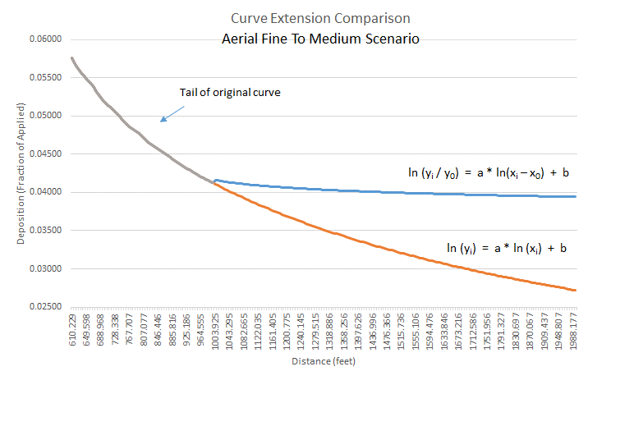

**Series of Tests to Compare model results between Python and Agdrift V2.1.1**

Now that the curve extension methods have been determined and coded in both Excel and Python it’s time to exercise the Agdrift V2.1.1 and Agdrift (Python) on a series of scenarios and compare results (we refer to this series of tests as integration tests).

*One aspect of the integration testing proved to be a challenge. The OPP Agdrift scenario results are presented in the user interface and as such are formatted (i.e., with a limited set of significant digits included). Further, the OPP Agdrfit interface employs a few formats; including a) rounding to four decimal places when value is less than 1 and greater than 1e-4, b) using scientific notation with 3 significant digits when values are less than 1e-4, and c) rounding to 2 decimal places when value is greater than 1. In our comparisons we emulate these output value formats in the Python code (we have an internal option that turns rounding on/off). When comparing results between the two models we consider a fractional difference (e.g., [a – b] / a ) of less than 1e-3 as a match (this is principally due to the rounding off conducted by the Agdrift V2.1.1 model in its interface).*

The following series of 25 integration tests have been automated (see Excel spreadsheet entitled *‘ubertool crosswalk’* and worksheet *‘agdrift_qaqc_final’* for complete set of test data and expected outputs. The tests are organized to test each of the major pathways through the models, including:

1. Forward and inverse calculation. The models can be run in forward mode where the distance to a point or area of interest is specified in the input and the model calculates the average deposition at that point or over the area OR the models can be run in inverse mode where the average deposition (or related variables, e.g., water concentration resulting from deposition onto a pond or wetland) are specified in the input and the model calculates the distance from the edge of the source area (i.e., the field where pesticides are released).
2. Area of interest completely or partially contained within original extent of distance/deposition data/curve (i.e., 997ft).
3. User Defined and EPA Defined dimensions of area of interest. EPA Defined dimensions are set by the OPP. Note: the EPA Defined dimensions can also be set in the User Defined mode.
4. We run the tests using a variety of data scenarios (e.g., Aerial release, fine to medium drop size).
5. We run the tests using a variety of pesticide release and exposure assessment combinations (e.g, aquatic assessment, EPA Defined Wetland, application rate, distance to area of interest, etc.).

The protocol is to run the Agdrift V2.1.1 model user interface with the test based input data, record the ‘expected’ results in the Excel spreadsheet that contains all test input sets (*‘ubertool crosswalk’* and worksheet *‘agdrift_qaqc_final’)*, and run the Python model (that reads the input data and expected results from the Excel file) in ‘integration test’ mode that executes the Python Agdrift model and automatically reports results of the comparison.

The following is a summary of the individual/group test objectives (they are numbered in accordance with the numbering listed in the Excel spreadsheet). All tests have been run successfully (i.e., all relevant results generated by the two models compare within the specified tolerance of 1e-3).

**Tests 0&1**: to ensure that model results are same when selecting EPA Defined vs User Defined (Pond or Wetland) when dimensions of the area of interest are specified to be the same

* Forward calculation (distance to Wetland specified)
* Aquatic Assessment
* EPA Defined Wetland (test 0) User Defined Wetland (test 1)
* area of interest contained completely within original distance/deposition data extent
* Aerial release
* Medium to Coarse drop size

**Test 2&3**: To ensure that tests 0&1, when run in inverse mode, by specifying the ‘fraction of applied’ resulting from tests 0&1, calculate the distance to area of interest (as specified in tests 0&1)

* inverse calculation (fraction of applied specified)
* Aquatic Assessment
* User Defined Wetland (test 2) EPA Defined Wetland (test 3)
* area of interest contained completely within original distance/deposition data extent
* Aerial release
* Medium to Coarse drop size

*Note: in conducting these tests it is not possible to generate the exact results of tests 0&1 due to the fact that the Agdrift V2.1.1 model rounds off the output variable values (see discussion above). Thus these tests confirm that inverse mode produces the same results for both the EPA Defined and User Defined specification of the input values as reported by the Agdrift V2.1.1 model.*

**Tests 4**: To reproduce test 0 model outputs in inverse mode.

* inverse calculation
* Aquatic Assessment/EPA Defined Wetland
* area of interest contained completely within original distance/deposition data extent
* Aerial release
* Medium to Coarse drop size

*Note: As stated in the previous test note it was not possible to replicate tests 0&1 in inverse mode using the value of ‘fraction of applied’ calculated by Agdrift due to the rounding off of the Agdrift V2.1.1 model output valuest. Thus, to conduct this test the greater number of significant digits available from the Python model test 0 (i.e., for ‘fraction of applied’) was used as input to the Agdrift V2.1.1 and Python models in inverse mode. To explain further, in tests 0/1 the distance to the area of interest was input as 712ft and the resulting ‘fraction of applied’ from the Agdrift V2.1.1 model was 0.006 (this is a rounded number and thus when we specified .006 as input to tests 2/3 we did not reproduce the expected 712ft distance to the area of interest). Because the Python code and Agdrfit model matched in tests 0/1 we can take the ‘fraction of applied’ value from the Python code and assume that’s what the Agdrift model produced (before rounding). Hang in there, it gets even more complicated. You’ll notice that the result of this test is a distance to the area of interest of 715.21ft and not the 712ft specified in tests 0/1. This is because the Agdrift model also rounds up the distance to the area of interest to the nearest half segment (i.e., midpoint of two x values when actual calculated distance is less than half the distance between the two adjoining x points and the next x point when the distance is greater than half the distance between the two adjoining x points -- in inverse mode the Agdrift model always reports the distance to the distance to the area of interest as a midpoint between x points or an x point itself).*

**Tests 5-7**: To ensure that all inverse mode options operate consistently.

* inverse calculation
* Aquatic Assessment/EPA Defined Wetland
* area of interest contained completely within original distance/deposition data extent
* Aerial release
* Medium to Coarse drop size

*Note: In inverse mode the Agdrift V2.1.1 model allows the user to specify the ‘fraction of applied’ as any one of the following: ‘fraction of applied’, initial average deposition in grams/hectare, initial average deposition as lb/acre, or as the initial average concentration in the water body in nanograms/lite. All of these variables are directly computable from each other.*

**Tests 8&9**: To ensure that EPA Defined Terrestrial scenarios generate correct outputs.

* Forward calculation (specify distance to point of interest)
* Terrestrial Assessment/EPA Defined Terrestrial
* area of interest contained completely within original distance/deposition data extent
* Aerial release
* Fine to medium drop size

*Note: For EPA Defined Terrestrial scenarios the output of interest is a deposition at a point (rather than an average over an area of interest such as a pond). Thus, these scenarios are simply scanning the original deposition vs distance data curve to locate the ‘fraction of applied’ at the specified distance and report it in units of mg/cm2. Test 9 places inputs the distance to the point of interest at 1 foot to ensure that points very near the source are correctly handled.*

**Tests 10-13**: To ensure that EPA Defined Terrestrial operates consistently in inverse mode.

* Inverse calculation (specify one of the following: *‘fraction of applied’, initial average deposition in grams/hectare, initial average deposition as lb/acre, or* initial average deposition in mg/cm2)
* Terrestrial Assessment/EPA Defined Terrestrial
* area of interest contained completely within original distance/deposition data extent
* Aerial release
* Fine to medium drop size

**Test 14**: To ensure that model operates correctly when area of interest lies partially outside of original extent of deposition vs distance data.

* Forward calculation (specify distance to area of interest)
* Aquatic Assessment/User Defined Pond
* area of interest contained partially within original distance/deposition data extent
* Aerial release
* Fine to medium drop size

*Note: this test places a pond of maximum width (997ft) a maximum distance from the source (also 997ft), thus testing the fullest extent of the model dimensions.*

**Tests 15-16**: To ensure that model operates correctly in inverse mode when area of interest lies partially outside of original extent of deposition vs distance data.

* Inverse calculation (specify *‘fraction of applied’)*
* Aquatic Assessment/User Defined Pond
* area of interest contained partially within original distance/deposition data extent
* Aerial release
* Fine to medium drop size

**Test 17**: To ensure the model reports ‘out of range’ when input value is beyond extent of deposition vs distance data/curve.

* Inverse calculation (specify *‘fraction of applied’)*
* Aquatic Assessment/User Defined Pond
* area of interest contained partially within original distance/deposition data extent
* Aerial release
* Fine to medium drop size

**Test 18**: To ensure that Tier I Ground simulation operates correctly in inverse mode.

* Inverse calculation (specify *‘initial average deposition (g/ha’)*
* Terrestrial Assessment/User Defined Terrestrial
* area of interest contained completely within original distance/deposition data extent
* Ground release (High boom)
* Very fine drop size

**Test 19**: To ensure that Tier I Ground simulation operates correctly in forward mode.

* Forward calculation (specify *‘distance to terrestrial field’)*
* Terrestrial Assessment/User Defined Terrestrial
* area of interest contained completely within original distance/deposition data extent
* Ground release (High boom)
* Very fine drop size

**Test 20**: To ensure that Aquatic assessment operates correctly when area of interest for a pond lies partially outside of original deposition vs distance data/curve.

* Forward calculation (specify *‘distance to area of interest’)*
* Aquatic Assessment/User Defined Pond
* area of interest contained partially within original distance/deposition data extent
* Aerial release
* Fine to medium drop size

**Tests 21&22**: To ensure that Tier I Ground operates correctly in forward mode with Low/High boom heights.

* Forward calculation (specify *‘distance to area of interest’)*
* Terrestrial Assessment/User Defined Terrestrial
* area of interest contained partially within original distance/deposition data extent
* Ground release Low/High boom
* Fine to Medium/Coarse drop size

**Tests 23&28**: To ensure that Tier I Airblast scenarios operate successfully in forward mode under various EPA Defined and User Defined combinations.

* Forward calculation (specify *‘distance to area of interest’)*
* Terrestrial Assessment/User Defined Terrestrial
* area of interest contained partially or completely within original distance/deposition data extent
* Airblast release Sparse/Normal/Dense/Vineyard/Orchard

**Tests 29-31:** To ensure that the Tier I Airblast scenarios operate successfully in inverse mode

* Inverse calculation (specify ‘fraction of applied’, or ‘Initial Average Deposition (g/ha)’ etc. *)*
* Terrestrial Assessment/EPA Defined&User Defined Terrestrial
* area of interest contained completely within original distance/deposition data extent
* Airblast release Normal/Dense/Vineyard/Orchard

**Tests 32-34:** Tests that model determines when inputs result in ‘out of range’ results (i.e., the distance to the fraction of applied is within model data limits.

* Inverse calculation (specify ‘fraction of applied’, or ‘Initial Average Deposition (g/ha)’ etc. *)*
* Terrestrial Assessment/EPA Defined&User Defined Terrestrial
* area of interest not contained within original distance/deposition data extent
* Aerial/Airblast Normal releases