VNR Vignana Jyothi Institute of Engineering & Technology
Daily Report | 16 March 2026

1. Staff Attendance Report (Department-wise)
S.No | Department | On Rolls | Absent | Present | Attendance %
1 | AUTOMOBILE ENGINEERING | 27 | 2 | 25 | 92.6%
2 | CSE-(AIML & IOT), R&AI | 63 | 5 | 58 | 92.1%
3 | CHEMISTRY | 23 | 5 | 18 | 78.3%
4 | CIVIL ENGINEERING | 39 | 0 | 39 | 100.0%
5 | COMPUTER SCIENCE & ENGINEERING | 75 | 6 | 69 | 92.0%
6 | CSE - (CYS, DS) AND AI&DS | 82 | 8 | 74 | 90.2%
7 | ELECTRONICS & COMMUNICATION ENGINEERING | 67 | 3 | 64 | 95.5%
8 | ELECTRICAL & ELECTRONICS ENGINEERING | 51 | 7 | 44 | 86.3%
9 | ELECTRONICS & INSTRUMENTATION ENGINEERING | 33 | 0 | 33 | 100.0%
10 | INFORMATION TECHNOLOGY | 53 | 0 | 53 | 100.0%
11 | MATHEMATICS AND MANAGEMENT SCIENCES | 27 | 2 | 25 | 92.6%
12 | MECHANICAL ENGINEERING | 49 | 4 | 45 | 91.8%
13 | MENTORSHIP, TRAINING & PLACEMENTS | 8 | 0 | 8 | 100.0%
 | TOTAL | 597 | 42 | 555 | 93.0%
Library Staff Attendance
On Rolls | Absent (w/ leave) | Absent (w/o leave) | Present
6 | 0 | 0 | 6
2. Events / Seminars / Workshops
● GEOID 2026 — Civil Engineering [HIGH]
Date: 2026-03-16 to 2026-03-17 Duration: 2 days
The department is organizing a two-day Geotechnical Technical Symposium focusing on advancements in geotechnical engineering.
● Summer System Design Workshop — CSE - (CyS, DS) and AI&DS [HIGH]
Date: 2026-03-16 Duration: 2 days Internal: 100 Resource Person: Ms. Dolly Yadav (Salesforce), Mr. Naman Roy (Splunk)
An intensive workshop on building resilient architectures featuring industry experts from Salesforce and Splunk for 100 student participants.
● AI Toolverse — CSE - (CyS, DS) and AI&DS [MEDIUM]
Date: 2026-03-16 Duration: 1 day Resource Person: VJ ARC Seniors
An interactive session organized by VJ ARC where senior students demonstrated practical AI tools for productivity and academic applications.
Photos from Department Activities
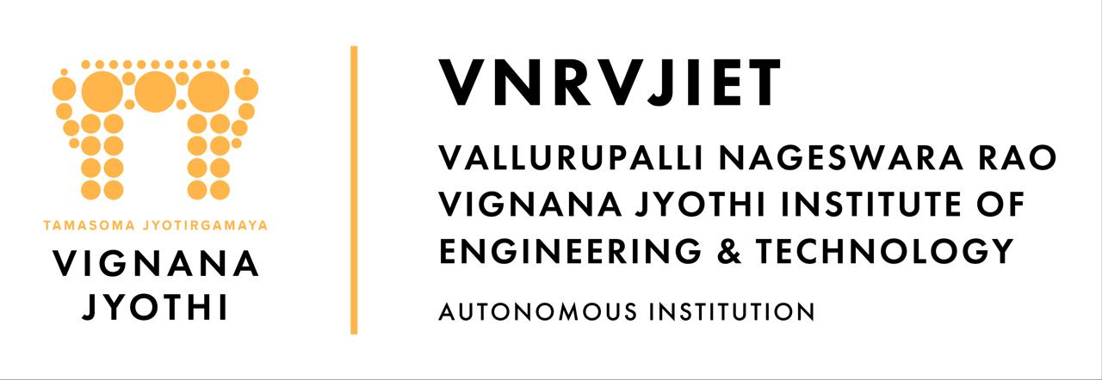
— AE Department —

— AIML Department —

— CHEM Department —

— CIVIL Department —

— CIVIL Department —

— CSE Department —
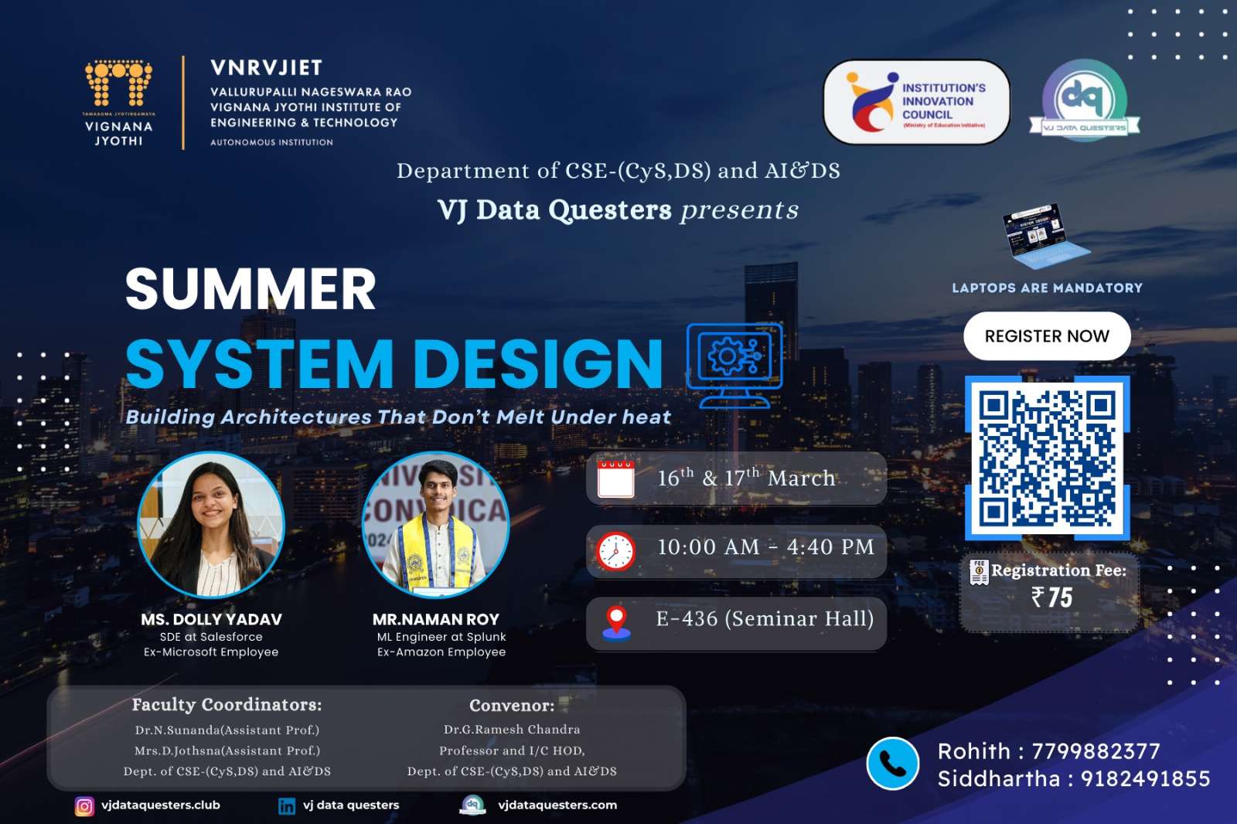
— CYS Department —
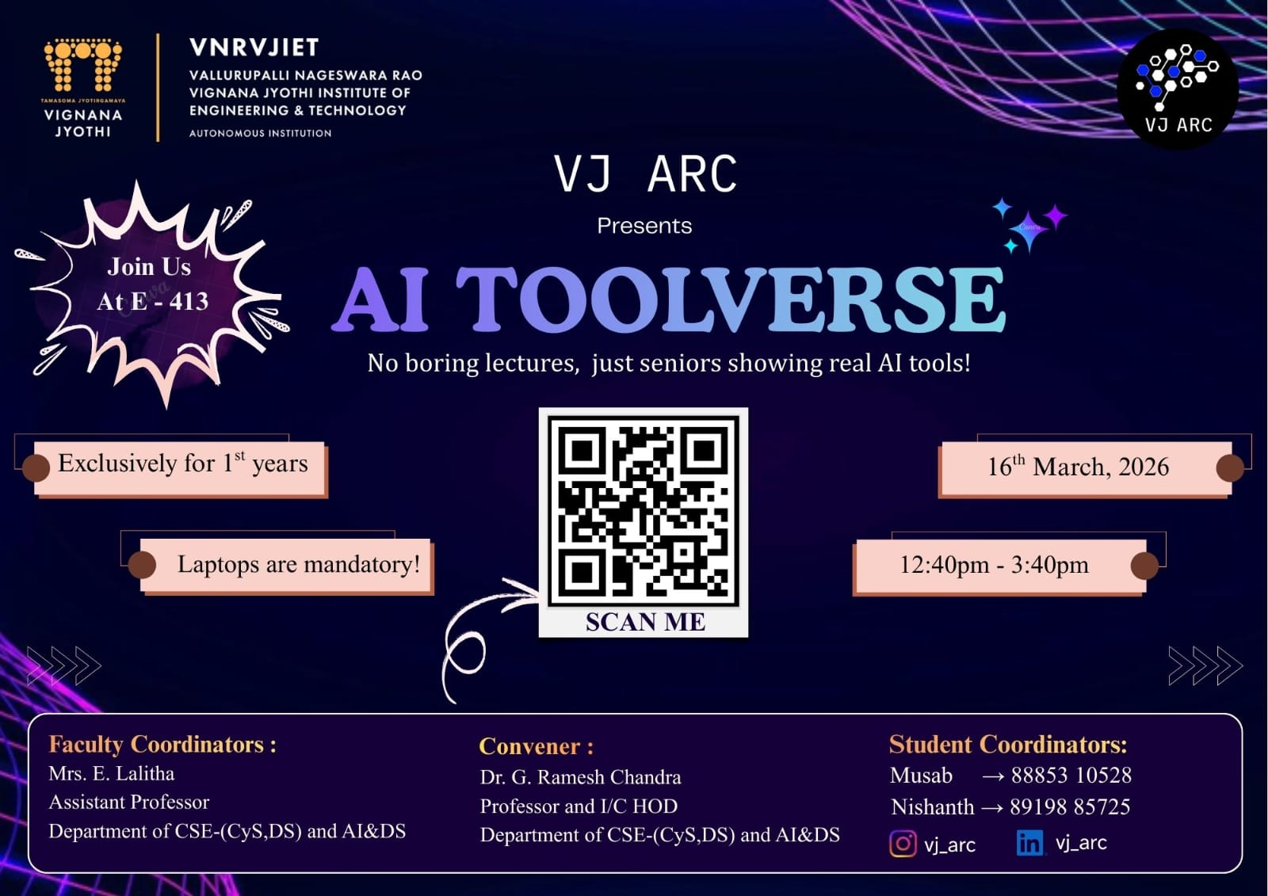
— CYS Department —

— ECE Department —

— ECE Department —

— EEE Department —

— EEE Department —
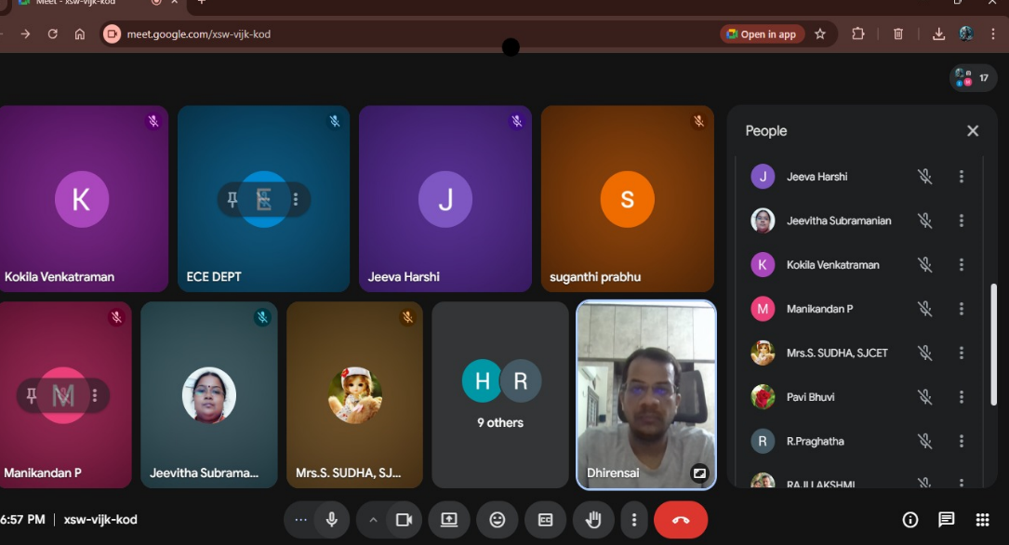
— EIE Department —
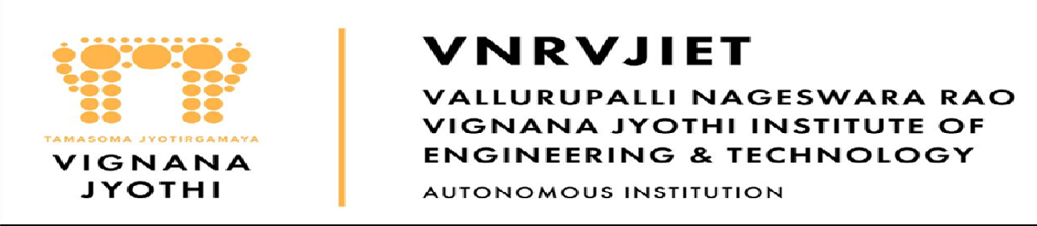
— EIE Department —

— IT Department —

— IT Department —

— M&MS Department —

— M&MS Department —

— ME Department —

— ME Department —

— MTP Department —
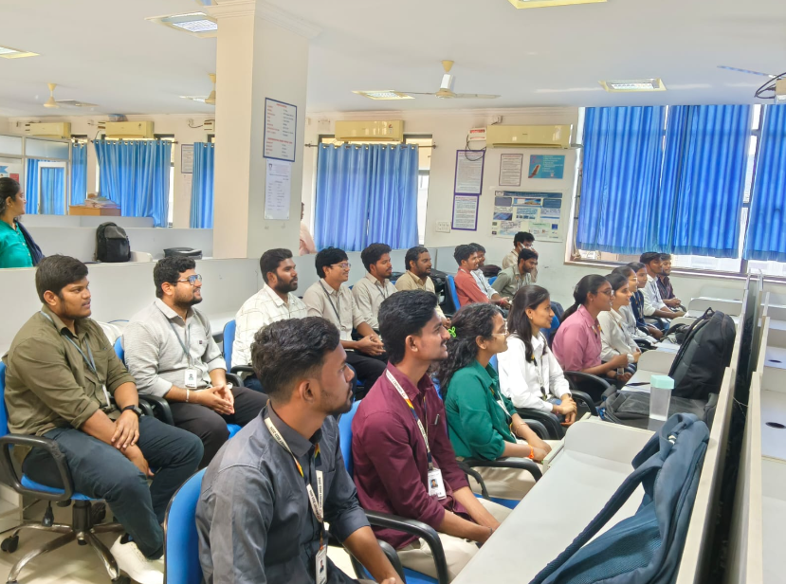
— MTP Department —
3. Participation by Staff & Students (External)
Staff Participation
● Mr. K. Sreenivasa Rao — CSE-(AIML & IoT), R&AI, Participant, at "Research paper writing and Publishing", (2026-02-28)
Participated in a one-day Faculty Development Programme focused on academic publishing.
● Dr. V. Nageshwar — Electronics & Instrumentation Engineering, Speaker, at "Recent Trends in Robotics, AI IoT and Industrial Automation", (2026-03-14)
Delivered a guest lecture on 'IoT and Its Application' at an external 5-day FDP.
● Dr. N. Mangathayaru — Information Technology, Participant, at "Outcome-Based Education for Effective Teaching and Assessment", (2026-03-16)
Attended a specialized session on OBE and assessment strategies conducted by the Principal of JNTU Sultanpur.
● S. Anoosha — Information Technology, Participant, at "Outcome-Based Education for Effective Teaching and Assessment", (2026-03-16)
Attended a session on effective teaching and assessment through Outcome-Based Education.
● Donthamsetti Veera Bhadra Rao — Information Technology, Participant, at "Outcome-Based Education for Effective Teaching and Assessment", (2026-03-16)
Participated in the OBE workshop to enhance teaching and assessment methodologies.
● Anuraghavi — Information Technology, Participant, at "Outcome-Based Education for Effective Teaching and Assessment", (2026-03-16)
Participated in the faculty session regarding Outcome-Based Education frameworks.
● A. Soujanya — Information Technology, Participant, at "Outcome-Based Education for Effective Teaching and Assessment", (2026-03-16)
Attended the OBE workshop led by Dr. S. Viswanadha Raju.
4. Classwork Adjustments / Lecture Interchange
S.No | Department | Number of Adjustments
1 | AUTOMOBILE ENGINEERING | 3
2 | CSE - (CYS, DS) AND AI&DS | 5
5. Library Services & Transactions
Library Transactions
Particulars | Count
Books Issued (Check Out) | 60
Books Returned (Check In) | 70
Today's Visitors to LIRC | 320
Evening Users (5 PM – 8 PM) | 16
Digital Library Visitors | 25
6. Any Other Matters
CHEMISTRY: Research paper titled 'Nano-Sulfonated Graphene Oxide: A Metal-Free Catalyst for the Synthesis of Benzimidazoles and Antimicrobial Activities' by Dr. M. Brahmayya accepted in the Journal of Environmental Nano Technology (Scopus).
ELECTRONICS & COMMUNICATION ENGINEERING: Department faculty meeting conducted by Dr. Y. Srinivasa Rao, R&D Director, on March 16, 2026.
INFORMATION TECHNOLOGY: Dr. G. Madhu submitted a project proposal to ICMR titled 'Development of AI-Enabled Acoustic Digital Biomarkers for Non-Invasive Monitoring of Dialysis Adequacy' in collaboration with IIIT.

Consolidated by AI | VNRVJIET Principal's Office

