

Day Report

I. Details of Scholarships:
Description | Total to be received | Received till Date | Received Date | To be received
Outstanding fees due  from the State Govt. | 2590189300 | 1354467700 | Till Date | 1235721600

Pending RTF Amount Year-wise Statement of 2014-15 to 2024-2025 A.Y as on 30.01.2026
S.No. | Academic Year | No. of Students | Total Tuition Fee in Rs. | Released No. of Students | Released Amount in Rs. | Pending No. of Students | Pending Amount in Rs.
1 | 2014-15 | 2578 | 111477600 | 2578 | 111535500 | 0 | -57900
2 | 2015-16 | 2971 | 145407000 | 2970 | 145497700 | 1 | -90700
3 | 2016-17 | 3060 | 164171600 | 3054 | 161864900 | 6 | 2306700
4 | 2017-18 | 3197 | 184686700 | 3196 | 180969300 | 1 | 3717400
5 | 2018-19 | 3372 | 206744500 | 3366 | 199886900 | 6 | 6857600
6 | 2019-20 | 3383 | 219041000 | 3366 | 216759600 | 17 | 2281400
7 | 2020-21 | 3197 | 249738500 | 2874 | 162593600 | 323 | 87144900
8 | 2021-22 | 3120 | 287671900 | 1025 | 97685200 | 2095 | 189986700
9 | 2022-23 | 3115 | 337126000 | 329 | 42755000 | 2786 | 294371000
10 | 2023-24 | 3308 | 363555500 | 720 | 34920000 | 2588 | 328635500
11 | 2024-25 | 3614 | 320569000 | 0 | 0 | 3614 | 320569000
 | Total | 34915 | 2590189300 | 23478 | 1354467700 | 11437 | 1235721600

Bank Credit Amount is 10995000/- Date 30.01.2026

II | Staff & Student Attendance Report : Attached.  Consolidated Absent Faculty:  - Dr. A. Ramesh (Unknown) — Faculty – On Duty  - . (Unknown) — Full Day  - Name of the Faculty (Unknown) — Faculty – Half Pay Leave  - Name of the Faculty (Unknown) — Faculty - Study Leave  - Dr. Poonam Shekhawat (Unknown) — Name of the Faculty (ML/PL)  - . (Unknown) — b. Half Day  - Dr. Talluri Sunil Kumar(01-03-26 to 30-06-26) (CSE) — a.Full Day  - Dr. Bommisetty Durga Venkata Chandra Mohan Rao (CSE) — a.Full Day  - Reddy(FN) (CSE) — a.Full Day  - Mr.Velpula Vinay Kumar (CSE) — a.Full Day  - Dr. Kriti Ohri(10-03-26 to 20-03-26) (CSE) — a.Full Day  - Mrs.V.Susmitha(04-03-2026 to 05-04-26) (CSE) — a.Full Day  - Ms. Nam Vasundhara (CSE) — a.Full Day  - Nidamanuri Sudheer(FN) (CSE) — b. Half Day  - Faculty – Half Pay Leave (CSE) — b. Half Day  - Mrs. Dr.T. Preethi (CSE) — 1 Faculty - Study Leave  - Ms.Issac Neha Margaret (CSE) — 1 Faculty - Study Leave  - Mr.K.Sai Bhargav (CSE) — 1 Faculty - Study Leave  - a.Full (CSE) — Staff- Casual / Earn Leave  - Karri Vandana (CSE) — Staff- Casual / Earn Leave  - Gunreddy Laxma Reddy (CSE) — Staff- Casual / Earn Leave  - Mrs. A. Shobha (CSE) — 1 Staff – Maternity/Paternity Leave  - Dr Thayyaba Khatoon(Industry Fellowship) (CSE) — Faculty – On Duty  - Dr. Allam Venkata Siva Swetha (ML) (CSE) — Full Day Faculty– Casual / Earn Leave  - Dr C Kiran Mai(CL) (CSE) — Full Day Faculty– Casual / Earn Leave  - Dr B V Kiranmayee(CL) (CSE) — Full Day Faculty– Casual / Earn Leave  - Ms.A.Sandhya Rani(EL) (CSE) — Full Day Faculty– Casual / Earn Leave  - S Alankritha (CSE) — Faculty - Study Leave  - B Suneetha(CL) (CSE) — Full Day  - G Ram Reddy(CL) (CSE) — Full Day  - Ms. K. Anitha, Asst. Prof (CSE) — Full Day  - Ms. Preety Singh, Asst. Prof (CSE) — Full Day  - Mr. U. Veeresh, Asst. Prof (CSE) — Full Day  - Ms. V. Hemadevi, Asst. Prof (CSE) — Faculty – Maternity Leave (01)  - Ms. H. Sulekha, C.O (CSE) — Staff –Study Leave (01)  - Mr. M. Venkata Ramarao (CL) (AE) — a. Full Day  - Mr. Vinay Kulkarni (CL) (AE) — a. Full Day  - Name of the Faculty (AE) — Faculty – Half Pay Leave  - Name of the Faculty (AE) — Faculty - Study Leave  - Break in Service (AE) — Leave Without Pay  - Dr. Padmavathi P (Unknown) — 1 Faculty – On Duty  - Mrs. S. Prathyusha (PhD Defense) (Unknown) — a. Full Day  - NIL (Unknown) — Staff– Half Pay Leave  - Dr A. Gangadhara (Unknown) — Staff -Study Leave  - Dr P. Suresh (Unknown) — Staff -Study Leave  - Nil (Unknown) — Staff - Maternity Leave  - Nil (Unknown) — Staff– On Duty  - Nil (Unknown) — a. Full Day  - Nil (Unknown) — b. Half Day  - Mr. J. Sambasiva Rao (Unknown) — Staff– Half Pay Leave  - Nil (Unknown) — Staff -Study Leave  - Nil (Unknown) — Staff - Maternity Leave  - Dr.V.Priyanka (ECE) — a.03:Full Day  - Dr.K.B.Archana (ECE) — a.03:Full Day  - Dr.Sk.Shoukath Vali (ECE) — a.03:Full Day  - Dr.G.Kiran Kumar (ECE) — b. 01: Half Day  - G.Ramya (ECE) — 01: Faculty - Maternity Leave  - Faculty – Casual / Earn (Unknown) — Faculty – On Duty  - Dr.K.Anuradha (EL) (Unknown) — Full Day  - G.C.Prabhakar (ML) (Unknown) — Full Day  - I.Neelima (CL) (Unknown) — Full Day  - Dr.R.Geshma Kumari (CL) (Unknown) — Half Day  - Faculty – Half Pay Leave (Unknown) — Half Day  - Faculty - Study Leave (Unknown) — Half Day  - Name of the Faculty (ML/PL) (Unknown) — 0 Faculty - Maternity/Paternity Leave  - V.Malleswari (CL) (Unknown) — a.Full Day  - B.Sivaji (CL) (Unknown) — a.Full Day  - A.Geetha (CL) (Unknown) — a.Full Day  - P.H.Sham Rao (CL) (Unknown) — a.Full Day  - Mr. P.V. Gopi Kumar (Unknown) — Faculty – On Duty  - Mr. S.Bhargav (Unknown) — Faculty – On Duty  - Dr. N. Pothanna (M&MS) — Full Days  - Dr. G. Naga Malleswari (M&MS) — Full Days  - Dr. N. Aruna Kumari (M&MS) — 1 Faculty - Medical Leave  - 1Dr G Sireesha (M&MS) — 1 Faculty - Study Leave  - Dr. Bollu Satyanarayana – CL (Unknown) — Full Day  - Dr. Kaviti Ajay Kumar - CL (Unknown) — Full Day  - Putha Prasad Kumar – CL (Unknown) — Full Day  - Lagadapati Kamalakara Rao -EL (Unknown) — Full Day  Missing Reports From:  - IQAC Data Not Received
III | MTP:  --- Unknown ---  Any other matter to be reported:  Department of Civil Engineering is organizing a Geotechnical Technical Symposium, GEOID 2026 on 16-17 March, 2026  HOD – CE  --- CSE ---  Any other matter to be reported:  The Summer System Design Workshop at VNRVJIET brought together aspiring engineers for two days of intensive learning on building resilient architectures. With expert insights from industry professionals Ms. Dolly Yadav (Salesforce, ex-Microsoft) and Mr. Naman Roy (Splunk, ex-Amazon), participants explored practical approaches to system design. The sessions ran from 10:00 AM to 4:40 PM, combining theory with hands-on practice. Enthusiastic student participation and faculty coordination ensured a productive and engaging experience.  Attended 100 students  the AI Toolverse session organized by VJ ARC, where seniors demonstrated practical AI tools and their real-world applications. Explored different tools that can help improve productivity, learning, and project development. The session was interactive and provided useful insights into how AI can be applied in academics and daily tasks.  Dr. G.Ramesh Chandra  Prof. & I/C HOD  CSE-(CyS, DS) and AI&DS  --- CSE ---  Any other matter to be reported:  HOD– CSE  --- CSE ---  Any other matter to be reported:  HOD  CSE – (AIML & IoT), R&AI  --- AE ---  Any other matter to be reported:  HOD – AE  --- Unknown ---  Any other matter to be reported:  A paper entitled, “Nano-Sulfonated Graphene Oxide: A Metal-Free Catalyst for the Synthesis of Benzimidazoles and Antimicrobial Activities”, was accepted in the Scopus Journal, Journal of Environmental Nano Technology by Dr. M. Brahmayya  HOD  CHEMISTRY  --- Unknown ---  Mentoring, Training & Placements Department  VIII Classwork Adjustment / Lectures Interchanged:  IX. Participation by Staff/Students:  For Head of the Department.  --- ECE ---  Any other matter to be reported:  A meeting with the faculty members of the ECE Department was conducted by  Dr. Y. Srinivasa Rao, R&D Director, on 16-03-2026.  --- Unknown ---  Any other matter to be reported:  HOD – EEE  --- Unknown ---  Any other matter to be reported:  HOD–EIE  --- IT ---  Any other matter to be reported:  Dr.G.Madhu,Professor submitted project proposal bearing Project ID IIRPSG(AN)-F-2026-01-00595 and titled Development of AI-Enabled Acoustic Digital Biomarkers for Non-Invasive Monitoring of Dialysis Adequacy in Patients with End-Stage Renal Disease has been submitted on dated 15-Mar-2026 18:17:11 PM to the Indian Council of Medical Research (ICMR) With collaboration of iiit and VNR  HOD – IT  --- M&MS ---  Any other matter to be reported:  HOD  Mathematics and Management Sciences  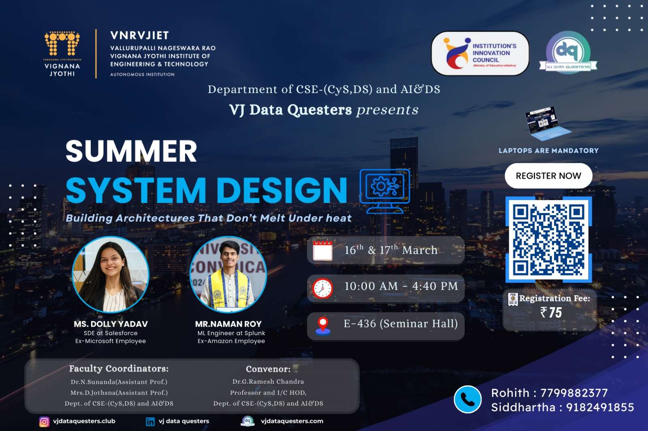  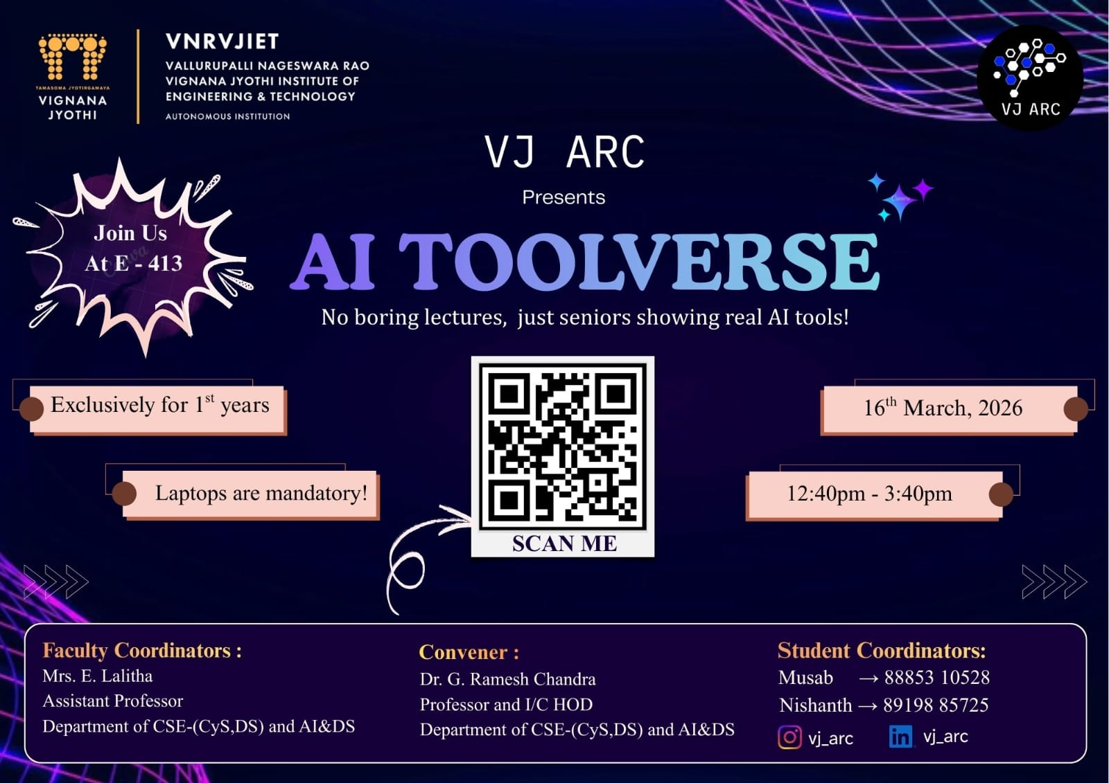  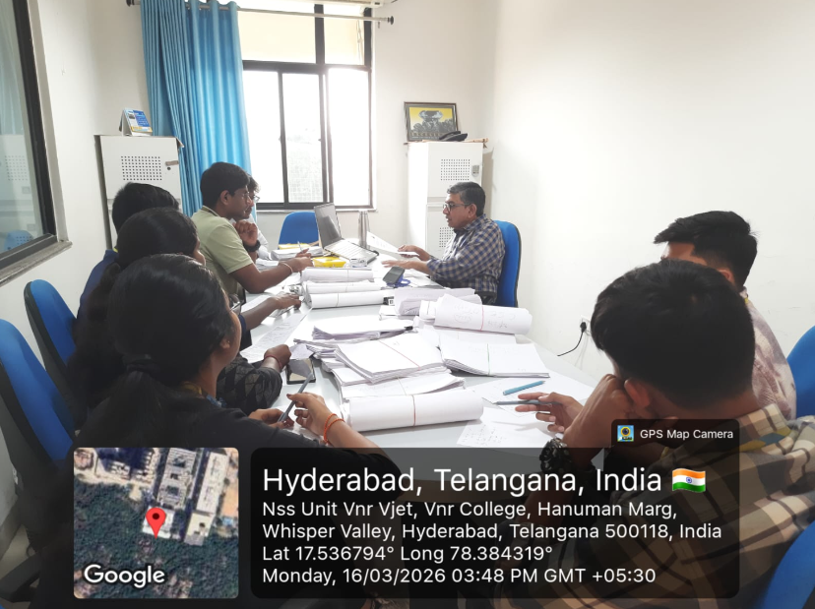  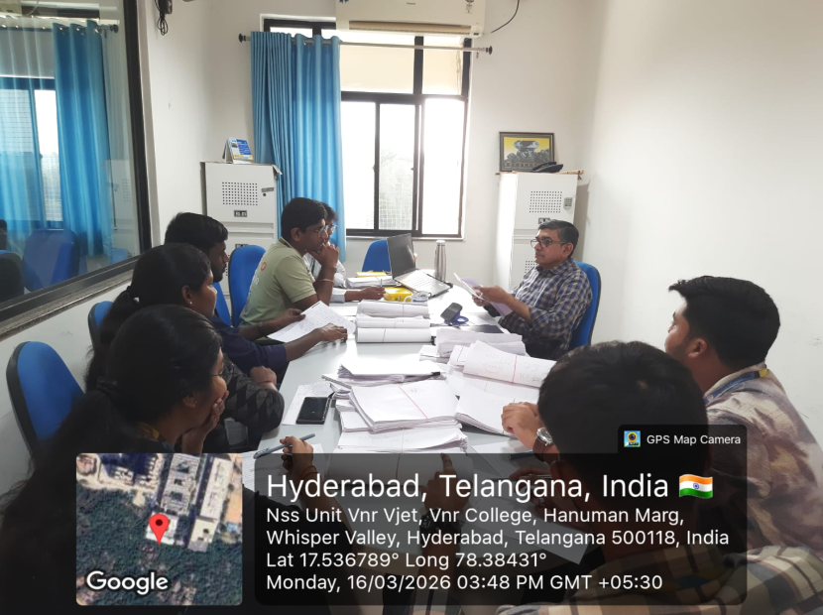  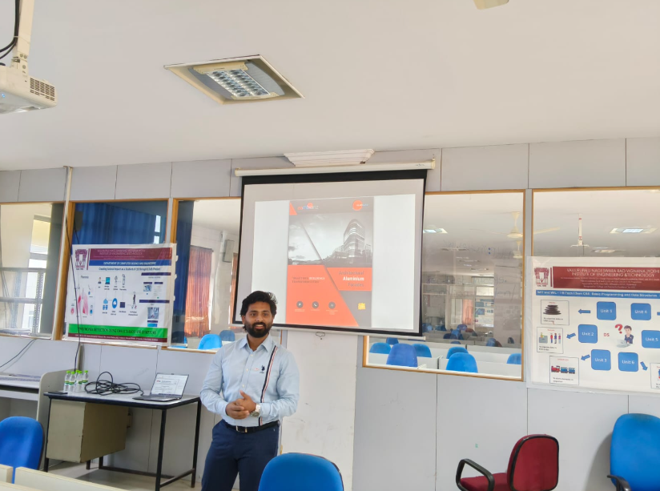  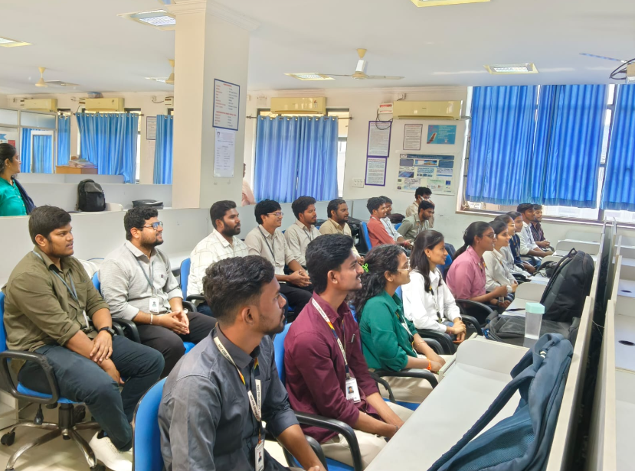  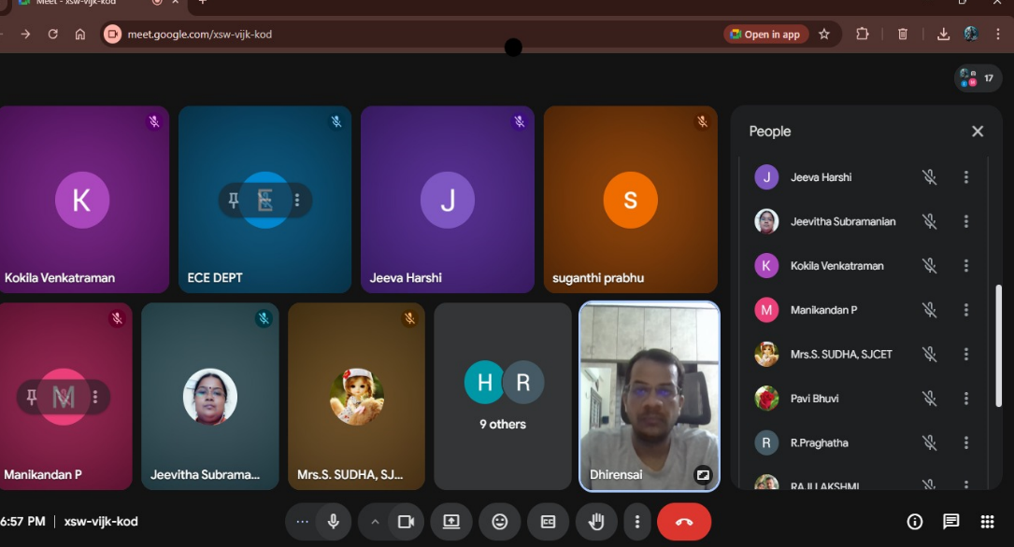
IV | HOD-M&MS:
V | HOD-AE:

VI | Particulars of Library Services and Transactions: | No.s
1 | Total No. of Books Issued or Check-out | 60
2 | Total No. of Books Returned or Check-in | 70
3 | Total No. of Students who visited the LIRC | 320
4 | Previous day’s total No. of Users between 5.00 PM to 8.00 PM (16-02-2026)
5 | Staff Visited LIRC
6 | Visitors to Digital Library
7 | Show & Tell Visitors | --
8 | C.V.P.C Visitors | --
9 | Plagiarism check conducted through Turn-Tin Anti Plagiarism Software | - Staff Papers
Dr. B.Chennakesava Rao
Principal

