VNR Vignana Jyothi Institute of Engineering & Technology
Daily Report | 16 March 2026

1. Staff Attendance Report (Department-wise)
S.No | Department | On Rolls | Absent | Present | Attendance %
1 | AE | 27 | 2 | 25 | 92.6%
2 | AIML | 63 | 5 | 58 | 92.1%
3 | CHEM | 23 | 5 | 18 | 78.3%
4 | CIVIL | 39 | 0 | 39 | 100.0%
5 | CSE | 75 | 6 | 69 | 92.0%
6 | CYS | 82 | 8 | 74 | 90.2%
7 | ECE | 67 | 3 | 64 | 95.5%
8 | EEE | 51 | 7 | 44 | 86.3%
9 | EIE | 33 | 0 | 33 | 100.0%
10 | IT | 53 | 0 | 53 | 100.0%
11 | M&MS | 27 | 2 | 25 | 92.6%
12 | ME | 49 | 4 | 45 | 91.8%
13 | MTP | 8 | 0 | 8 | 100.0%
 | TOTAL | 597 | 42 | 555 | 93.0%
Library Staff Attendance
On Rolls | Absent (w/ leave) | Absent (w/o leave) | Present
6 | — | 6 | —
2. Events / Seminars / Workshops
● Summer System Design Workshop — CYS [HIGH]
Date: 16-March-2026 Duration: 2 days Internal: 100 Resource Person: Ms. Dolly Yadav (Salesforce, ex-Microsoft), Mr. Naman Roy (Splunk, ex-Amazon)
VNRVJIET hosted a two-day Summer System Design Workshop with industry experts Ms. Dolly Yadav (Salesforce) and Mr. Naman Roy (Splunk), providing 100 student participants with intensive learning on building resilient architectures through theory and hands-on practice.
● Geotechnical Technical Symposium, GEOID 2026 — Civil [MEDIUM]
Date: 16-17 March, 2026 Duration: 2 days
The Civil Engineering department is organizing GEOID 2026, a Geotechnical Technical Symposium, to be held over two days, focusing on advancements and discussions in geotechnical engineering.
● AI Toolverse session by VJ ARC — CYS [LOW]
Date: 16-March-2026
VJ ARC organized an AI Toolverse session where senior students demonstrated practical AI tools and their real-world applications, offering insights into improving productivity and project development.
Photos from Department Activities
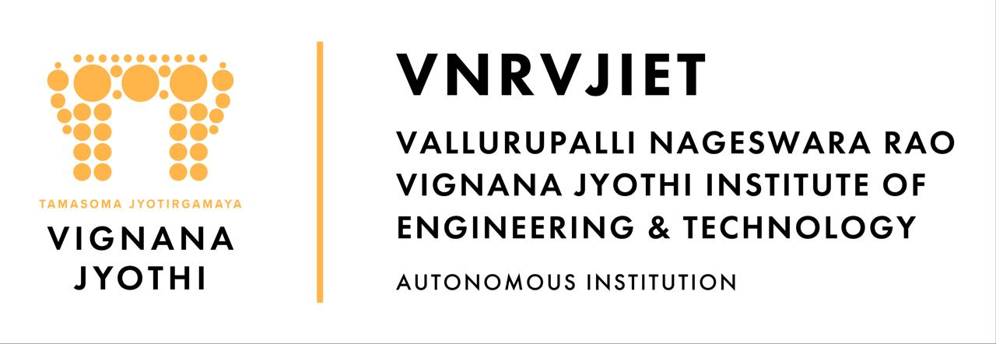
— AE Department —

— AIML Department —

— CHEM Department —

— CIVIL Department —

— CIVIL Department —

— CSE Department —
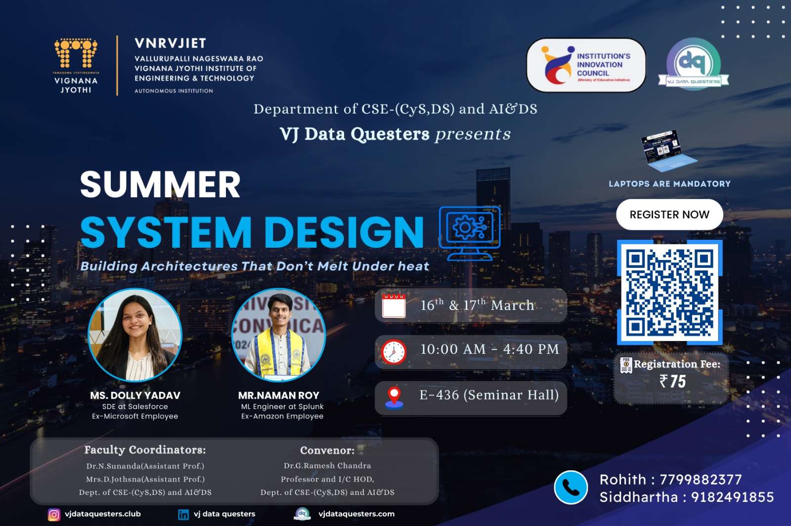
— CYS Department —
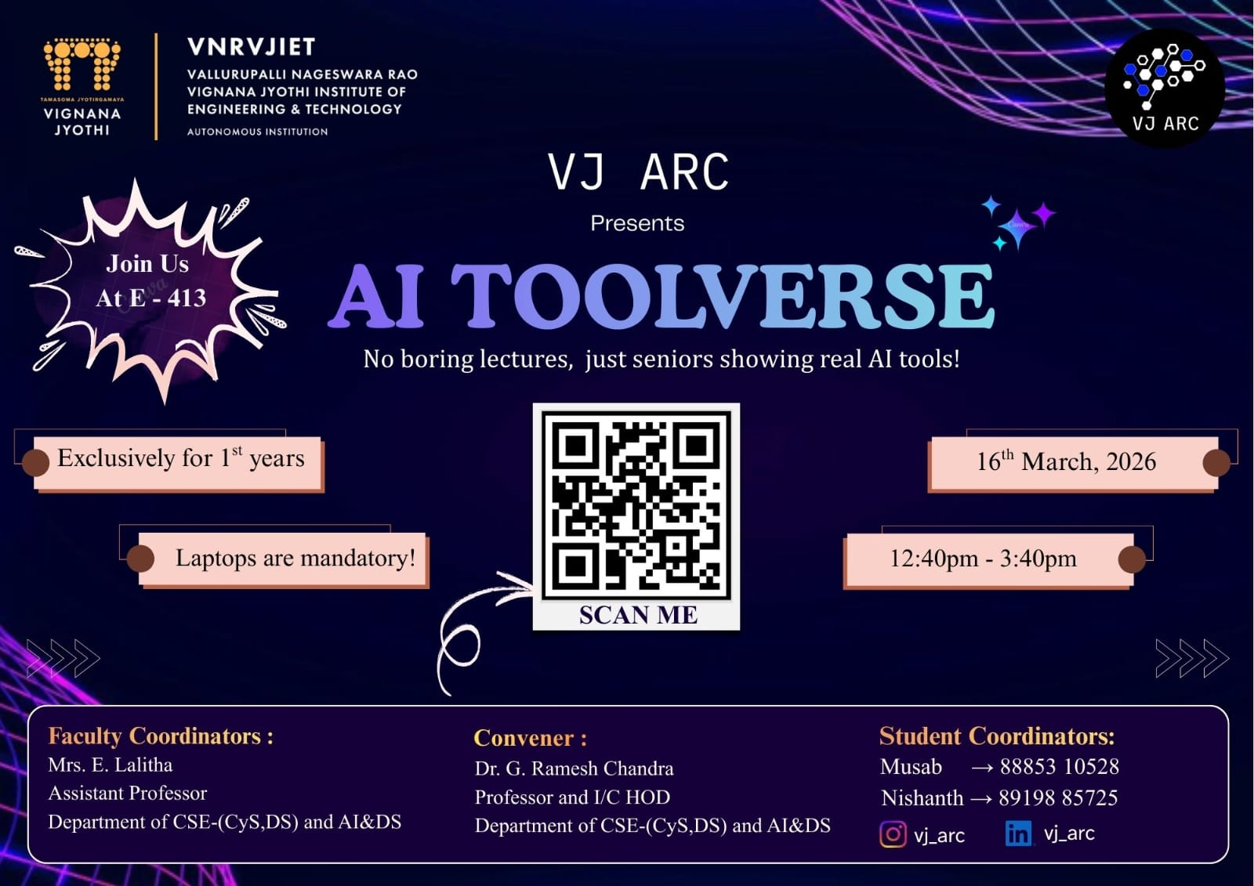
— CYS Department —

— ECE Department —

— ECE Department —

— EEE Department —

— EEE Department —
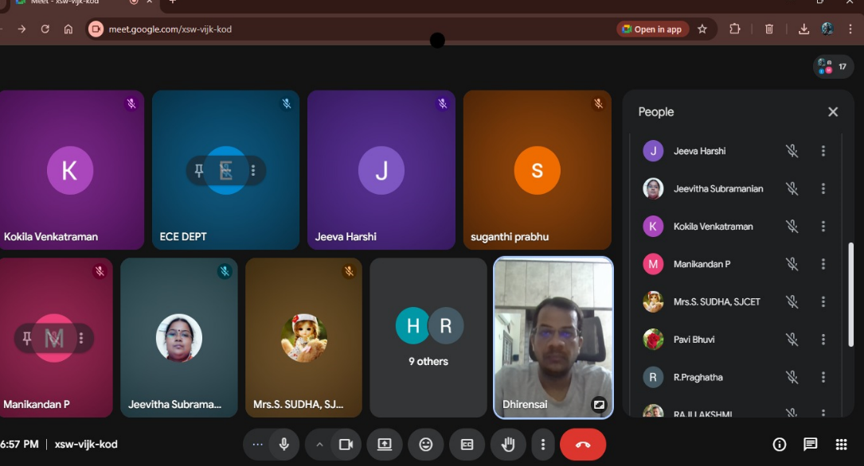
— EIE Department —
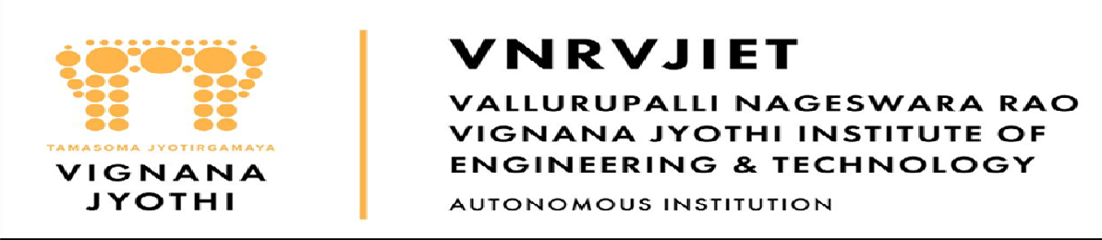
— EIE Department —

— IT Department —

— IT Department —

— M&MS Department —

— M&MS Department —

— ME Department —

— ME Department —
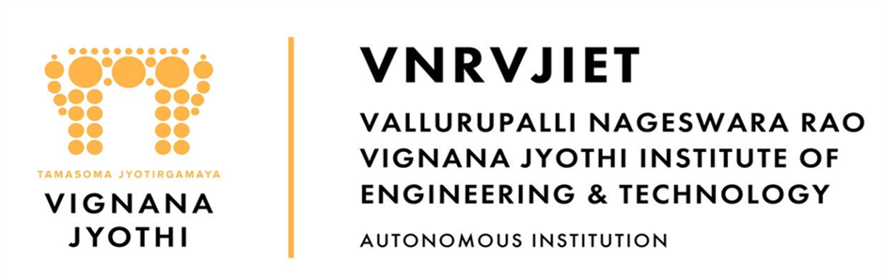
— MTP Department —
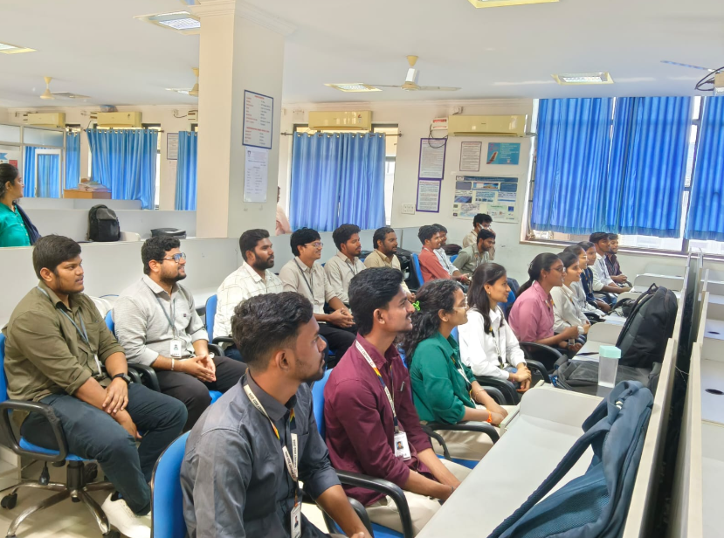
— MTP Department —
3. Participation by Staff & Students (External)
Staff Participation
● Mr. K. Sreenivasa Rao — AIML, Participated, at "One Day Faculty Development Programme on “Research paper writing and Publishing”", (Feb 28, 2026)
Mr. K. Sreenivasa Rao participated in a one-day FDP on research paper writing and publishing, organized by Government Degree College, TUNI, to enhance his academic skills.
● Dr. V. Nageshwar — EIE, Lecturer, at "5-day Faculty Development Program on Recent Trends in Robotics, AI, IoT and Industrial Automation", (14-03-2026)
Dr. V. Nageshwar delivered a lecture on "IoT and Its Application" at an external 5-day FDP, contributing expertise to a broader academic audience.
● Dr. N. Mangathayaru — IT, Attended, at "Outcome-Based Education for Effective Teaching and Assessment", (16th March)
Dr. N. Mangathayaru attended a seminar on Outcome-Based Education for Effective Teaching and Assessment, led by Dr. S. Viswanadha Raju from JNTU Sultanpur.
● S. Anoosha — IT, Attended, at "Outcome-Based Education for Effective Teaching and Assessment", (16th March)
S. Anoosha attended a seminar on Outcome-Based Education for Effective Teaching and Assessment, led by Dr. S. Viswanadha Raju from JNTU Sultanpur.
● Donthamsetti Veera Bhadra Rao — IT, Attended, at "Outcome-Based Education for Effective Teaching and Assessment", (16th March)
Donthamsetti Veera Bhadra Rao attended a seminar on Outcome-Based Education for Effective Teaching and Assessment, led by Dr. S. Viswanadha Raju from JNTU Sultanpur.
● Anuraghavi — IT, Attended, at "Outcome-Based Education for Effective Teaching and Assessment", (16th March)
Anuraghavi attended a seminar on Outcome-Based Education for Effective Teaching and Assessment, led by Dr. S. Viswanadha Raju from JNTU Sultanpur.
● A. Soujanya — IT, Attended, at "Outcome-Based Education for Effective Teaching and Assessment", (16th March)
A. Soujanya attended a seminar on Outcome-Based Education for Effective Teaching and Assessment, led by Dr. S. Viswanadha Raju from JNTU Sultanpur.
4. Classwork Adjustments / Lecture Interchange
S.No | Department | Number of Adjustments
1 | AE | 3
2 | CYS | 5
5. Library Services & Transactions
Library Transactions
Particulars | Count
Books Issued (Check Out) | 60
Books Returned (Check In) | 70
Today's Visitors to LIRC | 320
Evening Users (5 PM – 8 PM) | 16
Digital Library Visitors | 25
6. Any Other Matters
CHEMISTRY: Dr. M. Brahmayya had a paper titled “Nano-Sulfonated Graphene Oxide: A Metal-Free Catalyst for the Synthesis of Benzimidazoles and Antimicrobial Activities” accepted in the Scopus Journal, Journal of Environmental Nano Technology.
ECE: Dr. Y. Srinivasa Rao, R&D Director, conducted a meeting with the faculty members of the ECE Department on 16-03-2026.
IT: Dr. G. Madhu, Professor, submitted a project proposal (ID IIRPSG(AN)-F-2026-01-00595) titled "Development of AI-Enabled Acoustic Digital Biomarkers for Non-Invasive Monitoring of Dialysis Ade

Consolidated by AI | VNRVJIET Principal's Office

