

Day Report

I. Details of Scholarships:
Description | Total to be received | Received till Date | Received Date | To be received
Outstanding fees due  from the State Govt. | 2590189300 | 1354467700 | Till Date | 1235721600

Pending RTF Amount Year-wise Statement of 2014-15 to 2024-2025 A.Y as on 30.01.2026
S.No. | Academic Year | No. of Students | Total Tuition Fee in Rs. | Released No. of Students | Released Amount in Rs. | Pending No. of Students | Pending Amount in Rs.
1 | 2014-15 | 2578 | 111477600 | 2578 | 111535500 | 0 | -57900
2 | 2015-16 | 2971 | 145407000 | 2970 | 145497700 | 1 | -90700
3 | 2016-17 | 3060 | 164171600 | 3054 | 161864900 | 6 | 2306700
4 | 2017-18 | 3197 | 184686700 | 3196 | 180969300 | 1 | 3717400
5 | 2018-19 | 3372 | 206744500 | 3366 | 199886900 | 6 | 6857600
6 | 2019-20 | 3383 | 219041000 | 3366 | 216759600 | 17 | 2281400
7 | 2020-21 | 3197 | 249738500 | 2874 | 162593600 | 323 | 87144900
8 | 2021-22 | 3120 | 287671900 | 1025 | 97685200 | 2095 | 189986700
9 | 2022-23 | 3115 | 337126000 | 329 | 42755000 | 2786 | 294371000
10 | 2023-24 | 3308 | 363555500 | 720 | 34920000 | 2588 | 328635500
11 | 2024-25 | 3614 | 320569000 | 0 | 0 | 3614 | 320569000
 | Total | 34915 | 2590189300 | 23478 | 1354467700 | 11437 | 1235721600

Bank Credit Amount is 10995000/- Date 30.01.2026

II | Staff & Student Attendance Report : Attached.  Consolidated Absent Faculty:  - Dr. A. Ramesh (Unknown) — Faculty – On Duty  - . (Unknown) — Full Day  - Name of the Faculty (Unknown) — Faculty – Half Pay Leave  - Name of the Faculty (Unknown) — Faculty - Study Leave  - Dr. Poonam Shekhawat (Unknown) — Name of the Faculty (ML/PL)  - . (Unknown) — b. Half Day  - Dr. Talluri Sunil Kumar(01-03-26 to 30-06-26) (CSE) — a.Full Day  - Dr. Bommisetty Durga Venkata Chandra Mohan Rao (CSE) — a.Full Day  - Reddy(FN) (CSE) — a.Full Day  - Mr.Velpula Vinay Kumar (CSE) — a.Full Day  - Dr. Kriti Ohri(10-03-26 to 20-03-26) (CSE) — a.Full Day  - Mrs.V.Susmitha(04-03-2026 to 05-04-26) (CSE) — a.Full Day  - Ms. Nam Vasundhara (CSE) — a.Full Day  - Nidamanuri Sudheer(FN) (CSE) — b. Half Day  - Faculty – Half Pay Leave (CSE) — b. Half Day  - Mrs. Dr.T. Preethi (CSE) — 1 Faculty - Study Leave  - Ms.Issac Neha Margaret (CSE) — 1 Faculty - Study Leave  - Mr.K.Sai Bhargav (CSE) — 1 Faculty - Study Leave  - a.Full (CSE) — Staff- Casual / Earn Leave  - Karri Vandana (CSE) — Staff- Casual / Earn Leave  - Gunreddy Laxma Reddy (CSE) — Staff- Casual / Earn Leave  - Mrs. A. Shobha (CSE) — 1 Staff – Maternity/Paternity Leave  - Dr Thayyaba Khatoon(Industry Fellowship) (CSE) — Faculty – On Duty  - Dr. Allam Venkata Siva Swetha (ML) (CSE) — Full Day Faculty– Casual / Earn Leave  - Dr C Kiran Mai(CL) (CSE) — Full Day Faculty– Casual / Earn Leave  - Dr B V Kiranmayee(CL) (CSE) — Full Day Faculty– Casual / Earn Leave  - Ms.A.Sandhya Rani(EL) (CSE) — Full Day Faculty– Casual / Earn Leave  - S Alankritha (CSE) — Faculty - Study Leave  - B Suneetha(CL) (CSE) — Full Day  - G Ram Reddy(CL) (CSE) — Full Day  - Ms. K. Anitha, Asst. Prof (CSE) — Full Day  - Ms. Preety Singh, Asst. Prof (CSE) — Full Day  - Mr. U. Veeresh, Asst. Prof (CSE) — Full Day  - Ms. V. Hemadevi, Asst. Prof (CSE) — Faculty – Maternity Leave (01)  - Ms. H. Sulekha, C.O (CSE) — Staff –Study Leave (01)  - Mr. M. Venkata Ramarao (CL) (AE) — a. Full Day  - Mr. Vinay Kulkarni (CL) (AE) — a. Full Day  - Name of the Faculty (AE) — Faculty – Half Pay Leave  - Name of the Faculty (AE) — Faculty - Study Leave  - Break in Service (AE) — Leave Without Pay  - Dr. Padmavathi P (Unknown) — 1 Faculty – On Duty  - Mrs. S. Prathyusha (PhD Defense) (Unknown) — a. Full Day  - NIL (Unknown) — Staff– Half Pay Leave  - Dr A. Gangadhara (Unknown) — Staff -Study Leave  - Dr P. Suresh (Unknown) — Staff -Study Leave  - Nil (Unknown) — Staff - Maternity Leave  - Nil (Unknown) — Staff– On Duty  - Nil (Unknown) — a. Full Day  - Nil (Unknown) — b. Half Day  - Mr. J. Sambasiva Rao (Unknown) — Staff– Half Pay Leave  - Nil (Unknown) — Staff -Study Leave  - Nil (Unknown) — Staff - Maternity Leave  - Dr.V.Priyanka (ECE) — a.03:Full Day  - Dr.K.B.Archana (ECE) — a.03:Full Day  - Dr.Sk.Shoukath Vali (ECE) — a.03:Full Day  - Dr.G.Kiran Kumar (ECE) — b. 01: Half Day  - G.Ramya (ECE) — 01: Faculty - Maternity Leave  - Faculty – Casual / Earn (Unknown) — Faculty – On Duty  - Dr.K.Anuradha (EL) (Unknown) — Full Day  - G.C.Prabhakar (ML) (Unknown) — Full Day  - I.Neelima (CL) (Unknown) — Full Day  - Dr.R.Geshma Kumari (CL) (Unknown) — Half Day  - Faculty – Half Pay Leave (Unknown) — Half Day  - Faculty - Study Leave (Unknown) — Half Day  - Name of the Faculty (ML/PL) (Unknown) — 0 Faculty - Maternity/Paternity Leave  - V.Malleswari (CL) (Unknown) — a.Full Day  - B.Sivaji (CL) (Unknown) — a.Full Day  - A.Geetha (CL) (Unknown) — a.Full Day  - P.H.Sham Rao (CL) (Unknown) — a.Full Day  - Mr. P.V. Gopi Kumar (Unknown) — Faculty – On Duty  - Mr. S.Bhargav (Unknown) — Faculty – On Duty  - Dr. N. Pothanna (M&MS) — Full Days  - Dr. G. Naga Malleswari (M&MS) — Full Days  - Dr. N. Aruna Kumari (M&MS) — 1 Faculty - Medical Leave  - 1Dr G Sireesha (M&MS) — 1 Faculty - Study Leave  - Dr. Bollu Satyanarayana – CL (Unknown) — Full Day  - Dr. Kaviti Ajay Kumar - CL (Unknown) — Full Day  - Putha Prasad Kumar – CL (Unknown) — Full Day  - Lagadapati Kamalakara Rao -EL (Unknown) — Full Day  Missing Reports From:  - IQAC Data Not Received
III | MTP:  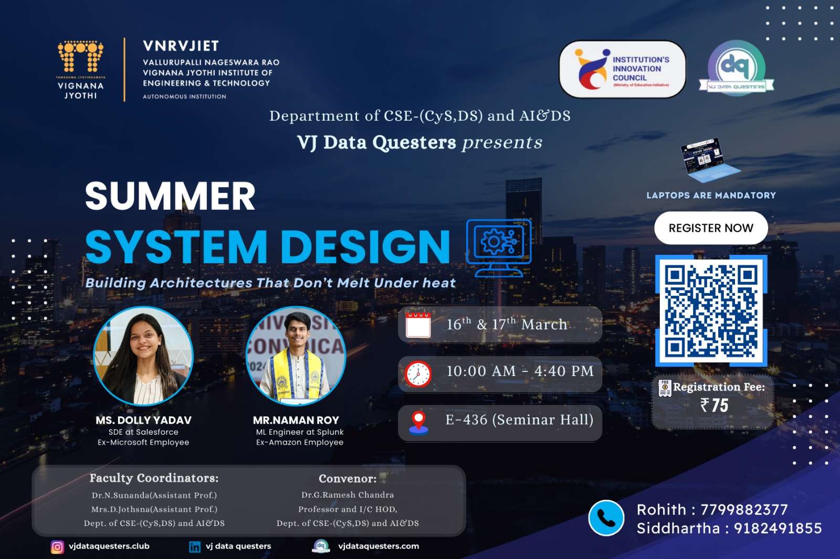  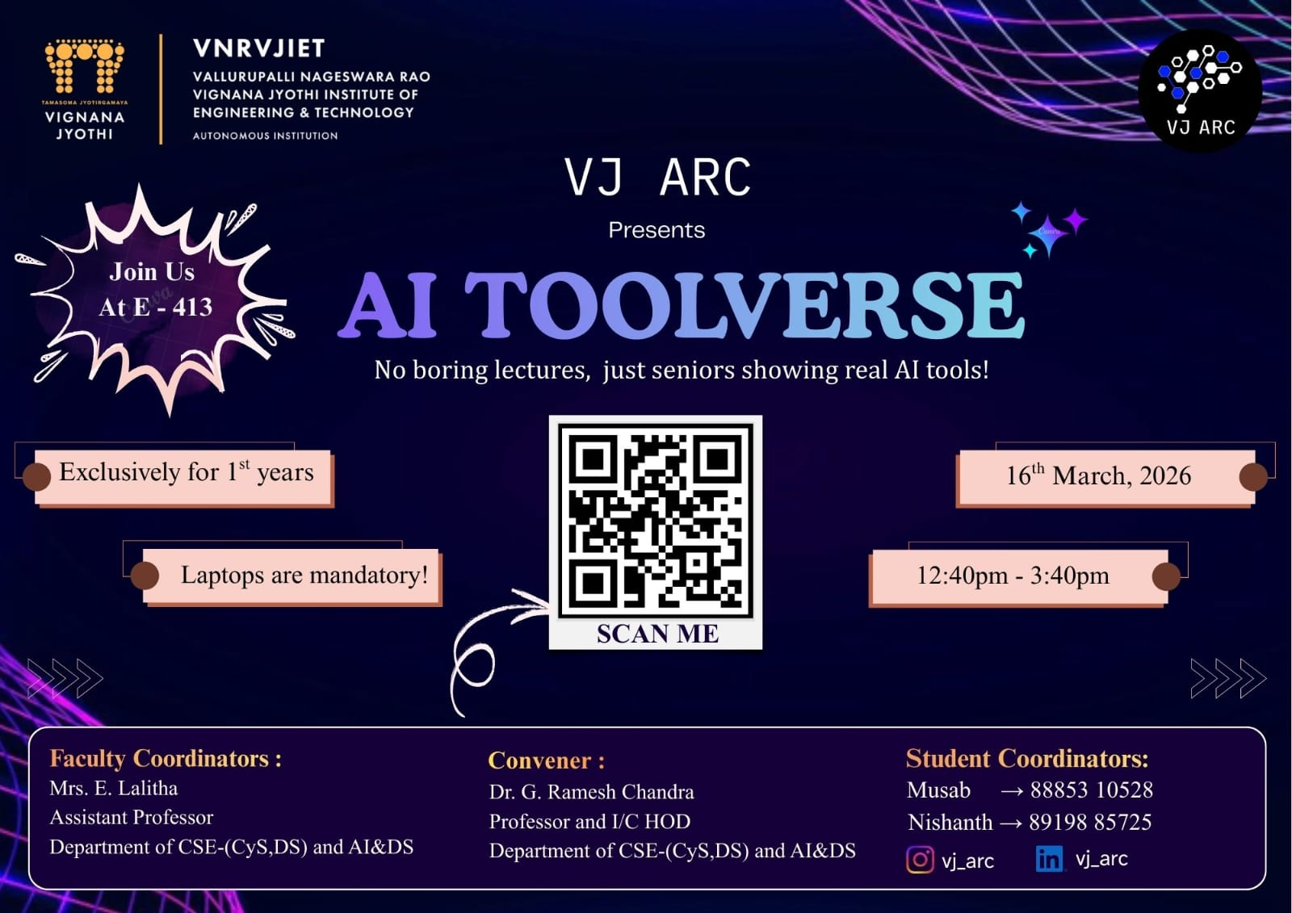          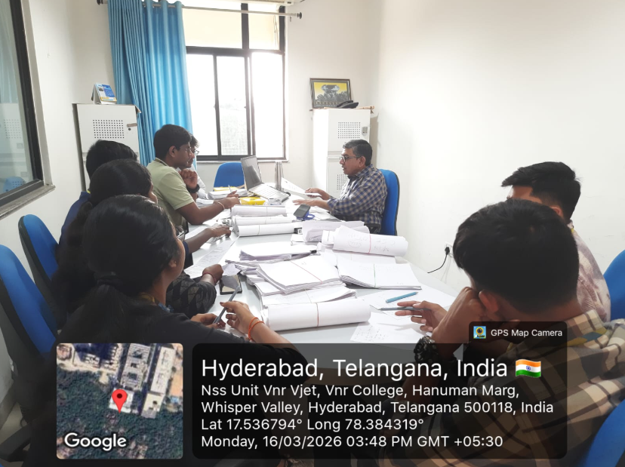  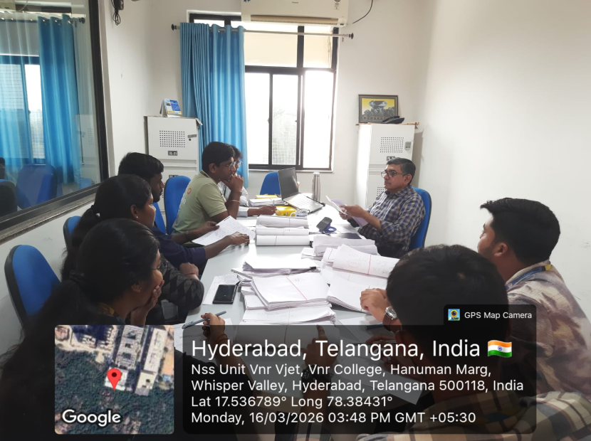  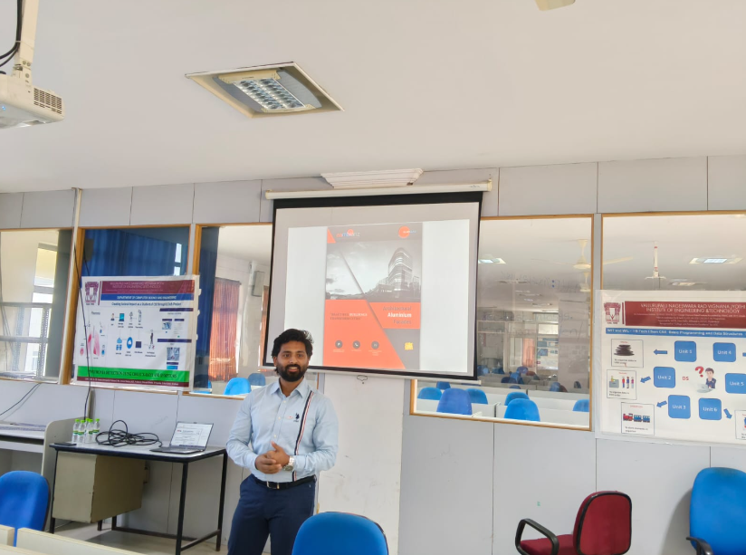  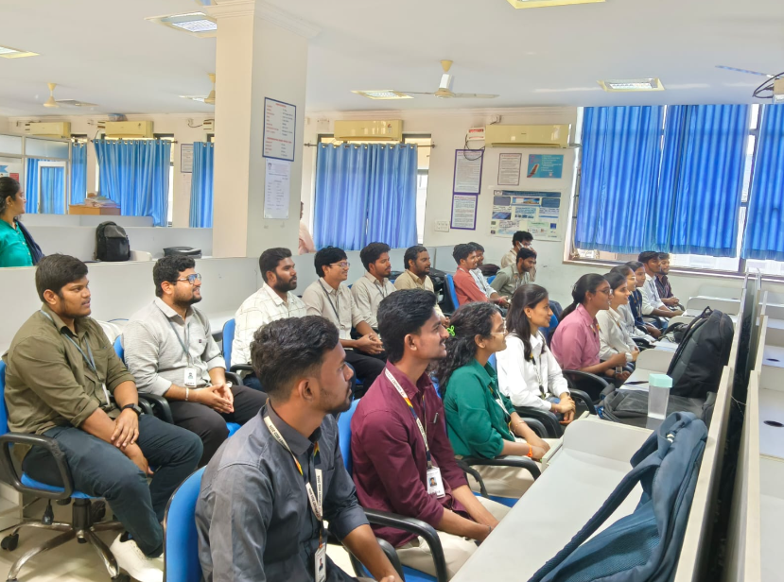        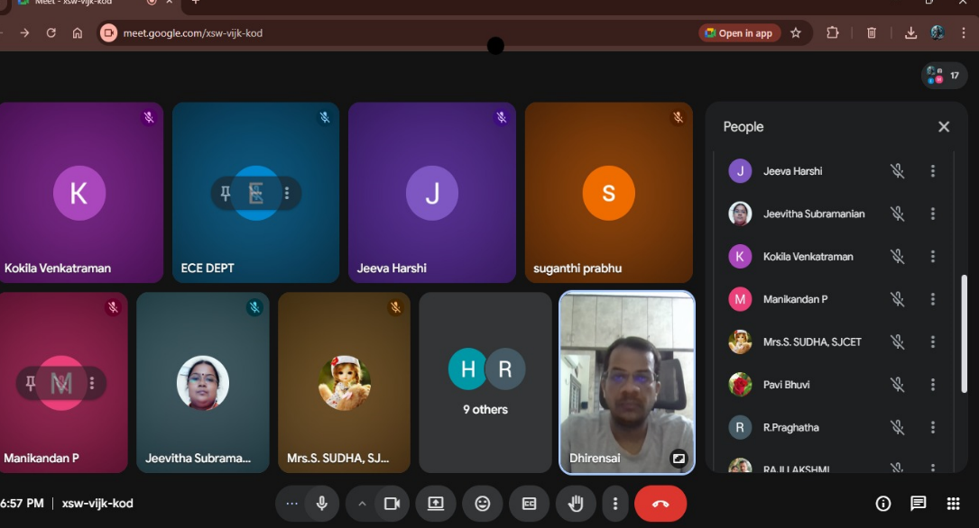    
IV | HOD-M&MS:  Any other matter to be reported:  HOD  Mathematics and Management Sciences
V | HOD-AE:  Any other matter to be reported:  HOD – AE
HOD-Unknown:
Any other matter to be reported:
HOD–EIE
HOD-CSE:
Any other matter to be reported:
HOD
CSE – (AIML & IoT), R&AI
HOD-ECE:
Any other matter to be reported:
A meeting with the faculty members of the ECE Department was conducted by
Dr. Y. Srinivasa Rao, R&D Director, on 16-03-2026.
HOD-IT:
Any other matter to be reported:
Dr.G.Madhu,Professor submitted project proposal bearing Project ID IIRPSG(AN)-F-2026-01-00595 and titled Development of AI-Enabled Acoustic Digital Biomarkers for Non-Invasive Monitoring of Dialysis Adequacy in Patients with End-Stage Renal Disease has been submitted on dated 15-Mar-2026 18:17:11 PM to the Indian Council of Medical Research (ICMR) With collaboration of iiit and VNR
HOD – IT

VI | Particulars of Library Services and Transactions: | No.s
1 | Total No. of Books Issued or Check-out | 60
2 | Total No. of Books Returned or Check-in | 70
3 | Total No. of Students who visited the LIRC | 320
4 | Previous day’s total No. of Users between 5.00 PM to 8.00 PM (16-02-2026)
5 | Staff Visited LIRC
6 | Visitors to Digital Library
7 | Show & Tell Visitors | --
8 | C.V.P.C Visitors | --
9 | Plagiarism check conducted through Turn-Tin Anti Plagiarism Software | - Staff Papers
Dr. B.Chennakesava Rao
Principal

