About the data :-
Here we simulate an example that consists of two 2-dimensional
Gaussian classes each with a unit covariance matrix and different means. The mean of the first class is μ1 =(1, 1) and the second class has μ2 = (3, 3). The distributions of these two classes are shown in Fig. 2.2

Classification of the data :-
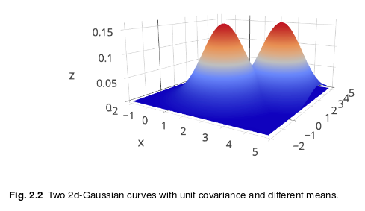
So the gausian distribution of the data is as follows. Here we are trying to classify the data into the two classes. For this we try to insert a hyper plane into the centre intersection of the 2 curves :-

Graphical description about the classification of the data :-
Here we pictorially describe the situation in which we bisect the two distributions with a hyperplane. So that we get the intersection of the two curves and we can easily subtract the intersection of the two datasets.

For this in the graph we integrate from the mean of the first graph to the intersection of the two distributions.

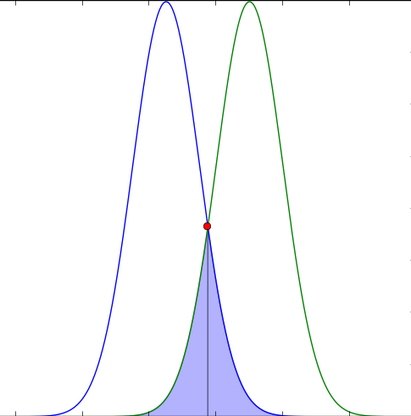

Mean of the first class :- μ1 =(1, 1)
Mean of the second class :- μ2 = (3, 3)

So here we will integrate the gausian curve from the mean of one of the class to the 1 dimensional intersection point of the two curves. Which is equivalent to integrating the gausian curve from (1,1) to (2,2) i.e. The integrated area we need to subtract from each of the curves so that we get the two classified curve areas.

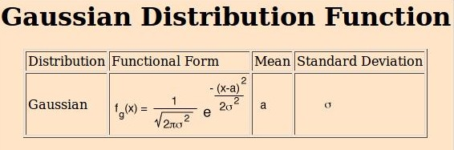

So now we integrate the area of the two curves. The code snippet is below :-

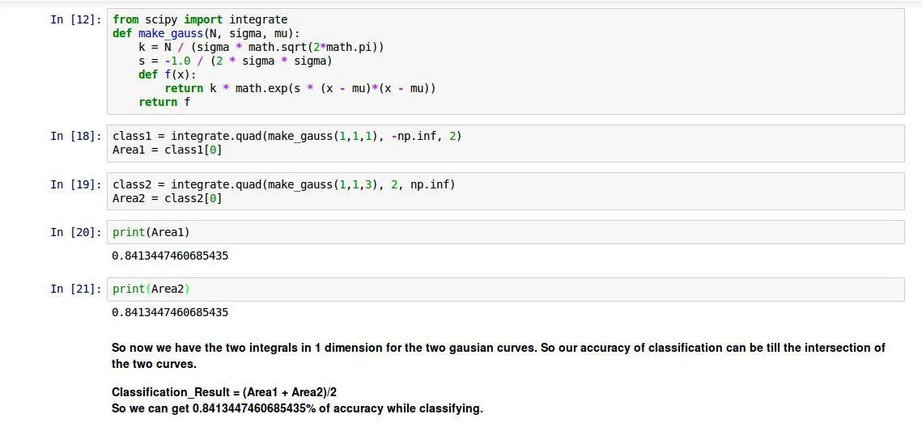

So we can classify the results upto 84% accuracy.

