**1.** **Write a program to design semantic and non - semantic tags with web page form layout to get this desired output ?**

**Expected output:**

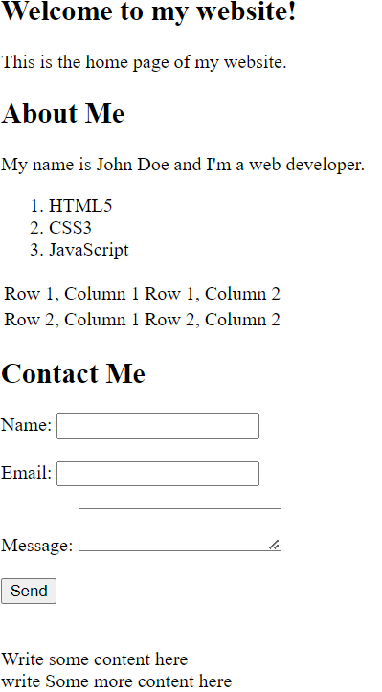

**2.Write a program to display the text formatting tags and meta tags in HTML as given below?**

**Expected output:**

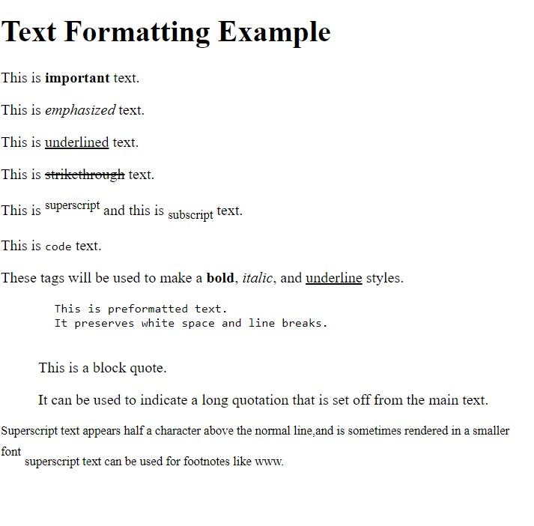

**3.Write a program to show all form input controls in HTML5 as given below ?**

**Expected output:**

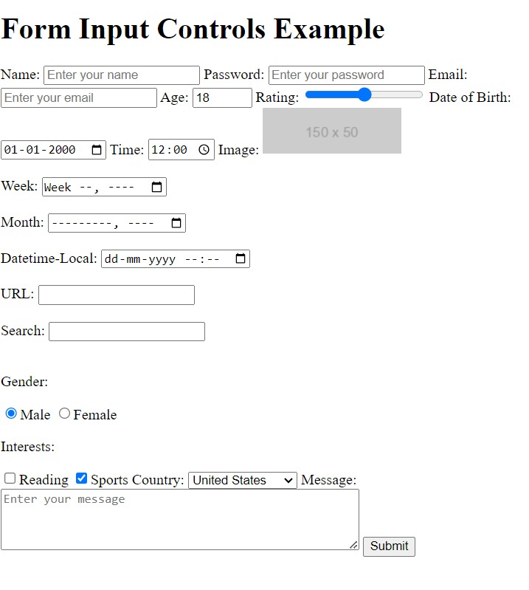

**4.Write a program to load multimedia content into a webpage like given below?**

**Expected output:** 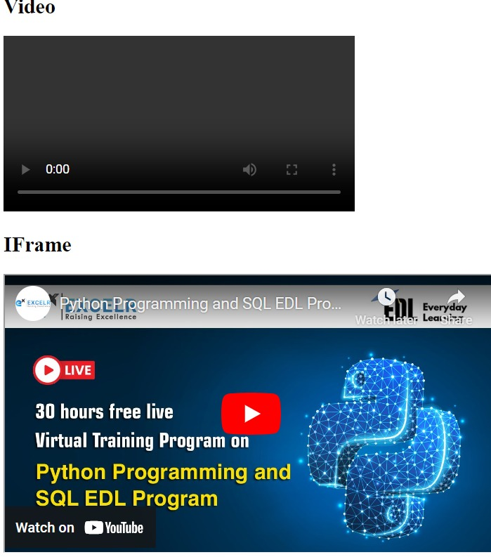



**5.Write a program to create ‘SVG’ inline and external like given below?**

**Expected output:**

