1. **Write a program to demonstrate JavaScript loops, operators and conditions?**

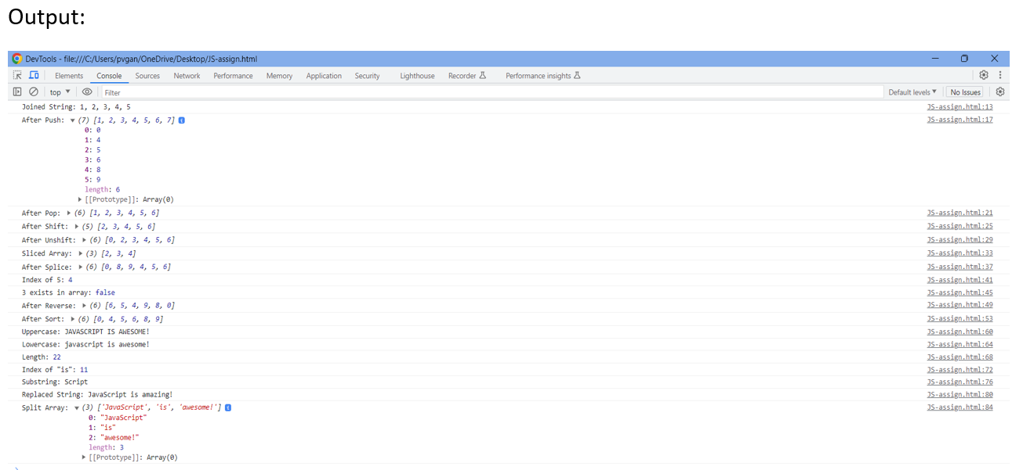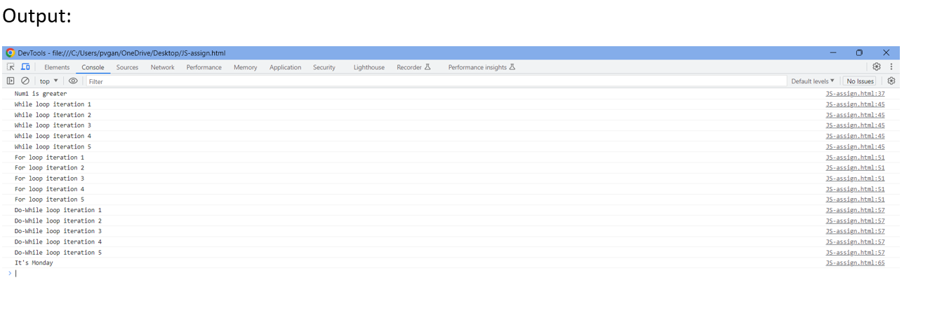 **2. Write a program to demonstrate different array and string methods in JavaScript?**

**3. Write a program to show different ways to create a function in JavaScript?**

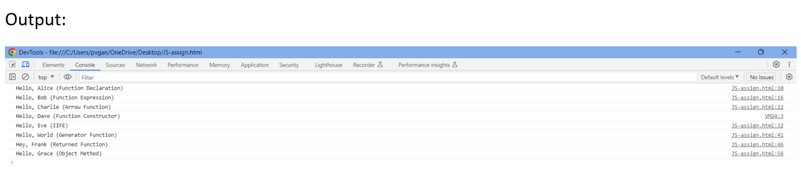

**4. Write a program to implement pomodoro using JavaScript DOM?**

Output:

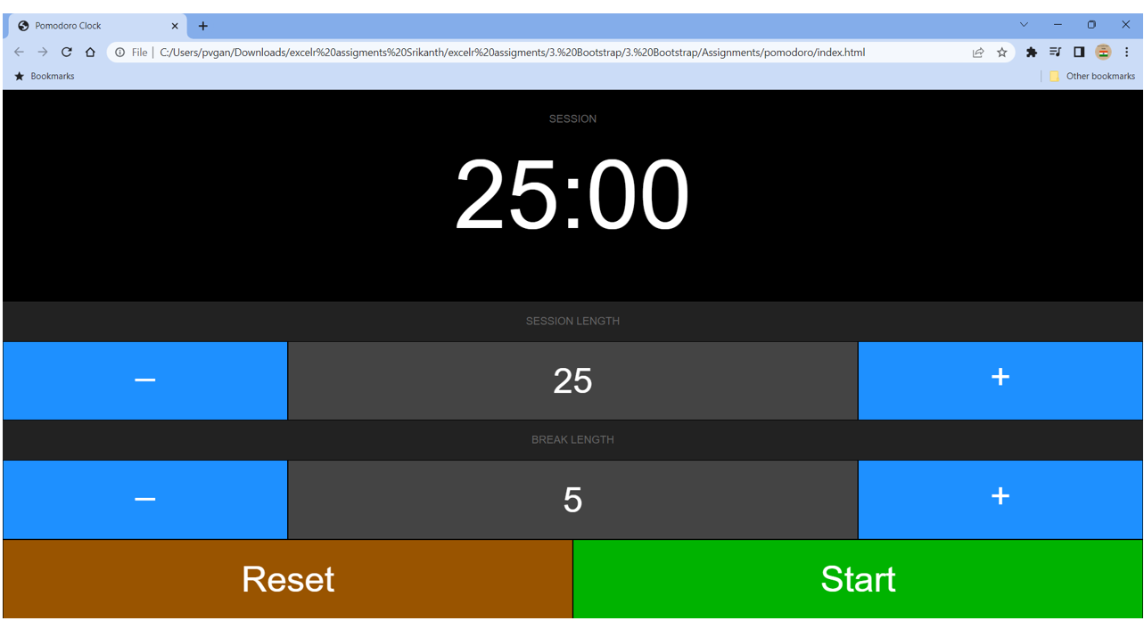

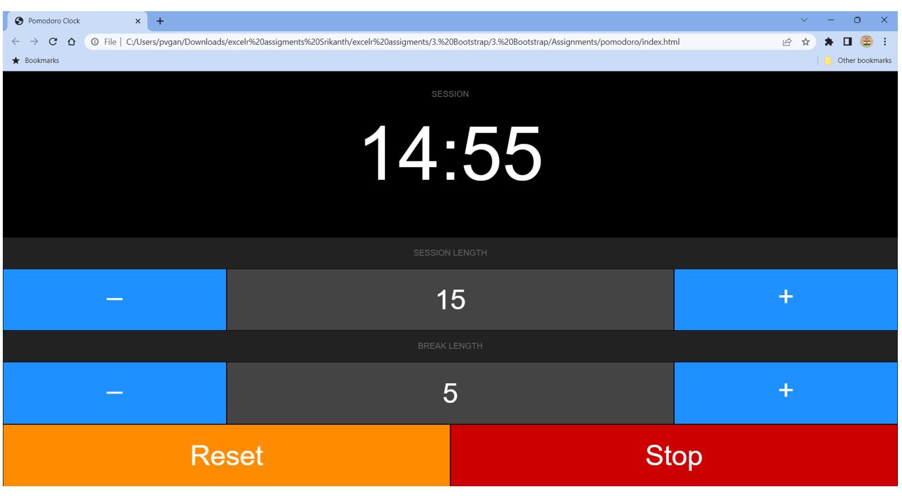

**5. Write a program to implement swap 1 to 9 numbers using drag and drop?**

Output:

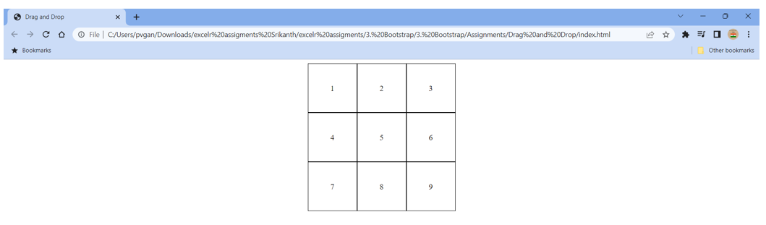

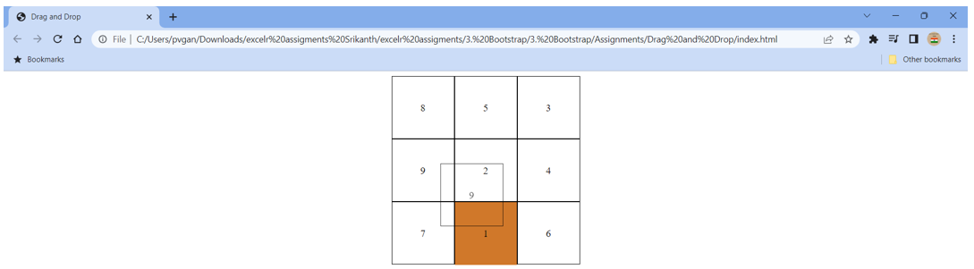

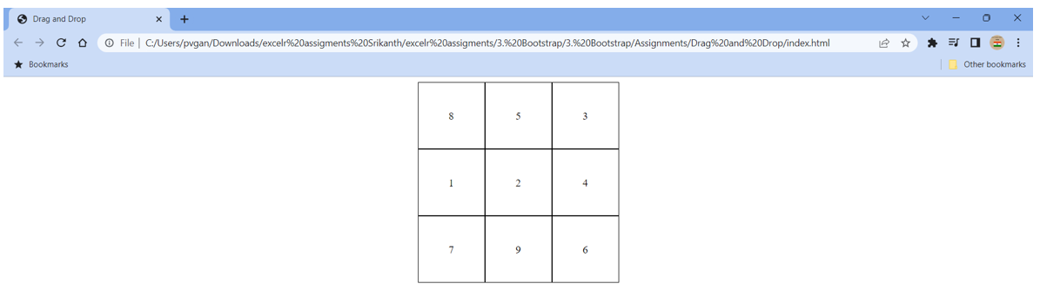

**6. Demonstrate all ES6 concepts with examples.**