CSS ASSIGNMENT QUESTIONS
1.Write a program to style content using different CSS selectors to generate this output?

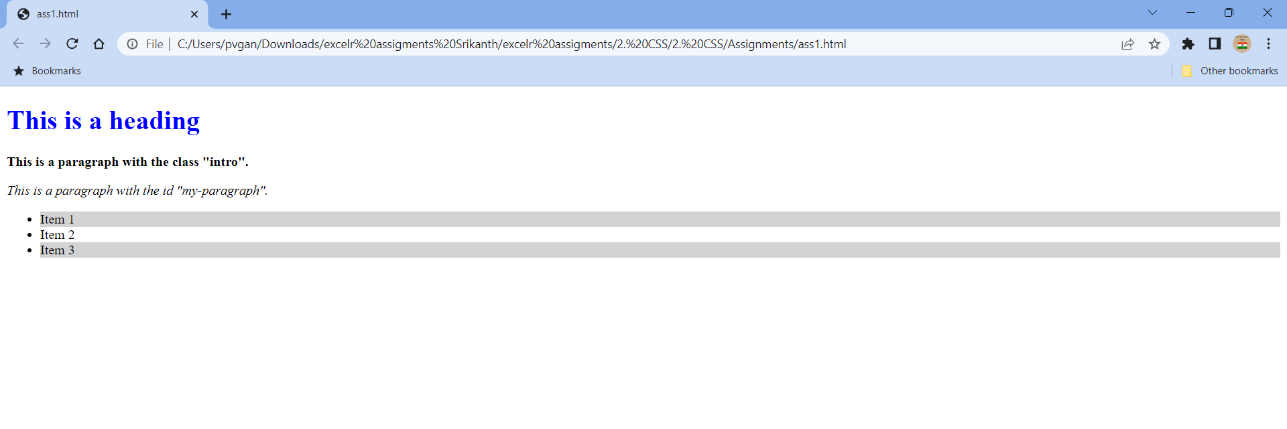

2.Write a program to show different background properties and display course information using different font properties in css to generate this output?

 pattern.png  image.jpg
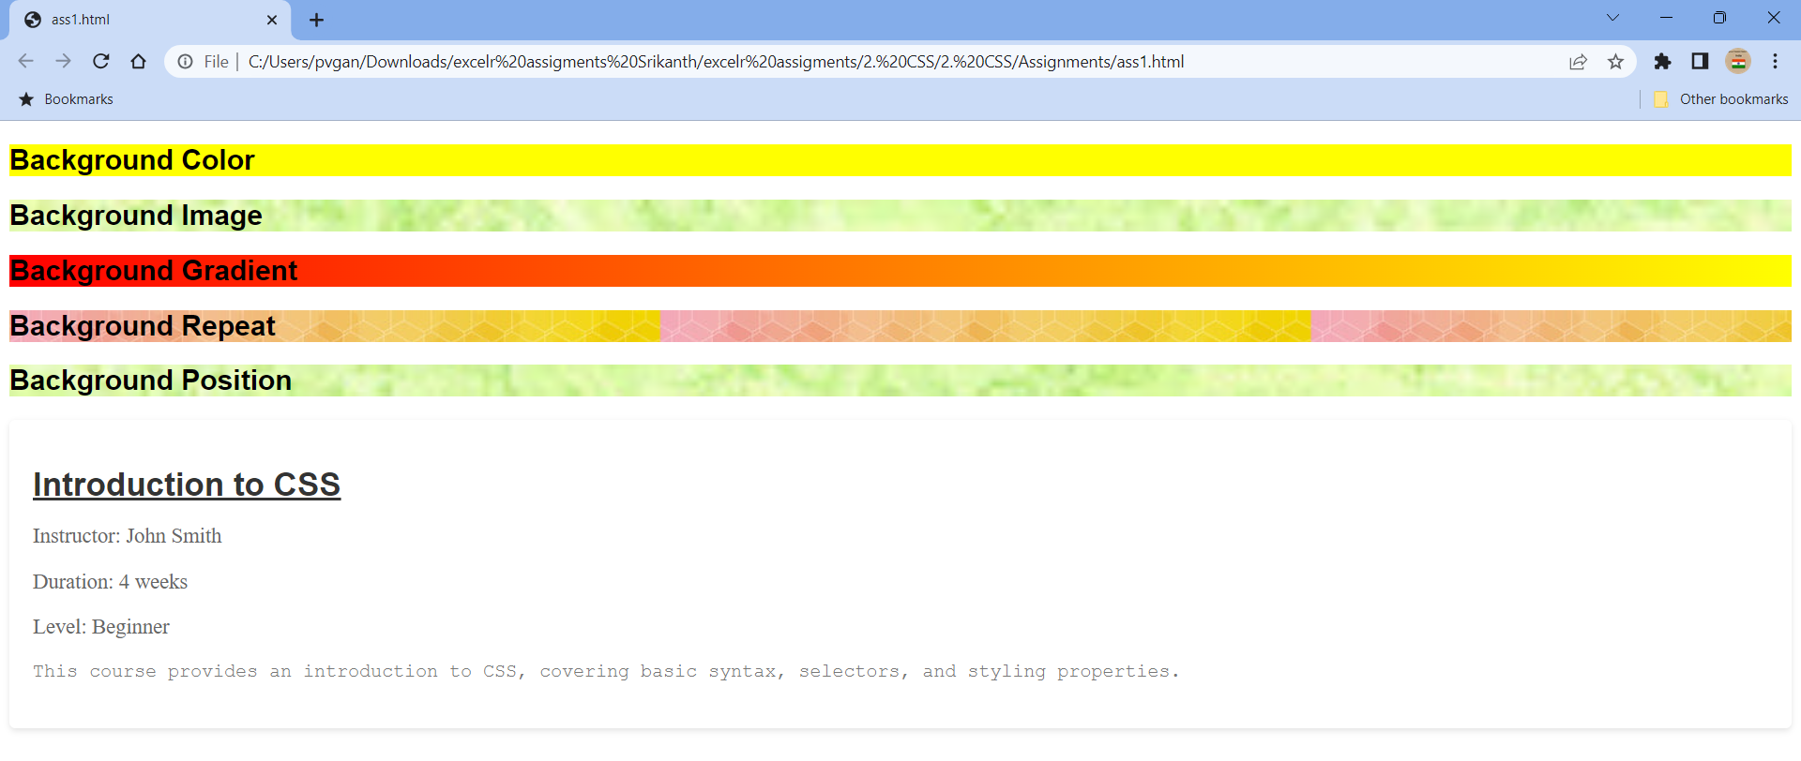

3.Write a program to display courses in a tile using flexbox to generate this output ?

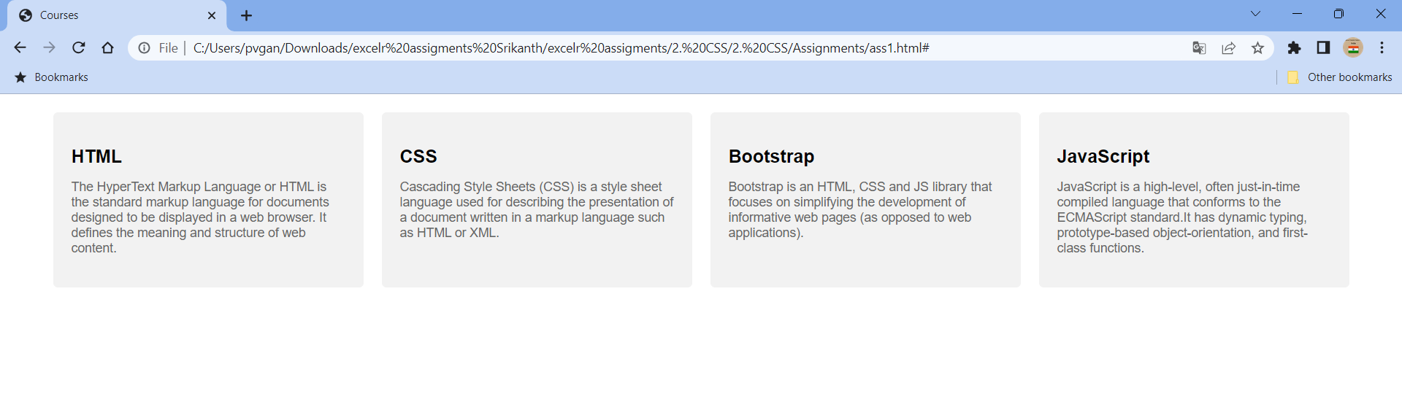

4.Write a program to design standard web layout using GRID?

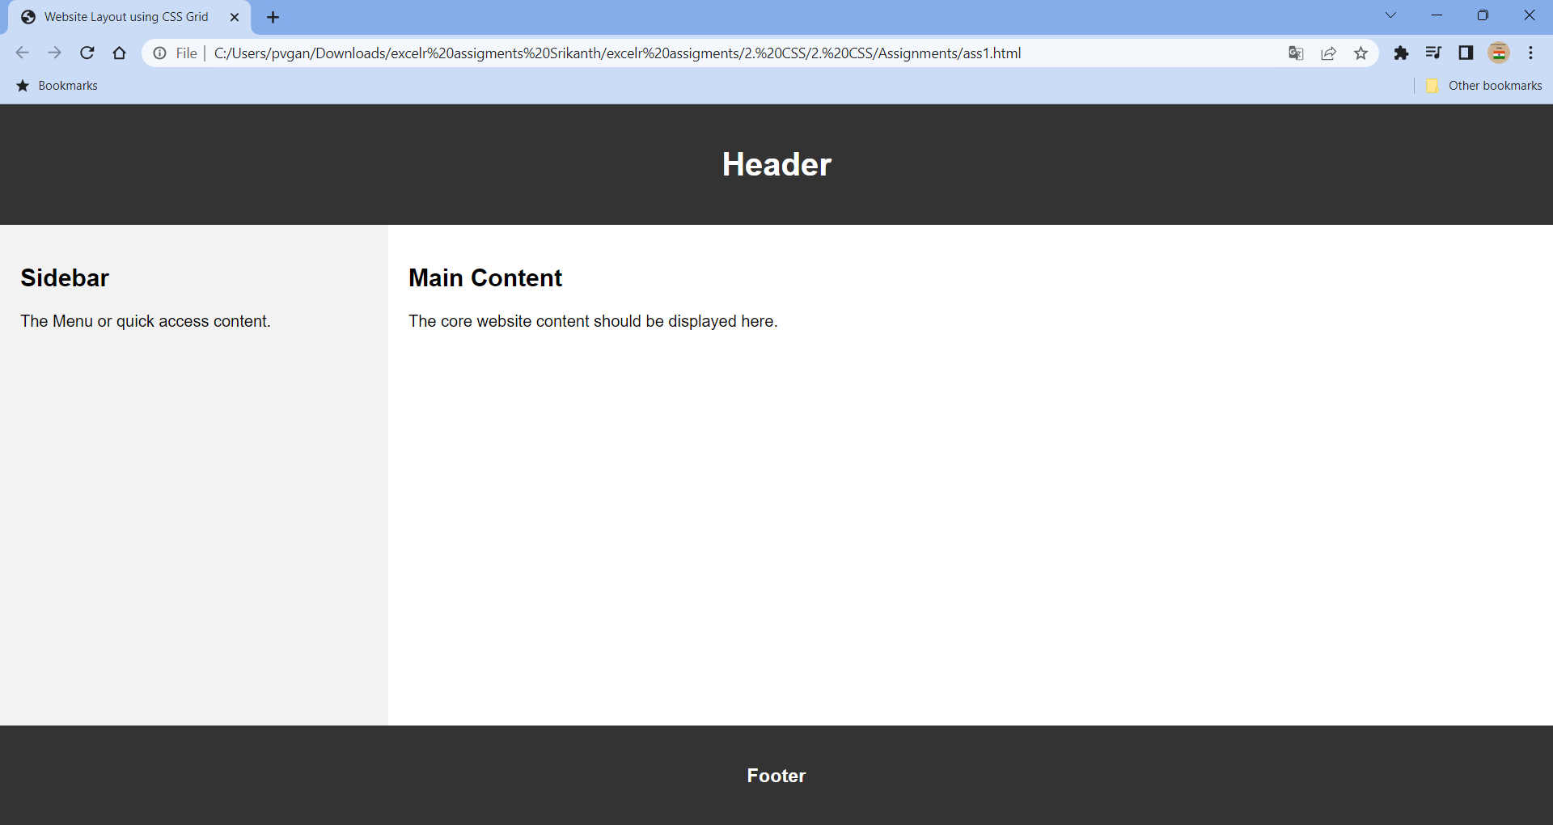

5.Write a program to create responsive menu using media queries CSS to generate this output?

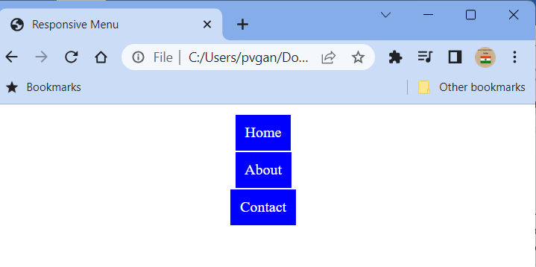
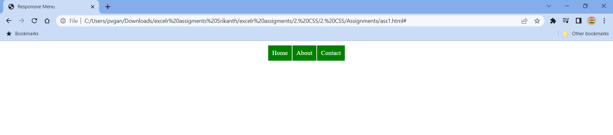
6.Write a program to animate a tile in CSS to generate this output?

