BDAT

B-Business arch

D-Data arch

A-Application arch

T-Technology arch

-----

Concern: An interest in a system to stakeholders is referred as “Concern”

----  
Deliverable - is Arch document

Artifact – say diagrams, matrix of….

A Deliverable will contain many Artifacts within it

If the Arch doc is approved, it doesn’t mean, change should not happen

But, change should go thro Change mgmt. process

------  
Architecture levels:  
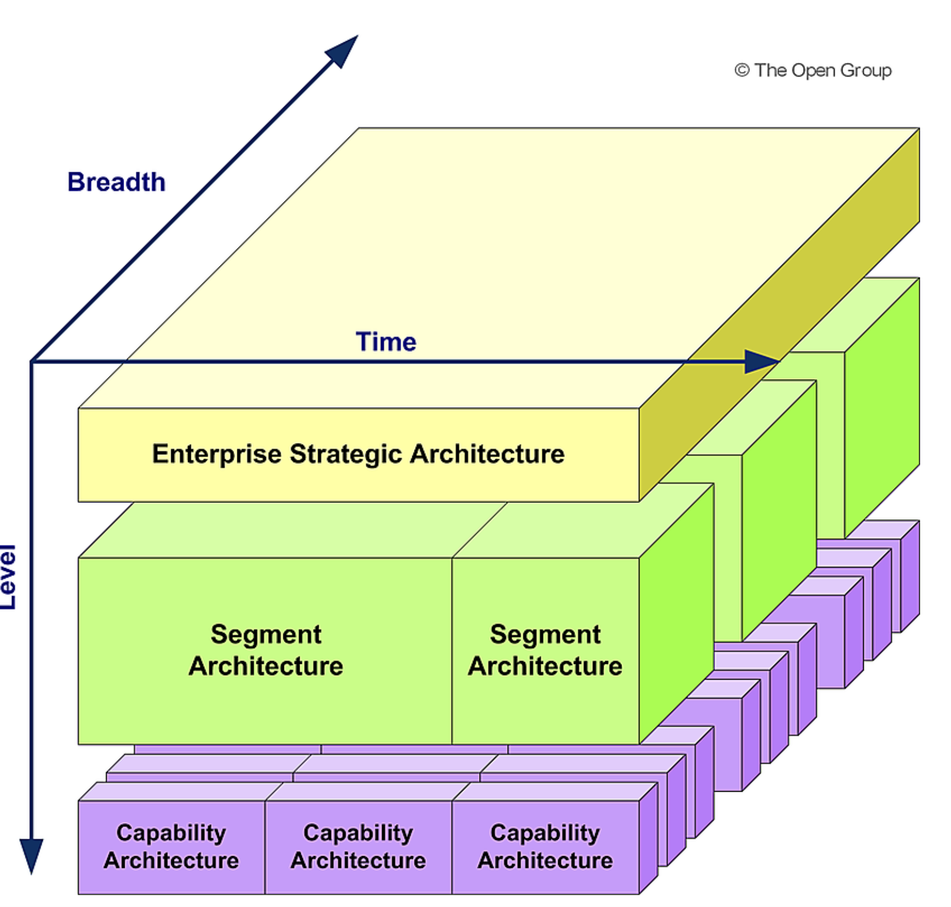

Strategic: supports direction setting at an executive level

Segment: program or portfolio level

Capability: most detailed

------

Preliminary phase:

- preparation phase of setting up the ecosystem like templates, approvals, change mgmt.,…

------

Architecture principles:

-created in Preliminary phase

-In Architecture vision phase: reviewed/modified, new ones added

-in Business, Information (Data and Application) and Technology arch phases: ensure your target arch meets arch principles. If needed, arch principle can be modified or anything new can be added

------

Architecture vision:

Business requirements are discovered and documented in this phase only

Business Scenarios is a technique to do that

Arch vision, also referred as conceptual architecture, is documented in Statement of Architecture work. To contain

--Requirements in scope/out of scope

--stakeholder list

--conceptual arch (very high level)

-need to get approval from stakeholders to proceed ahead with next phases

------  
Business architecture:  
-Business architecture is prerequisite for Data, Application and Technology architecture, (because these architectures need to enable and support the business architecture)

----  
In exam: any question on technology – think of technology architecture

-----  
Migration planning (Release planning):

-Migration planning (Release planning) is started in Solution phase, but completed in migration planning phase

-architecture development cycle is completed in migration planning phase, but its governance needs to be continued even in subsequent phases (I think, for changes)

-architecture roadmap is finalised in migration planning

-in subsequent phases, implementation of the architecture starts

-Implementation governance model is finalised in Migration planning phase and applied in Implementation Governance phase

Which deliverable describes an approach enabling Architecture Governance on a project basis?

1. Implementation Governance Model
2. Implementation and Migration Plan

Ans: Implementation Governance Model

-----  
Architecture Change Management:

-during Implementation and Governance phase, more details may emerge, which might have been missed in the Architecture. So, CR process needs to be followed

-change classification:

a) Simplification change (handled via change mgmt. techniques)

b) Incremental change (may require partial re-architecting)

c) Re-architecting change (requires a new architecture development cycle)

------  
Architecture Definition Document:

Document which captures the Epic architecture and solution design

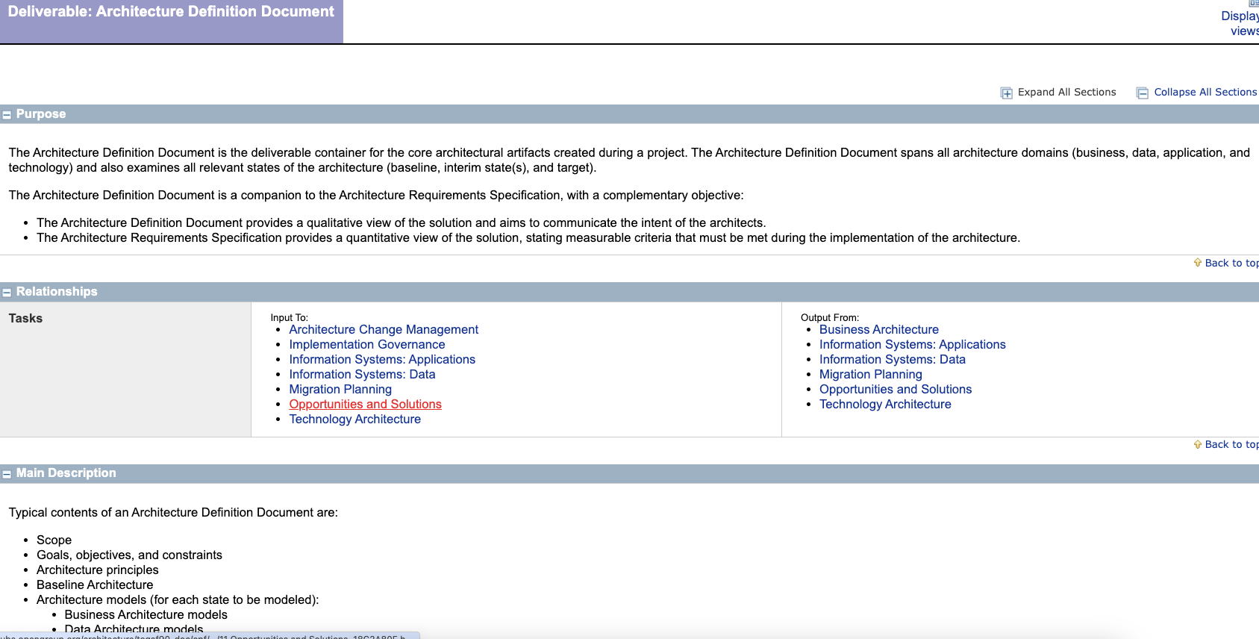

------------

Content framework:

-an org can use content framework of TOGAF, Zachman,…

-it describes what content needs to be captured in each of the phases

Ex: Data arch to contain data entities,…

**Maybe, this can be used to come up with the template for arch and solution design**-part of Preliminary phase

----------  
Enterprise Metamodel:

-While Content framework defines what content to capture, Enterprise Metamodel defines how to capture that content

Ex: UML, Archimate, Flowchart, ER diagram,…

-Togaf does not force to use any specific thing

-part of Preliminary phase

-have content that address stakeholder concerns. (do not add unnecessary content). I think, should be part of content framework

-------  
Enterprise Repository:

-place where the info mentioned in Content framework is stored

Ie place where the deliverables for each of the phases is stored

Ex: confluence

-also, tells the structure of the confluence

Ex: Solution Building Blocks to contains Solution design docs, Reference Library to contain org reference materials,…

-----  
Enterprise Continuum:

-Enterprise Continuum presents mechanisms to help improve productivity through leverage.

-

a) the Architecture Continuum provides a framework for organizing and classifying reusable architecture assets,

b) while the Solutions Continuum provides a framework for organizing and classifying solutions to specific business problems.

-left side: generic; right side: specific

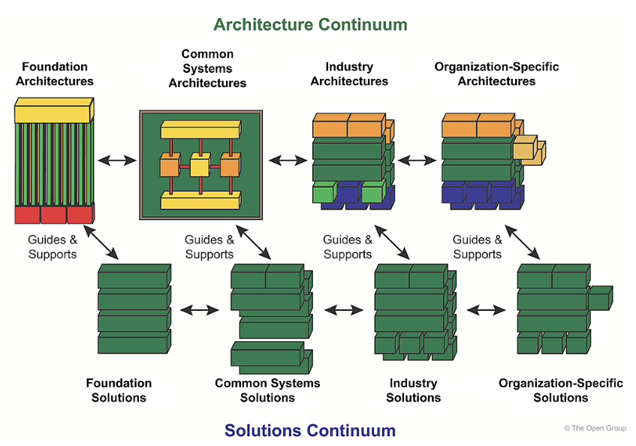

-also known as: view on artifacts held in the enterprise repositories

------  
Architecture Governance:

-Corporate Governance is at the top, under which comes Architecture Governance

Architecture Board:

-decision rights are with stakeholders, and not Arch Board

-----  
Architecture Capability:

Purpose Capabilities:

a) Architecture to support Strategy

Level of detail: Low

b) Architecture to support Portfolio

Level of detail: Typically low, detailed for constraints

c) Architecture to support Projects

Level of detail: Detailed

d) Architecture to support Solution Delivery

Level of detail: Most detailed

--------  
Definitions:

baseline – formally reviewed and agreed upon; serves as the basis for further development or change, and **that can be changed only through formal change control procedures**

Building block – **potentially re-usable component**  that can be combined with other building blocks to deliver architectures and solutions

Capability architecture – an architecture the describes the abilities that an enterprise possesses

**Logical** architecture – **implementation independent** definition of the architecture

I think, can be implemented in java,.net,…does not go in that much detail

A logical architecture is realized thro a physical architecture

Solution Building Blocks (SBBs) – physical or implementation specific component that realizes logical ABBs

Strategic architecture – executive level, long term view

------  
Practice exam:

-Gap analysis is done in Opportunities and solutions

Identifies the need for change within the Enterprise

-Contextual, Conceptual, Logical and Physical Abstraction Level

-Security Architecture is not part of the TOGAF Fundamental content

- A **building block** is a **package of functionality** defined to meet the business needs across an organization

It is NOT a software component or a microservice

-A view is unique to an architecture (note: not viewpoint)

Viewpoint: reusable template for an architecture view

View: content

-Architecture Contracts are the joint agreements between development partners (I think, vendors) and sponsors on the deliverables, quality, and fitness-for-purpose of an architecture.

It is signed in Implementation and Governance phase

-The Architecture Landscape is the architectural representation of assets deployed within the operating enterprise at a particular point in time - the landscape is likely to exist at multiple levels of abstraction to suit different architecture objectives.

-Reference Library: templates,…

-Standards Library: Providing standards with which new architectures and implementations must comply

-General reference of all the docs:

<https://pubs.opengroup.org/architecture/togaf9-doc/arch/chap32.html#tag_32_02_01>

-TOGAF Series Guides: provides guidance material on how to use and adapt the TOGAF Standard for specific needs.

-Phase A: Architecture Vision: initial phase of an architecture development cycle

- Creation of architecture capability is NOT a one off thing

(The establishment of the architecture practice should not be seen as a phase of an architecture project, or a one-off project, but rather as an ongoing discipline that provides the context, environment and resources to govern and enable architecture delivery to the organization.)

The Architecture Capability is a business capability with organization, roles, skills responsibilities & processes

-Dimensions for defining the scope of an architecture:

Level(Depth), Breadth, Time period, Architecture Domains(BDAT)

- Architecture Change Management

Deploying monitoring tools is part of it (I think, reason: only when you have proper monitoring setup, you will find if things are not as per expected. So, CR should be created to rectify it ex: Hypercare fixes)

- Which of the TOGAF Standard deliverables should contain mitigation actions addressing business transformation readiness risks?

Implementation and Migration Plan

- Who normally initiates a(n Architecture) Compliance Assessment?

Architecture Board

Transition architecture:

-A Transition Architecture is a formal description of one state of the architecture at an architecturally significant point in time.

-Transition architectures are defined in Opportunities and Solutions

Finalised in Migration and Planning phase

Confirmed in Migration and Planning phase with stakeholders

Quality criteria for Architecture principles:

Complete, Consistent, Robust, Stable and Understandable

Requirements should be: SMART