**Architecture**

**Social Distancing Detection**

|  |  |
| --- | --- |
| **Revision Number** | 1.0 |
| **Last Date of Revision** | 6-March-2022 |
| **Author** | Puru Sharma |

**Document Version Control**

|  |  |  |  |
| --- | --- | --- | --- |
| Date Issued | Version | Description | Author |
| 06-March-2022 | 1.0 | First Draft | Puru Sharma |
|  |  |  |  |

**Contents**

|  |  |
| --- | --- |
| **Topic** | **Page No** |
|  |  |
| Document Version Control | 2 |
| Abstract | 4 |
| 1. Introduction | 5 |
| 1.1 Why this Low-Level Design Document | 5 |
| 1.2 Scope | 5 |
| 1.3 Constraints | 6 |
| 1.4 Risks | 6 |
| 1.5 Out of Scope | 6 |
| 2. Technical Specifications | 6 |
| 2.1 Technology Stack | 6 |
| 3. Proposed Solution | 7 |
| 4. User I/O Workflow | 8 |
| 5. Exceptional Scenarios | 8 |
| 6. Test Cases | 9 |

# Abstract

The rampant coronavirus disease 2019 (COVID-19) has brought global crisis with its deadly spread to more than 180 countries, and about 3,519,901 confirmed cases along with 247,630 deaths globally as on May 4, 2020. The absence of any active therapeutic agents and the lack of immunity against COVID19 increases the vulnerability of the population. Since there are no proper vaccines available for complete prevention, social distancing is the only feasible approach to fight against this pandemic.

Motivated by this notion, this system proposes a deep learning based framework for automating the task of monitoring social distancing using surveillance video. The proposed framework utilizes the YOLO v3 object detection model to segregate humans from the background and Deepsort approach to track the identified people with the help of bounding boxes and assigned IDs. The results of the YOLO v3 model are further compared with other popular state-of-the-art models, e.g. faster region-based CNN (convolution neural network) and single shot detector (SSD) in terms of mean average precision (mAP), frames per second (FPS) and loss values defined by object classification and localization. To detect the distance between persons we use Euclidean Distance. Later, the pairwise vectorized L2 norm is computed based on the three-dimensional feature space obtained by using the centroid coordinates and dimensions of the bounding box. The violation index term is proposed to quantize the non adoption of social distancing protocol. From the experimental analysis, it is observed that the YOLO v3 with Deepsort tracking scheme displayed best results with balanced mAP and FPS score to monitor the social distancing in real-time.

## 1 Introduction

**1.1 Why this Low-Level Design Document?**

The purpose of this document is to present a detailed description of the Social Distancing Detection System. It will explain the purpose and features of the system, the interfaces of the system, what the system will do, the constraints under which it must operate and how the system will react to external stimuli. This document is intended for both the stakeholders and the developers of the system and will be proposed to the higher management for its approval.

The main purpose of the Social Distancing Detection System is to enable the process of automating the task of monitoring social distancing using surveillance video. Since there are no proper vaccines available for covid-19 complete prevention, social distancing is the only feasible approach to fight against this pandemic.

It is only recently that technology has reached a level of stability, usability and affordability which permits its use in real life scenarios rather than research projects. The use of the Social Distancing Detection System is being hailed as the next advance in the world of AI and computer vision. Many companies are developing systems to support such concepts and also few countries have already implemented this concept in congestion areas like malls, hotels, restaurants and more places.

Social Distancing Detection has recently become increasingly popular and dispersed in the wake of faster and cheaper internet connections and better technologies. Modern standalone camera units or footage provide advanced video and audio quality due to more efficient compression and can function over normal broadband internet connections. Growing processing power and cheaper accessories, such as security cams, have also made it possible to participate in a Social Distancing Detection using dedicated software on a normal personal computer without any expensive special hardware.

**1.2 Scope**

Low-level design (LLD) is a component-level design process that follows a step-by step refinement process. This process can be used for designing data structures, required software architecture, source code and ultimately, performance algorithms. Overall, the data organization may be defined during requirement analysis and then refined during data design work.

### 1.3 Constraints

The Social Distancing Detection system must be user friendly, as automated as possible and users should not be required to know any of the workings.

**1.4 Risks**

Document specific risks that have been identified or that should be considered.

**1.5 Out of Scope**

Delineate specific activities, capabilities, and items that are out of scope for the project.

### 2. Technical Specifications

#### 2.1. Technology Stack

|  |  |
| --- | --- |
| Programming Language | Python |
| Real Time Object Detection | YOLOv3 (You Only Look Once, Version 3) |
| Distancing Algorithm Used | Euclidean Distance |
| Open Source Computer Vision Library | Open CV |
| For GPU Runtime | Google Collab |
| For CPU Runtime and OS | Ubuntu |

1. **Proposed Solution**

The emergence of deep learning has brought the best performing techniques for a wide variety of tasks and challenges including medical diagnosis, machine translation, speech recognition, and a lot more. Most of these tasks are centered around object classification, detection, segmentation, tracking, and recognition. In recent years, the convolution neural network (CNN) based architectures have shown significant performance improvements that are leading towards the high quality of object detection, which presents the performance of such models in terms of mAP and FPS on standard benchmark datasets, PASCAL-VOC and MS-COCO, and similar hardware resources. In the present article, a deep learning based framework is proposed that utilizes object detection and tracking models to aid in the social distancing remedy for dealing with the escalation of COVID-19 cases. In order to maintain the balance of speed and accuracy, YOLO v3 alongside the Deepsort are utilized as object detection and tracking approaches while surrounding each detected object with the bounding boxes. Later, these bounding boxes are utilized to compute the pairwise L2 norm with computationally efficient vectorized representation for identifying the clusters of people not obeying the order of social distancing. Furthermore, to visualize the clusters in the live stream, each bounding box is color-coded based on its association with the group where people belonging to the same group are represented with the same color. Each surveillance frame is also accompanied with the streamline plot depicting the statistical count of the number of social groups and an index term (violation index) representing the ratio of the number of people to the number of groups. Furthermore, estimated violations can be computed by multiplying the violation index with the total number of social groups.

1. **User I/O Workflow**

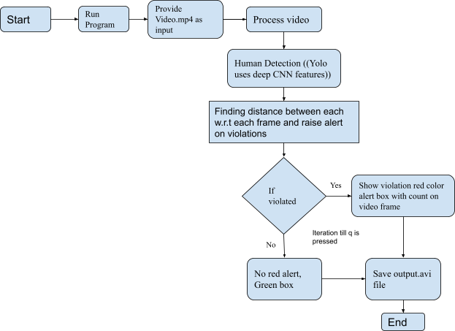

1. **Exceptional Scenarios**

|  |  |  |  |
| --- | --- | --- | --- |
| **Step** | **Exception** | **Mitigation** | **Module** |
|  |  |  |  |

1. **Test Cases**

|  |  |  |  |
| --- | --- | --- | --- |
| **Test case** | **Steps to perform test case** | **Module** | **Pass / Fail** |
|  |  |  |  |