**Low Level Design**

**Social Distancing Detection System**

|  |  |
| --- | --- |
| **Written By** | Puru Sharma |
| **Documentation Version** | 0.1 |
| **Last Revised Date** | 06-03-2022 |

**Document Control Change Record:**

|  |  |  |  |
| --- | --- | --- | --- |
| **Version** | **Date** | **Author** | **Comments** |
| 0.1 | 06-March-2022 | Puru Sharma |  |
|  |  |  |  |

**Reviews:**

|  |  |  |  |  |  |  |
| --- | --- | --- | --- | --- | --- | --- |
| **Version** | **Date** |  | **Reviewer** |  | **Comments** | |
|  |  |  |  |  |  | |
| **Approval Status:** | |  | |  | | |
| **Version** | **Review Date** | **Reviewed By** | | **Approved By** | | **Comments** |
|  |  |  | |  | |  |

# Contents

|  |  |
| --- | --- |
| **Topic** | **Page No** |
| 1. Introduction | 4 |
| 1.1. What is a Low-Level design document? | 4 |
| 1.2. Scope | 4 |
| 2. Architecture | 5 |
| 3. Architecture Description | 6 |
| 3.1. Yolov3 | 6 |
| 3.2. Open CV | 6 |
| 3.3. Euclidean Distance | 6 |
| 3.4. Object Detection | 6 |
| 3.5. Distance Calculation | 6 |
| 4. Unit Test Cases | 7 |

# Introduction

1.1. What is a Low-Level design document?

The goal of LLD or a low-level design document (LLDD) is to give the internal logical design of the actual program code for the Social Distancing Detection System. LLD describes the class diagrams with the methods and relations between classes and program specs. It describes the modules so that the programmers can directly code the program from the document.

1.2. Scope

Low-level design (LLD) is a component-level design process that follows a step-by-step refinement process. This process can be used for designing data structures, required software architecture, source code and ultimately, performance algorithms. Overall, the data organization may be defined during requirement analysis and then refined during data design work.

# Architecture

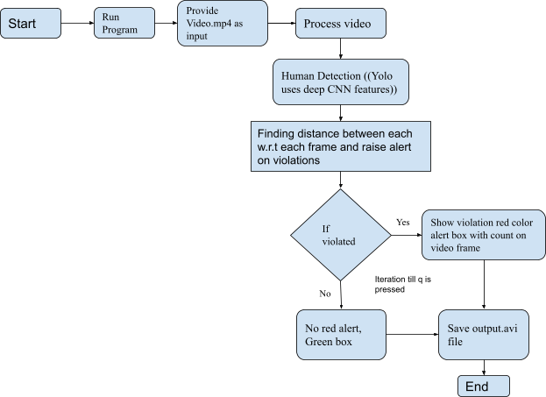

# Architecture Description

3.1. Yolov3

YOLOv3 (You Only Look Once, Version 3) is a real-time object detection algorithm that identifies specific objects in videos, live feeds, or images. YOLO uses features learned by a deep convolutional neural network to detect an object.

3.2. Open CV

OpenCV (Open Source Computer Vision Library) is an open source computer vision and machine learning software library.

3.3. Euclidean Distance

Euclidean Distance represents the shortest distance between two points. Most machine learning algorithms including K-Means use this distance metric to measure the similarity between observations.

3.4. Object detection:

* We will be using YOLOv3, trained on the COCO dataset for object detection.
* In general, single-stage detectors like YOLO tend to be less accurate than two-stage detectors (R-CNN) but are significantly faster.
* YOLO treats object detection as a regression problem, taking a given input image and simultaneously learning bounding box coordinates and corresponding class label probabilities.
* It is used to return the person's prediction probability, bounding box coordinates for the detection, and the centroid of the person.

3.5. Distance calculation:

* NMS (Non-maxima suppression) is also used to reduce overlapping bounding boxes to only a single bounding box, thus representing the true detection of the object. Having overlapping boxes is not exactly practical and ideal, especially if we need to count the number of objects in an image.
* Euclidean distance is then computed between all pairs of the returned centroids. Simply, a centroid is the center of a bounding box.
* Based on these pairwise distances, we check to see if any two people are less than/close to 'N' pixels apart.

# Unit Test Cases

|  |  |  |
| --- | --- | --- |
| **Test Case Description** | **Pre-Requisite** | **Expected Result** |
| Verify whether the  Application is accessible to the user | 1. Application should be installed with requirements.txt file | Application should be accessible to the user |
| Verify whether the  Application loads completely for the user when the system is accessed | 1. 1. Application should be installed with requirements.txt file 2. Application is deployed | The Application should load completely for the user when the URL is accessed |
| Verify whether the User is able to run the application | 1. Application is accessible | The User should be able to run the application |
| Verify whether user is able to successfully run the application in GPU runtime | 1. Application is accessible 2. User is able to run the  application | User should be able to successfully run the application with GPU runtime |
| Verify whether user is able to mount drive in google collab | 1. Application isaccessible 2. User is able to run the   application | User should be able to mount drive in google callable and able to access the files from  drive |
| Verify whether user is able to input video file | 1. Application isaccessible 2. User is able to run theapplication 3. User is able to input data | User should be able to provide input a video file for social distance detection |
| Verify whether the paths to | 1. Application is | User should be provided with |

|  |  |  |
| --- | --- | --- |
| respective files configured properly or not | accessible   1. User is able to run theapplication 2. User is able to input data 3. All files are configured | respective config files and paths |
| Verify whether user is able to run the system or not | 1. Application isaccessible 2. User is able to run theapplication 3. User is able to input data 4. All files are configured | User should be able to run the system without predefined errors |
| Verify whether user is able to see the processing of imputed video file | 1. Application isaccessible 2. User is able to run theapplication 3. User is able to input data 4. All files are configured | User should be able to see process happening on providing video input file |
| Verify whether user is able to observe the boxes, alerts for violations per each frame of input video file | 1. Application isaccessible 2. User is able to run theapplication 3. User is able to input data 4. All files are configured5. User able to observe the process and steps involved in the system | User should be able to observes the steps and process involved like the boxes, alerts for violations  per each frame of input video file |
| Verify whether User is able to quit the process on entering q | 1. Application isaccessible 2. User is able to run theapplication 3. User is able to input data 4. All files are configured5. User able to observe the process and steps involved in the system   6. User is able to quit | User should be able quit the process |
| Verify whether user is able to download the output.avi file | 1. Application isaccessible 2. User is able to run theapplication 3. User is able to input data | User should be able to access the output file |

|  |  |  |
| --- | --- | --- |
|  | 4. All files are configured 5. User able to observe the process and steps involved in the system  6. User is able to download output file |  |