High Level Design (HLD)

Restaurant Rating Prediction

|  |  |
| --- | --- |
| Written By | Puru Sharma |
| Document Version | 1.0 |
| Last Revised Date | 05-Jan-2022 |

**Document Change Control Record**

|  |  |  |  |
| --- | --- | --- | --- |
| **Version** | **Date** | **Author** | **Comments** |
| 1.0 | 05-Jan-2022 | Puru Sharma |  |
|  |  |  |  |

Review

|  |  |  |  |
| --- | --- | --- | --- |
| **Version** | **Date** | **Reviewer** | **Comments** |
|  |  |  |  |

**Approval**

|  |  |  |  |  |
| --- | --- | --- | --- | --- |
| **Version** | **Review date** | **Reviewed By** | **Approved By** | **Comments** |
|  |  |  |  |  |

Table of Contents

Abstract 4

1. Introduction 5

1.1 Why this High-Level Design Document? 5

1.2 Scope 5

1.3 Definitions 5

2. General Description 6

2.1 Product Perspective 6

2.2 Problem statement 6

2.3 Tools used 6

2.4Data Requirements: 6

2.5 Hardware used: 6

2.6 Constraints 7

3. Design Details 7

3.1 Functional Architecture 7

3.2 Event log 7

3.3 Error Handling 7

4. Performance 7

4.1 Reusability 8

4.2 Application Compatibility 8

4.3 Application Compatibility 8

4.4 Deployment 8

5. Dashboards 8

5.1 KPIs (Key Performance Indicators) 8

6 Conclusion 9

# Abstract

Bengaluru is one of the most famous cities of India, with over 12,000 restaurants providing cuisine from all over the world. With new restaurants opening every day, the sector hasn't yet reached saturation, and demand is growing by the day. Despite rising demand, new eateries are finding it difficult to compete with established establishments. The majority of them provide the same dishes. Bengaluru is known as India's IT capital. Because they don't have time to prepare, the majority of the people here rely heavily on restaurant cuisine. Therefore, it is necessary to examine the demography of the region with such an overwhelming demand from eateries. What sort of cuisine in a town is most popular. The main objective of this project is to conduct thorough Zomato Dataset Exploratory Data Analyse(EDA) and to create a suitable machine learning model, which will enable several Zomato Restaurants to forecast their respective ratings based on specific elements.

# 1. Introduction

## 1.1 Why this High-Level Design Document?

The purpose of this High-Level Design (HLD) Document is to add the necessary detail to the current project description to represent a suitable model for coding. This document is also intended to help detect contradictions prior to coding, and can be used as a reference manual for how the modules interact at a high level.

The HLD will:

* Present all of the design aspects and define them in detail
* Describe the user interface being implemented
* Describe the hardware and software interfaces
* Describe the performance requirements
* Include design features and the architecture of the project
* List and describe the non-functional attributes like:

o Security o Reliability o Maintainability o Portability o Reusability o Application compatibility o Resource utilization o Serviceability

## 1.2 Scope

The HLD documentation presents the structure of the system, such as the database architecture, application architecture (layers), application flow (Navigation), and technology architecture. The HLD uses non-technical to mildly-technical terms which should be understandable to the administrators of the system.

## 1.3 Definitions

|  |  |
| --- | --- |
| *Term* | *Description* |
| *EDA* | Exploratory Data Analysis |
| *Database* | Collection of all the information monitored by this system |
| *IDE* | Integrated Development Environment |
| *AWS* | Amazon Web Services |

# 2. General Description

## 2.1 Product Perspective

While choosing a restaurant to eat whether to dine in or order for home delivery restaurant rating is one of the most important factor for choosing the restaurant. Bangalore being one of the most famous cities in India with such a diverse culture. There are more than 10,000 restaurants to choose from offering variety of cuisines.

## 2.2 Problem statement

The objective of the project is to perform exploratory data analysis and data visualization techniques to understand the insight of the data and creating a machine learning model solution to predict rating of the restaurants.

## 2.3 Tools used

Python programming language and frameworks such as NumPy, Pandas, Scikit-learn, Matplotlib, flask are used to build the whole model.







# 2.4Data Requirements:

Data requirement is completely based on our problem statements.

* Zomato dataset of Bangalore city restaurants.
* It is defined by the mathematical function (x, y).

## 2.5 Hardware used:

The following hardware is required:

• PC with minimum configuration (i3 and above, min(500gb of ROM with 4gb RAM)

## 2.6 Constraints

The restaurant rating prediction solution system must be user friendly.

# 3. Design Details

# 3.1 Functional Architecture

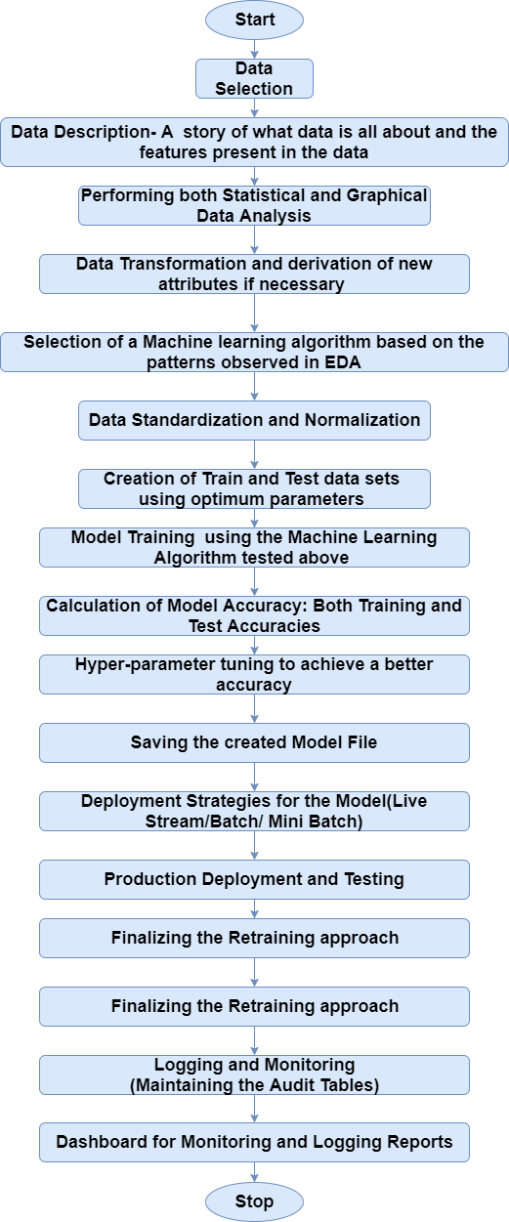

Data Source Exploratory Data Analysis Data splitting Prediction

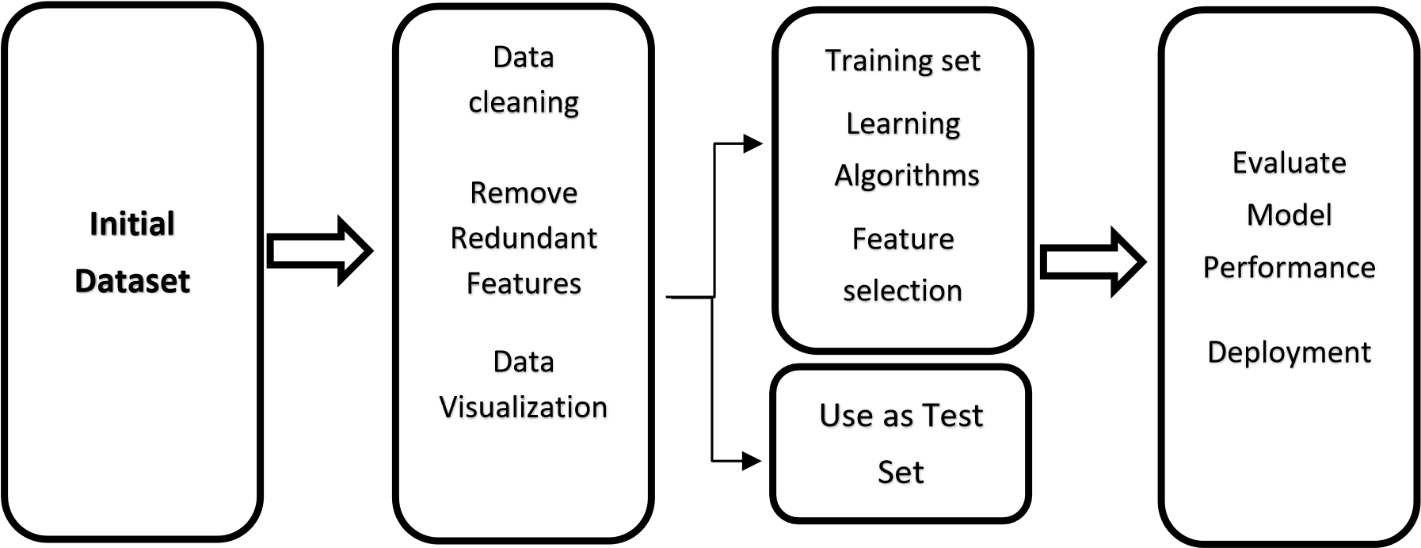

Figure 1: Functional Architecture of Building Machine learning model

## 3.2 Event log

The system should log every event so that the user will know what process is running internally.

**Initial Step-By-Step Description:**

1. The System identifies at what step logging required
2. The System should be able to log each and every system flow.
3. Developer can choose logging method. You can choose database logging/ File logging as well.
4. System should not hang even after using so many loggings. Logging just because we can easily debug issues so logging is mandatory to do.

## 3.3 Error Handling

Should errors be encountered, an explanation will be displayed as to what went wrong? An error will be defined as anything that falls outside the normal and intended usage.

# 4. Performance

The restaurant rating prediction solution is used for predicting the rating of the restaurants by entering specific necessary details. It can help setup new restaurant owners to choose which location to choose which cuisine etc. for a better rating, which in turns can lead to a successful restaurant business. Any wrong prediction through the model may result to loss the business owner.

## 4.1 Reusability

The code written and the components used should have the ability to be reused with no problems.

## 4.2 Application Compatibility

The different components for this project will be using Python as an interface between them. Each component will have its own task to perform, and it is the job of the Python to ensure proper transfer of information.

## 4.3 Application Compatibility

The different components for this project will be using Python as an interface between them. Each component will have its own task to perform, and it is the job of the Python to ensure proper transfer of information.

## 4.4 Deployment



# 5. Dashboards

Dashboard will be implemented to display and indicate certain KPIs and relevant indicators for the unveiled problems that if not addressed in time could cause wrong prediction and lead to bad business decision.

## 5.1 KPIs (Key Performance Indicators)

Key indicators displaying a summary of the restaurant rating prediction and its relationship with different metrics.

* Impact of Location of the restaurant across the City
* Influence of different cuisines offered by the restaurant on the ratings
* Impact of votes given to different restaurants on the ratings
* Influence of Cost of two people at the restaurant
* Influence of availability of online order or not on the rating

# 6 Conclusion

The restaurant rating prediction solution will be able to predict the rating of the restaurants in the city of Bangalore based on the Zomato dataset, which have been used to train the model with different algorithms. So that we can identify or tell the rating of the restaurant based on certain features selected for the model. So business owners can see requirements before starting restaurant business in Bangalore city.