High Level Design (HLD)

**Django - Video Conferencing Web App**

|  |  |
| --- | --- |
| **Revision Number** | 1.0 |
| **Last date of revision** | 13/02/2022 |

**Django - Video Conferencing Web App** 1

# Document Version Control

|  |  |  |  |
| --- | --- | --- | --- |
| **Date Issued** | **Version** | **Description** | **Author** |
| 13/02/2022 | 1 | Initial HLD — V1.0 | Puru Sharma |
|  |  |  |  |

**Contents**

Document Version Control 2

Abstract 5

1. Introduction 6

1.1. Why this High-Level Design Document? 6

1.2. Scope 6

1.3. Definitions 6

2. General Description 7

2.1. Product Perspective 7

2.2. Problem Statement 7

2.3. Proposed Solution 7

2.4. Further Improvements 8

2.5. Components of video conference web app 8

2.5.1. The Hardware 8

2.5.2. The Network 9

2.5.3. The Conference Environment 9

2.6. Tools Used 9

2.7. Constraints 11

2.8. Assumptions 11

3. Design Details 11

3.1. Process Flow 11

3.1.1. Deployment Process 13

3.2. Event log 13

3.2.1. Error Handling 13

4. Performance 14

4.1. Reusability 14

4.2. Application Compatibility 14

4.3 Resource Utilization 14

4.4 Deployment 14

5. Conclusion 15

6. References 15

|  |  |
| --- | --- |
| **Topics** | **Page No** |

# Abstract

For the past decade, video conferencing (VC) has become more popular and more reliable as a tool to bridge the distance gap when travel is not an option, impractical or undesired.Real-time Communication is quickly becoming a “must-have” feature in many types of applications. From customer service to telehealth, video conferencing is rapidly integrating into different industries’ workflows. Video conferencing uses audio and video telecommunications to bring people at different sites together. Understanding what is required for videoconferencing and its application has become one of the major researched topics by various learning institutions and businessmen. In this paper, an introduction to video conferencing is presented with the emphasis on its application in distance learning.

# 1. Introduction

## 1.1 Why this High-Level Design Document?

The purpose of this High-Level Design (HLD) Document is to add the necessary detail to the current project description to represent a suitable model for coding. This document is also intended to help detect contradictions prior to coding, and can be used as a reference manual for how the modules interact at a high level.

The HLD will:

* Present all of the design aspects and define them in detail
* Describe the user interface being implemented
* Describe the hardware and software interfaces
* Describe the performance requirements
* Include design features and the architecture of the project
* List and describe the non-functional attributes like:
  1. Security
  2. Reliability
  3. Maintainability
  4. Portability
  5. Reusability
  6. Application compatibility
  7. Resource utilization
  8. Serviceability

## 1.2 Scope

The HLD documentation presents the structure of the system, such as the database architecture, application architecture (layers), application flow (Navigation), and technology architecture. The HLD uses non-technical to mildly-technical terms which should be understandable to the administrators of the system.

## 1.3 Definitions

|  |  |  |  |  |  |  |  |  |  |
| --- | --- | --- | --- | --- | --- | --- | --- | --- | --- |
| |  |  | | --- | --- | | **Term** | **Description** | | VC | Video Conference | | |  |  | | --- | --- | | Database | Collection of information | | IDE | Integrated Development  Environment | |

# 2. General Description

## 2.1 Product Perspective

The Django - Video Conference Web App is a web based video conference system built with the help of python based Django framework which will help us to bridge the distance gap when travel is not an option, impractical or undesired.

## 2.2 Problem Statement

To create a web solution for video conferences using django framework and to implement the following use cases.

* To Authenticate users - SignIn, SignUp.
* To Bridge the distance gap when travel is not an option.
* To Implement meetings with video, audio and screen sharing capabilities.

## 2.3 Proposed Solution

The solution proposed here is a web based Video Conference App using python - django framework can be implemented to perform above mention use cases .In first case, if Video Conference Web App detects any illegal activities like [Cross](https://docs.djangoproject.com/en/4.0/topics/security/#cross-site-scripting-xss-protection) [site](https://docs.djangoproject.com/en/4.0/topics/security/#cross-site-scripting-xss-protection) [scripting](https://docs.djangoproject.com/en/4.0/topics/security/#cross-site-scripting-xss-protection) [(XSS)](https://docs.djangoproject.com/en/4.0/topics/security/#cross-site-scripting-xss-protection) [protection](https://docs.djangoproject.com/en/4.0/topics/security/#cross-site-scripting-xss-protection), [Cross](https://docs.djangoproject.com/en/4.0/topics/security/#cross-site-request-forgery-csrf-protection) [site](https://docs.djangoproject.com/en/4.0/topics/security/#cross-site-request-forgery-csrf-protection) [request](https://docs.djangoproject.com/en/4.0/topics/security/#cross-site-request-forgery-csrf-protection) [forgery](https://docs.djangoproject.com/en/4.0/topics/security/#cross-site-request-forgery-csrf-protection) [(CSRF)](https://docs.djangoproject.com/en/4.0/topics/security/#cross-site-request-forgery-csrf-protection) [protection](https://docs.djangoproject.com/en/4.0/topics/security/#cross-site-request-forgery-csrf-protection), [SQL](https://docs.djangoproject.com/en/4.0/topics/security/#sql-injection-protection) [injection](https://docs.djangoproject.com/en/4.0/topics/security/#sql-injection-protection) [protection](https://docs.djangoproject.com/en/4.0/topics/security/#sql-injection-protection), [Clickjacking protection](https://docs.djangoproject.com/en/4.0/topics/security/#clickjacking-protection), [SSL/HTTPS](https://docs.djangoproject.com/en/4.0/topics/security/#ssl-https), [Host](https://docs.djangoproject.com/en/4.0/topics/security/#host-header-validation) [header](https://docs.djangoproject.com/en/4.0/topics/security/#host-header-validation) [validation](https://docs.djangoproject.com/en/4.0/topics/security/#host-header-validation), [Referrer](https://docs.djangoproject.com/en/4.0/topics/security/#referrer-policy) [policy](https://docs.djangoproject.com/en/4.0/topics/security/#referrer-policy), [Cross-origin](https://docs.djangoproject.com/en/4.0/topics/security/#cross-origin-opener-policy) [opener policy](https://docs.djangoproject.com/en/4.0/topics/security/#cross-origin-opener-policy), [Session](https://docs.djangoproject.com/en/4.0/topics/security/#session-security) [security](https://docs.djangoproject.com/en/4.0/topics/security/#session-security) all these will be handled by Django automatically to provide high security to our application, user sign in, sign up options provided will be used to authorize if user is already existing in database else will provide an option to register by themselves, further in the second use case, Video Conference Web App creates a bridge to share information to distance if travel is not an option like during covid lock down situation education classes can be held via video conference system and lastly in the final use case of Video Conference Web App, it implements meetings with video, audio, screen sharing facility to transfer information through online via web app helps viewers or students to grasp the knowledge without traveling.

## 2.4. Further Improvements

Video Conference Web App can be added with more use cases like file sharing, record sessions, white board etc. Video Conference Web App can also be synchronized for better and fast response or action, with help of react js and Video Conference Web App synchronized it can be implemented in the other domains like education, business meetings, office meetings, client meetings, social media, telecommunication, healthcare.

## 2.5. Components of video conference web app

Videoconferencing has three essential components:

* The Hardware.
* The intervening network that carries the signals between sites.
* The conference environment or room.

#### 2.5.1. The Hardware

Basic equipment needed for a video conference session include a camera, microphone, a video conferencing unit, display unit, and audio system.

**Camera** – A camera to capture images and convert them into an electrical signal. Location of the camera must be ideal to allow for realistic eye-contact. Also, good quality and functionality of the cameras should be able to provide a sharper, more colorful image, with less visual noise.

**Microphone** – Microphones used in VC are usually very sensitive and should be placed away from equipment like projectors which can produce some background noise.

**Video Conferencing Unit** – The VC unit usually referred as the codec (Coder/Decoder) accepts the vision and sound signals (video and audio) and processes them into a suitable format for transmission through the network to the remote site. To receive information the Decoder does the reverse: it accepts the digital signals from the remote site over the network and decodes or converts these into video and audio. Finally this video and audio are fed to a display unit and speaker to display the pictures and reproduce the sound from the remote site respectively.

**Display Unit** – A display unit can be either a TV unit or a projector projecting onto a surface. The display unit is connected onto the codec.

**Audio System** – A good audio system is ideal for video conferencing. In some instances, TV speakers are used but in most instances (i.e. classroom, boardrooms, etc.), a good audio system with a mixer, amplifier and speakers might be required.

#### 2.5.2. The Network

Video conferencing technology works across internet protocol (IP) networks and integrated system digital network (ISDN). Through these vast networks, videoconferencing has the capabilities for connectivity to worldwide audiences. With IP transmission, the results can be variable as the videoconference data has to compete with other computing data. ISDN guarantees connections at the selected quality, giving more reliable conferences, but as call charges are levied it is also more expensive than IP. A simple video conference can be initiated with as low as 384 kbps with 30

frames of video per second real-time.

#### 2.5.3. The Conference Environment

Lighting is an easy way to improve picture quality. If the room is not specially built or equipped for video conferencing, it is probable that there are not enough lights to provide the optimum quality for the video conference cameras. The result is a flickering visual noise seen especially when the cameras are zoomed in. Another result is a lack of color saturation. Thus proper lightning is an easy way to improve video quality. Also, the room should be well acoustically designed to

avoid the echo.

## 2.6. Tools Used

Python programming language and its framework such as Django, Db sqlite-3, Html, Javascript, Jinja2, Css, Bootstrap and agora are used to build the whole model.

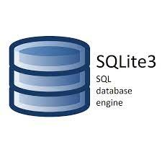

* VsCode / PyCharm can be used as IDE.
* For structure HTML.
* For styling cascading style sheets (CSS).
* For actions Javascript.
* Sqlite-3 is used to retrieve, insert, delete, and update the database.
* Front end development is done using HTML/CSS
* Python Django is used for backend development.
* GitHub is used as a version control system.

## 2.7. Constraints

The VC system must be user friendly, as automated as possible and users should not be required to know any of the workings.

## 2.8. Assumptions

The main objective of the project is to implement the use cases as previously mentioned (2.2 Problem Statement) for scheduling one to one mentoring sessions, office meetings, online classes for education system, social media communication purpose. Django is used for heliding the above-mentioned use cases via web portal. It is also assumed that all aspects of this project have the ability to work together in the way the designer is expecting.

# 3. Design Details

## 3.1. Process Flow

For identifying the different types of anomalies, we will use a deep learning base model. Below is the process flow diagram as shown below.

Proposed Methodology

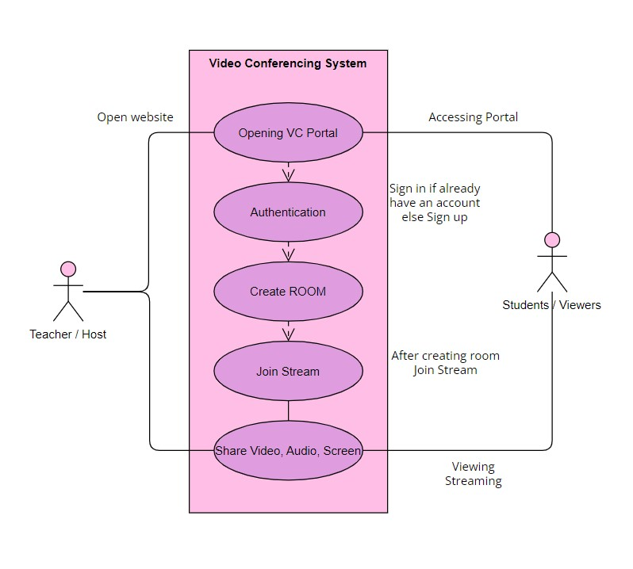

#### 3.1.1. Deployment Process

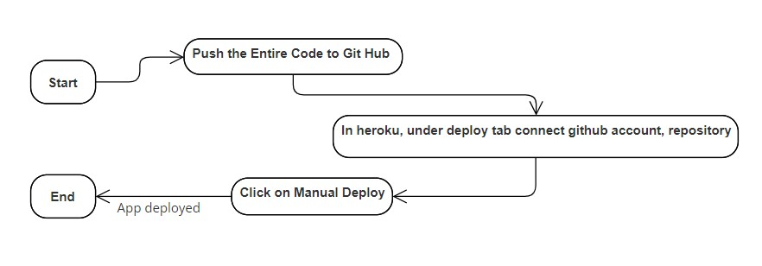

## 3.2. Event log

The system should log every event so that the user will know what process is running internally.

**Initial Step-By-Step Description:**

1. The System identifies at what step logging required
2. The System should be able to log each and every system flow.
3. Developers can choose logging methods. You can choose database logging/ File logging as well.
4. System should not hang even after using so many loggings. Logging just because we can easily debug issues so logging is mandatory to do.

### 3.2.1. Error Handling

Should errors be encountered, an explanation will be displayed as to what went wrong? An error will be defined as anything that falls outside the normal and intended usage.

# 4. Performance

Proper internet, best hosting service with scalable resources is needed in order to hold good performance.

## 4.1. Reusability

The code written and the components used should have the ability to be reused with no problems.

## 4.2. Application Compatibility

The different components for this project will be using Python as an interface between them. Each component will have its own task to perform, and it is the job of the Python to ensure proper transfer of information.

## 4.3. Resource Utilization

When any task is performed, it will likely use all the processing power available until that function is finished.

## 4.4. Deployment



# 5. Conclusion

Video conferencing could lead the way for a dual approach, giving students more responsibility for their learning, working in groups, and doing educational tasks; all of which would benefit conventional teaching, but video conferencing provides an opportunity to implement them. It does not replace the use of print or other methods used in the conceptualization process. It can be used to encourage construction and it's true use lies in encouraging dialogue and increasing the scope for dialogue. With the advancement and ease of availability of high speed and cheap internet connections, it is expected that video Conferencing will increasingly become popular thus, leading to more interest and use of distance learning. In this paper, an introduction to video conferencing and its application in distance learning was presented as an effective way of delivering subject matter in classrooms.

# 6. References

1. https://en.wikipedia.org/wiki/Web_conferencing
2. Google.com for images of VC hardware.