**Low Level Design**

**Django - Video Conferencing Web App**

|  |  |
| --- | --- |
| **Written By** | Puru Sharma |
| **Documentation Version** | 0.1 |
| **Last Revised Date** | 15-02-2022 |

**Document Control Change Record:**

|  |  |  |  |
| --- | --- | --- | --- |
| **Version** | **Date** | **Author** | **Comments** |
| 0.1 | 15-Feb-2022 | Puru Sharma |  |
|  |  |  |  |

**Reviews:**

|  |  |  |  |  |
| --- | --- | --- | --- | --- |
| **Version** | **Date** | **Reviewer** | **Comments** |  |
|  |  |  |  |  |
| **Approval Status:** | |  |  |  |
| **Version** | **Review Date** | **Reviewed By** | **Approved By** | **Comments** |
|  |  |  |  |  |

**Contents**

|  |  |
| --- | --- |
| **Topic** | **Page No** |
| 1. Introduction | 4 |
| 1.1. What is a Low-Level design document? | 4 |
| 1.2. Scope | 4 |
| 2. Architecture | 5 |
| 3. Architecture Description | 6 |
| 3.1. User Authentication | 6 |
| 3.2. LogIn / SignUp | 6 |
| 3.3. Database | 6 |
| 3.4. Verification | 6 |
| 3.5. Lobby | 6 |
| 3.6. Publish - Subscribe | 6 |
| 4. Unit Test Cases | 7 |

# 1. Introduction

1.1. What is a Low-Level design document?

The goal of LLD or a low-level design document (LLDD) is to give the internal logical design of the actual program code for the Django - Video Conferencing Web App System. LLD describes the class diagrams with the methods and relations between classes and program specs. It describes the modules so that the programmers can directly code the program from the document.

## 1.2. Scope

Low-level design (LLD) is a component-level design process that follows a step-by-step refinement process. This process can be used for designing data structures, required software architecture, source code and ultimately, performance algorithms. Overall, the data organization may be defined during requirement analysis and then refined during data design work.

# 2. Architecture

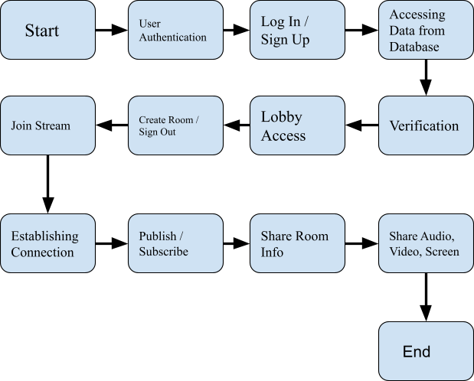

# 3. Architecture Description

## 3.1. User Authentication

Django comes with a user authentication system. It handles user accounts, groups, permissions and cookie-based user sessions.

## 3.2. LogIn / SignUp

If a user already has an account user can login with username and password otherwise user can register himself using sign up page. Username must be alphanumeric.

3.3. Database

Using Sqlite-3 user data is stored, accessed and used for authentication.

## 3.4. Verification

User verification will be done at two levels, one at the time of registration via email verification and another via authentication at the time of sign in.

## 3.5. Lobby

Authorized users will be given access to the lobby, where they can create a room and join stream or logout options are available.

## 3.6. Publish - Subscribe

Once Room is created the host will share or publish the room name to the users and users can subscribe or access the Room to join the stream.

Though this web site is hosted on the internet (heroku) everyone can access and enjoy its benefits.

# 4. Unit Test Cases

|  |  |  |
| --- | --- | --- |
| **Test Case Description** | **Pre-Requisite** | **Expected Result** |
| Verify whether the  Application URL is accessible to the user | 1. Application URL should be defined | Application URL should be accessible to the user |
| Verify whether the  Application loads completely for the user when the URL is accessed | 1. Application URL isaccessible 2. Application is deployed | The Application should load completely for the user when the URL is accessed |
| Verify whether the User is able to sign up in the application | 1. Application is accessible | The User should be able to sign up in the application |
| Verify whether user is able to successfully login to the application | 1. Application is accessible 2. User is signed up to the application | User should be able to successfully login to the application |
| Verify whether user is able to see input  fields on logging in | 1. Application isaccessible 2. User is signed upto the application 3. User is logged in to the application | User should be able to see input  fields on logging in |
| Verify whether user is able to edit all input fields | 1. Application isaccessible 2. User is signed upto the application 3. User is logged in to the application | User should be able to edit all input fields |
| Verify whether user gets  Submit  button to submit the inputs | 1. Application isaccessible 2. User is signed up | User should get Submit  button to submit the inputs |

|  |  |  |
| --- | --- | --- |
|  | to the application 3. User is logged in to the application |  |
| Verify whether user is presented with Lobby on clicking submit | 1. Application isaccessible 2. User is signed upto the application 3. User is logged in to the application | User should be presented with  Lobby on clicking submit |
| Verify whether user is able to edit the room field and name field and check working condition of sign out button | 1. Application isaccessible 2. User is signed upto the application 3. User is logged in to the application | User should be able to create the room and join stream, logout |
| Verify whether user is redirected to entered Room on clicking join stream button | 1. Application isaccessible 2. User is signed upto the application 3. User is logged in to the application | User should be able to publish the created the room and join stream |
| Verify whether audio, video, screen share options are working for users or not | 1. Application isaccessible 2. User is signed upto the application 3. User is logged in to the application | User should be able to access the controls of video conferencing system |
| Verify whether user is able to exit from the stream | 1. Application isaccessible 2. User is signed upto the application 3. User is logged in to the application | User should be able to exit from the stream on clicking victory symbol |
| Verify whether user is redirected to Lobby page and able to log out | 1. Application isaccessible 2. User is signed upto the application 3. User is logged in to the application 4. User is logged out | User should be redirected to Lobby again and should be logged out on clicking sign out button |