Exporting an HTML Email out of Eloqua
  - From the Eloqua Today (home) page, on the Navigation bar, select Communicate > Email Marketing and click the Email tab.
  - Select your Invite
  - Go to Source Editor > located under the design editor drop down
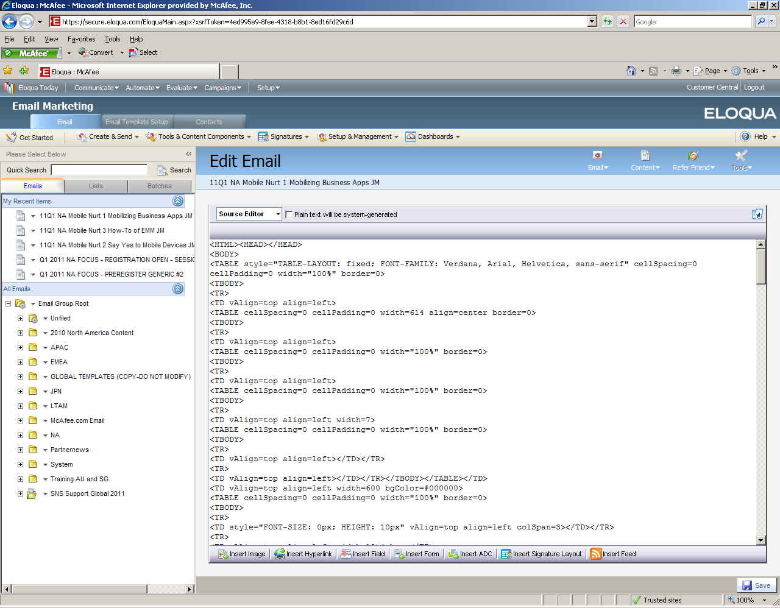
  - Right click
  - Select < Select All
  - Right Click
  - Select < Copy
  - Go to Notepad
Note: Notepad is a Windows program located outside of Eloqua.
From the Windows Start Button >Select Programs>Select Accessories>Select Notepad

  - Place your cursor in the white space within Notepad
  - Select Edit Paste
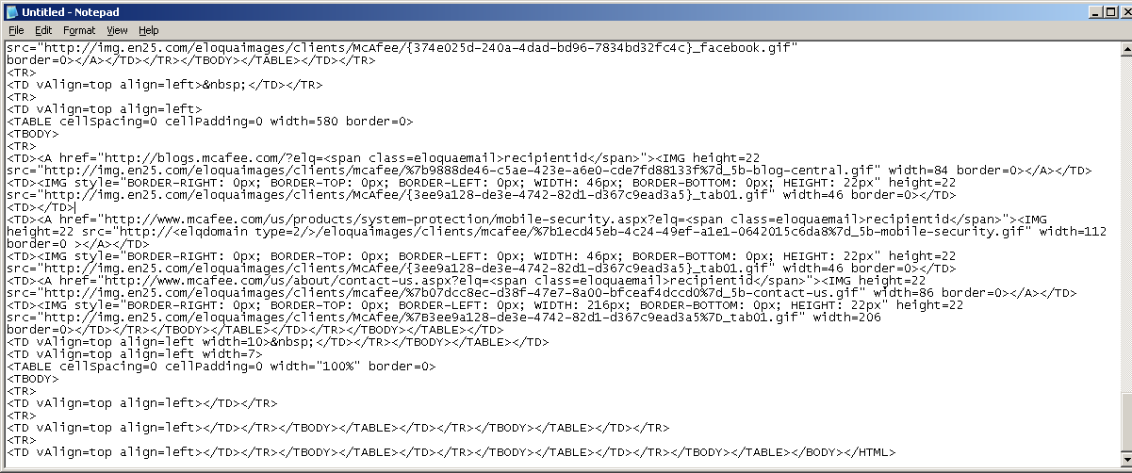
  - In file name field type in your <last name.HTML> alternatively you can type in your last name and select save as HTML (depends on your Windows version)
  - In the Save as type field select All Files from the drop down
  - The default encoding field may remain as is
  - Hit Save

Updating Image Links in the HTML Email
In order for the images to appear properly in your email, you will need to edit the image links. The correct image link url should start with
http://img.en25.com/eloquaimages/clients/mcafee
In some cases, Eloqua will default the image link to:
http://<elqdomain type=2/>/eloquaimages/clients/mcafee
  - Wherever you see the <elqdomain type=2/> in your html, you should replace it with img.en25.com
  - Once you do this, hit save again.

Updating Asset/Page Links in the HTML Email
The links to assets and landing pages will include special coding that Eloqua uses to track the individual contact opens, clicks, etc. When sending emails through Outlook, the tracking code will not work, so you will need to replace these links with the “direct” links. There are two different link types you will find in the email.
Replacing a “Redirect Link”
This is an example of a redirect link:
<A href="http://<elqdomain type=1/>/e/er.aspx?s=<span class=eloquaemail>siteid</span>&lid=5070&elq=<span class=eloquaemail>recipientid</span>">
  - To find the direct link, go to Tools & Content Components> Redirect Links
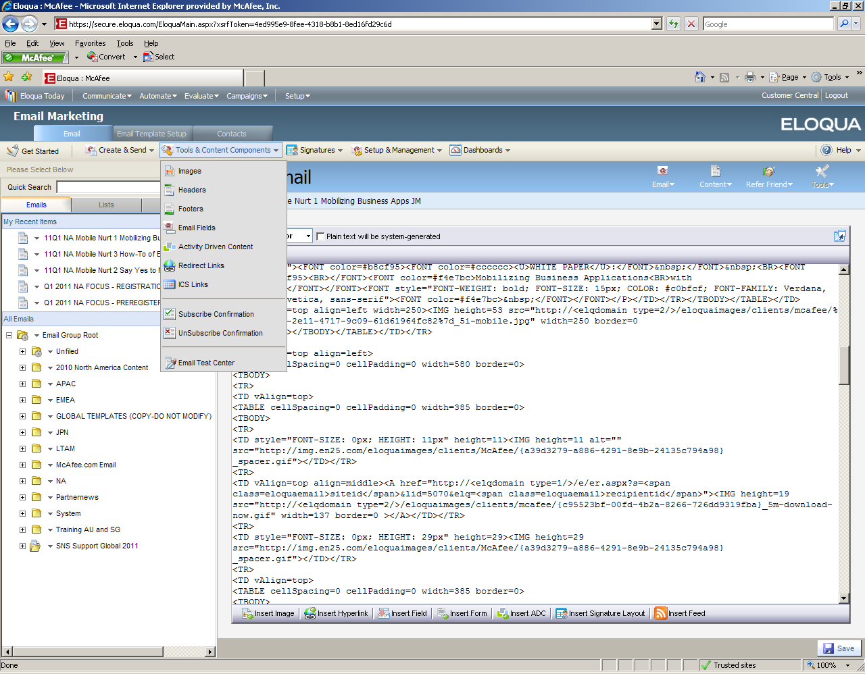

  - Type in the number for the Link ID into the field “Start From Link ID” (the number to enter is following the lid= in the example above) to find the direct url associated with that redirect Link ID referred to as “Redirect Link Name” below.
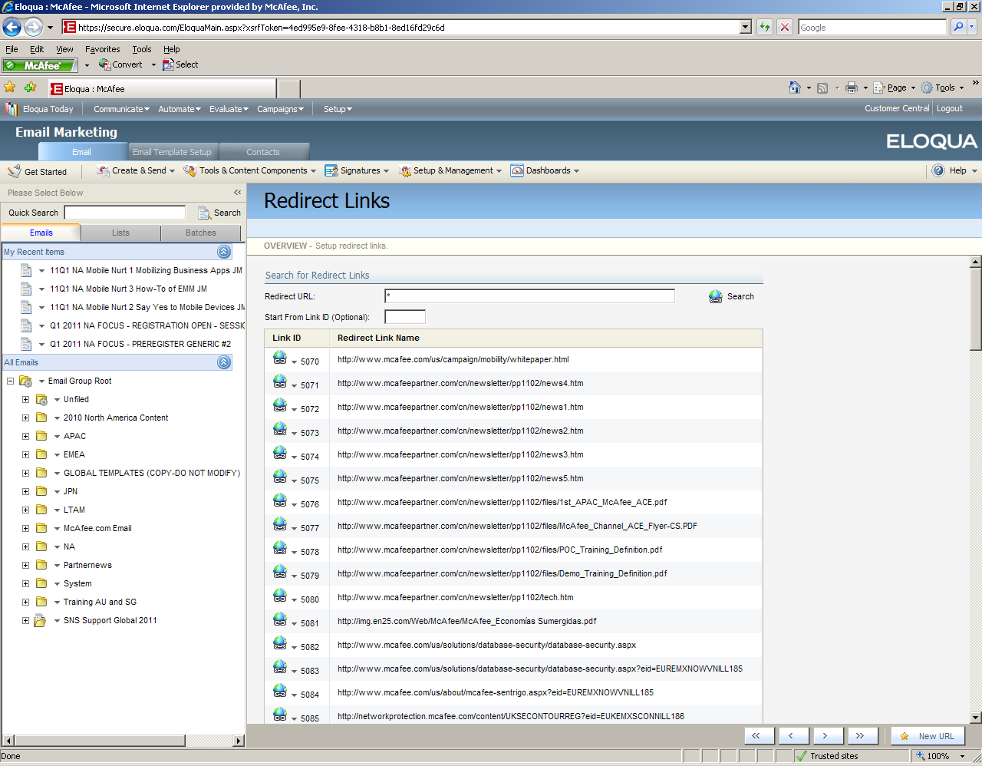
  - In this example of an asset link, you would replace this:
<A href="http://<elqdomain type=1/>/e/er.aspx?s=<span class=eloquaemail>siteid</span>&lid=5070&elq=<span class=eloquaemail>recipientid</span>">
With this:
<A href="http://www.mcafee.com/us/campaign/mobility/whitepaper.html">
  - In some cases, the redirect is easier to edit. Here is another example:
<A href="http://www.mcafee.com/us/campaigns/secure_enterprise_mobility/how_it_works.html?elq=<span class=eloquaemail>recipientid</span>">
In this case, you just remove the eloqua tracking code at the end:
<A href="http://www.mcafee.com/us/campaigns/secure_enterprise_mobility/how_it_works.html">
Adding the Header to the HTML
You will need to add the Eloqua header to the email (because it includes the McAfee branding).
  - To find the header code for your region, go to the original email you extracted and go to “Email Details” under the “Email” tab at the top right.
  - Click the icon next to the header name to open the header selection tool.
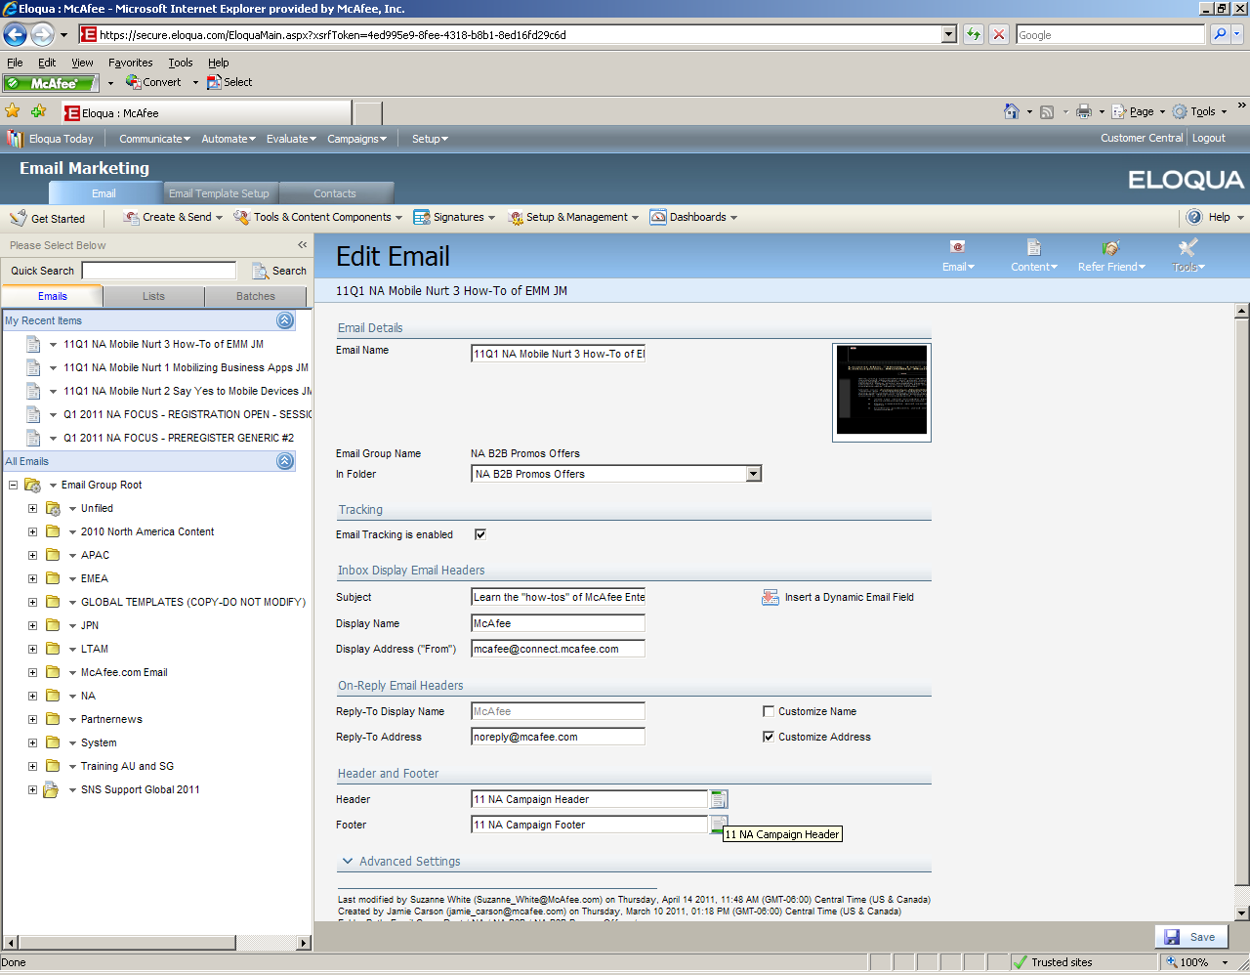

  - Click the “Selected Header” area to display the header editing window.
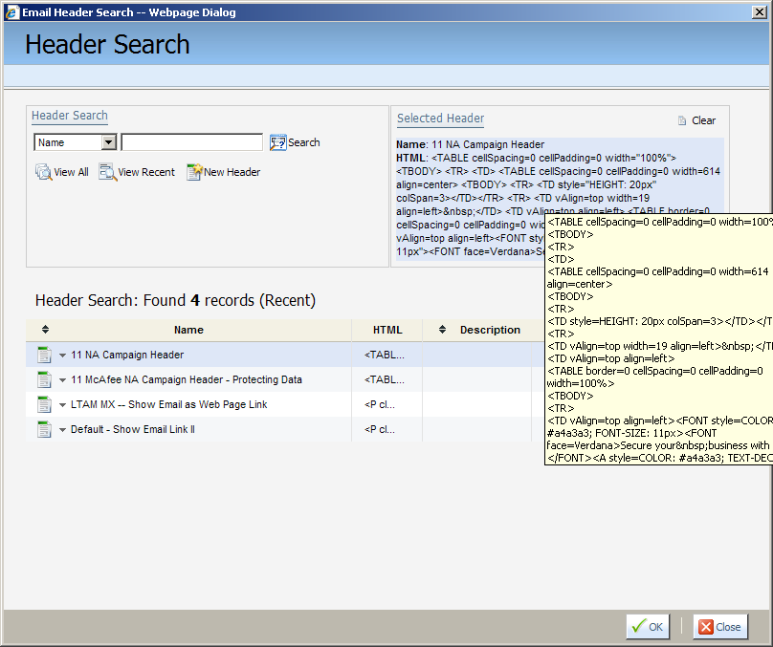
  - Change from “Design Editor” to “Source Editor”
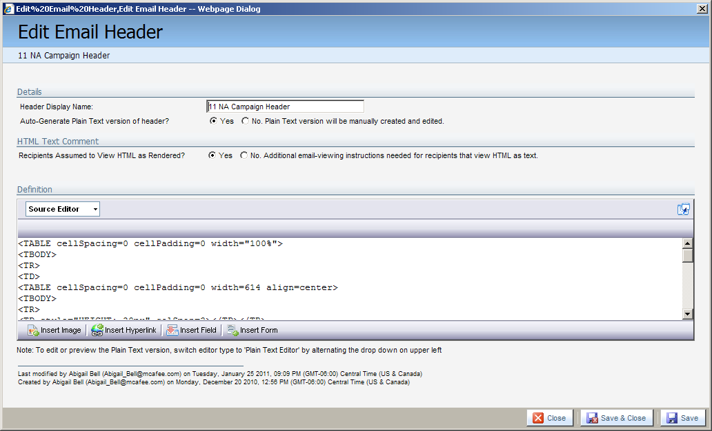

  - Scroll to the end of the code, click at the end and drag all the way to the top to select all the content.
  - Press the “Ctrl” and “c” key at the same time to “Copy” the contents of the Header window.
  - Go to your extracted email in Notepad
  - Add a line just below the first <BODY> tag at the top of the html
  - Place your cursor on the blank line directly under the <BODY> tag
  - Select Edit Paste
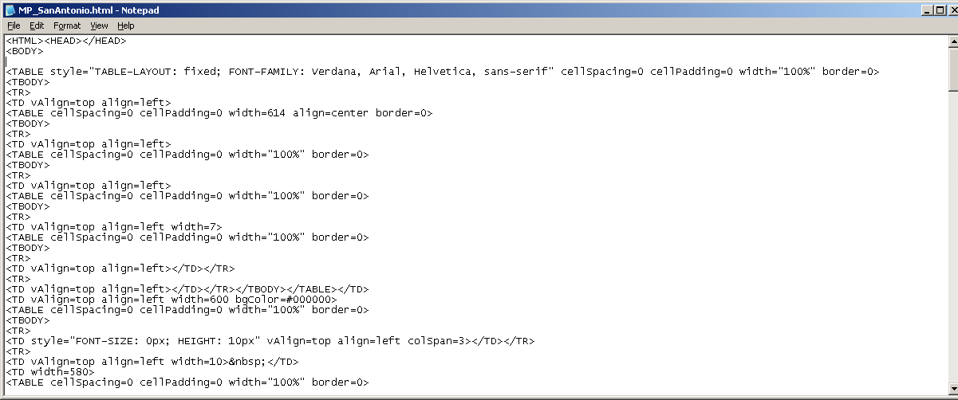
  - You will now see the following code on your Notepad. You will need to make a minor edit to remove the link to the Eloqua generated html version of the email.
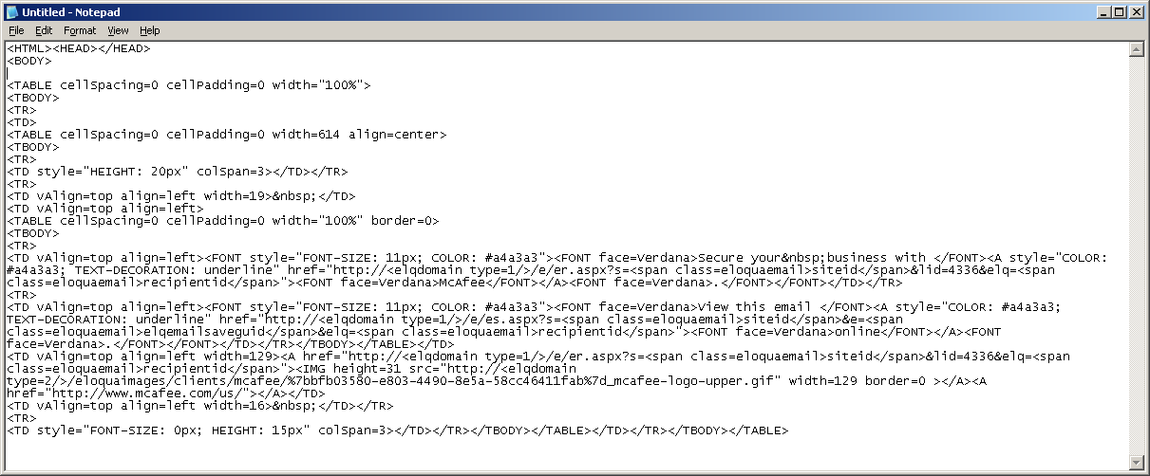
  - Remove the following code from the part you just pasted:
<TD vAlign=top align=left><FONT style="FONT-SIZE: 11px; COLOR: #a4a3a3"><FONT face=Verdana>View this email </FONT><A style="COLOR: #a4a3a3; TEXT-DECORATION: underline" href="http://<elqdomain type=1/>/e/es.aspx?s=<span class=eloquaemail>siteid</span>&e=<span class=eloquaemail>elqemailsaveguid</span>&elq=<span class=eloquaemail>recipientid</span>"><FONT face=Verdana>online</FONT></A><FONT face=Verdana>.</FONT></FONT></TD>
Adding the Footer to the HTML
You will need to add the standard opt-out footer language in order for the email to be compliant with anti-spam laws. The opt-outs are currently managed through IMI for all emails sent outside of Eloqua. So, the content of the opt-out footer will not exactly match what is in Eloqua because the handling of these opt-outs is different when emails are sent outside of the system.
  - The code highlighted below is what you need to insert into your Notepad at the end of the file:
<TBODY>
<TR>
<TD vAlign=top align=left></TD></TR>
<TR>
<TD vAlign=top align=left></TD></TR></TBODY></TABLE></TD></TR></TBODY></TABLE></TD></TR>
<TR>
<TD vAlign=top align=left></TD></TR></TBODY></TABLE></TD>
<TR>
<TD vAlign=top align=left><FONT style="FONT-SIZE: 11px; COLOR: #a4a3a3"><FONT face=Verdana></BR>To manage your email preferences, please go <a href="http://mcafee.imiinc.com/nai7642/addUnsubscribe.do">here.</a></BR></BR>
McAfee, Inc.| 2821 Mission College Blvd | Santa Clara, CA | 95054 | 888.847.8766 | <a href="www.mcafee.com/us">www.mcafee.com</a></BR></BR>
McAfee and/or additional marks herein are registered trademarks or trademarks of McAfee, Inc. and/or its affiliates in the US and/or other countries. McAfee Red in connection with security is distinctive of McAfee brand products. All other registered and unregistered trademarks herein are the sole property of their respective owners. © 2011 McAfee, Inc. All rights reserved
</FONT></TD></TR>
</TBODY></TABLE>
<p></p>
</TD></TR></TBODY></TABLE></BODY></HTML>
  - Highlight the above with your cursor and Right Click
  - Select < Copy
  - Scroll to the bottom of your extracted HTML file in Notepad, and highlight the text as it appears in the screen shot below and Right Click
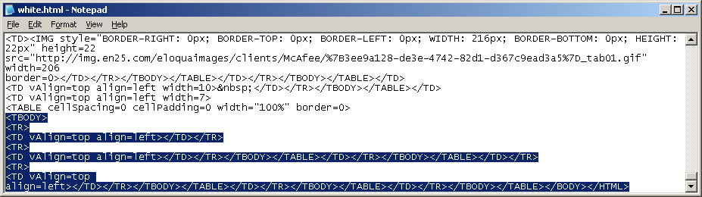
  - Select < Paste
  - Save the file.

Viewing Your HTML
  - Find your HTML from the location where you saved it. It should appear as an HTML page.
  - Double click the file name to open it in your browser window to see if all the links have been corrected and the header and footer are appearing properly.
Inserting Your HTML Email Into Outlook
  - Open a new email in Outlook
  - Go to Insert File or Attach File
  - Browse to find your HTML file
  - Use the down arrow to the right of the Insert button and select “Insert as Text”
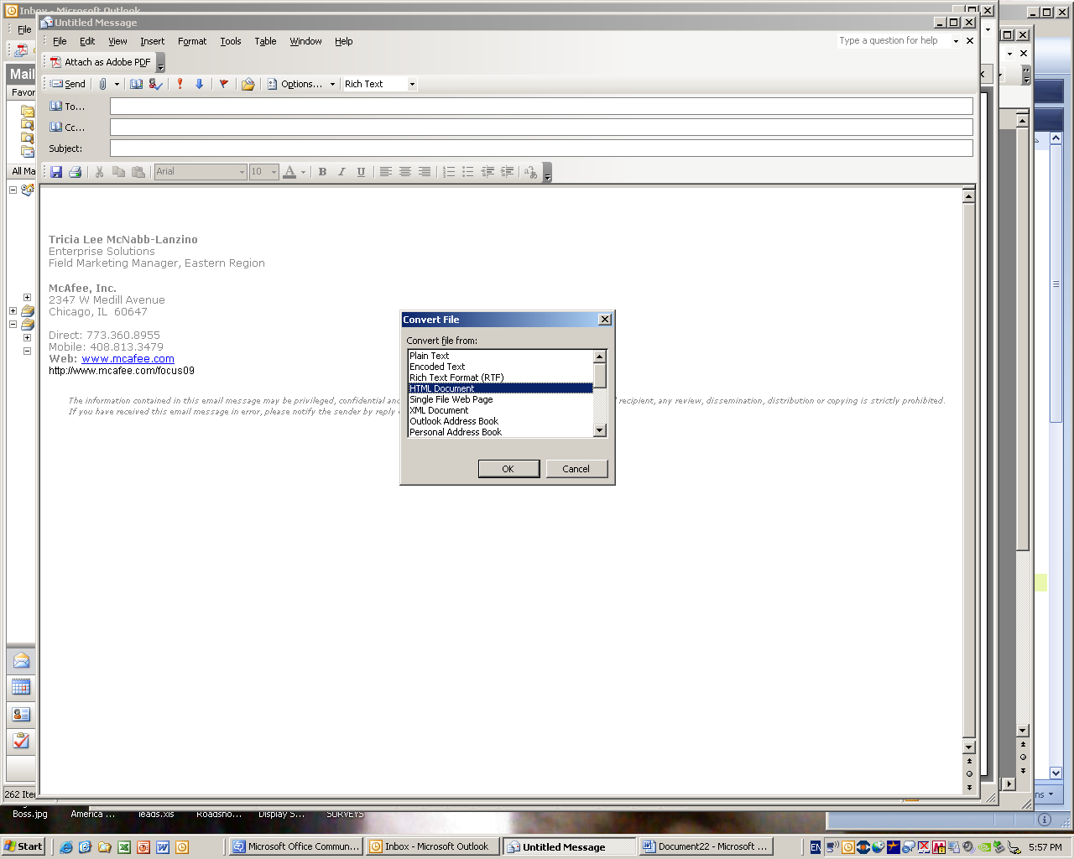
Depending upon your settings, you may be prompted to “Convert file”. Be sure to select “HTML document”.
  - Your HTML is now inserted
  - SAVE within Outlook
Forwarding to Sales for Distribution
It is possible that your sales team will not know how to correctly forward an embedded HTML file. Below are some instructions to include when you send your email out for distribution to sales:
Here is the email (INSERT TOPIC OF EMAIL HERE) that you may forward to your customers. Type a custom intro message is this area or delete from the line up and be sure your email is set to send as HTML. You can select the HTML setting under the Options menu in Outlook.
_____________________________________________

