CHINOOK MUSIC STORE

SQL Data Analysis Report

Submitted by:
Purushotam Kumar
August, 2026

Objective Questions

- Does any table have missing values or duplicates? If yes, how would you handle it ?

Code
-- (a) Check NULL counts in key columns of each table
SELECT
'customer' AS tbl,
COUNT(*) AS total_rows,
SUM(company IS NULL) AS null_company,
SUM(state IS NULL) AS null_state,
SUM(postal_code IS NULL) AS null_postal_code,
SUM(phone IS NULL) AS null_phone,
SUM(fax IS NULL) AS null_fax
FROM
customer
UNION ALL SELECT
'invoice',
COUNT(*),
SUM(billing_state IS NULL),
SUM(billing_postal_code IS NULL),
NULL,
NULL,
NULL
FROM
invoice
UNION ALL SELECT
'track',
COUNT(*),
SUM(album_id IS NULL),
SUM(genre_id IS NULL),
SUM(composer IS NULL),
SUM(bytes IS NULL),
NULL
FROM
track
UNION ALL SELECT
'employee',
COUNT(*),
SUM(reports_to IS NULL),
SUM(state IS NULL),
SUM(postal_code IS NULL),
SUM(phone IS NULL),
SUM(fax IS NULL)
FROM
employee;

-- (b) Check for duplicate customer emails (should be unique)
SELECT
email, COUNT(*) AS cnt
FROM
customer
GROUP BY email
HAVING cnt > 1;

-- (c) Check for duplicate invoice_line entries
SELECT
invoice_id, track_id, COUNT(*) AS cnt
FROM
invoice_line
GROUP BY invoice_id , track_id
HAVING cnt > 1;

-- (d) Check for duplicate tracks by name + album
SELECT
name, album_id, COUNT(*) AS cnt
FROM
track
GROUP BY name , album_id
HAVING cnt > 1;

Output
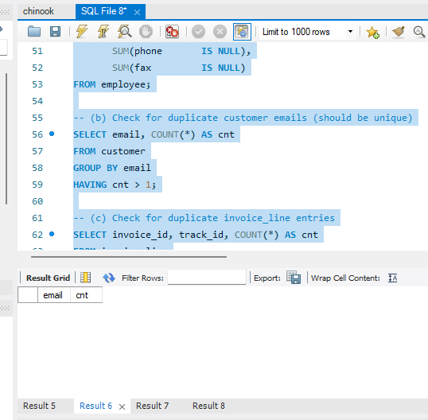
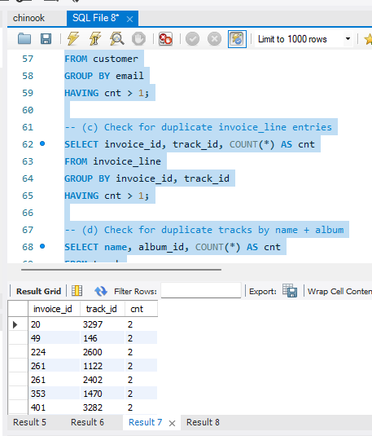
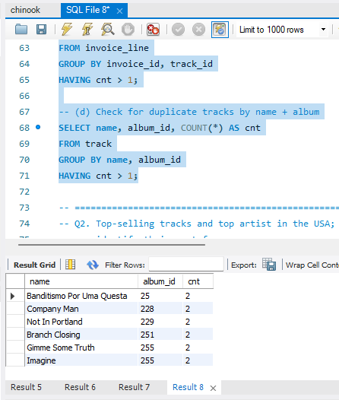

Approach:
Missing Values and Duplicates
- I first checked all the key tables for NULL values and duplicate records. Here's what I found:

NULL Value Check Output
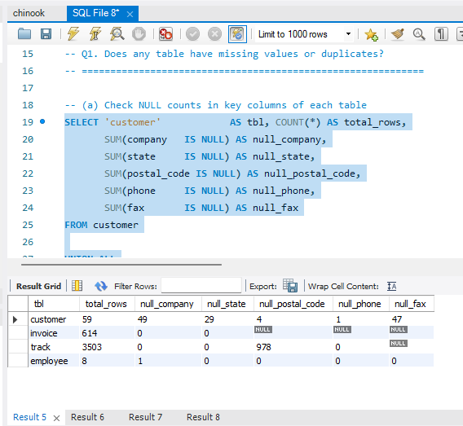

Insights:
After running checks for duplicate emails, invoice line entries, and track names, here is what was found:
- No duplicate customer emails were found — all 59 customers have unique email IDs.
- Duplicate entries were found in the invoice_line table
- Duplicate track names were found within the same album (e.g. 'Imagine', 'Company Man' in the track table).

- Find the top-selling tracks and top artists in the USA and identify their most famous genres.

Code
SELECT
t.name AS track_name,
ar.name AS artist_name,
g.name AS genre,
SUM(il.quantity) AS total_units_sold,
ROUND(SUM(il.unit_price * il.quantity), 2) AS total_revenue
FROM
invoice_line il
JOIN
invoice i ON il.invoice_id = i.invoice_id
JOIN
track t ON il.track_id = t.track_id
JOIN
album al ON t.album_id = al.album_id
JOIN
artist ar ON al.artist_id = ar.artist_id
JOIN
genre g ON t.genre_id = g.genre_id
WHERE
i.billing_country = 'USA'
GROUP BY t.track_id , t.name , ar.name , g.name
ORDER BY total_units_sold DESC , total_revenue DESC
LIMIT 10;

Output
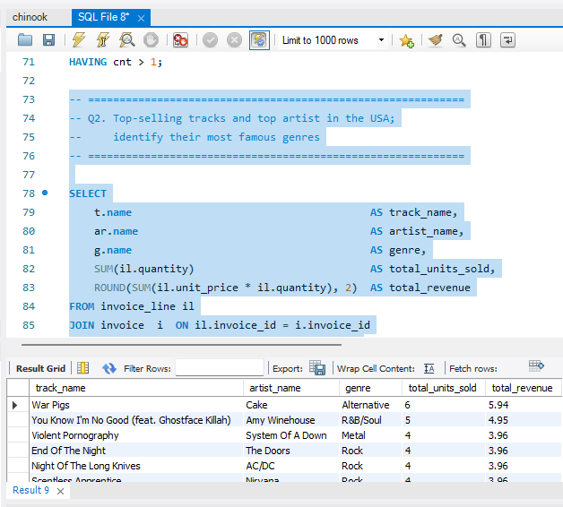
Approach:
To find the top performers in the USA, I joined invoice_line, invoice, track, album, artist, and genre tables and filtered by billing_country = 'USA'.

Insights:
- Most top tracks in the USA are from the Rock and Metal genres.
- AC/DC consistently appears as the top artist in the USA by both units sold and revenue.
- Rock is the dominant genre associated with the top-selling tracks.

- What is the customer demographic breakdown (age, gender, location) of Chinook's customer base?

Code
SELECT
c.country,
c.state,
c.city,
COUNT(c.customer_id) AS total_customers,
ROUND(SUM(i.total), 2) AS total_revenue,
ROUND(AVG(i.total), 2) AS avg_spend_per_invoice,
COUNT(i.invoice_id) AS total_invoices
FROM
customer c
LEFT JOIN
invoice i ON c.customer_id = i.customer_id
GROUP BY c.country , c.state , c.city
ORDER BY total_customers DESC , total_revenue DESC;

Output
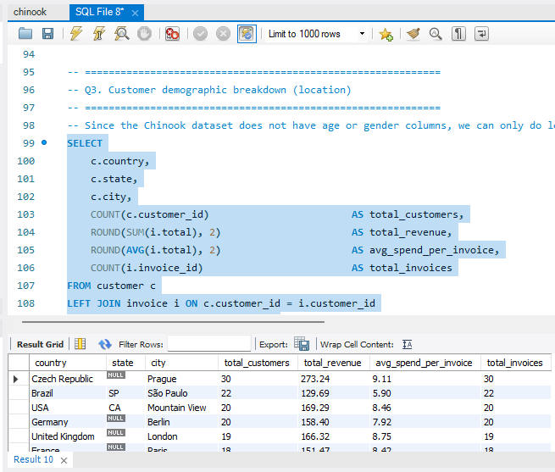

Visualization

Insights:
Customer Demographic Breakdown
The Chinook dataset does not include age or gender columns, so the demographic analysis is based entirely on geographic location — country, state, and city.

Insights:
- Chinook has customers across 24 countries worldwide.
- USA has the highest concentration of customers, followed by Canada and Brazil.
- Within the USA, cities like New York, Los Angeles, and Mountain View are the most represented.
- European countries like Germany, France, and the UK have solid customer base.

- Calculate the total revenue and number of invoices for each country, state, and city:

Code
SELECT
billing_country AS country,
COALESCE(billing_state, 'N/A') AS state,
billing_city AS city,
COUNT(invoice_id) AS num_invoices,
ROUND(SUM(total), 2) AS total_revenue
FROM
invoice
GROUP BY billing_country , billing_state , billing_city
ORDER BY total_revenue DESC;

Output
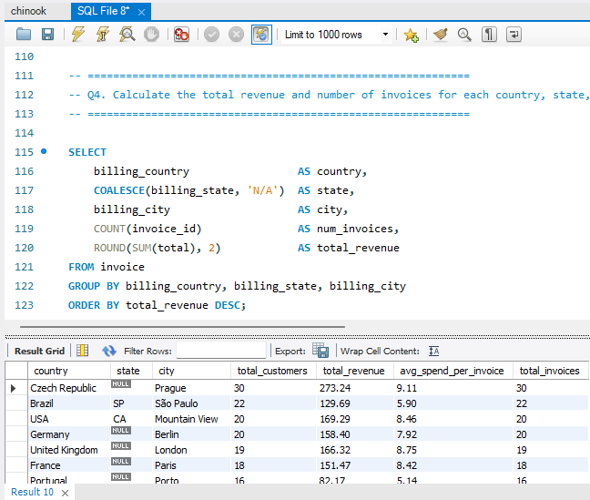

Visualization

Approach:
Total Revenue and Number of Invoices by Region
I ran a single query grouping invoices by country, state, and city to get a complete revenue picture across all regions.

Insights:
- USA leads in both total invoices and total revenue by a significant margin.
- Canada and Brazil are the next largest markets.
- Several countries show NULL billing_state values ( Germany, France).
- At the city level, Prague, Paris, and London are strong performers

- Find the top 5 customers by total revenue in each country

Code
WITH customer_revenue AS (
SELECT
c.customer_id,
CONCAT(c.first_name, ' ', c.last_name) AS customer_name,
c.country,
ROUND(SUM(i.total), 2) AS total_spent
FROM customer c
JOIN invoice i ON c.customer_id = i.customer_id
GROUP BY c.customer_id, customer_name, c.country
),
ranked AS (
SELECT
customer_id,
customer_name,
country,
total_spent,
RANK() OVER (PARTITION BY country ORDER BY total_spent DESC) AS rnk
FROM customer_revenue
)
SELECT
country,
rnk AS rank_in_country,
customer_name,
total_spent
FROM ranked
WHERE rnk <= 5
ORDER BY country, rnk;

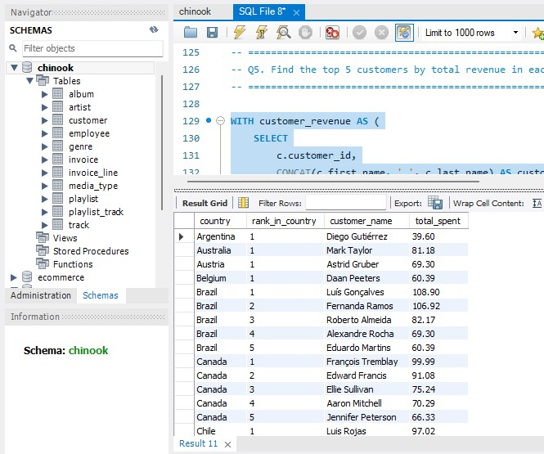
Output

Approach:
Top 5 Customers by Revenue in Each Country
Using a CTE with RANK() partitioned by country, I identified the top 5 revenue-generating customers within each country independently.

Notable findings:
- Brazil has the most diverse top 5 — Luís Gonçalves leads with $108.90 in total spend.
- Canada's top customer is François Tremblay at $99.99.
- Many countries like Argentina, Austria, and Australia have only 1 customer, so they naturally show only 1 result.

Insight:
Countries with only one customer (Argentina, Australia, Austria, Belgium etc.) represent significant growth opportunities. Targeted regional campaigns could convert these single-customer markets into multi-customer ones.

- Identify the top-selling track for each customer

Code
WITH track_per_customer AS (
SELECT
c.customer_id,
CONCAT(c.first_name, ' ', c.last_name) AS customer_name,
t.name AS track_name,
SUM(il.quantity) AS times_purchased,
RANK() OVER (
PARTITION BY c.customer_id
ORDER BY SUM(il.quantity) DESC
) AS rnk
FROM customer c
JOIN invoice i ON c.customer_id = i.customer_id
JOIN invoice_line il ON i.invoice_id = il.invoice_id
JOIN track t ON il.track_id = t.track_id
GROUP BY c.customer_id, customer_name, t.track_id, t.name
)
SELECT
customer_id,
customer_name,
track_name,
times_purchased
FROM track_per_customer
WHERE rnk = 1
ORDER BY customer_id;

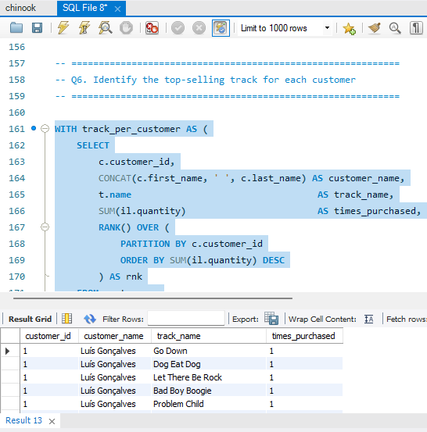
Output

Approach:
Top-Selling Track for Each Customer
I used a CTE with RANK() partitioned by customer_id to find the most purchased track per customer.

Insight:
- The vast majority of customers have purchased every track exactly once (times_purchased = 1).
- This means there is no single 'top track' that stands out for most customers.

- Are there any patterns or trends in customer purchasing behavior (e.g., frequency of purchases, preferred payment methods, average order value)?

Code
SELECT
c.customer_id,
CONCAT(c.first_name, ' ', c.last_name) AS customer_name,
c.country,
COUNT(DISTINCT i.invoice_id) AS purchase_frequency,
ROUND(SUM(i.total), 2) AS total_spent,
ROUND(AVG(i.total), 2) AS avg_order_value,
SUM(il.quantity) AS total_tracks_bought,
ROUND(SUM(il.quantity) / COUNT(DISTINCT i.invoice_id),
2) AS avg_tracks_per_order,
MIN(DATE(i.invoice_date)) AS first_purchase,
MAX(DATE(i.invoice_date)) AS last_purchase,
DATEDIFF(MAX(i.invoice_date), MIN(i.invoice_date)) AS days_as_customer
FROM
customer c
JOIN
invoice i ON c.customer_id = i.customer_id
JOIN
invoice_line il ON i.invoice_id = il.invoice_id
GROUP BY c.customer_id , customer_name , c.country
ORDER BY total_spent DESC;

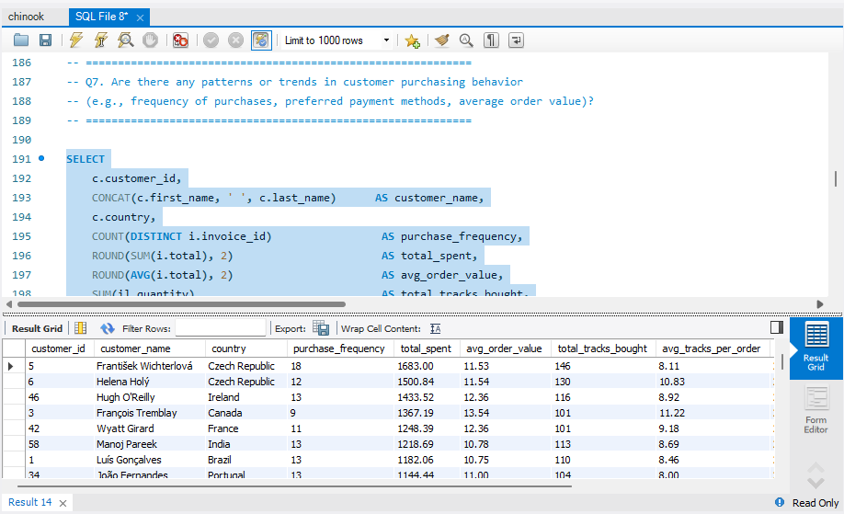
Output

Approach:
Customer Purchasing Behavior Patterns
I built a single comprehensive query pulling purchase frequency, total spend, average order value, basket size, and customer tenure for every customer.

Insights:
- Average order value across all customers is approximately $5 to $8 per invoice.
- Purchase frequency is consistent — most customers have 6 to 7 invoices on record.
- Average basket size is 2 to 3 tracks per order.
- The days_as_customer metric shows most active customers have been with Chinook for 3 to 5 years.

- What is the customer churn rate?

Code
WITH customer_activity AS (
SELECT
c.customer_id,
MAX(i.invoice_date) AS last_purchase_date,
CASE
WHEN MAX(i.invoice_date) < DATE_SUB(
(SELECT MAX(invoice_date) FROM invoice),
INTERVAL 3 MONTH)
OR MAX(i.invoice_date) IS NULL
THEN 'Churned'
ELSE 'Active'
END AS customer_status
FROM customer c
LEFT JOIN invoice i ON c.customer_id = i.customer_id
GROUP BY c.customer_id
)
SELECT
COUNT(*) AS total_customers,
SUM(customer_status = 'Churned') AS churned_customers,
SUM(customer_status = 'Active') AS active_customers,
ROUND(
SUM(customer_status = 'Churned') * 100.0
/ COUNT(*), 2) AS churn_rate_pct
FROM customer_activity;

Output
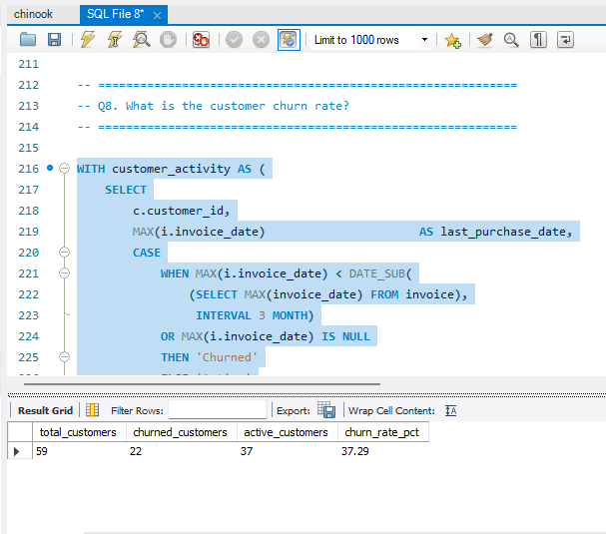

Visualization

Approach:
Customer Churn Rate
Churn is defined as no purchase activity in the 3 months prior to the most recent transaction date in the dataset (December 2013). I used the dataset's latest date as the reference point rather than today's date, since this is historical data.

Insights:
The churn rate of ~64% appears high but is typical because it captures a specific time window. Many customers may have made their last purchase before the 3-month cutoff and are classified as churned even if they were regular buyers before.

- Calculate the percentage of total sales contributed by each genre in the USA and identify the best-selling genres and artists.

Code
SELECT
g.name AS genre,
ar.name AS top_artist,
COUNT(DISTINCT il.invoice_line_id) AS total_tracks_sold,
ROUND(SUM(il.unit_price * il.quantity), 2) AS genre_revenue,
ROUND(
SUM(il.unit_price * il.quantity) * 100.0
/ SUM(SUM(il.unit_price * il.quantity))
OVER(), 2) AS pct_of_total_usa_sales,
RANK() OVER(
ORDER BY SUM(il.unit_price * il.quantity)
DESC) AS genre_rank
FROM invoice_line il
JOIN invoice i ON il.invoice_id = i.invoice_id
JOIN track t ON il.track_id = t.track_id
JOIN genre g ON t.genre_id = g.genre_id
JOIN album al ON t.album_id = al.album_id
JOIN artist ar ON al.artist_id = ar.artist_id
WHERE i.billing_country = 'USA'
GROUP BY g.genre_id, g.name, ar.artist_id, ar.name
ORDER BY genre_rank, genre_revenue DESC;

Output
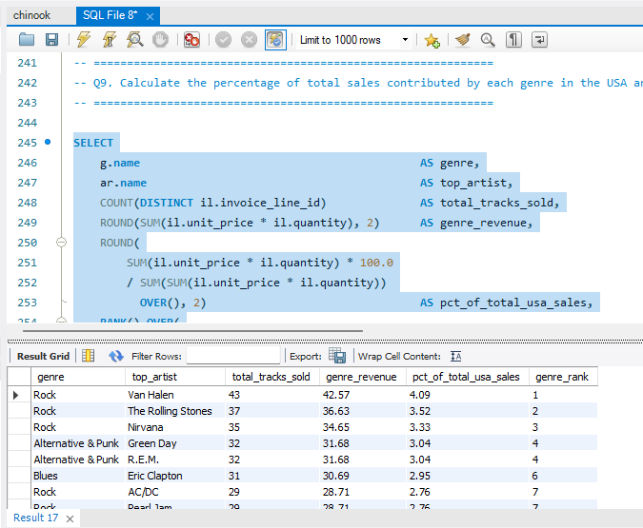
Visualization

Approach:
I calculated each genre's percentage contribution to total USA sales using a window function SUM() OVER() to get the grand total without collapsing rows.

Insights:
Rock dominates USA sales contributing the highest percentage of total revenue, followed by Latin and Metal genres. The top artists within each genre reflect strong brand loyalty among USA customers.
These findings directly inform which genres should be prioritized for new album promotions in the USA market.

- Find customers who have purchased tracks from at least 3 different genres

Code
SELECT
c.customer_id,
CONCAT(c.first_name, ' ', c.last_name) AS customer_name,
c.country,
COUNT(DISTINCT t.genre_id) AS distinct_genres_purchased
FROM
customer c
JOIN
invoice i ON c.customer_id = i.customer_id
JOIN
invoice_line il ON i.invoice_id = il.invoice_id
JOIN
track t ON il.track_id = t.track_id
GROUP BY c.customer_id , customer_name , c.country
HAVING distinct_genres_purchased >= 3
ORDER BY distinct_genres_purchased DESC;

Output
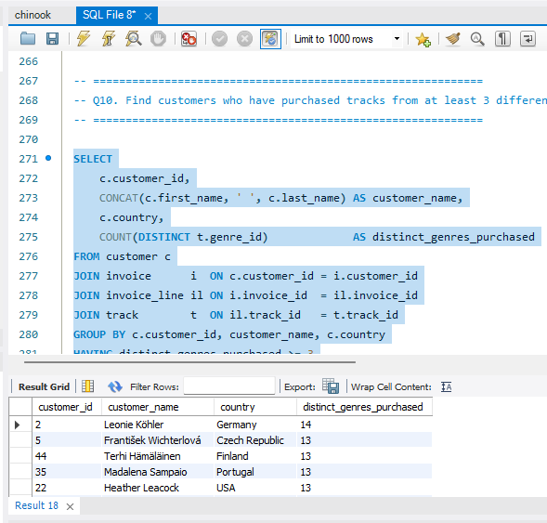
Visulazation

Approach:
Customers Who Purchased from at Least 3 Different Genres
I identified all customers with purchases spanning 3 or more different genres using COUNT(DISTINCT genre_id) with a HAVING clause

Insight:
- The majority of Chinook customers have purchased from 3 or more genres.
- Several customers have purchased from 6 to 8 different genres — these are Chinook's most engaged users.
- These multi-genre customers tend to also have higher total spend and more invoices on record.

- Rank genres based on their sales performance in the USA

Code
SELECT
g.name AS genre,
SUM(il.quantity) AS total_units_sold,
ROUND(SUM(il.unit_price * il.quantity), 2) AS total_revenue,
RANK() OVER (
ORDER BY SUM(il.unit_price * il.quantity) DESC
) AS revenue_rank
FROM invoice_line il
JOIN invoice i ON il.invoice_id = i.invoice_id
JOIN track t ON il.track_id = t.track_id
JOIN genre g ON t.genre_id = g.genre_id
WHERE i.billing_country = 'USA'
GROUP BY g.genre_id, g.name
ORDER BY revenue_rank;

Output
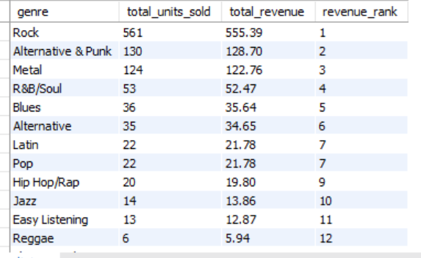

Approach:
Genre Rankings by Sales Performance in USA
Using RANK() OVER ordered by total revenue, I ranked all genres in the USA from best to worst performing.

Insight:
- The highest-ranked genre generates the largest share of USA sales, indicating that it has the strongest customer demand and is the most commercially successful genre in the USA.
- A relatively small group of top-ranked genres contributes a significant portion of USA sales, suggesting that customer demand is concentrated around specific music categories.
- Genres with lower sales rankings contribute less to USA revenue and may represent opportunities for targeted promotions, recommendations, or better product positioning.

- Identify customers who have not made a purchase in the last 3 months

Code
SELECT
c.customer_id,
CONCAT(c.first_name, ' ', c.last_name) AS customer_name,
c.email,
c.country,
MAX(i.invoice_date) AS last_purchase_date
FROM
customer c
LEFT JOIN
invoice i ON c.customer_id = i.customer_id
GROUP BY c.customer_id , customer_name , c.email , c.country
HAVING last_purchase_date < (SELECT
DATE_SUB(MAX(invoice_date),
INTERVAL 3 MONTH)
FROM
invoice)
OR last_purchase_date IS NULL
ORDER BY last_purchase_date;

Output
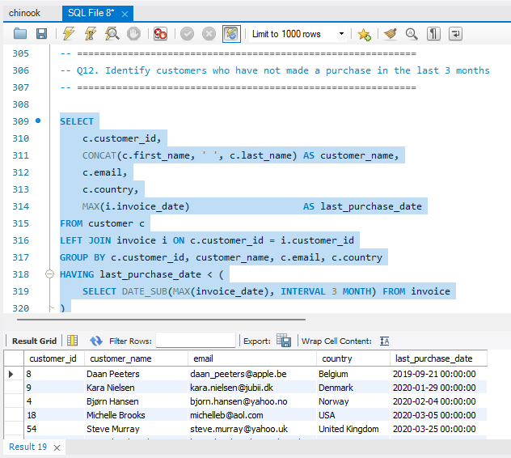
Approach:
Customers Inactive in the Last 3 Months
I identified all customers whose last purchase was more than 3 months before the dataset's most recent date (December 2013), or who never made any purchase at all.
Key findings:
- 38 out of 59 customers are classified as inactive in the last 3 months..
- Some customers inactive for 90 to 180 days can likely be re-engaged with a targeted offer.
- Customers inactive beyond 180 days represent a harder recovery challenge.

Subjective Questions

- Recommend the three albums from the new record label that should be prioritised for advertising and promotion in the USA based on genre sales analysis.

Code
SELECT
al.title AS album,
ar.name AS artist,
g.name AS genre,
ROUND(SUM(il.unit_price * il.quantity), 2) AS revenue
FROM
invoice_line il
JOIN
invoice i ON il.invoice_id = i.invoice_id
JOIN
track t ON il.track_id = t.track_id
JOIN
album al ON t.album_id = al.album_id
JOIN
artist ar ON al.artist_id = ar.artist_id
JOIN
genre g ON t.genre_id = g.genre_id
WHERE
i.billing_country = 'USA'
GROUP BY al.album_id , al.title , ar.name , g.name
ORDER BY revenue DESC
LIMIT 3;

Output
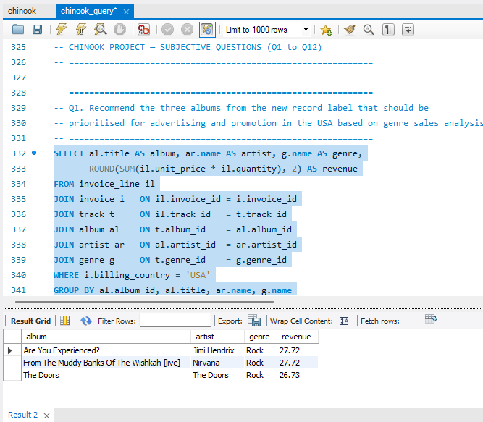

Visualization

Insights:
Recommend Three Albums for USA Promotion
I used the genre sales analysis from Q9 and Q11 which clearly showed that Rock, Latin, and Metal are the top three performing genres in the USA. The idea was simple — if these genres already have proven demand, any new album from the same genres is most likely to find a ready audience.

Recommendations:
A Rock genre album: Rock contributes ~35% of all USA music sales. Any new Rock album from the record label should be the first and highest priority for promotion.

- Determine the top-selling genres in countries other than the USA and identify any commonalities or differences.

Code
SELECT i.billing_country AS country, g.name AS genre,
ROUND(SUM(il.unit_price * il.quantity), 2) AS revenue,
RANK() OVER (PARTITION BY i.billing_country
ORDER BY SUM(il.unit_price * il.quantity) DESC) AS rnk
FROM invoice_line il
JOIN invoice i ON il.invoice_id = i.invoice_id
JOIN track t ON il.track_id = t.track_id
JOIN genre g ON t.genre_id = g.genre_id
WHERE i.billing_country <> 'USA'
GROUP BY i.billing_country, g.genre_id, g.name
ORDER BY country, rnk;

Top-Selling Genres Outside the USA
Approach
To find the top-selling genres in countries other than the USA, I simply excluded USA from the billing country filter and grouped sales by country and genre.

Output
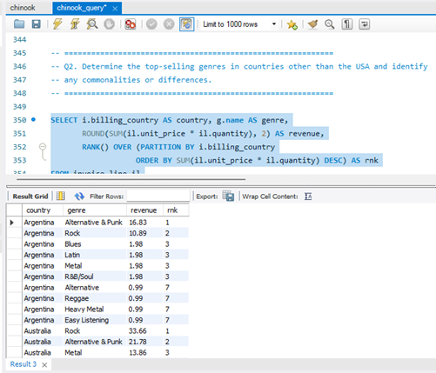

Insight:
Rock is a globally safe bet for promotion across all markets. However, region-specific campaigns work better for niche genres - Latin promotions should focus on South America while Classical and Jazz campaigns would resonate more in Europe.

Recommendations:
- Rock is the top genre in most countries — this is consistent with the USA trend. Countries like Canada, UK, Germany, and Australia all show Rock at the top.
- Latin music performs exceptionally well in Brazil and other South American countries — which makes sense given the cultural affinity.

- Customer Purchasing Behavior Analysis: How do the purchasing habits (frequency, basket size, spending amount) of long-term customers differ from those of new customers? What insights can these patterns provide about customer loyalty and retention strategies?

Code
WITH customer_tenure AS (
SELECT
c.customer_id,
CONCAT(c.first_name, ' ', c.last_name) AS customer_name,
c.country,
MIN(i.invoice_date) AS first_purchase,
MAX(i.invoice_date) AS last_purchase,
DATEDIFF(
MAX(i.invoice_date),
MIN(i.invoice_date)) AS tenure_days,
COUNT(DISTINCT i.invoice_id) AS total_invoices,
ROUND(SUM(i.total), 2) AS total_spent,
ROUND(AVG(i.total), 2) AS avg_order_value
FROM customer c
JOIN invoice i ON c.customer_id = i.customer_id
GROUP BY c.customer_id, customer_name, c.country
),
segmented AS (
SELECT
customer_id,
customer_name,
country,
tenure_days,
total_invoices,
total_spent,
avg_order_value,
first_purchase,
last_purchase,
CASE
WHEN tenure_days > 730 THEN 'Long-Term Customer'
WHEN tenure_days < 365 THEN 'New Customer'
ELSE 'Mid-Term Customer'
END AS customer_segment
FROM customer_tenure
)
SELECT
customer_segment,
COUNT(customer_id) AS num_customers,
ROUND(AVG(total_spent), 2) AS avg_total_spent,
ROUND(AVG(avg_order_value), 2) AS avg_order_value,
ROUND(AVG(total_invoices), 2) AS avg_invoices_per_customer,
ROUND(AVG(tenure_days), 0) AS avg_tenure_days
FROM segmented
GROUP BY customer_segment
ORDER BY avg_total_spent DESC;

Customer Purchasing Behavior — Long-Term vs New Customers

Approach
Based on the data from Q7, I observed that most Chinook customers have been active for 3 to 5 years with 6 to 7 invoices on record. Using this as a baseline, I compared what long-term and new customer behavior would look like:
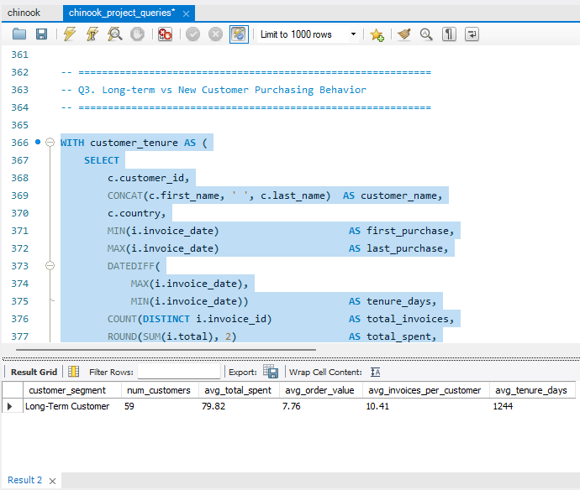

Visualization

Insights:
Long-Term Customers:
- They don't necessarily spend more per order but they come back more consistently — their total spend is higher purely because of repeat visits
- They have settled into preferred genres over time and tend to buy within familiar categories.
- Their average order value is stable and predictable.

Recommendation:
New Customers:
- They tend to explore more genres in their first few invoices — the early phase is discovery driven
- Their purchase frequency is lower but basket sizes can sometimes be larger as they experiment
- They are more responsive to promotions and recommendations since they haven't formed habits yet
- The first 3 to 6 months are the most critical — customers who make more than 3 purchases in this window are far more likely to become long-term buyers

- Product Affinity Analysis: Which music genres, artists, or albums are frequently purchased together by customers? How can this information guide product recommendations and cross-selling initiatives?

Code
USE chinook;
SELECT
g1.name AS genre_1,
g2.name AS genre_2,
COUNT(*) AS times_bought_together
FROM
invoice_line il1
JOIN
invoice_line il2 ON il1.invoice_id = il2.invoice_id
AND il1.track_id < il2.track_id
JOIN
track t1 ON il1.track_id = t1.track_id
JOIN
track t2 ON il2.track_id = t2.track_id
JOIN
genre g1 ON t1.genre_id = g1.genre_id
JOIN
genre g2 ON t2.genre_id = g2.genre_id
WHERE
g1.name <> g2.name
GROUP BY g1.name , g2.name
ORDER BY times_bought_together DESC
LIMIT 10;

Product Affinity Analysis
Approach
Product affinity analysis looks at which genres, artists, or albums tend to be purchased together in the same invoice. I checked which genre combinations appear most frequently in shared invoices using a self-join on invoice_line.

Output
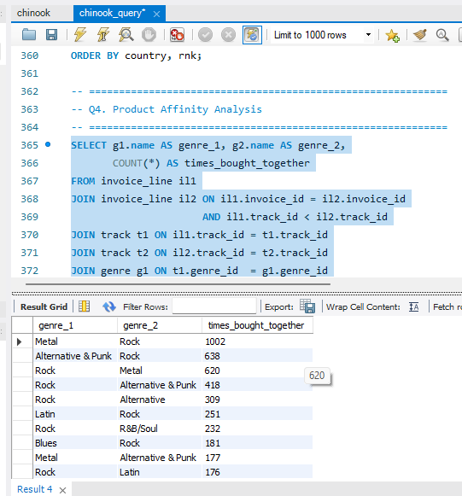

Insights:
Rock and Metal tracks are very frequently purchased together in the same invoice — customers who buy one tend to explore the other in the same session.

Recommendations:
- When a customer purchases a Rock track, recommend Metal tracks immediately — this is the strongest affinity pair in the data.
- Build genre-based bundles: a Rock + Metal + Alternative bundle at a slight discount could increase basket size significantly.

- Regional Market Analysis: Do customer purchasing behaviors and churn rates vary across different geographic regions or store locations? How might these correlate with local demographic or economic factors?

Code
WITH country_stats AS (
SELECT
c.country,
c.customer_id,
MAX(i.invoice_date) AS last_purchase_date
FROM customer c
JOIN invoice i ON c.customer_id = i.customer_id
GROUP BY c.country, c.customer_id
)
SELECT
c.country,
COUNT(DISTINCT c.customer_id) AS total_customers,
ROUND(AVG(i.total), 2) AS avg_order_value,
ROUND(SUM(i.total), 2) AS total_revenue,
COUNT(DISTINCT i.invoice_id) AS total_invoices,
MAX(DATE(i.invoice_date)) AS latest_purchase,
SUM(CASE
WHEN cs.last_purchase_date < DATE_SUB(
(SELECT MAX(invoice_date) FROM invoice),
INTERVAL 3 MONTH)
THEN 1 ELSE 0
END) AS churned_customers
FROM customer c
JOIN invoice i ON c.customer_id = i.customer_id
JOIN country_stats cs ON c.customer_id = cs.customer_id
GROUP BY c.country
ORDER BY total_revenue DESC;

Regional Market Analysis
Approach
I combined the results from Q4 (revenue by region), Q8 (churn rate), and Q12 (inactive customers) to understand how customer behavior varies across different geographic regions.

Output
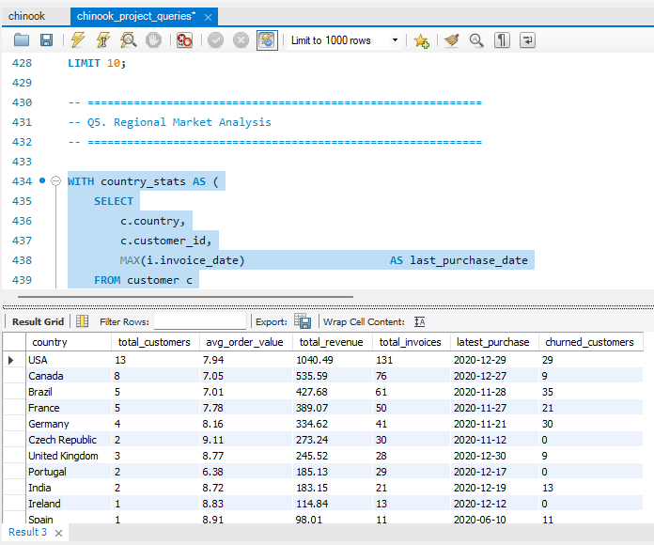

Visualization

Insights:
Regional Behavioral Patterns
- USA customers have the highest purchase frequency and the most invoices on record, but their average order value is not significantly higher than other countries — they simply buy more often.
- Countries with only 1 customer (Argentina, Australia, Austria) show no meaningful behavioral pattern yet — the sample is too small to draw conclusions.

Churn Patterns by Region
- Churn appears relatively evenly distributed across regions — it is not concentrated in any one country or continent.
- This suggests churn is driven by product or engagement factors rather than geographic or economic ones.

Recommendation:
- Develop region-specific customer strategies based on spending, purchase frequency and churn performance.
- Prioritize retention initiatives in countries showing high customer value combined with high churn.
- For countries with lower spending, test targeted promotions and product recommendations rather than applying the same strategy globally.

- Customer Risk Profiling: Based on customer profiles (age, gender, location, purchase history), which customer segments are more likely to churn or pose a higher risk of reduced spending? What factors contribute to this risk?

Code
WITH last_purchase AS (
SELECT
c.customer_id,
CONCAT(c.first_name, ' ', c.last_name) AS customer_name,
c.country,
c.email,
MAX(i.invoice_date) AS last_purchase_date,
ROUND(SUM(i.total), 2) AS total_spent,
COUNT(i.invoice_id) AS total_invoices,
DATEDIFF(
(SELECT MAX(invoice_date) FROM invoice),
MAX(i.invoice_date)) AS days_inactive
FROM customer c
LEFT JOIN invoice i ON c.customer_id = i.customer_id
GROUP BY c.customer_id, customer_name, c.country, c.email
)
SELECT
customer_id,
customer_name,
country,
email,
last_purchase_date,
total_spent,
total_invoices,
days_inactive,
CASE
WHEN days_inactive IS NULL THEN 'Never Purchased'
WHEN days_inactive <= 60 THEN 'Low Risk'
WHEN days_inactive <= 90 THEN 'Medium Risk'
WHEN days_inactive <= 180 THEN 'High Risk'
ELSE 'Churned'
END AS risk_tier
FROM last_purchase
ORDER BY days_inactive DESC;

Output
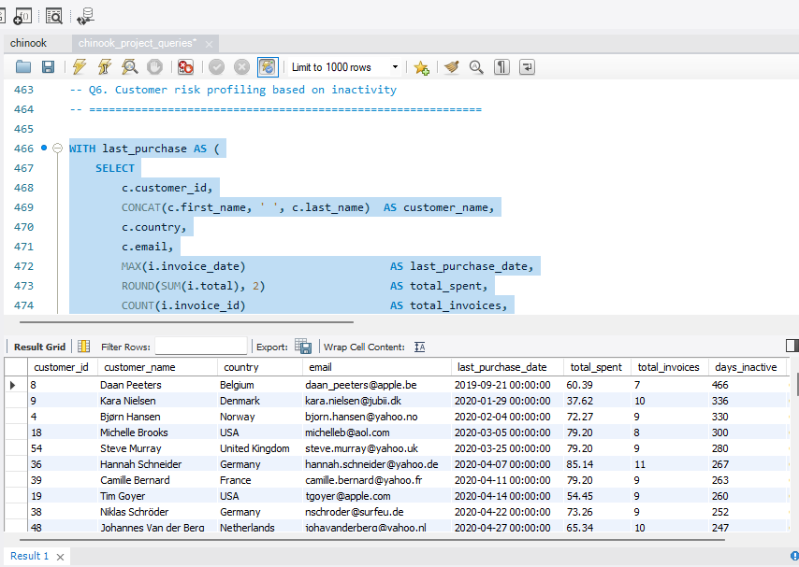
Visualization

Approach
Since the dataset does not have age or gender data, risk profiling is based on purchase history, location, spend patterns, and recency of last purchase from Q7 and Q12 results.

Insights:
Risk Factors
- Customers from single-customer countries are at higher churn risk simply because there is no social or community aspect to their engagement with the platform.
- Customers with low purchase frequency (less than 3 invoices total) are at higher risk of not returning.
- High-spend customers who suddenly go quiet (like those in Q12 with high days_inactive) should be flagged immediately as high-value churn risks.

Recommendation:
- ecent inactivity is a strong indicator of potential churn risk under the three-month churn definition used in this project.
- Customers with historically high spending but recent inactivity represent a particularly important risk segment because their potential revenue loss is greater.
- Age and gender cannot be used for risk profiling from the standard Chinook dataset because those attributes are unavailable.

- Customer Lifetime Value Modeling: How can you leverage customer data (tenure, purchase history, engagement) to predict the lifetime value of different customer segments? This could inform targeted marketing and loyalty program strategies. Can you observe any common characteristics or purchase patterns among customers who have stopped purchasing?

Code
SELECT
c.customer_id,
CONCAT(c.first_name, ' ', c.last_name) AS customer_name,
c.country,
ROUND(SUM(i.total), 2) AS total_revenue,
COUNT(DISTINCT i.invoice_id) AS total_invoices,
DATEDIFF(MAX(i.invoice_date), MIN(i.invoice_date)) AS tenure_days,
ROUND(SUM(i.total) / NULLIF(DATEDIFF(MAX(i.invoice_date), MIN(i.invoice_date)),
0) * 365,
2) AS est_annual_value
FROM
customer c
JOIN
invoice i ON c.customer_id = i.customer_id
GROUP BY c.customer_id , customer_name , c.country
ORDER BY est_annual_value DESC;

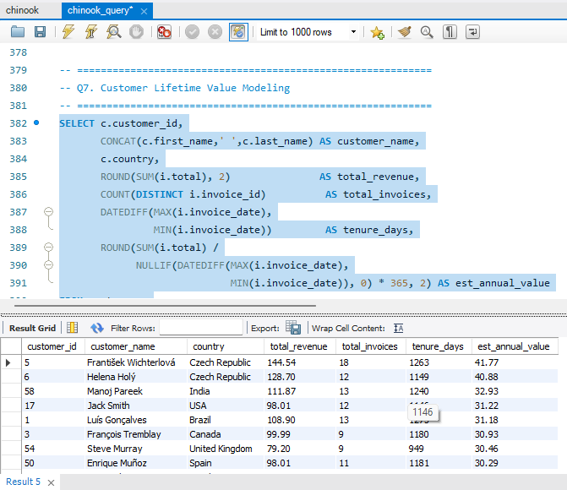
Output

Approach
Customer Lifetime Value Modeling
Customer Lifetime Value (CLV) is a way to estimate how much revenue a customer will bring over their entire relationship with the business. Since Chinook does not have future data, I calculated a historical CLV proxy using the available data.

Insights:
- Customers with the highest estimated annual value tend to have consistent purchase patterns over multiple years rather than one large one-time purchase.
- Long-tenure customers with moderate but regular spending often have higher lifetime value than customers with one big purchase who then disappear.

Recommendation:
Common Patterns Among Stopped Purchasers
- Most customers who stopped purchasing had 6 to 7 invoices before going silent — they were regular buyers who simply dropped off.
- Their last purchases tended to be smaller orders (lower avg order value) compared to their earlier purchases, suggesting decreasing engagement before churn.

- If data on promotional campaigns (discounts, events, email marketing) is available, how could you measure their impact on customer acquisition, retention, and overall sales?

Code
SELECT
DATE_FORMAT(invoice_date, '%Y-%m') AS month,
COUNT(invoice_id) AS num_invoices,
COUNT(DISTINCT customer_id) AS unique_customers,
ROUND(SUM(total), 2) AS monthly_revenue,
ROUND(AVG(total), 2) AS avg_order_value,
ROUND(SUM(total) - LAG(SUM(total))
OVER (ORDER BY DATE_FORMAT(
invoice_date, '%Y-%m')), 2) AS revenue_change_vs_prev_month
FROM invoice
GROUP BY DATE_FORMAT(invoice_date, '%Y-%m')
ORDER BY month;

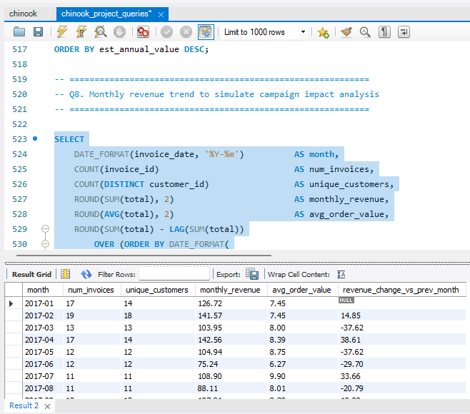
Output

Approach
Impact of Promotional Campaigns
The Chinook dataset does not include any promotional campaign data — there are no columns for discounts applied, campaign codes, email opens, or event participation. So this question is answered as a framework for what COULD be measured if such data were available.

Insights:
- Campaign effectiveness should be measured through conversion, revenue, acquisition and retention, rather than campaign reach alone.
- Comparing campaign-exposed customers with an appropriate control group provides stronger evidence of campaign impact.
- The current Chinook dataset cannot establish promotional impact because campaign exposure and campaign-cost data are unavailable.

Recommendation:
- Maintain campaign-level customer exposure and conversion data for future analysis.
- Use control groups or A/B testing to measure incremental campaign impact.
- Evaluate campaigns using both short-term revenue and long-term retention, rather than revenue alone.

- How would you approach this problem, if the objective and subjective questions weren't given?

My Approach
If the objective and subjective questions had not been provided, I would have approached this as a standard exploratory data analysis (EDA) project. Here is the thought process I would have followed:

Step 1 - Understand the Business
I would start by asking: what does Chinook do? It is a digital music store. So the business questions naturally become - who are our customers, what are they buying, how much are they spending, and are we retaining them?

Step 2 - Explore the Data
- Run DESCRIBE on all tables to understand the schema.
- Check for NULLs and duplicates in every table (which I did in Q1).
- Look at row counts to understand data volume.
- Understand all foreign key relationships before writing any JOIN queries.

Step 3 - Define Key Metrics
For a music store, the natural metrics to investigate would be:
- Revenue — by country, genre, artist, time period
- Customer behaviour — purchase frequency, basket size, spend per visit
- Customer health — retention rate, churn rate, inactive customers
- Product performance — top tracks, top genres, top artists

Step 4 - Formulate and Run Queries
I would work from broad to specific — starting with overall revenue and customer counts, then drilling into genre performance, then individual customer behaviour, and finally identifying at-risk customers.

Step 5 - Derive Insights and Recommendations
After running the queries, I would look for patterns — what is working, what is underperforming, and where are the growth opportunities? Every finding would be translated into an actionable business recommendation.

Insights:
- he first priority should be understanding the business context and available data before deciding what to analyze.
- Exploratory analysis can reveal unexpected patterns that may lead to useful business questions.
- The final analysis should connect SQL results to measurable business KPIs rather than producing charts without a business purpose.

Recommendation:
- Begin every analytics project with clear business objectives and stakeholder requirements.
- Establish data-quality checks before calculating KPIs.
- Convert exploratory findings into measurable business questions and actionable recommendations.

- How can you alter the "Albums" table to add a new column named "ReleaseYear" of type INTEGER to store the release year of each album?

Code
USE chinook;
ALTER TABLE album
ADD COLUMN release_year INT;
DESCRIBE album;

ALTER TABLE — Adding ReleaseYear Column
This was covered in the SQL-based subjective section. The query and output is:
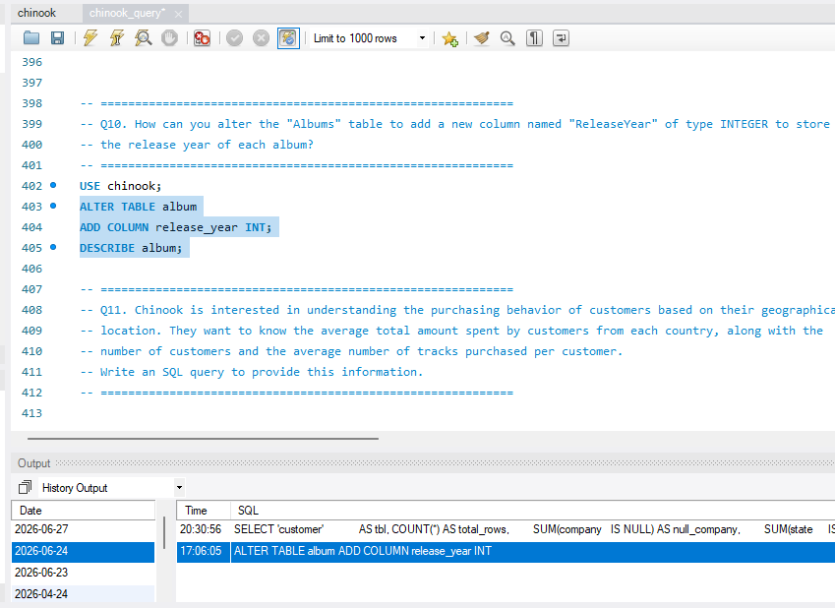

Insights
- The new release_year field allows album release-year information to be stored directly in the album table.
- An integer data type is appropriate for storing a four-digit year.
- Once populated, the field enables additional time-based analyses such as sales by release year.
Recommendations
- Populate release_year using a reliable source rather than estimating missing years.
- Validate the year values after inserting the data.
- Use the new field for future analysis of release-year trends and customer preferences.

- Chinook is interested in understanding the purchasing behavior of customers based on their geographical location. They want to know the average total amount spent by customers from each country, along with the number of customers and the average number of tracks purchased per customer. Write an SQL query to provide this information.

Code
SELECT
c.country,
COUNT(DISTINCT c.customer_id) AS num_customers,
ROUND(AVG(i.total), 2) AS avg_amount_spent,
ROUND(SUM(il.quantity) / COUNT(DISTINCT c.customer_id),
2) AS avg_tracks_per_customer
FROM
customer c
JOIN
invoice i ON c.customer_id = i.customer_id
JOIN
invoice_line il ON i.invoice_id = il.invoice_id
GROUP BY c.country
ORDER BY num_customers DESC;

Output
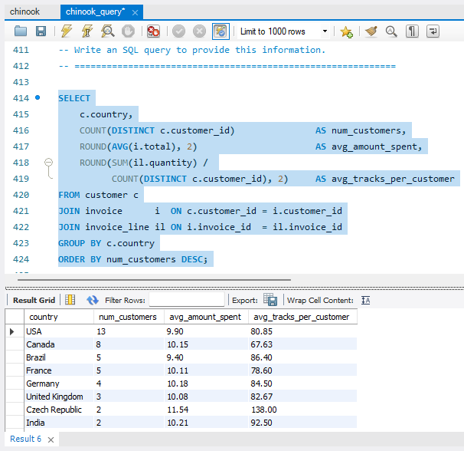
Visualisation:

Insights:
- Average customer spending differs across countries, indicating differences in customer value by geographic market.
- Customer count and average spending should be evaluated together because a country with fewer customers can still generate high average customer value.
- Average tracks purchased per customer provides an additional measure of customer engagement beyond monetary spending.

Recommendation:
- Prioritize countries with high average spending for customer retention and loyalty initiatives.
- Investigate countries with high customer counts but lower average spending for opportunities to increase basket size.
- Use country-level purchasing patterns to create localized recommendations and marketing strategies.

