ANOMADATA

(Automated Anomaly Detection for Predictive Maintenance)

1

AnomaData – Automated Anomaly Detection for Predictive Maintenance

# Context

The issue of equipment failure is a problem that is faced by various industries in different domains. It can result into costly downtime, unsafe environment, and ineffective operations. The idea behind predictive maintenance is to utilise data analytics in the identification of early anomalies that may indicate potential failures before they happen.

# Objective

The objective of the AnomaData project is to predict machine breakdowns through identifying irregularities in collected data. This allows organisations to take preventative measures against equipment failures, optimise their maintenance schedules and improves efficiency of operation overall.

# The Data

Our dataset comprises over 18,000 rows collected over several days. The binary label column, denoted as ‘y,’ indicates the presence of anomalies. The remaining columns serve as predictors, providing valuable insights into equipment behaviour.

# Exploratory Data Analysis (EDA):

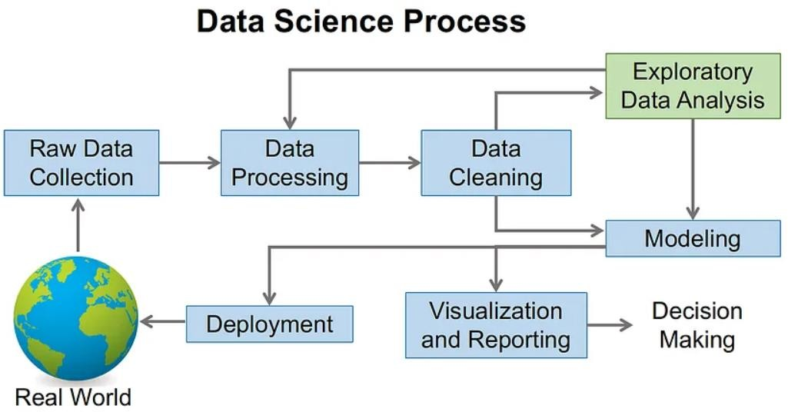

**Purpose: EDA helps us gain insights into the dataset and understand its characteristics.**

Actions:

* Data Patterns and Relationships:
  + Examine statistical summaries (mean, median, standard deviation) for each feature.
  + Identify correlations between features (using correlation matrices or scatter plots).
* Handling Missing Values and Outliers:
  + Check for missing data and decide on an imputation strategy (mean, median, or other methods).
  + Detect outliers using methods like the Interquartile Range (IQR) and decide whether to remove or transform them.
* Visualisation:
  + Create histograms, box plots, and scatter plots to visualize feature distributions and relationships.
  + Explore time series patterns if applicable (e.g., anomalies over time).
* Data Cleaning and Standardisation:
* **Purpose**: Ensure data quality and consistency.
* Standardisation:
* Convert features to a common scale (e.g., z-score normalisation) to avoid bias.
* Handling Missing Values:
  + Impute missing data (mean, median, or other methods) based on context.
  + Consider domain knowledge when making imputation decisions.
* Outlier Treatment:
* Identify extreme values using IQR or other methods.
* Decide whether to remove outliers or transform them (e.g., winsorization).
  + Feature Engineering:
  + **Purpose**: Enhance model performance by creating relevant features.
* Techniques:
* Transformation:
* Interaction Terms:
* Aggregation:
* Combine related features (e.g., sum, average, or count of specific columns).
* Apply mathematical functions (e.g., log, square root) to existing features.

3

* Create new features by combining existing ones (e.g., product of two features).
* Domain-Specific Features:
  + Engineer features based on domain knowledge (e.g., time-based features).
  + Model Selection and Training:
  + **Purpose**: Choose an appropriate ML model and train it.
* Model Choice:
* Train-Test Split:
* Evaluation Metrics:
* Consider the problem type (classification for anomaly detection) and data size.
* Common choices include Random Forest, SVM, or neural networks.
* Divide data into training and testing subsets (e.g., 80% train, 20% test).
* Model Training:
* Fit the chosen model on the training data.
* Select appropriate metrics (accuracy, precision, recall, F1-score) for model evaluation.
  + Hyperparameter Tuning and Model Validation:
  + **Purpose**: Optimize model performance and assess generalization.
* Hyperparameter Tuning:
  + Use techniques like grid search or random search to find optimal hyperparameters.
  + Tune parameters such as learning rate, max depth, or regularization strength.
* Cross-Validation:
* Perform k-fold cross-validation to estimate model performance on unseen data.
* Address overfitting by monitoring training and validation scores.
  + Model Deployment Plan:
  + **Purpose**: Prepare the trained model for production use.
* Integration:
* Scalability:
* Integrate the model into the existing system (e.g., API, web service).
* Monitoring:
* Continuously monitor model performance and retrain if necessary.

4

* + Ensure the model can handle real-time data and scale as needed.

# Future Directions

As I chart the course ahead, AnomaData’s evolution gains momentum.

* Real-time Vigilance:
  + Our compass points toward streaming data integration.
  + Timely alerts will empower proactive maintenance, preventing equipment breakdowns before they unfold.
* Ensemble Exploration:
  + I delve into the art of ensemble methods.
  + By combining models, we unlock robust predictions—our compass needle quivers with anticipation.
* Agile Adaptation:
* The heartbeat of AnomaData lies in continuous improvement.
* Regular model updates, fueled by fresh data insights, propel us toward efficiency and excellence.

# Summary

The project AnomaData has effectively built an automated anomaly detection system for predictive maintenance.With astute application of machine learning methodologies and rigorous preprocessing of the data, the model has achieved a very high level of accuracy in the prediction of breakages of machines.This is not only a milestone achieved but also forms a foundation for further optimisation and industrial application in various industries.

# Source Code

The source code used to create the pipeline can be found in the attached files.

Thank you for the opportunity to work on the AnomaData project. For any further inquiries or assistance, please feel free to reach out.

Sincerely, Purushotham Ganguly

5