**ANGULAR:**

Angular is a development platform for building a single-page application for mobile and desktop.

Angular is not a programming language in itself like javascript. Angular is a Javascript framework which allows us to create single page application(SPA).

FRAMEWORK:

A framework can have pre-defined classes and functions that can be re-used to add several functionalities, which otherwise we would have to write from scratch by our own.

ADVANTAGES OF SPA:

Since we are using javascript to change the content of the page, it is much faster . Here we are not reaching out to the server to request a new piece of HTML data, every time we navigate to a different Url. This allows us to create an application which is fast and reactive.

LIMITATIONS OF JAVASCRIPT/JQUERY:

Javascript or jquery code becomes hard to maintain and we will need a way to properly structure our application.

A lot of applications built using javascript/ jquery is hard to test.

There are some functionalities which we will have to write from scratch when using javascript/ jquery.

ADVANTAGES OF USING ANGULAR;

Angular gives our application a clean and loosely coupled structure that is easy to understand and maintain.

It brings a lot of utility code which can be re-used in lot of applications. Especially, when dealing with user navigation and browser history.

Applications built with angular are more testable.

**Install angular:**

**Install the angular CLI(command line interface),which is used to perform various angular operations, such as creating and running apps, testing and deploying.**

**npm install -g @angular/cli**

**To create a new angular app, we need to use the command.**

**ng new name application-name**

**To run the application we need to use.**

**ng serve –open**

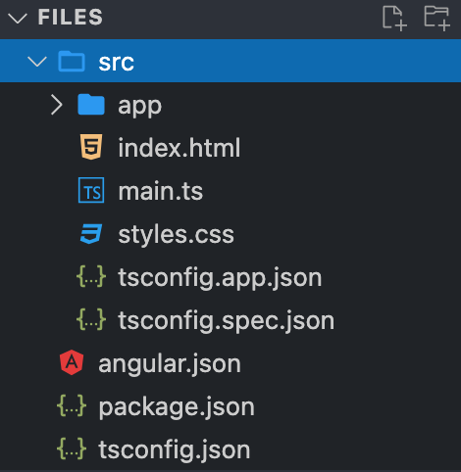

**The source files reside in the src/subfolder.**

**->index.html is the main HTML of the app.**

**->main.ts is the entry point of your app and runs when your app is launched.**

**->style.css is the main css file, which includes the styles for your app.**

**-> The app folder includes app.component.ts and app.component.html file. They represent the root component of our project.**

**Components:**

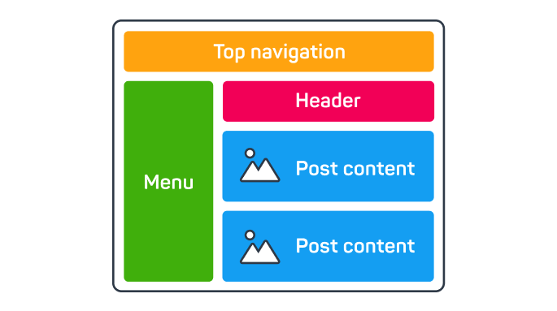

Components are the most basic building blocks of an angular app’s user interface(UI).An angular app has a root component, which is the parent of all the other components used to build the page. The root component is automatically created with a new angular project.

@Component({

selector: 'app-root',

standalone: true,

templateUrl: './app.component.html',

styleUrls: ['./app.component.css'],

})

export class AppComponent { }

The @component decorator specifies metadata for the component class, including the HTML and CSS templates.

The selector property is used to reference the component later as an HTML tag.

For example, the component with the selector ‘app-root’ can be called using the HTML tag <app-root/> in the index.html file.

<body>

<app-root />

</body>

The template Url property links the corresponding html file of the component.

The StyleUrl property links the corresponding css file of the component.

**Component:**

Command : ng generate component Header –standalone –inline-template