 

##### ANY COMPANY

**A MINI PROJECT REPORT**

***Submitted by***

### A.GURU PRASAD (111419205005)

**V.NETHAJI (111419205027)**

### T.KARTHIK (111419205039)

***in partial fulfilment for the award of the degree of***

##### BACHELOR OF TECHNOLOGY

**in**

##### INFORMATION TECHNOLOGY PRATHYUSHA ENGINEERING COLLEGE

**THIRUVALLUR-602 025**

### ANNA UNIVERSITY : CHENNAI 600025

**MAY 2022**

### ANNA UNIVERSITY : CHENNAI 600025 BONAFIDE CERTIFICATE

Certified that this project report **“ANY COMPANY”** is the bonafide work of **T.KARTHIK(111419205039),V.NETHAJI(111419205027)**

**A.GURU PRASAD(111419205005)**who carried out the project work under my supervision.

##### SIGNATURE SIGNATURE

**Dr.R. THIYAGARAJAN, MR.A.SUBBA RAYUDU,**

##### PROFESSOR, ASSOCIATE PROFESSOR, HEAD OF THE DEPARTMENT, SUPERVISOR,

Department of IT, Department of IT,

Prathyusha Engineering College, Prathyusha Engineering college, Thiruvallur- 602 025. Thiruvallur- 602025.

**Place:** Thiruvallur

##### Date:

Submitted for the Project Viva-Voce held on at

PRATHYUSHA ENGINEERING COLLEGE, Thiruvallur - 602 025.

**INTERNAL EXAMINER EXTERNAL EXAMINER**

### ACKNOWLEDGEMENT

Our sincere thank to **Shri. P. RAJARAO,** Chairman Prathyusha Engineering College for facilitating us to do this project.

We are grateful to our CEO, **Smt. P. PRATHYUSHA,** for being a source of Inspiration.

We are sincerely thanking **Dr. B.R. RAMESH BAPU,** Principal, Prathyusha Engineering College for encouraging our endeavours for this project.

We are sincerely thanking **Dr. R.THIYAGARAJAN,** Associate Professor, Head of the Department, for supporting us in all stages of project conduction.

We are grateful to our project coordinator **Ms. K.SHILPA,** Associate professor, for her valuable suggestions and guidance.

We are grateful to our internal guide **MR .A.SUBBA RAYUDU,** Professor, for his valuable suggestions and guidance for the successful completion of this project.

We also wish to extend our sincere thanks to all the committee members for their constant support throughout the review.

We wish to express our sincere gratitude to **PARENTS AND FRIENDS** for valuable help, co-operation and encouragement during this project work.

Last but not least, we wish to express our sincere thanks to the entire teaching faculty and non-teaching staff for their support.

## ABSTRACT

Our Aim is to design and create a data management System for a car rental company.This enables admin can rent a vehicle that can be used by a customer .

This system increases customer retention and simplify vehicle and staff Management in an efficient way.This software car Rental System has a very user friendly interface.

Thus the users will feel very easy to work on it. By using this system admin can manage customer confirm and cancel booking request, customer Testimonials, customer issues. The car information can beadded to the system. Or existed car information can be edited or deleted too by Administrator.There is no delay in the availability of any car information, whenever needed, car information can be Captured very quickly and easily.

The customers can also use the system to get car rent. The customer should create a new account before logging in or he / she can log into the System with his/her created account. Then he/she can book the available cars and can book this car .This system will helpful to the admin as well as to the customer also.

### TABLE OF CONTENTS

|  |  |  |
| --- | --- | --- |
| **CHAPTER NO** | **TITLE** | **PAGENO** |
|  | **ABSTRACT**  **LIST OF FIGURES LIST OF TABLES**  **LIST OF ABBREVIATIONS LIST OF SYMBOLS** | **iv viii**  **ix x** |
| **1.** | **INTRODUCTION**  1.1 OVERVIEW | **1**  2 |
|  | 1.2 OBJECTIVE | 3 |
|  | 1.3 LITERATURE SURVEY | 4 |
| **2.** | **SYSTEM ANALYSIS**  2.1 EXISTING SYSTEM | **6**  7 |
|  | 2.1.1 DISADVANTAGES | 7 |
|  | 2.2 PROPOSED SYSTEM | 7 |
|  | 2.2.1 ADVANTAGES | 7 |

|  |  |  |  |  |
| --- | --- | --- | --- | --- |
| **3.** |  | **SYSTEM REQUIREMENTS 8**  3.1 INTRODUCTION 9 | |  |
|  |  | 3.2 HARDWARE REQUIREMENTS 9 | |  |
|  |  | 3.3 SOFTWARE REQUIREMENTS 9 | |  |
|  |  | 3.4 SOFTWARE DESCRIPTION 10 | |  |
|  | **4.** | **SYSTEM DESIGN 14**   * 1. SYSTEM ARCHITECTURE 15   2. UML DIAGRAMS 17      1. USE CASE DIAGRAM 17 | |  |
|  |  | 4.2.2 CLASS DIAGRAM 18 | |  |
|  |  | 4.2.3 ACTIVITY DIAGRAM 19 | |  |
|  |  | 4.2.4 SEQUENCE DIAGRAM 20 | |  |
|  |  | 4.2.5 COLLABORATION DIAGRAM 21 | |  |
|  | **5.** | **SYSTEM IMPLEMENTATION 24**   * 1. LIST OF MODULES 25   2. MODULE DESCRIPTION 25      1. FINDING MACHINES REQUIRES 25      2. BOOKING MACHINES 26 | |  |
|  |  |  |
|  |  |  |

**6 TESTING 32**

* 1. UNIT TESTING 33
  2. INTEGRATION TESTING 36
  3. SYSTEM TESTING 36

1. RESULTS AND DISCUSSION 37
   1. RESULTS 38
   2. DISCUSSION 38
2. CONCLUSION AND FUTURE ENHANCEMENT 39
   1. CONCLUSION 40
   2. FUTURE ENHANCEMENT 40

##### ANNEXURE

|  |  |  |  |
| --- | --- | --- | --- |
|  | **WEBSITE** SOURCE CODE | |  |
| **REFERENCES** | |  |
|  | |  |
|  | |  |
|  |  |

### LIST OF ABBREVIATIONS

**Android OS** Android Operating System

**XML** Extensible Markup Language

**JVM** Java Virtual Machine

**SOS** Save Our Ship

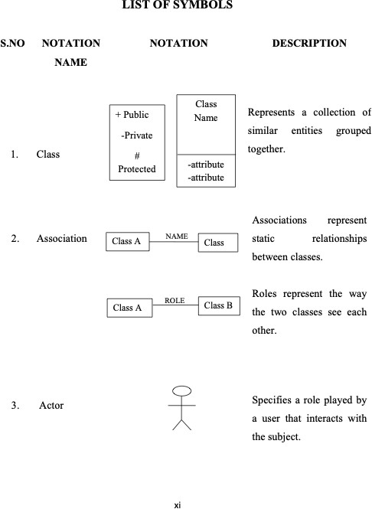

## CHAPTER 1 INTRODUCTION

### CHAPTER 1 INTRODUCTION

##### OVERVIEW

There are three phases to this vehicle rental system.

1. The first phase entails organizing vehicle rental locations into pools and allowing pooled vehicle rental outlets to share a fleet of automobiles.

1. The second phase for each pool determines the types and quantities of vehicles to be acquired and delivered to the auto manufacturer, as well as the geographic redistribution of automobiles among pools across the long-term planning horizon.
2. The third phase entails day-to-day operations, during which the fleet's deployment within each pool and among its locations is determined.
3. Need for Vehicle Rental System

Nowadays, there is Online Vehicle Rental, which benefits users greatly. A rental service is one where customers come to seek the rental of a rental unit. It is more convenient than paying for the unit's ownership and maintenance. A vehicle rental company lends autos for a price for a few hours, a few days, or a week or more.

1. Objective of Vehicle Rental System

The project's goal is to automate vehicle rental and reservation so that clients don't have to waste time calling and waiting for a vehicle. To convert the manual vehicle rental procedure into a digital method. A customer satisfaction test was used to validate the rental automobile system. As a system development reference, create documents such as Software Requirement Specification (SRS) and Software Design Description.

C. Methodology/Procedure The database was designed on PHPMYADMIN, the back end was developed in simple PHP, and we utilized the same basic PHP codes for the frontend. Software methods are concerned with the process of developing software, not so much with the technical elements as with the organizational ones. Since the dawn of information technology, a variety of software development methodologies have been employed.

D. Project Framework A framework is a set of defined concepts, techniques, and criteria for dealing with a certain type of problem that may be used as a guide for approaching and resolving future challenges of the same sort.

E. Data and Information Data gathering plays a vital function in a project's succession and also it plays an unavoidable role in the timely completion of the project. The project's data comprises the clients' contact information as well as their feedback/complaints, which are saved in a database. Only the admin has access to the information given by the clients in order to ensure security.

F. Tools Used

1. XAMPP: a) Apache: (Website application Server) The Apache Software Foundation

developed Apache, also known as Server, which is an opensource Java Servlet Container. b) MySQL Server: It is significantly quicker than previous methods of handling big databases. It comprises a multi-threaded SQL server that supports a variety of back ends, as well as a variety of client website applications and libraries, administrative tools, and website application programming interfaces (APIs). MySQL Server is well-suited for accessing databases via the Internet due to its connection, speed, and security.

2) Sublime Text: Sublime Text is a powerful text editor that can handle code, markup, and prose. The sleek user interface, exceptional features, and outstanding performance will impress you.

3) Web Browsers: Any web browser will suffice.

4) GitHub: GitHub Inc. is a Git-based version control web hosting service. It's primarily utilized in computer programming. It has all of Git's distributed version control and source code management features, as well as those of its own.

### OBJECTIVE

To build an effective, fast and reliable agricultural website application to bridge the direct path between farmers and harvesting machine owners.

### LITERATURE SURVEY

1. System Analysis

System analysis is a thorough examination of a system's different processes and their interrelationships both within and outside the system. The key question here is – why are there so many flaws in the current system? What measures should be taken to address the problem? When a user or management begins a study of the software utilizing the current system, analysis begins. Data was collected on numerous files, decision points, and transactions handled by the current system during the analysis. For example Data Flow Diagrams, etc. are widely utilized in the system. For the collection of important information needed to create the system, training, experience, and common sense are necessary. The system's success is primarily determined by how well the problem is identified, fully studied, and apppriately implemented via the selection of a solution. A good analytical model should include not just methods for comprehending the problem, but also the framework for solving it. As a result, it should be extensively investigated by gathering data about the system. The suggested system should next be extensively examined in light of the requirements. System analysis is divided into four sections.

1) Initial research and system architecture.

2) Using analytic tools to do structured analysis.

3) Feasibility study.

4) Analyze the cost and benefits.

B. Problem Analysis

We are currently creating a new system because there is no existing system at this time. There is currently no system on the market with these features and capabilities. This system is designed for a wide range of users, with a highly adaptable and adjustable solution that will ensure worldwide marketing.

C. Design and Development Problem

1) There is a problem operating XAMPP.

2) During the development process, to debug the mistake.

3) To depict a connection between two or more entities.

4) A database table has a minor mistake.

D. Feasibility Analysis

Once the problem is fully recognized, a feasibility study is carried out.

E. Economical Analysis

The economic feasibility of a system is used to assess the project's or system's advantages as well as the expenses involved. A method known as cost-benefit analysis is used to accomplish this. It offers both concrete and intangible benefits, such as cost savings, increased flexibility, quicker activities, and efficient database administration. The website application is on a medium scale, and it is financially possible for us to complete. This necessitates a cost-benefit analysis. As a result, there is no issue with excessive costs or cost-benefit analyses.

F. Software Analysis

1) When developing web websites, it takes a long time.

2) The expense of research and analysis to establish the real-world requirement.

3) Implementation of the programme on the server, as well as the expense of web servers.

1. Data Conversion

Data conversion is another expense connected with the implementation of this web application. The previously used software database must be saved and backed up so that no time or money is wasted in the implementation of the new web-based application.

G.Operational Feasibility

The system is operationally practical since it can be used by ordinary users with basic computer abilities who do not require any further training. We created this system with the willingness and capacity to design, administer, and run a system that is simple for end-users to use.

## CHAPTER 2 SYSTEM ANALYSIS

### CHAPTER 2 SYSTEM ANALYSIS

The system study is to provide the description about the existing system, its limitation and proposed system of the project

##### EXISTING SYSTEM:

There is an existing system for rental of cars and bikes services providing companies for the people.

##### DISADVANTAGES

* + - * Always, need of internet access to access website application.
      * Hard complex design at the owner end.
      * More no of features.

##### PROPOSED SYSTEM

The proposed system makes a bridge that any one can register or any company can provide their service to the people.

##### ADVANTAGES

* + - * It will allow the user to easily communicate with the farmer.
      * Easy of access.
      * Customizable.

7

## CHAPTER 3

**SYSTEM REQUIREMENTS**

### CHAPTER 3

**SYSTEM REQUIREMENTS**

##### INTRODUCTION

The requirements specification is a technical specification of requirements for the software products. It is the first step in the requirements analysis process; it lists the requirements of a particular software system including functional, performance and security requirements. The requirements also provide usage scenarios from a user, an operational and an administrative perspective. This describes the project's target audience and its user interface, hardware and software requirements.

##### HARDWARE REQUIREMENTS

Processor : Snapdragon 855 or Higher

Memory : 50MB

RAM : 2GB or Higher.

##### SOFTWARE REQUIREMENTS

Client side requirement : Android phone Client side languages : Html,css,xml.

Backend : javascript,php.

Database : Mysql,tomcat

Operating system : Android 4.4+

Tools : Normal browser

##### SOFTWARE DESCRIPTION

* + 1. **HTML**

HTML, or **HyperText Markup Language**,allows web users to create and structure sections, paragraphs, and links using elements, tags, and attributes. However, it’s worth noting that HTML is not considered a programming language as it can’t create dynamic functionality.

HTML has a lot of use cases, namely:

* **Web development**. Developers use HTML code to design how a browser displays web page elements, such as text, hyperlinks, and media files.
* **Internet navigation**. Users can easily navigate and insert links between related pages and websites as HTML is heavily used to embed hyperlinks.
* **Web documentation**. HTML makes it possible to organize and format documents, similarly to Microsoft Word.

.

* + - 1. **Extensible Markup Language (XML)**

Extensible Markup Language (XML) is a markup language that defines a set of rules for encoding documents in a format that is both human-readable and machine-readable. The design goals of XML emphasize simplicity, generality, and usability across the Internet. The android schema of xml used for UI and Other data sharing like Language , vectors and manifest..

##### CSS

**C**ascading **S**tyle **S**heets, fondly referred to as **CSS**, is a simply designed language intended to simplify the process of making web pages presentable. CSS allows you to websitely styles to web pages. More importantly, CSS enables you to do this independent of the HTML that makes up each web page. It describes how a webpage should look: it prescribes colors, fonts, spacing, and much more. In short, you can make your website look however you want. CSS lets developers and designers define how it behaves, including how elements are positioned in the browser.

##### FIREBASE

Most websites need to know the identity of a user. Knowing a user's identity allows an website to securely save user data in the cloud and provide the same personalized experience across all of the user's devices.

The data is stored and shared across the devices in firebase due the simple and secure architecture of the data sharing in the system.

##### ANDROID

Android OS is the key to establish the future of palm devices. The Website application is made for the android devices and makes it more secure by encrypting the signals with android OS.Our Website runs on Android 4.4+ with help of the gps and camera hardwares.

##### Word press

Word press is the official Integrated Development Environment(IDE) for Google’s Android Operating Systems, built on JetBrains’ Intellij IDEA software and designed specifically for Android Development. our Website is build with the functions using gradle services and jcenter library integration for the Website application for android OS

**Features of website Instant Run**

It is an advanced technology in which it cleverly understands the transmutations done in the website applications and delivers it instantly without taking time to rebuild the apk and installations. So, quickly, you can see the changes in the website

immediately. This is done by launching the URL on an Android websitelication and installing the native libraries with Android Instant websites. Instant Website sometimes known as ” **New Module Wizard**“.

**Visual Layout Editor**

Layout editor helps to build the layout quickly by adding different attributes either by hard-code or drag and drop. The preview of the codes can be seen easily on the visual editor screen and changes can be made accordingly by resizing it dynamically. This will make testing the website application process more facile and more exhaustive.

### Fast Emulator

Android has a great feature of Emulator which is exactly like the android phones to test how the website application looks like in physical devices. It gives real-time experience to the website applications.

### Intelligence Code Editor

It provides you with the intelligent and quick code editor. This will help you and guide you with the accurate code. It helps you to complete code in advance and analyze your code in advance before building.

### Addition of New Activity as a Code Template

Yes, Android also has the feature of templates built-in. If you know to build that accordingly, that makes your task easier. it has both pros and cons, you don’t find every template in Word press.

### Help to Build Up Website for All Devices

Word press builds website applications for every screen size, for wear and gear devices etc. It also can stimulate the various types of features which a hardware has like GPS location tracker, multi-touch.

### Help to Connect with Firebase

Word press helps to give real-time experience with IOT based project development with dynamic upgrades in the website application.Firebase connectivity helps to create direct updates and provide database connectivity.

#### Color Previews

Word press helps to see the code CSS,XML part in a preview to know how perfectly we are designing the website application according to the need before launching the websitelication.

## CHAPTER 4 SYSTEM DESIGN

## CHAPTER 4 SYSTEM DESIGN

System design is the process of planning a new system or to replace the existing system. Simply, system design is like the blueprint for building, it specifies all the features that are to be in the finished product.

##### SYSTEM ARCHITECTURE

A System architecture or systems architecture is the conceptual model that defines the structure, behavior, and more views of a system. An architecture description is a formal description and representation of a system, organized in a way that supports reasoning about the structures and behaviors of the system.

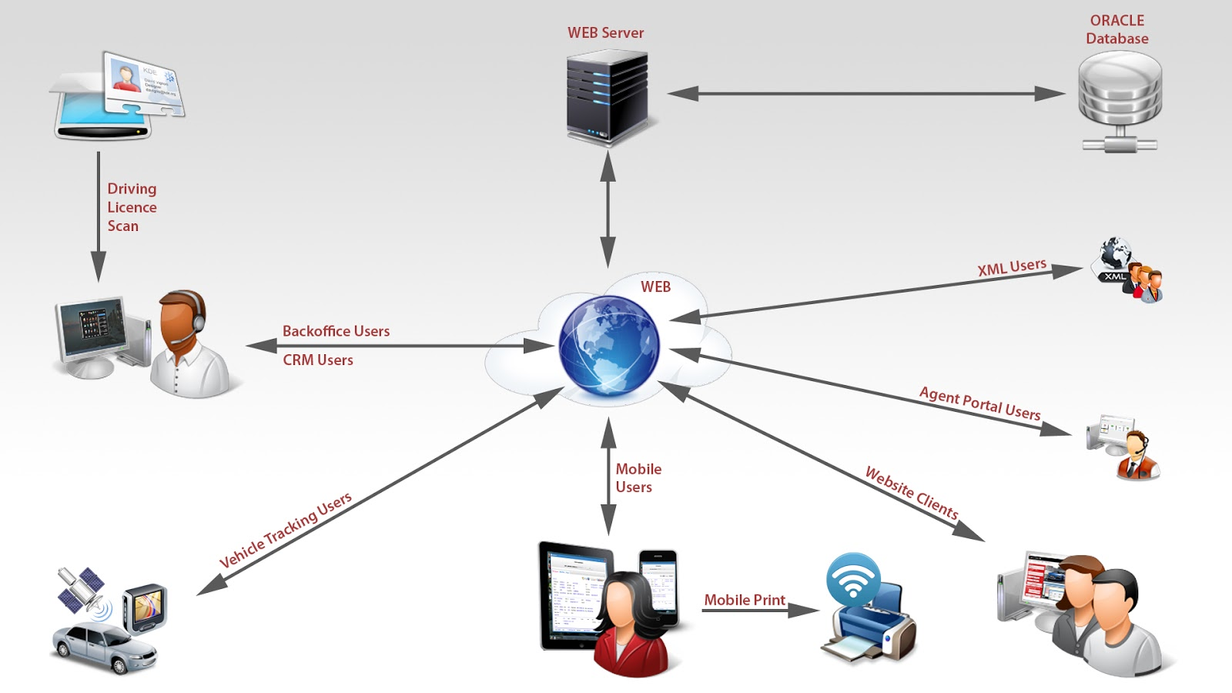

##### Fig 4.1 System Architecture for Any company

* 1. **UML DIAGRAMS**

##### USE CASE DIAGRAM FOR ANY COMPANY

Use Cases are used to describe the visible interactions that the system will have with users and chatbot. They are used to describe how a user would perform their role using the system. In our project, users can take up the acronyms only after login and can continue by giving the acronym and getting its expansion as output.

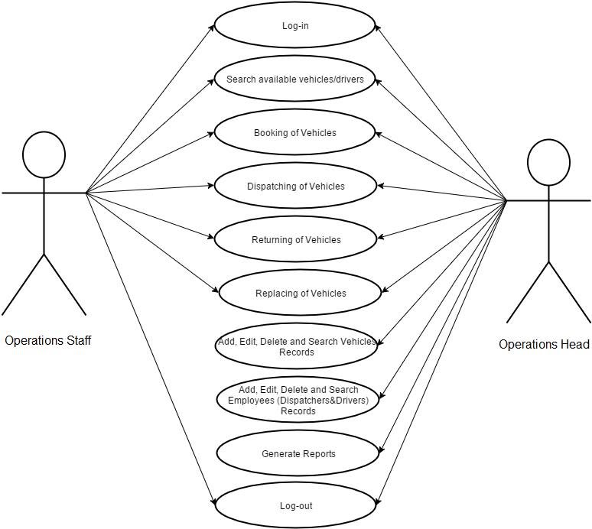

##### Fig 4.2.1 Use case diagram for Any company

* + 1. **CLASS DIAGRAM FOR ANY COMPANY**

The class diagram is a static structure diagram. It represents the static view of an websitelication. In the design of a system, a number of classes are identified and grouped together in a class diagram that helps to determine the static relations between them.here the classes which are defined and able to access the methods and access members which able to make the work in the Android OS to make it more efficient to use multiple classes to get inheritances for future purposes.

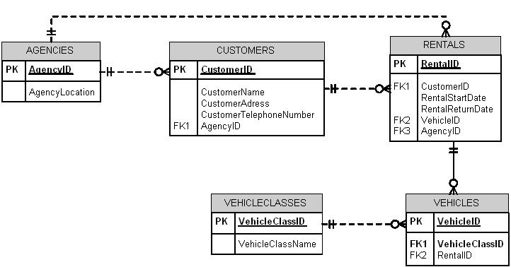

##### Fig 4.2.3 Class diagram for Any company

* + 1. **ACTIVITY DIAGRAM FOR ANY COMPANY**

Activity diagram is defined as a UML diagram that focuses on the execution and flow of the behavior of a system instead of implementation. It is also called object-oriented flowchart. Activity diagrams consist of activities that are made up of actions which websitely to behavioral modeling technology. Users need to register and after that, they need to log in to go to the main screen.

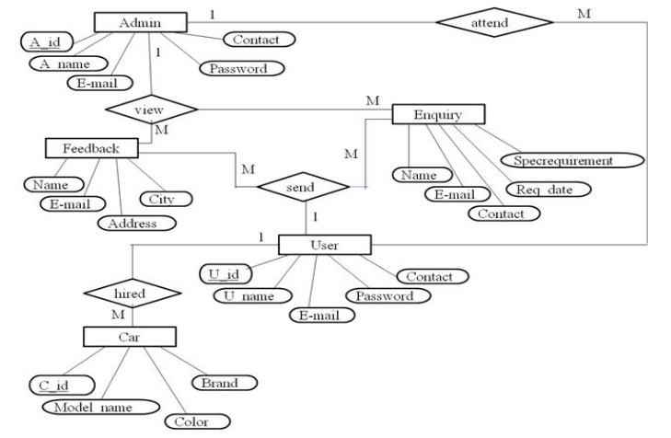

##### Fig 4.2.2 Activity diagram for Any company

* + 1. **SEQUENCE DIAGRAM FOR ANY COMPANY**

A Sequence diagram is a kind of interaction diagram that shows how processes operate with one another and in what order. It is a construct of a Message Sequence Chart. A sequence diagram shows object interactions arranged in time sequence. It depicts the objects and classes involved in the scenario and the sequence of messages exchanged between the objects needed to carry out the functionality of the scenario.

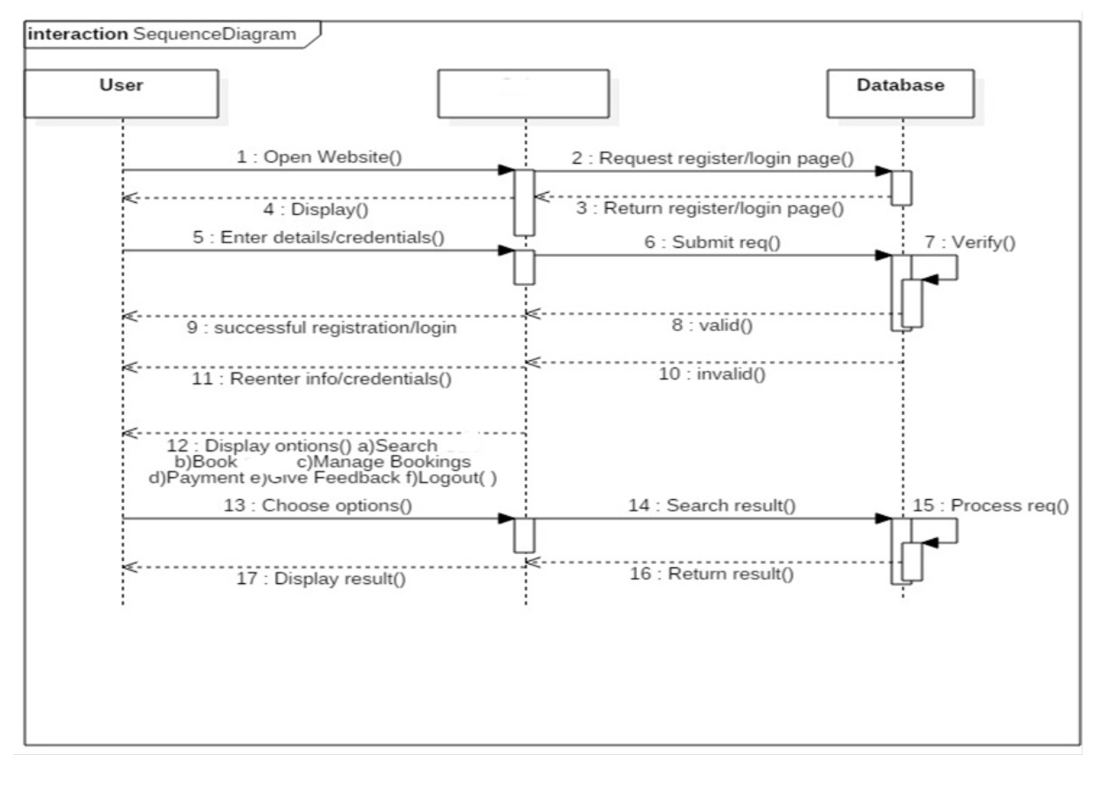

vehicle

##### Fig 4.2.4 Sequence diagram for Any company

* + 1. **COLLABORATION DIAGRAM FOR ANY COMPANY**

A collaboration diagram, also called a communication diagram or interaction diagram, is an illustration of the relationships and interactions among software objects in the Unified Modeling Language (UML). The concept is more than a decade old although it has been refined as the modeling paradigms have evolved. The different services need to interact to get the right information at the right time which is possible by threading from the different processes.

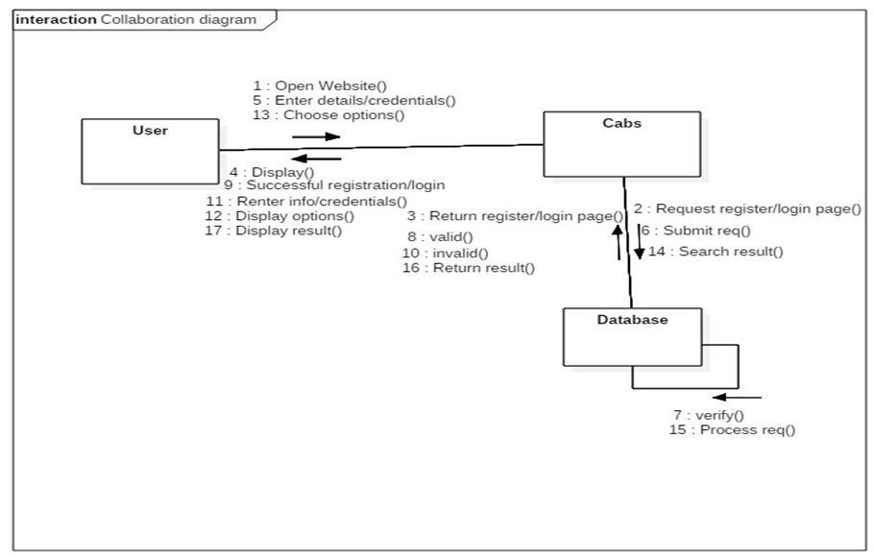

vehicles

**Fig 4.2.5 Collaboration diagram for Any company**

## CHAPTER 5

**SYSTEM IMPLEMENTATION**

### CHAPTER 5

**SYSTEM IMPLEMENTATION**

##### LIST OF MODULES

* + 1. **Finding the suitable machine needed**
    2. **Booking the machine**
    3. **Request booking**
    4. **Accepting booking from owner side.**
  1. **MODULE DESCRIPTION**

##### Finding the suitable machine

* + - * 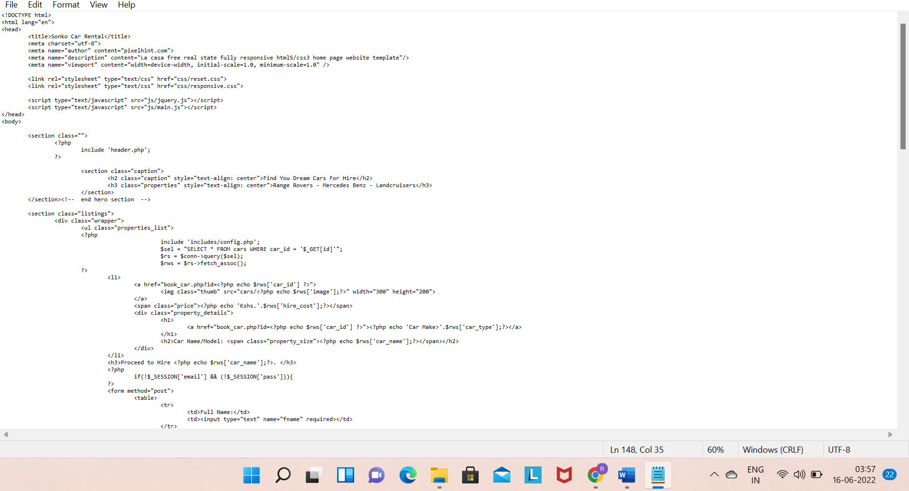

##### Booking the machine

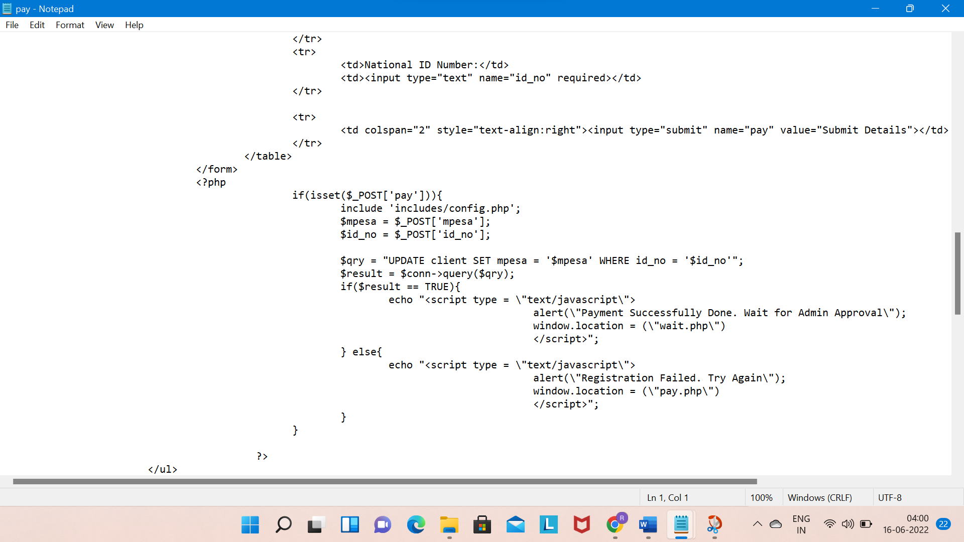

##### Connectivity with Database

##### 

##### UI Designs

* + - * The mobile website consists of three activities namely login activity,signup activity and main activity.
      * If the user is using the website for the first time,then he/she has to sign up by providing the required details.
      * Else the user can login once and interact with the Any company(website).

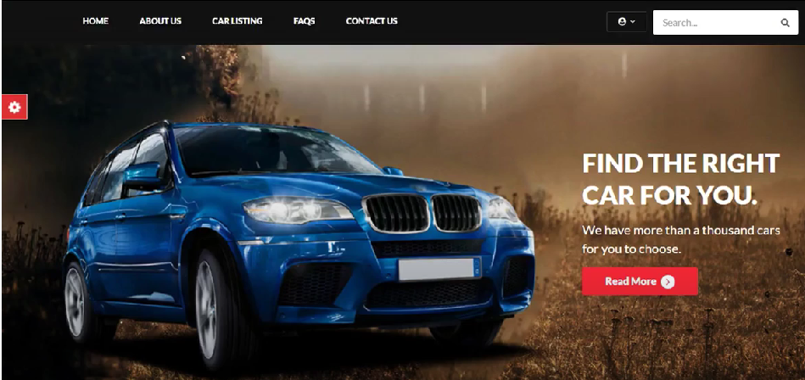

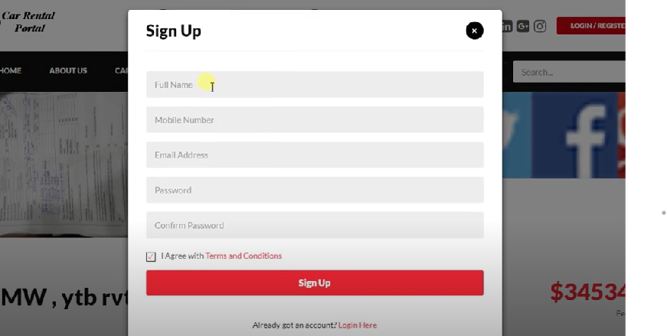

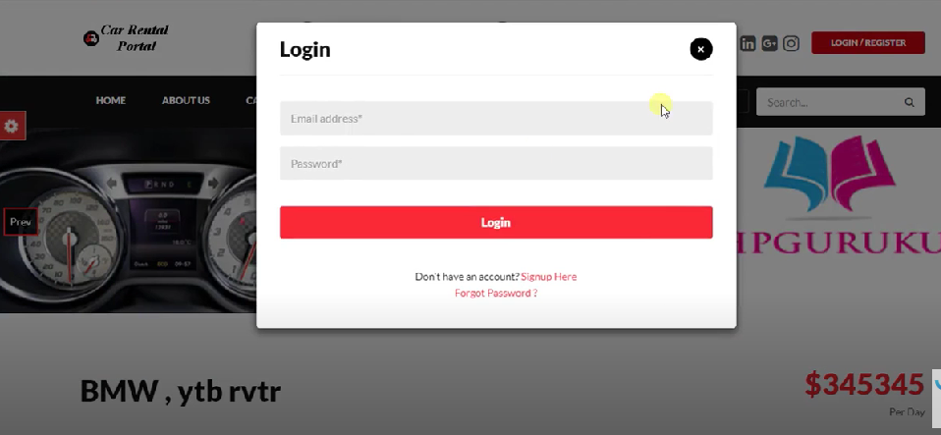

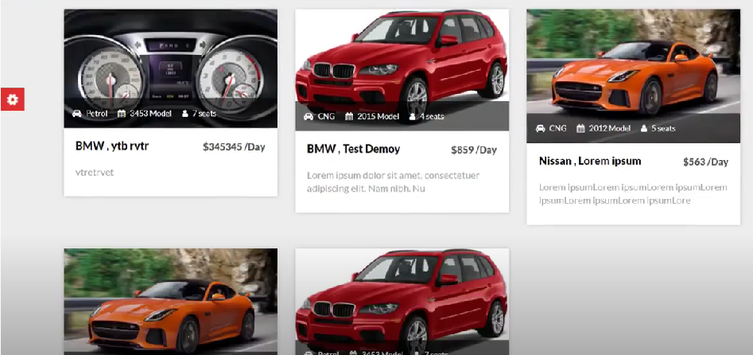

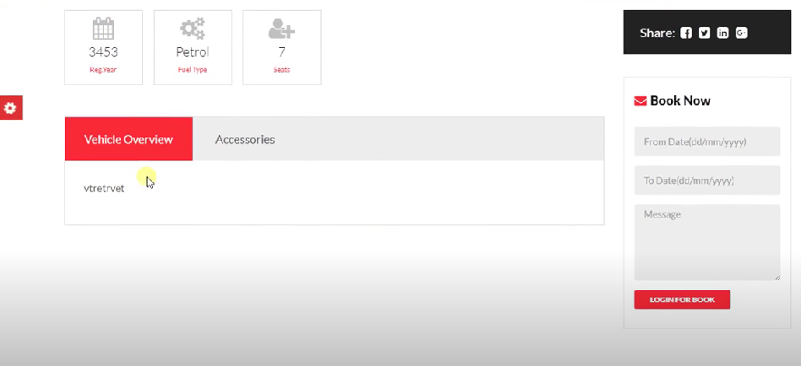

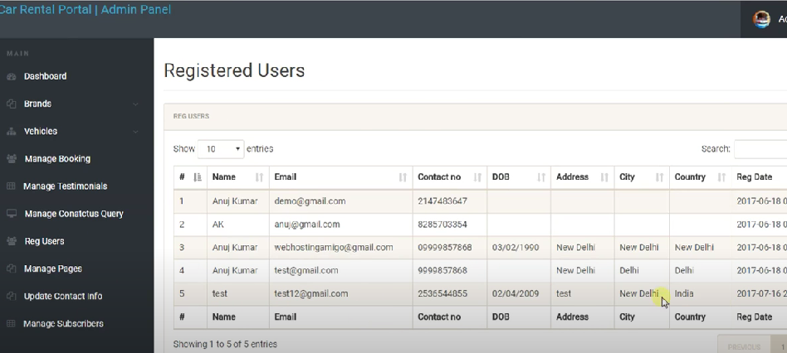

### CHAPTER 6 TESTING

**CHAPTER6**

**TESTING**

### TESTING AND IMPLEMENTATION

Testing is the process of executing a program or website application with the intent of finding software bugs, and to verify that the software product is fit for use.

##### UNIT TESTING

Unit testing focuses verification efforts on the smallest unit of software design in the module. This is also known as module testing. The module of the system is tested separately. This testing is carried out during the programming stage itself. In this testing each module is found to work satisfactorily as regard to the expected output from the module. In this project, all statements are executed properly.

##### TEST CASES OF ANY COMPANY

|  |  |  |  |  |  |
| --- | --- | --- | --- | --- | --- |
| **ID** | **TEST**  **CASES** | **PRE-**  **CONDITIONS** | **EXPECTED**  **RESULTS** | **ACTUAL**  **RESULTS** | **PASS/FAIL** |
| TC001 | User (Public) Registration | User Details. | Successful account Creation for issuer | Successful account Creation for issuer | PASS |

|  |  |  |  |  |  |
| --- | --- | --- | --- | --- | --- |
| TC002 | Any company vehicle is  selection | Selection vehicle  present in the data set | Successfully selected | Successfully selectedd | PASS |
| TC003 | Any company is  Booking request | Request for booking | Successfully sended request to machine owner | Successfully sended request to machine owner | PASS |

##### INTEGRATION TESTING

Integration testing (sometimes called integration and testing, abbreviated I&T) is the phase in software testing in which individual software modules are combined and tested as a group.website applied with the tomcat server and with the mobile functionalities website tests defined in an integration test plan to those aggregates, and delivers as its output the integrated system ready for system testing.

##### SYSTEM TESTING OF ANY COMPANY

The listed tests were conducted by the admin manually at the various development stages. Unit testing was conducted and errors were changed. The integration testing is performed after the system integration of the tomcat server with website and errors are rectified systems like data transmission etc. The results were analyzed, and the appropriate alterations were made. The test results proved to be positive and henceforth the website application is feasible, and test website is approved.

## CHAPTER 7

**RESULTS AND DISCUSSION**

36

### CHAPTER 7 RESULTS AND DISCUSSION

##### RESULTS

Currently, The car rental companies have their own company website ad which can book, but smaller companies which have a website and individual persons having vehicles unable to explore their network.this website will helpful for the person,any one can book for any company and any company upload their vehicle services to this website.

##### DISCUSSION

The listed tests were conducted by the admin manually at the various development stages. Unit testing was conducted and errors were changed. The integration testing is performed after the system integration of the tomcat server with website and errors are rectified systems like data transmission etc. The results were analyzed, and the appropriate alterations were made. The test results proved to be positive and henceforth the website application is feasible, and test website is approved.

37

## 

## CHAPTER 8

**CONCLUSION AND FUTURE ENHANCEMENT**

38

### CHAPTER 8

**CONCLUSION AND FUTURE ENHANCEMENT**

##### CONCLUSION

Currently, The car rental companies have their own company website ad which can book, but smaller companies which have a website and individual persons having vehicles unable to explore their network.this website will helpful for the person,any one can book for any company and any company upload their vehicle services to this website.

##### FUTURE ENHANCEMENT

As a future recommendation this website application can have the ai implementation through which we can decrease the effort of accessing with the ai automation.

## ANNEXURE

### ANNEXURE

**SOURCE CODE:**

### Add_vehicle.php

<!DOCTYPE html PUBLIC "-//W3C//DTD XHTML 1.0 Transitional//EN" "http://www.w3.org/TR/xhtml1/DTD/xhtml1-transitional.dtd">

<html xmlns="http://www.w3.org/1999/xhtml">

<head>

<meta http-equiv="Content-type" content="text/html; charset=utf-8" />

<title>Admin Home</title>

<link rel="stylesheet" href="css/style.css" type="text/css" media="all" />

<script type="text/javascript">

function sureToApprove(id){

if(confirm("Are you sure you want to delete this car?")){

window.location.href ='delete_car.php?id='+id;

}

}

</script>

</head>

<body>

<!-- Header -->

<div id="header">

<div class="shell">

<?php

include 'menu.php';

?>

</div>

<!-- End Main Nav -->

</div>

</div>

<div id="container">

<div class="shell">

<div class="small-nav">

<a href="index.php">Dashboard</a>

<span>&gt;</span>

Vehicle Management

</div>

<br />

<div id="main">

<div class="cl">&nbsp;</div>

<div id="content">

<div class="box">

<!-- Box Head -->

<div class="box-head">

<h2 class="left">Our Vehicles</h2>

<div class="right">

<label>search vehicles</label>

<input type="text" class="field small-field" />

<input type="submit" class="button" value="search" />

</div>

</div>

<div class="table">

<table width="100%" border="0" cellspacing="0" cellpadding="0">

<tr>

<th width="13"><input type="checkbox" class="checkbox" /></th>

<th>Vehicle Make</th>

<th>Car Type</th>

<th>Hire Price</th>

<th width="110" class="ac">Content Control</th>

</tr>

<?php

include '../includes/config.php';

$select = "SELECT * FROM cars WHERE status = 'Available'";

$result = $conn->query($select);

while($row = $result->fetch_assoc()){

?>

<tr>

<td><input type="checkbox" class="checkbox" /></td>

<td><h3><a href="#"><?php echo $row['car_type'] ?></a></h3></td>

<td><?php echo $row['car_name'] ?></td>

<td><a href="#"><?php echo $row['hire_cost'] ?></a></td>

<td><a href="javascript:sureToApprove(<?php echo $row['car_id'];?>)" class="ico del">Delete</a><a href="#" class="ico edit">Edit</a></td>

</tr>

<?php

}

?>

</table>

<!-- Pagging -->

<div class="pagging">

<div class="left">Showing 1-12 of 44</div>

<div class="right">

<a href="#">Previous</a>

<a href="#">1</a>

<a href="#">2</a>

<a href="#">3</a>

<a href="#">4</a>

<a href="#">245</a>

<span>...</span>

<a href="#">Next</a>

<a href="#">View all</a>

</div>

</div>

<!-- End Pagging -->

</div>

<h2><input type="submit" onclick="window.print()" value="Print Here" /></h2>

</div>

<!-- End Box -->

</div>

<!-- End Content -->

<!-- Sidebar -->

<div id="sidebar">

<!-- Box -->

<div class="box">

<!-- Box Head -->

<div class="box-head">

<h2>Management</h2>

</div>

<!-- End Box Head-->

<div class="box-content">

<a href="add_cars.php" class="add-button"><span>Add new Vehicles</span></a>

<div class="cl">&nbsp;</div>

<p class="select-all"><input type="checkbox" class="checkbox" /><label>select all</label></p>

<p><a href="#">Delete Selected</a></p>

<!-- Sort -->

<div class="sort">

<label>Sort by</label>

<select class="field">

<option value="">Car Type</option>

</select>

<select class="field">

<option value="">Car Name</option>

</select>

<select class="field">

<option value="">Hire Price</option>

</select>

</div>

<!-- End Sort -->

</div>

</div>

<!-- End Box -->

</div>

<!-- End Sidebar -->

<div class="cl">&nbsp;</div>

</div>

<!-- Main -->

</div>

</div>

<!-- End Container -->

<!-- Footer -->

<div id="footer">

<div class="shell">

<span class="left">&copy; <?php echo date("Y");?> - Sonko Rescue Team</span>

<span class="right">

Design by Consi</a>

</span>

</div>

</div>

<!-- End Footer -->

</body>

</html>

### Addvehicle.php

<?php

include '../includes/config.php';

?>

<!DOCTYPE html PUBLIC "-//W3C//DTD XHTML 1.0 Transitional//EN" "http://www.w3.org/TR/xhtml1/DTD/xhtml1-transitional.dtd">

<html xmlns="http://www.w3.org/1999/xhtml">

<head>

<meta http-equiv="Content-type" content="text/html; charset=utf-8" />

<title>Admin Home</title>

<link rel="stylesheet" href="css/style.css" type="text/css" media="all" />

</head>

<body>

<div id="header">

<div class="shell">

<?php

include 'menu.php';

?>

</div>

</div>

</div>

<div id="container">

<div class="shell">

<div class="small-nav">

<a href="index.php">Dashboard</a>

<span>&gt;</span>

Add New Vehicles

</div>

<br />

<div id="main">

<div class="cl">&nbsp;</div>

<div id="content">

<div class="box">

<div class="box-head">

<h2>Add New Vehicles</h2>

</div>

<form action="" method="post" enctype="multipart/form-data">

<div class="form">

<p>

<span class="req">max 100 symbols</span>

<label>Vehicle Name <span>(Required Field)</span></label>

<input type="text" class="field size1" name="car_name" required />

</p>

<p>

<span class="req">max 20 symbols</span>

<label>Vehicle Make <span>(Required Field)</span></label>

<input type="text" class="field size1" name="car_type" required />

</p>

<p>

<span class="req">max 20 symbols</span>

<label>Vehicle Hire Price <span>(Required Field)</span></label>

<input type="text" class="field size1" name="hire_cost" required />

</p>

<p>

<span class="req">Current Images</span>

<label>Vehicle Image <span>(Required Field)</span></label>

<input type="file" class="field size1" name="image" required />

</p>

<p>

<span class="req">In Terms of Passenger Seats</span>

<label>Vehicle Capacity<span>(Required Field)</span></label>

<input type="text" class="field size1" name="capacity" required />

</p>

</div>

<div class="buttons">

<input type="button" class="button" value="preview" />

<input type="submit" class="button" value="submit" name="send" />

</div>

</form>

<?php

if(isset($_POST['send'])){

$target_path = "../cars/";

$target_path = $target_path . basename ($_FILES['image']['name']);

if(move_uploaded_file($_FILES['image']['tmp_name'], $target_path)){

$image = basename($_FILES['image']['name']);

$car_name = $_POST['car_name'];

$car_type = $_POST['car_type'];

$hire_cost = $_POST['hire_cost'];

$capacity = $_POST['capacity'];

$qr = "INSERT INTO cars (image, car_name,car_type,hire_cost,capacity,status)

VALUES ('$image','$car_name','$car_type','$hire_cost','$capacity','Available')";

$res = $conn->query($qr);

if($res === TRUE){

echo "<script type = \"text/javascript\">

alert(\"Vehicle Succesfully Added\");

window.location = (\"add_vehicles.php\")

</script>";

}

}

else 'Failed';

}

?>

</div>

</div>

<div id="sidebar">

<div class="box">

<div class="box-head">

<h2>Management</h2>

</div>

<div class="box-content">

<a href="add_vehicles.php" class="add-button"><span>View Our Vehicles</span></a>

<div class="cl">&nbsp;</div>

<p class="select-all"><input type="checkbox" class="checkbox" /><label>select all</label></p>

<p><a href="#">Delete Selected</a></p>

<!-- Sort -->

<div class="sort">

<label>Sort by</label>

<select class="field">

<option value="">Car Type</option>

</select>

<select class="field">

<option value="">Car Name</option>

</select>

<select class="field">

<option value="">Hire Price</option>

</select>

</div>

</div>

</div>

</div>

<div class="cl">&nbsp;</div>

</div>

</div>

</div>

<div id="footer">

<div class="shell">

<span class="left">&copy; <?php echo date("Y");?> - Sonko Rescue Team</span>

<span class="right">

Design by Consi</a>

</span>

</div>

</div>

</body>

</html>

### Approve.php

<?php

include '../includes/config.php';

$id = $_REQUEST['id'];

$query = "UPDATE client SET status = 'Approved' WHERE client_id = '$id'";

$result = $conn->query($query);

if($result === TRUE){

echo 'Request has Successfully been Approved';

?>

<meta content="4; client_requests.php" http-equiv="refresh" />

<?php

}

?>

### Client_request.php

<!DOCTYPE html PUBLIC "-//W3C//DTD XHTML 1.0 Transitional//EN" "http://www.w3.org/TR/xhtml1/DTD/xhtml1-transitional.dtd">

<html xmlns="http://www.w3.org/1999/xhtml">

<head>

<meta http-equiv="Content-type" content="text/html; charset=utf-8" />

<title>Admin Home</title>

<link rel="stylesheet" href="css/style.css" type="text/css" media="all" />

<script type="text/javascript">

function sureToApprove(id){

if(confirm("Are you sure you want to Approve this request?")){

window.location.href ='approve.php?id='+id;

}

}

</script>

</head>

<body>

<!-- Header -->

<div id="header">

<div class="shell">

<?php

include 'menu.php';

?>

</div>

</div>

<div id="container">

<div class="shell">

<div class="small-nav">

<a href="index.php">Dashboard</a>

<span>&gt;</span>

Client Requests

</div>

<br />

<div id="main">

<div class="cl">&nbsp;</div>

<div id="content">

<div class="box">

<!-- Box Head -->

<div class="box-head">

<h2 class="left">Client Requests</h2>

<div class="right">

<label>search requests</label>

<input type="text" class="field small-field" />

<input type="submit" class="button" value="search" />

</div>

</div>

<div class="table">

<table width="100%" border="0" cellspacing="0" cellpadding="0">

<tr>

<th width="13"><input type="checkbox" class="checkbox" /></th>

<th>Client Name</th>

<th>Client Phone</th>

<th>Car Booked</th>

<th>Mpesa ID</th>

<th>Status</th>

<th width="110" class="ac">Content Control</th>

</tr>

<?php

include '../includes/config.php';

$select = "SELECT client.client_id,client.fname,client.phone,cars.car_name,cars.hire_cost,client.status

FROM client JOIN cars ON client.car_id=cars.car_id";

$result = $conn->query($select);

while($row = $result->fetch_assoc()){

?>

<tr>

<td><input type="checkbox" class="checkbox" /></td>

<td><h3><a href="#"><?php echo $row['fname'] ?></a></h3></td>

<td><h3><a href="#"><?php echo $row['phone'] ?></a></h3></td>

<td><?php echo $row['car_name'] ?></td>

<td><a href="#"><?php echo $row['hire_cost'] ?></a></td>

<td><a href="#"><?php echo $row['status'] ?></a></td>

<td><a href="javascript:sureToApprove(<?php echo $row['client_id'];?>)" class="ico del">Approve</a><a href="#" class="ico edit">Delete</a></td>

</tr>

<?php

}

?>

</table>

<!-- Pagging -->

<div class="pagging">

<div class="left">Showing 1-12 of 44</div>

<div class="right">

<a href="#">Previous</a>

<a href="#">1</a>

<a href="#">2</a>

<a href="#">3</a>

<a href="#">4</a>

<a href="#">245</a>

<span>...</span>

<a href="#">Next</a>

<a href="#">View all</a>

</div>

</div>

<!-- End Pagging -->

</div>

<h2><input type="submit" onclick="window.print()" value="Print Here" /></h2>

</div>

<!-- End Box -->

</div>

<!-- End Content -->

<div class="cl">&nbsp;</div>

</div>

<!-- Main -->

</div>

</div>

<!-- End Container -->

<!-- Footer -->

<div id="footer">

<div class="shell">

<span class="left">&copy; <?php echo date("Y");?> - Sonko Rescue Team</span>

<span class="right">

Design by Consi</a>

</span>

</div>

</div>

<!-- End Footer -->

</body>

</html>

### delete.php

<?php

include '../includes/config.php';

$id = $_REQUEST['id'];

$query = "DELETE FROM client WHERE client_id = '$id'";

$result = $conn->query($query);

if($result === TRUE){

echo 'Request has Successfully been Deleted';

?>

<meta content="4; client_requests.php" http-equiv="refresh" />

<?php

}

?>

### deletemessage.php

<?php

include '../includes/config.php';

$id = $_REQUEST['id'];

$query = "DELETE FROM message WHERE msg_id = '$id'";

$result = $conn->query($query);

if($result === TRUE){

echo "<script type = \"text/javascript\">

alert(\"Message Successfully Send\");

window.location = (\"index.php\")

</script>";

}

?>

### Index.php

<!DOCTYPE html PUBLIC "-//W3C//DTD XHTML 1.0 Transitional//EN" "http://www.w3.org/TR/xhtml1/DTD/xhtml1-transitional.dtd">

<html xmlns="http://www.w3.org/1999/xhtml">

<head>

<meta http-equiv="Content-type" content="text/html; charset=utf-8" />

<title>Admin Home</title>

<link rel="stylesheet" href="css/style.css" type="text/css" media="all" />

<script type="text/javascript">

function sureToApprove(id){

if(confirm("Are you sure you want to delete this message?")){

window.location.href ='delete_msg.php?id='+id;

}

}

</script>

</head>

<body>

<!-- Header -->

<div id="header">

<div class="shell">

<?php

include 'menu.php';

?>

</div>

<!-- End Main Nav -->

</div>

</div>

<div id="container">

<div class="shell">

<div class="small-nav">

<a href="index.php">Dashboard</a>

<span>&gt;</span>

Client Messages

</div>

<br />

<div id="main">

<div class="cl">&nbsp;</div>

<div id="content">

<div class="box">

<!-- Box Head -->

<div class="box-head">

<h2 class="left">Client Messages</h2>

<div class="right">

<label>search messages</label>

<input type="text" class="field small-field" />

<input type="submit" class="button" value="search" />

</div>

</div>

<div class="table">

<table width="100%" border="0" cellspacing="0" cellpadding="0">

<tr>

<th width="13"><input type="checkbox" class="checkbox" /></th>

<th>Message Content</th>

<th>Time Send</th>

<th>Status</th>

<th width="110" class="ac">Content Control</th>

</tr>

<?php

include '../includes/config.php';

$select = "SELECT * FROM message";

$result = $conn->query($select);

while($row = $result->fetch_assoc()){

?>

<tr>

<td><input type="checkbox" class="checkbox" /></td>

<td><h3><a href="#"><?php echo $row['message'] ?></a></h3></td>

<td><?php echo $row['time'] ?></td>

<td><a href="#"><?php echo $row['status'] ?></a></td>

<td><a href="javascript:sureToApprove(<?php echo $row['msg_id'];?>)" class="ico del">Delete</a><a href="#" class="ico edit">Edit</a></td>

</tr>

<?php

}

?>

</table>

<!-- Pagging -->

<div class="pagging">

<div class="left">Showing 1-12 of 44</div>

<div class="right">

<a href="#">Previous</a>

<a href="#">1</a>

<a href="#">2</a>

<a href="#">3</a>

<a href="#">4</a>

<a href="#">245</a>

<span>...</span>

<a href="#">Next</a>

<a href="#">View all</a>

</div>

</div>

<!-- End Pagging -->

</div>

<h2><input type="submit" onclick="window.print()" value="Print Here" /></h2>

</div>

<!-- End Box -->

</div>

<!-- End Content -->

<!-- Sidebar -->

<div id="sidebar">

<!-- Box -->

<div class="box">

<!-- Box Head -->

<div class="box-head">

<h2>Management</h2>

</div>

<!-- End Box Head-->

<div class="box-content">

<a href="#" class="add-button"><span>Send Messages</span></a>

<div class="cl">&nbsp;</div>

<p class="select-all"><input type="checkbox" class="checkbox" /><label>select all</label></p>

<p><a href="#">Delete Selected</a></p>

</div>

</div>

<!-- End Box -->

</div>

<!-- End Sidebar -->

<div class="cl">&nbsp;</div>

</div>

<!-- Main -->

</div>

</div>

<!-- End Container -->

<!-- Footer -->

<div id="footer">

<div class="shell">

<span class="left">&copy; <?php echo date("Y");?> - Sonko Rescue Team</span>

<span class="right">

Design by Consi</a>

</span>

</div>

</div>

<!-- End Footer -->

</body>

</html>

### Indexx.php

<!DOCTYPE html PUBLIC "-//W3C//DTD XHTML 1.0 Transitional//EN" "http://www.w3.org/TR/xhtml1/DTD/xhtml1-transitional.dtd">

<html xmlns="http://www.w3.org/1999/xhtml">

<head>

<meta http-equiv="Content-type" content="text/html; charset=utf-8" />

<title>Admin Home</title>

<link rel="stylesheet" href="css/style.css" type="text/css" media="all" />

</head>

<body>

<!-- Header -->

<div id="header">

<div class="shell">

<?php

include 'menu.php';

?>

</div>

</div>

<!-- End Header -->

<!-- Container -->

<div id="container">

<div class="shell">

<!-- Small Nav -->

<div class="small-nav">

<a href="#">Dashboard</a>

<span>&gt;</span>

Current Articles

</div>

<br />

<!-- Main -->

<div id="main">

<div class="cl">&nbsp;</div>

<!-- Content -->

<div id="content">

<!-- Box -->

<div class="box">

<!-- Box Head -->

<div class="box-head">

<h2>Add New Article</h2>

</div>

<!-- End Box Head -->

<form action="" method="post">

<!-- Form -->

<div class="form">

<p>

<span class="req">max 100 symbols</span>

<label>Article Title <span>(Required Field)</span></label>

<input type="text" class="field size1" />

</p>

<p class="inline-field">

<label>Date</label>

<select class="field size2">

<option value="">23</option>

</select>

<select class="field size3">

<option value="">July</option>

</select>

<select class="field size3">

<option value="">2009</option>

</select>

</p>

<p>

<span class="req">max 100 symbols</span>

<label>Content <span>(Required Field)</span></label>

<textarea class="field size1" rows="10" cols="30"></textarea>

</p>

</div>

<!-- End Form -->

<!-- Form Buttons -->

<div class="buttons">

<input type="button" class="button" value="preview" />

<input type="submit" class="button" value="submit" />

</div>

<!-- End Form Buttons -->

</form>

</div>

<!-- End Box -->

</div>

<!-- End Content -->

<!-- Sidebar -->

<div id="sidebar">

<!-- Box -->

<div class="box">

<!-- Box Head -->

<div class="box-head">

<h2>Management</h2>

</div>

<!-- End Box Head-->

<div class="box-content">

<a href="#" class="add-button"><span>Add new Article</span></a>

<div class="cl">&nbsp;</div>

<p class="select-all"><input type="checkbox" class="checkbox" /><label>select all</label></p>

<p><a href="#">Delete Selected</a></p>

<!-- Sort -->

<div class="sort">

<label>Sort by</label>

<select class="field">

<option value="">Car Type</option>

</select>

<select class="field">

<option value="">Car Name</option>

</select>

<select class="field">

<option value="">Hire Price</option>

</select>

</div>

<!-- End Sort -->

</div>

</div>

<!-- End Box -->

</div>

<!-- End Sidebar -->

<div class="cl">&nbsp;</div>

</div>

<!-- Main -->

</div>

</div>

<!-- End Container -->

<!-- Footer -->

<div id="footer">

<div class="shell">

<span class="left">&copy; <?php echo date("Y");?> - Sonko Rescue Team</span>

<span class="right">

Design by Consi</a>

</span>

</div>

</div>

<!-- End Footer -->

</body>

</html>

### logout.php

<?php

session_start();

session_destroy();

header("location: ../index.php");

?>

### Menu.php

<?php

error_reporting("E-NOTICE");

?>

<?php

session_start();

if(!$_SESSION['uname'] && (!$_SESSION['pass'])){

header("location: ../login.php");

}

?>

<div id="top">

<h1><a href="#">Sonko Rescue Team</a></h1>

<div id="top-navigation">

Welcome <a href="#"><strong>Administrator</strong></a>

<span>|</span>

<a href="#">Help</a>

<span>|</span>

<a href="#">Profile Settings</a>

<span>|</span>

<a href="logout.php">Log out</a>

</div>

</div>

<div id="navigation">

<ul>

<li><a href="index.php"><span>Dashboard</span></a></li>

<li><a href="add_vehicles.php"><span>Vehicle Management</span></a></li>

<li><a href="client_requests.php"><span>Hire Requests</span></a></li>

<li><a href="index.php"><span>Messages</span></a></li>

<li><a href="#"><span>Services Control</span></a></li>

</ul>

</div>

# REFERENCES

# REFERENCES

[1]Thakur, A., & Dhiman, K. (2021). Chat Room Using HTML, PHP, CSS, JS, AJAX. International Research Journal of Engineering and Technology (IRJET), 08(June), 1948–1951. https://doi.org/https://doi.org/10.6084/m9.figshare.14869167 .

[2] Thakur, Amey and Karan Dhiman. “Chat Room Using HTML, PHP, CSS, JS, AJAX.” ArXiv abs/2106.14704 (2021): n. pag.

[3] Waspodo, Bayu, Qurrotul Aini, and Syamsuri Nur. "Development of car rental management information system." In Proceeding International Conference on Information Systems For Business Competitiveness (ICISBC), pp. 101-105. 2011.

[4] Osman, Mohd Nizam, Nurzaid Md Zain, Zulfikri Paidi, Khairul Anwar Sedek, Mohamad NajmuddinYusoff, and Mushahadah Maghribi. "Online Car Rental System Using Web-Based and SMS Technology." Computing Research & Innovation (CRINN) 2 (2017): 277.

[5] Fink, Andreas, and Torsten Reiners. "Modeling and solving the short-term car rental logistics problem." Transportation Research Part E: Logistics and Transportation Review 42, no. 4 (2006): 272-292.