# ***DIGITAL PRINCIPLES AND***

***SYSTEM DESIGN***

# ***Mini project-2***

### *Topic*: *Design a 6 person voting system using 4 bit parallel adder.*

*V.NARASIMMAN*

111722107031

FIRST YEAR CSD-B

### Q.Design a 6 person voting system using 4 bit parallel adder

### A.

### *Components*:Use two full adders and a 4 bit parallel adder.

### Each full adders can sum upto 3 votes.

*MATERIALS*: You'll need

Ic's: (74hc283 x 2), 74ls47 with x3 16 pin bases and Lm7805 (regulator)

Veroboard , Some pieces of jumper wires ,Solder ,Led's: (red x 4), (Green x 6)

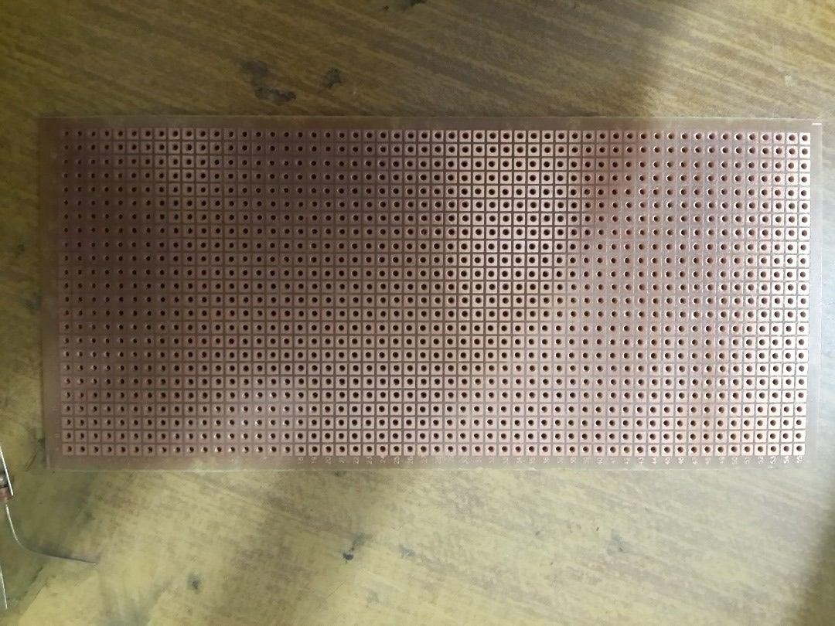7 segment led's x 2 (Anode) , Resistor's: (330 ohms x 12), (1 k x 7) Switches: spst x 7

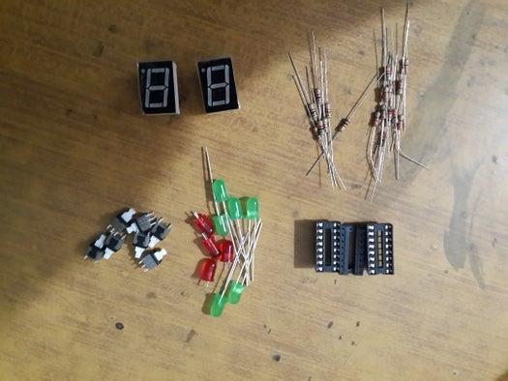

*Circuit Diagram:*

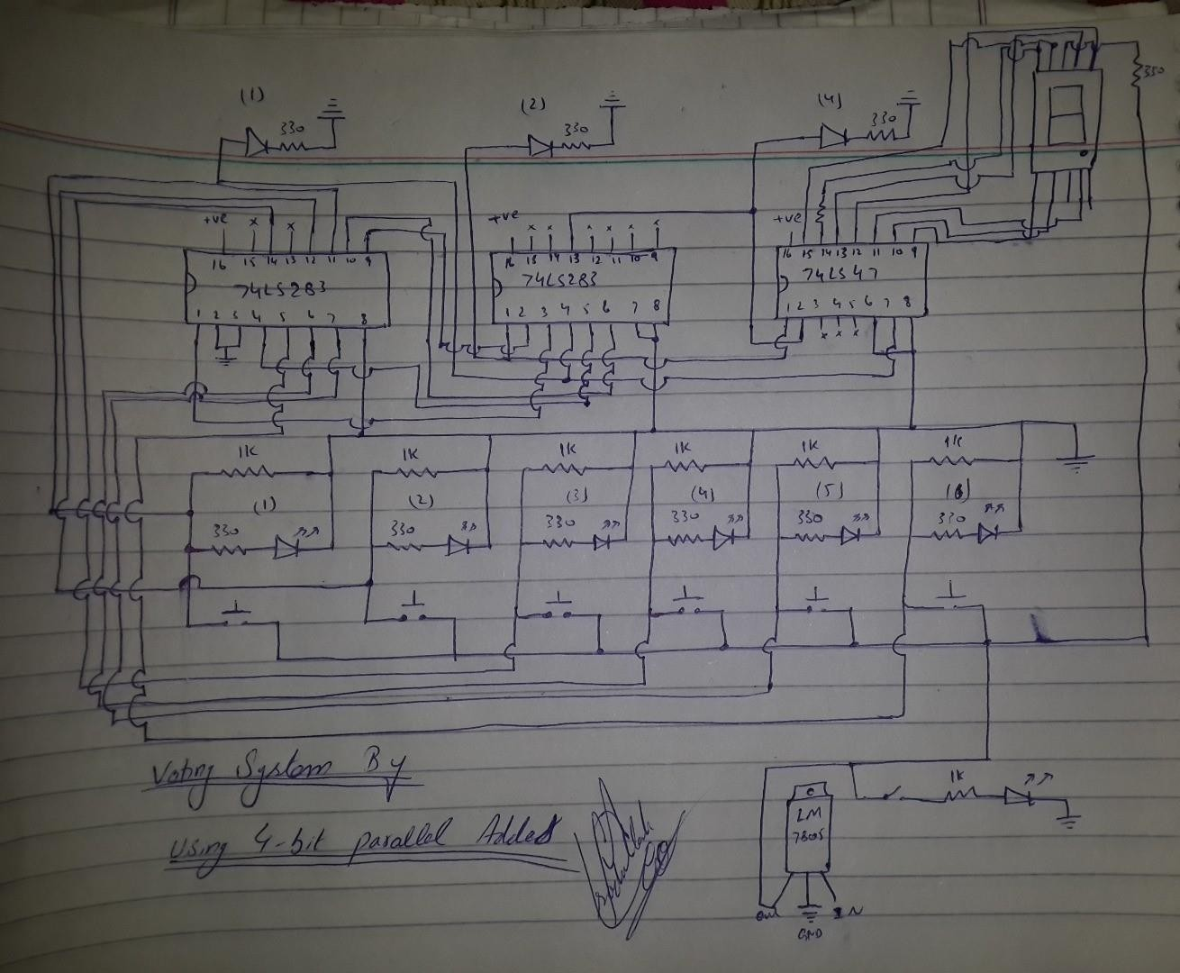

With the help of this diagram we can build our own voting system project very easily. Just follow the diagram very carefully. Let me tell you something at the pin 14 of 74ls47 a 330 ohm resistor is attached with 7 segment led's which is not mention in a diagram by mistake.

*Component placing:*

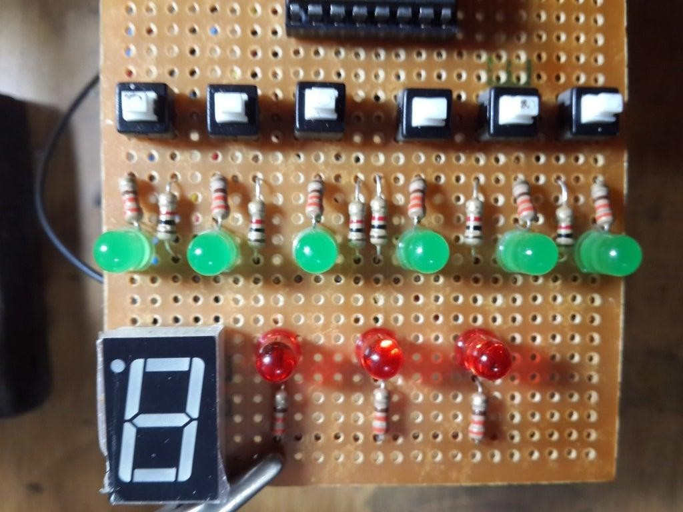

Place the components according to the diagram on veroboard and soldering it.

*Soldering and jumper wires*:

## https://content.instructables.com/F2R/PJ6T/IEIDFDT5/F2RPJ6TIEIDFDT5.jpg?auto=webp&frame=1&width=1024&height=1024&fit=bounds&md=3c20c97f64186996eccd4d7e2fbfd2fd

***THANK YOU***