Table of Contents

1. Introduction: What is Bootstrap?
Bootstrap is the world's most popular frontend open-source CSS framework, providing pre-built responsive components, a powerful grid system, and utility classes that enable rapid mobile-first website development without writing CSS from scratch (Bootstrap Team, 2024). Originally developed at Twitter by Mark Otto and Jacob Thornton in 2011, Bootstrap standardized responsive web design practices and democratized access to professional-grade UI components.
The portfolio leverages Bootstrap 5.3.2, imported via CDN in the HTML `<head>` section alongside custom CSS. This hybrid approach—using Bootstrap for structural components and custom styles for aesthetic differentiation—represents a pragmatic development strategy: leveraging tested, accessible components while maintaining unique visual identity through override styles.

2. The Responsive Grid System
Bootstrap's grid system, built upon CSS Flexbox, divides page width into 12 columns with responsive breakpoints: xs (<576px), sm (≥576px), md (≥768px), lg (≥992px), and xl (≥1200px). These breakpoints enable layouts that adapt automatically across device sizes without custom media queries for every change (Bootstrap Team, 2024).
The portfolio's Bootstrap Grid Visualizer (Figure 1) demonstrates this adaptability interactively. Users toggle between breakpoints to observe how column configurations transform: `.col-12` occupies full width on mobile; `.col-md-6` halves width on tablets; `.col-lg-3` reduces to quarter width on desktops. The visualizer displays six columns that stack vertically on extra-small screens, pair horizontally on small screens, form triplets on medium screens, quarter on large screens, and display six-across on extra-large screens.
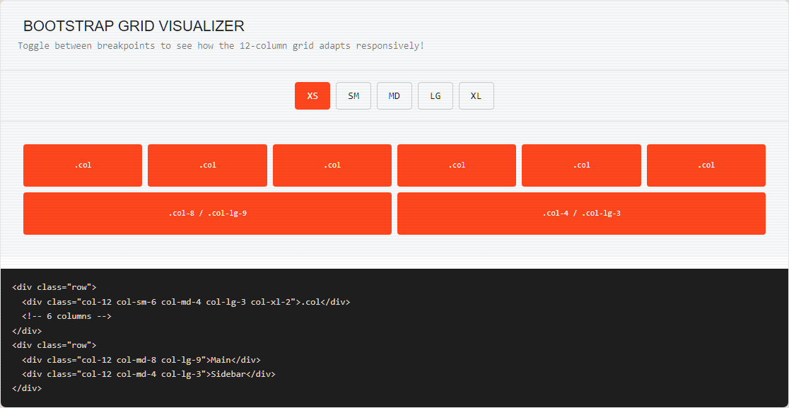
Figure 1: Bootstrap Grid Visualizer Demonstrating Responsive Columns
This behavior emerges from combining breakpoint classes: `<div class="col-12 col-sm-6 col-md-4 col-lg-3 col-xl-2">` progressively refines column width as viewport expands. The second demo row illustrates asymmetric layouts with `.col-md-8` (main content) alongside `.col-md-4` (sidebar), a common pattern for content-heavy pages. Understanding this 12-column logic eliminates the need for manual breakpoint calculations, accelerating responsive development significantly.

3. Bootstrap Components in Practice
Rather than reinventing interface elements, the portfolio utilizes Bootstrap's extensively tested UI components. The components showcase (Figure 2) features Cards, Alerts, Buttons, Modal, and Carousel tabs, each demonstrating distinct Bootstrap capabilities.
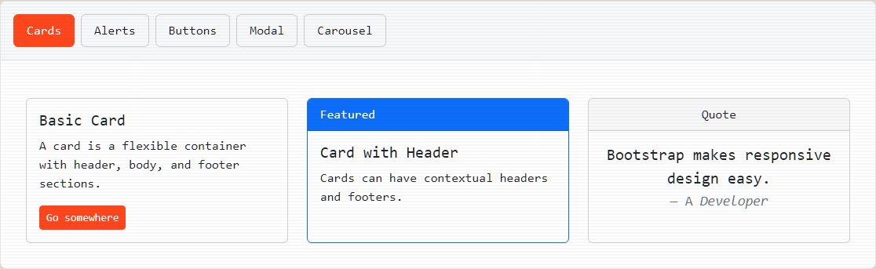
Figure 2: Bootstrap Components Showcase (Cards, Alerts, Buttons)
Navbar: The portfolio's sticky navigation employs `navbar` and `navbar-expand-lg` classes. On desktop, menu items display horizontally; on mobile, they collapse into a responsive "hamburger" menu triggered by `navbar-toggler`. This behavior requires minimal markup—Bootstrap handles the complex CSS transitions, ARIA accessibility attributes, and click-outside-to-close functionality automatically.
Cards: The card component structures information with optional headers, bodies, and footers. The portfolio displays basic cards, cards with contextual headers (`bg-primary`), and quote cards with centered blockquote content—demonstrating component versatility through simple class variations.
Alerts and Buttons: Contextual classes like `btn-primary`, `alert-success`, and `alert-danger` apply predefined color schemes instantly. The buttons demo showcases standard, outline, and sized variants, while the alerts demo presents five contextual states with appropriate icons—functionality that would require extensive custom CSS to replicate manually.
Modal and Carousel: The modal component creates accessible dialog overlays with backdrop dimming and keyboard navigation. The carousel implements automatic cycling with indicators and touch support for mobile devices. Both components require only HTML markup and data attributes, with Bootstrap's JavaScript handling all interaction logic (Bootstrap Team, 2024).
The actual HTML code implementing the responsive navbar (Figure 3) illustrates Bootstrap's class-based approach: `navbar-expand-lg` controls breakpoint behavior, `navbar-dark bg-dark` sets color themes, `data-bs-toggle="collapse"` enables toggle functionality, and `ms-auto` pushes navigation items rightward. This declarative markup style—describing what elements should do rather than how—represents Bootstrap's core philosophy.
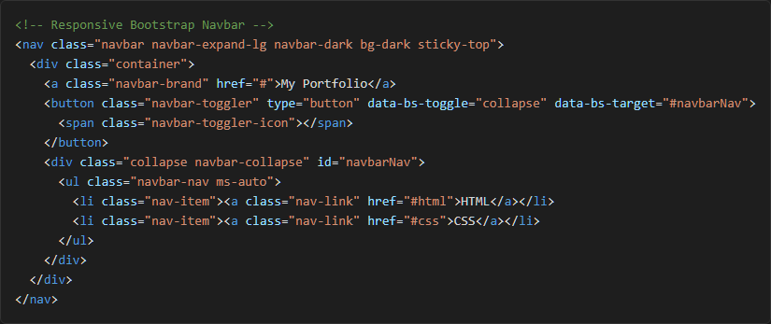
Figure 3: HTML Markup for Responsive Bootstrap Navbar

4. Utility Classes and Rapid Development
Bootstrap includes hundreds of utility classes for spacing, colors, display properties, and flex behavior. These atomic classes enable rapid styling without custom CSS rules. The portfolio demonstrates spacing utilities (`m-0` through `m-5` for margin scales), text colors (`.text-primary`, `.text-success`), background colors (`.bg-primary`, `.bg-danger`), and display utilities (`.d-inline`, `.d-block`, `.d-inline-block`).
This utility-first approach accelerates prototyping by eliminating context-switching between HTML and CSS files. Rather than writing `.custom-spacing { margin: 1rem; }` in a stylesheet and applying the class, developers simply add `m-3` directly to HTML elements. While extensive utility usage can clutter markup, strategic application—particularly for spacing and color—significantly improves development velocity (Bootstrap Team, 2024).

5. Reflection
Bootstrap substantially accelerated my development workflow. I learned that custom media queries are unnecessary for every layout change—understanding the 12-column grid and breakpoint classes ensured the portfolio appeared polished on both laptops and smartphones with minimal effort. The framework taught me the value of established libraries in production environments: leveraging thousands of hours of community testing and accessibility review rather than rebuilding components independently. Bootstrap does not replace CSS knowledge but amplifies it, providing solid foundations upon which custom designs can flourish.

6. References
Bootstrap Team (2024) Bootstrap: The most popular HTML, CSS, and JS library. Available at: https://getbootstrap.com/ (Accessed: 17 June 2026).
Mozilla Foundation (2024) MDN Web Docs. Available at: https://developer.mozilla.org/ (Accessed: 17 June 2026).
World Wide Web Consortium (2024) W3C. Available at: https://www.w3.org/ (Accessed: 17 June 2026).

